* Ma trận đề kiểm tra học kỳ 1 môn tiếng Anh lớp 5
Thứ tự | Nội dung | Cấp độ |  |  |  | Số câu-Số điểm
Thứ tự | Nội dung | 1 | 2 | 3 | 4 | Số câu-Số điểm
Phần I | Listening |  |  |  |  | 12 câu = 3điểm 30%
Bài 1  04 câu | Listen and tick the correct answers / pictures  Unit 2: I always get up early. How about you?  Unit 7: How do you learn English?  Unit 8: What are you doing? | 1 câu | 2 câu | 1 câu |  | 4 câu=1.0 điểm
Bài 2  04 câu | Listen and number  Review 1 and Review 2 | 1 câu | 1 câu | 2 câu |  | 4 câu=1.0 điểm
Bài 3  04 câu | Listen and complete.  Unit 1: What’s your address?  Unit 5: Where will you be this weekend?  Unit 6: How many lessons do you have today? | 1 câu | 1 câu |  | 2 câu | 4 câu=1.0 điểm
Phần II | Pronunciation |  |  |  |  | 6 câu=1.5 điểm  15%
Bài 4  06 câu | Circle the word which has the stressed syllable different from the rest ones | 2 câu | 2 câu | 1 câu | 1 câu | 6 câu=1.5 điểm
Phần III | Reading |  |  |  |  | 16 câu = 4,0điểm 40%
Bài 5  06 câu | Look and read: Choose the correct words and write them on the lines/ Choose the best answer  Unit 4: Did you go to the party?  Unit 7: How do you learn English?  Unit 9: What did you see at the zoo? | 1 câu | 2 câu | 1 câu | 2 câu | 6 câu=1.5 điểm
Bài 6  05 câu | Fill in the blank  Unit 3: Where did you go on holiday?  Unit 6: How many lessons do you have today? | 1 câu | 1 câu | 2 câu | 1 câu | 5 câu=1.25 điểm
Bài 7  05 câu | Read and circle/ tick (T/F)  Unit 5: Where will you be this weekend?  Unit 8: What are you doing? | 1 câu | 2 câu | 1 câu | 1 câu | 5 câu=1.25 điểm
Phần IV | Writing |  |  |  |  | 6 câu = 1.5điểm 15%
Bài 8  06 câu | Arrange the words to make sentences  Unit 1: What’s your address?  Unit 3: Where did you go on holiday?  Unit 6: How many lessons do you have today?  Unit 8: What are you doing?  Unit 10: When will Sports Day be? | 1 câu | 2 câu | 2 câu | 1 câu | 6 câu=1.5 điểm
 | Tổng | 9 câu =2.25đ  22.5% | 13 câu =3.25đ  32.5% | 10 câu = 2.5đ  25% | 8 câu=  2.0đ  20% | 40 câu = 10 điểm 100%

UBND HUYỆN VĨNH BẢO  TRƯỜNG TIỂU HỌC VĨNH AN | ĐỀ KHẢO SÁT CHẤT LƯỢNG HỌC KỲ I  MÔN TIẾNG ANH LỚP 5  NĂM HỌC 2023 - 2024  (Thời gian làm bài: 40 phút)
PART I: Listening
Question 1. Listen and circle the correct answer (1pt).
1.
a. | b. | c.
2.
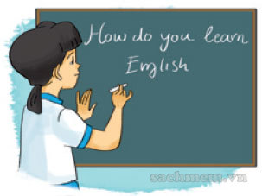a. | b. | c.
3.
a. | b. | c.
4.
a. | b. | c.
Question 2: Listen and number (1pt)
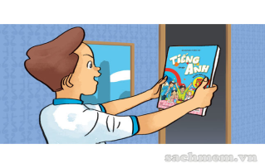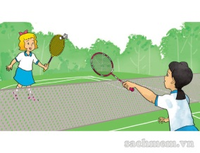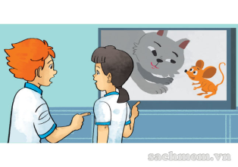

Question 3: Listen and write (1pt)
A: My (1).............................................. is Da Nang
B: I lived in a village in the (2).......................................
C: My village is small and (3)...........................................
D: Is it (4)............................................? - Yes, I think so.
PART II: Pronunciation
Questions 4: Circle the word which has the stressed syllable different from the rest ones (1,5pts)
1. a. cartoon | b. village | c. district | d. country
2. a. invite | b. repeat | c. explore | d. listen
3. a. address | b. seaside | c. sunday | d. tower
4. a. water | b. comic | c. complete | d. picnic
5. a. party | b. enjoy | c. birthday | d. city
6. a. become | b. return | c. island | d. begin
III. READING
Question 5: Choose the best answer (1,5pts)
1. Did you ................................ on a picnic?
a. went b. go c. goed d. goes
2. She ……………………..with her friends at the party last night.
a. chat b. chated c. chatted d. chats
3. How does she practise listening to English?
a. She watches English cartoons on TV b. She reads short stories
c. She learns vocabulary d. She writes emails to her friends
4. I learn English because I want ………………….
a. singing English songs b. talk with to my friends
c. to watching English cartoons on TV d. to read English comic books
5. The peacocks ………………………………
a. roared loudly b. ate slowly c. moved beautifully d. moved quietly
6. ..............................can spray water with their trunks
a. The peacocks b. The tigers c. The gorillas d. The elephants
Question 6: Fill in the blank (1,25pts)
by because went house views

Dear Mai,
I ………………..(1) back to my hometown to visit my grandparents last weekend. They live in the north of England. I went to King’s Cross railway station (2)………… underground. Then I took a train to my hometown . I like going by train (3) …………………. I can enjoy the beautiful (4) …………….………… on the way. I walked from the train station to my grandparents’ (5) ………………………….. I had a wonderful time in my hometown.
Love,
Linda
Question 7. Read and tick True (T) or False (F) (1,25pts).
Hello, I’m Tom. I’ll visit Tuan Chau Island with my classmates next week. It’ll have a lot of fun. In the morning, I think Peter will sunbathe. Mary and Linda will build sandcastles on the beach. In the afternoon, we will play foodball on the beach and swim in the sea. We love swimming . In the evening, we will have dinner in a restaurant by the sea. Then we will go for a walk along the beach. I hope we will have a good time in Tuan Chau island.
1. Tom will visit Tuan Chau island next week …………….
2. Peter, Mary and Linda will build sandcastles on the beach. ……………
3. They will swim in the sea in the morning. ……………..
4. They will have dinner after going for a walk along the beach. ………………..
5. They will have a good time in Phu Quoc …………….
IV. WRITING
Question 8: Arrange the words to make sentences (1,5pts)
1. you / take / Sports Day / Will / in / part /?/
.............................................................................................................................................
2. hard working / Tam / is /./
..............................................................................................................................................
3. lessons / have / How many / do / today / you /?/
...............................................................................................................................................
4. Hoi An / We / Ancient Town / went / by / to / coach /./
............................................................................................................................................
5. like / What / the / village / is /?/
..............................................................................................................................................
6. Aladdin / I / is / think / generous.
......................................................................................................................................................

UBND HUYỆN VĨNH BẢO  TRƯỜNG TIỂU HỌC VĨNH AN  (Đề đề xuất) | ĐÁP ÁN ĐỀ KHẢO SÁT CHẤT LƯỢNG HK I  MÔN TIẾNG ANH LỚP 5  NĂM HỌC 2023 - 2024  (Thời gian làm bài: 40 phút)
PART I: Listening
Question 1: Listen and tick the correct pictures.(1pt)
4 câu x 0,25 = 1đ
1 c 2 b 3 c 4 a
Question 2: Listen and number (1pt)
4 câu x 0,25 = 1đ
1. d 2.c 3.a 4.b
Question 3: Listen and write (1pt)
4 câu x 0,25 = 1đ
1. hometown 2. mountains 3. quiet 4. beautiful
PART II: Pronunciation
Questions 4: Circle the word which has the stressed syllable different from the rest ones (1pt)
6 câu x 0,25 = 1,5đ
1.a 2.d 3.a 4. C 5.b 6.c
III. READING
Question 5: Choose the correct words and write them on the lines (1,25pt)
6 câu x 0,25 = 1,25đ
1.b 2.c 3.a 4.d 5.c 6.d

Question 6: Fill in the blanks (1,25pt)
5 câu x 0,25 = 1,25đ
1. went 2. By 3. Because 4. Views 5. house

Question 7: Read and Tick True (T) or False (F) (1,25pt)
5 câu x 0,25 = 1,25đ
1. T 2. F 3. F 4. F 5. T
IV. WRITING
Question 8: Arrange the words to make sentences (1,25pt)
5 câu x 0,25 = 1,25đ
1. Will you take part in sports day?
2. Tam is hard working.
3. How many lessons do you have today?
4. We went to Hoi An Ancient Town by coach.
5. What is the village like?
6. I think Aladdin is generous.

KÝ DUYỆT CỦA BGH | NGƯỜI RA ĐỀ  (Ký, ghi rõ họ, tên)

