UBND HUYỆN VĨNH BẢO  TRƯỜNG TH TAM CƯỜNG  (Đề đề xuất) | ĐỀ KHẢO SÁT CHẤT LƯỢNG HỌC KỲ 1  MÔN TIẾNG ANH LỚP 3  NĂM HỌC 2023 - 2024  (Thời gian làm bài: 40 phút)
I. LISTENING
Question 1. Listen and tick (1pt)
- a. 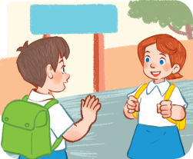 b. 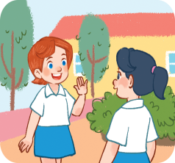 2.a  b. 
3.a. . b.  4.a  b.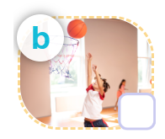
Question2: Listen and number:(1p)
 | 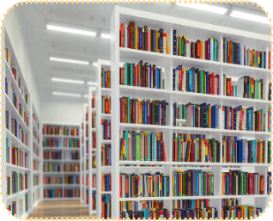 | 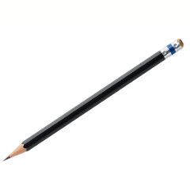 | 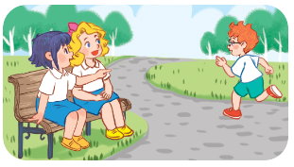
Question3: Listen and complete:(1p)
1. A: …. your Book Please!
2. A: What’s your hobby? B: I like …..
3. A: May I ….. in?- B: Yes,You can
4. A: What’s your hobby? B: It’s …..
Question 4: Odd one out:(1.5p)
1. a.football b. breaktime c. basketball d. volleyball
2. a. red b. book c. white d. black
3. a. Touch b. hand c. head d. nose
4. a. eight b. nine c.years d. ten
5.a. eyes b.ears c.mouth d. open
6. a. yellow b. blue c.pink d.colour
Question 5: Choose the best answer:(1.5p)
1. Is this your computer room?
a. Yes, it is. b. Yes, it do c. No, it is d.No, I don’t
2. What’s your...........? – It’s singing.
a. name b. hobby c. hoppy d. colour
3 What is it ? – It’s a …..
a. May b. pen c. play d. open
4. Do you have a pencil? .
a. Yes, it is. b. Yes, it do c. No, it is d Yes, I do
5. ............this Ben?- Yes,It is
a. What b. Is c. Are d. Do
6. ............is your hobby?- I like cooking
a. What b. How c. When d. Who
Question 6: Read and complete: (1.5p)
Open red hobby colour swimming nose
1. What is your ……?- It’s drawing.
2. ……. your Book, Please!
3. I like ………
4. What …….is it ? It is green.
5.What is this? It’s a ……
6. I have a pencil case. It’s …..
Question 7:Look at the pictures and write the words: (1.0p)



1.Open your …..,Please! 2. A:How old are you?
B:I am …..years old.
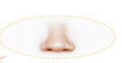
3.A: What is that? 4. A:What do you do at break time?
B:It is a…… B:I play ……at break time

Question 8: Reorder these words to make sentences: (1.5p)
1. am/ I/ Bill/ Hello./..................................................................
2.cooking/ I/ like/....................................................................................................
3.your/What/is /hobby/?/.....................................................................................
4./this/your/Is/school/?/..............................................................................
5.at/ my/Look/ things/ school/...................................................................................
6.white/a/ruler/have/I.......................................................................................

PHẦN 2: ĐẤP ÁN

UBND HUYỆN VĨNH BẢO  TRƯỜNG TH TAM CƯỜNG  (Đề đề xuất) | ĐÁP ÁN ĐỀ KHẢO SÁT CHẤT LƯỢNG HK 1  MÔN TIẾNG ANH LỚP 3  NĂM HỌC 2023 - 2024  (Thời gian làm bài: 40 phút)
PART I: Listening
Questions 1:Listen and tick (1pt)
4 câu x 0,25 = 1đ
1.B 2.B 3.A 4.B
Question2 : Listen and number. (1pt)
4 câu x 0,25=1đ
1.B 2.A 3.C 4.D
Question 3 :Listen and complete (1pts)
4 câu x 0,25=1đ
- Open 2- swimming 3- come 4- singing

Part II : Reading
Question 4 : Odd one out. (1,5pt).
6 câu x 0,25=1,5đ

1- B 2-B 3-A 4-C 5-D 6-D
Question 5 : Choose the best answer.(1,5pt)
6 câu x 0,25=1,5đ

- A 2-B 3- B 4- D 5-B 6-A
Question 6 : Read and complete.(1,5pts)
- Hobby 2-Open 3- Swimming 4. Colour 5-Nose 6-Red

Part III : Writing
Questipon 7:Look at the pictures and write the words. (1pts)
1. Mouth
2.Seven
3.Nose
4. Chess

Questipon 8:Arrange the words to make sentences.(1,5pts)
1. am/ I/ Bill/ Hello./-> Hello,I am Bill.
2.cooking/ I/ like/-> I like cooking
3.your/What/is /hobby/?/-> What is your hobby?
4./this/your/Is/school/?/-> Is this your school?
5.at/ my/Look/ things/ school/-> Look at my school things.
6.white/a/ruler/have/I -> I have a white ruler.

