UBND HUYỆN VĨNH BẢO  TRƯỜNG TH TAM CƯỜNG  (Đề đề xuất) | ĐỀ KHẢO SÁT CHẤT LƯỢNG HỌC KỲ 1  MÔN TIẾNG ANH LỚP 5  NĂM HỌC 2023 - 2024  (Thời gian làm bài: 40 phút)
PART I: Listening
Question 1: Listen and tick (1.0p)
1. | a. | b.  | c. 
2. | a. | b.  | c. 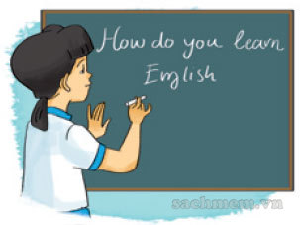
3. | a. | b. | c.
4. | a. | b. | c.
Question 2: Listen and number (1pt)
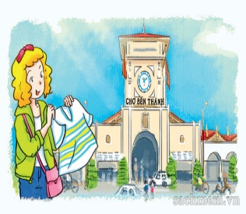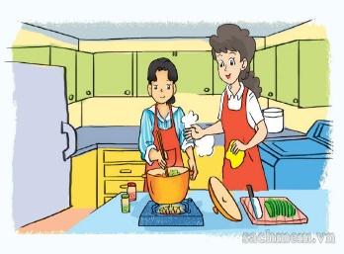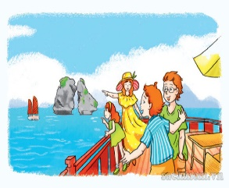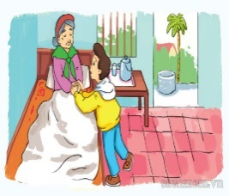
A.  B. C. D.
Question 3: Listen and write one word in each blank.(1pt)
1. Linda: _________________, High Street
2. Tony: ________________, Green Lane
3. Peter: 765, ___________________
4. Tom: the ______________ of City Tower
PART II: Pronunciation
Question 4:Circle the word which has the stressed syllable different from the rest ones(1.5pt).
1. a. comic | b. listen | c. cartoon | d. picnic
2. a. explore | b. seaside | c. island | d. countryside
3. a. party | b. invite | c. enjoy | d. complete
4. a. tower | b. village | c. repeat | d. mountain
5. a. hometown | b. invite | c.busy | d. listen
6. a. always | b. often | c. usually | d.carton
Question 5: Choose the correct words and write them on the lines (1,5pt)
1. How do you practise ................ to English?
a. listen b. listens c. listening d. listened
2. Mai learns English ...................... she wants to watch English cartoons on TV
a. because b. and c. but d.by
3.What did you do at Mai’s birthday party? – We _______ with our friends.
A. chat B. chatted C. chated D. chats
4. Why does Minh learn English? – Because he ________ to speak English with her foreign friends.
A. wanted B. wants C. want D. wantes
5. What did the peacocks do when you were at the zoo?They ____________.
A. move beautifully B. move loudly C. roared loudly D. eat slowly
6. What ______ you do at the party? I _____ nice food and drink.
a. did/have b. do/ had c. did/ had d.did/ has
Question 6:Fill in the blank(1,25pt)
swam | island | badminton | plane | by
Dear Tony,
My mother and I went to Phu Quoc (1)............... last summer. First, we went from our house to the airport (2) ..................... taxi. Then we went to the island by (3).......... . It is a wonderful place. In the morning, we played (4)................ . In the afternoon, we (5)............ in the pool. We had a wonderful time there.
See you soon, Nam
Question 7: Read and tick (T/F) (1,25pt)
Tom likes reading. On Sundays, he often stays at home and reads comic books. He likes Case Closed very much. It is a Japanese story. The main character is a schoolboy called Jimmy Kudo. He often helps the police. He is good at his job. Jimmy Kudo is Tom's favourite character because he is clever and brave.
True False
1.Tom likes reading books in his free time.
2.Case Closed is a Malaysian story.
3.The main character is Jimmy Kudo.
4.Jimmy Kudo is a policeman.
5.Jimmy Kudo is clever and brave.
Question 8: Arrange the words to make sentences(1,5pt)
1. moutains/ family/ my/ lived/ a/ village/in/in/ the
.....................................................................................................................................
2. she/did/go/ on/ holiday?/ where
....................................................................................................................................
3. We/ by// went/ Danang/ to/ plane/ summer/ last/.
....................................................................................................................................
4. An Tiem/ hard- working/ generous/ was /I/think. /and
......................................................................................................................................
5. How/ do/have/ English/ often/ you/ ?/
....................................................................................................................................
6.Independence Day/ on/ the/ is/ September/ of/ second/
.......................................................................................................................................

Đáp án
Question 1
- c 2. b 3. a 4. b
Question 2:
1.c 2d 3a 4b
Question 3:
1. 208 2. 321 3. White Street. 4. second floor

Question 4: 1.c 2a 3a 4c 5b 6d
Question 5: Choose the correct words and write them on the lines (1,5pt)
1.c 2a 3b 4b 5a 6.c
Question 6:Fill in the blank(1,25pt)
1.island 2.by 3.plane 4.badminton 5.swam
Question 7: Read and circle/ tick (T/F) (1,25pt)
1.T 2.F 3T 4F 5T
Question 8: Arrange the words to make sentences(1,5pt)
1. My family lived in a village in the moutains.
2. Where did she go on holiday?
3.We went to Danang by plane last summer.
4. I think. An Tiem was hard – working and generous.
5. How often do you have English?
6.Independence Day is on the second of September.
.......................................................................................................................................

