UBND HUYỆN VĨNH BẢO  TRƯỜNG TH TAM CƯỜNG  (Đề đề xuất) | ĐỀ KHẢO SÁT CHẤT LƯỢNG HỌC KỲ I  MÔN TIẾNG ANH LỚP 4  NĂM HỌC 2023 - 2024  (Thời gian làm bài: 40 phút)
I.LISTENING
Question 1: Listen and tick: (1.0pt)
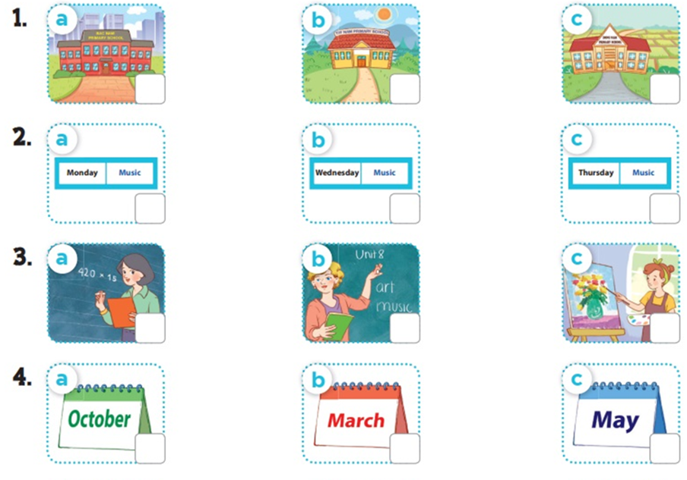
Question 2: Listen and number: (1.0pt)

Question 3: Listen and complete:(1.0pt)
1. A: What ..............do you have today? B: I have Vietnamese.
2. A: What subjects do you have today? B: I have .................
3. A: What subjects do you have today? B: I have ..................
4. A: What subjects do you have today? B: I have .................
II.PRONUNCIATION
Question 4: Odd one out (1.25pt)
1.a. America b.Australia c.Britain d.Vietnamese
2.a. fifteen b.thirty c. forty-five d.time
3. a. chicken b.grapes c. lemonade d. cakes
4. a. Sport day b. December c.June d. July
5. a. campsite b. beach c. zoo d. where
Question 5: Circle the word which has pronounced differently: (1.0 pt)
1. a. can b. grapes c. have d. campsite
2. a. swim b. bike c. like d.ride
3.a. sunny b. running c. computer room d.bus
4.a.Britain b.history c. science d. village
5.a. watch b. teacher c. school d. beach
Question 6: Choose the best answer.(1.25 pt)
1. I .............. my housework .............. Saturdays.
a. do/ on b. do/in c. do/at d. do/from
2. Can you play the piano?
a. Yes, I do. b. Yes, I can. c.Yes, It is. d. Yes, She can.
3................subject do you have today?
a. Why b. What c. where d. who
4.My favourite subjects .............. English and Art.
a. is b. are c. like d. have
5. What day is it today?
a. It’s Sunday b. It’s on Sunday c. It Sunday
Question 7: Read and tick (1.pt)
Our sports day is in November. It is in the school playground. There are many pupils and teachers. We play different sports and games. The boys play badminton. The girls play football. The teachers play basketball. It is a lot of fun.
 | True | False
- Our sports day is in November.
- There are many pupils and teachers.
- We play same sports and games.
- The boys and the girls play badminton.
Question 8: Look at the pictures and write the words.(1pt)
  1.I go to ....................at six....................... |   2. I was ..................................last weekend.
  1.I want some....................and....................... | 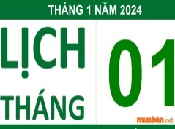  4. My birthday is in....................

Question 9: Arrange the words to make sentences: (1.5pt)
1. Tony/ from/ America/ is
......................................................................................................................................
2. my/can/ sister/ roller/ skate/
...................................................................................................................................
3. can/ father/ your/ play/?/ piano/ the
................................................................................................................................
4. is/ your/ favourite/ what/ subject/?
........................................................................................................................
5. English/I/I/ because/ want/ like/ to/an / teacher/ English/be
...........................................................................................................................
6. is/where/ friend/ her/from?
.........................................................................................................................................................

DAP AN

Question 1: Listen and tick(1pt)
4 câu x 0,25 = 1đ
1.b 2c 3b 4c
Question 2: Listen and number (1pt)
4 câu x 0,25 = 1đ
1. b 2. d 3. a 4. c
Question 3: Listen and complete (1pt)
4 câu x 0,25 = 1đ
1. subjects 2.science 3.maths 4. English
PART II: Pronunciation
Question 4: Odd one out (1.25pt): 1d. 2. D 3.c 4d 5a 6d
Question 5: Circle the word which has pronounced differently: (1.0 pt)
1. b 2a 3c 4c 5c
Question 6: Choose the best answer.(1.25 pt)
1.a 2b 3b 4b 5a
III. READING
Question 7: Read and tick (1.pt)
1. T 2T 3F 4f
IV. WRITING
Question 8: Look at the pictures and write the words.(1pt)
1. SCHOOL/ THIRTY 2 AT THE CAMPSITE
3 CHIPS/ WATER 4 JANUARY

Question 9: Arrange the words to make sentences: (1.5pt)
1. Tony is from America

2. My sister can roller skate.
3. Can your father play the piano?
4.What is your favourite subject?

5. I like English because I want to be an English teacher.

6. Where is her friend from?

