SBD: .............  Phòng thi :.............. | BÀI KHẢO SÁT CHẤT LƯỢNG CUỐI NĂM  NĂM HỌC 2024 - 2025  Môn Tiếng Anh - Lớp 3  (Thời gian làm bài : 40 phút )  ~~~~~~~~~~~~~~~~~~
  Điểm : ................
  Bằng chữ :............
  Người  coi | Người chấm

Part 1: Listening:
Question 1: Listen and number (1pt)
 |  |  |   hi Hi
a. | b. | c. | d.
Question 2: Listen and tick the correct sentences (1pt)
1. In Thessaloniki, there are nice parks and ___________________
a. museum | b. theatre | c. markets | d. bookshop
2. There is a ___________________ toyshop.
a. big | b. cool | c. small | d. large
3. ___________________ is a big pool.
a. There | b. Those | c. These | d. They
4. Her favourite part of town is the ___________________

a. zoo | b. library | c. toyshop | d. playground
Question 3: Listen and circle the correct pictures (1pt)
1. | 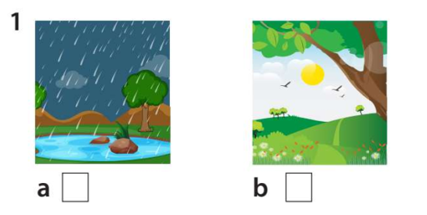 |  | 2. | 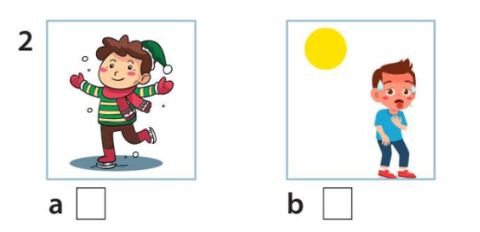
1. | a. | b. | 2. | a. | b.
3. |  |  | 4. | 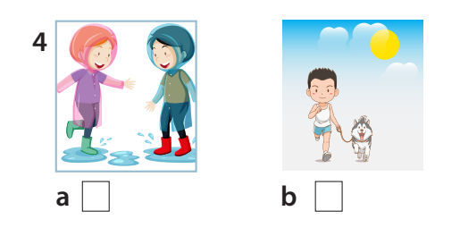
3. | a. | b. | 4. | a. | b.
PART II: PRONUNCIATION
Question 4: Odd one out (1,25 pt)

1. a. cook | b. sing | c. swim | d. summer
2. a.Speak English | b. rock | c. play the guitar | d. play the drums
3. a. cold | b. rainy | c. winter | d. sunny
4. a. summer | b. hot | c. autumn | d. spring
5. a. drums | b. play | c. colour | d. paint

Question 5. Choose the best answer (1,25pt)
1. ............. run in the library, please.
a. Isn’t b. Doesn’t c. Don’t d. Aren’t
2. .............. are you doing ? I’m swimming in the pool.
a. What b. Where c . Who d. How
3. There ........... a lot of …………. in the box.
a. is / sweet b. are /sweets c. its / sweet d. it / sweets
4. How many …………. are there ? – ………. are fourteen.
a. apple/ there. b. bananas/ these c. tomatoes/ there d. pears/ those
5. May I ........... football with everybody? – Yes, you can.
a. plays b. playing c. to play d. play
Question 6. Read and match column A with B (1,25 pt)
A | B
1. What day is it today? | a. I go to school with my sister. | 1.
2. Do they swim in summer? | b. I go to the zoo by bus. | 2.
3. What do you do on Mondays? | c. It is Sunday. | 3.
4. Who do you have dinner with? | d. I have dinner with my family. | 4.
5. How do you go to the zoo ? | e. Yes, they do. | 5

Question 7: Read and choose the best answer
Kate: Hi, Tom.
Tom: Hi, Kate. What are you doing?
Kate: I’m buying a teddy bear at the toy shop. There are nice teddy bears here.
Tom: Cool!
Kate: And you?
Tom: I’m in the park. We’ve got a new bike. My brother is riding it. It’s fun!
- Is Kate at the toy shop?
a. Yes, she is b. Yes, she are
c. No, she is d. No, she in’t
- What’s she doing?
a. She is buying a bike. b. He is buying a teddy bear.
c. She is buying a teddy bear. d. She is riding a bike.
- What is Tom’s brother doing?
a. He is buying a tedddy bear. b. He’s riding a bike.
c. He’s buying a new bike. d. He is going to the toy shop.
- Is Tom at the toy shop, too?
a. Yes, he is b. No, he isn’t
c. No, he is d. Yes, it is
Question 8. Arrange the words to make sentences (1,25 pt)
1. go/ zoo/ Let’s/ the/ to/  a. Let’s go to the zoo.  b. Go to the let’s zoo.  c. Go to the zoo let’s. | 2. Are/ there/ thirteen/ tomatoes.  a. There are tomatoes thirteen.  b. Are there thirteen tomatoes.  c. There are thirteen tomatoes.
3. Can/ speak/ you/ English?  a. You can speak English?  b. Can you English speak?  c. Can you speak English? | 4. My/sport/is/favourite/hockey/.  a. My favourite sport is hockey.  b. Hockey is sport my favourite.  c. My sport favourite is hockey.
5. In/take/Let’s/the/photos/park/.
a. Let’s take photos in the park.
b. Let’s take the photos in park.
c. Let’s photos take in the park.

Question 9. Look at the picture and write one word in the blank (1 pt)

 |  |  | 
1. He’s playing……. | 2. He’s…….... the ball | 3. He’s playing……. | 4.She’s ………… a kite

Answer key

Question 1: Listen and number (1pt)
 |  |  |   hi Hi
a.  1 | b.  4 | c.  2 | d.  3
Question 2: Listen and tick the correct sentences (1pt)

1. In Thessaloniki, there are nice parks and ___________________
a. museum | b. theatre | c. markets  V | d. bookshop
2. There is a ___________________ toyshop.
a. big | b. cool  V | c. small | d. large
3. ___________________ is a big pool.
a. There  V | b. Those | c. These | d. They
4. Her favourite part of town is the ___________________
a. zoo | b. library | c. toyshop | d. playground  V
Question 3: Listen and circle the correct pictures (1pt)
1. |  |  | 2.
1. | a | b | 2. | a | b
3. |  |  | 4.
3. | a | b | 4. | a | b
PART II: PRONUNCIATION
Question 4: Odd one out (1,25 pt)
- D 2. B 3. C 4. B 5. A
Question 5. Choose the best answer (1,25pt)
1. ….......... run in the library, please.
a. Isn’t b. Doesn’t c. Don’t d. Aren’t
2. …........... are you doing ? I’m swimming in the pool
a. What b. Where c . Who d. How
3. There …........ a lot of …………. In the box
a. is / sweet b. are /sweets c. its / sweet d. it / sweets
4. How many …………. Are there ? – ………. Are fourteen
a. apple/ there. B. bananas/ these c. tomatoes/ there d. pears/ those
5. May I …........ football with everybody? – Yes, you can.
a. plays b. playing c. to play d. play
Question 6. Read and match column A with B (1,25 pt)
A | B
1. What day is it today? | a. I go to school with my sister. | 1. C
2. Do they swim in summer? | b. I go to the zoo by bus. | 2. E
3. What do you do on Mondays? | c. It is Sunday. | 3. A
4. Who do you have dinner with? | d. I have dinner with my family. | 4. D
5. How do you go to the zoo ? | e. Yes, they do. | 5. B

Question 7. Read the text and circle the correct answer (1pt)
- A 2. C 3. B 4. B
Question 8. Arrange the words to make sentences (1,25 pt)
- A 2. C 3. C 4. A 5. A
Question 9. Look and write (1 pt)

- Hockey
- Kicking
- Baseball
- Flying

