UBND HUYỆN VĨNH BẢO  TRƯỜNG TH VĨNH LONG-THẮNG THỦY | ĐỀ KHẢO SÁT CHẤT LƯỢNG HỌC KỲ II  TIẾNG ANH LỚP 5  NĂM HỌC 2024 - 2025  (Thời gian làm bài: 40 phút)
PART I. LISTENING (3pts)
Question 1. Listen and number (1pt)
a. 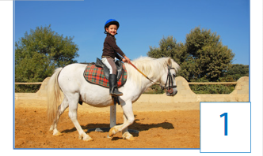 b. 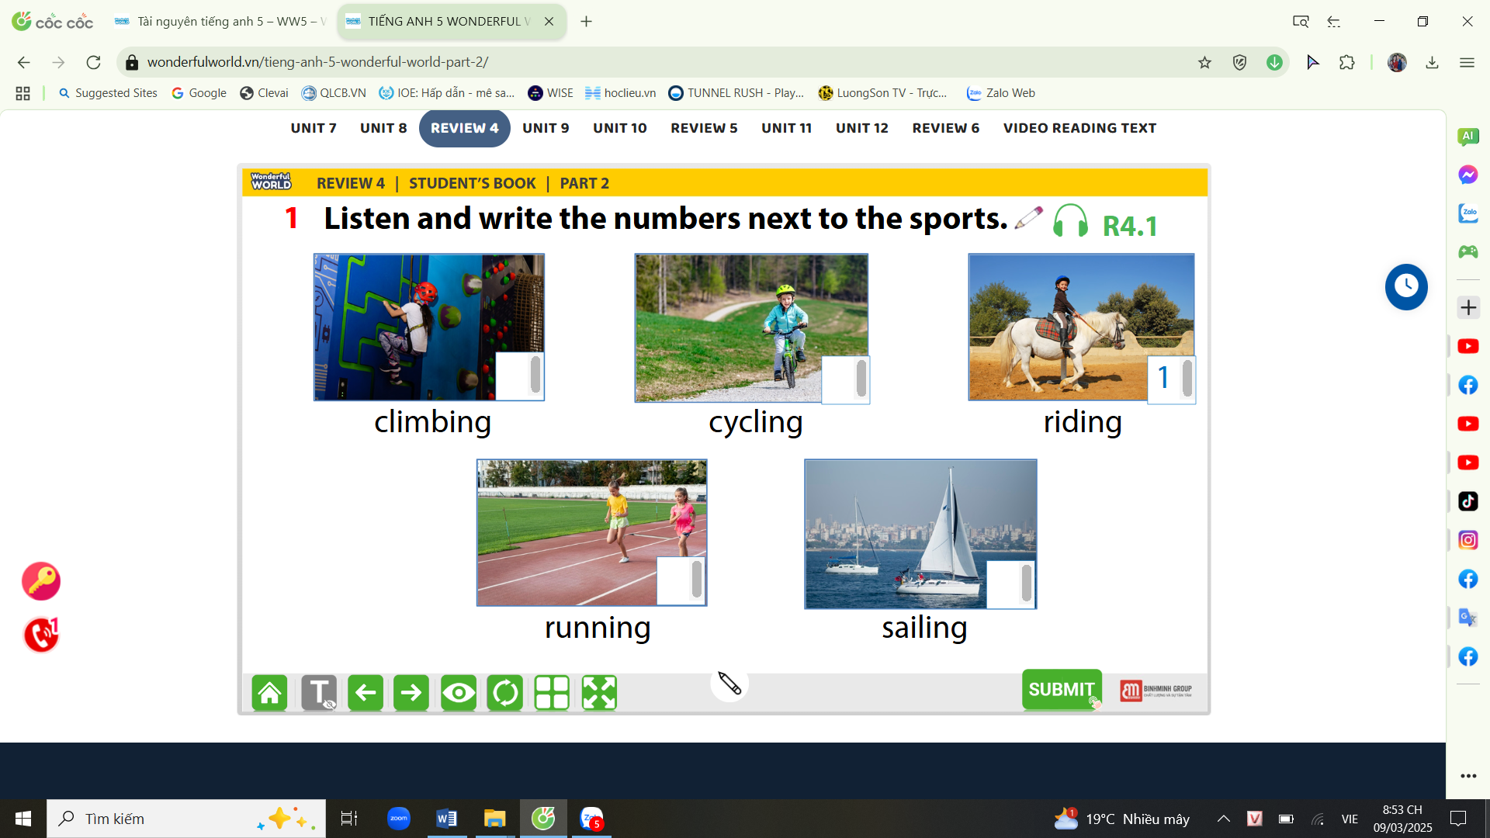 c.
d. e.

Question 2. Listen and tick T for True or F for False (F) (1pt)
 |  | True | False
1 | Last night, the family slept in a hotel.
2 | Last week, Mary and her mother went shopping together.
3 | Tom ate a pizza at a food stall yesterday.
4 | His mother told him a lot of stories at night when he was small.

Question 3. Listen and circle the correct answers (1pt)
1. Which animal is she talking about?
a. lion b. crocodile c. bear d. tiger
2. Crocodiles eat……………………..
a. sausages b. vegetables c. leaves d. animals
3. The crocodiles are ……………….long.
a. 5 metres b. 6 metres c. 7 metres d. 8 metres
4. Which place don’t they live in? - They don’t live in the _____________
a. lake b. sea c. river d. park

Part II: Pronunciation (1, 25pts)
Question 4: Circle the word which is pronounced differently from the rest (1,25pts)
1. a. stopped | b. needed | c. liked | d. walked
2. a. visited | b. ended | c. wanted | d. travelled
3. a. asked | b. pointed | c. jumped | d. stopped
4. a. worked | b. listened | c. liked | d. danced
5. a. loved | b. cycled | c. jumped | d. climbed
PART III. READING AND WRITING (5,75pts)
Question 5. Read and choose the best answer (1.25pts)
1. They _____________ now.
a. are running b. is running c. runs d. is runing
2. Young people shouldn’t ______________ computer games too much.
a. playing b. to play c. play d. played
3. Did Mary_____________ a lot of food at the supermarket?
a. bought b. buy c. buys d. buyed
4. Melina _____________the film, but she _____________ the play.
a. saw/ didn’t see b. see/ didn’t see c. saw/ didn’t saw d. saw/see
5. Tommy plays basketball every Saturday and Sunday. He plays it _________
a. once a week b. twice a week c. once a month d. twice a month

Question 6: Read and choose the best answer (1,25pts)
Deep underground, there is a special head: geothermal energy (geo means “earth” and thermal means “heat” in Greek). We need energy to light our homes and cook. The sun and wind provide clean energy, but geothermal energy can help people even more.
The Boiling River, deep in the Amazon rainforest, has very hot water (up to 99 degree). This water is dangerous for animals. Scientists are studying the river to understand geothermal energy better. They also protect other parts of the Amazon. They don’t want people to cut down trees and destroy the rainforest. We hope that people will save the environment and save geothermal energy.

- What does the word “geo” mean?
a. moon b. earth c. land d. mar
- What does the word “thermal” mean?
a. heat b. water c. fire d. air
- Where is the Boiling River?
a. in the Red River b. in the Nile River c. in the Amazon rainforest d. in the highlands
- Is this water dangerous for animals?
a. Yes, it is b. No, it is c. No, it isn’t d. Yes, it does
- Scientists hope that people will save ……………………….
a. the rubbish b. the games
c. the flowers d. the environment and save geothermal energy.
Question 7: Find and circle the mistakes. (1pt)
1. Do you watch the film with your friends last night?
a b c d
2. My sister and I bought some apples, but we didn’t bought any tomatoes.
a b c d
3. Helen learned to play the violin when she is small.
a b c d
4. Peter was a creative man; he could draw very good.
a b c d
Question 8. Arrange the words to make the meaningful sentences (1.25pt)
1. Horses / faster / turtles / are / than
a. Horses are than faster turtles. b. Horses are faster than turtles.
c. Horses are faster turtles than. d. Horses are turtles than faster.
2. really / cat / she / her / love.
a. She really her loves cat b. She really loves her cat
c. She love really her cat d. She loves really her cat
3. is/ a / really / It / film / interesting.
a. It is a interesting really film to watch b. It is a really film interesting to watch
c. It is a really interesting film to watch d. It really is a interesting film to watch
4. does exercise everyday / keep / My mother / healthy / to/.
a. My mother does exercise to keep everyday heathy. b. My mother does exercise to keep heathy.
c. My mother does exercise everyday to keep heathy. d. My mother exercises to everyday keep heathy.
5. elephants / lions / stronger / Are / than / ? /
a. Are elephants than lions stronger? b. Are lions elephants than stronger?
c. Are than elephants lions stronger? d. Are elephants stronger than lions?
Question 9: Look at the pictures and write the words (1pt)
 |  |  | 
.................................... | ........................................... | ....................................... | ..........................................

ĐÁP ÁN
UBND HUYỆN VĨNH BẢO  TRƯỜNG TH VĨNH LONG-THẮNG THỦY  (Đề đề xuất) | ĐỀ KHẢO SÁT CHẤT LƯỢNG HỌC KÌ II  MÔN TIẾNG ANH LỚP 5  NĂM HỌC 2024 - 2025  (Thời gian làm bài : 40 phút)
PART I: Listening
Question 1: (1pt)
4 câu x 0,25 = 1đ
4
3
2
5

Question 2: | Key | Mark
1 | T | 0.25
2 | F | 0.25
3 | F | 0.25
4 | T | 0.25
Question 3
1 | b | 0.25
2 | d | 0.25
3 | b | 0.25
4 | d | 0.25
Question 4
1 | b | 0.25
2 | d | 0.25
3 | b | 0.25
4 | b | 0.25
5 | c | 0.25
Question 5
1 | a | 0.25
2 | c | 0.25
3 | b | 0.25
4 | a | 0.25
5 | b | 0.25
Question 6
1 | b | 0.25
2 | a | 0.25
3 | c | 0.25
4 | a | 0.25
5 | d | 0.25
Question 7
1 | a | 0.25
2 | c | 0.25
3 | d | 0.25
4 | c | 0.25
Question 8
1 | b | 0.25
2 | b | 0.25
3 | c | 0.25
4 | c | 0.25
5 | d | 0.25
Question 9
1 | advert | 0.25
2 | award | 0.25
3 | set | 0.25
4 | anime | 0.25

