UBND HUYỆN VĨNH BẢO  TRƯỜNG TH VĨNH TIẾN - CỔ AM  (ĐỀ ĐỀ XUẤT) | ĐỀ KHẢO SÁT CHẤT LƯỢNG HỌC KỲ II  MÔN TIẾNG ANH - LỚP 3  NĂM HỌC 2024 - 2025  (Thời gian làm bài: 40 phút)
I. LISTENING
Question 1. Listen and number.
a.  | b.  | c.  | d. 
Question 2. Listen and tick the correct sentences.
1. Lan is buying a doll at the ............
a. toy shop b. market c. park
2. My mum is buying flowers at the ................
a. zoo b. market c. playground
3.Nam is swimming in the ..........
a. library b. museum c. pool
4. My dad is running with my sister in the .......
a. shop b. theatre c. park
Question 3. Listen and circle the correct pictures.
1.a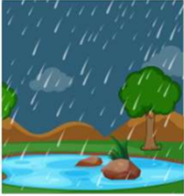 | b.  | 2. a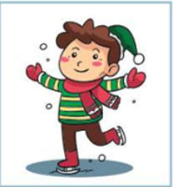 | b. 
3.a | b. 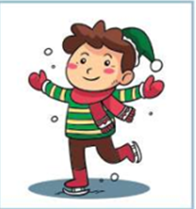 | 4.a. 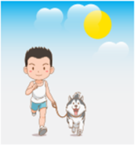 | 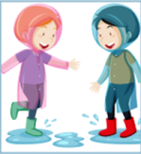  b.
II.READING
Question 4. Odd one out.
1.a . cold | b. hot | c.sunny | d. summer
2.a. climb | b. river | c. rock | d. tree
3. a. drum | b. guitar | c. piano | d. play
4.a. summer | b. sunny | c. autumn | d. spring
5. a. paint | b. dance | c. piano | d. sing
Question 5. Choose the best answer
1..................... is the pen? It's on the table.
a. Where b. What c. Where's d. How
2.There is a lot of ....................
a. apple b. banana c. bread d. pear
3. I have got .......... pear and .............. apple.
a. an/ an b. a/ an c. an/ a d. a/a
4.There .................... some sweets in the box.
a. are b. is c. a d. 's
5. How many .................... are there? Ten
a. biscuit b. sweet c. pizza d. pears
Question 6. Read and match column A with B.
A | B
1. How do you go to school? | a. No, they don't. They drink milk.
2. Do they drink juice? | b. No , I can't.
3. I don't | c. like summer.
4. Can you swim in the river? | d. By bus.
5. I climb | e. the rock.
Question 7. Read the text and circle the correct answer.
Kate: Hi, Tom.
Tom: Hi, Kate. What are you doing?
Kate: I'm buying a teddy bear at the toy shop. There are nice teddy bears here.
Tom: Cool!
Kate: And you?
Tom: I'm in the park. We've got a new bike . My brother is riding it. It's fun!
1. a. Kate is buying a teddy bear. b. Kate is buying a bear.
c. Kate isn't buying a teddy bear.
2. a. Kate is at the shop. b. Kate is at the toy shop. c. Kate is at the zoo.
3. a. Tom is in the pool. b. Tom is in the park. c. Tom is in the museum.
4. a.Tom’ s brother is riding a bike. b.Tom’ s brother is running.
c.Tom’ s brother is having a bike.
III.WRITING
Question 8 . Reorder these sentences.
1. playing / My / is / the/sister/guitar/.  A. My sister is playing the guitar.  B. My sister is the guitar playing.  C. My sister is playing guitar. | 4. doing/ what/ the/ is/monkey/?  A. What the monkey is doing?  B. What is the monkey doing?  C. What is monkey the doing?
2. can/ he/kick/ ball/ the/?  A. Can he kick the ball ?  B. He can kick the ball ?  C. Can he kick ball the ? | 5. shark/ the/ is/ swimming /?  A. The shark is swimming?  B. Is the shark swimming?  C. Is shark the swimming?
3. ice/ eat/ Let's/ cream/.
A. Let’t eat ice cream.
B. Let’s eat cream ice
C. Let’s eat ice cream.
Question 9. Look at the pictures and write one word.
1. I can play ......................  | 2. She's ............................. 
3. Tim is ........................ 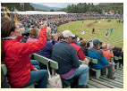 | 4. I'm playing with my .........................

PART I. LISTENING
Question 1. Listen and number (1pt)
1.a 2.c 3.d 4. b
Question 2. Listen and tick (1pt)
1.a 2. a 3.b 4b
Question 3. Listen and circle the correct pictures (1pt)
1.a 2. b 3. b 4.a
Part II: READING
Question 4: Odd one out.(1,25pts)
1. d. 2. a 3. d 4. b 5. c
Question 5. Choose the best answer (1.25pts)
1. a 2. c 3. b 4. a 5. d
Question 6: Match A with B
1a 2.a 3.c 4b 5c
Question 7: Read and choose the best answer
1.a 2.b 3.b 4.a
Question 8. Arrange the words to make the meaningful sentences (1pt)
1.a 2.a 3.c 4.b. 5b
Question 9: Look at the pictures and write the words
1. football 2. jumping 3. watching a match 4. team

