UBND HUYỆN VĨNH BẢO  TRƯỜNG TH VĨNH TIẾN - CỔ AM  (ĐỀ ĐỀ XUẤT) | ĐỀ KHẢO SÁT CHẤT LƯỢNG HỌC KỲ II  MÔN TIẾNG ANH - LỚP 4  NĂM HỌC 2024 - 2025  (Thời gian làm bài: 40 phút)
LISTENING
Question 1. Listen and number (1pt)
 | 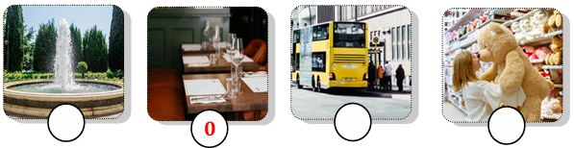
Question 2. Listen and tick the correct sentence (1pt)
1. |  | A. They are doing homework. | 2. |  | A. It’s my new smartphone.
1. |  | B. They are learning English. | 2. |  | B. It’s my new tablet.
3. |  | A. His trip to Vietnam was exciting. | 4. |  | A. They were at a bridge in America.
3. |  | B. My trip to Turkey was exciting. | 4. |  | B. They were at a temple in Vietnam.
Question 3. Listen and circle the correct picture (1pt)
1.  | 2.
3. 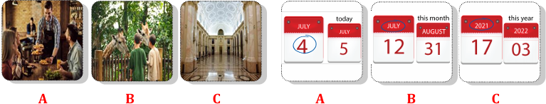 | 4.
READING AND WRITING
Question 4. Odd one out (1.25pts)
- a. doctor b. teacher c. job d. firefighter
- a. take b. photo c. feed d. work
- a. photographer b. studio c. hospital d. clinic
- a. scary b. yesterday c. huge d. strong
- a. big b. small c. clever d. dinosaur
Question 5. Choose the best answer (1.25pts)
- Can we _______________ the smart phone ? – No, you can’t.
A. use B. do C. look D. have
- ______________ computer is it? – It’s his computer.
A. What B. Who C. Whose D. How
- Ms Lien wants her students to work in ____________.
A. school B. two C. class D. pairs
- The is library ______________ of the cinema.
A. near B. in front C. opposite D. next
- Tony is ______________ in the pool.
A. swimming B. shopping D. dancing D. crossing
Question 6. Match column A – B (1.25pts)
A | B
1. What do you like doing? | A. It was funny. | 1 -
2. What was a mammoth? | B. She’s flying to Ho Chi Minh City. | 2 -
3. Where is she flying to? | C. It was a big elephant. | 3 -
4. How was your music lesson? | D. I can see many big dinosaur bones. | 4 -
5. What can you see at the museum? | E. I like reading books. | 5 -
Question 7. Read the text and choose the best answer (1pt)
Ms. Jane: Today, we are going to use the computer lab (1) ________ my class. Are you ready?
Class: Yes, teacher!
Tom: Can we use smartphones in class?
Ms. Jane: No, you can’t. But you can(2) ________ books and tablets to look at the word list.
Tim: Look at the computer, Rose! Who can change the (3) _____________?
Rose: I think teachers can. But don’t use the computer! The teacher is talking!
Ms. Jane: Quiet, please! I can use the(4) __________________ if you can’t hear me. You can work in groups, understand?
Class: Yes, teacher!
- A. in B. on C. to D. behind
- A. look B.do C. have D. use
- A. tablet B. word C. computer D. password
- A. microphone B. headphone C. speaker D. book
Question 8. Reorder the words to make meaningful sentences (1.25pts)
1. brothers/ do/ What/ do/ your/? | A. What do your do brothers ?  B. What do your brothers do ?  C. What do broters your do ?
2, takes /her / care / animals / mother/ of | A. Her takes care of mother animals  B. Her mother takes care of animals  C. Mother her takes care of animals
3, holiday / hotel /a /staying /Mary / likes/ on / her/ in | A. Mary likes staying in a hotel on holiday  B. Mary likes in staying a hotel on holiday  C. Mary likes staying on a hotel in holiday
4. presents / I/ buy/ some/ toy shop/ the/ at/. | - I at the toy shop some presents buy.  - At the toy shop, I buy presents some.  - I buy some presents at the toy shop.
5. on/ Which/ would/ like/ visit/ place/ you/ to/ holiday/on/ ? | - Which would you like to visit place on holiday?  - Which place would you like to visit on holiday?  - On holiday to which place would you like visit?
Question 9. Look and write the word (1pt)
 | 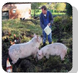
1. My father is a………………. | 3. My uncle is feeding………………
 | 
2. He works in a…………………. | 4. He is a…………………….
Answer key
LISTENING
Question 1. Listen and number (1pt)
3 - 1 - 4 - 2
Question 2. Listen and tick the correct sentence (1pt)
- A 2. B 3. B 4. A
Question 3. Listen and circle the correct picture (1pt)
- B 2. C 3. B 4. A
READING
Question 4. Odd one out (1.25pts)
- C 2. B 3. A 4. B 5. D
Question 5. Choose the best answer (1.25pts)
- A 2. C 3. D 4. B 5.A
Question 6. Match column A – B (1.25pts)
- E 2. C 3.B 4. A 5. D
Question 7. Read the text and choose the best answer (1pt)
- A 2. D 3. D 4. C
Question 8. Reorder the words to make meaningful sentences (1.25pts)
- C 2.B 3. A 4. C 5. B
WRITING
Question 9. Look and write the word (1pt)
- farmer
- studio
- animals / pigs
- photographer

