UBND HUYỆN VĨNH BẢO  TRƯỜNG TH TRẤN DƯƠNG | ĐỀ KHẢO SÁT CHẤT LƯỢNG CUỐI HỌC KÌ II  MÔN TIẾNG ANH LỚP 4  NĂM HỌC 2024 - 2025  (Thời gian làm bài : 40 phút)

Question 1 : Listen and number

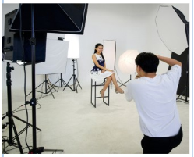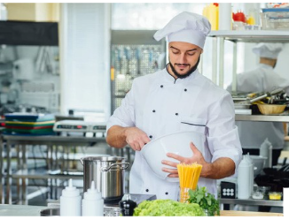

Question 2: Listen and tick the correct sentences
1.a.I sometimes go to ther park with my brother
b.I sometimes go to ther park with my father
c. I sometimes go to ther park with my brother
2. a.Jane always plays games on the computer
b.Jane always makes videos on the computer
c. Jane always writes emails on the computer
3. a. My teacher always writes emails on the phone
b. My teacher always writes emails on the computer
c. My teacher never write emails on the phone
4. a. Her mother sometimes takes photos of the house
b. Her mother sometimes takes photos of her house
c. Her mother sometimes takes photos of animals
Question 3: Listen and circle the correct pictures.
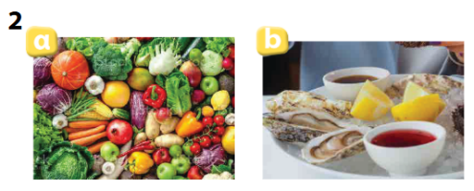
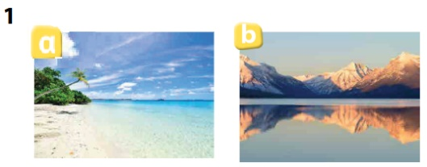

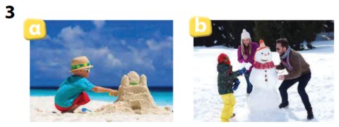
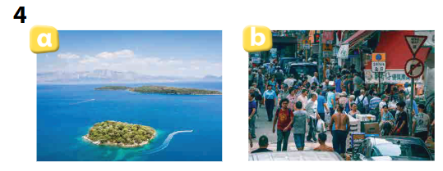

Question 4: Odd one out
1 Chef doctor farmer dolphin
2. Restaurant hospital teacher studio
3. cook animals feed take
4. dinosaur strong scary huge
5. elephant dinosaur cave monkey
Question 5: Choose the best answer
- The teacher wants her students to work in ____________.
A. books B. two C. classroom D. pairs
- The cinema is ______________ to the library.
A. next B. in front D. near D. opposite
- They are ______________ in the supermarket.
A. crossing B. swimming D. dancing D. shopping
- Mark always…………. English on his computer.
- learns B. plays C. makes D. takes
- How do we get to the bookshop? – Go…………. on Ba Trieu Street and then turn right.
- straight B. cross C. turn left D. behind
Question 6: Read and match column A with B

Was she at the supermarket lastweek? | Ha Long Bay
Where were you yesterday? | He like going sightseeing
What’s your favourite dinosaur? | Yes, she was
Which place would she like to visit? | I was at the museum
What does he like doing on holiday? | It’s big dinosaur

Question 7: Read the text and circle the correct answer
Jane likes fruits. She always eats fruits at home. She also loves ice hockey and sometimes she plays on Saturday. Jane sometimes talks to her grandma on the phone. she sometimes cooks for her family, too. She always takes care of her dog .

- Jane always eats……………….at home
- fruits b. foods c. junk food d. meat
- She ……………..plays on Saturday
- always b. never c. sometimes d. really
- She sometimes talks to her …………….. on the phone
- father b. mother c, friends d. grandma
- Jane sometimes ……………….for her family
- cooks b. cleans c. makes cake d. loves

Question 8: Arrange the words to make sentences

- in /My/ clinic/ works /a /uncle
- My uncle works in a clinic
- My uncle works a in clinic
- A uncle works in my clinic
- takes /Her / care / animals / mother/ of
- Her mother care takes of animals
- Her mother takes care of animals
- Mother takes care of her animals
- use /Mr John / computer/ the / Can?/ lab
- Mr John can use the computer lab?
- Mr John can use the lab computer
- Can Mr John use the computer lab?
- visit /he / to /Which / would / holiday?/ places/ his / like/ on
- which places would you like to visit on his holday?
- Which places you would like to visit on his holiday?
- Which holiday would you like to visit on his holiday?

- holiday / hotel /a /staying /Mary / likes/ on / her/ in
- Mary likes staying in a hotel on her holiday
- Mary likes staying on a hotel in her holiday
- Mary likes staying in her hotel on a holiday

Question 9: Look at the picture and write one word in the blank
 My mother works in a …………….

 Her brother is a ……………..
 My father is a ………………

 His uncle puts out ……………..

