UBND HUYỆN VĨNH BẢO  TRƯỜNG TIỂU HỌC NHÂN HOÀ | ĐỀ KHẢO SÁT CHẤT LƯỢNG HỌC KỲ II  MÔN: TIẾNG ANH LỚP 5  NĂM HỌC 2024 – 2025  (Thời gian làm bài:40 phút)
Name: ……………………………….. Class: …………………………………
PART I. LISTENING
Question 1. Listen and number (1pt)

a. | b. | c. | 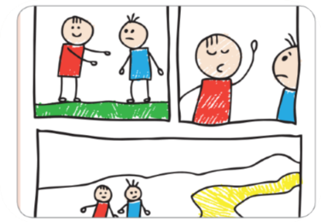d.
Question 2. Listen and write T (True) or F (False) (1pt)
0. Tim usually plays outside with his family. | F
1. He woke up at 9 o’clock yesterday.
2. He stayed in his room to play online games after lunch.
3. Tim played football at the playground.
4. He stayed up late to play video games.
Question 3. Listen and circle the correct answers (1pt)
1.Which animal is she talking about?
A B  C 
2.How long are crocodiles?
A. 6 metres B. 7 metres C. 8 metres
3. What do crocodiles eat?
A. B.  C. 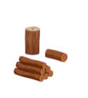
4.Where do they live? They live in the _____________
A.  B. 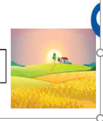 C. 
PART II. READING AND WRITING
Question 4. Odd one out (1.25pt)
1. a. looked | b. visited | c. wanted | d. needed
2. a.watched | b. liked | c. touched | d. played
3. a. stopped | b. waited | c. jumped | d. worked
4. a. asked | b. talked | c. laughed | d. pointed
5. a. enjoyed | b. walked | c. travelled | d. played
1. …………… to the concert yesterday?
a. Did Stella not go b. Stella went c. Did Stella go
2. Melina and I bought some burgers, but we …………….. any chips.
a. did not buy b. bought c. didn’t bought
3. The film is ……………….
a. interesting very b. very interesting c. very interesting film
4. Linda ………………. in the pool at present.
a. swimming b. is swimming c. swims
5. Children shouldn’t ……….. TV many hours a day.
a. watch b. watching c. watched
Question 6: Read the passage and circle the correct answer (1,25pts)
Deep underground, there is a special heat geothermal energy (geo means “earth” and thermal means “heat” in Greek). We need energy to light our homes and cook. The sun and wind provide clean energy, but geothermal energy can help people even more.
The Boiling River, deep in the Amazon rainforest, has very hot water (up to 99°C). This water is dangerous for animals. Scientists are studying the river to understand geothermal energy better. They also protect other parts of the Amazon. They don’t want people to cut down trees and destroy the rainforest. We hope that people will save the environment and save geothermal energy.
- What do you call special energy deep underground?
- Geothermal energy b. Heat c. Earth
- What do we need energy to?
- light our homes b. cook c. Both a and b
- Where is the Boiling River?
A.in the Amazon rainforest B. Amazon rainforest C. the Amazon rainforest.
- How hot is the water in the Boiling River?
- up to 99 b. very hot c. a hot water
- Why are scientists studying the Boiling River?
- to understand geothermal energy better B, to understand geothermal energy
C, understand geothermal energy better
Question 7: Find and circle the mistakes. (1pt)
1. My mother learns to play the piano when she was a child.
A B C D
2. There was many smoke because he started a fire.
A B C D
3. When I was a child, my mom tells me many bedtime stories.
A B C D
4. I had a small birthday party in my class next month.
A B C D
Question 8. Arrange the words to make sentences (1,25pt)
1. elephant/is/an/stronger/a/rabbit/than.  A. An elephant is stronger than a rabbit.  B. An rabbit is stronger than a elephant.  C. An elephant is than stronger a rabbit.  2. horses/faster/are/than/turtles?  A. Horses are faster than turtles.  B. Are horses faster than turtles?  C. Are horses than faster turtles?  3. plays/the/she/after/school/to/piano/relax.  A. She plays the piano to relax after school.  B. She plays the piano to relax school after.  C. She plays the piano relax to after school. | 4. some/bought/a/eggs/make/to/cake/he.  A. He bought eggs some to make a cake.  B. He bought eggs to a make some cake.  C. He bought some eggs to make a cake.  5. some / nice / there / places / really /this / in / town / are /.  a. There are some really nice places in this town.  b. There are some really nice places this in town.  c. There are some nice really places in this town.
Question 9. Look at the picture and write the words (1pt)
.  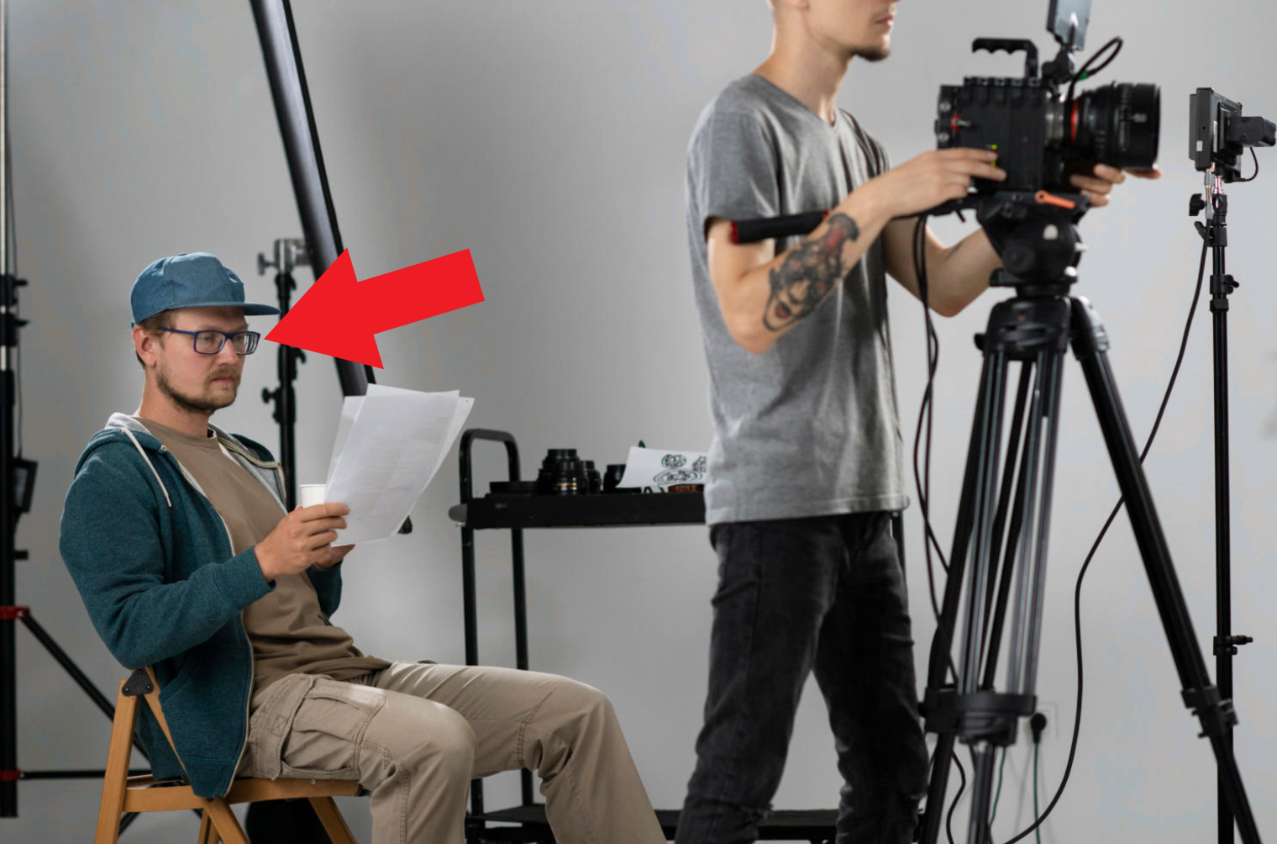  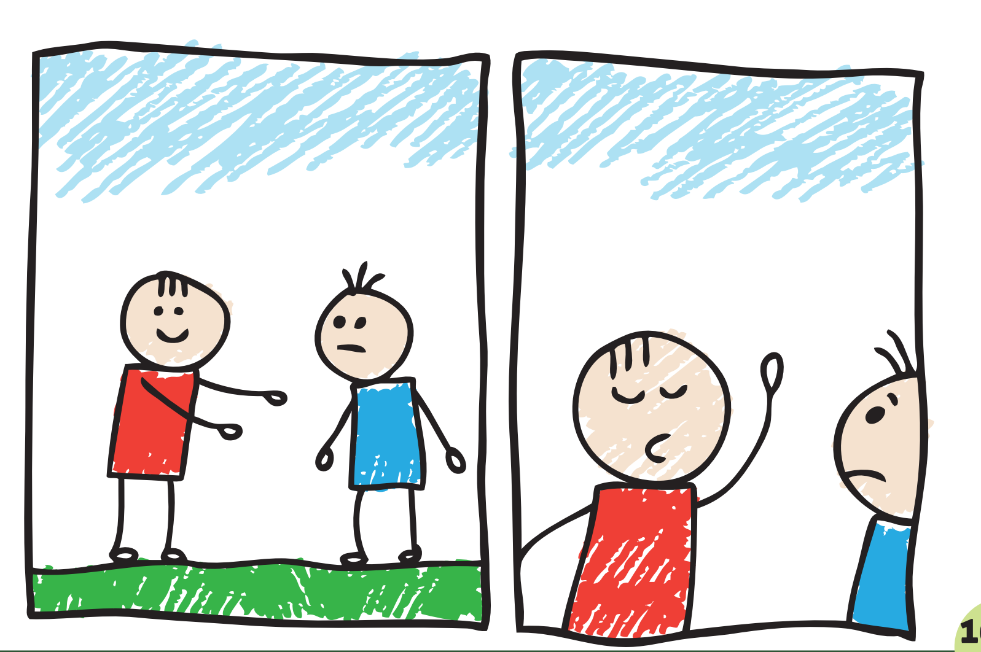
1. 2. 3. 4.

ĐÁP ÁN
PART I : Listening
Question 1: (1pt)
4 câu x 0,25 = 1đ
1.c 2. a 3. d 4. b
Question 2: (1pt)
4 câu x 0,25 = 1đ
1.T 2. T 3. F 4. T
Question 3: (1pt)
4 câu x 0,25 = 1đ
1. b 2. a 3. a 4. b
PART III : Reading and writing
Question 4: (1.25pt)
5 câu x 0,25 = 1.25 đ
1a 2.d 3.b 4. d 5.b
Question 5: (1,25pt)
6 câu x 0,25 = 1,5đ
1.b 2.c 3. c 4. a 5. b
Question 6: (1,25pts)
c
1. a 2. c 3. b 4. b 5. a
Question 7: (1pt)
4 câu x 0,25 = 1đ
1. a 2. b 3. c 4. d
Question 8: (1,25 pt)
5 câu x 0,25 = 1,25đ
1. A.2. B 3. A4. C 5.B

Question 9: (1pt)
4 câu x 0,25 = 1đ
1. autograph 2. Director 3. Make up 4.cartoon

