UBND HUYỆN VĨNH BẢO  TRƯỜNG TH VIỆT TIẾN | ĐỀ KHẢO SÁT CHẤT LƯỢNG HỌC KỲ II  TIẾNG ANH LỚP 5  NĂM HỌC 2024 - 2025  (Thời gian làm bài: 40 phút)
PART I. LISTENING
Question 1. Listen and number (1pt)

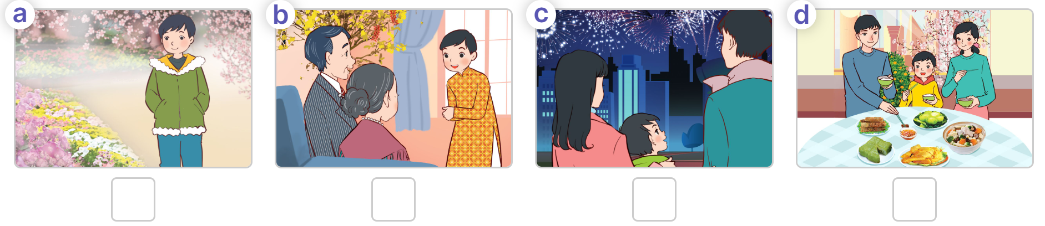
Question 2. Listen and tick or cross (1pt)

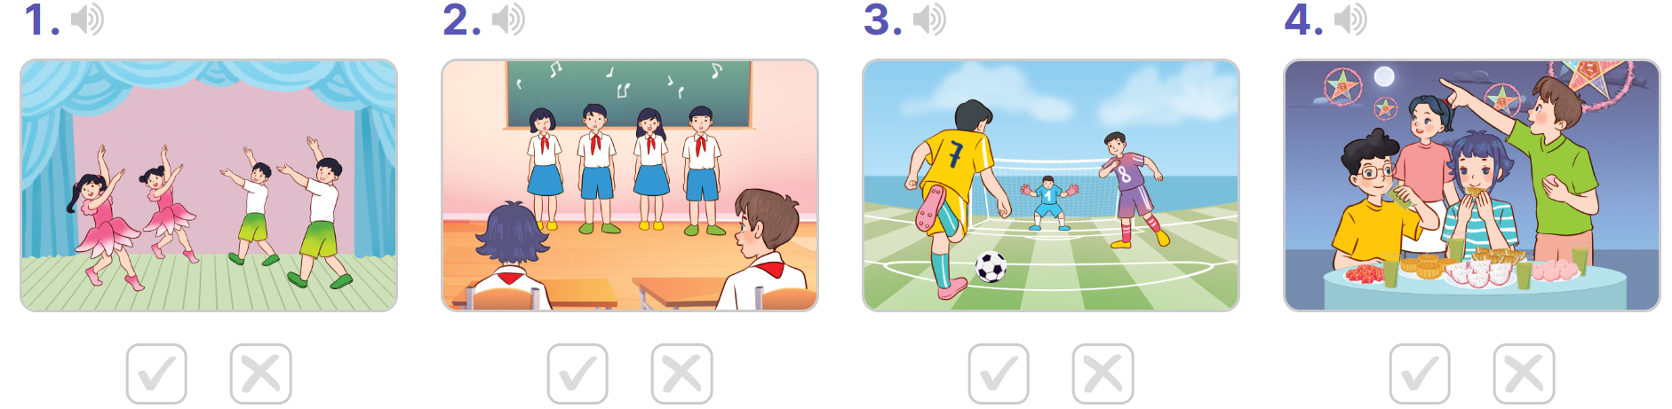 Question 3. Listen and circle the correct answers (1pt)
1. The story is about ___________
a. a grasshopper b. crocodile c. an ant d. an ant and a grasshopper
2. The ant worked____________
a. hard b. well c. fast d. slowly
3. When winter came, the grasshopper did not have any_______________
a. vegetables b. food c. friends d. water
4. The grasshopper said: “ I’ll work hard like you ___________
a. next week b. next month c. next year d. tommorrow
Part II: Pronunciation
Question 4:Circle the odd one out.(1,25pts)
1. a. swam | b. take photos | c. collect seashells | d. walk on the beach
2. a. toothache | b. health | c. headahe | d. stomachache
3. a. summer | b. spring | c. winter | d. swimmer
4. a. fox | b. hare | c. crow | d. tortoise
5. a. peaceful | b. exciting | c. beautiful | d. warm
PART III. READING AND WRITING
Question 5. Read and choose the best answer (1.5pts)
1. He__________ with her mother last Sunday.
a. swim b. swam c. swimming d. swims
2. What do you think _________ Ban Gioc Waterfall?
a. of b. about c. on d. in
3. What _________ your family _____________ in Ha Long Bay last weekend?
a. do / did b. did / do c. do / do d. does / do
4. How ___________ is it from Ha Noi to Hai Phong?
a. long b. often c. far d. old
5. Linda __________ some souvenirs for her friends yesterday.
a. bought b. buy c. buys d. to buy
Question 6: Read and choose the best answer

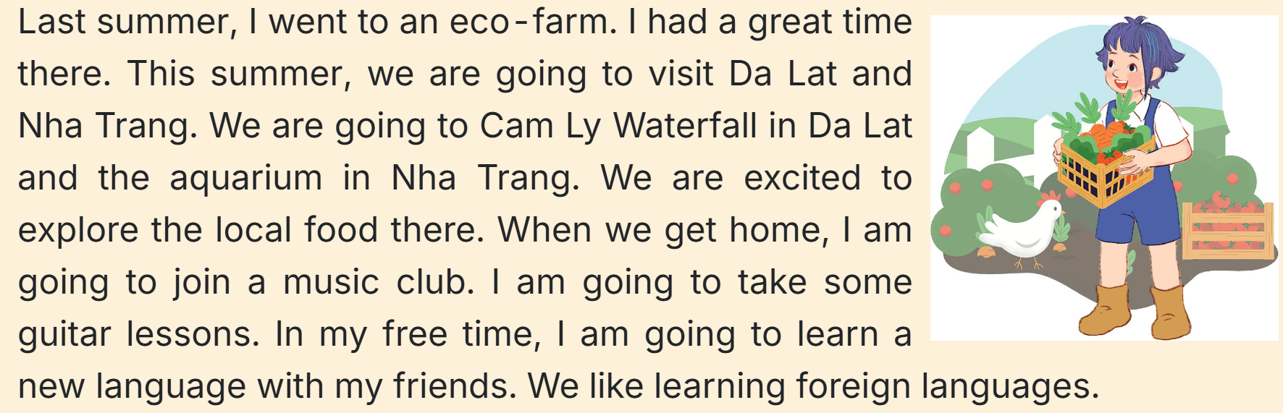
1. Where did Linh go last summer?
a. went to an eco - farm b. goes to an eco - farm c. go to an eco – farm d. went to Da Lat
2. Are they going to Da Lat this summer?
a. Yes, they aren’t. b. No, they aren’t. c. Yes, they are. d. No, they are.
3. They are_________ to explore the local food there.
a. excited b. interested c. happy d. bored
4. When they get home what is Linh going to do?
a. Join an English class b. join a football team c. join a music club d. join a yoga club
5. What is she going to do in her free time? – She’s going to____________
a. learn English b. learn Chinese c. learn maths d. learn new lagguage
Question 7: Find and circle the mistakes. (1pt)
1. Did you watched the film with your friends last night?
A B C D
2. Lucy want to visit Ha Noi Opera House with her friends
A B C D
3. We took a boat trip around the bay next weekend.
A B C D
4. You can get to Dam Sen Park on a taxi.
A B C D
Question 8. Arrange the words to make the meaningful sentences (1,25pts)
1.go / Where / Tet / will / she / at?
……………………………………………………………………………………..
2. the/ characters / are / main / Who / story / in/
………………………………………………………………………………………
3. fireworks / I / ‘ll / to / go / a / show.
……………………………………………………………………………………
4. you / a / Will / buy / for / Tet / branch / peach / of / blossoms?
……………………………………………………………………………………..
5. cooked / dwarfs / She / everyday / for / meals / seven / the
…………………………………………………………………………………….
Question 9: Look at the pictures and write the words(1pt)
 |  | 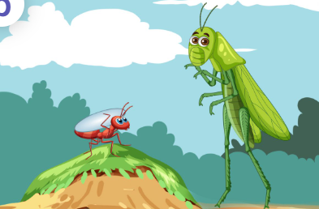 | 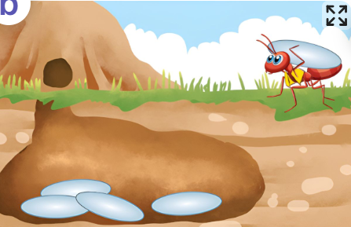
Play………………... | Eat……………………. | The ant and………………….. | Work…………………

Đáp Án

UBND HUYỆN VĨNH BẢO  TRƯỜNG TH VIỆT TIẾN | ĐỀ KHẢO SÁT CHẤT LƯỢNG HỌC KỲ II  TIẾNG ANH LỚP 5  NĂM HỌC 2024 - 2025  (Thời gian làm bài: 40 phút)
PART I : Listening
Question 1: (1pt)
4 câu x 0,25 = 1đ
2-1-4-3
Question 2: (1pt)
4 câu x 0,25 = 1đ
1.x 2.x 3. v 4. v
Question 3: (1pt)
4 câu x 0,25 = 1đ
1. d 2. a 3. b 4. c
Part II: Pronunciation
Question 4: (1,25pt)
5 câu x 0,25 = 1,25đ
1a 2.b 3.d 4. c 5. d
PART III : Reading and writing
Question 5: (1,25pt)
5 câu x 0,25 = 1,25đ
1.b 2.a 3. b 4. c 5. a
Question 6: (1,25pts)
- câu x 0,25 = 1,25đ
1. a 2. c 3. a 4. c 5. d
Question 7: (1pt)
4 câu x 0,25 = 1đ
1. B 2. A 3. D 4. C
Question 8: (1,25 pt)
5 câu x 0,25 = 1,25đ
- Where will she go at Tet?
- Who are the main characters in the story?
- I’ll go to a fireworks show.
- Will you buy a peach of blossoms for Tet?
- She cooked meals everyday for the seven dwarfs.
Question 9: Arrange the words to make sentenmces (1pt)
4 câu x 0,25 = 1đ
1. sports 2. vegetables 3. the grasshopper 4. hard

