UBND HUYỆN VĨNH BẢO  TRƯỜNG TH VIỆT TIẾN | ĐỀ KHẢO SÁT CHẤT LƯỢNG HỌC KỲ II  TIẾNG ANH LỚP 4  NĂM HỌC 2024 - 2025  (Thời gian làm bài: 40 phút)

PART I. LISTENING
Question 1: Listen and number: (1pt)
 |  | 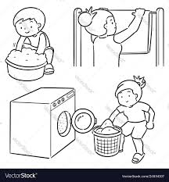 | 
Question 2: Listen and tick or cross( 1pt)
1. 2. 3. 4.
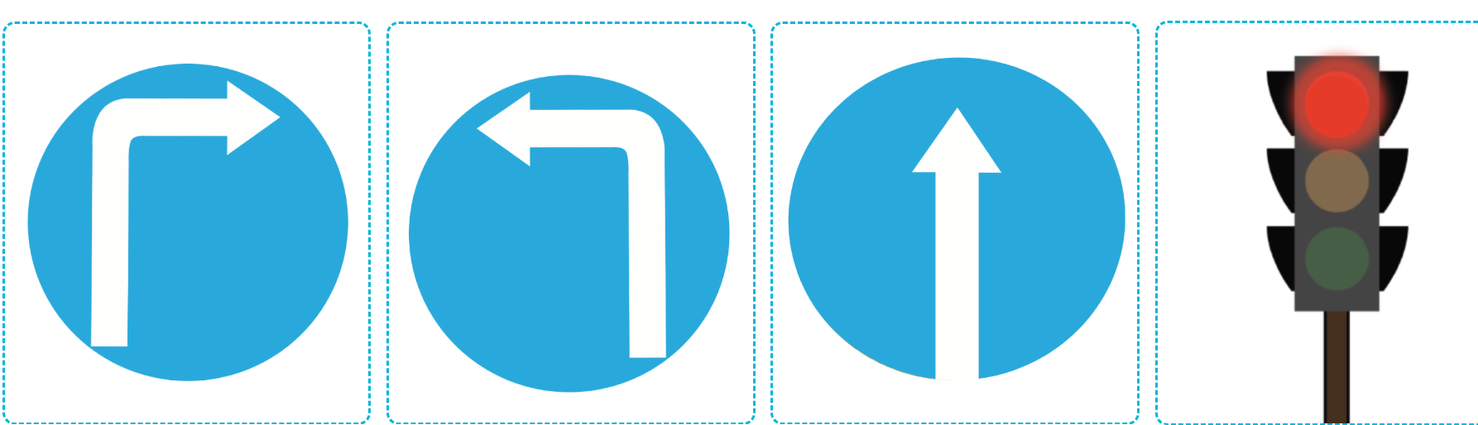
Question 3: Listen and complete:(1pt)
1. My grandfather has a ....................face.
2. My brother has long ................
3. Last weekend, the weather was..............
4. Last……………., the weather was sunny in the countryside.
Part II: Pronunciation
Question 4: Choose the words which have stress different from the others(1pt)
1. a. sunny b. rainy c. behind d. windy
2. a. bookshop b. between c. loudly d. quickly
3. a. email b. behind c. between d. girraffe
4.a. behind b. campsite c. visit d. opposite
Question 5: Odd one out(1,25pts)
1.a. cinema b.food stall c. swimming pool d. help
2. a.cook b. sports c. roar d.watch
3. a. crocodile b. giraffe c. putting d. hippo
4.a. building b .morning c. taking d. roaring
5.a.beautifulbeauti b. quickly b. loudly c.merrily
PART III. READING AND WRITING
Question 6: Choose the best answer:
1. What does your father do?
a. She’s a teacher b. He’s a policeman c. I am a nurse d. she’s a policeman.
2. My sister is ............. office worker.
a. the b. a c. works d.an
3. ………….does she work?
a. What b. When c. Where d. Who
4. What does she look like? She ………a round face.
a. is b. has c. have d. are
5..Is your brother an actor?
a. Yes, she is. b. No, he isn’t c. Yes, she is not. d. No, she is
Question 7: Read and complete
busy | village | small | beautiful | garden

I live in a (1)...................flat with my parents. It is in Le Lai Street. The street is very (2)......................... At the weekend, I visit my grandparents. They live in a big house with a beautiful garden in a (3) .................. The village is quiet and(4) .......................
Question 8. Look at the pictures and write the words
1. Kate is at the......................................   | 2. The weather was................ yesterday.  
3. My aunt works at a........................   | 4.My brother is a..................................  
Question 9: Arrange the words to make sentences
1. you / watch / TV/ When / do / ?
……………………………………………………………………………………………..
2. sister /my /At / and/I/ noon,/ the/ dishes. / wash
………………………………………………………………………………………………
3. the/ do/ you/ afternoon. /in/What/do/?
…………………………………………………………………………………………………
4. loudly. / These/ roar/ animals/
………………………………………………………………………………………….
5.books/ in / read/ My / and / I / father / the / evening. /
……………………………………………………………………………………………..
6. after / you / What / do / do / lunch ?
………………………………………………………………………………………………..

Keys
1. 2-4-2-3
2. 1V 2X 3V 4X
3. 1 round 2.hands 3.cloudy 4. Sunday
4. 1c 2b 3a 4a
5. 1d 2b 3c 4b 5a
6. 1b 2d 3c 4b 5b
7. 1. Small 2. Busy 3. Village 4. Beauiful
8. 1. Bakery 2. Rainy 3. Nursing home 4. Policeman
9. 1. when do you watch TV?
2. At noon, my sister and I wash the dishes.
3. What do you do in the afternoon?
4. These animals roar loudly.
5. My father and I read books in the evening.
6. What do you do after lunch?

