MA TRẬN ĐỀ KSCL HỌC KỲ 1 MÔN TIẾNG ANH LỚP 4 NĂM HỌC 2024 - 2025
I. Tiếng Anh lớp 4- Sách Wonderful World

- Ma trận đề
Thứ tự | Nội dung | Cấp độ |  |  |  |  | Số câu-Số điểm
Thứ tự | Nội dung | 1 | 2 | 3
 |  |  |  | thấp | cao
Part I | Listening |  |  |  |  | 12 câu = 3,0 điểm 30%
Question 1 | Listen and number  Unit 7. Jobs  Unit 9. Places in town | 2 câu | 1 câu | 1 câu |  | 4 câu=1.0 điểm
Question 2 | Listen and tick the correct sentences  Unit 8. Technology  Unit 12. Cool places | 1 câu | 1 câu | 2 câu |  | 4 câu =1.0 điểm
Question 3 | Listen and circle the correct pictures.  Unit 10. On holiday  Unit 11. Before our time | 2 câu | 1 câu | 1 câu |  | 4 câu=1.0 điểm
Part II | Reading and Writing |  |  |  |  | 28 câu= 7,0 điểm  70%
Question 4 | Odd one out  Unit 7. Jobs  Unit 11. Before our time | 1 câu | 2 câu | 2 câu |  | 5 câu=1.25điểm
Question 5 | Choose the best answer  Unit 8. Technology  Unit 9. Places in town | 2 câu | 1 câu | 2 câu |  | 5 câu=1.25điểm
Question 6 | Read and match column A with B  Unit 10. On holiday  Unit 11. Before our time | 2 câu | 1 câu | 5 câu |  | 5 câu=1.25điểm
Question 7 | Read the text and circle the correct answer  Unit 8. Technology | 2 câu | 1 câu | 1 câu |  | 4 câu=1.0 điểm
Question 8 | Arrange the words to make sentences  Review 4  Review 5 | 1 câu | 2 câu | 1 câu | 1 câu | 5 câu=1,25 điểm
Question 9 | Look at the picture and write one word in the blank  Unit 7. Jobs | 1 câu | 1 câu | 1 câu | 1 câu | 4 câu=1.0 điểm
 |  | 11 câu  = 2,75đ  27,5 % | 11 câu  = 2,75đ  27,5 % | 16 câu  = 4 đ  40 % | 2 câu  = 0,5đ  5 % | 40 câu = 10điểm 100%

UBND HUYỆN VĨNH BẢO  TRƯỜNG TIỂU HỌC VĨNH AN | ĐỀ KHẢO SÁT CHẤT LƯỢNG HỌC KỲ II  MÔN: TIẾNG ANH LỚP 4  NĂM HỌC 2024 – 2025  (Thời gian làm bài:40 phút)
Name: ……………………………….. Class: …………………………………
LISTENING
Question 1. Listen and number (1pt)
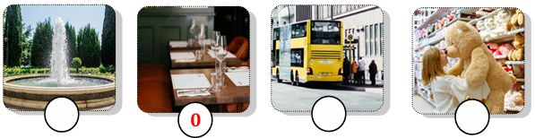
Question 2. Listen and tick the correct sentence (1pt)
1. |  | A. They are doing homework. | 2. |  | A. It’s my new smartphone.
1. |  | B. They are learning English. | 2. |  | B. It’s my new tablet.
3. |  | A. His trip to Vietnam was exciting. | 4. |  | A. They were at a bridge in America.
3. |  | B. My trip to Turkey was exciting. | 4. |  | B. They were at a temple in Vietnam.
Question 3. Listen and circle the correct picture (1pt)
1. 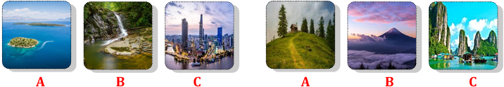2.
3.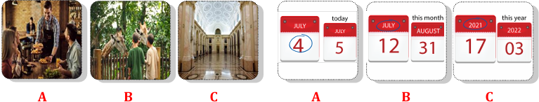4.
READING AND WRITING
Question 4. Odd one out (1.25pts)
- a. firefighter b. chef c. job d. doctor
- a. put b. feed c. photo d. take
- a. clinic b. hospital c. work d. studio
- a. yesterday b. huge c. strong d. scary
- a. small b. clever c. big d. mammoth
Question 5. Choose the best answer (1.25pts)
- Can we _______________ the tablet? – No, you can’t.
A. use B. do C. look D. have
- ______________ smartphone is it? – It’s her smartphone.
A. What B. Who C. Whose D. How
- The teacher wants her students to work in ____________.
A. books B. two C. class D. pairs
- The cinema is ______________ to the library.
A. next B. in front D. near D. opposite
- They are ______________ in the supermarket.
A. crossing B. swimming D. dancing D. shopping
Question 6. Match column A – B (1.25pts)
A | B
1. What do you like doing? | A. It was great. | 1 -
2. What was a mammoth? | B. I like buying presents. | 2 -
3. Where is he flying to? | C. I can see many big dinosaur bones. | 3 -
4. How was your history lesson? | D. It was a big elephant. | 4 -
5. What can you see at the museum? | E. He’s flying to Da Lat City. | 5 -
Question 7. Read the text and choose the best answer (1pt)
Ms. Jane: Today, we are going to use the (1) _____________lab in my class. Are you ready?
Class: Yes, teacher!
Tom: Can we use smartphones in class?
Ms. Jane: No, you can’t. But you can use books and tablets to look at the (2) ________ list.
Tim: Look at the computer, Rose! Who can (3) _____________ the password?
Rose: I think teachers can. But don’t use the computer! The teacher is talking!
Ms. Jane: Quiet, please! I can use the speaker if you can’t hear me. You can work in (4) __________________, understand?
Class: Yes, teacher!
- A. computer B. smartphones C. tablets D. class
- A. tablets B. computer C. emails D. word
- A. make B. write C. use D. change
- A. pair B. two C. groups D. books
Question 8. Reorder the words to make meaningful sentences (1.25pts)
1. books/ I/ buy/ comic/ bookshop/ the/ at/. | - I at the bookshop comic books buy.  - At the bookshop I buy books comic.  - I buy comic books at the bookshop.
2. sister/ does/ What/ do/ your/? | A. What does sister your do?  B. What does your sister do?  C. What do your sister does?
3. video/ class/ games/ Can/ we/ in/ play/? | A. Can we play video games in class?  B. In class we can play video games?  C. Play video game in class can we?
4. on/ Which/ would/ like/ visit/ place/ you/ to/ holiday/? | - Which would you like to visit place on holiday?  - Which place would you like to visit on holiday?  - On holiday to which place would you like visit?
5. Jack/ vet/ because/ animals/ he/ wants/ become/ a/ loves/ to/. | A. Because Jack wants to become a vet he loves animals.  B. Jack wants animals because he loves to become a vet.  C. Jack wants to become a vet because he loves animals.
Question 9. Look and write the word (1pt)
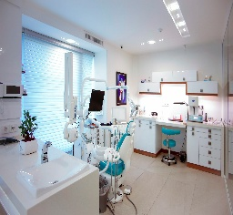
______________ ___________________ ______________________ ______________
Answer key
LISTENING
Question 1. Listen and number (1pt)
2 – 4 – 1 - 3
Question 2. Listen and tick the correct sentence (1pt)
- A 2. B 3. B 4. A
Question 3. Listen and circle the correct picture (1pt)
- B 2. C 3. B 4. A
READING
Question 4. Odd one out (1.25pts)
- C 2. C 3. C 4. A 5. D
Question 5. Choose the best answer (1.25pts)
- A 2. C 3. D 4. A 5. D
Question 6. Match column A – B (1.25pts)
- B 2. D 3. E 4. A 5. C
Question 7. Read the text and choose the best answer (1pt)
- A 2. D 3. D 4. C
Question 8. Reorder the words to make meaningful sentences (1.25pts)
- C 2. B 3. A 4. B 5. C
WRITING
Question 9. Look and write the word (1pt)
- Firefighter
- In a clinic
- Feed animals
- Photographer

