UBND HUYỆN VĨNH BẢO  TRƯỜNG TH DŨNG TIẾN | ĐỀ KHẢO SÁT CHẤT LƯỢNG GIỮA HỌC KỲ II  MÔN TIẾNG ANH LỚP 4  NĂM HỌC 2024 - 2025  (Thờigianlàmbài: 40 phút)
Name……………………………………………………class…………………..
Question 1 : Listen and number (1pt)
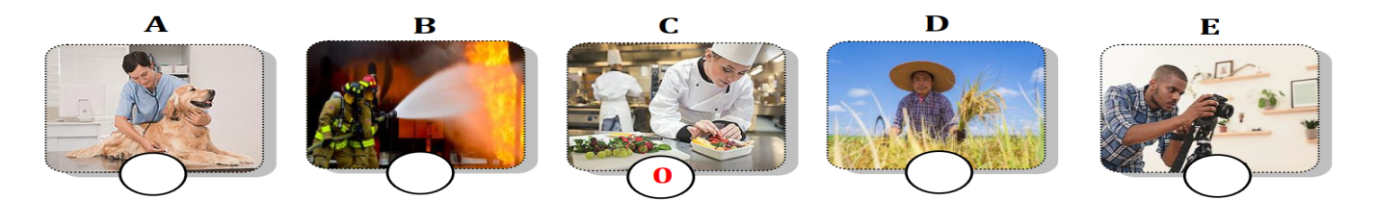
Question 2: Listen and tick . (1pt)
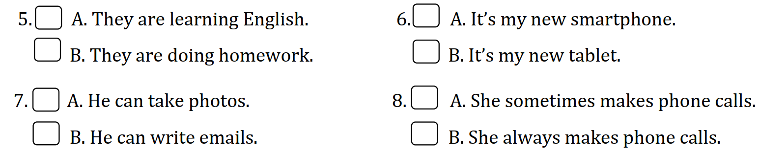
Question 3: Listen and tick . (1pt)
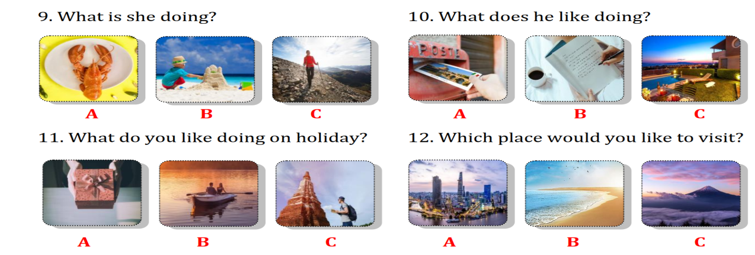
Question 4: Odd one out
1.a. chef b. photographer c. job d. doctor
2.a. studio b. restaurant c. field d. vet
3.a. yesterday b. put out c. take care d. feed
4.a. huge b. last week c. scary d. strong
5. a. last year b. last week c. farmer d. last month
Question 5: Choose the best answer A, B, C or D to complete the sentences:
1. She sometimes ............ videos on her smartphone.
a. make b. takes c. makes d. see
2. Teacher, can we use the computer lab? - : ..........................
a. Yes, I can. b. Yes, he can. c. No, you can.d. No, you can’t.
3. We go ..........................at the supermarket.
a.shopping b.camping c. shoping d.hiking
4. .................. do you get to the cinema?
Go straight on High street and then turn right.
a. What b. Where c.How d. Who
5. The theatre is ....................the library and the bus stop.
a. opposite b. in front of c. next tod. between
Question 6: Match
A | Answer | B
1. Which place would you like to visit? | 1- | a. but I don’t like going to the airport.
2. What do you like doing on holiday? | 2- | b.was
3. I like flying to new places on holiday, ....... | 3- | c. I’d like to visit Cat Ba island.
4. I ......... at the museum last week. | 4- | d.small
5. The dinosaur wasn’t ................ | 5- | e.I’d like to visit PhongNhaKe Bang nationalPark.
Question 7: Read the text and choose the best answer
Anna: This is my cousin, Andy on TV.
He's cooking in a studio.
Alex: Wow! What does he do?
Anna: He's a chef. He can cook great food.
Alex: Cool! Where does he work?
Anna: He works in a restaurant in Hanoi. He can cook Vietnamese food, too.
1. Anna’s cousin is cooking in ..........................
a. kitchen b. field c. farm c. studio
2. What does Anna’s cousin do?
a. He’s a doctor. b. He’s a photographer.
b. He’s a chef. d. He’s a vet.
3. He can cook ...................... food.
a. Vietnamese b. chicken c. English d. Japanese
4. He works in a .....................
a. museum b. clinic c. restaurant d. school
Question 8: Reorder these words to make sentences;
1, the fountain/in front of/is/behind/the museum/or/?
a. Is the fountain behind, in front of or the museum?
b. Is the fountain or the museum behind in front of?
c. Is the fountain in front of or behind the museum?
2, takes/a/of/many/animals/vet/care/.
a. A vet takes care of many animals. b. A vet take care of many animals.
c. A vet care takes of many animals.
3. sometimes/she/videos/on/her smartphone/makes/.
a. She makes sometimes videos on her smartphone. b. She sometimes makes videos on her smartphone.
c. She makes videos sometimes on her smartphone.
4. get/how/to/the post office/do/you/? a. How you do get to the post office?
b. How you get do to the post office?
c. How do you get to the post office?
5. can/use/who/the/lab/computer/?
a. Who the computer lab can use? b. Who can use the computer lab?
c. Who use can the lab computer?
Question 9: Look at the pictures and write one word only to complete sentences:
  1. A ……………………..works in a studio. | 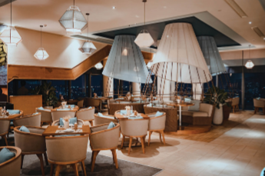  2. He works in a ……………….
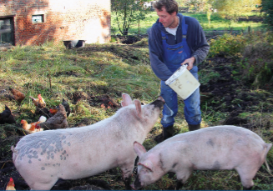  3.His father ………………….. on the farm |   4.A firefighter …………………..

ĐÁP ÁN
Question 1 : Listen and number (1pt)
1.c | 2.a | 3.d | 4.b
Question 2: Listen and circle . (1pt)
22 | 24 | 26 biscuits | 25 orange trees
Question 3: Listen and tick . (1pt)
1. b | 2.a | 3.b | 4.b
Question 4: Listen to the question and circle the correct answer. (1pt)
1.c 2.b
Q5: 0.25 x 6 câu= 1. 5 point
1.d 2a 3d 4b 5a 6a
Q6 0.25 x 6 câu= 1. 5 point
1d 2a 3a 4a 5 c 6.c
Q7 0.25 x 6 câu= 1. 5 point
1.are 2.sunny 3next 4 hiking 5 can’t 6many
Q8: 0.25 x 4 câu= 1point
- What is the weather like in summer?
- They are playing hide- and seek with me.
- They are cooking in the kitchen now.
- Where are Peter and Alex playing board games?
Q9: : 0.25 x 4 câu= 1point
- Clever 2. Cheerful/ friendly 3.polite 4. twins

