UBND HUYỆN VĨNH BẢO  TRƯỜNG TH DŨNG TIẾN | ĐỀ KHẢO SÁT CHẤT LƯỢNGHỌC KỲ II  TIẾNG ANH LỚP 5  NĂM HỌC 2024 - 2025  (Thờigianlàmbài: 40 phút)
PART I. LISTENING
Question 1. Listen and number (1pt)
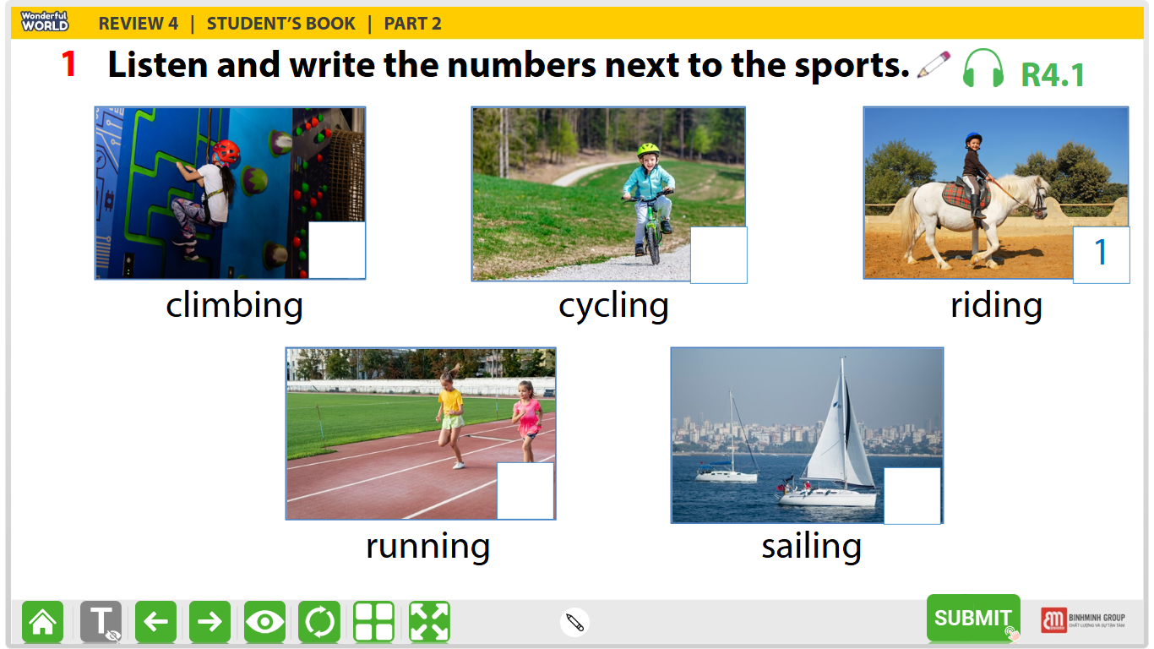
Question 2. Listen and write T for True or F for False (1pt) T F
- Barcelona is a large city in Spain.
- La Rambla is a small street in Barcelona’s city centre.
- In La Rambla, you can go shopping or have a snack is a café.
- The SagradaFamilia is a large church in Barcelona.
Question 3. Listen and circle the correct answers (1pt)
- What animal is she talking about?
- The tiger B. the crocodile C. the bear
- How long are crocodiles?
- 6 metres B. 7 metres C. 8 metres
- What do crocodiles eat?
- They eat vegetables: carrots, potatoes, tomatoes…….
- They eat a lot of fish, birds, snakes and they also eat very big animals.
- They eat a lot of apples, pears, bananas……
- How long do they usually live?
- 70 years B. 60 years C. 90 years
Question 4. Circle the odd one out.
1. | a. needed | b. wanted | c. worked | d. visited
2. | a. touched | b. stopped | c. jumped | d. pointed
3. | a. liked | b. played | c. travelled | d. stayed
4. | a. touched | b. asked | c. laughed | d. learned
5. | a. looked | b. danced | c. needed | d. talked
Part III. Reading and writing
Question 5. Choose the best answer.
1. Mary …………. to the amusement park last weekend.
A. go B. went C. didn’t went D. did go
2. Did your mother buy a new shirt yesterday ?
A. Yes, he did B. No, she did C. Yes, my mother did D. No, she didn’t
3. They watch cortoons ……………………..
A. twice a week B. one a day C. lastnight D. two a week
4. John is…………… a horse at the moment.
A. running B. riding C. walking D. going
5. When did you see that film ? A. two years ago B. It’s interesting
C. It’s a comedy D. in the cinema
Question 6:Read the passage and circle the correct answer (1,25pt)
Deep underground, there is a special heat: geothermal energy( geo means “earth” and thermal means “ heat” in Greek). We need energy to light our homes and cook. The sun and wind provide clean energy, but geothermal energy can help people even more.
The Boiling River, deep in the Amazon rainforest, has very hot water ( up to 99⁰C). This water is dangerous for animals. Scientists are studying the river to understand geothermal energy better. They also protect other parts of the Amazon. They don’t want people to cut down trees and destroy the rainforest. We hope that people will save the environment and save geothermal energy.
1. What does the word “geo” mean?
a. earth b. land c. moon d. mar
2. What does the word “ thermal” mean
a. air b. fire c. water d. heat
3. Where is the Boiling River?
a. in the Red River b. in the Nile River c. in the Amazon rainforest d. in the highlands
4. Is this water dangerous for animals?
a. No, it is b. Yes, it is c. No, it isn’t d. Yes, it does
5. Scientistshope that people will .................. the environment and save geothermal energy.
a. saving b. saved c. saves d. save
Question 7: Find and circle the mistakes. (1pt)
1. My family don’twatched an interesting TV show last night.
A B C D
2. Mainot did go to the cinema with her friends yesterday.
A B C D
3. He play chess with his father at home last night .
A B C D
4. Did you wentto Ha Noi by train last Sunday?
A B C D
Question 8. Arrange the words to make sentences (1.25pt)
- to the beach / to swim / They / often /go/.
- They often go to the beach to swim.
- They go often to the beach to swim.
- They often to swim go to the beach.
- went to / the zoo / to see / animals / We/.
- We went to the zoo to see animals.
- We went to see animals to the zoo.
- We to see animals went to the zoo.
- plays / the / She / after school / to / piano / relax/.
- She plays to the guitar relax after school.
- She plays the guitar after school to relax.
- She plays after school the guitar to relax.
- friends / Cheetah cubs / play/need/to/with/.
- Cheetah cubs need play with to friends.
- Cheetah cubs play with friends need to.
- Cheetah cubs need friends to play with.
- some/bought/a/eggs/make/ to / cake / He/.
- He bought some eggs to make a cake.
- He make a cake to bought some eggs.
- He bought a cake to make some eggs.
Question 9. Look at the picture and write the words (1pt)
 | 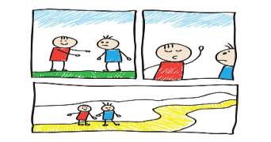 | 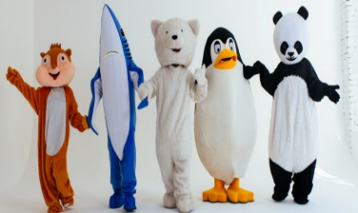 | 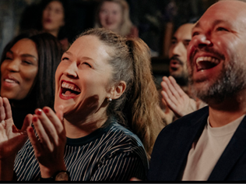
1. | 2. | 3. | 4.

ĐÁP ÁN
PART I. LISTENING
Question 1. Listen and number (1pt)
Mỗicâu 0.25 x 4 = 1 điểm
2- cycling 3- running 4- sailing 5- climbing
Question 2. Listen and write T for True or F for False (1pt) U8. 8.7
Mỗicâu 0.25 x 4 = 1 điểm
- T 2- F 3- T 4- T
Question 3. Listen and circle the correct answers (1pt)
Mỗicâu 0.25 x 4 = 1 điểm
- B 2- A 3- B 4- B
PARTII. PRONUNCIATION
Question 4. Circle the odd one out (1.25pt)
Mỗicâu 0.25 x 5 = 1.25 điểm
1- C 2- D 3-A 4-D 5-C
PART III. READING AND WRITING
Question 5. Choose the best answer (1.25pts)
Mỗicâu 0.25 x 5 = 1.25 điểm
1-B 2- D 3- A 4- B 5- A
Question 6:Read the passage and circle the correct answer (1,25pt)
Mỗicâu 0.25 x 5 = 1.25 điểm
- (a). earth
- (d). heat
3. (c). in the Amazon rainforest
4. (b). Yes, it is
5. (d). save
Question 7: Find and circle the mistakes. (1pt)
Mỗicâu 0.25 x 5 = 1.25 điểm
1-B 2- B 3- A 4- B
A (B ) C D
Question 8. Arrange the words to make sentences (1.25pt)
Mỗicâu 0.25 x 5 = 1.25 điểm
- B 2- A 3- B 4- C 5- A
Question 9. Look at the picture and write the words (1pt)
Mỗicâu 0.25 x 4 = 1 điểm
 | 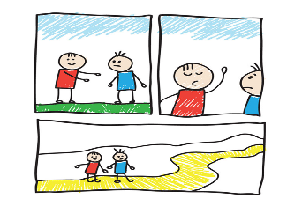
1. advert | 2. cartoon | 3. character | 4. comedy

