UBND HUYỆN VĨNH BẢO  TRƯỜNG TH GIANG BIÊN | ĐỀ KHẢO SÁT CHẤT LƯỢNG CUỐI HỌC KỲ II  MÔN TIẾNG ANH LỚP 2  NĂM HỌC 2024 – 2025  (Thời gian làm bài: 40 phút)
Name: ………………………….. Class: ………………………..
I. LISTENING
Question 1. Listen and tick () (1.5 pt)
1 | 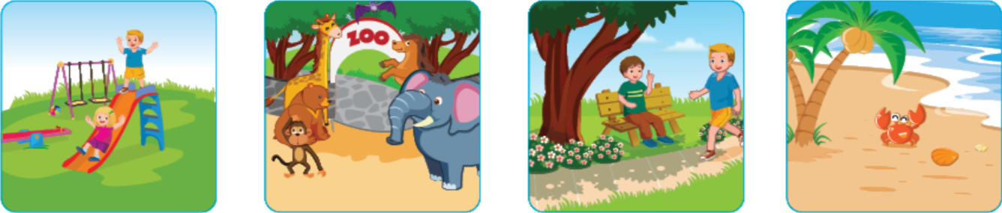 | 2 |  | 3
Question 2. Listen and circle the correct word (1 pt)
1 | A. Bus | B. Plane
2 | A. Friday | B. Thursday
3 | A. Sunday | B. Tuesday
4 | A. Motorbike | B. Boat
Question 3. Listen and number (1pt)
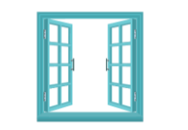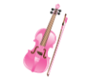
II. READING
Question 4. Circle the odd one out (1pt)
1 | A. T-shirt | B. clothes | C. dress
2 | A. plane | B. bus | C. shoes
3 | A. hat | B. socks | C. shorts
4 | A. those | B. these | C. this
Question 5. Read and tick the box (1.5pt)
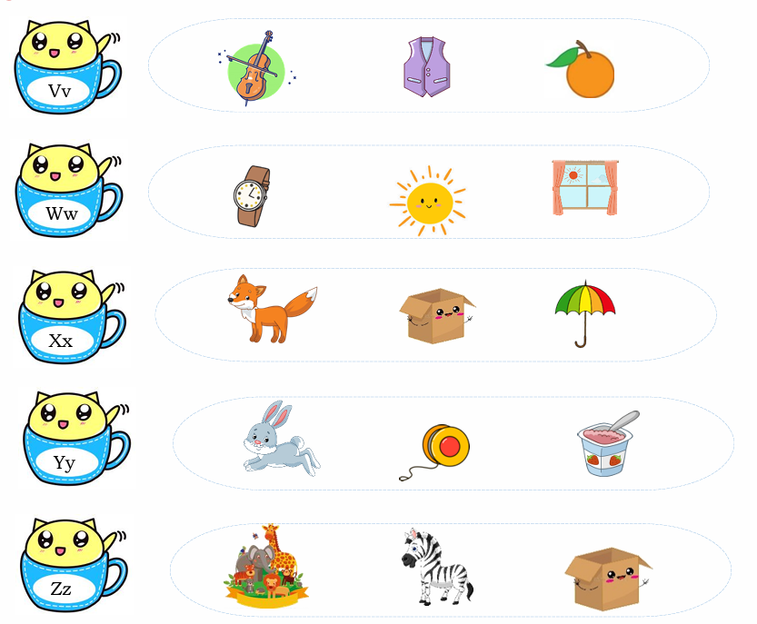
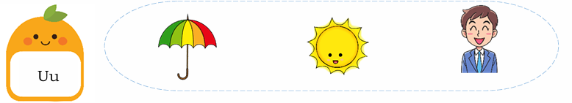
Question 6. Read and match (1pt)
1. 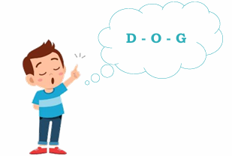 | a. I want to go to the zoo.
2. 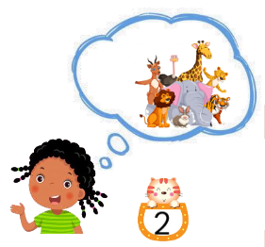 | b. Pick up your crayon.
3. 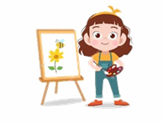 | c. I can spell words.
4.  | d. I draw pictures on Monday.
Question 7. Look and write (1.5pt)
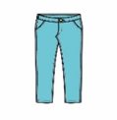
1. These are my ____________. 2. Can you see the _______________ ?
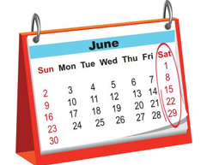3. What’s this? – It’s ______________.
Question 8. Reorder the words to make the correct sentence. (1.5pt)
1. to / I / playground / go / the / want / to.
____________________________________________
2. these / socks / Are / your / ?
____________________________________________
3. count / on / I / Wednesday / numbers / .
____________________________________________

UBND HUYỆN VĨNH BẢO  TRƯỜNG TH GIANG BIÊN | ĐỀ KHẢO SÁT CHẤT LƯỢNG CUỐI HỌC KỲ II  MÔN TIẾNG ANH LỚP 2  NĂM HỌC 2024 – 2025  (Thời gian làm bài: 40 phút)
Name: ………………………….. Class: ………………………..
I. LISTENING
Question 1. Listen and tick () (1.5 pt)
1 |  | 2 |  | 3
Question 2. Listen and circle the correct word (1 pt)
1 | A. Bus | B. Plane
2 | A. Friday | B. Thursday
3 | A. Sunday | B. Tuesday
4 | A. Motorbike | B. Boat
Question 3. Listen and number (1pt)
II. READING
Question 4. Circle the odd one out (1pt)
1 | A. T-shirt | B. clothes | C. dress
2 | A. plane | B. bus | C. shoes
3 | A. hat | B. socks | C. shorts
4 | A. those | B. these | C. this
Question 5. Read and tick the box (1.5pt)
Question 6. Read and match (1pt)
1. | a. I want to go to the zoo.
2. | b. Pick up your crayon.
3. | c. I can spell words.
4. | d. I draw pictures on Monday.
Question 7. Look and write (1.5pt)
1. These are my ____pants________. 2. Can you see the ______plane_________ ?
3. What’s this? – It’s ____Saturday__________.
Question 8. Reorder the words to make the correct sentence. (1.5pt)
1. to / I / playground / go / the / want / to.
I want to go to the playground.
2. these / socks / Are / your / ?
Are these your socks?
3. count / on / I / Wednesday / numbers / .
I count numbers on Wednesday.

