UBND HUYỆN VĨNH BẢO  TRƯỜNG TH HÙNG TIẾN  Name:.....................................................  PART I: LISTENING | ĐỀ KHẢO SÁT CHẤT LƯỢNG HỌC KỲ II  MÔN TIẾNG ANH LỚP 3  NĂM HỌC 2024 - 2025  (Thời gian làm bài: 40 phút)  Class:........................................
Question 1 : Listen and number (1pt)

a. b. c. d.

Question 2: Listen and tick the correct sentences (1pt)
1. In Thessaloniki, there are nice parks and ___________________
a. museum | b. theatre | c. markets | d. bookshop
2. There is a ___________________ toyshop.
a. big | b. cool | c. small | d. large
3. ___________________ is a big pool.
a. There | b. Those | c. These | d. They
4. Her favourite part of town is the ___________________
a. zoo | b. library | c. toyshop | d. playground
Question 3: Listen and circle the correct pictures (1pt)
1. | 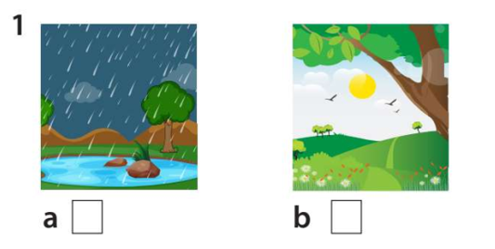 |  | 2. | 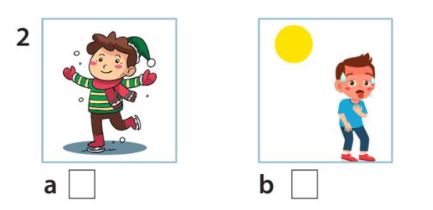
1. | a. | b. | 2. | a. | b.
3. |  |  | 4. | 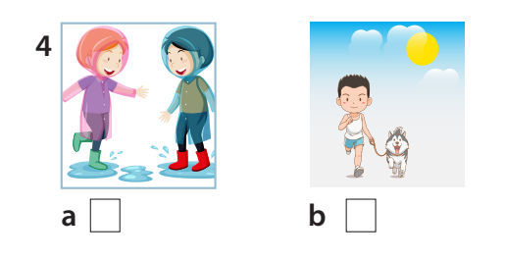
3. | a. | b. | 4. | a. | b.
PART II: PRONUNCIATION
Question 4: Odd one out (1,25 pt)
1. a. tree | b. cook | c. swim | d. run
2. a. piano | b. guitar | c. sing | d. drum
3. a. summer | b. hot | c. winter | d. spring
4. a. sunny | b. rainy | c. cold | d. autumn
5. a. can | b. dance | c. sing | d. buy
Question 5. Choose the best answer (1,25pt)
1. ............. run in the library, please.
a. Isn’t b. Doesn’t c. Don’t d. Aren’t
2. .............. are you doing ? I’m swimming in the pool.
a. What b. Where c . Who d. How
3. There ........... a lot of …………. in the box.
a. is / sweet b. are /sweets c. its / sweet d. it / sweets
4. How many …………. are there ? – ………. are fourteen.
a. apple/ there. b. bananas/ these c. tomatoes/ there d. pears/ those
5. May I ........... football with everybody? – Yes, you can.
a. plays b. playing c. to play d. play
Question 6. Read and match column A with B (1,25 pt)
A | B | A - B
1. Do they swim in winter? | a. I go to school. | 1 -
2. It’s hot and sunny | b. I have dinner with my family. | 2 -
3. What do you do on Mondays? | c. No, they don’t. | 3 -
4. Who do you have dinner with? | d. By bus | 4 -
5. How do you go to the park? | e. in summer. | 5 –
Question 7. Read the text and circle the correct answer (1pt)
Today is Saturday. It’s nice. Minh and his friends are in the park. Minh is drawing a picture. Lan is playing badminton with Nga. Nam is flying a kite. Mai is taking photos. They have a lot of fun in the park.
1. Where are Minh and his friends?
a. at the zoo b. in the park c. in the pool d. in the playground
2. Is Lan playing badminton with Nga?
a. No, she isn’t b. No, she is c. Yes, she is d. No, he isn’t
3. What’s Mai doing?
a. She’s playing football b. She’s running c. She’s drawing d. She’s taking photos
4. Do they have fun in the park?
a. Yes, they do b. Yes, they can c. No, they can’t. d. No, they don’t.
Question 8. Arrange the words to make sentences (1,25 pt)
1. are / some / There / the / apples / under / table/.
a. There are under some apples the table.  c. are There some apples under the table. | b. There are under the apples some table.  d. There are some apples under the table.
2. a / can’t / dog / bike / My / ride/.
a. My dog can’t ride a bike.  c. My dog can’t bike a ride. | b. My dog ride can’t a bike.  d. My dog can’t a bike ride.
3. can / I / the / piano / I / sing / play/ but/ can’t/.
a. I play can the piano but I can’t sing.  c. I can play the piano I but can’t sing. | b. I can play the piano but I can’t sing  d. I can the play piano but I can’t sing
4. are / tomatoes / There / in/ box/ eleven / the /.
a. There are tomatoes eleven in the box .  c. There are eleven tomatoes in the box. | b. are There eleven tomatoes in the box.  d. There are the tomatoes in eleven box .
5. cooking / She / is / in the kitchen/ her mother/ with/.
a. She is cooking with mother her in the kitchen.  c. She is cooking with her mother the in kitchen. | b. She cooking is with her mother in the kitchen.  d. She is cooking with her mother in the kitchen.
Question 9. Look at the picture and write one word in the blank (1 pt)
 |  |  | 
1. | 2. | 3. | 4.

ĐÁP ÁN CUỐI KÌ II MÔN TIẾNG ANH LỚP 3
Question 1: Listen and number (1pt)
a. b. c. d.

Question 2: Listen and tick the correct sentences (1pt)

1. In Thessaloniki, there are nice parks and ___________________
a. museum | b. theatre | c. markets  V | d. bookshop
2. There is a ___________________ toyshop.
a. big | b. cool  V | c. small | d. large
3. ___________________ is a big pool.
a. There  V | b. Those | c. These | d. They
4. Her favourite part of town is the ___________________
a. zoo | b. library | c. toyshop | d. playground  V
Question 3: Listen and circle the correct pictures (1pt)
1. |  |  | 2.
1. | (a) | b | 2. | a | (b)
3. |  |  | 4.
3. | a | (b) | 4. | (a) | b
PART II: PRONUNCIATION
Question 4: Odd one out (1,25 pt)
1. a. tree | b. cook | c. swim | d. run
2. a. piano | b. guitar | c. sing | d. drum
3. a. summer | b. hot | c. winter | d. spring
4. a. sunny | b. rainy | c. cold | d. autumn
5. a. can | b. dance | c. sing | d. buy
Question 5. Choose the best answer (1,25pt)
1. ............. run in the library, please.
a. Isn’t b. Doesn’t c. Don’t d. Aren’t
2. .............. are you doing ? I’m swimming in the pool
a. What b. Where c . Who d. How
3. There ........... a lot of …………. in the box
a. is / sweet b. are /sweets c. its / sweet d. it / sweets
4. How many …………. are there ? – ………. are fourteen
a. apple/ there. b. bananas/ these c. tomatoes/ there d. pears/ those
5. May I ........... football with everybody? – Yes, you can.
a. plays b. playing c. to play d. play
Question 6. Read and match column A with B (1,25 pt)
A | B | A -B
1. Do they swim in winter? | a. I go to school. | 1 - c
2. It’s hot and sunny | b. I have dinner with my family. | 2 - e
3. What do you do on Mondays? | c. No, they don’t. | 3 - a
4. Who do you have dinner with? | d. By bus | 4 - b
5. How do you go to the park? | e. in summer. | 5 - d
Question 7. Read the text and circle the correct answer (1pt)
1. Where are Minh and his friends?
a. at the zoo b. in the park c. in the pool d. in the playground
2. Is Lan playing badminton with Nga?
a. No, she isn’t b. No, she is c. Yes, she is d. No, he isn’t
3. What’s Mai doing?
a. She’s playing football b. She’s running c. She’s drawing d. She’s taking photos
4. Do they have fun in the park?
a. Yes, they do b. Yes, they can d. No, they can’t. d. No, they don’t.
Question 8. Arrange the words to make sentences (1,25 pt)
1. are / some / There / the / apples / under / table/.
(d). There are some apples under the table.
2. a / can’t / dog / bike / My / ride/.
(a). My dog can’t ride a bike.
3. can / I / the / piano / I / sing / play/ but/ can’t/.
(b). I can play the piano but I can’t sing
4. are / tomatoes / There / in/ box/ eleven / the /.
(c). There are eleven tomatoes in the box.
5. cooking / She / is / in the kitchen/ her mother/ with/.
(d). She is cooking with her mother in the kitchen.
Question 9. Look and write (1 pt)
1. baseball | 2. tennis | 3. flying a kite | 4. basketball

