ĐỀ TAM CUONG
PART I. LISTENING
Question 1. Listen and number (1pt)
a.  | b.  | c.  | d. 
Question 2. Listen and tick (1pt)

1. |  | A. I’m swimming in the pool. | 2. |  | A. She’s jumping at the playground.
1. |  | B. I’m reading in the library. | 2. |  | B. He’s jumping at the playground.
3. |  | A. I go to the park with my friends. | 4. |  | A. I go to school with my friends.
3. |  | B. I go to school with my friends. | 4. |  | B. I have dinner with my family.
Question 3. Listen and circle the correct pictures (1pt)
1.a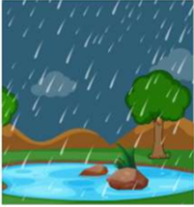 | b.  | 2. a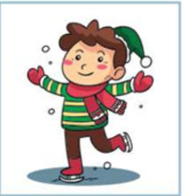 | b. 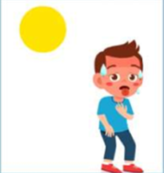
3.a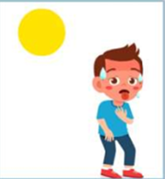 | b. 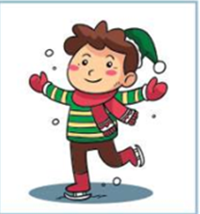 | 4.a. 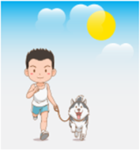 | 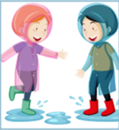  b.
Part II: READINg Question 4: Odd one out.(1,25pts
1. a. look | b. read | c. write | d. eraser
2. a. violin | b. football | c. guitar | d. piano
3. a. cold | b. rainy | c. weather | d. sunny
4. a. summer | b. spring | c. autumn | d. snow
5. a. lunch | b. dinner | c. colour | d. breakfast
Question 5. Choose the best answer (1.25pts)
1. He’s ……………..football with his friends now.
a. plays b. play c. playing d. played
2. Let’s ____________ apples and pears.
a. go b. drink c. buy d. look
3. What do you do …………Mondays?- I ride a bike in the park.
a. on b. in c. at d. to
4. There is some ________ on the table.
a. water lemon b. apple c. bananas d. Pear
5. …………….do you go to school?- I walk to school every day.
a. How b. Who c. What d. Where
Question 6: Match A with B
A | B
1. What day is it today? | a. I go to school with my sister. | 1.
2. Do they swim in summer? | b. I go to the zoo by bus. | 2.
3. What do you do on Mondays? | c. It is Tuesday. | 3.
4. Who do you have lunch with? | d. I have lunch with my friends. | 4.
5. How do you go to the zoo ? | e. Yes, they do. | 5

Question 7: Read and choose the best answer
Today is Sunday. It’s sunny and windy. Mai and her friends are in the park. Mai is riding a bike. Minh is drawing an elephant. Linh is taking photos. Quan is playing football with Phong. They have a lot of fun in the park.
1. Where are Mai and her friends?
a. in the playground b. in the pool c. in the park
2. Is Linh riding a bike?
a. No, she isn’t b. Yes, she is c. No, she is
3. What’s Quan doing?
a. He’s playing football b. He’s running c. He’s taking photos
4. Do they have fun?
a. Yes, they can b. Yes, they do c. No, they don’t.
Question 8. Arrange the words to make the meaningful sentences (1pt)
1.are /There / tomatoes /the/ at /market ./ many/
A. There are many tomatoes at the market. B. Are there many tomatoes at the market.
C. There are tomatoes many at the market.
2.go / Let’s / to / zoo / the.
A. Let’s go to the zoo. B. Let’s the go to zoo. C. Let’s zoo go to the.
3.You / play, / and / can / run / climb / here.
A.You can here and play, run climb. B.You can play, here run and climb.
C. You can play, run and climb here.
4.is/She / in /cooking / kitchen ./the /
A.Is she cooking in the kitchen. B.She is cooking in the kitchen
C.She cooking is in the kitchen
5.My sister / English / at / isn’t / learning / school/.
A.My sister isn’t learning at school English. B. My sister isn’t learning English at school.
C.My sister isn’t at English learning school.
Question 9: Look at the pictures and write the words
  1. ___________ |   2 ………………… | 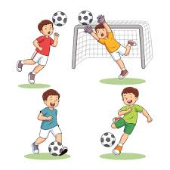  3…………….. | 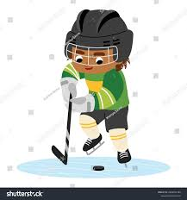  4……………………

PART I. LISTENING
Question 1. Listen and number (1pt)
1.a 2.c 3d 4 b
Question 2. Listen and tick (1pt)
1.a 2a 3.b 4b

Question 3. Listen and circle the correct pictures (1pt)
1.a 2. b 3. b 4.a
Part II: READING
Question 4: Odd one out.(1,25pts)
1. d- 2b 3.c 4d. 5c
Question 5. Choose the best answer (1.25pts)
1.c 2.c 3.a 4c 5a
Question 6: Match A with B
A | B
1. What day is it today? | a. I go to school with my sister. | 1. c
2. Do they swim in summer? | b. I go to the zoo by bus. | 2.e
3. What do you do on Mondays? | c. It is Tuesday. | 3.a
4. Who do you have lunch with? | d. I have lunch with my friends. | 4.d
5. How do you go to the zoo ? | e. Yes, they do. | 5b

Question 7: Read and choose the best answer
1.c 2.a 3.a. 4.b
Question 8. Arrange the words to make the meaningful sentences (1pt)
1.a 2.a 3.c 4,b. 5b
Question 9: Look at the pictures and write the words
- Volleyball 2. Swimming 3. Football 4. Hockey

