UBND HUYỆN VĨNH BẢO  TRƯỜNG TIỂU HỌC TAM CUONG | ĐỀ KIỂM TRA KSCL CUỐI HỌC KÌ 2  Năm học 2024-2025  Môn : TIẾNG ANH 4  Thời gian : 40 phút
PART I : LISTENING ( 3pts)
Question 1. Listen and number (1pt)
A.  | B.  | C. 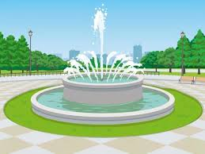 | D.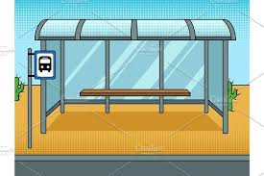
Question 2. Listen and tick the correct sentence (1pt)
1. |  | A. They are doing homework. | 2. |  | A. It’s my new smartphone.
1. |  | B. They are learning English. | 2. |  | B. It’s my new tablet.
3. |  | A. His trip to Vietnam was exciting. | 4. |  | A. They were at a bridge in America.
3. |  | B. My trip to Turkey was exciting. | 4. |  | B. They were at a temple in Vietnam.
Question 3. Listen and circle the correct picture (1pt)
1.   A B | 2.    A B
3.    A B | 4.   A B
PART II : READING AND WRITING ( 7pts)
Question 4 : Odd one out (1,25pts)
1.A. supermarket | B. shopping centre | C. opposite | D. train station
2.A.teacher | B. studio | C. firefighter | D. doctor
3.A. turn | B. send | C. speak | D. dinosaur
4.A. in a studio | B. take care of people | C. feed animals | D. put out fires
5.A. bay | B. hill | C. place | D. national park
Question 5 : Choose the best answer (1,25pts)
1. Teacher, can we surf the internet ?
A. Yes, you can’t B. No, you can C. No, we can D. Yes, you can
2. The teacher wants her students to work in ____________.
A. books B. two C. class D. pairs
3. What ……… we do on a smartphone? – We can take photos.
- should B. can C. do D. are
4……..do we get to the toy shop ? – Go straight and then turn right.
A. How B. When C. What D. Where
5. We buy food and drink…………….
A. At the bus stop. B. At the post office. C. At the toy shop. D. At the supermarket
Question 6 : Read and match column A with B (1,25pts)
A | B | C
1.Which place would you like to visit on holiday? | a.No, she wasn’t. She was there last week. | 1
2.What can we do on Ha Long Bay ? | b. A. Early people were small.. | 2
3. Was she at the shopping centre last week? | c.I’d like to visit Ba Na Hill. | 3
4.What do you like doing at Do Son beach ? | d.We can row a boat and eat seafood. | 4
5. How were early people? | e.I like making sandcastle and swimming | 5
Question 7 : Read the text and circle the correct answer (1pt)
Lan: (1)………..phone is it? It's nice!
Linda: It's my new (2)…………...
Lan: Wow, what can you do on your smartphone?
Linda: I can take photos and (3)………… on my phone.
Lan: Cool! (4)………..we write emails on a smartphone?
Linda: Yes, we can. I (5)…………..write emails on my phone.
- A. Whose B. Where C. Which D. When
- A. computer B. smartphone C. tablet D. speaker
- A. use the projector B. play football C. make videos D. go shopping
- A. Do B. Are C. Is D. Can
- A. never B. sometimes C. sometime D. always
Question 8 : Arrange the words to make sentences(1,25pts)
- in / father/ works / hospital. / a / My /
- Father my works a in hospital. B.My father works in a hospital
C.My father in works a hospital.
2 .students / phones / Can / use / in / their / class /?
- Can students use their phones in class? B.Can students use in their phones class?
C.Can their students use phones class in?
3.place / you / Which / to / on / would / visit / holiday / like /?
- Which place would you like to visit on holiday?
- Which place would you like visit on to holiday?
- Which place would you like to visit holiday on?
4. books/ I/ buy/ comic/ bookshop/ the/ at/.
A.I at the bookshop comic books buy. B. At the bookshop I buy books comic.
C.I buy comic books at the bookshop.
5. next to / The / is / the / post office / shopping / centre /.
- The post office next to is the shopping centre. B.The post office is next to the shopping centre.
- The shopping next to post office is the centre.
Question 9 : Look at the picture and write one word in the blank (1pt)
1.He is a……………….   | 3.Mr. Lee works in a…………………..  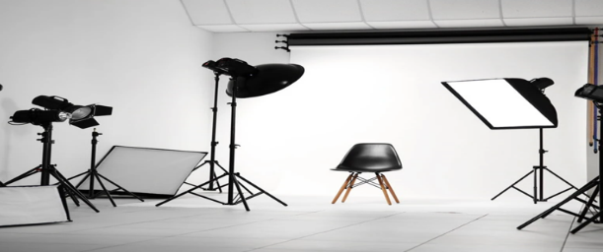
2.My father is a……………………..   | 4. He works in a……………………..  

ĐÁP ÁN
Question 1
1.C 2. A 3. D 4. B
Question 2
A 2. B 3. B 4. A
Question 3
1.A 2. A 3. B 4. B
Question 4
1.C 2. B 3. D 4. A 5. C
Question 5
1.D 2. B 3. C 4. A 5.B
Question 6
1-C 2 – D 3 – A 4 – E 5 – B
Question 7
1.A 2. B 3. C 4. B
Question 8
1.B 2. A 3. A 4. C 5. B
Question 9
1.chef 2. STUDIO 3. firefighter 4. CLINIC

