- Match Column A with column B
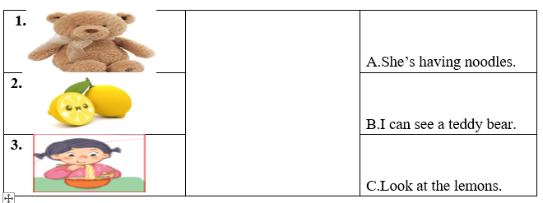

 | 
 | 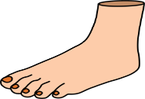
 | 
c. cat | 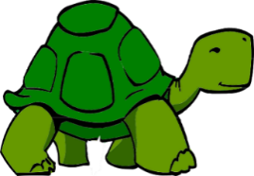

2. That’s a ….
a. dog b. monkey c. mouse
3. Point to your …..
a. goat b. hand c. foot
4. I like …..
a. bananas b. mango c. apples
5. I can see a …
a. duck b. turtle c. cat
6. Điền vào chỗ trống
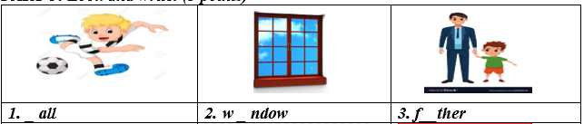

7 .

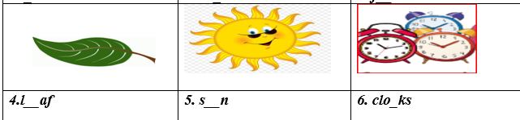

8. I like lemonlade.




9. This is my _____________________
8.

