UBND XÃ KIẾN HƯNG  TRƯỜNG TIỂU HỌC ĐẠI HÀ | BÀI KIỂM TRA HỌC KÌ I  Môn : Tiếng Anh 1 – Năm học 2025-2026  Thời gian: 35 phút
Name: .................................................................... Class: 1…....
Listening | Reading | Writing | Speaking | Total marks

PART 1. LISTENING
Question 1. Listen and circle A or B. (2pts).
  1.  Pink flower  A |   B |   2.  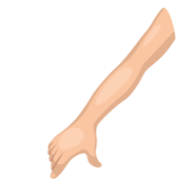  A B
  3.  A |   B | 4.  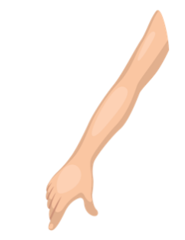  A |   B

Question 2. Listen and draw lines (2pts)
 |  |  |  | 

4
3
2
1
0

PART II. READING
Question 3. Read and draw lines. (2pts).
A.   B.  C.  | 1. I have a cap  2. It’s a pen.  3. Touch your head.  4. This is my mother  5. I like dogs. | D.     E.
PART III. WRITING
Question 4. Look, choose the correct letters from the box and complete the words. (2pts)

d f a b g

 |  |  |  | 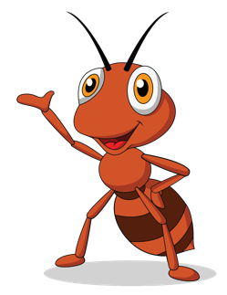
1. girl | 2. _ood | 3. _ag | 4. _oor | 5. _nt
PART III: SPEAKING
Question 8: Getting to know each other/ Point, ask and answer. (2 points)
1. It’s ______.
2. Touch your_____.
3. It’s a _____.
4. I like _____.
----- THE END -----

