UBND XÃ KIẾN HƯNG  TRƯỜNG TIỂU HỌC ĐẠI HÀ | BÀI KIỂM TRA HỌC KÌ I  Môn : Tiếng Anh 3 – Năm học 2025-2026  Thời gian: 35 phút
Name: .................................................................... Class: 3…....
Listening | Reading | Writing | Speaking | Total marks
PART 1. LISTENING
Exercise 1: Listen and match. There is one example. (1pt)
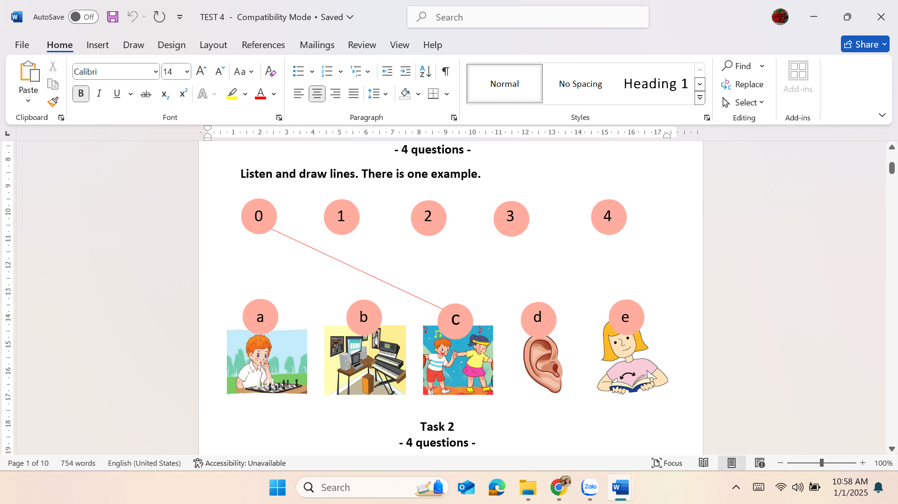
Exercise 2: Listen and complete. There is one example (1pt)
- What colour are they? – They’re…..white…….
- Is this our …………………………..? Yes, it is.
- What’s your hobby? It’s …………………………………………………………..
- What do you do at break time? – I play …………………………………………..
- I have a ……………………………………
Exercise 3: Listen and number. There is one example (1pt)
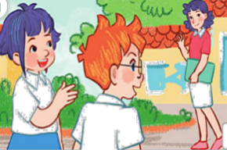 |  | 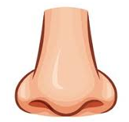 | 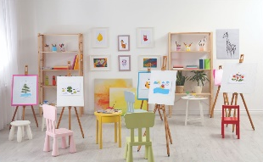 | 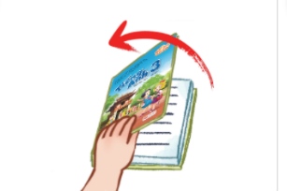
- b. c. d. e.
0
Exercise 4: Listen and tick. There is one example (1pt)
    orange |   blue |   green
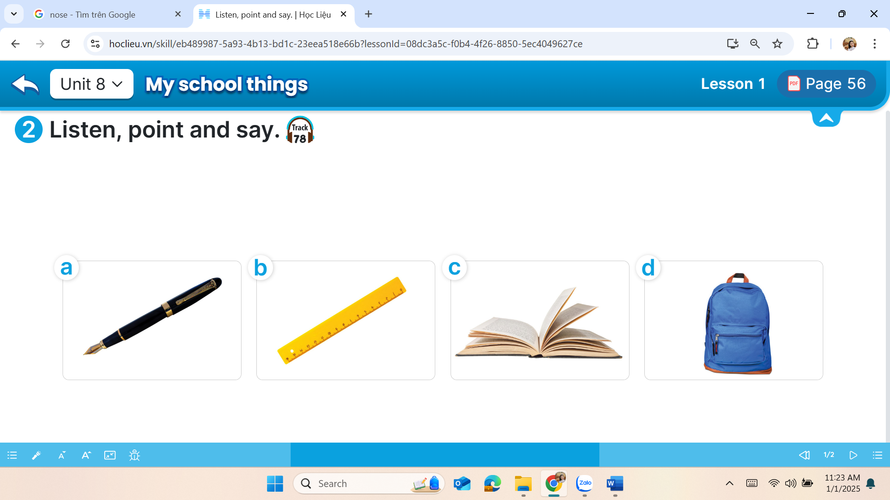
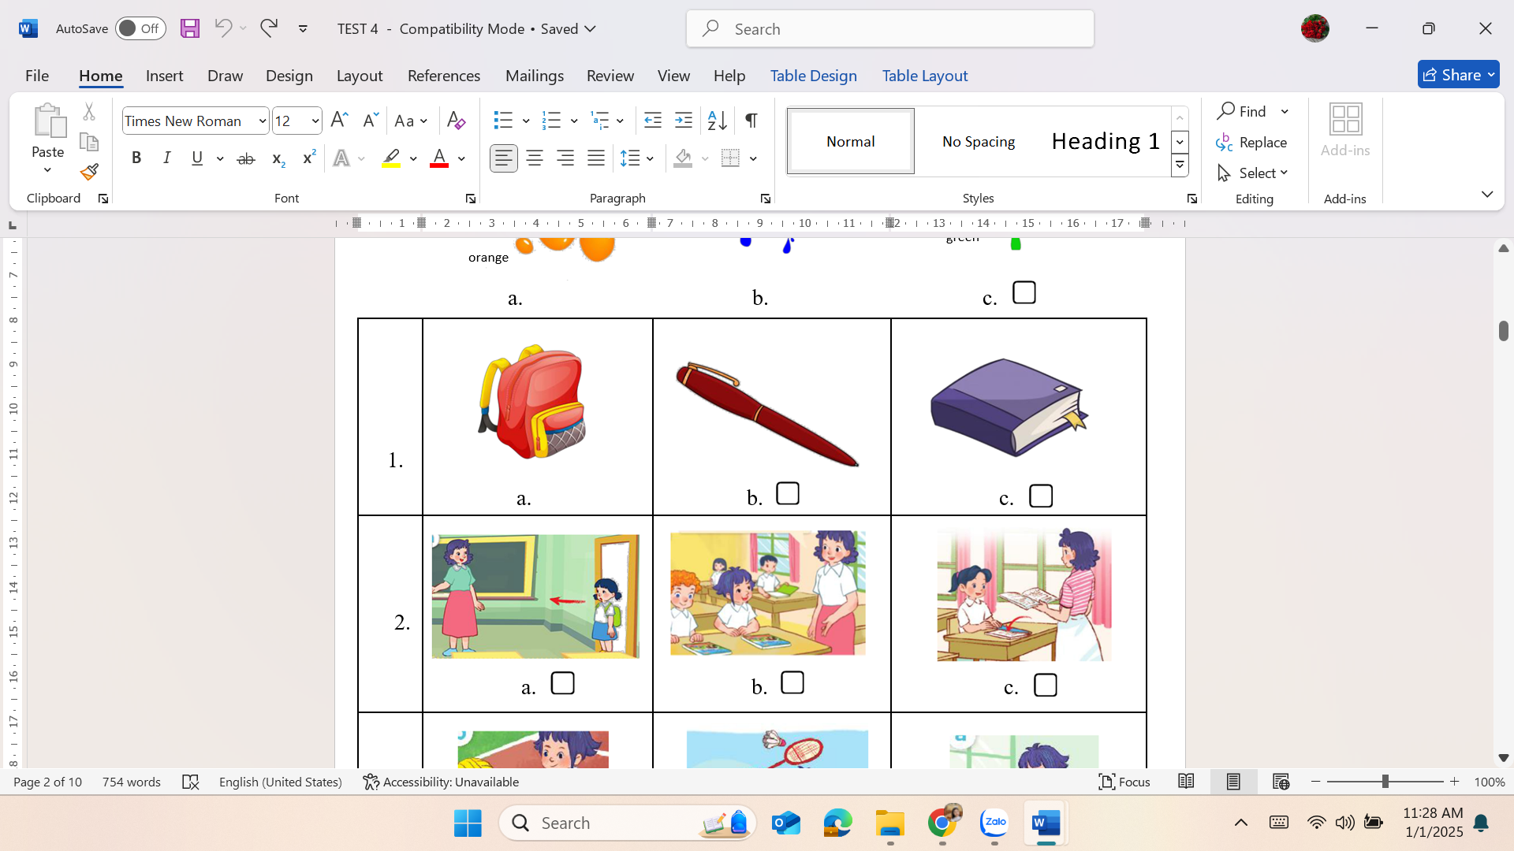
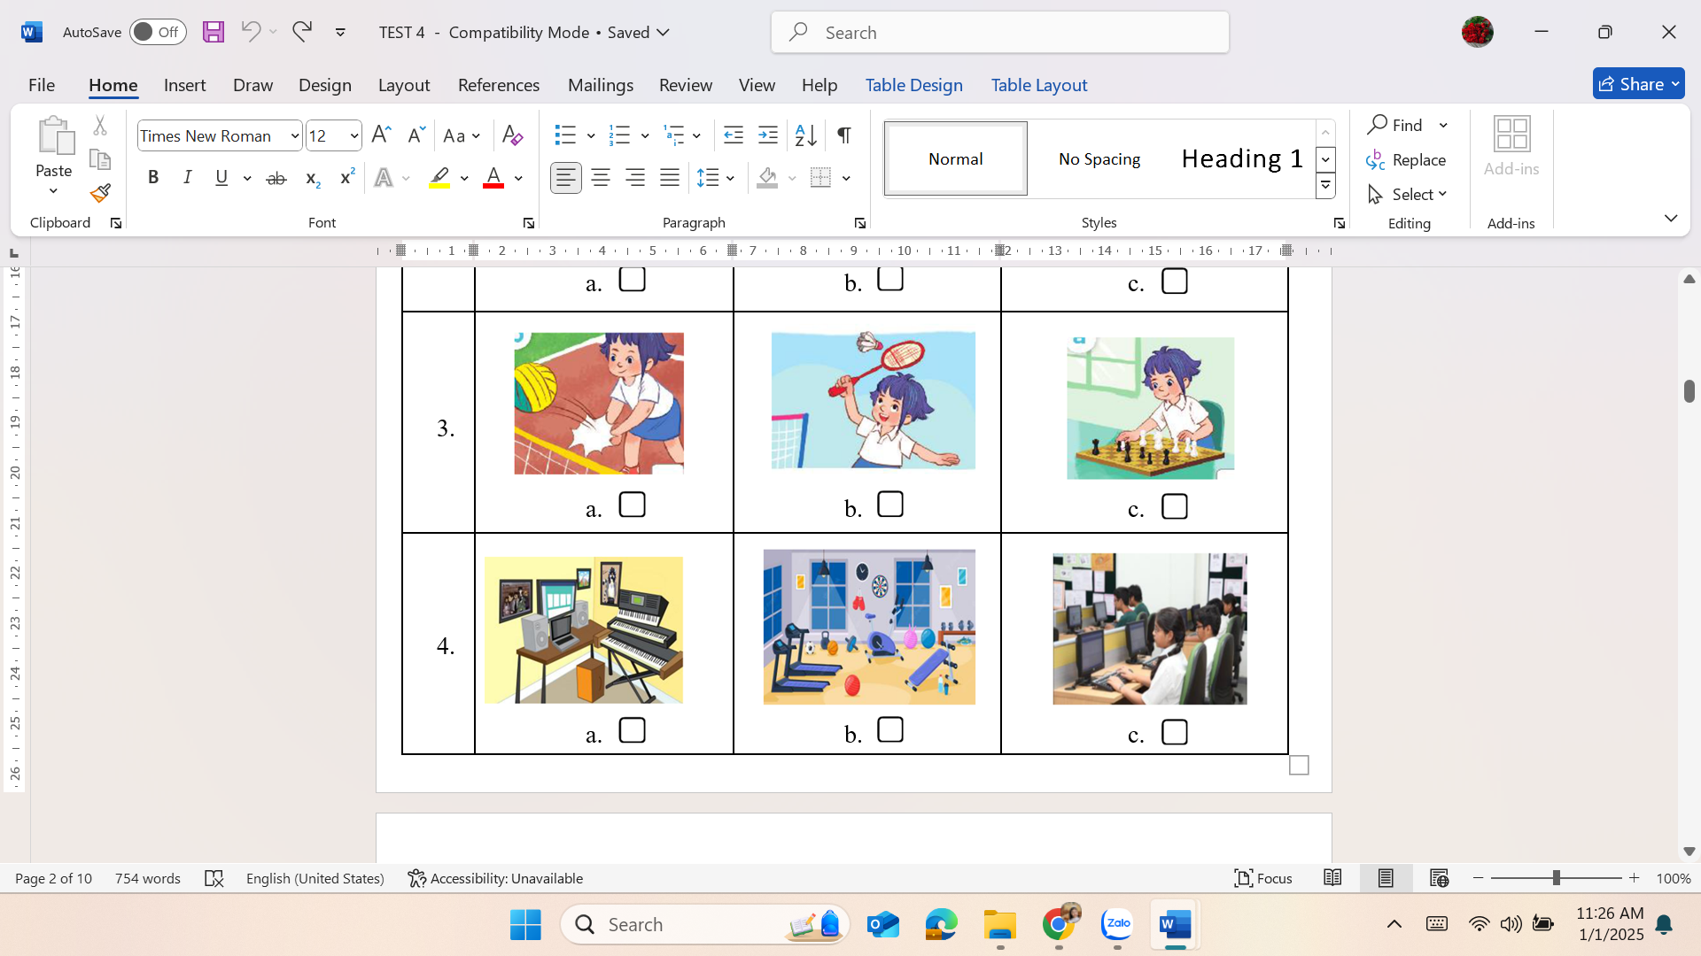

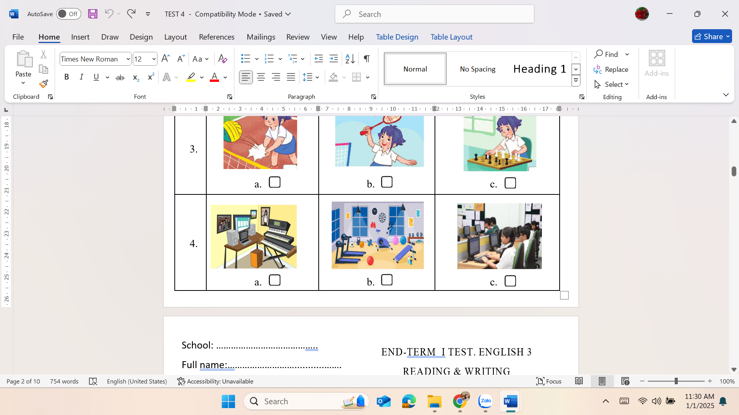
PART 2. READING
Exercise 5: Read and match. There is one example (1pt)
A |  | B
0. The books are …………….. | 0. – d | a. at break time
1. I play badminton …………… | 1. - | b. singing.
2. It isn’t Tom. | 2. - | c. a pen.
3. My hobby is ……………….. | 3. - | d. blue.
4. I have …………………. | 4. - | e. It’s Tony.
Exercise 6: Read and complete. There is one example (1pt)
play | dancing | brown | chat | They
Hi, my name’s Anna. I’m nine years old. This is my school bag. It’s (0) …brown…. This is my ruler. It’s blue. I have three pencils. (1) ………………………….. are yellow. I like swimming and (2) ……………………………….. At break time, I often (3) ……………………... badminton and (4) …………………..….. with my friends. This is my school. It’s very nice.
PART 3. WRITING
Exercise 7: Order the words (1pt)
- room / computer / this / your / Is / ?  ………………………………………………  - your / What / is / colour / pen / ?  ……………………………………………… | - go / to / Let’s / the / playground / .  ………………………………………………  - sit down / May / I /? – you/ can / Yes/.  ………………………………………………
Exercise 8: Answer the question (1pt)
- How old are you? ………………………………………………………………………….
- What is your hobby? ………………………………………………………………………
- What colour are your books? ……………………………………………………………...
- What do you do at break time? ……………………………………………………………
PART 4. SPEAKING
- Greeting. (1.0 pt)
- Talking about familiar objects (1.0 pt)

********** GOOD LUCK TO YOU **********

