Class: 1
Period 41 Unit 8: Hh: Lesson 3

OVERVIEW OF THE LESSON
Name  of the lesson | Unit 8 – Lesson 3
Content  of the lesson | Act 1. Trace the letter.  Act 2. Look and read.
Language focus | - Trace the letter H, sound /h/ and words, write a, an in horse and hippo  - Structure and vocabulary review
Time Allowed | 35 minutes
I. OBJECTIVES
By the end of the lesson, students will be able to:
Knowledge | - Trace the letter, sound and words.  - Structure: Recognize and use the sentence structure to express what they see
Skills | - Writing: trace the letter, the sound and the words  - Reading: Read the sentences about where the animals are.
Attitude | - Be confident to write letter, sound and words in English.  - Be confident use English to talk about where an animal is.
II. TEACHING AIDS
Text books, flash cards,board, chalks, computer, projector or TV,…
III. TEACHING PROCEDURE
Title | Teacher’s activities | Student’s activities
1. Warm up (5’)
Goal | - Create a friendly and exciting atmosphere before the lesson  - Students have positive energy to start the lesson
Content | - Play a warm-up song/ Play a short game  - Group division  - Class rules
Outcome | Students get engaged in the lesson, well behave and stay focused
Implementation | - Greet students.  - Set the rules in class.  - Divide the class into 3-4 groups.  - Ask students some questions to recognize their teams.  - Energize and revise the language learnt by having the class say the chant in Lesson 1. Replace the word hippo with horse in the second time. | - Greet teacher.  - Listen and follow the class rules  - Answer teacher’s questions  - Sing a song or play a game  - Review previous lesson
2. Presentation (10’): Act 1. Trace the letters
Goal | Students get more vocabulary about words begin with letter H and sound /h/
Content | - Write / trace the letter and words  - Drilling
Outcome | - Remember the letter, the sound and the words of letter H  - Get correct pronunciation
Implementation | - Introduce students the capital letter H and the small letter h. Tell them that they are going to know how to write them.  - Have the class look at the screen and watch the tracing of H and h a few times.  - Have students write the letters in the air, on the palm, or their friends’ backs.  - Ask students to open their book and trace letters H, h and the words (horse, hippo) with their index finger or a pencil. Go around to offer help if necessary.  - Check students’ work. | - Watch  - Write  - Trace
3. Practice (10’): Act 2. Look and read.
Goal | - Help students to practice and memorize what they have learnt.
Content | - Look and do the Task 2
Outcome | - Students look and read what they see.
Implementation | - Tell Tell students that they are going to look and read.  - Give students a few seconds to look at the pictures and elicit from them horse, goat, elephant, farm, zoo.  - Give students time to do the task. Let students read the sentence individually  - Get students to check their answers in pairs and take turns read their answers before checking as a class.  - Get the class to take turns to read aloud sentence by sentence  - Play the media and get the class to listen and repeat as a whole class, in groups, and individuals.  Key  a. The horse is in the zoo.  b. The goat is on the farm.  c. The elephant is in the zoo. | Follow teacher’s instructions  Answer the questions.  Look and read  Listen and repeat.
4. Production (8’): Act 3. Activity Book
Goal | - Revise what students have learnt
Content | - Revise words and structures
Outcome | - Do the exercises in activity book.
Implementation | Instruct students to do the exercise in Activity Book  1. Trace the letters.  Students look and trace the letter H, h, using their pencils.  2. Listen, colour and write.  - Teacher helps students elicit hippo, horse. Students listen, colour the picture and write.  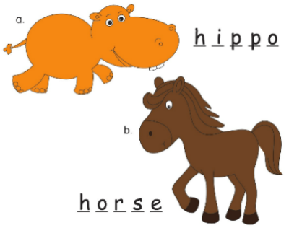 | - Follow teacher’s instructions  - Do the exercises.
Sum-up (2’) | - Review all what they have learned by using flashcards.  - Count the stars.  - Give compliments. | - Look and say  - Count the stars

