GRADE 3 – REVIEW – Name: ……………………………
I – Odd one out.
1. cat rabbit parrot pet
2. fine five nine twelve
3. Where What Do How
4. under next near behind
5. in on of front
6. garden fish tank flower pot table
7. dog mouse goldfish cat
8. truck doll car plane
9. toy ship plane kite
10. like have play yo-yo
11. reading cooking morning listening
12. music sing book floor
13. homework draw watch do
14. skate sing clean piano
15. father brother family mother
16. cycle park skip fly
17. kite bike ball play
18. weather sunny rainy cloudy
19. wind rain sun snowy
20. today afternoon tomorrow tonight
21. skating playing weather flying
22. football happy fine hungry
23. north central town south
24. near far next to from
25. museum south theatre temple
II – Circle a, b or c.
1. I have five . a. rabbit b. goldfish c. dog
2. Do you have parrots? a. any b. some c. a
3. The cats are next to the flower .a. cage b. tank c. pot
4. are the parrots? - They’re in the cage. a. How many b. What c. Where
5. The dog is in of the fish tank. a. next b. on c. front
6. I two parrots and a rabbit. a. has b. have c. am
7. Where is the goldfish?
a. They’re in the cage. b. It’s in the tank c. They’re in the fish tank.
8. I love pets but my brother .a. doesn’t b. don’t c. isn’t
9. toys do you like? – I like dolls .a. How many b. What c. Where
10. The are in the playroom. a. boy b. student c. children
11. How many do you have? a. parrots b. rabbit c. two dogs
12. Mai four goldfish. a. have b. has c. is
13. What toys do you ? - I have a parrot and two cats.
a. have b. like c. play
14. What your children doing? a. do b. is c. are
15. My sister is the floor. a. clean b. cleaning c. drawing
16. Phong is playing . a. piano b. guitar c. the guitar
17. Tony and Linda . a. are cook b. is singing c. are skating
18. Today my family is home. a. at b. in c. on
19. My brother is to music and I am .
a. singing / listening b. listening / singing c. listen / sing
20. What are they ? a. do b. play c. doing
21. the weather like today in Ha Noi?
a. What’s b. What c. What’s is
22. It is today in Nha Trang. a. suny b. windy c. rain
23. It is cloudy Da Nang today. a. in b. at c. near
24. Where is Linda?
a. She’s cooking b. She’s in the park c. She in her room
25. Where’s Sa Pa? - It’s in Viet Nam.
a. north b. central c. south
26. Where’s Can Tho? - It’s in Viet Nam.
a. north b. central c. south
27. Where’s Hue? - It’s in Viet Nam.
a. north b. central c. south
28. Ha Noi is Hai Phong. a. near b. far from
29. Quy Nhon is Ho Chi Minh city. a. near b. far from
30. Da Nang is Can Tho. a. near b. far from
III – Read and write.
A. My name is Phong. Today I am in the park with my friends. We are doing sports and playing games. Some of the boys and I are playing football. Some of the girls are skipping. My friend Mai is cycling. Nam and Quan are flying kites. We are happy in the park.
1. The children are in the
2. Some of the boys are
3. Some of the girls are
4. Mai is
5. Nam and Quan are
B. Hello! My name is Nam. I am nine years old. My family is in Hue. It is in central Viet Nam. Hue is near Da Nang but far from Nha Trang. There are a lot of mountains and trees in my place.
1. Nam’s family is ..............................................................................
2. He is ...............................years old.
.........................................................................................................................
3. Hue is ........................ Viet Nam..
4. Hue is ............................ Nha Trang?
5. There are a lot of …………………and …………………in Nam’s place.
IV – Fill in the blanks.
1. I have a lot of (pets / toy)
2. She has one (dogs / cat) and three (goldfish / parrot)
3. The parrots are in the (cage / fish tank)
4. Where are your ? (rabbit / cats)
5. They’re the table. (next / under)
6. My pets are the garden. (in / on)
7. Do you have goldfish? (any / an)
8. The rabbit is next to the flower . (cage / pot)
9. I have two trucks, one doll and a (planes / kite)
10. Peter and Tom ships. (like / likes)
11. How goldfish do you have? (much / many)
12. Hung has toys in his playroom. (many / a)
13. I have a kite. (new / old)
14. Linda has three dogs. about you? (Where / What)
15. Hoa is in her bedroom. (cooking / reading)
16. Quan is his homework. (reading / doing)
17. are listening to music. (They / She)
18. My mother is cooking in the . (bathroom / kitchen)
19. Mr Pike is a picture. (drawing / singing)
20. Mai is a song. (watching / singing)
21. The boys are in the yard. (skating / watching TV)
22. Nam and Tony are flying . (kite / kites)
23. are skipping. (The girls / The boy)
24. It is in Ha Noi today. (rainy / cloud)
25. What’s the weather today? (like / be like)
26. Ha Long Bay is in Viet Nam. (north / south)
27. is Hue? (Where’s / Where)
28. Quy Nhon city is in Viet Nam. (central / south)
29. Quy Nhon is Da Nang. (near / far from)
30. Ho Chi Minh City is Ha Noi. (near / far from)
V – Find a mistake and correct it. ( Tìm lỗi và sửa)
1. Do you have some cats?
2. I has a lot of pets.
3. The dogs is in front of the house.
4. Where are the rabbit?
5. He’s is in the garden.
6. The rabbits are next in the flower pot.
7. The goldfishes are in the fish tank.
8. What toy do you like?
9. Linda like dolls and kites.
10. Peter and Tony like truck and ships.
11. How many pet do you have?
12. He have two cats and one dog.
13. They has four goldfish.
14. What pets does she likes?
15. What is you doing?
16. Lan is drawing to music.
17. My sister is clean the floor.
18. My mother is cooking in the bedroom.
19. Tony is play the piano.
20. What is the boys doing now?
21. They are flying kite in the park.
22. What’s weather like today?
23. It’s hot and rainy in Ha Noi.
24. It’s wind in Vung Tau today.
25. Ha Noi is in central Viet Nam.
26. Can Tho is at south Viet Nam.
27. Hue is far to Ha Noi.
28. Are Da Nang near Hue?
29.Hue is far from Da Nang.
30. Ho Chi Minh city is near from Hai Phong.
VI - Reorder the words to make sentences.
1. lot / I / have / pets / a / of /.

2. are / cage / The / in / parrots / the / .

3. goldfish / Where / are / the / ?

4. fish tank / cats / are / The / behind / the /.

5. Do / have / trucks / you / any / ?

6. like / you / do / toys / What /?

7. likes / dogs / He / and / parrots /.

8. many / How / have / you / do / goldfish / ?

9. He / five / plane / has / and /a / ships /.

10. in / listening / Hoa / is / music / the / to / room /.

11. mother / My / dinner / cooking / is /.

12. a / picture / is / drawing / He /.

13. skipping / The / yard / the / are / girls / in /.

VII – Read and do the task.
This is Jane. She is ten years old. She has a cat, two dogs, two parrots and three rabbits. They are all in the garden. She also likes toys. She has five dolls and two ships. Her friend Jack has three trucks and four planes. Jane is cleaning the floor in the living room. Jack is playing with his toys in the playroom. She likes singing and drawing. He likes playing the piano. They cycle and fly their kites after school. The weather is sunny today. Jane lives in Ha Noi. Jack lives in Ho Chi Minh City
 | True | False
1. Jane has eight pets.
2. She doesn’t like toys.
3. Jack is Jane’s brother.
4. He like planes and trucks.
5. She is cleaning the floor.
6. He is watching TV.
7. She likes singing.
8. It’s rainy today.
9. Jane lives far from Jack.
10. They skate after school.

B. Answer the questions.
1. Does Jane have any pets?
2. How many parrots does she have?
3. How many toys does Jack have?
4. What is she doing?
5. Where is Jack?
6. Is he singing?
7. Does she like drawing?
8. What’s the weather like today?
9. Is Ha Noi near Ho Chi Minh city?
10. What does he like?
TEST – G3- Name: ……………………..
I. Read and match
1. dining room a. phòng khách
2. kitchen b. phòng tắm
3. garden c. phòng ngủ
4. bathroom d. vườn
5. bedroom e. phòng ăn
6. living room f. phòng bếp
II. Fill in the blanks
1. There ….. my bedroom. A. am B. is C.are
2. - …. there a garden? - Yes, ….. is.
A. Is – there B. Are – this C. Am – these
3. - ………… tables are there? - There are five.
A. How long B. How far C. How many
4. - How many …. do you have? - I have five
A. doll B. kites C. plane
5. - There are four …… A. windows B. window C. door
6 . - ……. are the posters? - They’re on the bed. A. What B. When C. Where
7. - Where …. the cat? - It’s under the table.
A. am B. is C.are
8. - Where are the ……? - They’re in the cage.
A. parrots B. parrot C. rabbit
9. - …… is Ha Long Bay ? - It’s in north Viet Nam
A. What B. When C. Where
10. - Where’s Hue? - It’s in ….. … Viet Nam
A. North B. South C. Central
11. - Where’s Ho Chi Minh city? - It’s in …….. Viet Nam
A. North B. South C. Central
12. - Is Ha Noi …… Hue? - No, it isn’t. It’s …. from Hue.
A. near – far B. far – near C. near – near
13. Is Hai Duong near Ha Noi? A. Yes, it is B. No, it isn’t.
14. - Are there ….. maps in your room? - Yes, there are
A. this B. any C. that
15. - Are there any sofas in your living room? - No, there …..
A. are B. is C. aren’t
16. - ….. you have a robot? - Yes, I ….
A. Does – do B. Do – do C. Do – does
17. - Do you have a doll? - …., I don’t
A. Yes B. No
18. - ….. he have a plane? - No, he ….
A. Do – does B. Does – does C. Does – doesn’t
19. - Do you have …. pets? - Yes, I do.
A. this B. any C. that
20. - Do you have any ….. ? - No, I don’t.
A. parrots B. parrot C. cat
21. - What toys do you like ? - I like ….
A. cat B. goldfish C. truck
22. - What ….. do you like? - I like rabbit
A. pets B.toys
23. - …. are you doing? - I’m reading
A. What B. When C. Where
24. - What is she doing? - She is ….
A. cook B. cooking C. cooks
25. - What …. you doing?
- ….. am cleaning the floor
A. am - you B. is - she C.are - I
26. - What are they doing? - …….. are flying kites?A. He B. They C. You
27. - What is the …… like ? - It’s sunny. A. weather B. weathers C. sun
28. - What’s the weather like? - It’s …… A. rain B. raining c. rainy
3. Fill preposition “on, near, under, behind” in the blank
1………  2………  3………  4………  5……… | 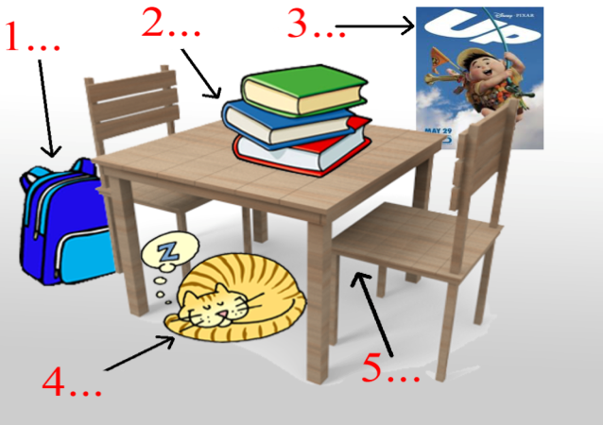
4. Look and write
 |  |  | 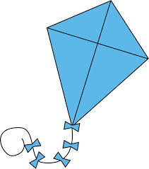
 | 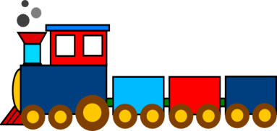 |  | 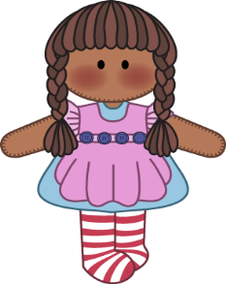
a. robot b. kite c. doll d.puzzle e. plane
f. ship g. train h. yo-yo
5. Read and match
1. cleaning the floor a. hát
2. cooking b. chơi đàn piano
3. reading c. xem ti vi
4. listening to music d. nấu ăn
5. drawing e. lau nhà
6. playing the piano f. đọc sách
7. singing g. vẽ
8. watching TV h. nghe nhạc
7. Look and answer the question “What are they doing?’
1. They’re ….. |  | 3. They’re….. | 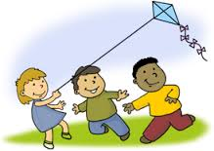
2. They’re…... |  | 4. They’re….. | 

8. Read and answer the question “ What’s the weather like?”
1. It’s …. |  |  | 4. It’s ….. | 
2. It’s …. |  | 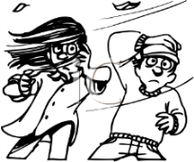 | 5. It’s ….. | 
3. It’s …. |  | 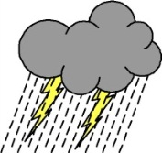 | 6. It’s ….. | 

Question 5. Look and read. Put a tick ( ) or cross (X) in the box. . (1 point)

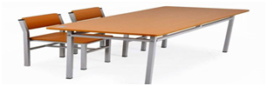 | 1. There are two chairs behind the desk.
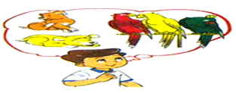 | 2. Nam has one dog and three parrots.
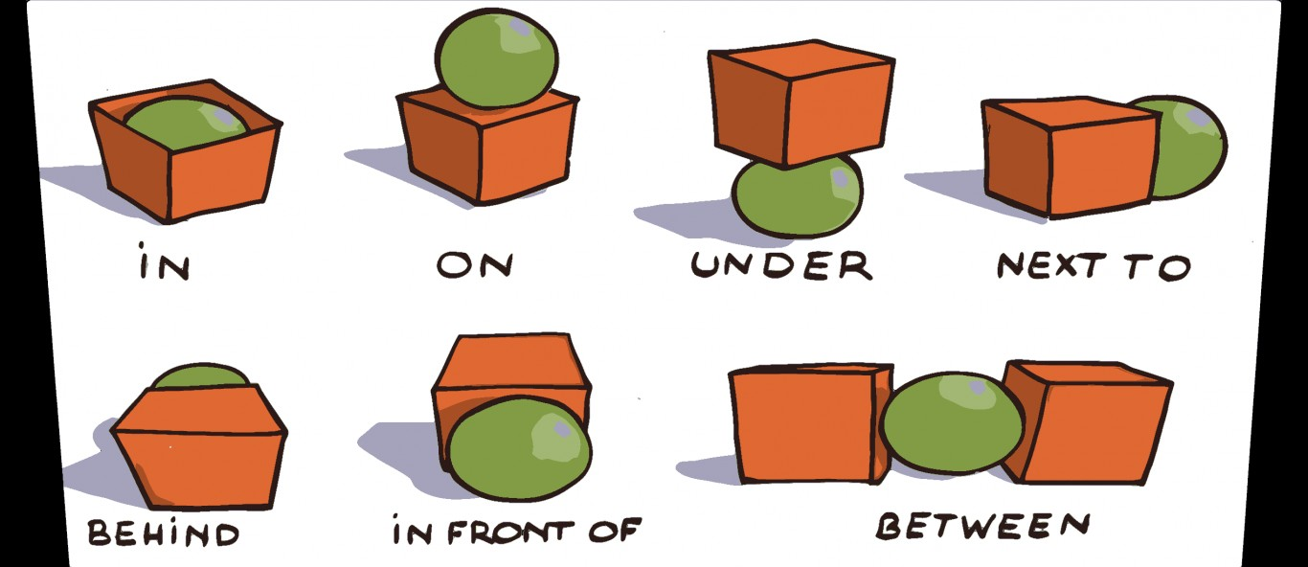  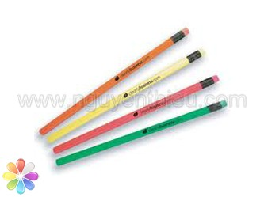 | 3.There is a ball under the box  4. How many pencils do you have ?_ I have three.
Question 6: Select and circle A, B or C: . (1 point)
1. What are they doing? – They are _____ with paper boat.
A. doing B. making C. playing
2. Has she got any pets? – No, she_____.
A. has B. hasn’t C. haven’t
3. What’s Mai doing? – She’s ______.
A. play cycling B. cycling C. cycles
4. What is the ---------- like today?
A. activity B. colour C. weather

skating playing weather flying park
The (0) weather is fine today. It’s sunny and windy. We are in the (1)……….. …… Mai and Linda are (2)………………….. kites. Nam, Phong and Tony are (3)……………. football. Peter and Quan are(4)………………… We are happy in the park.
Question 7: Look at the pictures and circle the right word. (1pt).
1/ There is a …………in the room.  a. table b. desk c. chair | 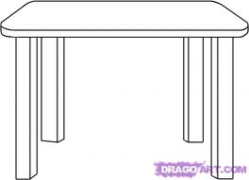
2/ She is ………………  a. playing football b. flying kites  c. playing badminton | 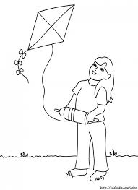
3/ It is ………….. today.  a. windy b. cloudy c. sunny | 
4/ This is the ………………in my house.
- living room b. dining room

c. bedroom

Question 8: Read and write. (1pt)
My name’s Mai. I have a lot of pets. This is my cat. It is on the bed. And that is my dog. It is under the table. I also have two parrots and a rabbit. They are all in the garden.
- Mai has a lot of…………..
- She has a…………….. It is on the bed.
- She has a dog. It is ………………..the table.
- She has two parrots and a rabbit. They are in the………………
Question 9: Read the words and match the pictures. (1pt)
1/ ball | a. 
2/ truck | b. 
3/ goldfish | c. 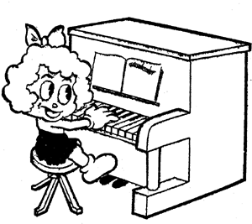
4/ picture | d. 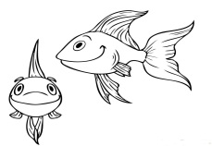
5/ play the piano | e. 