Full name: ...............................................  Class: ...................................................... | END - TERM TEST ( SEMESTER 2) – GRADE 4  Time: 35 minutes
I. Listen and number. (2 points)
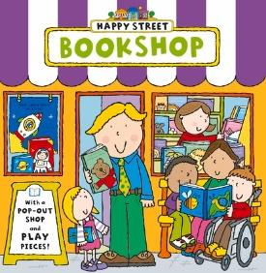 |  |  | 
- ⬜ | - ⬜ | - ⬜ | - ⬜
II. Listen and draw lines. (1 point)
1. 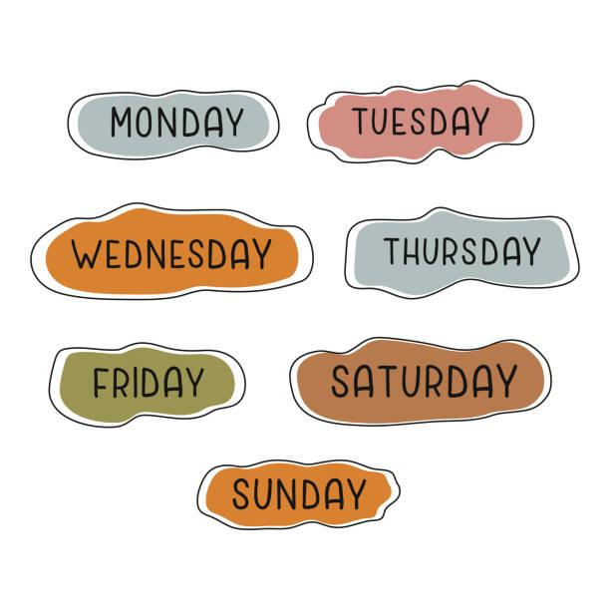 | a. 
2. | b. 
3. | c. 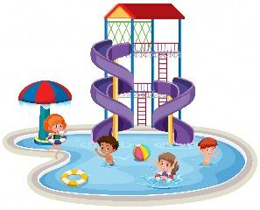
4. | d. 
III. Listen and complete. (1 point)
1. What does it say? – It says ‘____________’.
2. What is Ben doing? – He’s ________________.
3. How much is the _____________? – It’s 200,000 dong.
4. What was the weather like last weekend? – It was ____________.
IV. Read and choose A, B or C. (1 point)
1. |  | Do you want to go to the gift shop?  A. Yes, I can’t.  B. Sorry, I can’t.  C. Great, I can’t.
2. | 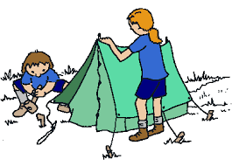 | What are they doing?  A. They’re building a campfire.  B. They’re dancing around a campfire.  C. They’re putting up a tent.
3. |  | What are these animals?  A. They’re crocodiles.  B. They’re birds.  C. It is a crocodile.
4. |  | What was the weather like last Sunday?  A. It says sunny.  B. It is sunny.  C. It was sunny.
V. Write suitable questions for the answers given. (1,5 points)
1. |  | - _______________________________?  - It was cloudy and rainy yesterday.
2. |  | - ___________________________________?  - It’s 70,000 dong.
3. |  | - ________________________________?  - Because they roar loudly.
VI. Read and write T (True) or F (False). (1,5 points)
Tim and his family are on a camping trip. The weather is sunny and windy. They camp near a lake. They put up a big tent. Tim helps to clean up. There is chicken and corn for lunch. When it gets dark, they start to build a campfire. They tell stories and dance around the campfire.
1. Tim and his family are on a camping trip. ___________
2. The weather is sunny and cloudy. ___________
3. They build a campfire and sing loudly. ___________
VII. Fill in the blanks. (1 point)
Today is my sister’s birthday. I go to a (1) _____________ to buy her a present. It’s next to the (2)  ___________. I choose a pink (3) ____________ for her. It looks beautiful. Then I go to the (4) 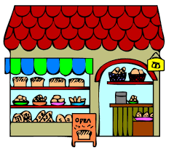_______ to buy a birthday cake. When I give her the present, she is very happy. She smiles and says “Thank you!”.
VIII. Write suitable answers to the questions using given words. (1 point)
taking a photo | turn right | sunny | great
1. Do you want to go to the water park?
⭢ ____________________________________________________
2. What is Lucy doing?
⭢ _____________________________________________________
3. What does it say?
⭢ ______________________________________________________
4. What was the weather like last Saturday?
⭢ ______________________________________________________
The end

