Full name: ...............................................  Class: ...................................................... | END - TERM TEST ( SEMESTER 2) – GRADE 5  Time: 40 minutes
I. LISTENING
Task 1. Listen and match. There is one example (0).

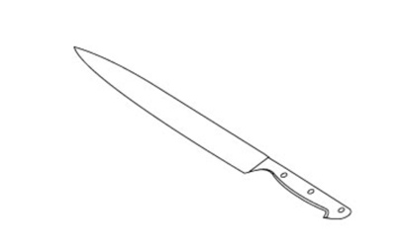  A. |  | 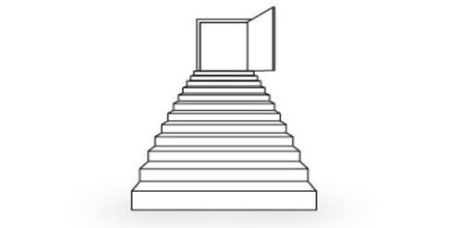  D.
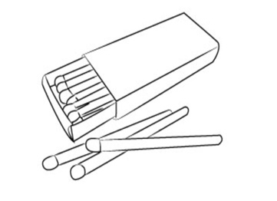  B. |  | 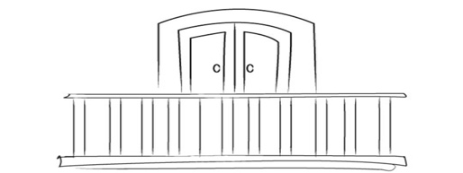  E.
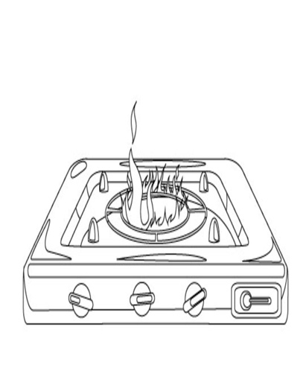  C. |  | 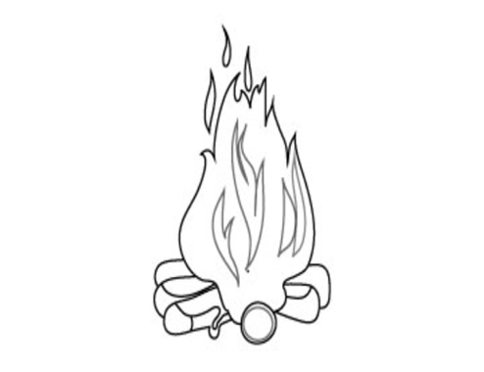  F.

Task 2. Listen and tick  A, B or C. There is one example.

Example: | A. It’s in Ninh Binh Province.
 | B.  It’s very big.
 | C. It’s not very far.

1. A. Yes, I’d like it.
B. Yes, I like it.
C. Yes, I’d like to.
2. A. West Lake
B. Thong Nhat Stadium
C. Tran Quoc Pagoda
3. A. I visited Huong Pagoda.
B. I am going to visit Huong Pagoda.
C. I’d like to visit Huong Pagoda.
4. A. It’s in Quang Ninh Province.
B. It’s more beautiful than I expected.
C. It’s a bay.
5. A. It’s in Ha Long Bay.
B. It’s quite small.
C. It’s in the centre of Ha Noi.
Task 3. Listen and tick the correct pictures. There is one example.
Example:
What does she do in her free time?
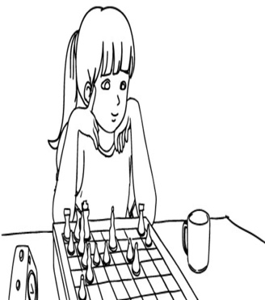 | 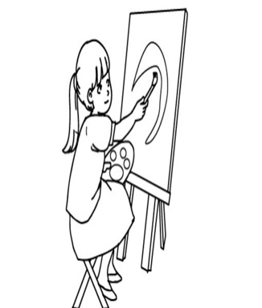 | 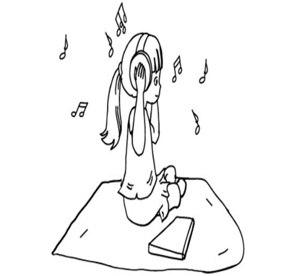
A. | B. | C.
1. What does he do in his free time?
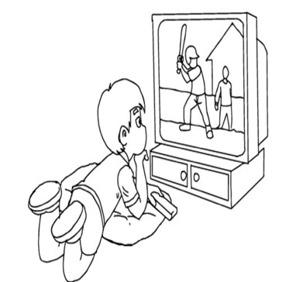  A. | 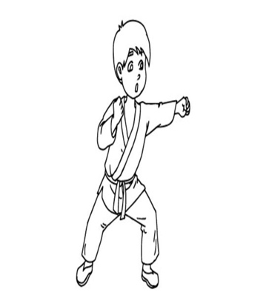  B. | 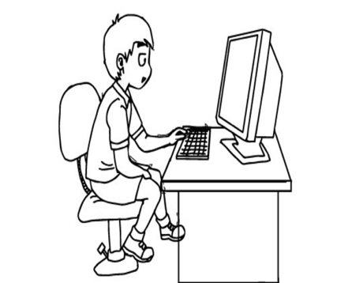  C.

2. What does his father often do in his free time?

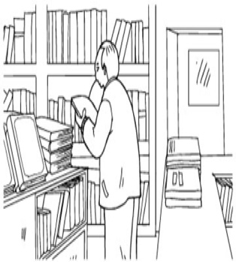  A. | 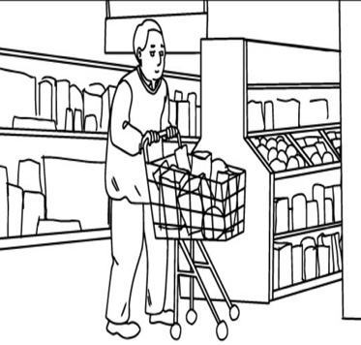  B. | 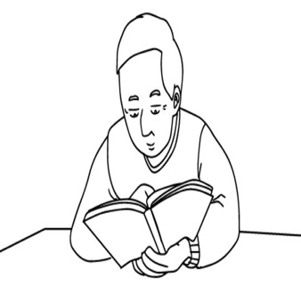  C.

3. What do they often do at the English club?

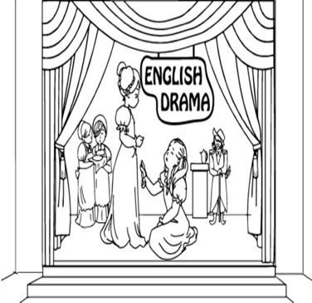  A. | 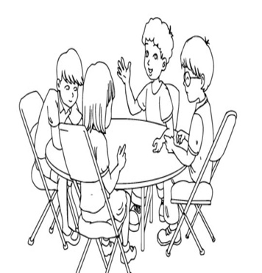  B. | 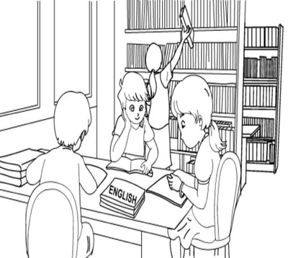  C.

4. What does Lan do in her free time?

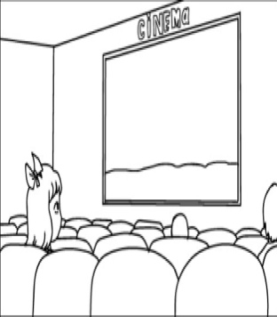  A. | 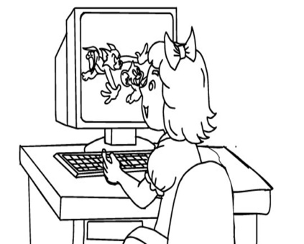  B. | 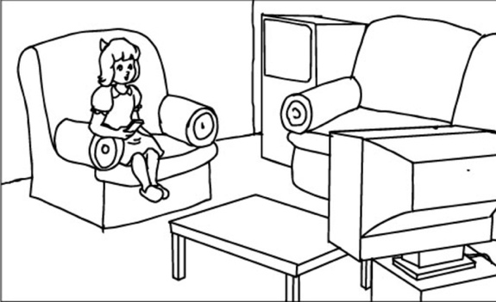  C.

5. What’s his favourite programme?

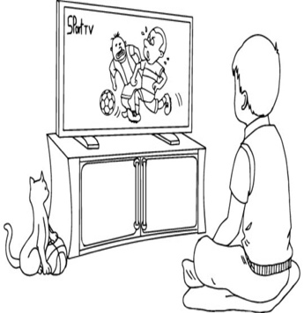  A. | 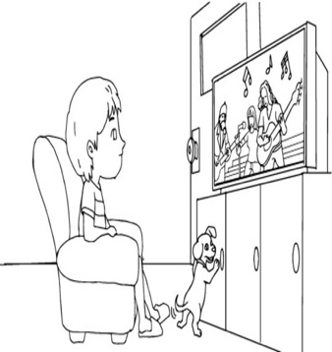  B. | 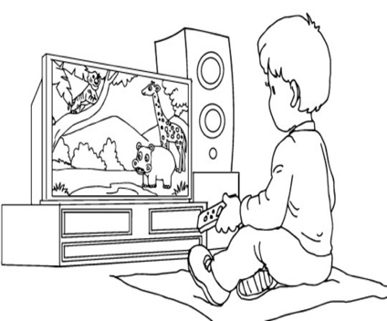  C.

Task 4. Listen and write T for True or F for False. There is one example (0).

0. Tom visited Thien Mu Pagoda last year. | ____F___
1. The pagoda is on a hill. | _________
2. It is near Huong River but far from the city centre. | _________
3. The pagoda is more beautiful than Tom expected. | _________
4. The tower is in the yard of the pagoda. | _________
5. Tom met his friends after the visit. | _________
II. READING
Task 1. Look and write the correct words. There is one example.

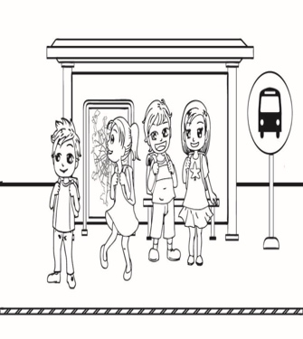 |  | 
bus stop | museum | theatre
 |  | 
post office | pharmacy | library

Example: We wait for the bus at this place. | bus stop
1. We send postcards and letters at this place. | __________
2. We see plays and operas at this place. | __________
3. We see different ancient things at this place. | __________
4. We buy medicine at this place. | __________
5. It’s a quiet place for people to read books. | __________
Task 2. Read and tick True or False. There is one example (0).
To stay fit and healthy, you shouldn’t eat too many fatty foods such as fried potatoes, fried meat and sausages. It is not good for you to eat too much butter and chocolate. You need to eat some fish, chicken or eggs for meals. Fruits and vegetables are important foods. They give you vitamins and minerals. Every day, you should have fruit juice for breakfast, eat a lot of vegetables at meal times. You also need to drink a lot of milk and water.
 | True | False
0. To keep good health, you can eat a lot of fatty foods such as fried potatoes, meat and sausages.
1. Eating too much butter and chocholate is not good for you.
2. You shouldn’t have some fish, chicken or eggs for your meals.
3. Fruits and vegetables give you vitamins and minerals.
4. You need to have some fruits for breakfast and eat some vegetables for meals.
5. You need to drink a lot of milk and water every day.
Task 3. Read and number the sentences in the correct order. The conversation begins with 0.
 | A | Mai: Which place would you like to visit, Thao Cam Vien or Ben Thanh Market?
 | B | Mai: You can walk there for twenty minutes. It’s not far from here.
 | C | Tony: I’d like to visit Thao Cam Vien. How can I get there?
0. | D | Mai: Where are you going this Sunday, Tony?
 | E | Tony: Really? Thank you, Mai.
 | F | Tony: I’m going to the city centre.
Task 4. Read and fill each gap with one word from the box. Write the word next to the number. There is one word that you do not need. There is one example (0).

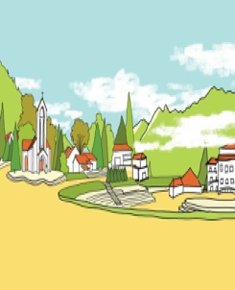 | 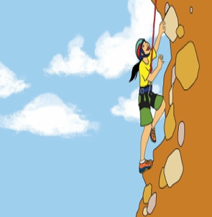 |  | 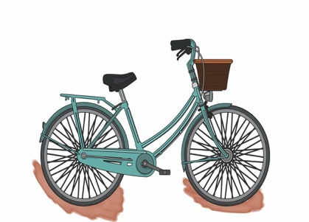
town | climb | mountains | bicycle
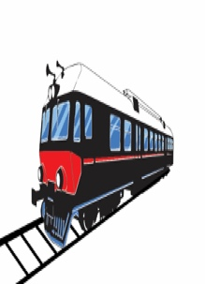 |  | 
train | cool | snows

Sa Pa is a (0) town in the North of Viet Nam. People often go to Sa Pa by coach or by (1) ___________to Lao Cai and change to bus or car after that. It is a good place for a summer holiday because it has beautiful views of (2) ___________, and the weather is very (3) ___________. In winter, it can be very cold, and sometimes it (4) __________. Many tourists love going to Sapa in winter because they want to (5) ___________ the mountains.
III. WRITING
Task 1. Look at the pictures and the example. Read the story and write the word(s) for each gap. There is one example (0).

0.   | 1.   | 2.  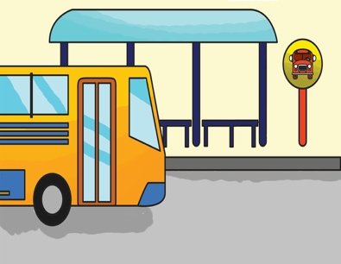
3.   | 4.  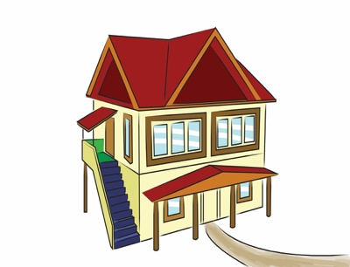 | 5.  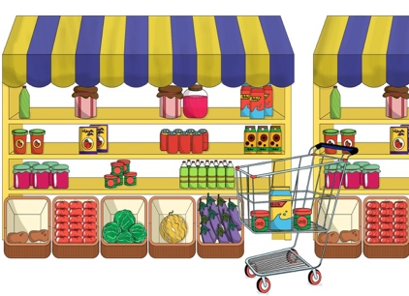

Dear Mai,
Tomorrow is Sunday. It will be (0) sunny. I’m happy because you’re going to visit us. You can take (1) _________ number 15 at South Street and get off at the third (2) _________. Then walk along West Street until you see North Street. Turn right and you will see the (3) _________ on the left. Our (4) two-storey ________ is between the post office and the (5) ________.
See you soon,
Jack
Task 2. Order the words. There is one example.

Example: be / it / dry / hot / and / will
It will be hot and dry.
1. like / the / will / weather / what / be / tomorrow
______________________________________________________________?
2. in / the / there / North / many / are / seasons / how
___________________________________________________________?
3. it / I / is / winter / like / because / cold
____________________________________________________________.
4. autumn / like / in / what / your / is / country
___________________________________________________________?
5. often / is / hot / dry / in / it / season / the
___________________________________________________________.
Task 3. Write a short letter to your friend and show her the way to get to you house. There is one example (0).

You can write about:
0. How do you feel when you know your friend is going to visit you?
1. What’s your address?
2. How long does it take to get to your house?
3. What means of transport can your friend take to get to your house?
4. From the post office, how can your friend get to your house?
5. Does your friend call you when she/he is near your house?
To: Anne Brown
215 Green Street, London
England

Dear Anne,
I’m very (0) happy you’re going to visit me in Viet Nam.
My address is (1) _______________________________________.
It takes about (2) _________________________ by bus or by (3) ________ to the city’s post office. From there you can (4) ___________________________.
Please (5) _________________________ when you are near my house.
See you soon.
Love,
Minh
The End

Key to The Test
I. LISTENING
Task 1. Listen and match. There is one example (0).
Key: 1. B 2. A 3. D 4. C 5. F
Hello. This is Tieng Anh 5. Unit 12. Listening Test.
Task 1. Listen and match. There is one example.
(G): Look. There’s a balcony.
(G): Look. There’s a balcony.
The answer is picture E. This is an example.
Now you listen and match.
1. (G) Look. There are matches.
2. (G) Look. There’s a knife.
3. (G) Look. There are stairs.
4. (G) Look. There’s a stove.
5. (G) Look. There’s a fire.
Now listen again.
That is the end of Task 1.

Task 2. Listen and tick A, B or C. There is one example.
Key: 1. C 2. A 3. A 4. B 5. C
Task 2. Listen and tick A, B or C. There is one example.
(B): Where is Bai Dinh Pagoda?
(B): Where is Bai Dinh Pagoda?
The answer is A. Can you see the tick? This is an example. Now you listen and tick.
1. (G): Woud you like to go somewhere?
2. (B): Which place would you like to visit, Thong Nhat Park or West Lake?
3. (G): What did you do last weekend?
4. (B): What do you think of Ha Long Bay?
5. (G): Where’s Ngoc Son Temple?
Now listen again.
That is the end of Task 2.
Task 3. Listen and tick the correct pictures. There is one example.
Key: 1. A 2. C 3. B 4. C 5. A
Task 3. Listen and tick the correct pictures. There is one example.
(B): What do you do in your free time?
(G): I listen to music.
(B): What do you do in your free time?
(G): I listen to music.
The answer is picture C. Can you see the tick? This is an example. Now you listen and tick.
1. (G): What do you do in your free time, Bin?
(B): I often watch TV sports programmes.
2. (G): What does your father often do in his free time?
(B): He reads books.
3. (B): What do you often do at the English club?
(G): We talk to each other in English.
4. (B): Do you like going to the cinema?
(G): No, I don’t. I often watch films on TV.
5. (G): What TV programme do you like?
(B): Sports.
Now listen again.
That is the end of Task 3.

Task 4. Listen and write R for Right or W for Wrong. There is one example (0).
Key: 1.R 2.W 3.R 4.W 5.W
Task 4. Listen and write R for Right or W for Wrong. There is one example.
(B): My name’s Tom. Yesterday, I visited Thien Mu Pagoda.
(B): My name’s Tom. Yesterday, I visited Thien Mu Pagoda.
(W): Look at the example. The sentence is wrong. Can you see letter W?
Now you listen and write.

(G): My name’s Tom. Yesterday, I visited Thien Mu Pagoda. It is on a hill near the Huong River and not far from the centre of Hue City. I went there by boat. Thien Mu Pagoda is always quiet. It is more attractive than I expected. There is a beautiful tower at the gate. There are flowers and trees in the yard. I met some friends there. My friends and I learnt more about the history of Hue City during the visit.

Now listen again.
That is the end of Task 4.
II. READING
Task 1. Look and write the correct words. There is one example.
Key: 1. post office 2. theatre 3. museum 4. pharmacy 5. library
Task 2. Read and tick True or False. There is one example (0).
Key: 1. True 2. False 3. True 4. False 5. True
Task 3. Read and number the sentences in the correct order. The conversation begins with 0.
Key: 1. F 2. A 3. C 4. B 5. E
Task 4. Read and fill each gap with one word from the box. Write the word next to the number. There is one word that you do not need. There is one example (0).
Key: 1. train 2. mountains 3. cool 4. snows 5. climb
III. WRITING
Task 1. Look at the pictures and the example. Read the story and write the word(s) for each gap. There is one example (0).
Key: 1. bus 2. bus stop 3. post office 4. house 5. supermarket
Task 2. Order the words. There is one example.
Key:
1. What will the weather be like tomorrow?
2. How many seasons are there in the North?
3. I like winter because it is cold.
4. What is autumn like in your country?
5. It is often hot in the dry season.
Task 3. Write a short letter to your friend and show her the way to get to you house. There is one example (0).
Student’s answers vary with correct grammar.
Giới thiệuHướng dẫn

