Week: 28 | D.P: March 24th, 2026
Period: 110 | D.T: March 25th, 2026

UNIT 16: SEASONS AND THE WEATHER
LESSON 3 : ACTIVITY 1-3
I. OBJECTIVES
By the end of this lesson, pupils will be able to:
1. Knowledge and skills
- Correctly repeat two sentences with falling intonation;
- Listen and correctly repeat four sentences paying attention to the word stress and falling intonation;
- Say the chant with the correct pronunciation, rhythm and intonation.
2. Competences
- Communication and collaboration: work in pairs and teams to complete the learning tasks.
- Self-control & independent learning: perform pronunciation and listening tasks.
3. Attributes
- Show their love and interest in the weather and seasons.
- Express their feelings about the weather of each season.
- Show their knowledge of choosing suitable clothes in different seasons.
II. MATERIALS
- Pupil’s book: Page 44
- Audio tracks 59, 60, 61
- Teacher’s guide: Pages 232, 233
- Website hoclieu.vn
- Flash cards/ pictures and posters (Unit 16)
- Lap - top, smart T.V.
III. PROCEDURES
* GREETINGS + SIT- DOWN TICKETS ( 2’-3’) : Show the pictures of the cards from unit 16 for each student to make read the words and sentences again. (autumn, spring, summer, winter, cold, cool, hot, warm, blouse, jeans, jumper, trousers, How’s the weather in Haiphong today? It’s….; What do you usually wear in…? I wear…)
* TEAM’S DIVIDION: 3 kinds of fruits as teams’s names.

Teacher’s activities | Students’ activities
1.Warm- up and review: (5’- 6’)  Game: Board Race (Listen & write)  * Show a video about the game’s rules+ Vietsub    *Aims: to create a friendly and active atmosphere in the class to beginning the lesson and lead in the new lesson through the posible answers.  *Procedure:  - Divide the class into three teams/ groups.  -Tell Ss they are going to play the game.  - Ask Ss to:  + line up in 3 rows.  + The last person of the row looks and whispers  + The first person of the row writes the words on the board  + The game ends when the music stops  + The team that writes the most correct words and the most words requested by the teacher wins  - Asks Ss to read again all the words  - Make some sentences with the possible answers.  2.Practice:  Activity 1. Listen and repeat (5’-6’)  *Aims: To correctly repeat two sentences with falling intonation.  1. It’s cloudy in autumn.  2. I wear jackets in winter.  *Procedure:  Step 1: Have pupils point at Sentence 1 and play the recording for them to listen and repeat in chorus and individually until they feel confident. Correct their pronunciation, stress, rhythm and intonation where necessary (by TPR). Repeat the same procedure with Sentence 2.  Step 2: Let pupils work in pairs or groups to practise saying the sentences.  Step 3: Invite a few pupils to listen to and repeat the sentences. Praise them when they have good pronunciation, stress, rhythm and intonation.  Extension: Ask pupils to use other words to replace the noun autumn and jeans in the sentences, practise reading the new sentences aloud, and pay attention to the correct word stress and falling intonation.  Mini game: Show an AI video for students to look at and read the sentences on the screen with falling intonation:  It’s hot in summer  I wear shorts in summer.  It’s cold in winter.  I wear jackets in winter.  3.Production:  Activity 2. Listen and repeat. Pay attention to the intonation (5’-6’)  *Aims: Ss will be able to listen and say four sentences with falling intonation.  *Procedure:  Step 1: Tell pupils the goal of the activity. Explain that they have to listen to the recording and repeat, paying attention to the word stress and falling intonation. Check comprehension.  Step 2: Play the recording, once or twice, for pupils to listen and repeat until they feel confident enough to say these sentences by themselves.  Step 4: Invite a few pupils to say aloud these sentences. Correct their pronunciation and word stress where necessary.  Game: Miming Game  - Divide the class into 3 teams.  - T Mimes one of the sentences of Part 2  - The first pupil to say the correct sentence wins a point for their team.  Keys:    Activity 3. Let’s chant (7’-8’)  *Aims: Ss will be able to say the chant with the correct pronunciation, rhythm and intonation  *Procedure:  Step 1: Have pupils look at the pictures and identify the seasons and the outfits that the children are wearing.  Step 2: Have pupils read the first verse of the chant. Check comprehension.  Step 3: Play the recording of the first verse for pupils to follow in their books. Play the recording again, line by line, for pupils to listen and repeat. Draw their attention to the pronunciation, word stress, rhythm, and intonation. Encourage them to clap and do actions while chanting.  Step 4: Repeat Steps 2 and 3 for the second verse of the chant.  Step 5: Play the recording all the way through for pupils to chant along and clap their hands in rhythm.  4. Fun corner and Wrap- up (5’-6’)  - Have Ss have fun corner with the activity of  Mini Fashion show: The magic suitcase  -T: Models the role of the MC “Oh, look at the sky here! It’s cold, cloudy and snowy.  - T: Gives the rule “1 Student go to the board, look at the screen and choose 1 or 2 suitable things to wear, when class says “Freeze”, you have to finish choosing and answer the question. If you’re right, you get points to your teams”  - The whole class says:  T: One, Two, three  Ss: One two three  T: What’s in the suitcase?  Ss: What’s the the suitcase?  Ss + T: Open it! Open it! One, two , Freeze!  Ss: Freeze  Ss: What do you wear? What do you wear?  S: I wear a jacket  Ss: in winter?  S: Yes, I wear a jacket in winter.  T:Does the same with : I wear…..in summer/ spring.  T: Plays the music for the student who choose the suitable outfits to catwalk and their groups say  “We wear …….in…..”)  - Summarize the scores for the activities, congratulate on the winners that get prizes.  - Watch an AI video and draw the lesson in life:  Sing the song of “Rain rain go away”(If the time is allowed) , say “ Good bye!”  - End the lesson with the sentence “ Let’s stay healthy by wearing the suitable outfits for each season!” OK? | -Watch the video, listen to the rules in English while reading the Vietsub on the screen and understand the rules  - Ss listen and answer teacher’s questions.  - Ss play the game  Possible answers:  Group 1: wear, spring, summer, autumn, winter  Group 2:cloudy, cold, hot, humid, good  Group 3: jeans, jackets, scarves, hat, outfits  -Reading while checking the corect answers  - Make some sentences with the possible answers.  -Pupils point at Sentence 1 and listen to the recording and repeat in chorus and individually. Pupils follow the teacher’s instructions with Sentence 2.  - Pupils work in pairs or teams to practise saying the sentences.  - A few pupils listen to and repeat the sentences.  - Pupils use other words to replace the noun autumn and jeans in the sentences, practise reading the new sentences aloud.  - Ss read the questions carefully. Ss read Question 1 and look at keywords and scan the text for relevant information.  - Ss watch the AI video and read the sentences on the screen with falling intonation:  - Ss do the task independently.  - Pupils listen to the teacher’s explanation, watch the video and say.  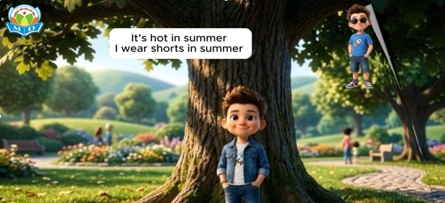  - Pupils listen to the recording, once or twice, and repeat.  - A few pupils say these sentences aloud.  Four sentences  Audio script:  1. It’s humid in spring.  2. Dresses are perfect for today.  3. I wear trousers in summer.  4. Jackets are good for winter.  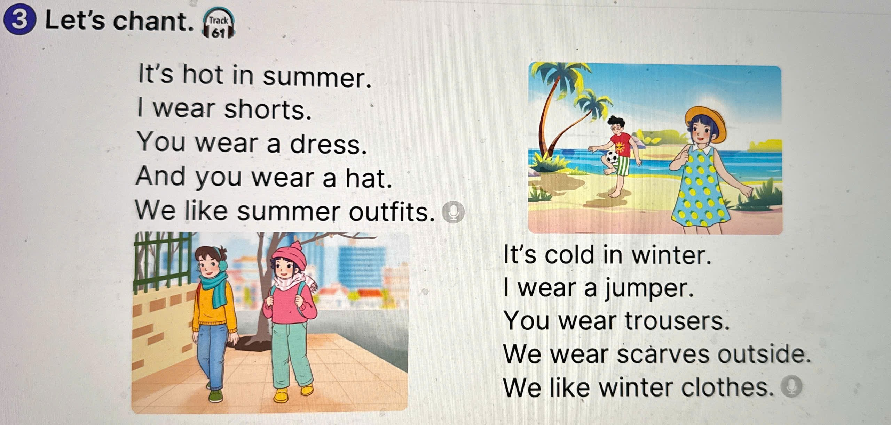  - Pupils look at the pictures and identify the seasons and the outfits that the children are wearing.  - Pupils read the first verse of the chant.  - Pupils listen to the recording of the first verse to follow in their books. Pupils listen to the recording again, line by line, and repeat. Pupils clap and do actions while chanting.  - Pupils follow the teacher’s instructions with the second verse of the chant.  - Pupils listen to the recording all the way through to chant along and clap their hands in rhythm.  : One, Two, three  Ss: One two three  T: What’s in the suitcase?  Ss: What’s the the suitcase?  Ss + T: Open it! Open it! One, two , Freeze!  Ss: Freeze  Ss: What do you wear? What do you wear?  S: I wear a jacket  Ss: in winter?  S: Yes, I wear a jacket in winter.  Ss: Yeah! ( show Like- icon)  T:Does the same with : I wear…..in summer/ spring.  T: Plays the music for the student who choose the suitable outfits to catwalk and their groups say  “We wear …….in…..”)    - Congratulate on the winning teams.  - Ss listen and answer Teacher’s questions.  - Sing the song of “ Rain rain go away”, think about the lesson in life from the lesson and say “ Stay heathy and strong!” + “ Good bye ” to the teachers.  -Ss listen to the teacher

The end

Teacher: Thu Thuy Nguyen + Students: Class 5B – My Duc 1 Primary School

