UBND ĐẶC KHU CÁT HẢI  TRƯỜNG TH NGUYỄN VĂN TRỖI |  |  | ĐỀ KIỂM TRA CUỐI KÌ I  Năm học: 2025 - 2026  Môn: Tiếng Anh 3 Thời gian: 35 phút
 | Listening, reading and writing | Speaking | Total | Giám khảo | Số phách
Mark
Comments

I.LISTENING
Task 1. Listen and tick  (1 point).
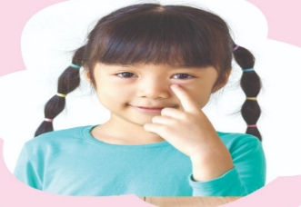  1.  a. | 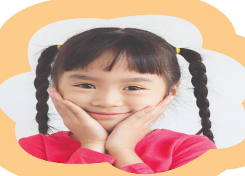  b. | 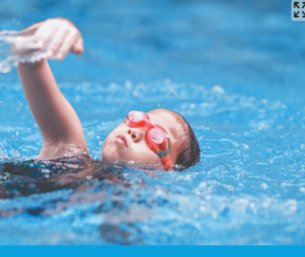  2.  a. | 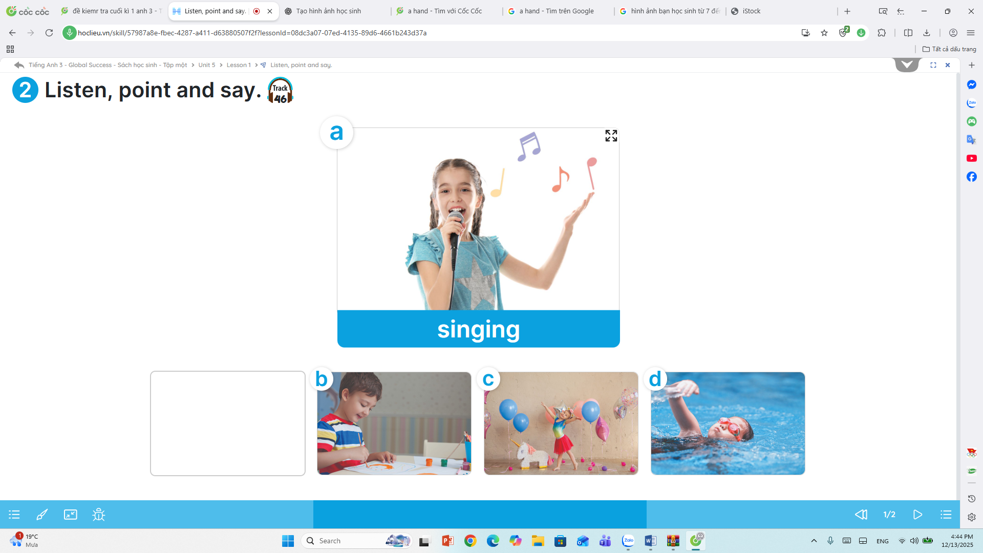  b.
  3.  a. |   b. | 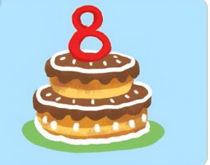  4.  a. | 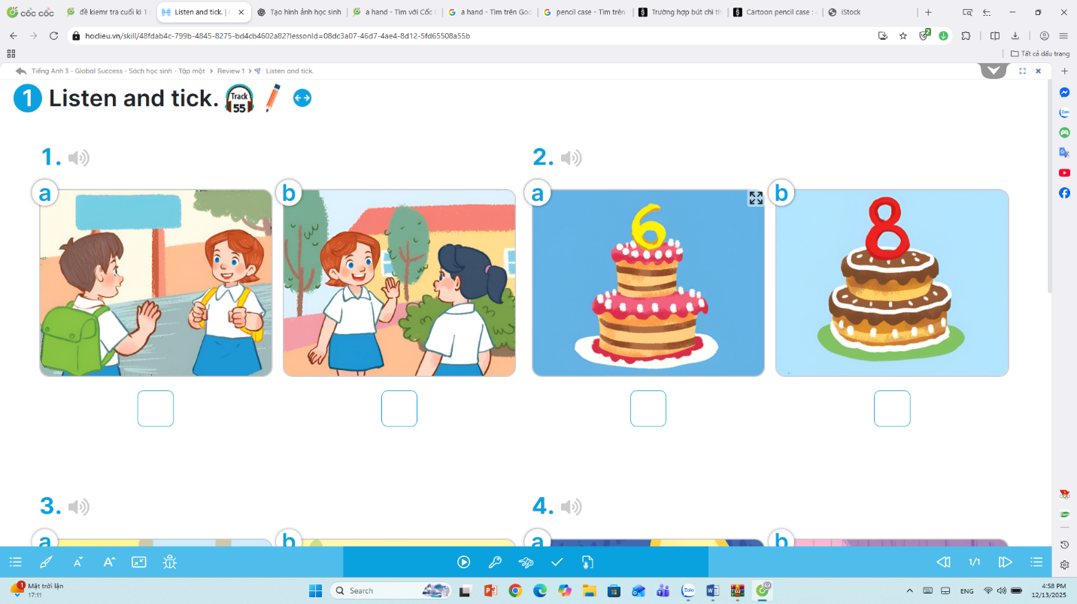  b.

Task 2. Listen and number 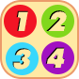(1point).
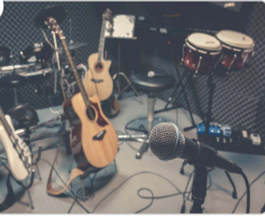  a. | 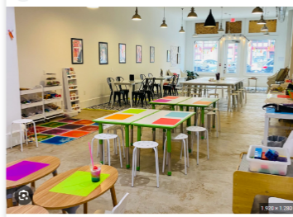  b. | 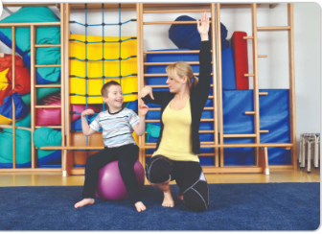  c. | 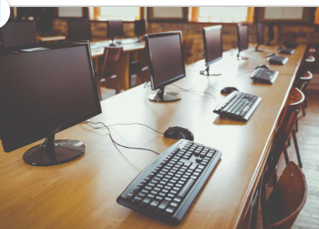  d.

Task 3. Listen and complete. (0,5pt)
1. Let’s go to the__________ room! Sorry, I am busy.
2. Do you have a __________? No, I don’t.

II. READING AND WRITING
Task 1. Read and match. (1point).
0. May I go out? Please! | 0. e | a. I play volleyball.
1. What’s your hobby? | 1. | b. They are yellow.
2. Do you have a pencil? | 2. | c. Yes, I do.
3. What do you do at break time? | 3. | d. I like dancing.
4. What colour are your pencils? | 4. | e. No, you can’t

Task 2. Read and circle(0,5pt)
- ___________colour are your pencils.

- When b. What c. Where

- I play basketball __________ break time.

- in b.on c. at

Task 3. Read and complete with the given words. (1point).
room | Minh | school | playground

Hi, I am Nam . I’m in Class 3B. This is my (1)___________ . It’s big. My classroom is big, too. Now it is break time. Many of my friends are in the (2)____________. I’m in the computer (3)____________ with my friend (4)____________
Task 4: Look and write. There is one example. (1point).

  - Let’s go to the ____________ |   2. A. What do you do at break time?  B. I play ____________

Task 5. Reorder the words to make sentences. (1,5point).
- name? / What / is / your
What is your name ?
- Let’s / go/music room./ the / to
____________________________________
- like/ singing / my friends./ I / songs/with/
____________________________________
- play/ break time./I / word / badminton / do /and / puzzles / at
_________________________________________________

ĐÁP ÁN ĐỀ KIỂM TRA CUỐI HỌC KÌ I MÔN TIẾNG ANH LỚP 3
Năm học: 2025- 2026
PART 1: LISTENING.
Task 2: Listen and number
1.b, 2.a, 3.b, 4.a
Task 2: Listen and number. (1point).
1.c, 2, b.3.d, 4.a
Task 3: Listen and complete. (0,5point).
1. music
2. pencil
PART 2: READING AND WRITING.
Task 1: Read and match (1 point).
1. D, 2.C, 3. A, 4. B
Task 2: Read and circle (0,5 point).
1. b, 2. c
Task 3: Read and complete with the given words. (1 point).
1. school , 2. playground, room, 4. Minh
Task 4: Look and write. (1 point).
1. library, 2. Badminton
Task 5: Reorder the words to make the sentences. (1,5 points).
1. Let’s go to the music room.
2. I like singing songs with my friends.
3. I play badminton and do word puzzles at break time.
I do word puzzles and play badminton at break time.
PART 3: SPEAKING. (2,5)

MA TRẬN ĐỀ KIỂM TRA ĐỊNH KỲ CUỐI HỌC KỲ I
MÔN TIẾNG ANH – LỚP 3
Năm hoc : 2025-2026
NỘI DUNG  KIẾN THỨC KỸ NĂNG | Tổng câu | Tổng điểm | Nhận biết |  | Thông hiểu |  | Vận dụng
NỘI DUNG  KIẾN THỨC KỸ NĂNG | Tổng câu | Tổng điểm | Số câu | Số điểm | Số câu | Số điểm | Số câu | Số điểm
LISTENING | 10 | 2,5 | 8 | 2 | 2 | 0,5
Task 1. Listen and tick. | 4 | 1 | 4 | 1 | - | 0 | - | 0
Task 2. Listen and number | 4 | 1 | 4 | 1 | - | 0 | - | 0
Task 3. Listen and complete | 2 | 0,5 | - | 0 | 2 | 0,5 | - | 0
READING AND WRITING | 14 | 5,0 | 8 | 2,5 | 4 | 1,5 | 2 | 1,0
Task 1. Read and tick. | 4 | 1,0 | 4 | 1,0 | - | 0 | - | 0
Task 2. Read and complete. | 2 | 1,0 | - | 0 | 2 | 1,0 | - | 0
Task 3. Read and circle | 4 | 1,0 | 2 | 0,5 | 2 | 0,5 |  | 0
Task 4. Reorder the words to make sentences | 2 | 1,0 | 2 | 1,0 | - | 0 | - | 0
Task 5. Look and write | 2 | 1,0 | - | 0 | - | 0 | 2 | 1,0
SPEAKING | 10 | 2,5 |  |  | 4 | 1,0 | 6 | 1,5
Look at the pictures and answer the questions | 5 | 1,25 | - | 0 | 4 | 1,0 | 1 | 0,25
Ask and answer | 5 | 1,25 | 0 | 0 | - |  | 5 | 1,25
Tổng | 34 | 10 | 16 | 4,5 | 10 | 3,0 | 8 | 2,5

