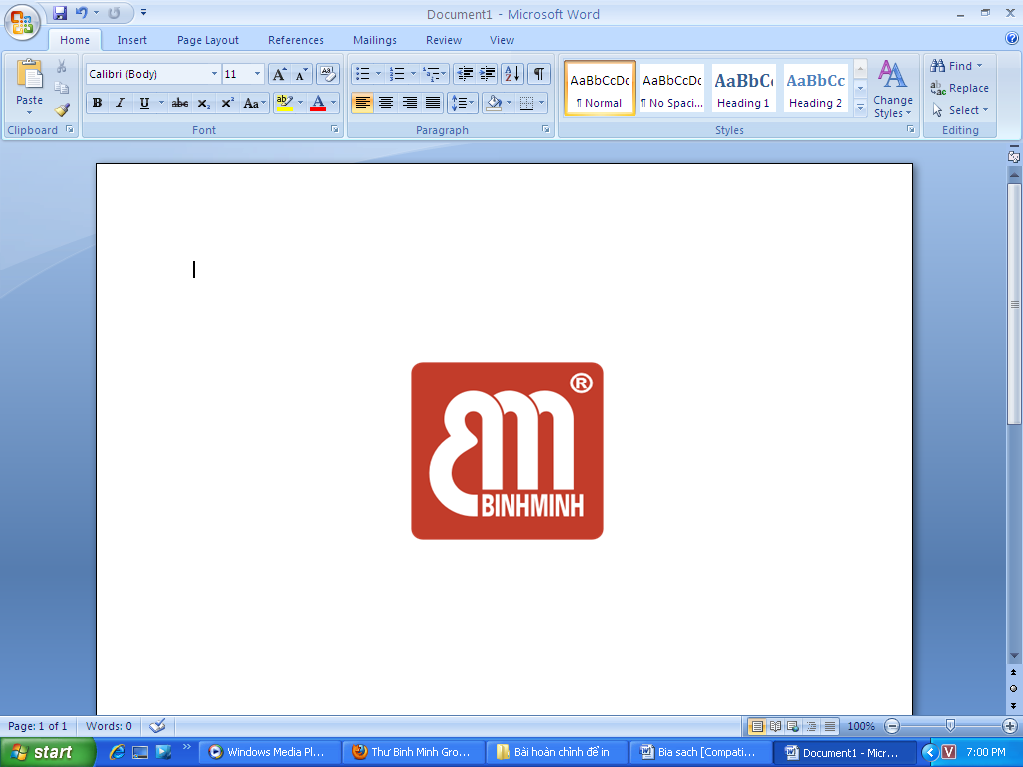

BINHMINH LANGUAGE CENTER
Address: Office 10, 3rd Floor, W2 Building, Vinhomes Westpoint, Pham Hung Street,
Nam Tu Liem District, Hanoi
Tel: 04 3976 6365 - Web: Binhminh.com.vn

NỘI DUNG ÔN TẬP HỌC KỲ 1
TIẾNG ANH 5 WONDERFUL WORLD

A. LANGUAGE CONTENTS
Unit 1……………………………………………………….page 2
Unit 2 ..……………………………………………………..page 3
Unit 3 ..……………………………………………………..page 4
Unit 4 ..………………………………………………….….page 5
Unit 5 ..………………………………………………….….page 5
Unit 6 ..………………………………………………….….page 5
B. HANDOUTS___________________________________PAGE 8
C. ANSWER KEYS_______________________________PAGE 12
- LANGUAGE CONTENTS
Unit 1: Family and Friends
I. Vocabulary
Characteristics | Verbs | Adverbs | Body traits
clever | come out of | carefully | curly
crazy about | keep warm | happily | dark
different | crazy about | loudly | fair
funny | leave | quickly | long
loud |  | slowly | short
quiet  same |  | well | straight
II. Grammar
1. Connectors: both, but.
● Both Lorena and Carla are clever.
● Becky is quiet but Emma is loud.
2. Adverbs of manners.
● Penguins can swim very well.
● She runs slowly.
3. Possessive: ‘s
● Lara’s hair is green.
● Her mother’s hair is brown.
+ Pronunciation: Word stress (First syllable)
Mother
Father
Friendly
Noisy
Unit 2: My Favourite Things
I. Vocabulary
Objects | Verbs | Prepositions
computer | moving | below
piece | scare | above
puzzle |  | inside
photo |  | outside
typewriter |  | in the middle of
country
globe
map
spider
II. Grammar
1. Past simple with to Be
● When you were seven, what was your favourite thing?
2. Preposition
● Two blue balls are below the chair.
● The pictures are above the table.
3. Connectors: and, but
● Computers are exciting and fun.
● The magazine is new but it’s boring.
+ Pronunciation: Word stress (second syllable)
Expensive
Computer
Fantastic
Banana
Unit 3: School Life
I. Vocabulary
Nouns | Activities | Adverbs of frequency
exercise | do homework | never
fitness centre | go to science clubs | sometimes
practice | have fun | often
problem | play a musical instrument | usually
solution | walk to school | always
 | wear a uniform
II. Grammar
1. Present simple (affirmative)
● Kevin goes to school every weekday.
● At the weekends, he washes his bike.
2. Present simple (interrogative)
● Does Dara have a music class on Mondays?
- No, she doesn’t.
● When does she start her lessons at school?
- She starts her lessons at 8 a.m.
3. Adverbs of frequency
● I often walk to school, but I sometimes ride my bike.
Pronunciation: -es, -s
/z/ goes
/s/ starts
/iz/ dances

Unit 4: Free Time
I. Vocabulary
Activities | Verbs | Location / Noun
collect stamps | be good at | amusement park
go ice-skating | enjoy | bookshop
make a paper bird | like | cinema
play the piano |  | restaurant
read comic books |  | sports centre
watch movies |  | wood
eat a big meal
go bowling
ride the roller coaster
II. Grammar
1. Ask and answer about abilities.
● What is she good at?
- She’s good at playing football.
- I’m good at swimming.
2. Ask and answer about permissions.
● Dad, I need some books. Can I go to the bookshop now?
- Yes, you can./ No, you can’t.
3. Talk about frequency of an activity.
● I often go swimming.
Phonics: /wh/ ; /w/ ; /h/
/wh/: when, who.
/w/: wood
/h/: hobby

Unit 5: Celebrations
I. Vocabulary
Activities |  | Verbs / Adjectives | Time
bonfire | mooncake | colourful | last month
celebration | parade | throw | last year
powder | memory
festival
lantern
lion dance
lunar month
Mid-Autumn Festival
II. Grammar
1. Requests and commands.
● Please buy some powder for the Holi Festival.
- Don’t be late for any meetings with your teachers.
- Let’s hope for a bright future.
2. Narration (present tense & past tense).
● There are six colourful balloons on the wall of my living room.
- Minh has to do a lot of housework.
• I went to a birthday party last weekend.
• He had a lot of work during Christmas.
• My mother did a lot of housework before Tet holiday.
Phonics: /w/ ; /d/
/w/: answer
/h/: handsome

Unit 6: Food
I. Vocabulary
Food |  | Noun (quantifier for foods) | Taste (Adjective)
bread | broccoli | bowl | crispy
butter | cucumber | piece | delicious
chocolate | hamburger | plate | salty
cupcake |  | slice | sour
salad |  |  | spicy
spaghetti |  |  | sweet
meatball |  |  | tasty
cereal
II. Grammar
1. Sentences with quantifiers
• We have a lot of bread, but we don’t have much butter.
• We have a lot of oranges, but we don’t have many apples.
• There’s a little milk in the glass.
• Let’s have a few biscuits with our orange juice
2. Using nouns as quantifiers for other objects.
● a bowl of rice
- a piece of pizza
- a plate of salad
- a glass of water
- a slice of bread
Phonics: Stress
Tomato
Chocolate
Hamburger
Cucumber


TEST SAMPLE - Grade 5
(Time allowed: 35 minutes)

PART A: LISTENING
1Listen and circle the correct pictures. / Nghe và khoanh tròn tranh phù hợp.

E.g:
A

B

C

1.  A  B  C | 2.  B  A  C
3.  A B C | 4.  A B C

❷ Listen and fill in the blanks. /Nghe và điền chỗ trống để hoàn thành đoạn văn sau.

Easter
box

hobby

piano

Christmas

buys
Hi! My name is James. My (0)hobby is collecting stamps. I collect stamps from many countries. I have a big (5)______________ of stamps from India, China, France and England. My father (6)_______________ me a new stamp on my birthday every year. My brother’s name is David. He likes playing musical instrument in his free time. He can play the piano and the drums. He likes playing at festivals. He played the (7)_________________ at our grandfather’s house last (8)____________________.
❸ Listen to the questions and circle the correct answers. / Nghe câu hỏi và khoanh tròn câu trả lời phù hợp.

A. I’m fine. Thank you.
E.g: -------?

B. I’m eleven years old.

C. I’m happy.

9. -------?

10. -------?

A. I’m good at swimming.
B. My favourite sport is swimming.
C. No, she doesn’t like swimming.

A. She starts her lessons at 8 A.M.
B. She goes to school every day.
C. She has to do a lot of homework.


PART B: READING
❶ Circle the odd one out. / Khoanh tròn từ khác loại.

E.g: | A. six | B. meet | C. ten
11. | A. year | B. month | C. lantern
12. | A. club | B. walk | C. practise
13. | A. football | B. ice-skating | C. wood
14. | A. many | B. hamburger | C. cereal
15. | A. clever | B. funny | C. puzzle
16. | A. curly | B. parents | C. straight
❷ Look at the pictures and circle the correct answers. / Hãy nhìn tranh, khoanh tròn câu trả lời phù hợp với nội dung câu hỏi.

A. It’s a marker.
B. It’s a pencil.
C. It’s a crayon.

E.g: What is this?

17. | When does she go swimming? | A. She goes swimming on Monday.  B. She goes swimming on Tuesday.  C. She goes swimming at 6 A.M.
18. | What does he have to do at home? | A. He has to do a lot of housework.  B. He has to do a lot of homework.  C. He has to go to a party.
19. | What must he buy for the festival? | A. He must buy some oranges.  B. He must buy some biscuits.  C. He must buy some balloons.
20. | When does she start her lessons at school? | A. She starts her lessons on Monday.  B. She starts her lessons at 9 A.M.  C. She starts her lessons at 12 A.M.
PART C: WRITING
❸Choose and write. / Chọn từ đúng và điền vào chỗ trống.
E.g: There (is/ are/ do) are two crayons on the table.
21. Don’t (is/ be/ going/)______________ late for the party!
22. We have (lot of/ some /few)________________ bread for dinner.
23. I (go/ went/ going) ________________ to her house last weekend.
24. He is good at (swim/ swimming/ go swimming)_____________________.

❹ Read and write ONE word in the blank. / Đọc và viết 1 từ vào ô trống.

Hi, my name is Lisa. I like (25)________________. It's my favorite food. But I don't like vegetables. I have a lot of (26)________________ because it’s (27)_____________ . I like salad, too. Every day, I have a (28)___________ of salad in the morning.

❺ Reorder the words to make sentences. / Hãy sắp xếp các từ tạo thành câu hoàn
chỉnh, bỏ dấu gạch chéo và không thêm, không bớt từ.
E.g: Whose/ it / rug / is /? (4 words) -> Whose rug is it?
29. crazy / Jimmy / about / games / is / video /. (6 words)
⇨ Jimmy.............................................................................................................................................................
30. often / She / school / walks / to/. (5 words)
⇨ She..................................................................................................................................................................
The end
ANSWER KEY
TEST SAMPLE
Note: The teacher reads the listening script to the students.
❶ Listen and circle the correct pictures.
E.g: Let’s go to the beach!
1. She buys some oranges for the party tomorrow.
2. He likes collecting stamps in his free time.
3. Jane’s favourite thing when she was young was her puzzle.
4. He often goes to the amusement park on weekends.
❷ Listen and fill in the blank.
Hi! My name is James. My (0)hobby is collecting stamps. I collect stamps from many countries. I have a big (5)box of stamps from India, China, France and England. My father (6)buys me a new stamp on my birthday every year. My brother’s name is David. He likes playing musical instrument in his free time. He can play the piano and the drums. He likes playing at festivals. He played the (7)piano at our grandfather’s house last (8)Christmas.
❸ Listen to the questions and circle the correct answers.
E.g: How old are you?
9. What sport are you good at?
10. How often does she go to school?
ANSWER KEY
1. C | 7. piano | 13. C | 19. C | 25. spaghetti
2. A | 8. Christmas | 14. A | 20. B | 26. chocolate
3. B | 9. A | 15. C | 21. be | 27. tasty / delicious
4. B | 10. B | 16. B | 22. some | 28. plate
5. box | 11. C | 17. A | 23. went
6. buys | 12. A | 18. A | 24. swimming
29. Jimmy is crazy about video games.
30. She often walks to school.

