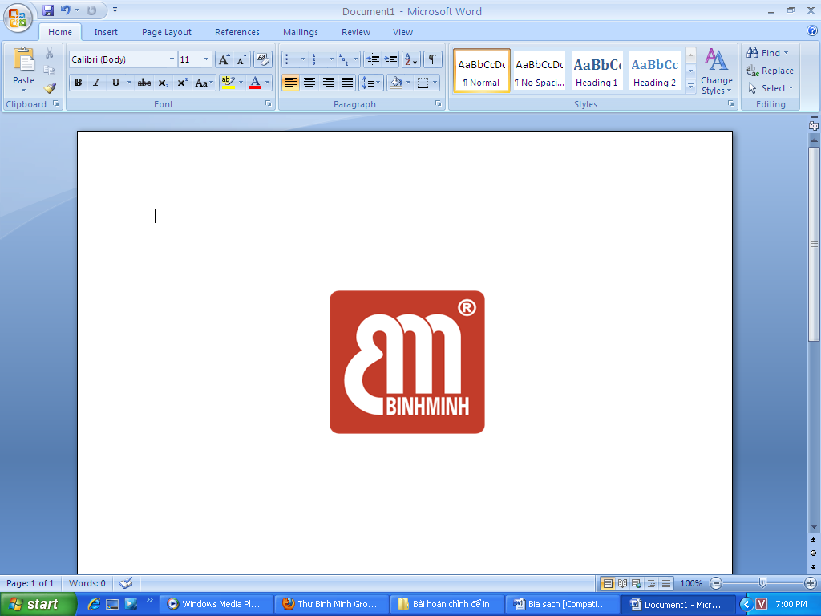

BINHMINH LANGUAGE CENTER
Address: Office 10, 3rd Floor, W2 Building, Vinhomes Westpoint, Pham Hung Street,
Nam Tu Liem District, Hanoi - Tel: 04 3976 6365 - Web: binhminh.com.vn

NỘI DUNG ÔN TẬP HỌC KỲ 2
TIẾNG ANH 5 – WONDERFUL WORLD 5

A. LANGUAGE CONTENT 2
A.1. WONDERFUL WORLD 2
Unit 7: Sports 2
Unit 8: People and places 3
Unit 9: Holidays and travel 4
Unit 10: Performing arts 5
Unit 11: Animals 6
Unit 12: Weather and nature 7
B. SAMPLE TEST 8
B.1. ORAL TEST + INSTRUCTIONS 8
B.2. WRITTEN TEST + ANSWER KEYS 11


LƯU Ý
Các Sample Test chỉ mang tính chất tham khảo với mục đích cho học sinh quen với các dạng đề có trong đề thi của Học kỳ II. Vì vậy, giáo viên nên chủ động thay đổi kiến thức cho học sinh để ôn luyện.

LƯU Ý
Các Sample Test chỉ mang tính chất tham khảo với mục đích cho học sinh quen với các dạng đề có trong đề thi của Học kỳ II. Vì vậy, giáo viên nên chủ động thay đổi kiến thức cho học sinh để ôn luyện.

A. LANGUAGE CONTENT

A.1. WONDERFUL WORLD

Unit 7: Sports
1. Vocabulary
fast, helmet, jump, race, win
control, fight, kick, mind, movement

2. Grammar structures
● Present continuous (affirmative)+ spelling rules and common time expressions: at present, now, at the moment.
● Anita is having a swimming lesson.
● I’m taking a bath now.
● Grammar: Should / Shouldn’t
● Children should learn to play a sport.
● Children shouldn’t watch TV many hours a day.
● Adverbs of frequency: once, twice, three times, four times
● I ride my bike twice a week.

3. Pronunciation
Word stress
helmet
competition

Unit 8: People and places
1. Vocabulary
balcony, basement, floor, garden, ladder, view
fasten, float, relax, soap, space, towel

2. Grammar structures
would like to
● Would you like to live in a treehouse?
– Yes, I would.
● I’d like to go to the beach.
must or mustn’t
● You must kick the ball.
● You mustn’t touch the ball with your hands.
Connector: because, so
● It’s Saturday, so we can go to the shops.
● I don’t like museums because they’re boring!

3. Pronunciation
Sentence stress
We must wear our helmets.
It’s an apartment near the city centre.

Unit 9: Holidays and travel
1. Vocabulary
bridge, canal, crime, lock, villager
flight, hot-air balloon, inventor, silk, smoke

2. Grammar structures
Past simple (regular verbs + time expressions: Last weekend/ year/ month/ night
Yesterday/ Two days/ Some months ago
● I travelled to Thailand with my friends last year.
Past simple (regular verbs)
● I played football.
● As a child, I wanted to go on a hot-air balloon ride.
Irregular verbs in past simple (cont.)
● Last night, my family slept in a hotel.
● Tom bought a pizza last week.

3. Pronunciation
-ed
/t/ looked
/id/ needed

Unit 10: Performing arts
1. Vocabulary
advert, autograph, director, film studio, make-up, set
action, animated, award, cartoon, character, company

2. Grammar structures
Past simple (negative with verbs)
● I got the singer’s autograph, but I did not get the actor’s.
Past simple (WH-Questions and answers + time expressions)
● When was Charlie Chaplin born? - In 1889.
● Why did Charlie sing on stage at age 5? - Because his mother was sick.
● Where did he go when he was 21? - He went to America.
Adjectives – Word order
● These are my favourite films.
● She’s a beautiful princess.

3. Pronunciation
Sentence stress
● I don’t like spiders.
● I just want to relax by the sea.

Unit 11: Animals

1. Vocabulary
binoculars, butterfly, cave, insect, lizard, torch
be together, care for, cheetah, cub, friendship, unusual

2. Grammar structures
Comparative with short, regular adjectives.
● An elephant is bigger than a rabbit.
● Snakes are longer than worms.
To + Verb (purpose)
● I use a binocular to see the birds well.
Really
● My dog is really smart

3. Pronunciation
Intonation
● Can cheetahs run very fast?
● Do turtles live in the water?

Unit 12: Weather and nature

1. Vocabulary
boiling, geothermal energy, environment, rainforest, underground
app, geocaching, GPS, treasure
underground, geothermal energy, rainforest, boiling
2. Grammar structures
Will/ Won’t (decision)
● John and I will walk to school.
● These vegetables won’t grow here.
will (negative and interrogative + time expressions for future)
Next week / tomorrow / next / year / In 2050 / in the future
● We won’t drive to the forest next Sunday.
Be going to (making plan)
● This summer holiday, I am going to go camping.

3. Pronunciation
Intonation in WH-Questions
● What are you going to do during the summer?

B. SAMPLE TEST

B.1. ORAL TEST + INSTRUCTIONS

SPEAKING

❶ Interview.
1. What’s your favorite subject?
2. Do you have Math/ Science/ … on Mondays/ Tuesdays/ …?
3. When does she start/ finish her lessons at school?
4. What do you like doing in your free time?
5. What are you good at? / Are you good at climbing/ singing/ …?
6. Would you like to live in a treehouse/ an apartment/ …?
7. Which place would you like to visit in your city?
❷ Look and answer the questions. / Nhìn tranh và trả lời câu hỏi.

PICTURES | SUGGESTED QUESTIONS
  1.  last weekend | - What is the name of the film?  - It is a science fiction/ cartoon/ comedy/ … film?  - When did you see that film?  - How many characters are there in the picture?
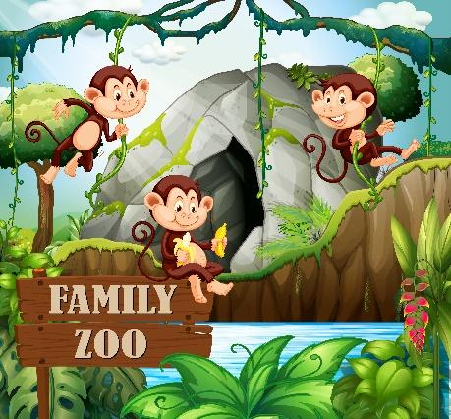  2. | - How many monkeys are there in the picture?  - What colour are they?  - What do they eat?  - Where do they live?  - What can they do?
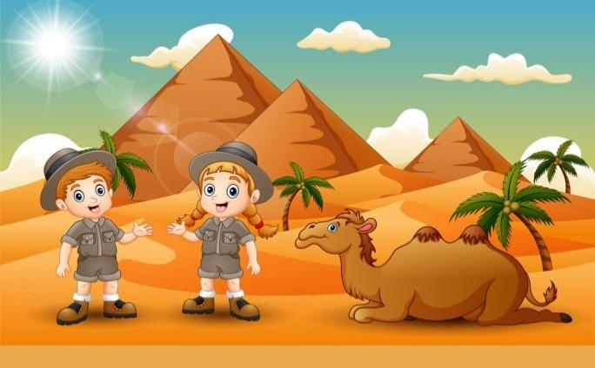  3.  Egypt  Robbie  Jenny | - What can you see in the picture?  - Where are they going to visit?  - Who is Jenny going to travel with?  - What activities are they going to do?

INSTRUCTIONS
ORAL TEST 2 – GRADE 5

❶ Interview.
- Students have to answer 4 out of 7 questions
- The teacher can choose one of two ways to test in the time allowed:
1. Testing individually (Each student interacts with the teacher)
- The teacher asks and the students answer any four of the questions.
Example: T: What is your favourite subject?
S: My favourite subject is Math.
2. Testing in pairs (Two students interact with each other)
- After 2 students ask and answer the first question, they will change roles.
- In this way, each student has to make 2 questions and answer 2 questions.
❷ Look and answer the questions.
- Students answer three questions about two of the pictures.
- There are two ways to test students’ oral language ability.
- The teacher can choose one of two ways to test in the time allowed:
1. Testing individually (Each student interacts with the teacher)
- The teacher asks the students to answer three questions about two of the pictures (3 questions for each picture).
Example: Picture 2: T: How many monkeys are there in the picture?
S: There are three monkeys in the picture.


B.2. WRITTEN TEST + ANSWER KEYS
PART A: LISTENING
❶Listen and complete the sentences./ Nghe và hoàn thành câu.
0. Children should learn to play a sport.
1. Anita is having a ______________ lesson.
2. Would you like to live in a ______________? – Yes, I would.
3. I don’t like ______________ because they’re boring!
4. We must wear our ______________ when we go cycling.

❷Listen and circle the correct pictures./Nghe và khoanh tròn tranh phù hợp.
0. Where’s the dog?

A

B
C

5. Where did he go when he was 21?            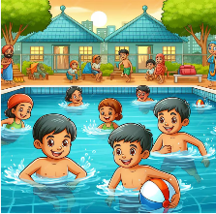  A B C | 6. What should we do to stay healthy?  A B C
7. Why would you like to go to the beach?        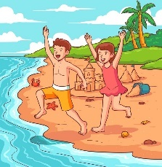      A B C | 8. What did you do yesterday?  A B C

❸Listen to the questions and circle the correct answers./ Nghe câu hỏi và khoanh tròn câu trả lời phù hợp.
0. -------?

A. I sometimes walk my dog.
B. I’m walking my dog.
C. I like dogs.

10. -------?

9. -------?

A. Here, use my binoculars.
B. Here, use my hands.
C. Here, use my energy.

A. A shark is weaker than a butterfly.
B. A shark is stronger than a butterfly.
C. A shark is faster than a butterfly.


PART B: READING
❶ Circle the odd one out./ Khoanh tròn từ khác loại.
0. | A. control | B. fast | C. fight | D. kick
11. | A. yesterday | B. last year | C. last week | D. inventor
12. | A. played | B. football | C. wanted | D. travelled
13. | A. balcony | B. basement | C. glass | D. Saturday
14. | A. autograph | B. doctor | C. singer | D. actor
15. | A. butterfly | B. dog | C. cave | D. elephant
16. | A. friendship | B. boring | C. exciting | D. fantastic
❷Read and circle the best answer./Đọc đoạn văn và khoanh tròn vào đáp án đúng.
My name is David. I live in Berlin, Germany. Last week, my family and I spent the summer holiday on my grandparents’ farm in the countryside. It was so far from Berlin. First, we took a taxi to the airport. Then, we went by plane. Everything on the farm was great. The weather was good. It was cool and sunny. We went to the farm and watered the plants. I helped my grandmother to milk the cow, too. I thought this job was interesting. I did it every day until the end of the holiday. My parents liked walking on the farm and feeding the sheep. We came back home yesterday.
0. He lives ____________ Berlin, Germany.

A. from B. at C. in
17. First, we took a ____________ to the airport.
A. taxi B. bus C. bike
18. They went to the farm and ____________ the plants.
A. cut B. watered C. played
19. He thought this job was ____________.
A. interesting B. boring C. happy
20. This parents liked ____________ on the farm and feeding the sheep.
A. flying B. running C. walking


PART C: WRITING
❶Choose and write./Chọn từ đúng và điền vào chỗ trống.
0. What’s your favourite colour? – I like (tennis/ green/ monkeys) green.
21. I use a binocular to (see/ saw/ seeing) _____________ the birds well.
22. Do turtles live (at/ in/ of) _____________ the water?
23. We won’t (drive/ drives/ driving) _____________ to the forest next Sunday.
24. I (got/ gets/ getting) _____________ the singer’s autograph, but I didn’t get the actor’s.
❷Look and write ONE WORD in each blank./ Nhìn tranh và viết một từ phù hợp vào mỗi chỗ trống.

0. Bella is wearing a red skirt.

25. You mustn’t touch the _______________ with your hands.
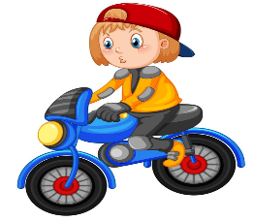

26. I _______________ my motorbike twice a week.


27. We hope lots of people will grow _______________ in their gardens.


28. Tom bought a ______________ from Little Italy restaurant last night.
❸Reorder the words to make sentences./ Hãy sắp xếp các từ tạo thành câu hoàn chỉnh, bỏ dấu gạch chéo và không thêm, không bớt từ.
0. dress / What / is / party / Anna’s / colour /? (6 words)
🡪 What colour is Anna’s party dress?
29. my/ hotel/ in/ family/ night,/ a/ slept/ Last/ . (8 words)
🡪 Last………………………………………………………………………………………………………………….
30. I/ to/ with/ friends/ year/ travelled/ Thailand/ my/ last/ . (9 words)
🡪 I ……………………………………………………………………………………………………………………….

--- THE END ---

INSTRUCTIONS + ANSWER KEYS
WRITTEN TEST 1 – GRADE 5

❶ Listen and number the pictures.
0. Children should learn to play a sport.
1. Anita is having a swimming lesson.
2. Would you like to live in a treehouse? – Yes, I would.
3. I don’t like museums because they’re boring!
4. We must wear our helmets when we go cycling.
❷ Listen and circle the correct pictures.
0. Where’s the dog? – It’s under the table. (Picture B)
5. Where did he go when he was 21? – He went to London.
6. What should we do to stay healthy? – We should go swimming every day.
7. Why would you like to go to the beach? – Because I’d like to build sandcastles and swim in the sea.
8. What did you do yesterday? – I played the piano.
❸ Listen to the questions and circle the correct answers.
0. What are you doing? (Sentence B)
9. Can you see that eagle in the sky?
10. Which animal is stronger, a shark or a butterfly?

ANSWER KEYS
1. swimming | 8. A | 15. C | 22. in
2. treehouse | 9. A | 16. A | 23. drive
3. museums | 10. B | 17. A | 24. got
4. helmets | 11. D | 18. B | 25. ball/ football
5. B | 12. B | 19. A | 26. ride
6. C | 13. D | 20. C | 27. flowers
7. B | 14. A | 21. see | 28. pizza
29. Last night, my family slept in a hotel.
30. I travelled to Thailand with my friends last year.

