UBND XÃ CHẤN HƯNG  TRƯỜNG TH TÂY HƯNG  Họ tên:……………………………………  Lớp:…….… | Kiểm tra tháng 2  Năm học 2025-2026  Môn Tiếng Anh lớp 2  Thời gian : 35 phút

Ex 1: Look and complete the words.

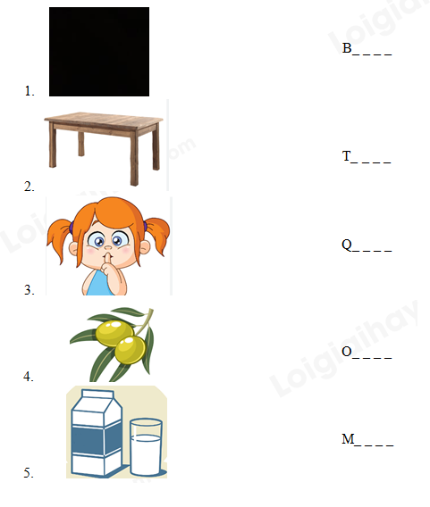

EX 2. Choose the correct answer.

1. How are you? – I’m good. ________.
A. Hello B. Thank you C. Goodbye.
2. What ______ you doing?
A. are B. am C. is
3. I swim on _______.
A. colour B. plane C. Sunday
4. The carrot is ______.
A. black B. orange C. pink
5. I ______ two oranges.
A. am B. swim C. see

EX 3. Reorder the words to make correct sentences.
1. is / it / What
______________________________?
2. don’t / I / lemons./ like
______________________________.
3. ruler / green./ The / I s
______________________________.
4. like / I’d / a / vest. / blue /
__________________________________________
5. is / This / my / uncle.
__________________________________________

