WEEK 17
REVIEW 3
Part 3 – VIDEO. Task 1, 2, 3
Period 65
I. OBJECTIVES:
1. Knowledge:
- Students will review the words and structures related to the topic Outdoor Activities:
2. Competences:
- English competences: Students will be able to talk about outdoor activities.
- Common competences: Students will have the opportunity to develop communication among friends.
3. Qualities:
- Students will be responsible and well-behaved in communicating in the classroom with friends and others.
II. EQUIPMENT AND MATERIALS:
- Basic things: Student’s book, flashcards.
- Advanced things: PPT, projector/interactive whiteboard/laptop/TV.
III. LESSON PROCEDURE:
Warm up (5 minutes)
Teacher’s activities | Student’s activities
- Greet students  Task 1: Unscramble (7 MINUTES)  Before unscrambling through a game  Ask sts to look at the screen and choose the characters they want. Then, answer all the questions and get stars  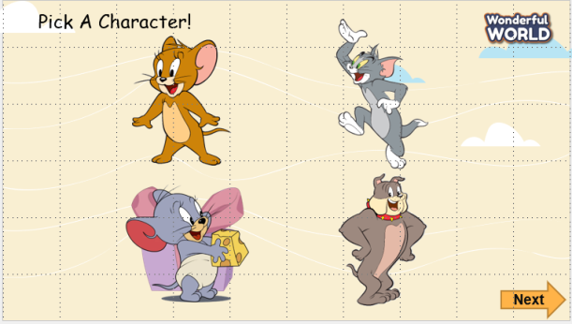  While playing  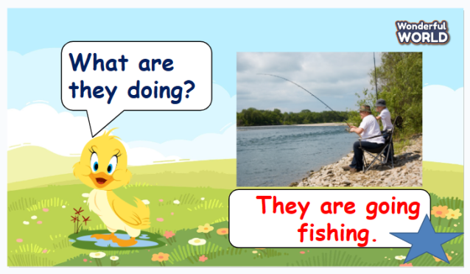  - Ask sts to work in groups  - Hand each group a print of task 1  - The sts will unscramble the words and get stars.  - The team, who gets the highest scores, will be the winner. | - Greet teacher  - Sit in 4 groups.  - Listen to the game rules carefully  - Play game
Review (20 minutes)
Teacher’s activities | Student’s activities
Activities: Video  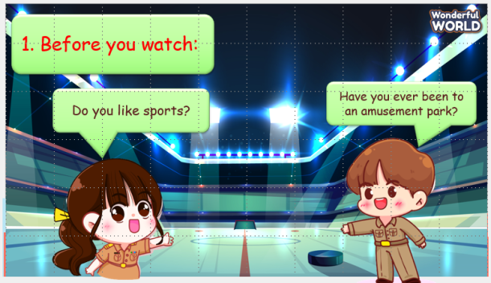  -Ask students to answer some questions before the video.  -Read the sentences aloud and ask students to repeat.  Watch the video  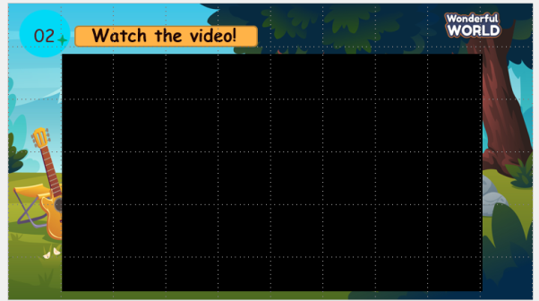  Activity: Talk about what’s in the video  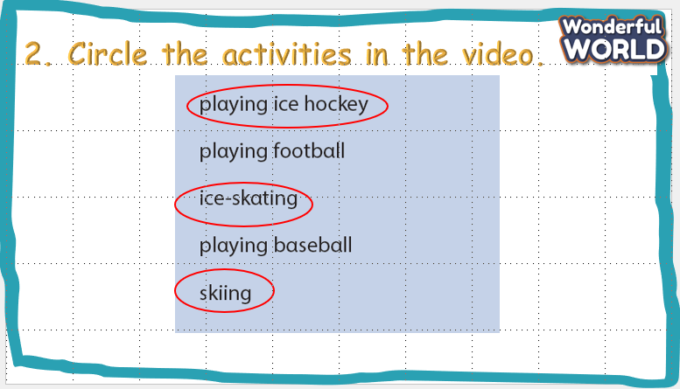  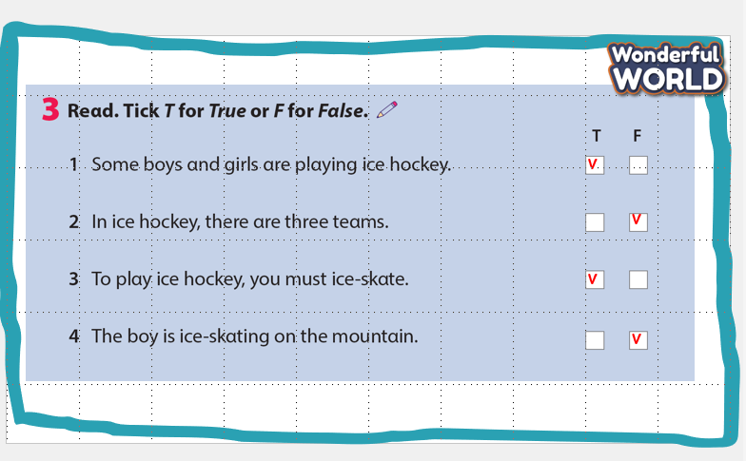  -Ensure students understand how to complete the task. Allow them enough time to complete it, monitoring and helping as necessary  -Check answers. Ask volunteers to read out their answers. | -Look  -Answer  -Listen  -Do the crossword  -Check answers  -Look and read the example.  -Repeat  -Match  -Check answers with friends  -Listen  -Ask and answer the questions in pairs  -Check and practice in front of class
Extra activity (10 minutes)
Teacher’s activities | Student’s activities
- Assessment.  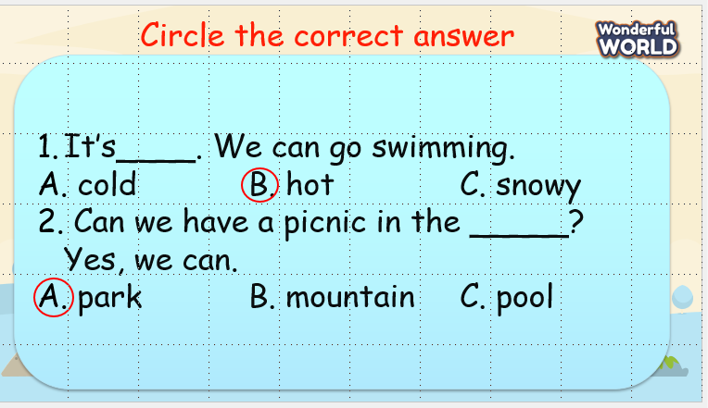  -Read out the question and the example answer.  -Ensure students understand how to complete the task. Allow them enough time to complete it, monitoring and helping as necessary  -Check answers. Ask volunteers to read out their answers.  - Give feedback to them.  -Ask students to sing the goodbye song | - Work in groups  - Present.  - Listen.
____________________________

REVIEW 3
Part 4. Task 1, 2, 3
Period 66
I. OBJECTIVES:
1. Knowledge:
- Students will review the words and structures related to the topic Outdoor Activities:
2. Competences:
- English competences: Students will be able to talk about outdoor activities.
- Common competences: Students will have the opportunity to develop communication among friends.
3. Qualities:
- Students will be responsible and well-behaved in communicating in the classroom with friends and others.
II. EQUIPMENT AND MATERIALS:
- Basic things: Student’s book, flashcards.
- Advanced things: PPT, projector/interactive whiteboard/laptop/TV.
III. LESSON PROCEDURE:
Warm up (5 minutes)
Teacher’s activities | Student’s activities
- Greet students  Task 1: The Mickey Quiz (7 MINUTES)  Before unscrambling through a game  Ask sts to look at the screen and choose the characters they want. Then, answer all the questions and get stars  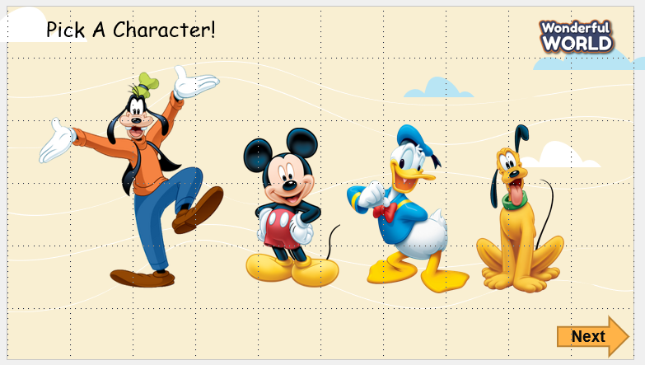  While playing  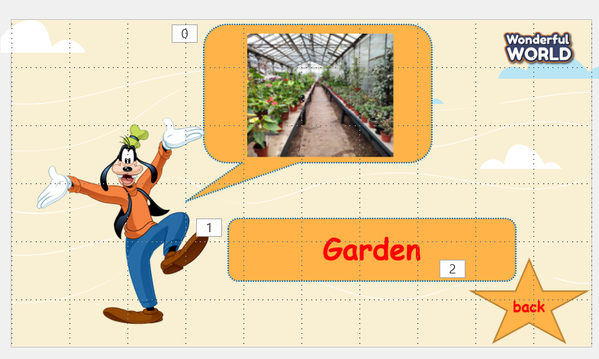  - Ask sts to work in groups  - Hand each group a print of task 1  - The sts will unscramble the words and get stars.  - The team, who gets the highest scores, will be the winner. | - Greet teacher  - Sit in 4 groups.  - Listen to the game rules carefully  - Play game
Review (20 minutes)
Teacher’s activities | Student’s activities
1. List sports.  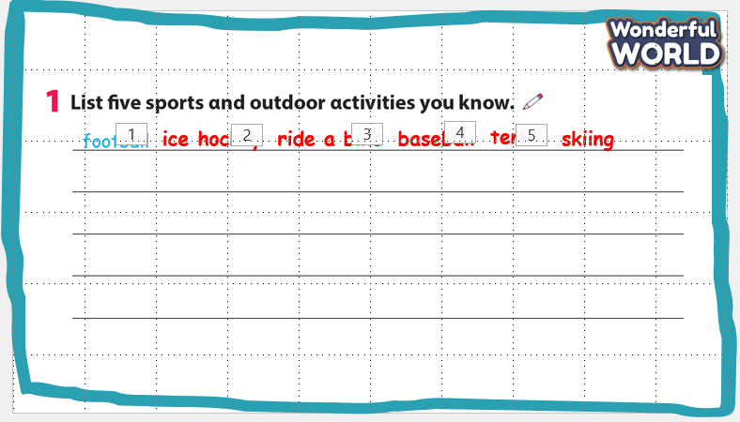  -Ask students to answer the questions.  -Read the words aloud and ask students to repeat.  - Ask them to act or make sentences with the words.  2. Talk  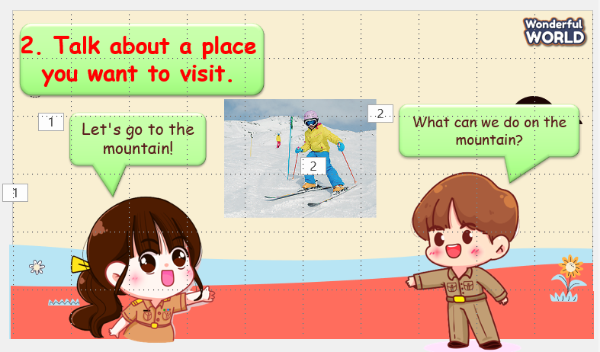  -Ask students to make sentences and talk about the pictures.  -Ensure students understand how to complete the task. Allow them enough time to complete it, monitoring and helping as necessary  -Check answers. Ask volunteers to read out their answers. | -Look  -Answer  -Listen  -Do the crossword  -Check answers  -Look and read the example.  -Repeat
Extra activity (10 minutes)
Teacher’s activities | Student’s activities
- Assessment.  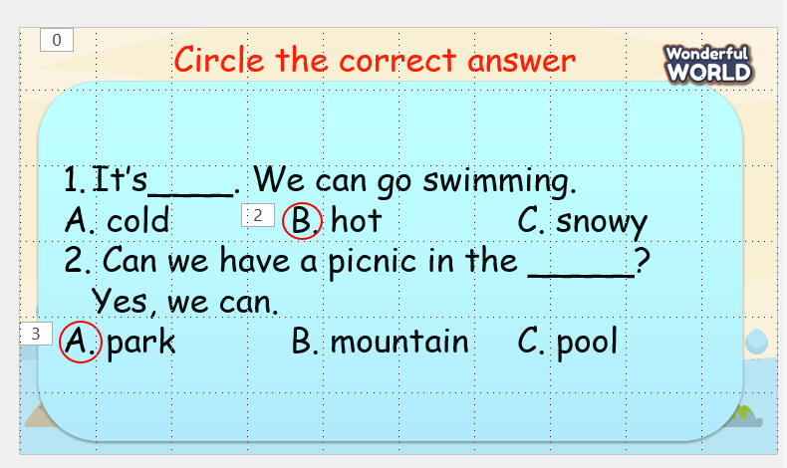  -Read out the question and the example answer.  -Ensure students understand how to complete the task. Allow them enough time to complete it, monitoring and helping as necessary  -Check answers. Ask volunteers to read out their answers.  - Give feedback to them.  -Ask students to sing the goodbye song | - Work in groups  - Present.  - Listen.
______________________________

END OF SEMESTER 1 REVIEW
Period 67
I. OBJECTIVES:
1. Knowledge:
- Students will know and recoginize how to do the effective final test in 4 English skills: Listening – Speaking – Reading – Writing.
- Students learn tips to do the test better by useful ways and instructions.
2. Competences:
- Common competences: Students will be able to identify and recoginze forms of the test,
strategies during the test.
3. Qualities:
- Students learn how to be calm, patient and careful when having the test.
II. EQUIPMENT AND MATERIALS:
- For Teacher: PP, handout, sample tests
- For students: pens, books
III. LESSON PROCEDURE:
Activity 1: Warm-up (5 minutes)
Aim: To warm up and make the lesson funny, raise Ss’ emotions before the lesson
Teacher’s Activities | Students’ Activities
Warm-up: Sing and Dance – Dance Freeze song  - T shows the clip and asks Ss to dance along  - Encourage Ss to do the best and award stars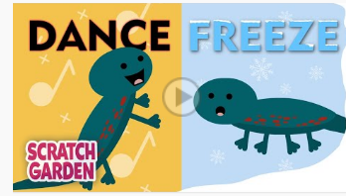 | - Join in the activity.
Activity 2: Presentation (15 minutes)
Aim: To understand and recognize types of the test; how to do the test effectively and strategies
Teacher’s Activities | Students’ Activities
* Introduce a sample test to have a quick look about the form of the test in oral test and written test  - Then share and give them some parts of the test that they have to do.  - In each part, T explains and guides how to get the best score in 4 English skills.  * Remind them in the oral test and written with various types of the test.  - Guide them how to interview with full sentences and make better sentences.  * Demonstrate a demo clip in speaking test individually with the T.  - Ask Ss to look and have questions about it such as:  + What can the boy do in the test?  + How does the teacher test every student?  + What should student do before – during – after the test?  ….  - Award points for the correct answer. | - Look at the types of the test  - Answer questions  - Watch a video clip and ask  - Answer questions
Activity 3: Practice (10 minutes)
Aim: To know and do the trial test/ types of tasks in the semester test
Teacher’s Activities | Students’ Activities
* Oral Test:  - T may ask some questions based on 2 parts in the test  - Call some students to answer questions  * Written test:  - Show a sample test again and set time for Ss to do in each task.  - Then call them come to the board and write the answers.  - T checks and correct mistakes. | - Look and write the answers on a piece of paper or notebook  - Come to the board to write the answers
Activity 4: Consolidation (5 minutes)
Aim: Remind Ss some parts of the test and strategies during the test that they have to pass. Then prepare new lessons next time
- Remind how to do the oral test and written test  - remember some basic tasks in the test  - Remind Ss to prepare well for next lessons | Answer questions with the T
_______________________
END OF SEMESTER 1 REVIEW
Period 68
I. OBJECTIVES:
1. Knowledge:
Students will review words and phrases learned from unit 1 to unit 6
2. Competences:
- English competences: Students will be able to remember the words and structures they have learnt.
- Common competences: Students will have the opportunity to develop logical thinking and develop communication among friends.
3. Qualities:
- Students develop love different leisure activities and be friendly to their friends in the class.
II. EQUIPMENT AND MATERIALS:
- For Teacher: PPT, flashcards.
- For students: textbook
III. LESSON PROCEDURE:
Activity 1: Warm-up (10 minutes)
Aims: warm-up activity to introduce the lesson, review the words from unit 1 to 6
Teacher’s Activities |  | Students’ Activities
Warm-up:  Listen and dance: - Song: “Move and freeze”.  - T asks Ss the date of the lesson and then writes on the board.  + T has Ss say the date several times.  -T writes the title of the lesson under the date.  - T plays the song, sing and dance with all class. |  | - Answer individually.  - Listen and dance along
Activity 2: Review
Aim: Practise words, ask and answer using structure unit 1 to 6
Review: Play game “- Game: Bricks down”  - Tell students how to play the game:  Instructions:  - Game’s rules: Ss choose to disappear a piece of brick, then guess the picture behind the bricks. If it is not enough to guess the word, Ss can choose more pieces of brick to open the picture.  - The less bricks are disappeared, the more stars Ss can get  - T shows the game, explains how to play the game to ensure all Ss understand the game’s rules.  - When Ss guess a word correctly, T asks all class repeat it one more time.  Review structure:  - T shows one by one question, lets Ss read the question and look at the picture given to answer the question.  - After each answer of a student, T shows the correct answer and asks all class listen and repeat it.  - Next, T calls some pairs to role play the conservations. |  | - Listen to the instruction carefully  - Repeat.  - Listen to T.  - Play the game.
Activity 3: Practice (12 minutes)
Aims: - Review words and structures
- Practise listening and speaking
Teacher’s Activities | Students’ Activities
Play game “- Game: Bomb game”  - T shows the game, explains how to play the game to ensure all Ss understand the game’s rules.  - Game’s rules: Ss choose a heart, then read the question and picture given to give an answer. If the answer is correct, Ss can choose a barrel to get stars or a bomb. If the answer is incorrect, they cannot get any star. | - Listen to the game’s rules.  - Play the game
Project:  - T tells the class that they are going to do a project about their outdoor activities. T asks each student to take a piece of paper to make a card, then has them copy the table given on to the card.  - T gives Ss time to write information about themselves.  - T asks Ss to swap their cards in pairs, then look at their partners’ cards and describe their outdoor activities.  - T call some Ss to the front of the class to tell about their partners’ outdoor activities. T make the activity more challenging, T may ask Ss not to look at the cards. | - Listen to the instructions carefully and do the same.  - Write their information.  - Swap the cards in pairs and describe their partners‘outdoor activities.
Activity 4: Assessment (3 minutes)
Aims: Do the exercise to review and remember the words
Consolidate the content of the lesson.

Teacher’s Activities | Students’ Activities
- T asks Ss to do homework and practice all the words and structures.  - T counts the stars with Ss to find out the winning team.  + T gives the winners stamps.  - T says good bye to Ss. | - Follow T.  - Say “Goodbye teacher”.

