WEEK 18
END OF SEMESTER 1
Do the test
Period 69
__________________________
END OF SEMESTER 1
Correct the test
Period 70
___________________________
UNIT 7. JOBS
Lesson 1. Task 1, 2, 3
Period 71
I. OBJECTIVES:
1. Knowledge:
Students will learn words and phrases related to the topic Jobs: chef, doctor, photographer, farmer, vet.
2. Competences:
- English competences: Students will be able to identify some jobs
- Common competences: Students will have the opportunity to develop logical thinking and develop communication among friends.
3. Qualities:
- Students develop thinking of the jobs and future and the adverbs in English.
II. EQUIPMENT AND MATERIALS:
- For Teacher: PP, flashcards, handout, track 7.1, track 7.2
- For students: pens, A4 paper, crayons,
III. LESSON PROCEDURE:
Teacher’s Activities | Students’ Activities
Activity 1: Warm up (5 minutes)
a.Aims: warm-up activity to introduce lesson and review the previous lesson
b. Procedure:  - Greet the students  - Divide class into 4 teams  - Play the video: Jobs song  https://www.youtube.com/watch?v=XINl8YvzxMc  - Ask students to sing along and remember jobs in the video.  - Ask students to answer the question: How many jobs in the video?  - Ask students to name the jobs they see in the video.  - Check students’answer and give comments.  Lead in: Photo time!  - Show the photo on page 76. Tell students to look at the photo on the screen and ask them what they can see. Elicit ideas from the class and write them on the board.  - Ask students to read the words on page 76 and tick them if they are in the photo.  - Check answers as a class.  - Write on the board “Jobs” and introduce the lesson. | - Greet the teacher  - Choose the team name  - Look, listen, sing and remember the name of jobs  - Answer the question of teacher  - Name the jobs  - Listen to the teacher.  -Look and listen  -Tick  -Check
Activity 2: Presentation (8 minutes)
a. Aims: Present new vocabulary: bubble tea, soft drink, lemonade, nuts, yoghurt
b. Procedure:  Task 1: Listen and point. Repeat. (Track 7.1)  - Use flashcards to introduce the vocabulary and structure of the lesson.  - Say the words/sentences for students to repeat in the chorus.  - Say a word/sentence for students to repeat then point.  - Play track 7.1 for the students to listen to, point to, and repeat the words in chorus, and group.  - Show pictures in random order and ask students to read out the correct words.  VOCABULARY CHECKING:  -There are 5 students in each turn. Line up in a horizontal row.  -Each student holds a picture, when the teacher gives the picture to students, asks them to read the word.  -Teacher reads any word, Ss holding the picture of that word must repeat and jump up high.  -Ss who jump wrong will lose, the last person left is the winner (there can be more than 1 winner) | -Repeat after the teacher.  -Tick and write the words
Activity 3: Practice (8 minutes)
a. Aims: Controlled-practice to practice listening skill and practice the vocabulary using: He/She is.....
Task 2: Listen and tick  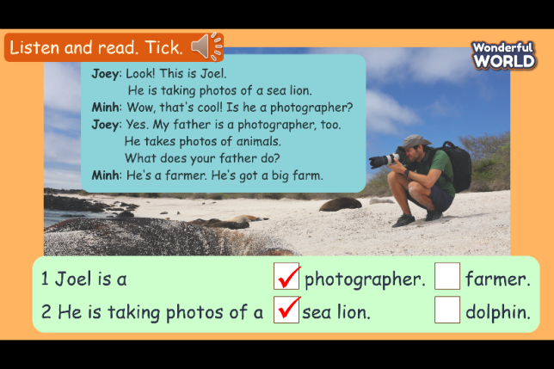  - Point to the picture and tell students: “This is the conversation between Joey and Minh.”  - Ask students to look at the sentence next to the picture. Read the sentence and the options.  - Play track 7.2 twice for students to listen and tick.  - Play the audio again and ask students to do cross-check  - Elicit the answer from students and check with the whole class.  - Ask students to act out the dialogue in pairs.  - Ask some volunteers to act it out in front of the whole class.  Task 3: Look and say.  Play game: Treasure hunt  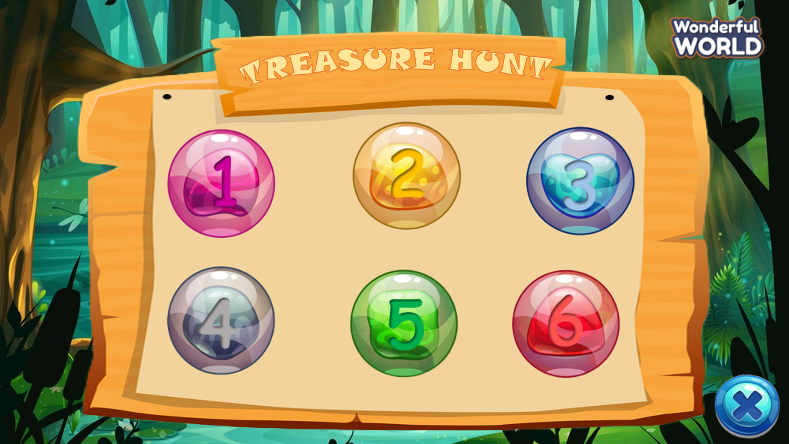  How to play: There are 5 questions and a lucky treasure. Students choose a number and answer the question. Students get treasure with each correct answer. Students do not have to answer questions if they find lucky treasures.  - Introduce and set game rules  - Do a demo  - Play several rounds.  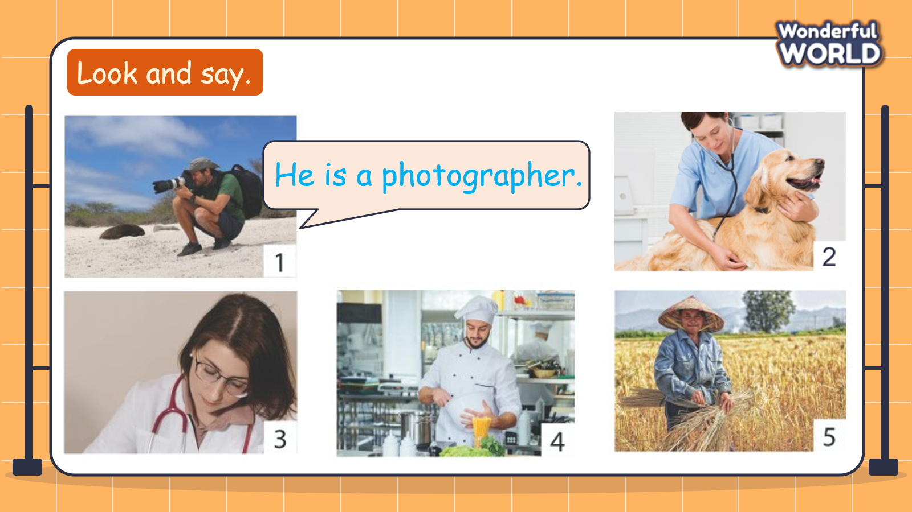  -Tell students to look at the picture for question 1 and ask who is in the picture. Elicit “a photographer”. Read out the example and ask students to repeat.  -Explain the rest of the task to students. Allow them  time to practise, saying the correct sentences  individually and in pairs. Go around the class helping  students when necessary.  - Ask volunteers to read out their answers. Correct  Mistakes if possible.  Suggested answer:  2 He is a vet.  3 She is a doctor.  4 He is a chef.  5 She is a farmer. | -Listen and read.  -Listen  -Read  -Listen and tick  -Check  -Check with the whole class  -Act out the dialogue in pairs  -Practice the dialogue in front of the class  -Join to the game  -Answer the question  -Practice
Activity 4: Production (9 minutes)
a. Aims: Apply structure to real world
b. Procedure:  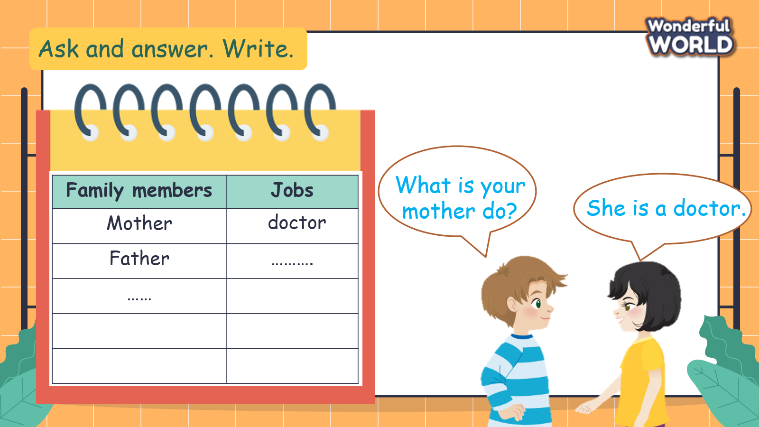  -Ask students to ask and answer about jobs of their family members in pairs, then write the answer on the table.  -Ask some pairs to present in front of class. | -Ask and answer the write
Activity 5: Assessment (3 minutes)
a. Aims: Do a quick exercise to consolidate the content of the lesson
b. Procedure:  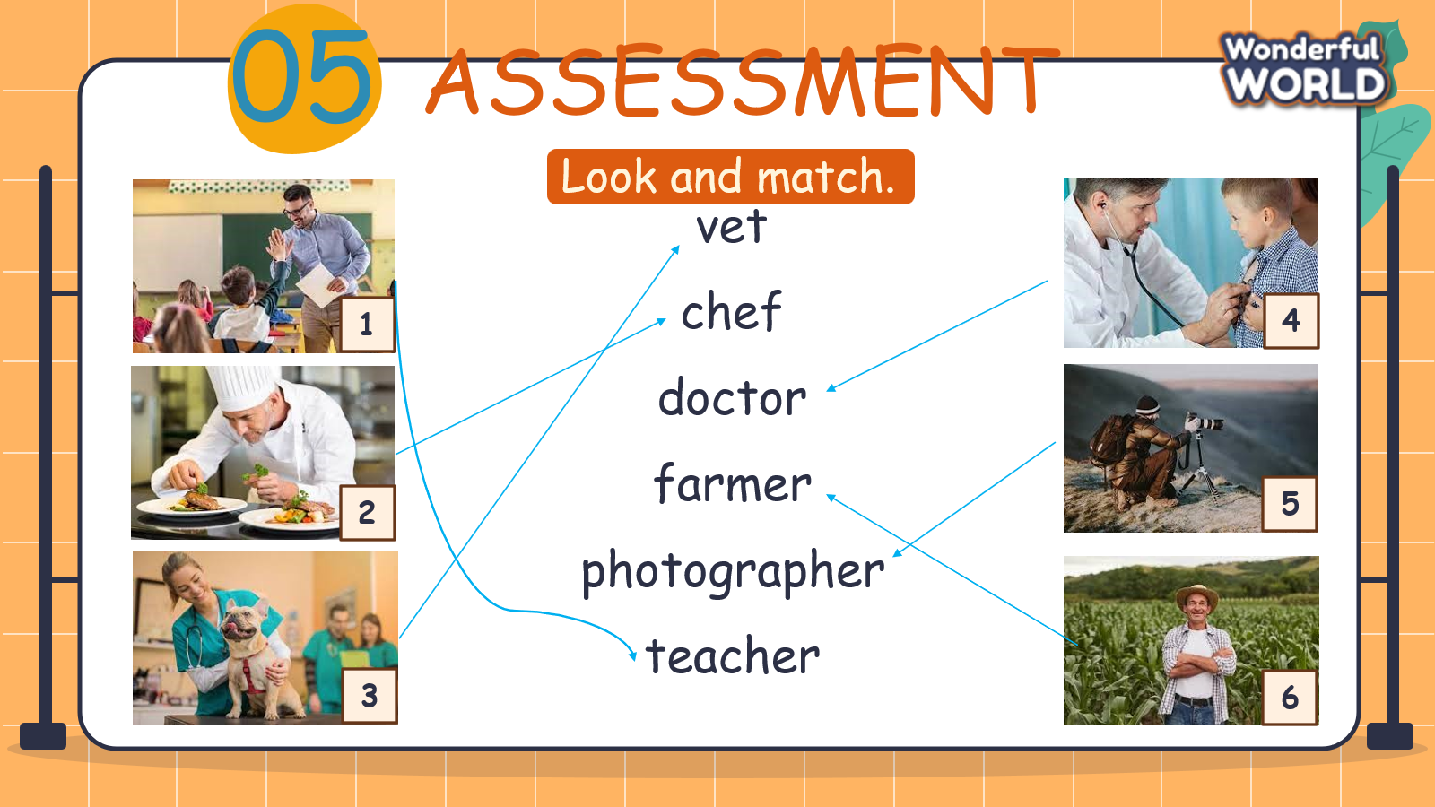  -Αsk students to look at the picture and elicit what foods they can see.  -Tell students they are going to look and match the pictures with the correct words  - Give an example.  -Αllow students enough time to complete the task individually. Go round the class helping students where necessary.  - Check students’answer and give comments  - Play the video, sing, do actions and ask students to sing along then say goodbye. | - Look at the picture and tell the foods in the picture.  - Listen to the teacher  - Complete the task  - Check the answers and listen to the teacher’s comments  - Stand up, sing and dance the say goodbye the teacher.
_______________________________
UNIT 7. JOBS
Lesson 1. Task 4, 5, 6
Period 72
I. OBJECTIVES:
1. Knowledge:
Students will review vocabulary: chef, doctor, farmer, photographer, vet and sentences:
● What does he do? - He’s a farmer.
● What does she do? - She’s a photographer
2. Competences:
- English competences: Students will be able to name some jobs.
- Common competences: Students will have opportunity to ask and answer questions
about someone’s job
3. Qualities:
- Students develop the love toward the jobs.
II. EQUIPMENT AND MATERIALS:
- For Teacher: PP, flashcards, handout, track 7.3
- For students: pens, student’s book.
III. LESSON PROCEDURE:

Activity 1: Warm up (5 minutes)
a. Aims: Warm up the class and get the students ready for the lesson by singing the song.
Teacher’s Activities | Students’ Activities
b. Procedure  Warm up by “Who am I?” game.  T read the clues and Ss guess what job it is before the time runs out.  Suggestions:  #1 : a chef  #2 : a teacher  #3 : a doctor  Then, listen to the song “JOBS SONG”  Link: https://www.youtube.com/watch?v=5rdlXji2jR0 | - Join the game.  - Listen to the songs.
Activity 2: Presentation (8 minutes)
a. Aims: Introduce the new sentences and help them to practice
Teacher’s Activities | Students’ Activities
b. Procedure  Listen and repeat. TR: 7.3  • To begin, ask students to look at and underline the sentences What does your father do? and He’s a farmer. In Activity 2. Tell them that it’s the way to ask and answer about what a person does in English and today they are going to learn more about how to ask and answer about people’s jobs.  • Tell students to look at the pictures and the sentences.  • Play the recording. Tell students to look at the pictures and follow the sentences with their fingers.  • Play the recording again. Ask students to repeat.  • Ask students to repeat the sentences. Let them know that this activity is linked to the next activity. | - Look  - Follow the sentences.  - Repeat.
Activity 3: Practice (14 minutes)
a. Aim: Controlled-practice to speak following a model conversation
Teacher’s Activities | Students’ Activities
b. Procedure  5 Look. Ask and Answer  Tell students to look at the pictures elicit the jobs that the pictures show.  • Tell students to look at the picture for question 1 and the example. Read out the example and ask students to repeat.  • Explain the rest of the task to students. Allow them enough time to practise saying the sentences individually and in pairs. Go round the class helping students where necessary.  • Ask volunteers to read out their answers. Correct any mistakes.  JOIN THE GAME “Happy Farmer”  • Suggested answer:  1 What does he do? He’s a chef.  2 What does he do? He’s a farmer.  3 What does he do? He’s a vet.  4 What does she do? She’s a student.  5 What does she do? She’s a teacher. | - Look  - Read out  - Answer the questions.
Activity 4: Production (9 minutes)
a. Aims: Apply the learned knowledge to act out the dialogue.
Teacher’s Activities | Students’ Activities
b. Procedure  6 Let’s talk  Tell students to look at the picture. Guide them to know what jobs they will be talking about.  • Tell students to look at the example dialogue.  • Read out the dialogue, pause after each sentence and ask students to repeat.  • Ask one or two students to act out the dialogue again.  • Ask students to work in pairs to talk about the jobs that they want to do in the future.  • Ask some volunteers to speak in front of the class. | - Talk  - Look  - Work in pair.
Activity 5: Assessment (3 minutes)
a. Aims: Consolidate the content of the lesson to evaluate how proficiency they are
Teacher’s Activities | Students’ Activities
b. Procedure  Let Sts do the assessment .  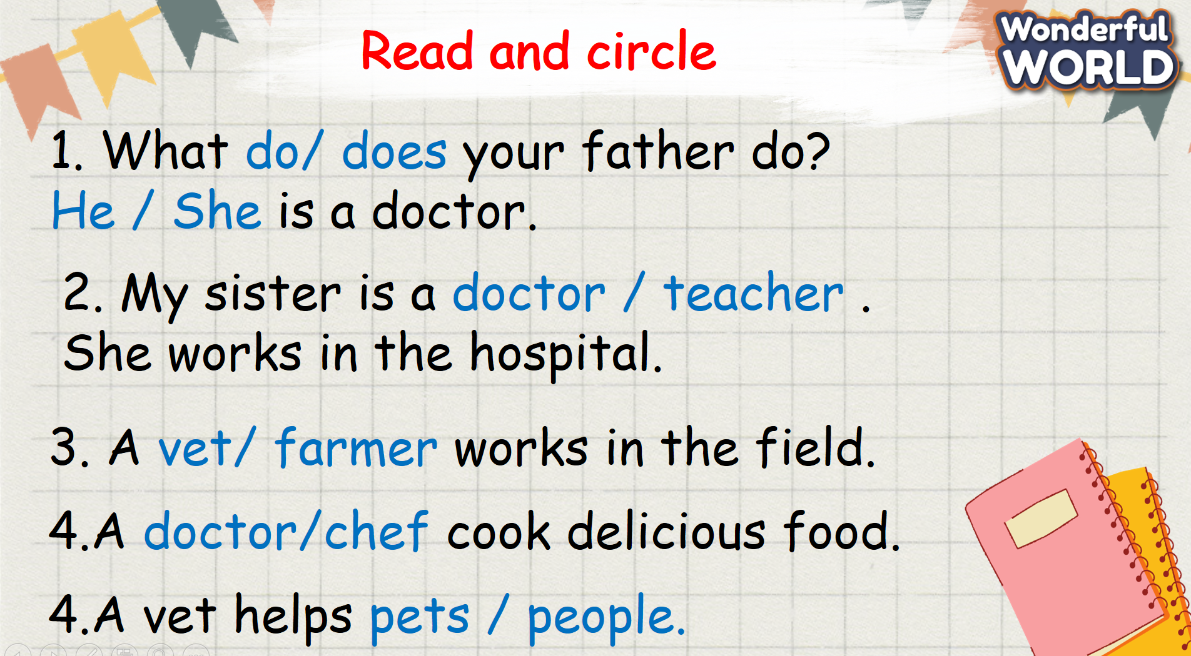 | Do the assessment .  