WEEK 19
UNIT 7. JOBS
Lesson 2. Task 1, 2, 3
Period 73
I. OBJECTIVES:
1. Knowledge:
- Students will review words related to the topic Jobs: in a hospital, in a restaurant, in a studio, in a clinic
- Learn and use new grammar: Where does he/she work?
2. Competences:
- English competences: Students will be able to use adverbs and nouns to describe the places of work.
- Common competences: Students will have the opportunity to develop logical thinking and develop communication among friends.
3. Qualities:
- Students develop thinking of the jobs and future and the adverbs in English.
- Be confident and active in communicating with friends and teachers.
II. EQUIPMENT AND MATERIALS:
- For Teacher: PPT, flashcards, blank papers, crayons, track 7.4, track 7.5.
- For students: textbook
III. LESSON PROCEDURE:

Activity 1: Warm-up (5 minutes)
Aim: warm-up activity to review the word and ways to introduce someone’s job from previous lesson.
Teacher’s Activities | Students’ Activities
- Greet the Ss  - Asks Ss to join a small game to review the word in previous lesson.  Warm-up: Play a small game “Catch the word”  T divides the class into 4 teams.  T introduces the rule of game:  (Game: Catch the word  - Each team will stand in lines. The first SS will be given a word and they must draw a picture according to that word.  After finishing, the picture will be passed down to the next one to re-draw. The last SS will write down the answer on the paper.  Each turn will last for 1’30s.)  T asks Ss to repeat after checking.    Lead in:  - T introduces that they will learn vocabulary about “Jobs” in English.  - Write on the board “Jobs” and introduce the lesson. | - Greet the teacher  - Listen and choose a team name  - Listen and play game in groups.  - Look at the images and guess the words  - Repeat.  - Listen to T.
Activity 2: Presentation (10 minutes)
Aim: Controlled practice: Help Ss to review and practice the vocabulary of Jobs.
Encourage Ss to make full sentences relating to Jobs.
Teacher’s Activities | Students’ Activities
Lead-in:  - Asks Ss about some jobs they know. Ask if they know what their family members’ do.  Presentation:  - T shows the 4 words in Lesson 1 and asks SS to listen and repeat.  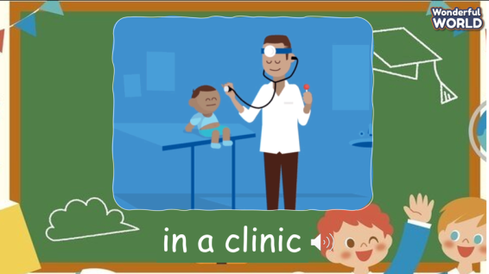 | - Discuss in groups  - Listen and answer.  - Repeat after the teacher.
Activity 3: Practice (12 minutes)
Aim: Practise new words, ask and answer using structure:
- What does he do?
- He’s a chef.
Encourage Ss to use long sentences while describe their activities.
Teacher’s Activities | Students’ Activities
Based on each tasks, T asks Ss to work individually, in pairs, or in groups  Task 1: Listen and point. Repeat. Track 7.4  - Tell students to look at the vocabulary box on page 80. Find out if they know any of the words.  - Play the recording for students to listen and point to the correct pictures.  - Play the recording again, pausing after each word for students to say  the word. Ask which people work inside, outside or both.  - Invite pairs of SS to read the words aloud.  - Give their feedback.  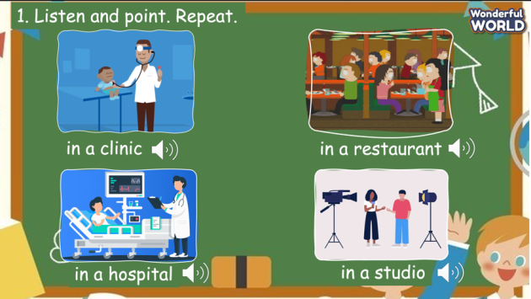  Task 2: Listen and read.  - Ask students to look at the photo and elicit what they can see.  - Point to the new words in the text. Read them out loud and ask students to repeat.  - Play the recording. Tell students to look at the picture and follow the  text with their fingers.  - Play the recording again, pause after each sentence and ask students to repeat.  - Give their feedback.  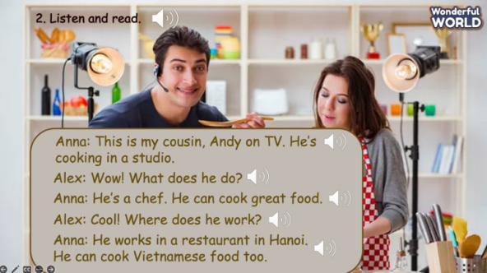  - Tell students to look at the sentences and the text and ask them what should be filled in the gap. Instruct them to look for similar sentences in the text. Elicit the correct answers.  - Ask students to practice reading the text in pairs and then ask volunteers to read the text aloud in front of the class.  Task 3: Match and say.  - Ask students to look at the pictures and elicit the job that the pictures show.  - Tell students to look at picture 1 and the example. Elicit that the man in the picture is a vet. Then read the example aloud and ask students to repeat after you.  Ask students to match the pictures with the places. Allow them enough time to complete the task. Check answer as the whole class.  - Put students in pairs and ask them to practice saying the sentences. Walk around and give help if necessary. Ask some volunteers to say the sentences in front of the class.  - Suggested answers:  1. He’s a vet. He works in a clinic.  2. He’s a chef. He works in a restaurant.  3. He’s a photographer. He works in a studio.  4. She’s a farmer. She works on a farm.  5. He’s a doctor. He works in a hospital  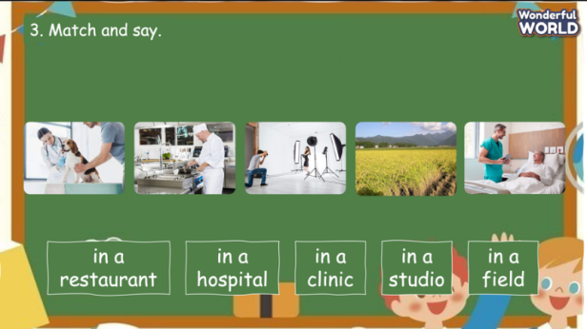 | - Look at the pictures and practice speaking in pairs.  - Work in pairs.  - Speak in front of the class.  - Look at the screen and listen to the whole conversation.  - Listen to each sentence and repeat.  - Practice the conversation in pairs.  - Speak in front of the class.  - Look at the pictures and elicit the job that the pictures show.  - Match the phrases with the pictures and create the full sentences.  - Speaking in front of the class.
Activity 4: Production (9 minutes)
Aim: Join the game to review the words and structure
Teacher’s Activities | Students’ Activities
Let’s talk  - Ask SS to play a game “Who wants to be a millionaire”.  - Introduce the rule of game.  (the rule of game: Who wants to be a millionaire  T divides the class into 4 groups. Each group will have a bell.  When the question is opened, each group will ring the bell to answer.  If the answer is correct, that group will get 1 point. If not, the chance is given to the other team.  When the game finishes, the group with higher score will win.)   | - Listen.  - Play the game.  - Take turn to answer the questions until the last ones.  - Check the final result.
Activity 5: Assessment (3 minutes)
Aim: Do the exercise to review and remember the words.
Consolidate the content of the lesson.
Teacher’s Activities | Students’ Activities
- Review the words that have learnt in the lesson without looking at the book.  - Ask sts to do the assessment.  - Check with the class.  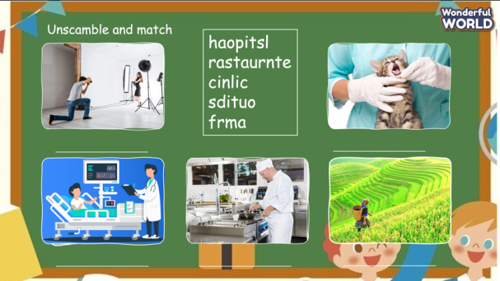 | - Do the assessment individually.  - Check with the teacher.
____________________________________
UNIT 7. JOBS
Lesson 2. Task 4, 5, 6
Period 74
I. OBJECTIVES:
1. Knowledge:
Students will review words related to the topic Jobs: in a hospital, in a clinic, in a restaurant, in a studio and structures:
- Where does he work?
- He works in a restaurant.
2. Competences:
- English competences: Students will be able to use adverbs and nouns to describe the places of work.
- Common competences: Students will have the opportunity to develop logical thinking and develop communication among friends.
3. Qualities:
- Students develop love ancient time and the adjective in English.
- Be confident and active in communicating with friends and teachers.
II. EQUIPMENT AND MATERIALS:
- For Teacher: PPT, flashcards, blank papers, crayons, track 7.6, track 7.7
- For students: textbook
III. LESSON PROCEDURE:
Activity 1: Warm-up (5 minutes)
Aim: warm-up activity to review the word from previous lesson and introduce the topic.
Teacher’s Activities | Students’ Activities
Greet the Ss  Asks the Ss to join the game to review the words in the previous lesson.  Warm-up: Play a small game “Cowboy game”  T divides the class into 2 teams.  T introduces the rule of game:  (Game: Cowboy game  - Each turn will have two SS from each team. 2 SS stand, face their backs to each other. Each S will be given a picture. When T counts 1,2,3, the two will turn back and look at the other’s picture and read that word aloud. Who read it correctly and faster will be the winner.  - The game will last for 7 rounds.)  T asks Ss to repeat after checking.    Lead in:  - T raises some pictures and ask Ss to guess the topic of the lesson  - T introduces that they will learn vocabulary about “Cool places” in English.  - Write on the board “Cool places” and introduce the lesson. | - Greet the T  - Listen to the rule of the game  - Listen and play game.  - Stand in the point and hold the pictures.  - Turn back when hearing the signal.  - Check the result.  - Repeat.  - Listen to T.
Activity 2: Presentation (10 minutes)
Aim: Controlled practice: Help Ss to review the words in previous lesson and practice the vocabulary of Jobs.
Encourage Ss to make full sentences relating to Jobs.
Teacher’s Activities | Students’ Activities
- Use flashcards to introduce the vocabulary and structure of the lesson.  - Say the words/sentences for students to repeat in the chorus.  - Say a word/sentence for students to repeat then point.  - Play the track for the students to listen to, point to, and repeat the words in chorus, and group.  - Show pictures in random order and ask students to read out the correct words.  - T shows the 4 words in previous lesson and asks SS to listen and repeat again.  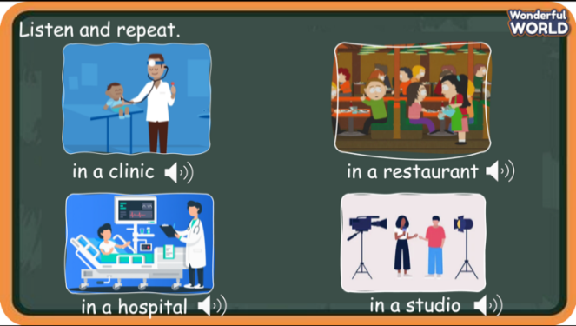  Task 4:  - To begin, ask students to look at and underline the sentence Where does he work? He works in a restaurant in Hanoi. in Activity 2. Tell them that they are going to learn more about how to ask and answer about the places where people work.  - Tell students to look at the pictures and the sentences.  - Play the recording. Tell students to look at the pictures and follow the sentences with their fingers.  - Play the recording again. Ask students to repeat.  - Ask students to repeat the sentences. Let them know that this activity is linked to the next activity  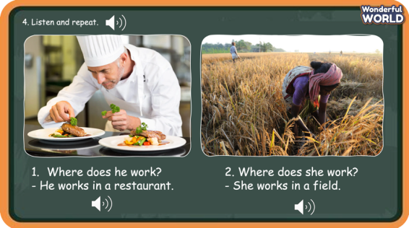 | - Discuss with the T and the class  - Listen and answer.  - Listen and repeat after each word  - Listen and repeat in chorus  - Repeat after the teacher.  - Look at the books and listen and point at the pictures.  - Listen and remember the adverbs going with each place.  - Repeat after teacher.  - Ask and answer in front of the class.
Activity 3: Practice (12 minutes)
Aim: Practise new words, ask and answer using structure:
- Where does he work?
- He works on a farm.
Encourage Ss to use long sentences while describe the jobs.
Teacher’s Activities | Students’ Activities
Based on each tasks to ask Ss work individual, in pairs, or in groups.  Task 5.  - Tell students to look at the pictures and the prompts. Read out the prompts and ask students to repeat.  - Tell students to look at the picture for question 1 and the example. Read out the example and ask students to repeat.  - Explain the rest of the task to students. Allow them enough time to practice saying the sentences individually and in pairs. Go round the class helping students where necessary.  - Ask volunteers to read out their answers. Correct any mistakes.  - Suggested answer:  2 Where does Teacher Mai work? - She works in Thang Long school.  3 Where does Mr. Lee work?- He works in a studio.  4 Where does Doctor Minh work?- He works in Bach Mai hospital.  - Invite pairs of SS to read the words aloud.  - Give their feedback.  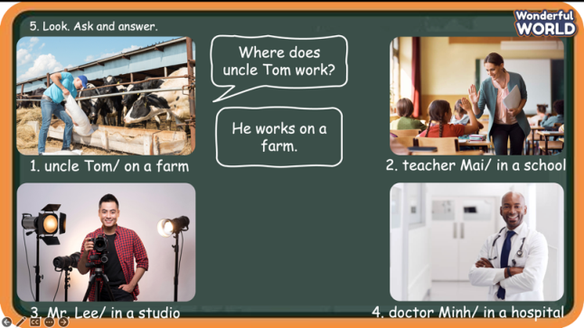  Task 6. Listen and chant.  - Tell students they are going to learn a chant about jobs. Ask students to read the song quickly and find two jobs (vet, chef). Ask which one is in the photo.  - Play the recording again and tell students to listen and follow the words with their fingers.  - Read out the chant one line at a time and ask students to repeat after T.  - Play the recording again. Encourage students to chant along. Practice several times until students are familiar with the words and sounds.  - Optional activity: Ask students to practice the chant individually and then pairs or in groups.  For example, one group can chant the first verse, and the other group can chant the second verse.  - Ask SS to work in groups of 4 and chant, then present in front of the class.  - Give their feedback.  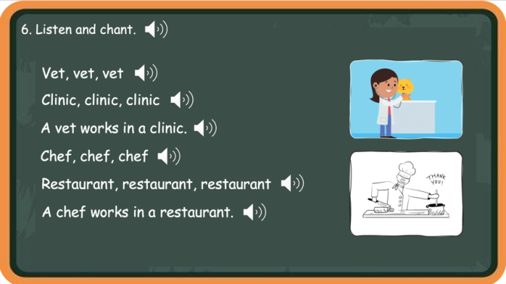 | - Look at the screen and listen to the T.  - Work in pairs. Do the role-play to ask and answer.  - Speak in front of the class.  - Figure out the jobs in the chant.  - Read the chant for the first time.  - Listen to the audio.  - Listen and learn to chant each sentence.  - Practice to chant the whole paragraph.  - Present in front of the class.
Activity 4: Production (9 minutes)
Aim: Join the game to review the words and structure actively
Teacher’s Activities | Students’ Activities
Introduce the rule of the game and create an exciting environment that can attract Ss  Let’s talk  - Ask SS to play a game “Football game”.  - Introduce the rule of game.  (the rule of game: Football game  T divides the class into 2 groups. Each group will choose a name and play rock, scissors, paper to decide which group goes first.  The two groups will take turns to choose a letter answer the corresponding questions.  If the answer is correct, T will click on the ball to make it move. If not, the chance is given to the other team.  Which team can bring to ball to the goal, or closer to the goal, they will win.)   | - Listen.  - Play the game.  - Take turns to answer the question.  - Pay attention to get the chance to answer when the first team gives out the incorrect one.  - Check the result with teacher.
Activity 5: Assessment (3 minutes)
Aim: Do the exercise to review and remember the words.
Consolidate the content of the lesson.
Teacher’s Activities | Students’ Activities
- Asks Ss about the words they have learnt in the lesson without looking at the book.  - Asks sts to do the assessment.  - Checks with the class.  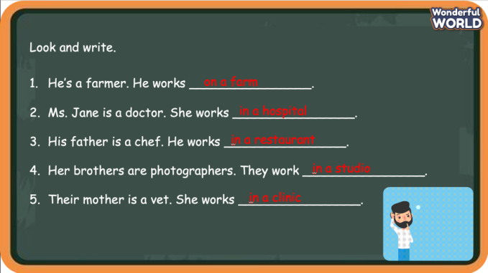 | -Do the assessment individually.  - Check with the teacher.
__________________________________
UNIT 7. JOBS
Lesson 2. Task 7, 8, 9
Period 75
I. OBJECTIVES:
1. Knowledge:
Review vocabulary: in a hospital, in a restaurant, in a studio, in a clinic and structures:
- Where does he work? – He works in a restaurant.
- Where does she work? – She works in a field.
2. Competences:
- English competences: Students will be able to talks about common jobs and the work places.
- Common competences: Students will have the opportunity to develop logical thinking and develop communication among friends.
3. Qualities:
- Students develop knowledge about jobs and occupations.
- Be confident and active in communicating with friends and teachers.
II. EQUIPMENT AND MATERIALS:
- For Teacher: PPT, flashcards, blank papers, crayons, track 7.8
- For students: textbook
III. LESSON PROCEDURE:

Activity 1: Warm-up (5 minutes)
Aim: warm-up activity to review the word in previous lesson and introduce the topic.
Teacher’s Activities | Students’ Activities
Greet the Ss  Asks the Ss to join the game to review the words in the previous lesson.  Warm-up: Play a small game “Pass the bomb”  T invites a group of students, standing in a circle.  T introduces the rule of game:  (Game: Pass the bomb  - One S will be given a ball.  - T plays a song and counts 1,2,3 to start the game.  - The S with the ball will say a word relating to before our time topic and pass the bomb to the one in their left.  - T will stop the song randomly. When the song is stopped, the one with the ball will lose and they will take the fine (dancing along or singing, etc.)  T asks Ss to repeat after checking.    Lead in:  - T introduces that they will review vocabulary about “Jobs” in English.  - Write on the board “Jobs” and introduce the lesson. | - Greet the T  - Stand in the circle to prepare and join the game  - Listen and play game.  - Receive and follow the fine  - Repeat.  - Listen to T.
Activity 2: Review (10 minutes)
Aim: review some places of work and asking and answering about someone’s job using structure
Where does he work? - He works in a restaurant.
Teacher’s Activities | Students’ Activities
- Use flashcards to introduce the vocabulary and structure of the lesson.  - Say the words/sentences for students to repeat in the chorus.  - Say a word/sentence for students to repeat then point.  - Play the track for the students to listen to, point to, and repeat the words in chorus, and group.  - Show pictures in random order and ask students to read out the correct words.  - T shows the 4 words in previous lesson and asks SS to listen and repeat again.  Presentation:  - T shows the words then asks SS to repeat.  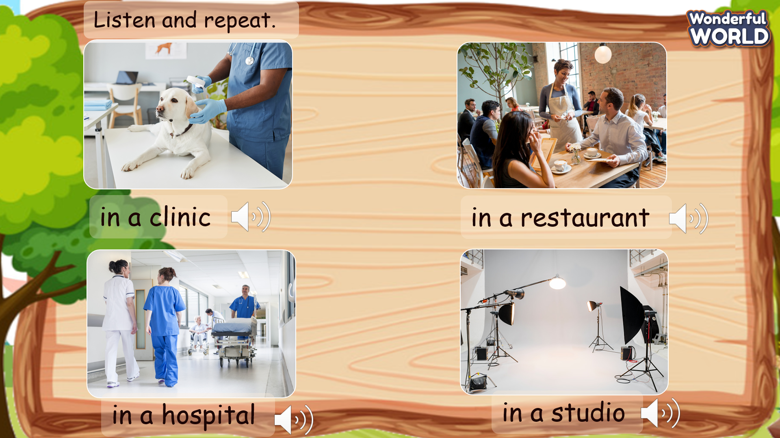 | - Look at the pictures and repeat the words/sentences.
Activity 3: Practice (12 minutes)
Aim: Guide some exercises to practise asking and answering about someone’s work
Teacher’s Activities | Students’ Activities
Based on each tasks to ask Ss work individual, in pairs, or in groups.  Task 7. Listen and circle. TR 7.8  - Tell students they are going to listen to some sentences and circle the correct answers.  - Ask students to read through sentences 1 – 4 and the options.  - Play the recording and tell students to listen and circle the correct answers for sentences 1– 4. Play the recording more than once if students cannot catch the answers.  - Play the recording again and pause after each sentence to check answers  - Invite SS to read their answers aloud.  - Ask SS to listen again and check the answer.  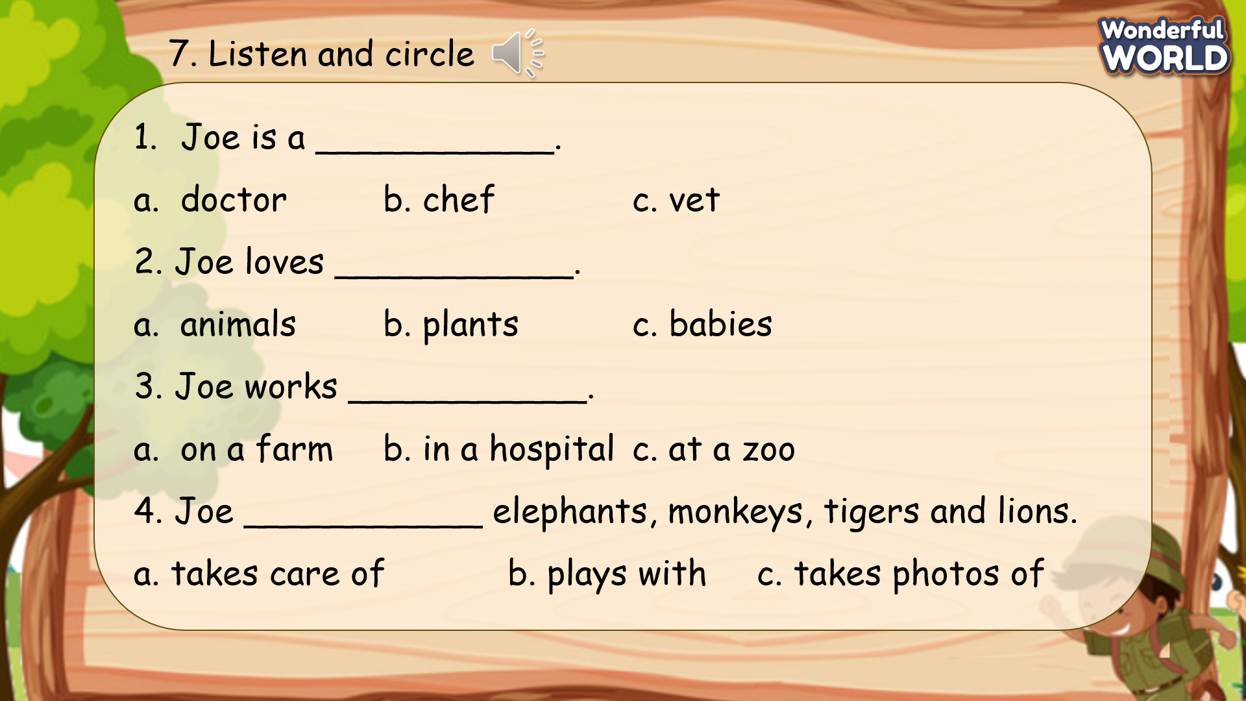  Task 8. Look, ask and answer.  - Point to the sentences. Explain that students must use words about jobs and feelings that they have learnt to fill in the blanks.  - Use the example provided in sentences 1 to explain the task to the students.  - Ask students to fill in the gaps and practice saying the sentences.  Go around the class helping where necessary.  - Ask volunteers to ask and answer in front of the class. Correct any mistakes.  - Give their feedback.  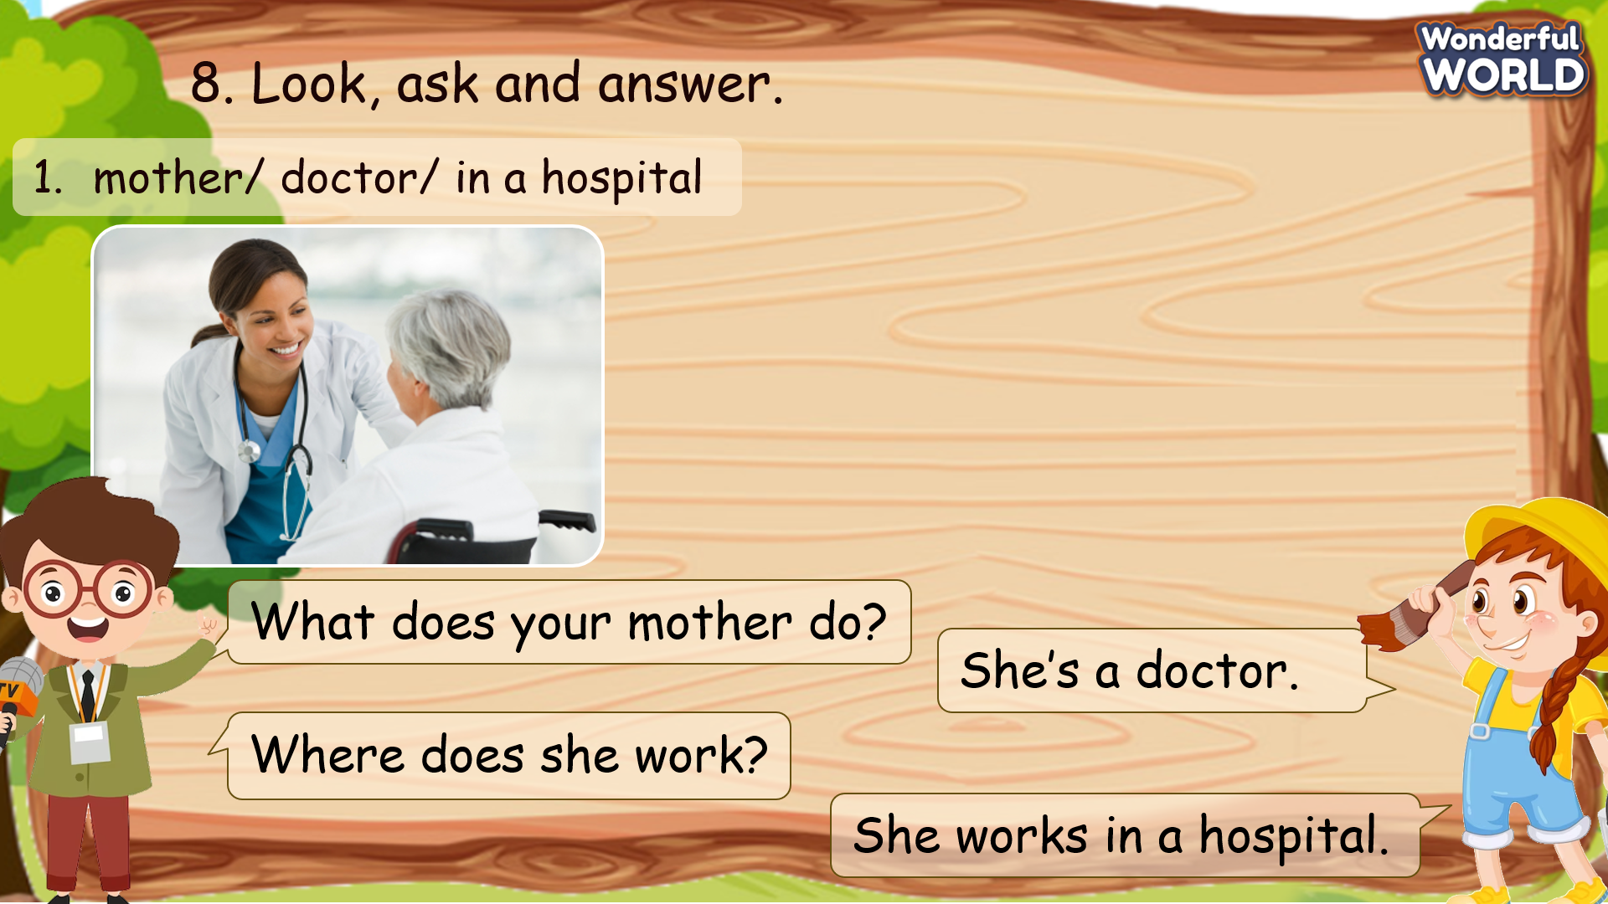 | - Look at the questions and read through the sentences.  - Listen to the record and circle the answers.  - Listen again and present their answers.  - Check the answer with T.  - Look at the sentences and practice the structure with the sample sentence.  - Look at the words and make the conversations in pairs.  - Role-play to present the conversation.
Activity 4: Production (9 minutes)
Aim: Expand knowledge by thinking about the work of Ss’ family members
Play a small game to review the words and structure
Teacher’s Activities | Students’ Activities
Task 9. Let’s talk.  - Tell students they are going to talk about the jobs of their family members.  - Tell students to look at the pictures and the dialogue.  - Read out the dialogue. Read it out again, pause after each sentence and ask students to repeat.  - Ask one or two students to read out the dialogue.  - Ask students to work in pairs to practice their dialogues.  - Ask some volunteers to speak in front of the class  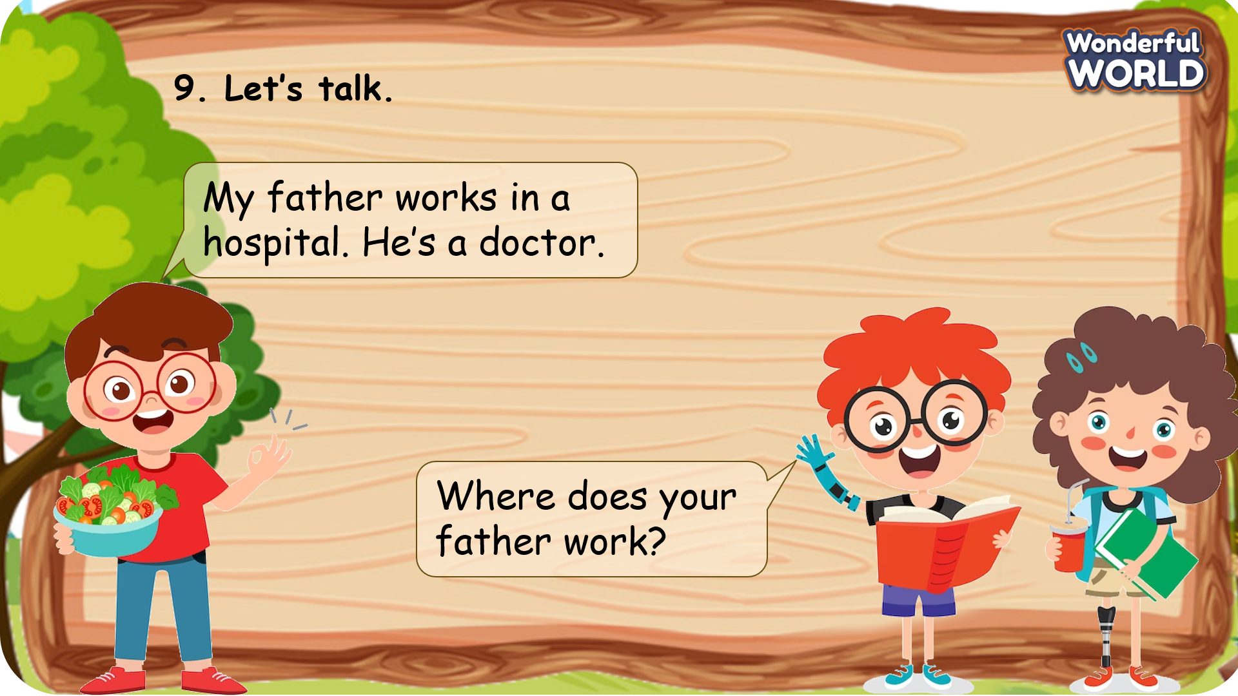  Introduce the rule of the game and create an exciting environment that can attract Ss  Mini game: Super Mario  - Ask SS to play a game “Super Mario”.  - Introduce the rule of game.  T divides the class into 2 groups. Each group will choose a name and play rock, scissors, paper to decide which group goes first.  The two groups will take turns to answer the questions.  Click on the face of the mushroom to choose a question (check the arrow).  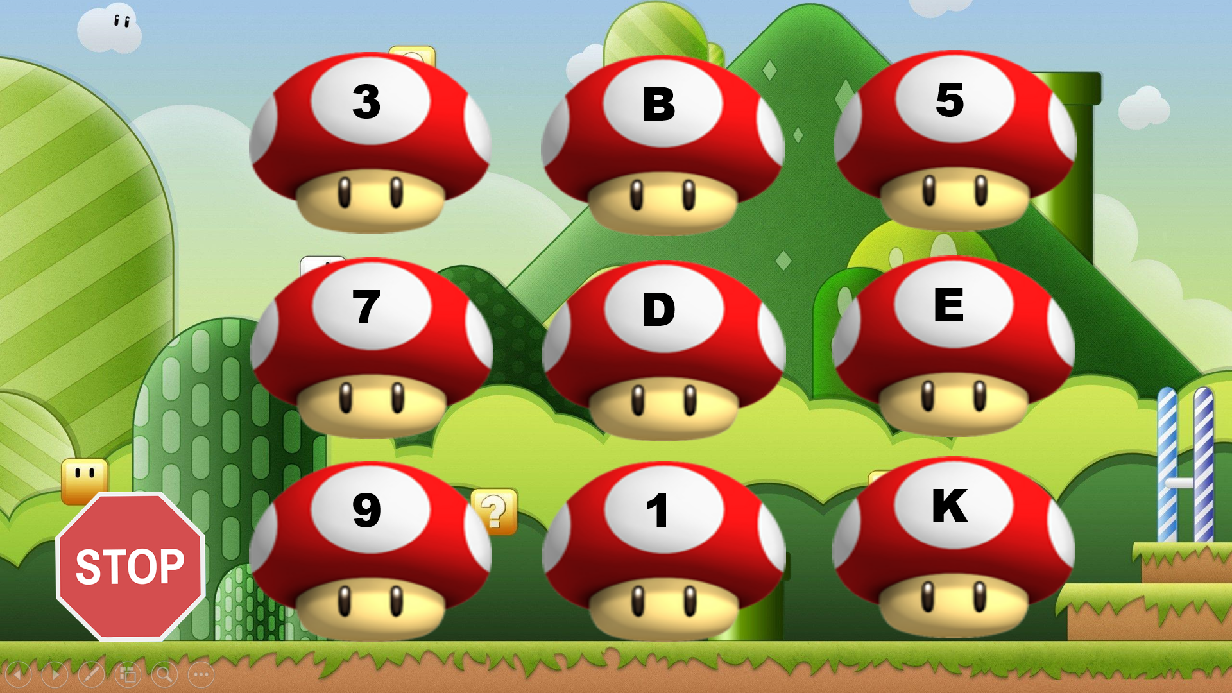  If the answer is correct, they will get the score. Click on the Mario icon to check the score (check the arrow). If not, the chance is given to the other team.  The rule to give the score:  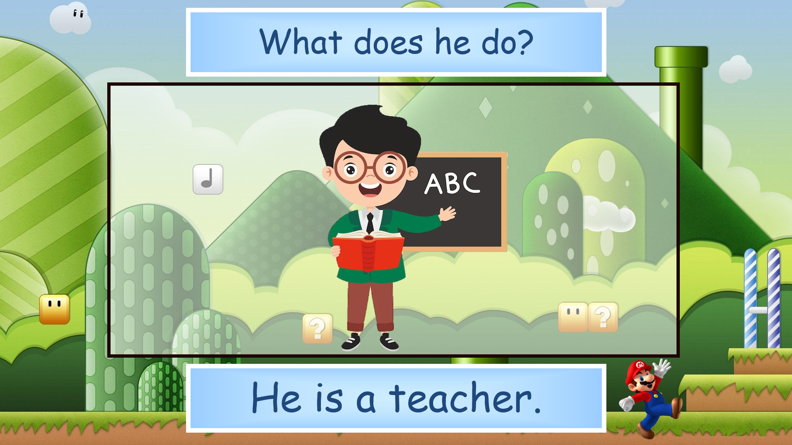  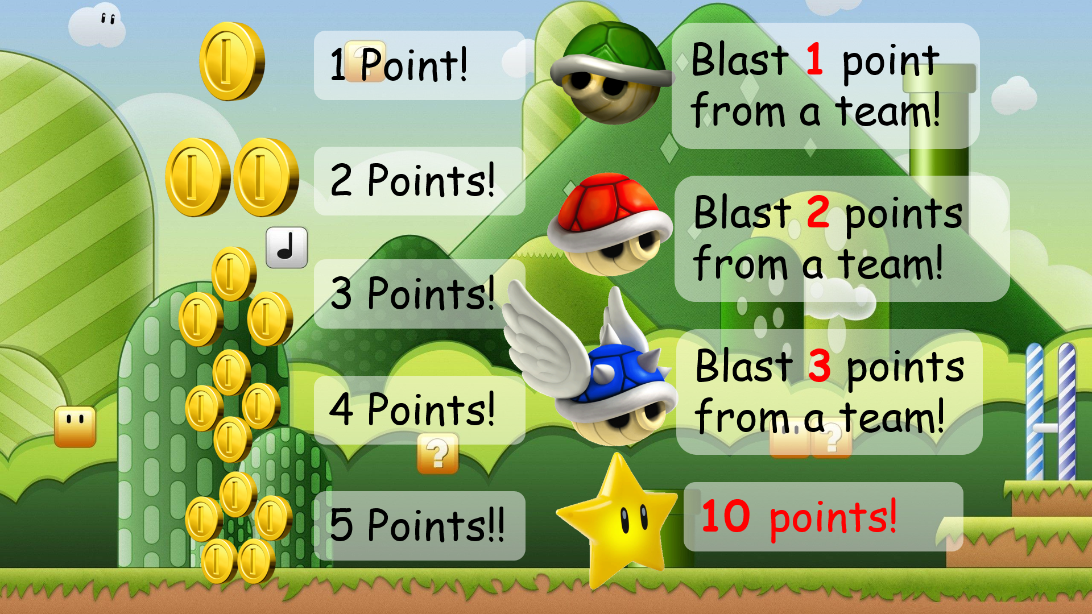    At the end, the team with higher score will win the game. | - Look at the example on the screen.  - Practice the example.  - Work in pair to make other conversations.  - Role-play and present the conversations in front of the class.  - Play the game.  - Choose a team name and play rock, scissors, paper to decide who goes first.  - Take turns to answer the questions.  - Check the result.
Activity 5: Assessment (3 minutes)
Aim: Do the exercise to review and remember the words
Consolidate the content of the lesson.
Teacher’s Activities | Students’ Activities
- Asks Ss about the words they have learnt in the lesson without looking at the book.  - Ask SS to do the assessment.  - Check with the class.  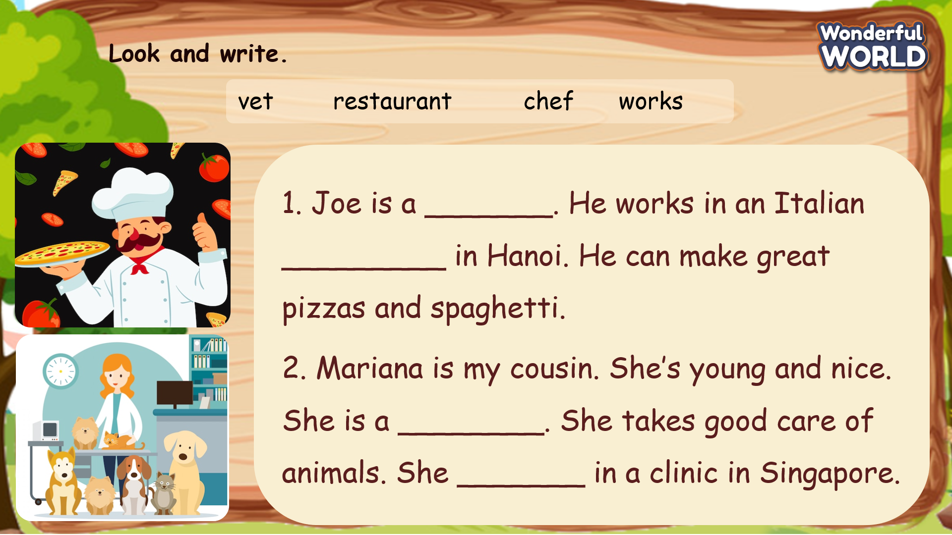 | - Do the assessment.  - Check with the teacher.
________________________________________
UNIT 7. JOBS
Lesson 3. Task 1, 2, 3
Period 76
I. OBJECTIVES:
1. Knowledge:
Students will learn new words related to the topic Jobs: firefighter, feed animals, put out fires, take care of
2. Competences:
- English competences: Students will be able to talk about some specific jobs such as firefighter or doctor, vet and the places of work.
- Common competences: Students will have the opportunity to develop knowledge about firefighter and develop communication among friends.
3. Qualities:
- Students develop knowledge about the jobs and how to describe one’s job in English.
- Be confident and active in communicating with friends and teachers.
II. EQUIPMENT AND MATERIALS:
- For Teacher: PPT, flashcards, blank papers, crayons, track 7.9, track 7.10.
- For students: textbook
III. LESSON PROCEDURE:
Activity 1: Warm-up (5 minutes)
Aim: warm-up activity to review the word in previous lesson and introduce the topic.
Teacher’s Activities | Students’ Activities
Greet the Ss  Asks the Ss to join the game to review the words in the previous lesson.  Warm-up: Watch the video We Are Firefighters! | Job Songs for Kids | Occupations  Link: https://www.youtube.com/watch?v=-mEcaOmiw3Y&ab_channel=PinkfongBabyShark-Kids%27Songs%26Stories    Lead in:  - Ask SS what they see in the video. Encourage them to guess the job.  - T introduces that they will learn vocabulary about “Jobs” in English.  - Write on the board “Jobs” and introduce the lesson. | - Greet the T  - Listen and watch the video.  - Try to dance along.  - Try to remember the job and the activity in the video.  - Repeat.  - Listen to T.
Activity 2: Presentation (10 minutes)
Aim: Controlled practice: Help Ss to know the new words and practice the vocabulary of Jobs.
Encourage Ss to make full sentences to describe one’s Job.
Teacher’s Activities | Students’ Activities
- Use flashcards to introduce the vocabulary and structure of the lesson.  - Say the words/sentences for students to repeat in the chorus.  - Say a word/sentence for students to repeat then point.  - Play the track for the students to listen to, point to, and repeat the words in chorus, and group.  - Show pictures in random order and ask students to read out the correct words.  - T shows the 4 words in previous lesson and asks SS to listen and repeat again.  Presentation:  - T shows the 4 words in Lesson 3 and asks SS to listen and repeat.  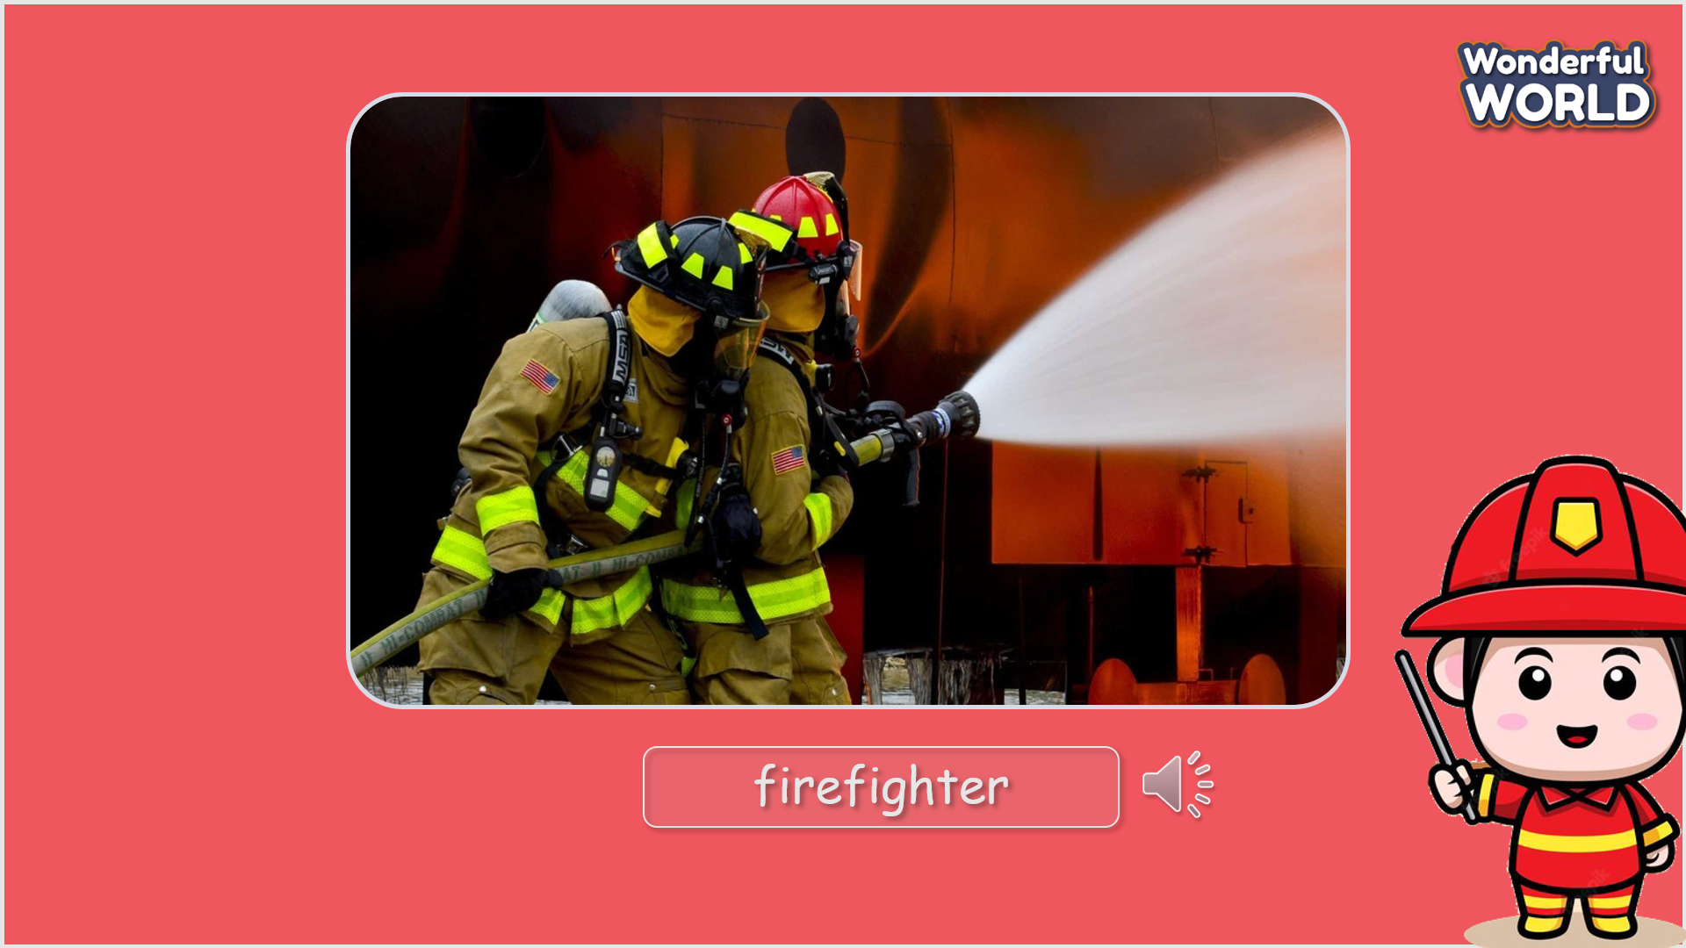 | - Listen and answer.  - Listen to the audio for the first time.  - Repeat after the teacher.
Activity 3: Practice (12 minutes)
Aim: Practise new words, ask and answer using structure:
- What does a firefighter do? – A firefighter puts out the fires.
Practice listening and reading by listen to and read a dialogue about someone’s job.
Teacher’s Activities | Students’ Activities
Based on each tasks to ask Ss work individual, in pairs, or in groups.  Task 1: Listen and point. Repeat. Track 7.9  - Tell students to look at the vocabulary box on page 84. Ask if they know any of the words. Play the recording for students to listen and point to the correct pictures.  - Play the recording again, pausing after each word for students to say the word.  - Invite SS to read the words aloud.  - Give feedback.  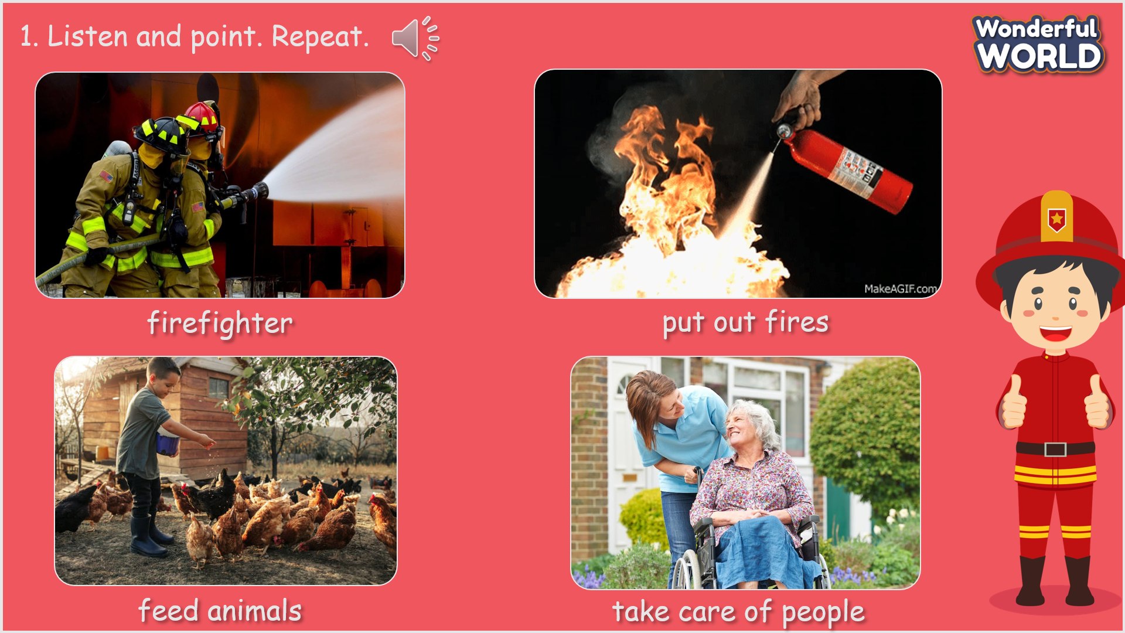  Task 2: Listen and tick.  - Ask students to look at the photo and elicit what they can see.  - Ask students to look at the sentences below the picture. Read the sentences and the options.  - Play the recording and ask students to listen and tick the correct options.  Play the recording more than once if students cannot catch all the answers.  - Play the recording again and pause after each sentence to check answers.  - Elicit the answer from students and check with the whole class.  - Ask students to act out the dialogue in pairs. Ask some volunteers to act it out in front of the whole class.  - Listen again and check.  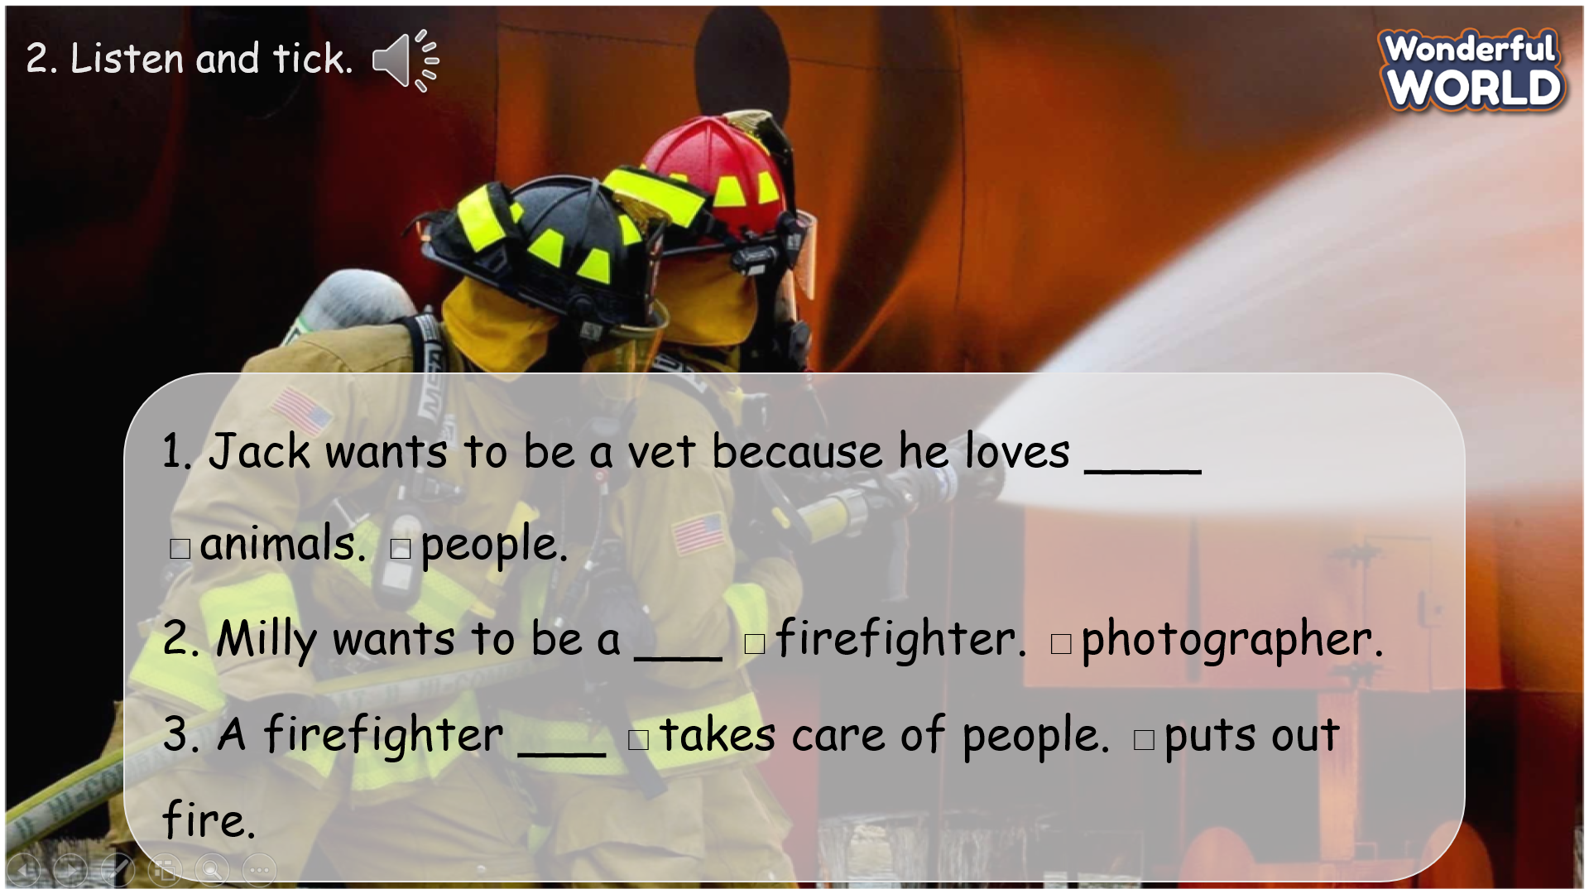 | - Look at the screen and discuss the words.  - Listen to the audio and point.  - Listen and gain and read the words aloud.  - Look at the photo and figure out the structures.  - Listen to the recording and tick the answers.  - Listen again and check the answers.  - Role-play and make the conversation again in front of the class.
Activity 4: Production (9 minutes)
Aim: Practise speaking
Join a small game to revive the words and structure
Teacher’s Activities | Students’ Activities
Task 3: Look and say.  - Ask students to look at the pictures and elicit the job that the pictures  show.  - Tell students to look at picture 1 and the example. Elicit that the man in the picture is a vet. Then read the example aloud and ask students to repeat after the T.  - Ask students to match the pictures with the places. Allow them enough time to complete the task.  - Check answer as the whole class.  - Put students in pairs and ask them to practice saying the sentences.  Walk around and give help if necessary. Ask some volunteers to say the sentences in front of the class.  - Give their feedback.    Mini game: Stop the bus  - Ask SS to play a game “Luck wheel”.  - Introduce the rule of game.  T divides the class into 2 groups. Each group will choose a name and play rock, scissors, paper to decide which group goes first.  The two groups will take turns to answer the questions.  If the answer is correct, they will get the score If not, the chance is given to the other team.  At the end, the team with higher score will win the game.  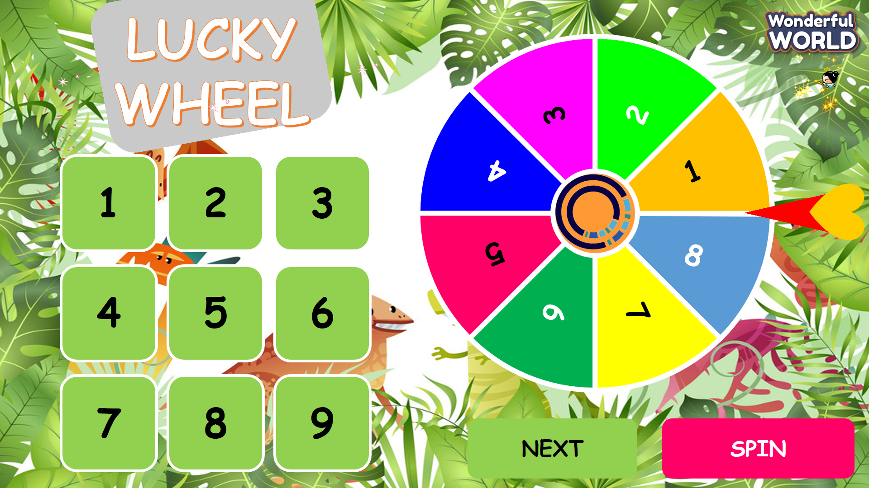 | - Look at the pictures and elicit the job that the pictures show.  - Look at the picture 1 and example, repeat after the T.  - Match the pictures and present in front of the class.  - Check the answers.  - Play the game.  - Choose a team name and play rock, scissors, paper to decide who goes first.  - Take turns to answer the questions.  - Check the result.
Activity 5: Assessment (3 minutes)
Aim: Do the exercise to review and remember the words
Consolidate the content of the lesson.
Teacher’s Activities | Students’ Activities
- Asks Ss about the words they have learnt in the lesson without looking at the book.  - Ask sts to do the assessment.  - Check with the class.  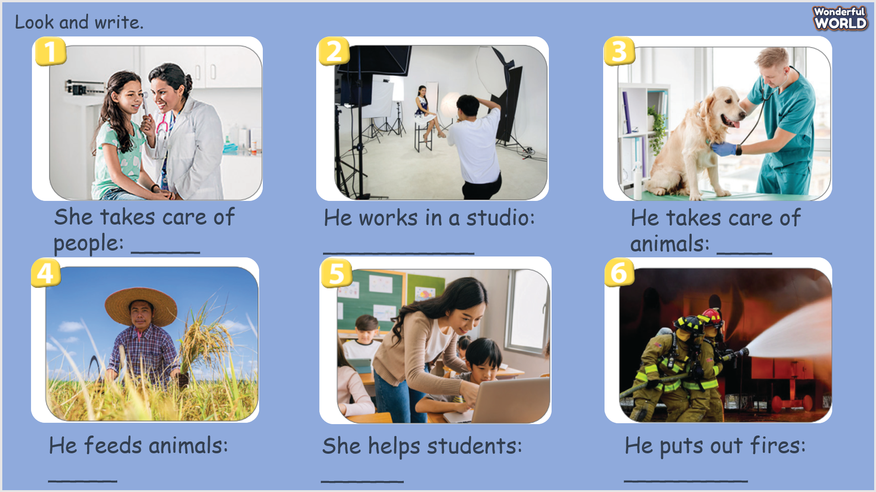 | -Do the assessment.  - Check with the teacher.
________________________

