TUẦN 21 Khối 3, 5 (Từ ngày 10/02/2025 đến ngày 14/02/2025)
THỨ | TIẾT | MÔN | TIẾT THỨ | NỘI DUNG BÀI DẠY |  | UDCNTT | ĐỒ DÙNG DẠY HỌC
Hai  10/02 | 1 | 5A | 81 | Unit 8. People and places | Lesson 1 (4, 5, 6) | Wonderfulworld | Flashcards, TV, books
Hai  10/02 | 2
Hai  10/02 | 3 | 3A | 81 | Unit 7. My favourite sport | Lesson 1 (4, 5, 6) | Wonderfulworld | Flashcards, TV, books
Hai  10/02 | 4 | 3A | 82 | Unit 7. My favourite sport | Lesson 2 (1, 2, 3) | Wonderfulworld | Flashcards, TV, books
Hai  10/02 | 5 | 5D | 81 | Unit 8. People and places | Lesson 1 (4, 5, 6) | Wonderfulworld | Flashcards, TV, books
Hai  10/02 | 6 | 3B | 81 | Unit 7. My favourite sport | Lesson 1 (4, 5, 6) | Wonderfulworld | Flashcards, TV, books
Hai  10/02 | 7
Ba  11/02 | 1 | 5C | 81 | Unit 8. People and places | Lesson 1 (4, 5, 6) | Wonderfulworld | Flashcards, TV, books
Ba  11/02 | 2 | 5B | 81 | Unit 8. People and places | Lesson 1 (4, 5, 6) | Wonderfulworld | Flashcards, TV, books
Ba  11/02 | 3 | 5A | 82 | Unit 8. People and places | Lesson 2 (1, 2, 3) | Wonderfulworld | Flashcards, TV, books
Ba  11/02 | 4
Ba  11/02 | 5 | 3A | 83 | Unit 7. My favourite sport | Lesson 2 (4, 5, 6) | Wonderfulworld | Flashcards, TV, books
Ba  11/02 | 6 | 5D | 82 | Unit 8. People and places | Lesson 2 (1, 2, 3) | Wonderfulworld | Flashcards, TV, books
Ba  11/02 | 7 | 3B | 82 | Unit 7. My favourite sport | Lesson 2 (1, 2, 3) | Wonderfulworld | Flashcards, TV, books
Tư  12/02 | 1 | 5A | 83 | Unit 8. People and places | Lesson 2 (4, 5, 6) | Wonderfulworld | Flashcards, TV, books
Tư  12/02 | 2
Tư  12/02 | 3
Tư  12/02 | 4
Tư  12/02 | 5 | 5B | 82 | Unit 8. People and places | Lesson 2 (1, 2, 3) | Wonderfulworld | Flashcards, TV, books
Tư  12/02 | 6 | 5C | 82 | Unit 8. People and places | Lesson 2 (1, 2, 3) | Wonderfulworld | Flashcards, TV, books
Tư  12/02 | 7
Năm  13/02 | 1 | 5C | 83 | Unit 8. People and places | Lesson 2 (4, 5, 6) | Wonderfulworld | Flashcards, TV, books
Năm  13/02 | 2 | 5B | 83 | Unit 8. People and places | Lesson 2 (4, 5, 6) | Wonderfulworld | Flashcards, TV, books
Năm  13/02 | 3 | 5A | 84 | Unit 8. People and places | Lesson 3 (1, 2, 3) | Wonderfulworld | Flashcards, TV, books
Năm  13/02 | 4
Năm  13/02 | 5 | 5D | 83 | Unit 8. People and places | Lesson 2 (4, 5, 6) | Wonderfulworld | Flashcards, TV, books
Năm  13/02 | 6 | 5C | 84 | Unit 8. People and places | Lesson 3 (1, 2, 3) | Wonderfulworld | Flashcards, TV, books
Năm  13/02 | 7
Sáu  14/02 | 1 | 3B | 83 | Unit 7. My favourite sport | Lesson 2 (4, 5, 6) | Wonderfulworld | Flashcards, TV, books
Sáu  14/02 | 2 | 5D | 84 | Unit 8. People and places | Lesson 3 (1, 2, 3) | Wonderfulworld | Flashcards, TV, books
Sáu  14/02 | 3 | 5B | 84 | Unit 8. People and places | Lesson 3 (1, 2, 3) | Wonderfulworld | Flashcards, TV, books
Sáu  14/02 | 4
Sáu  14/02 | 5
Sáu  14/02 | 6 | 3B | 84 | Unit 7. My favourite sport | Lesson 3 (1, 2, 3) | Wonderfulworld | Flashcards, TV, books
Sáu  14/02 | 7 | 3A | 84 | Unit 7. My favourite sport | Lesson 3 (1, 2, 3) | Wonderfulworld | Flashcards, TV, books

GRADE 3

WEEK 21 (FROM 10/02 TO 14/02)
UNIT 7. MY FAVOURITE SPORT
Lesson 1 - Task 4,5,6
Period 81
I. OBJECTIVES:
1. Knowledge:
Students will learn the new grammar: present continuous (affirmative) related to the topic Sport.
2. Competences:
- English competences: Students will be able to talk about things happening now related the sport activities.
- Common competences: Students will have opportunity to develop the autonomy in doing tasks and communication among friends.
3. Qualities:
- Students will have opportunity to talk about the sport activites
- Students will be friendly and confident in communicating with friends.
II. EQUIPMENT AND MATERIALS:
- Basic things: Student’s book, flashcards.
- Advanced things: PPT, projector/interactive whiteboard/laptop/TV.
III. LESSON PROCEDURE:
Activity 1: Warm up (5 minutes)
Teacher’s activities | Student’s activities
Game: HOT SEAT GAME  - One S sits in the “ Hot seat” .  - The other sts describe the actions without saying the words related the sports on the board such as : baseball, basketball, football, hockey, tennis so that the S can say the correct word. | - Sts volunteer  - Sts do the actions.  - Sts say the names of sports.
Activity 2: Presentation (8 minutes)
Teacher’s activities | Student’s activities
- Use the action or flashcard to teach present continuos - the structure I‘m, He’s, and She’s is followed by the action verb with -ing.  He’s playing baseball.  She’s playing basketball.  I’m playing tennis  STRUCTURES CHECKING GAME : (Listen and choose ) - Power point game  - Stick the pictures related the structures on the board.  - Let Sts listen and choose the correct pictures.  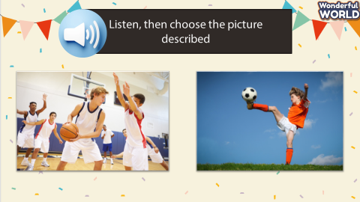  Task 4. Listen and repeat. TR: 7.3:  - Play the recording. Tell students to look at the pictures and follow the sentences with their fingers.  Play the recording again. Ask students to repeat.  - Tell students we can use this structure to talk about things happening now.  Ask students to repeat the sentences, and to take a look at how they may use what they have just learnt in the next activity. | - Sts listen.  - Sts listen and choose  - Sts repeat.
Activity 3: Practice (12 minutes)
Teacher’s activities | Student’s activities
Task 5 : Look and say :  - Tell students to look at the pictures and the prompts. Read out the prompts and ask students to repeat.  - Read out the example and ask students to repeat.  Explain the rest of the task to students. Allow them enough time to practise saying the sentences individually and then in pairs. Go round the class helping students where necessary.  - Ask volunteers to read out their answers. Correct any mistakes.  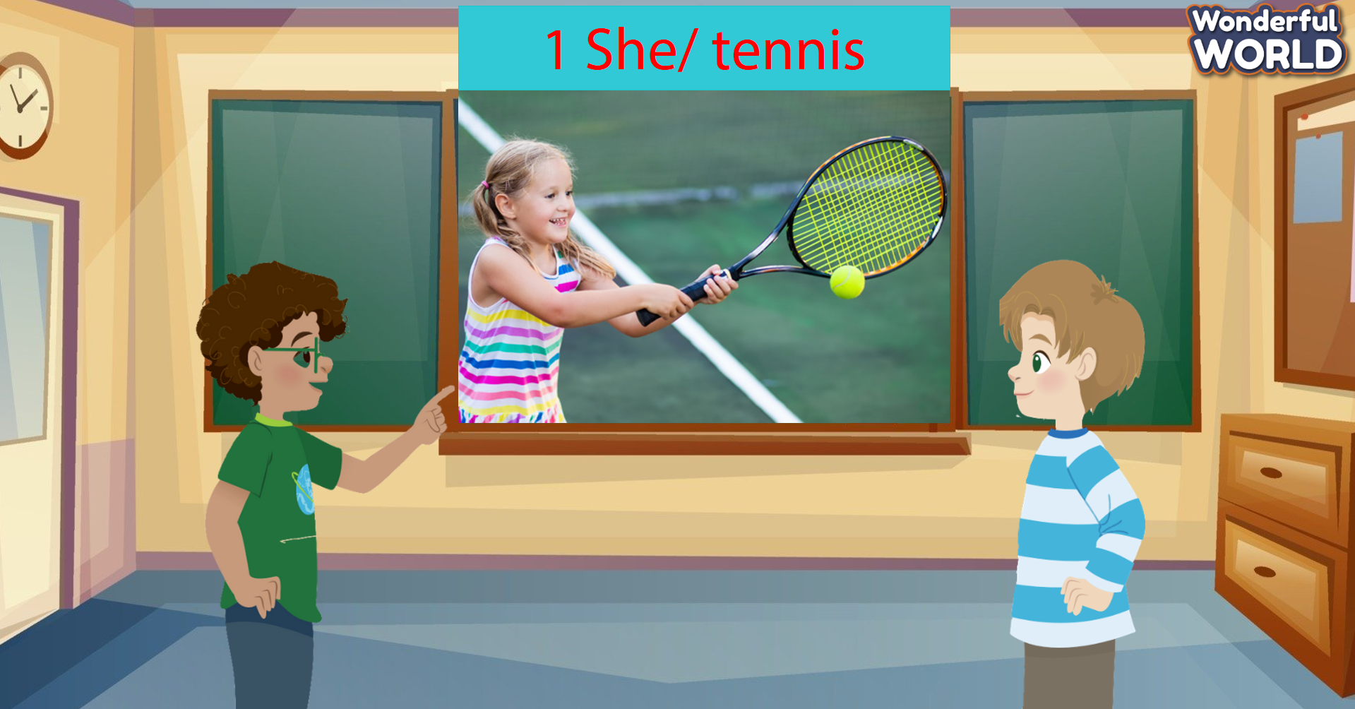 | - Repeat the words  - Repeat .  - Read out  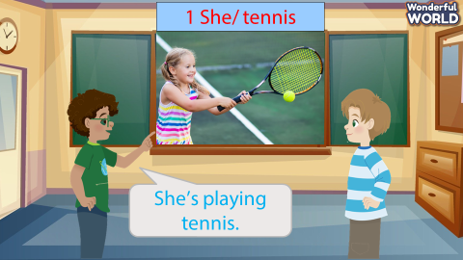
Activity 4: Production (7 minutes )
Teacher’s activities | Student’s activities
Task 6 : Let’s talk.  - Tell students to look at the sample sentences.  - Read out the sample sentences and mime the actions.  - Ask two students to read out the sample sentences again.  - Ask students to work in pairs. One student mimes the actions, the other says what their friend is doing by using  the structure He / She’s playing....  - Ask some volunteers to speak in front of the class.  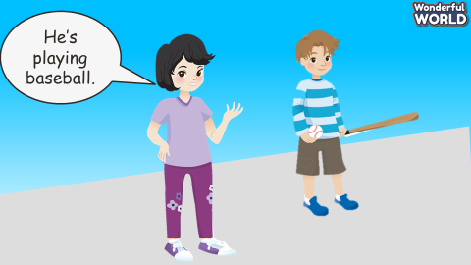 | - Look  - Read  - Work in pairs .
Activity 5 : Assessement (3 minutes )
Teacher’s activities | Student’s activities
- Ask students to do the assessment.  - Look and match  - Check in pair then whole class.  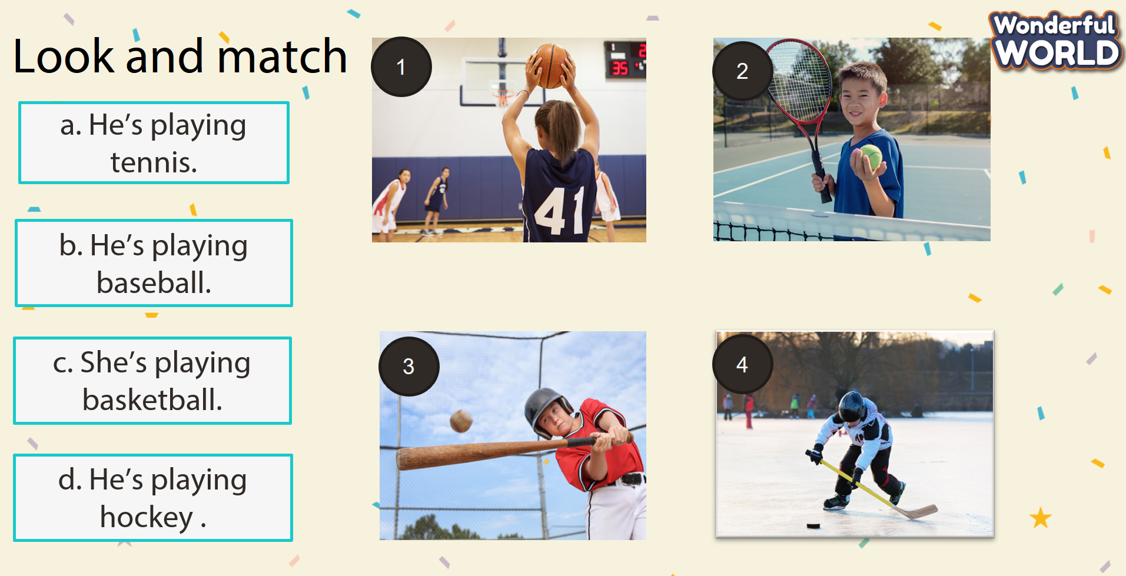  - Say goodbye | - Do the assessment.  - Check with friends and then with teacher and whole class.  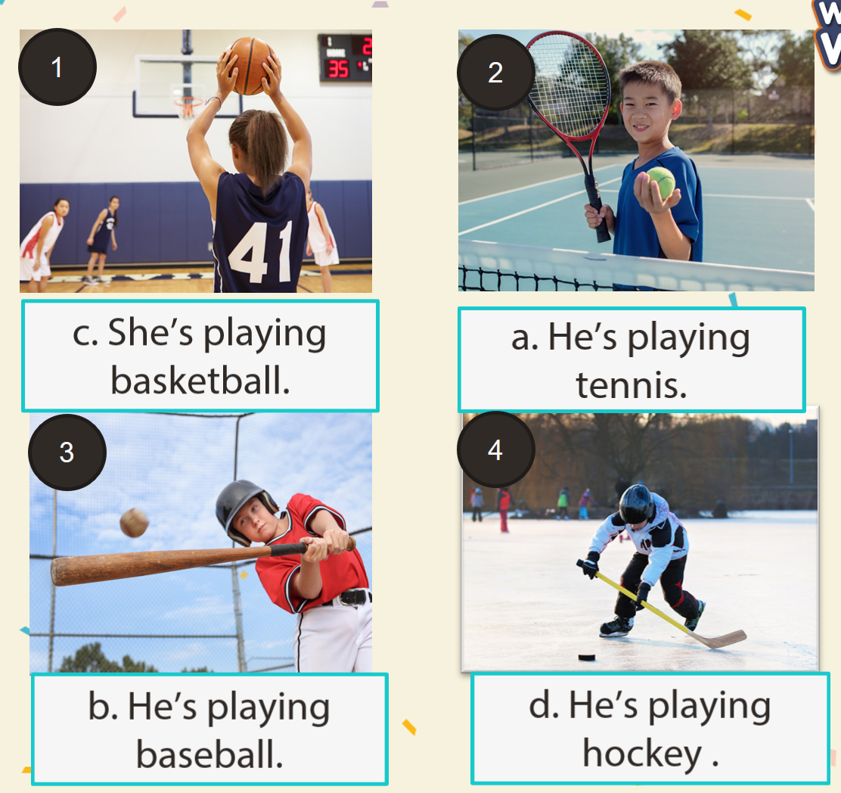  - Say goodbye.
____________________________________

UNIT 7. MY FAVOURITE SPORT
Lesson 2. Task 1, 2, 3
Period 82
I. OBJECTIVES:
1. Knowledge:
Students will be able to :
- Learn and use new vocabulary: catching, hitting, kicking, jumping, running
- Learn and use new grammar: present continuous
2. Competences:
- English competences: Students will be able to say the actions ( daily activities or sports)
- Common competences: Students will have opportunity to develop the autonomy in doing tasks and communication among friends.
3. Qualities:
- Students will have opportunity to talk about the activities what they are doing so that they can use languages in everyday life.
II. EQUIPMENT AND MATERIALS:
- For Teacher: PP, TV, flashcards, music, audio track 7.4
- For students: pictures, handout
III. LESSON PROCEDURE:
Activity 1: Warm up (5 minutes)
Teacher’s activities | Student’s activities
- Let Sts warm up by the song :  - Song : What are you doing ?  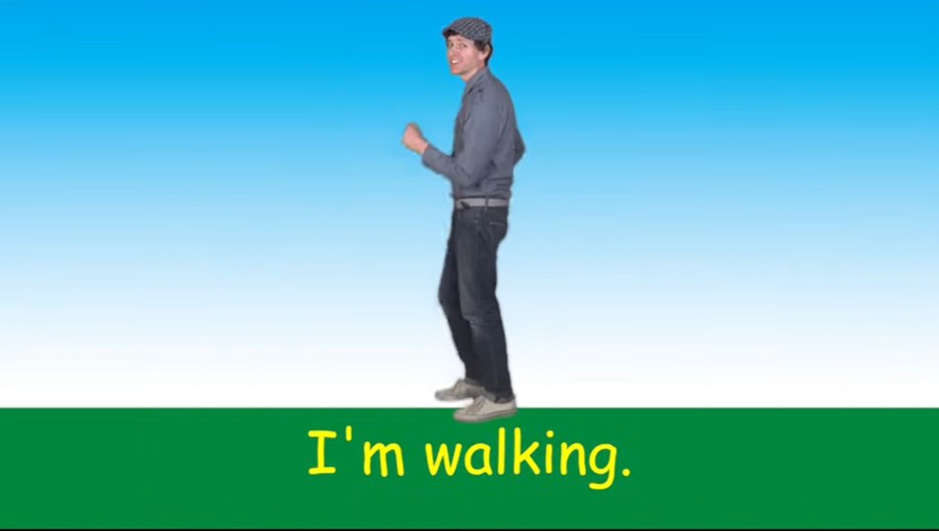 | - Sts sing along with the video.
Activity 2: Presentation (8 minutes)
Teacher’s activities | Student’s activities
Task 1. Listen and pont. Repeat. TR: 7.4  - Use the flashcards or do the action to introduce the vocabulary: catching, hitting, kicking, jumping, running  - Play the words one by one.  - Play the track 7.4 and ask students to listen and repest in chorus, groups.  - Put the 5 flashcards in 5 different corner around the room.  - Say a word for students to repeat then point.  - Vocabulary checking : MINI GAME : Listen and slap the board .  - Stick the pictures on the board.  - Let Sts listen to the sentences and slap on the correct pictures. | - Learn new words through flashcards and actions .  - Listen  - Repeat the words  - Repeat then point.  - Listen, look and say  - Sts join the game.
Activity 3: Practice (12 minutes)
Teacher’s activities | Student’s activities
Task 2 : Listen and tick.  - Ask students to look at the photo and describe what they can see.Then tell the students that they are going to read about hockey.  - Point to the new words in the text. Read them out and ask students to repeat.  - Play the recording. Tell students to look at the picture and follow the text with their fingers.  - Play the recording again, pause after each sentence and ask students to repeat.  - Ask students to practise reading out the text individually.  - Ask some volunteers to read it out in front of the whole class  - 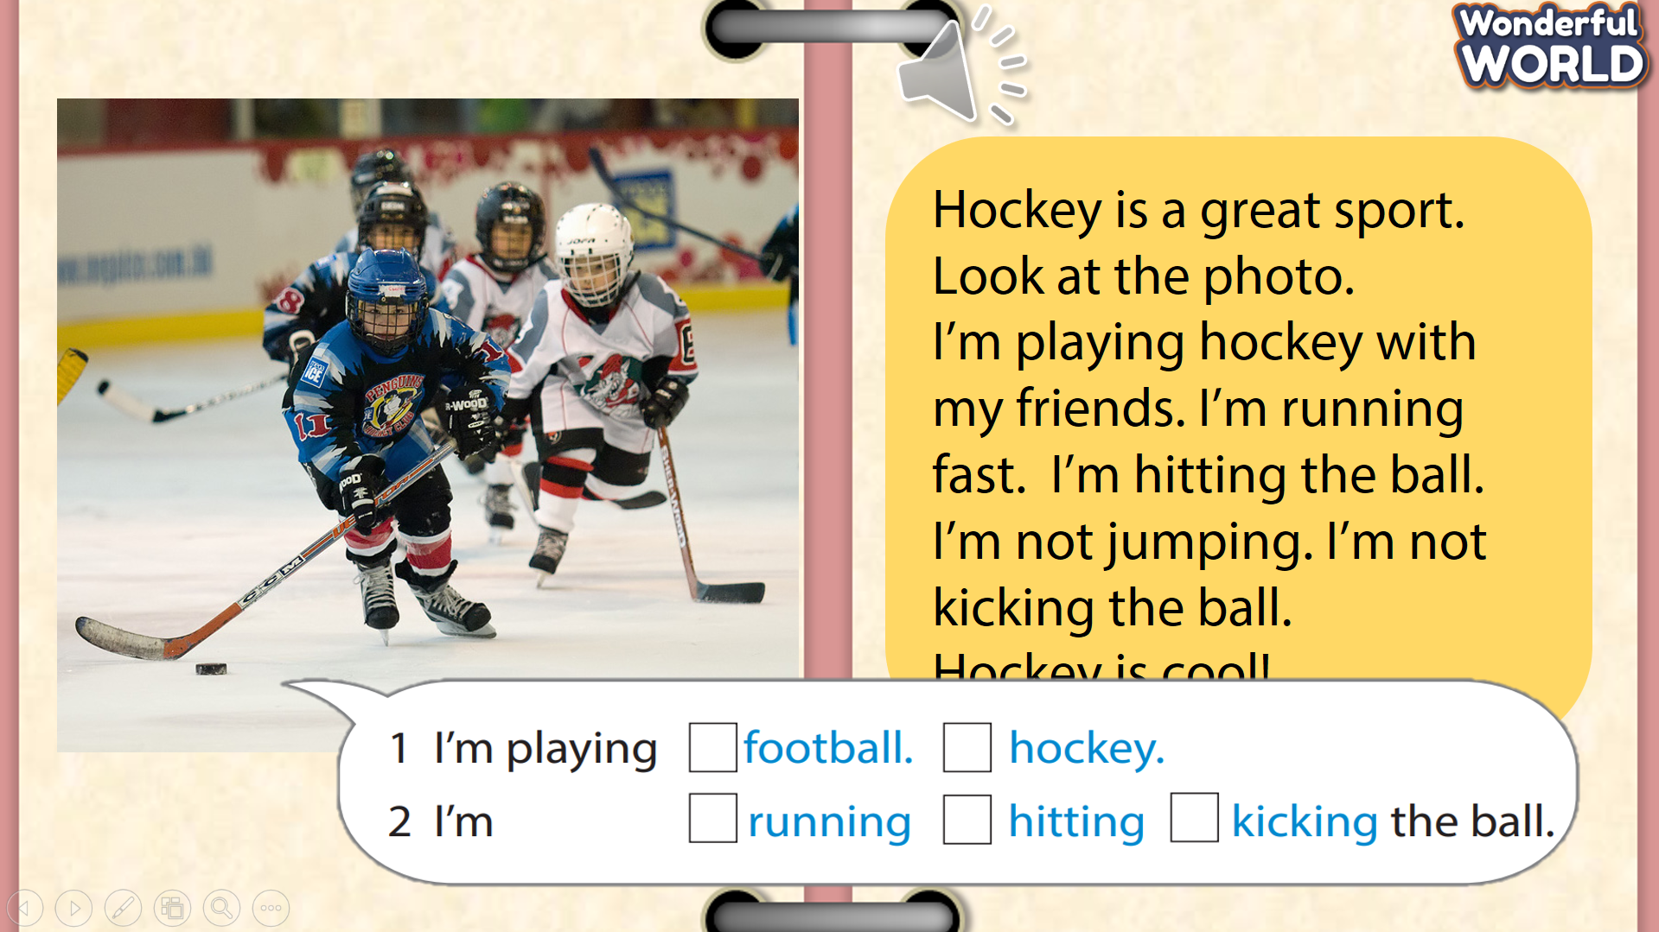 | - S answer  - Sts repeat.  - Sts practice.  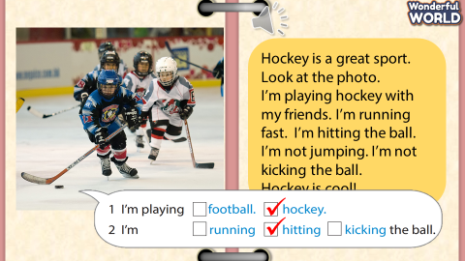
Activity 4: Production (7 minutes )
Teacher’s activities | Student’s activities
Task 3 : Let’s play. Use the words in Activity 1 :  - Let pairs of students of two teams come and roll the dice to choose the student (with the most points) who go first - is going to make a sentence with He/She’s + V-ing (e.g.: He’s catching the ball.) and they can choose the other player from the other team makes sentences “He/ She’s playing + sport” (e.g.: He’s playing baseball). The person who guesses correctly can play rock paper scissor to get the points .  - Join them by giving words in Activity 1 that they do not frequently use in the game to encourage everybody to use and familiarise themselves with all of the words in Activity 1.  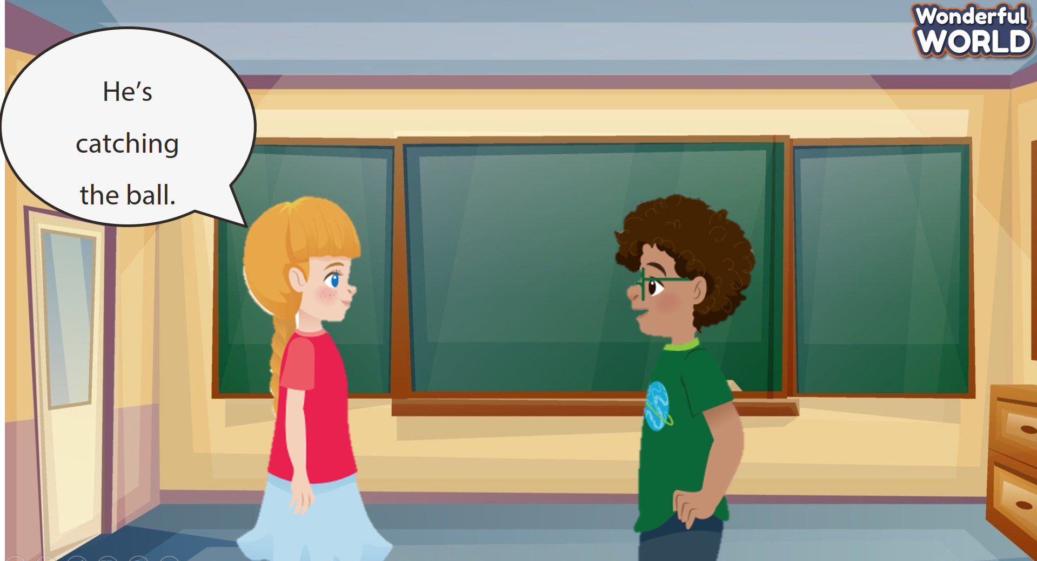  - If S say : She’s kicking the ball .  - He’s hitting the ball . | Sts join the game .  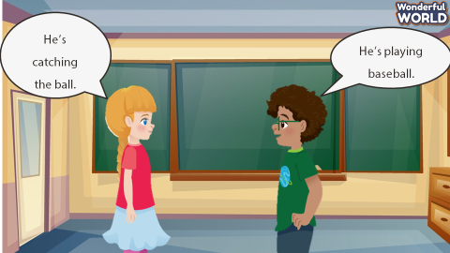  - The other answers : She’s playing football.  - He’s playing baseball.
Activity 5 : Assessemnet (3 minutes )
Teacher’s activities | Student’s activities
- Ask students to do the assessment.  - Use the words to make sentences :  - Check in pair then whole class.  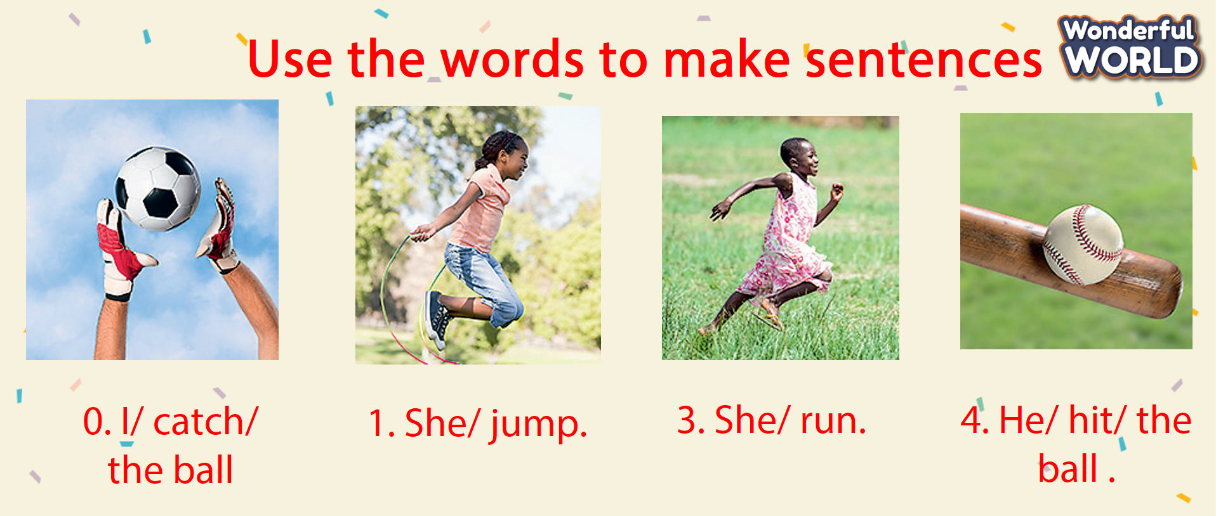  - Say goodbye | - Do the assessment.  - Check with friends and then with teacher and whole class.  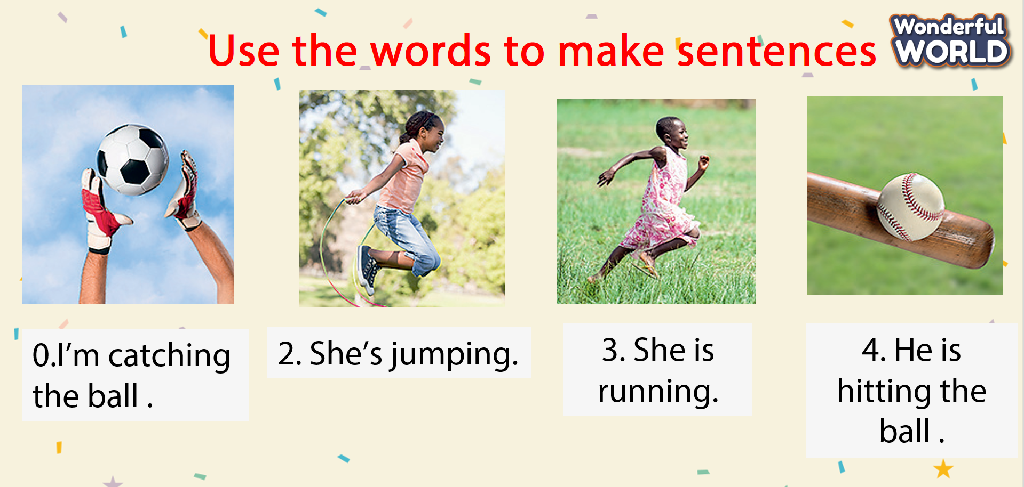  - Say goodbye
____________________________________

UNIT 7. MY FAVOURITE SPORT
Lesson 2 -Task 4,5,6
Period 83
I. OBJECTIVES:
1. Knowledge:
Students will learn present continuous in negative form: not be V_ing
2. Competences:
- English competences: Students will be able to talk about things that are
not happening now. ( daily activities or sports)
- Common competences: Students will have the opportunity to expose their love about the sports or activities by drawing and presenting.
3. Qualities:
- Students will have the opportunity to talk about the activities that they are happening or not happening to use languages in everyday life.
II. EQUIPMENT AND MATERIALS:
- For Teacher: PP, TV, flashcards, music, audio track
- For students: pictures, handout
III. LESSON PROCEDURE:
Activity 1: Warm-up (5 minutes)
Teacher’s activities | Student’s activities
Quick Eyes Game  - T show the pictures so that Sts can recall the words they’ve learnt , especially with the limited time. Then, cover all of them. After that, T shows one picture and asks sts to find the same picture which is covered.  - If they find the correct position, Sts will get the stars.  Example: T press “ START” Within 10 seconds, Sts have to recall 5 words. After 10 seconds, they’re covered. Then, only one picture is shown, T asks Sts to find the position of the same picture. | - Sts join the game.
Activity 2: Presentation (8 minutes)
Teacher’s activities | Student’s activities
Task 4: Listen and repeat (Track 4.6)  Lead in: *GAME: Who’s faster?  - Give instruction of game to lead in the new lesson. T shows the picture of the action .T asks the questions about talk about things that are happening now and Sts have to answer the sentences as quickly as possible,  - Give the word “not”, and ask the volunteers to make sentence with “not”, the faster group will get stars.  - Ask students to notice that the structure I’m not, He isn’t, and She isn’t is followed by the  action verb with -ing.  Tell the students we can use this structure to talk about things that are not happening now.  Listen and repeat:  - Play the track. Ask ss to listen and repeat in chorus, groups. Have sts listen and repeat the sentences  - Correct pronunciation when needed.  MINI VOCABULARY CHECKING GAME: Who am I?  (Stick the pictures on the board or use PowerPoint )  - Let Sts listen to the sentences and slap on the correct pictures.  - Further activity: There are some sentences about the pictures. Sts have to choose the sentence which is not correct to check their understanding. | - Learn new words through flashcards and actions.  - Listen  - Repeat the words  - Sts join the game.
Activity 3: Practice (12 minutes)
Teacher’s activities | Student’s activities
Task 5: Look and say.  TPR Game:  T shows the words on the paper or Sts can give the requirement.  Sts have to look and do the right action  Call 2 students of 2 teams, come and do the action. Then check and give the stars for the correct action.  Task 5: Look and say  Game: Turtle and rabbit. Sts will give the questions. If Sts can answer correctly, they will help their team, turtle or rabbit and find the winner in this game.  - Explain the rest of the task to students. Allow them enough time to practice saying the sentences individually and then in pairs. Go  round the class helping students where necessary.  - Ask volunteers to read out their answers. Correct any mistakes.  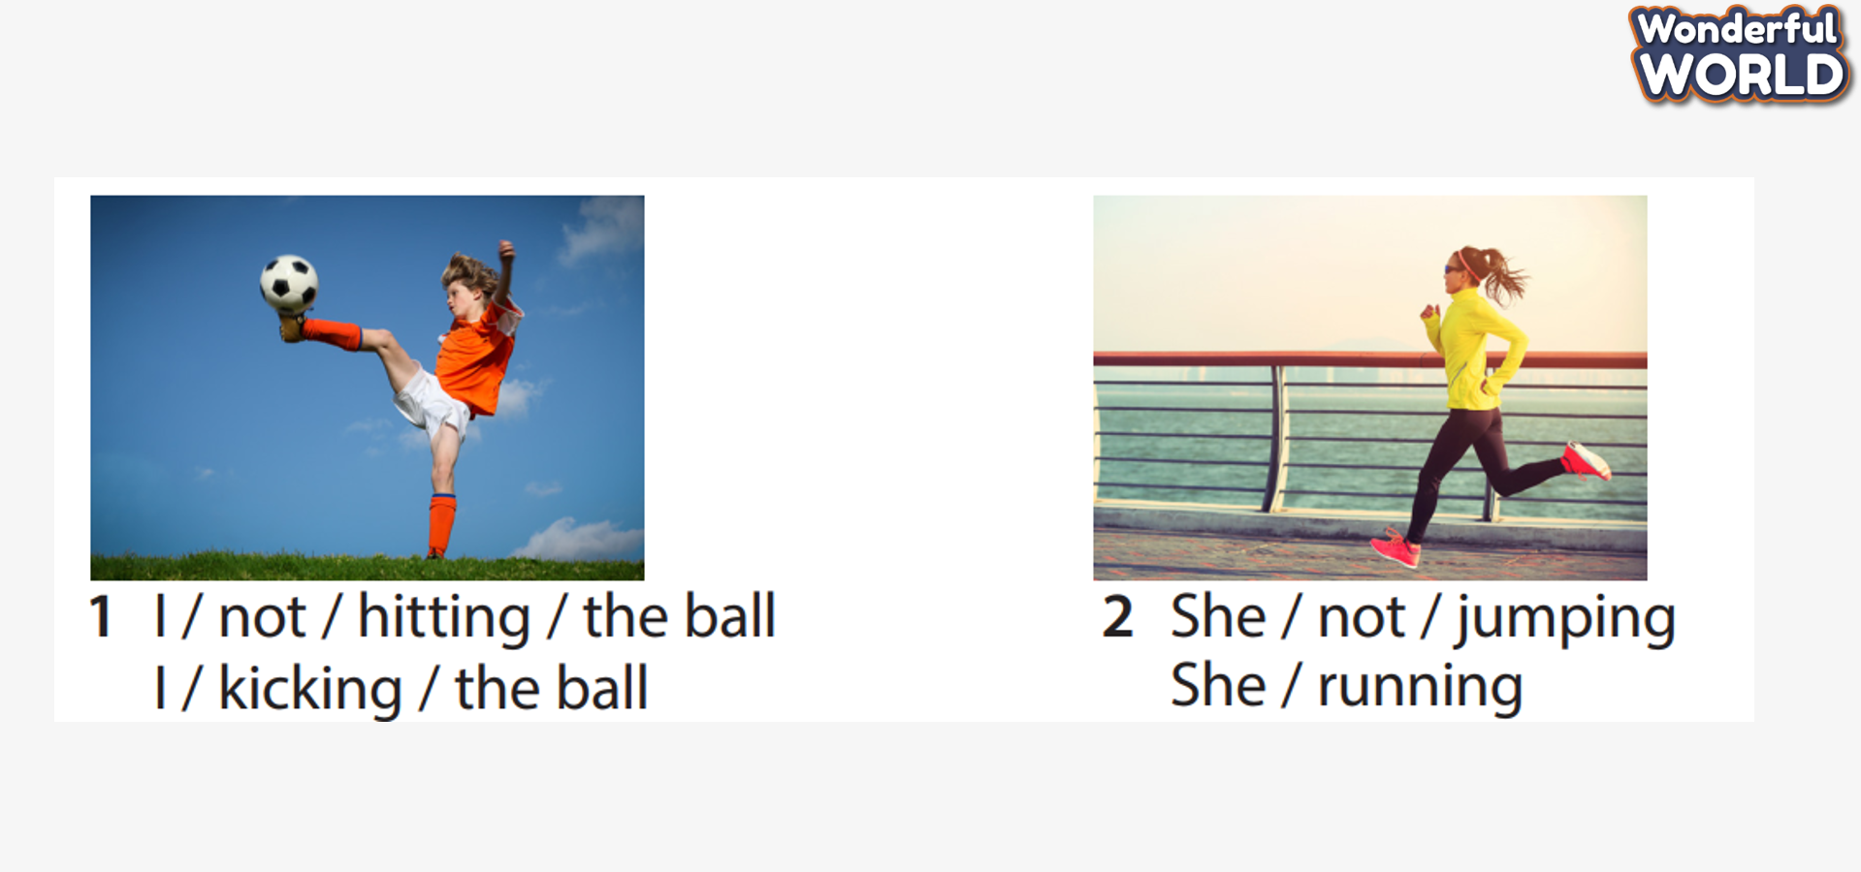  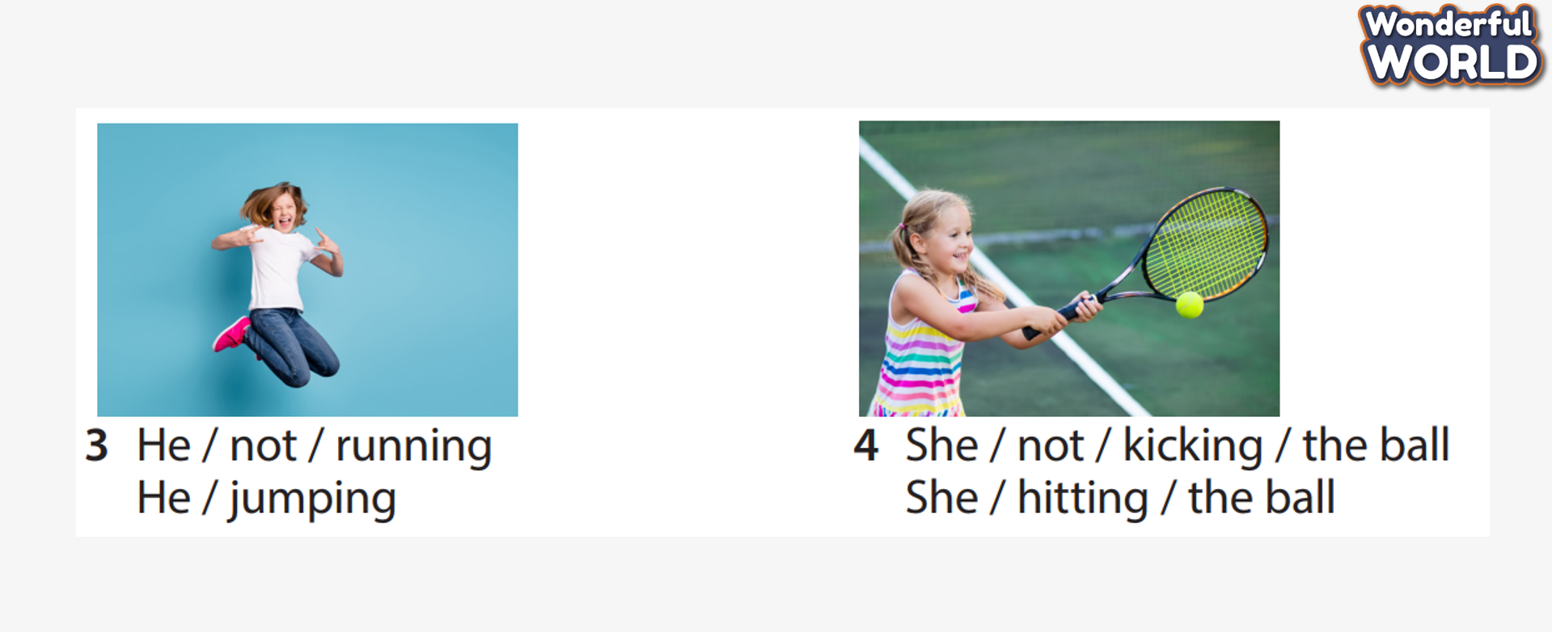 | Do the actions.  - Answer the questions and join the game.
Activity 4: Production (7 minutes )
Teacher’s activities | Student’s activities
Task 6: Draw and write. Say :  - Ask students about their favourite sport and then look at the girl’s drawing. Then read out the speech bubbles and ask them to repeat. Tell students to draw a picture of themselves doing something that they have learned so far. Go around the class suggesting ideas for the drawings.  - Tell them not to write anything yet. When they have finished ask them to show their classmates their pictures and talk about what they are doing in them. Encourage the classmates to ask questions. Then ask them to write some sentences. Help with spelling where necessary. | - Sts look.  - Sts write
Activity 5: Assessment (3 minutes )
Teacher’s activities | Student’s activities
- Ask students to do the assessment.  - Choose the best answer.  - Check in pair then whole class.  - Sts will be given a dice. If they answer correctly, they can row the dice and get the stars.  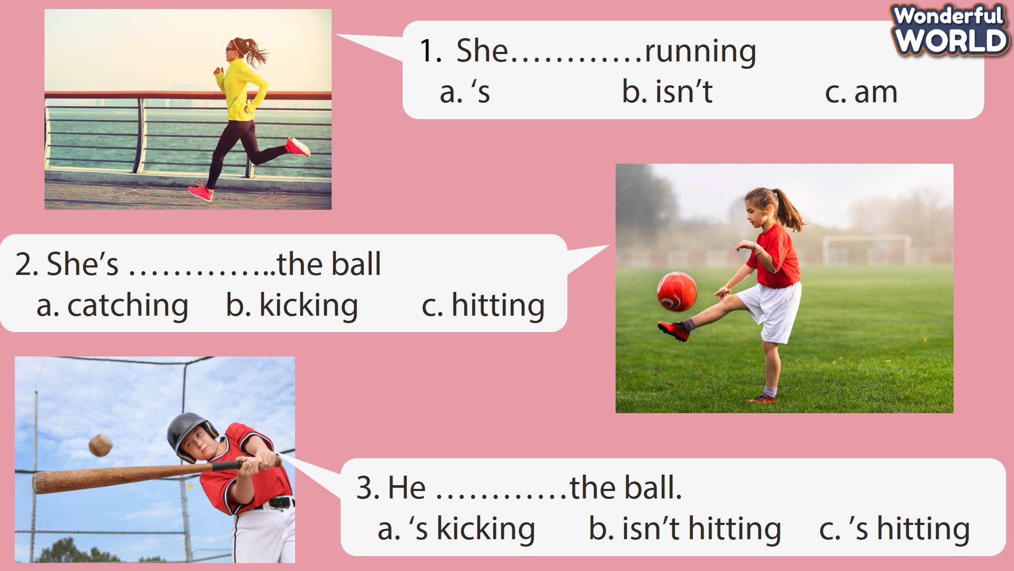  - Say goodbye | - Do the assessment.  - Check with friends and then with the teacher and the whole class.  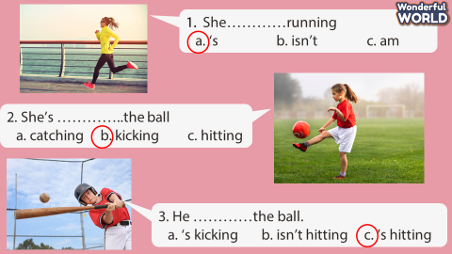  - Say goodbye
____________________________________

UNIT 7. MY FAVOURITE SPORT
Lesson 2. -Task 7,8,9
Period 84
I. OBJECTIVES:
1. Knowledge:
Students will review the present continuous tense and words/phrases related to daily activities and sports and practice listening, reading, speaking and writing skills
2. Competences:
- English competences: Students will be able to talk about things that are happening or
not happening now in daily activities or sports.
- Common competences: Students will have the opportunity to develop autonomy in doing tasks, and communicating among friends.
3. Qualities:
- Students will have the opportunity to talk about the activities that they are happening or not happening to use languages in everyday life.
II. EQUIPMENT AND MATERIALS:
- For Teacher: PP, TV, flashcards, music, audio track
- For students: pictures, handout
III. LESSON PROCEDURE:
Activity 1: Warm-up (5 minutes)
Teacher’s activities |  | Student’s activities
Let Sts warm up by the game to review the words and structures :  CROSSWORDS GAME  Sts answer the questions and find the letters of the keyword BOSSABALL  - Suggested questions:  1. What sport is it? -> BASEBALL  2. What are they doing? -> FOOTBALL  3. What is she doing? -> TENNIS  4. What are these ? – SPORTS  5. What is the action? – CATCH  6. What is it? – BALL  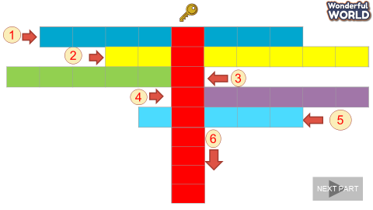 |  | - Sts join the game.  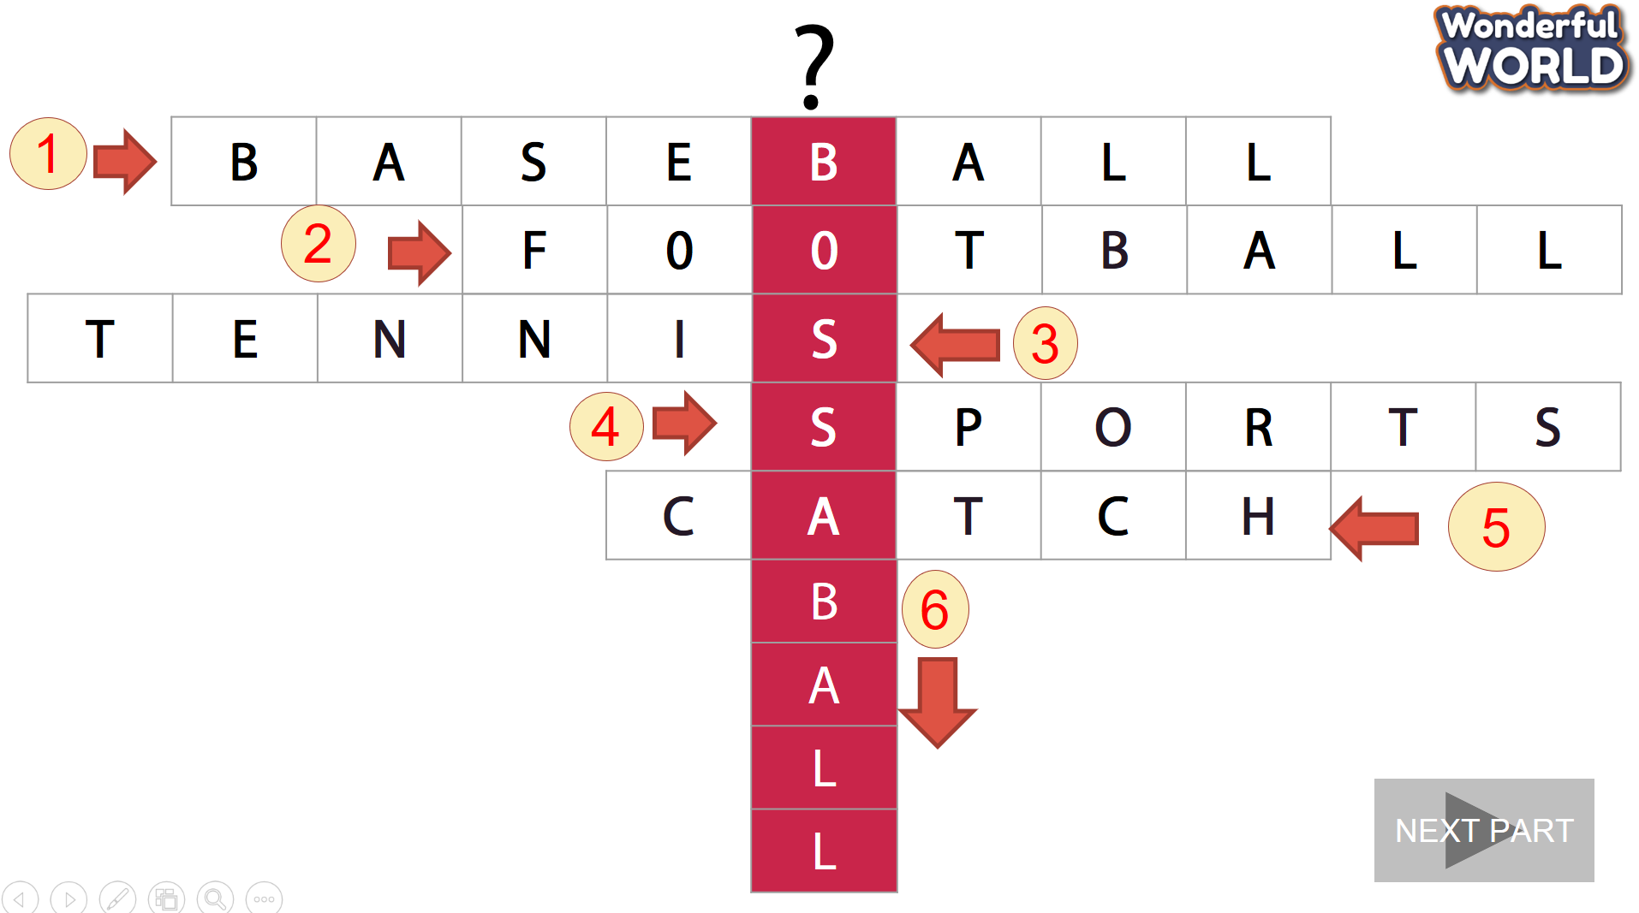
Activity 2: Presentation (8 minutes)
Teacher’s activities |  | Student’s activities
Task 7. Listen and tick  Pre-listening:  - Show a picture of bossaball game.  - Ask sts to talk about the picture  - Is he running?  - Are they jumping?  - Is he kicking the ball?  - Then, let them listen and fill the words to drill the content of bossaball game so that they can understand easily.  - While listening:  - Ask sts to listen and tick.  - Play the audio twice  - Have sts do cross-check  - Play audio again and check with the whole class  Post listening:  - Show the text and the picture  - Ask sts to listen and repeat sentence by sentence.  Task 7. Listen and tick  - Ask students to read through sentences 1 – 4.  - Play the recording and tell students to listen and tick the correct answers. Play the recording more than once if students cannot catch the answers.  - Play the recording again, and pause after each sentence to check the answers. |  | - Look and answer  - Read the text  - Guess the answers  - Listen and complete  - Do cross-check  - Check with the teacher  - Listen and repeat  - Act and say Read through.  - Listen and tick.
Activity 3: Practice (12 minutes)
Teacher’s activities |  | Student’s activities
Task 8: Write  - PowerPoint Game: Help the frog go home. Click on the numbers to answer the questions and help the frog go home.  Class’s activity :  - Make an enlarged copy of the worksheet and cut out the card, select the appropriate number of cards, ensuring that they write and complete sentences.  - Explain that the activity involves forming sentences, and each sentence consists the cards.  - Elicit the model sentence.  “The player is jumping”.  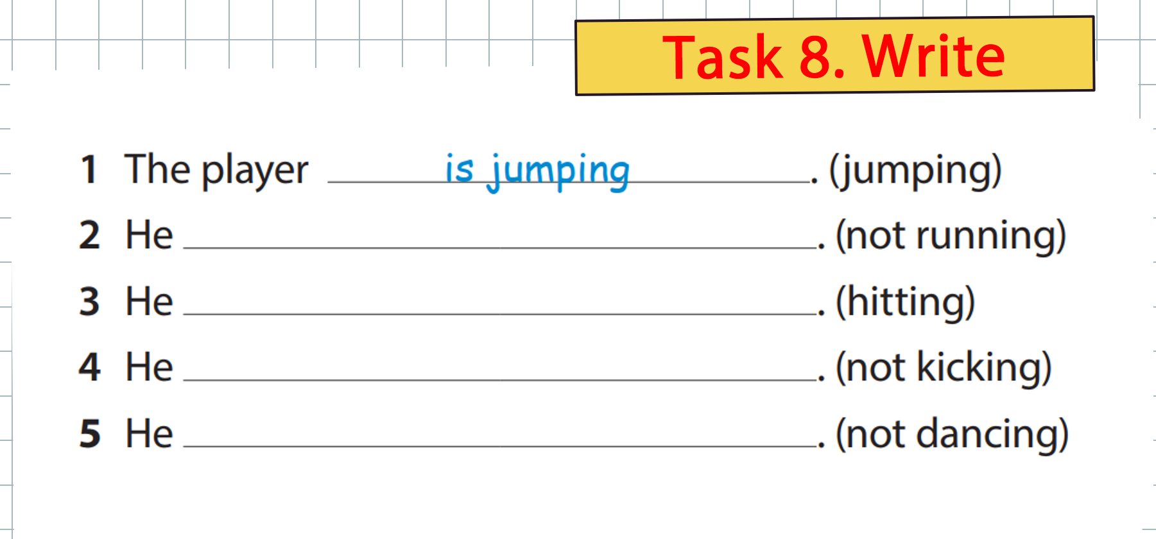  Give the sts the worksheet. Sts must put the correct words.  Set sts to work in groups  Pick up the picture and say |  | - Look.  - Complete  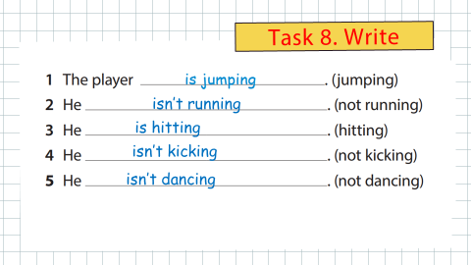
Activity 4: Production (7 minutes )
Teacher’s activities | Student’s activities
Task 9 . Look and say :  - Tell students they are going to describe what people are doing in a sport.  - Tell students to look at the picture and the dialogue.  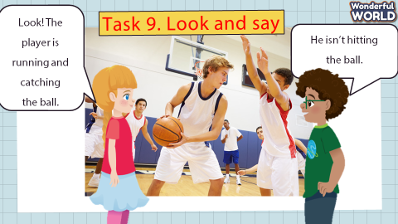  - Read out the dialogue. Read it out again, pause after each sentence and ask students to repeat.  - Ask two students to read out the dialogue.  - Ask students to work in pairs to describe what each person in the the picture is and isn’t doing  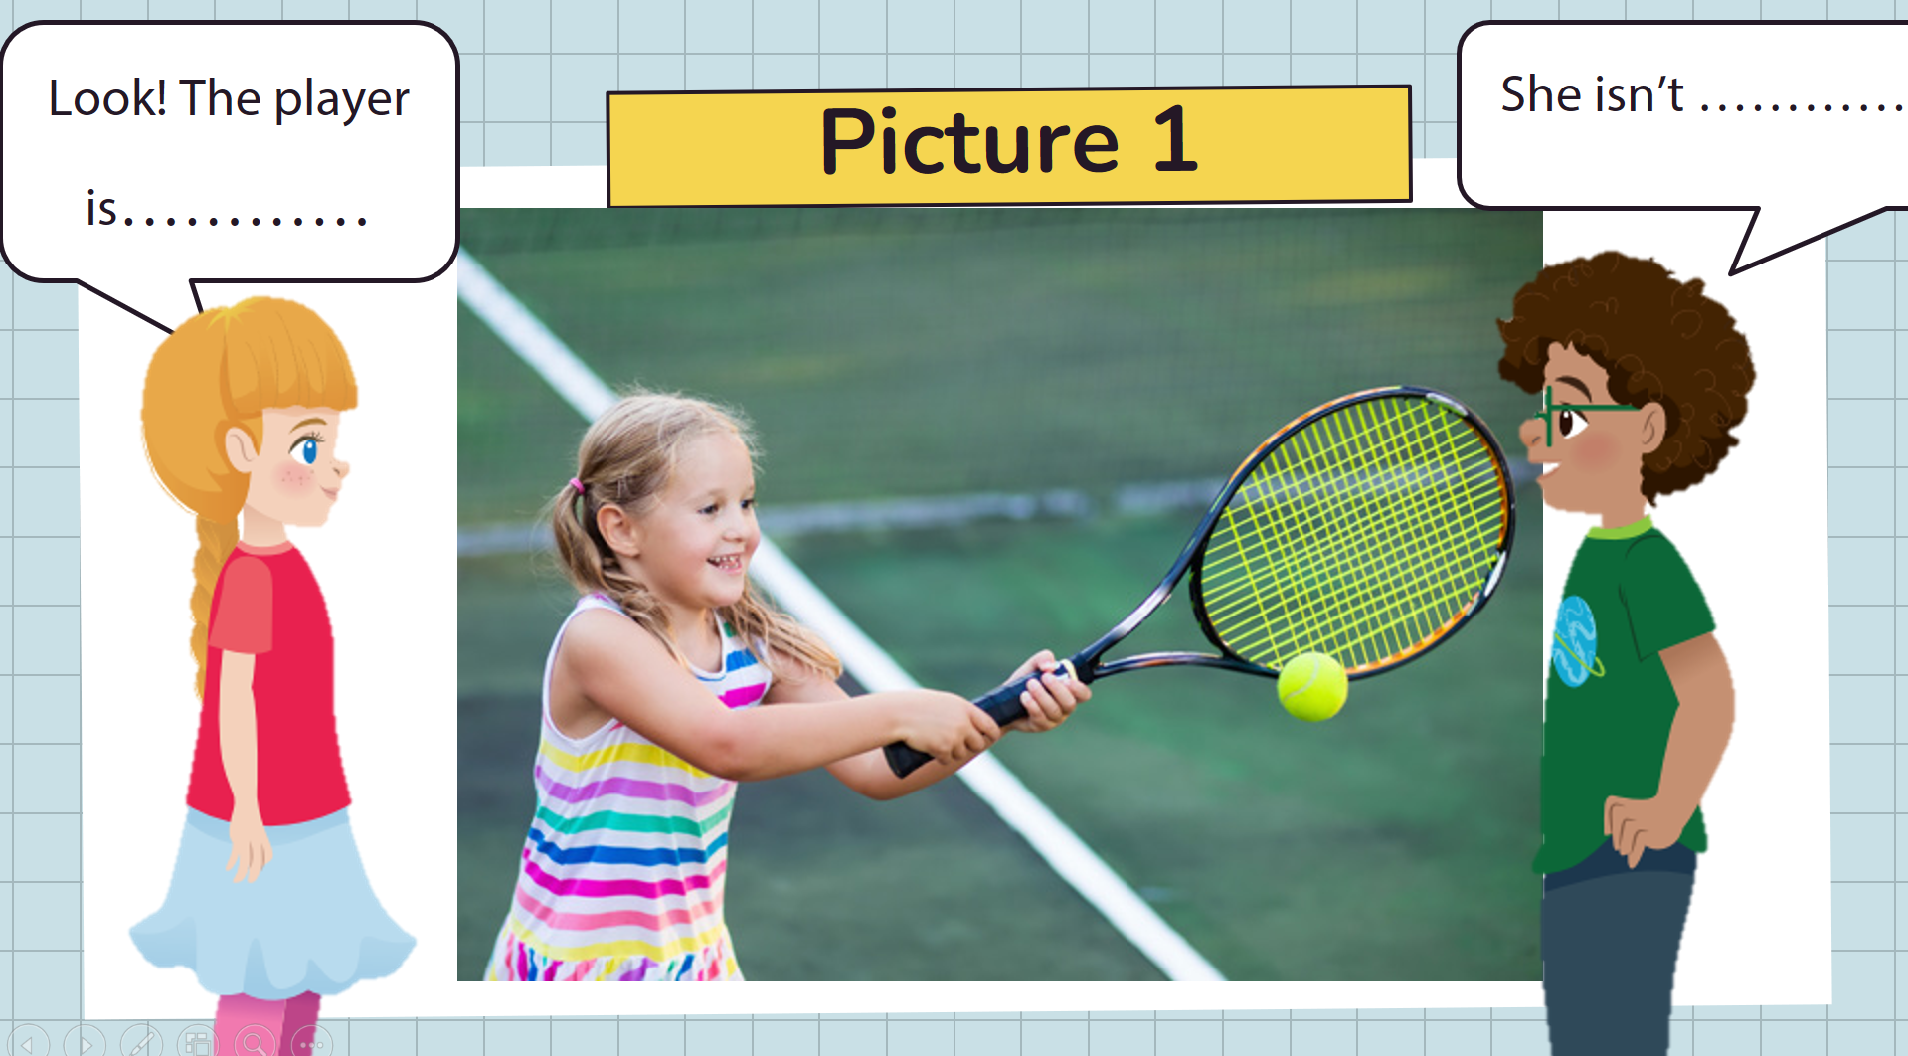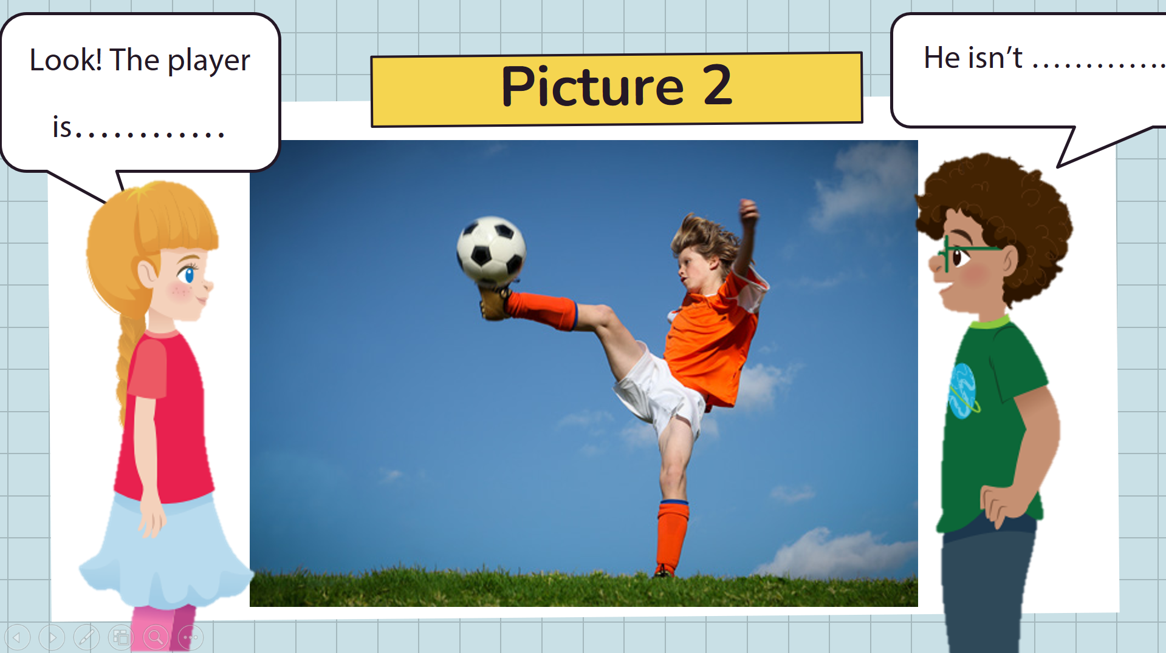  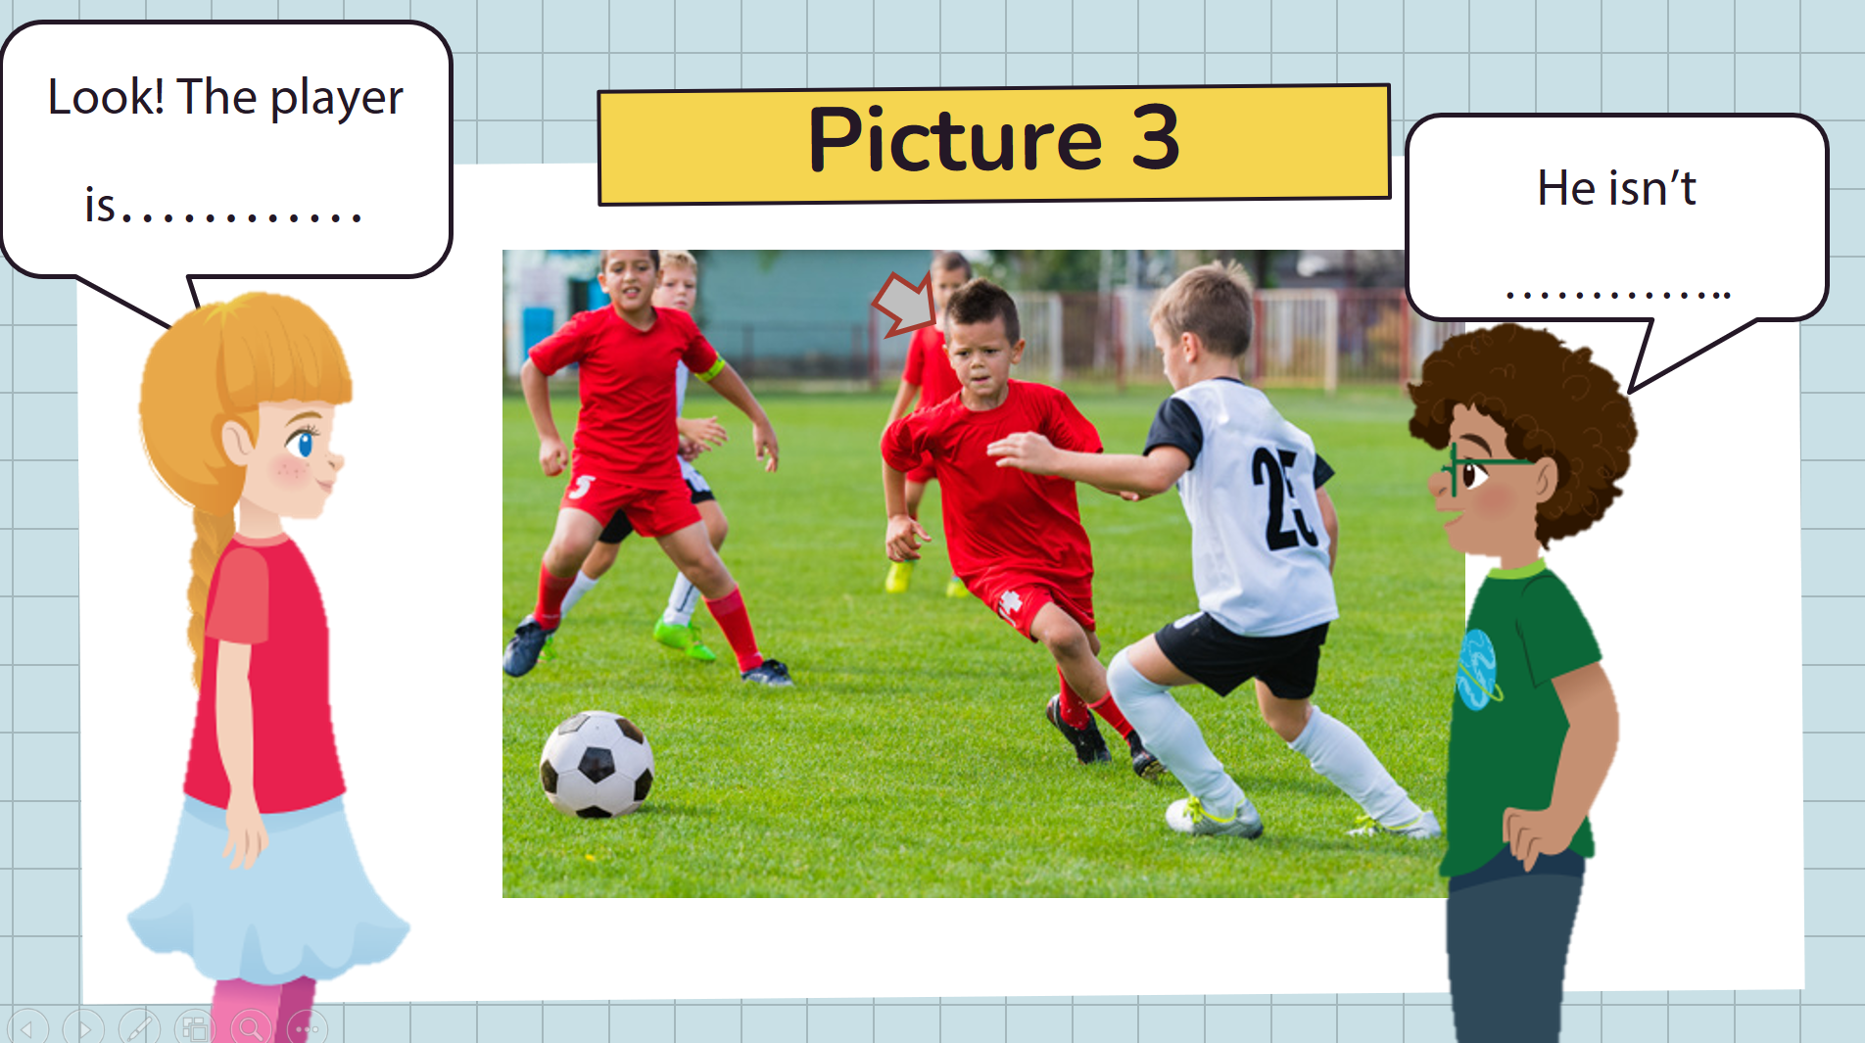 | - Sts look.  - Sts say in pairs or groups.  - Sts read.  - Sts work in pairs.  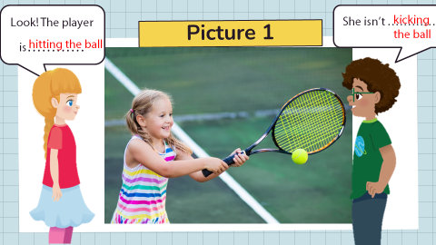  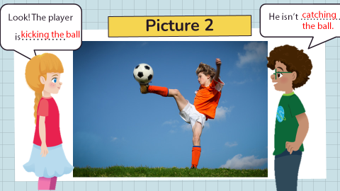  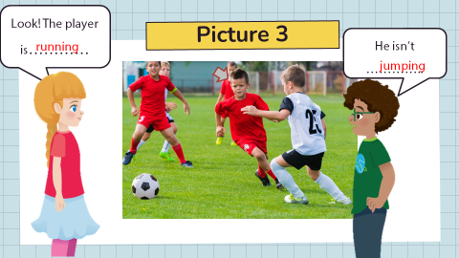
Activity 5: Assessment (3 minutes )
Teacher’s activities | Student’s activities
- Ask students to do the assessment.  - Read and tick.  - Check in pair then whole class.  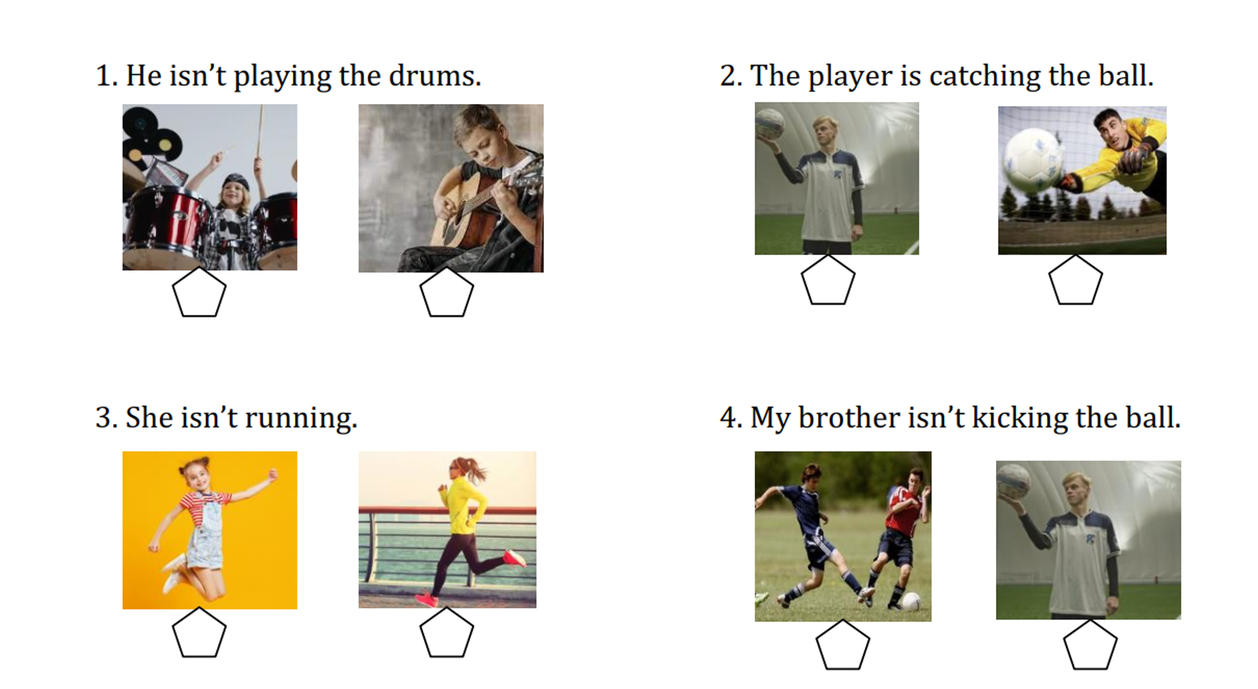  - Say goodbye | - Do the assessment.  - Check with friends and then with the teacher and the whole class.  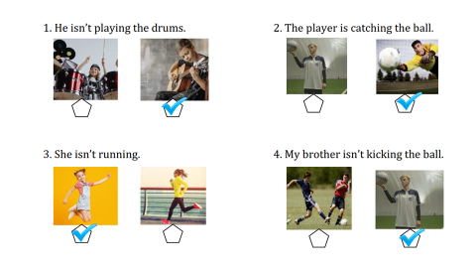  - Say goodbye.
__________________________________

GRADE 5
Week 21 (From 10/02 to 14/02)
Unit 8. People and places
Lesson 1- Part 4,5,6
Period 81
I. OBJECTIVES:
1. Knowledge:
To review words: balcony, basement, floor, garden, ladder, view
To learn the usage of Would like to
Grammar: Would like to
Would you like to live in a treehouse?
Yes, I would.
I’d like to go to the beach. relating to accommodation
2. Competences:
- English competences: Students will enhance their ability to recognize, understand, and correctly use the vocabulary words: balcony, basement, floor, garden, ladder, and view.
- Students will learn how to use "would like to" to express desires, preferences, or wishes. This involves understanding the grammatical structure (Subject + would like to + verb) and correctly incorporating it into sentences.
- Common competences: Students can draw their house and introduce them to their friends.
3. Qualities:
- Students will
+ Discuss accommodation types from different cultures, which enhances cross-cultural awareness and appreciation.
+ Develop a curiosity about different living environments and cultural practices related to housing.
II. EQUIPMENT AND MATERIALS:
- Basic things: Student’s book, flashcards, photos, papers
- Advanced things: PPT, laptop, TV.
III. LESSON PROCEDURE:
Activity 1: Warm-up (5 minutes)
Game: HOME QUIZ.
Quiz game about home
Aims: Welcome students. Warm the class up with a game to check their knowledge and widen their understanding about the accommodations.
Teacher’s Activities | Students’ Activities
Procedure
Choose the one that does not belong to…  1. A tree house/ a kitchen/ a bedroom/ a bathroom.  2. Wood/ bricks/ concrete/rubber.  3. An apartment/ a cottage/ a roof/ a tree house  Let’s find out different types of houses :  There are many different types of houses. Houses can come in different shapes, sizes, and styles. Some houses are made of bricks or wood, while others are made of stones or even mud. Some houses are found in busy cities, while others are in quiet countryside areas. Let’s give the answers :  - An apartment  - A cottage  - A castle  - An igloo  - A tree house | - Greet Teacher  - Join the activity.  - Answer the questions
Activity 2: Presentation – Controlled practice (8 minutes)
a. Aims: Ss can practise listening and writing skills about the topic: the house and the structure
Teacher’s Activities | Students’ Activities
With these words of the warm-up part, T asks the question to lead in the new structure :  “Would you like to live in a treehouse, a castle, an apartment, or a cottage ?”  T shows the structure tables to explain the use of "would like to" to express desires, preferences, or wishes. | 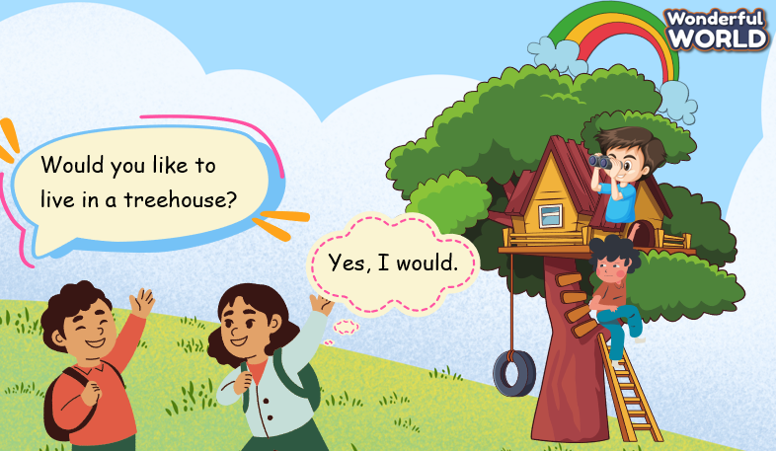
Activity 3: Practice – Controlled practice (8 minutes)
a. Aims: Ss can remember the new words.
Teacher’s Activities | Students’ Activities
RACING MONSTER TRUCK game :  By answering the question related to the topic and the structure :  1. Would you like to live in a shoe house?  Yes, I would.  2. Would you like to live in a treehouse?  B: Yes, I would. I love exploring nature.  3. What kind of house is it?  Upside down.  4. A: Would you like to live in an apartment?  B: No, I wouldn’t. I’d like to live in a house with a garden, so I can plant a lot of flowers in my garden.  5. A: Which place would you like to go on your holiday, to a mountain or a beach?  B: I’d like to go to the beach.  A: Why would you like to go to the beach?  B: Because I’d like to build sandcastles and swim in the sea.  5 Listen and circle.  Ask students to look at the sentences.  Explain that they are going to circle the words that they hear from the recording.  Elicit the first answer if necessary.  Play the recording and have students complete the rest of the task.  Have students share their answers.  Play the recording again. Pause after each conversation and explain the correct answer. | - Answer the questions.  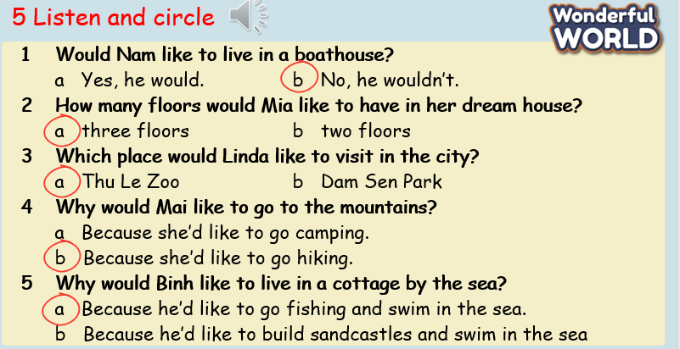
Activity 4: Production – Free practice (6 minutes)
Aims:
Apply their understanding in drawing the picture about the house and talk with their friends
Teacher’s Activities | Students’ Activities
- Creative Expression: Students will draw and decorate their dream house.  - Descriptive Language: Students will use descriptive language to present their drawings to the class.  - Communication Skills: Students will practice speaking and listening skills through presentations.  Materials:  - Drawing paper  - Crayons, markers, or colored pencils  - Rulers (optional)  - Example drawings (optional)  Lesson Steps:  1. Introduction  - Discuss: Talk briefly about what makes a house special. Ask students what features they would include in their dream house.  - Example: Show some example drawings of houses or describe features you might include in your own dream house.  2. Drawing the Dream House  - Instructions: Ask students to draw their dream house on a piece of drawing paper. Encourage them to include details such as rooms, garden, balcony, and any special features they want.  - Decorate: Allow time for students to color and decorate their drawings with crayons, markers, or colored pencils.  3. Preparing to Present  - Prepare: Have students think about what they will say when presenting their drawing. Prompt them with questions like, “What are the main features of your house?” or “Why did you choose these decorations?”  - Practice: Give students a few minutes to practice describing their house to a partner or in their own words.  4. Presenting to the Class (15-20 minutes):  - Share: Invite students to present their drawings to the class. They should describe the main features of their house, such as the rooms, garden, and any special decorations.  - Encourage: Encourage students to speak clearly and use descriptive language. Remind them to listen and ask questions when their classmates present.  T can elicit the structure “ would like to” by comparing the pictures of Students’ houses and asking them the question :  "Which home would you like to live in, an apartment in the town or a cottage in the countryside?" It focuses on comparing different types of accommodation and using the phrase "would like to." | - Draw and say in front of the class.
Activity 5: Wrap up & Assessment (4 minutes)
Teacher’s Activities | Students’ Activities
Aims:
- Check students’s understanding of what they have learned about the house and structure: would like to
Asks sts to do the assessment.  T assesses class and some Ss.  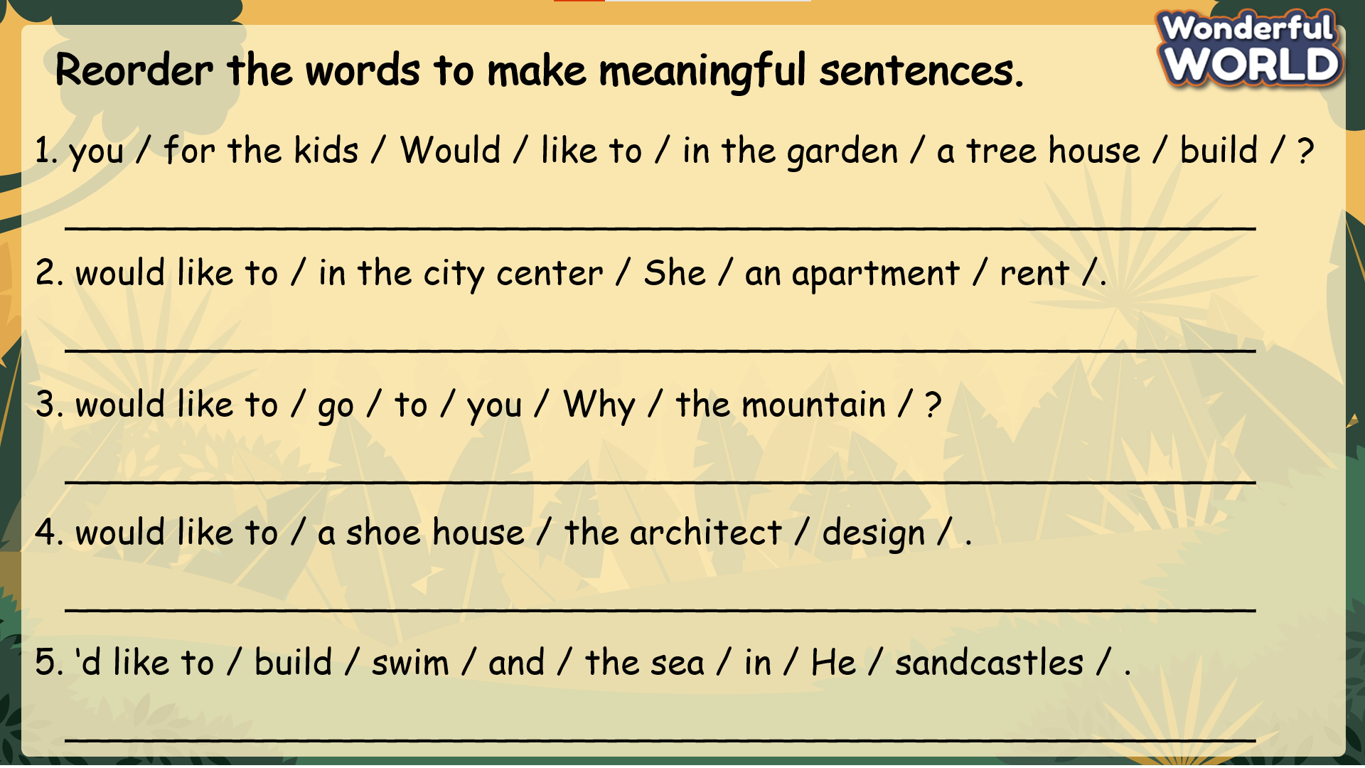  - Check with the class.  - Wrap-up  * Remember  Review Vocabulary:  balcony, basement, floor, garden, ladder, view  Grammar: Would like to  - Would you like to live in a treehouse?  Yes, I would.  - I’d like to go to the beach. | -Do the assessment.  -Check with the teacher  - Sts read the wrap-up  - Stand up and say goodbye to the teacher.  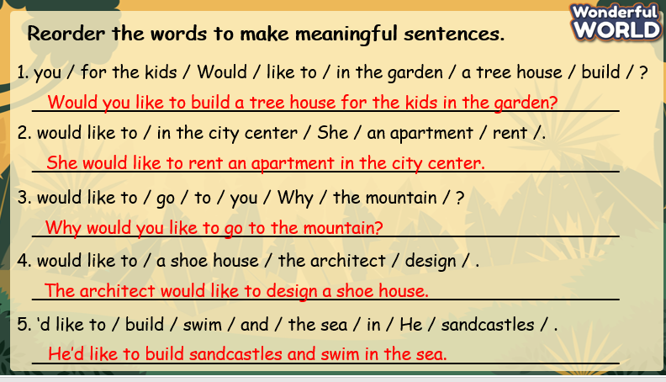

Unit 8. People and places
Lesson 2: Part 1-2-3
Period 82
I. OBJECTIVES:
1. Knowledge:
Vocabulary: fasten, float, relax, soap, space, towel
2. Competences:
- English competences: Students will identify words describing life in the space and correctly use the vocabulary words: fasten, float, relax, soap, space, towel
- Common competences: Students can imagine and write about life on the International Space Station to their friends.
3. Qualities:
- Students will
+ Understand Practical Space Travel Procedures
+ Experience and Imagine Space Life
II. EQUIPMENT AND MATERIALS:
- Basic things: Student’s book, flashcards, photos, papers
- Advanced things: PPT, laptop, TV.
III. LESSON PROCEDURE:
Activity 1: Warm-up
Activity 2: Presentation
Activity 3: Practice
Activity 4: Production
Activity 5: Wrap-up & Assessment
Activity 1: Warm-up (5 minutes)
Game: All about Space Quiz
Quiz game about the planet
Aims: Welcome students. Warm the class up with a game to check their knowledge and widen their understanding about the planet and lead in the
Teacher’s Activities | Students’ Activities
Procedure
#1: How many planets are in our solar system? -8  #2: TRUE or FALSE  Humans can breathe on the moon.-> FALSE  #3: Which planet is closest do the sun?  - Mercury  To lead the paragraph, set the context of the International Space Station :  T says “ WELCOME” | - Greet Teacher  - Join the activity.
Activity 2: Presentation – Controlled practice (8 minutes)
Aims: Ss can practice listening and writing skills about the topic: life on the International Space Station
Teacher’s Activities | Students’ Activities
- Tell students to look at the text about life on the International Space Station. Ask them to read quickly and find out what objects float in space (everything floats).  - Ask them if they would like to go there and why or why not.  - Play the recording. Pause after each sentence for students to repeat.  - Play the recording again. Ask students to each read out a sentence from the text  From the text, show the new words: fasten, float, relax, soap, space, towel  Tell students to look at the small photos on page 18. Ask if they know any of the words. Play the recording.  Play the recording again. Pause after each word for students to repeat. | 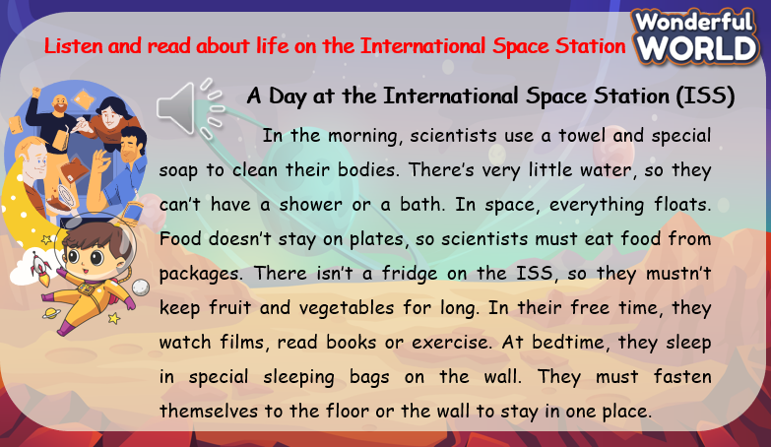
Activity 3: Practice – Controlled practice (8 minutes)
Aims: Ss can remember the new words.
Teacher’s Activities | Students’ Activities
Answer the questions of the passage.  SPACE GAME :  By answering the question related to the topic:  1. Why can’t scientists on the ISS have a shower?  b. Because there is very little water.  LUCKY BOX  2. Why don’t scientists use plates when they eat?  a. Because the food doesn’t stay on the plates.  3. Where do they sleep?  c. In sleeping bags on the wall  LUCKY BOX  4. What do the scientists do in their free time?  b. Watch films, read books, or exercise  5. Scientists in space__________themselves to the floor or the wall to stay in one place.  b. fasten  6. Scientists aboard the ISS have a refrigerator to store fruits and vegetables  FALSE  . | - Answer the questions.
Activity 4: Production – Free practice (6 minutes)
Aims:
Apply their understanding in writing a space journal.
Teacher’s Activities | Students’ Activities
Students will practice using descriptive language through a creative writing activity about an imaginary space adventure. They will use the given vocabulary words to describe their experiences in space and how they relax after a space mission.  Introduction :  Discuss Space Exploration: Begin with a brief discussion about space and what astronauts do. Show images of astronauts floating in space and the inside of a spaceship.  - Introduce Vocabulary Words: Write the words fasten, float, relax, soap, space, and towel on the board. Discuss their meanings and how they might be used in a space adventure.  Story Time :  - Read a Space Adventure: Read a short story or a passage about astronauts in space. Focus on how they might float around, use special equipment, and relax after their missions. Emphasize the vocabulary words in the story.  Vocabulary Integration Activity  - Create Space Adventure Writing Template: Distribute the "Space Adventure Writing Template" with prompts that incorporate the vocabulary words:  - Today, I had to fasten my seatbelt to… (Describe a space activity)  - In space, I could float around and… (Describe floating in space)  - After the mission, I needed to relax by… (Describe how you would relax)  - I used soap and a towel to… (Describe any cleaning up or relaxing activities)  Writing and Drawing  - Write and Illustrate: Ask students to complete their space adventure journal entry using the template. They should write about their space mission, how they floated, and how they relaxed afterward. Encourage them to draw pictures of their adventure, including using a towel and soap. | - Follow the teacher.  - Write  - Introduce
Activity 5: Wrap up & Assessment (4 minutes)
Teacher’s Activities | Students’ Activities
Aims:
- Check students’s understanding of what they have learnt.
Asks sts to do the assessment.  T assesses class and some Ss.  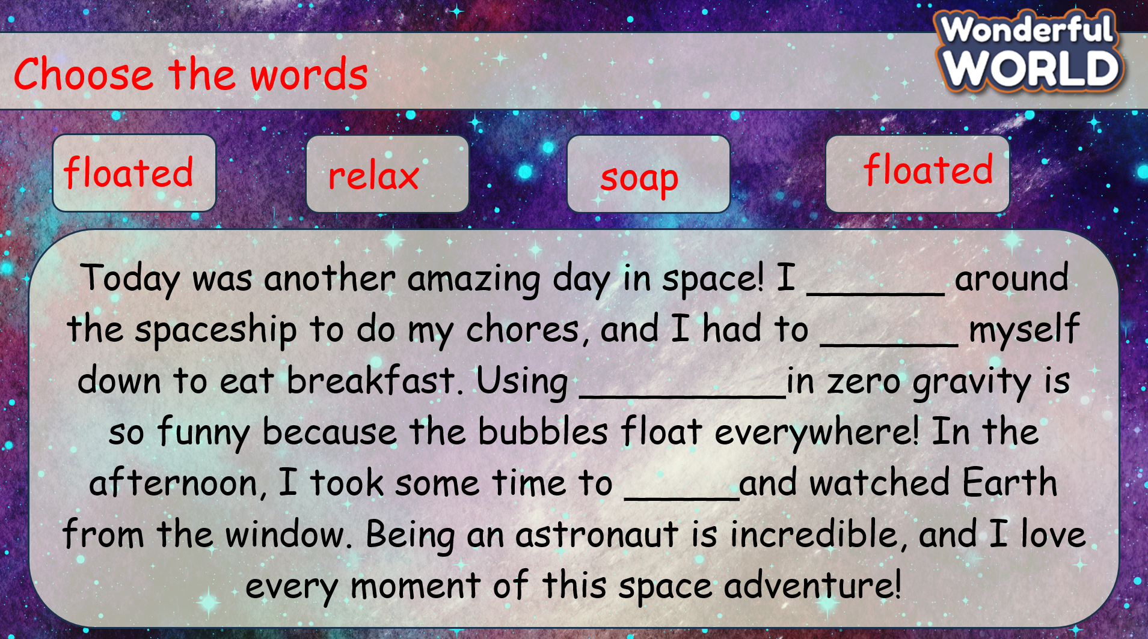  - Check with the class.  - Wrap-up  * Remember  Vocabulary:  fasten, float, relax, soap, space, towel | -Do the assessment.  -Check with the teacher  - Sts read the wrap-up  - Stand up and say goodbye to the teacher.  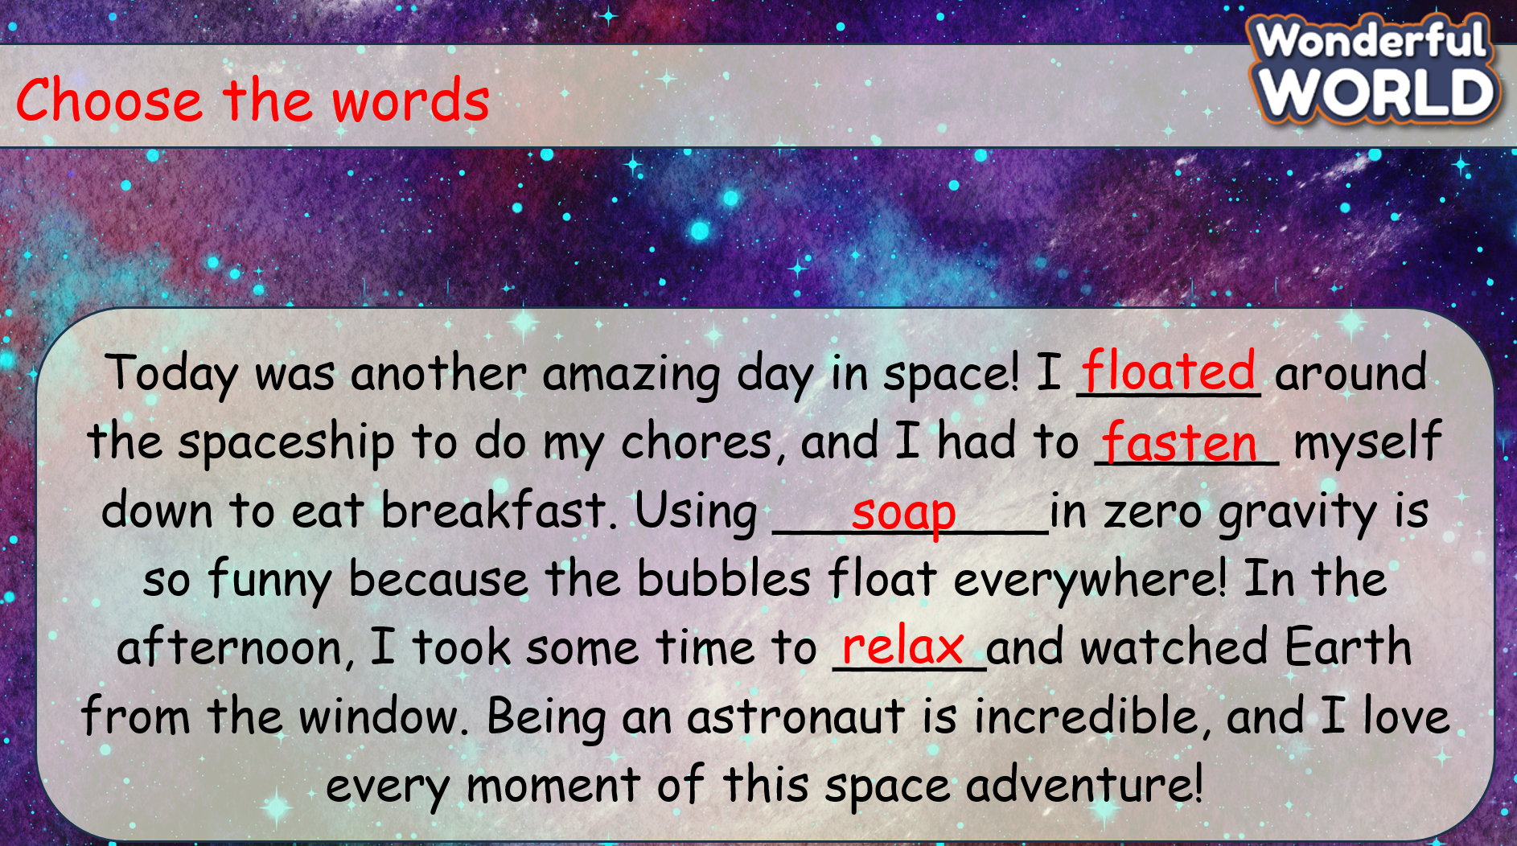

UNIT 8: PEOPLE AND PLACES
Lesson 2 - Part 4,5,6
Period 83

I. OBJECTIVES:
1. Knowledge:
- Students get to know the definitions and how to use the modal verb “Must” (format, example).
2. Competences:
By the end of the lesson, students will be able to:
- use “must” or “mustn’t” to talk about what they are allowed and not allowed to do.
- know the correct use of “must” and “mustn’t” and apply them in speaking.
3. Qualities:
- Students will
+ have strong confidence while talking about the rules and what they are allowed / not allowed to do.
II. EQUIPMENT AND MATERIALS:
- Basic things: Student’s book, flashcards, photos, papers.
- Advanced things: PPT, laptop, TV.
III. LESSON PROCEDURE:

Activity 1: Warm-up (5 minutes)
A guessing game “Can you guess?”
Aims: Welcome students. Engage the class (or warm the class up) with a guessing word game to revive the vocabulary (write the words here….) and lead in the new lesson.
Teacher’s Activities | Students’ Activities
Procedure
1. Greet students. Chatting…Do you like listening to music…  2. Introduce the game: Memory game  - Show the questions on the screen.  - Click on the blue rectangle to show the image.  - Ss can answer after T clicks on the rectangle.  - If Ss answer correctly before the alarm rings, they will get 5 stars. If they answer after that, they will get 3 stars.  - Click on the Check button to check the answer. Ask Ss to repeat the answer.  - Click on the Next button to move to the next question.  - Check the final result and give them comments.    Lead in:  - T raises some pictures and asks Ss to guess the topic of the lesson.  - T writes the topic “People and places”. | - Greet the T.  - Listen to the rules of the game.  - Read the questions and answer.  - Try to answer as fast as possible to get a higher score.  - Check the result.  - Repeat after T.  - Look at the pictures and guess the topic.
Activity 2: Presentation (12 minutes)
Aims:
- Ss can understand and know how to use the modal verbs “must” and “mustn’t” correctly.
- Ss can complete the given sentences with “must” and “mustn’t”
- Finish tasks 4,5
Procedure
Teacher’s Activities |  | Students’ Activities
PRESENTATION  - Show the modal verb “must” on the screen and explain the definition, format, and how to use it.  - Present examples. Ask Ss to make their sentences and invite some Ss to share with the class.  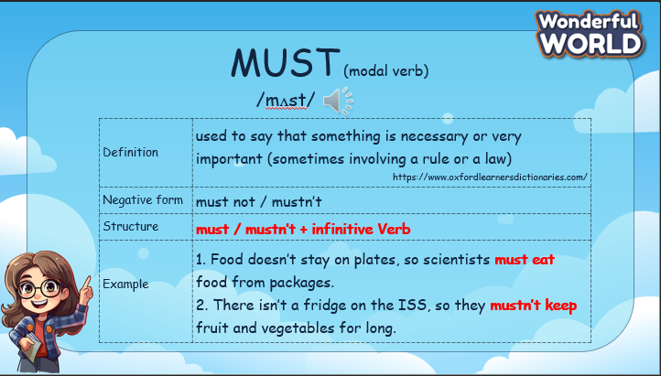  Task 4: Look at the pictures and complete the  sentences with must or mustn’t.  - Read the two examples in #1 to the class. Tell students to  repeat. Ask students what they notice about the form of  must. Draw attention to the bare infinitive form of the main  verb after must in the examples.  - Ask students to look again at the text and find examples of  must (they must fasten themselves to the floor) and mustn’t  (so they mustn’t keep these foods for long).  - Tell students to complete the sentences with must or  mustn’t. Elicit the first answer if necessary.  - Invite some Ss to share their answers  - Check answers as a class.  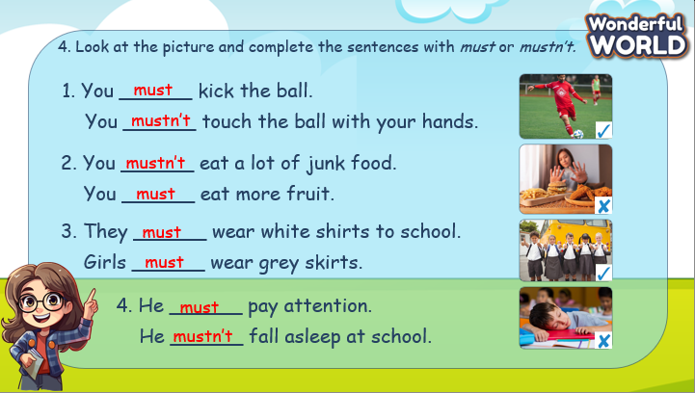  Task 5: Look, write, and say.  - Tell the students that they are going to look at the picture and  write sentences about what basketball players must do and  what they mustn’t do.  - Ask students to look at the first picture and the tick (✓) and elicit what they must or mustn’t do.  - Ask students to look at the example.  - Explain the rest of the task to students. Allow them enough time  to complete the task alone. Go round the class helping students  where necessary.  - Ask students to work in pairs to show their pictures and share their writing.  - Check the answers with the class.  - Invite some Ss to come to the board and write their answers.  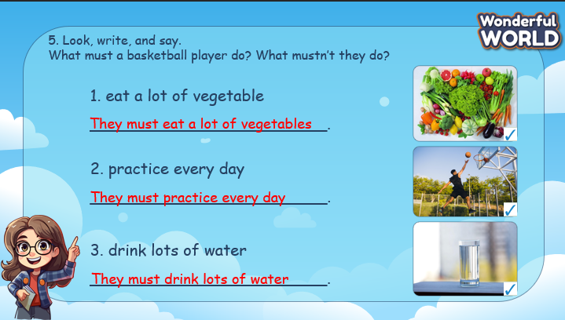 |  | - Look at the screen and listen to the explanation.  - Read the example make sentences and share with the class.  - Read the first example and remember the form of the verbs that go after the modal verb.  - Check the reading part 1 and find sentences that use “must” and “mustn’t”.  - Do task 4 individually.  - Write their answer on the board and check as a class.  - Look at the picture and the sentence about basketball players on the screen.  - Understand the tasks: write a sentence with “must” for the picture with the tick, and a sentence with “mustn’t” for the picture with the cross.  - Share their answers with the class.  - Check the answers.
Activity 3: Practice – Controlled practice (8 minutes)
Aims:
- Help Ss to remember the use of “must” and “mustn’t”
- Encourage Ss to think quickly by giving the correct answer in a short time.
Teacher’s Activities |  | Students’ Activities
Driving test  - T divides the class into 2 groups. Each group will choose a name and play rock, scissors, and paper to decide which group goes first.  - The two groups will take turns to answer the questions.  - T checks the answer. If it is correct, the team will get 5 points. If not, move to the next question.  - When all the questions are answered, the team with the higher score will win the game.  - The team with a lower score must do an exercise (hop, dance, sing, etc.).  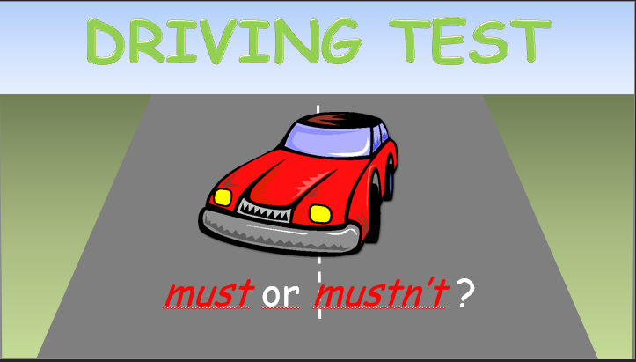 |  | - Listen to the rules of the game.  - Appoint a representative to do rock, scissors, and paper to decide who goes first.  - Take turns to answer the questions.  - Check the results.  - Do the exercise (for the team with a lower score)
Activity 4: Production – Writing & Speaking (6 minutes)
Aims:
- Apply the structures used in the paragraph to write a note about what we must or mustn’t do at school.
- Encourage Ss to explain the reason why we are allowed / not allowed to do those things.
- Encourage Ss to be willing to answer the extra questions.
Teacher’s Activities |  | Students’ Activities
- Tell students to look at the table and the sample sentences. Read  the sample sentences out loud and ask students to repeat after.  - Tell students to think about what they must or mustn’t do at school. Make sentences with words in the box.  - Explain that they should write two more sentences about what they must do at school in the MUST column and two more sentences about what they mustn’t do at school in the MUSTN’T column.  - Give them some time to complete the task. Help students with  spelling where necessary.  - Ask students to work in pairs to share their ideas.  - Ask some volunteers to share their writing with the class. Give  feedback.  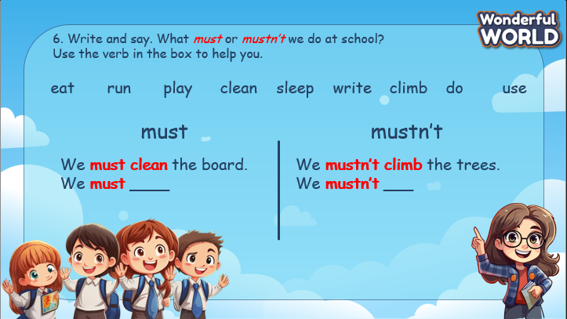 |  | - Look at the given words and check the meaning of each word.  - Read the sample sentences.  - Work in pairs.  - Share the sentences with the class. Try to explain why we are allowed / not allowed to do those things.  - Try to answer further questions to support their ideas.
Activity 5: Wrap up & Assessment (4 minutes)
Teacher’s Activities |  | Students’ Activities
Aims:
- Check Ss’s understanding of what they have learned.
- Students rehearse what they have learned in the lesson.
- Ask Ss to do the assessment.  - Give the assessment to the class and some Ss.  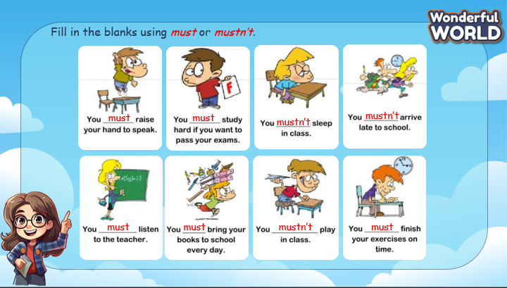  - Check with the class.  - T asks Ss about what they have learnt in today’s lesson.  - T shows the wrap-up slide and concludes the lesson.  * Remember  STRUCTURE  - Must and Mustn’t  - Food doesn’t stay on plates, so scientists must eat food from packages.  - There isn’t a fridge on the ISS, so they mustn’t keep fruit and vegetables for long. |  | - Do the assessment.  - Check with the teacher.  - Answer T’s question of what they have learnt in today’s lesson.  - Ss read the wrap-up.  - Stand up and say goodbye to the teacher.

UNIT 8: PEOPLE AND PLACES
Lesson 3 - Part 1,2,3
I. OBJECTIVES:
1. Knowledge:
- Students learn about famous places in Barcelona.
2. Competences:
By the end of the lesson, students will be able to:
- describe a place using a picture.
- describe their favourite place.
3. Qualities:
- Students will
+ have strong confidence while talking about the place they like.
II. EQUIPMENT AND MATERIALS:
- Basic things: Student’s book, flashcards, photos, papers.
- Advanced things: PPT, laptop, TV.
III. LESSON PROCEDURE:
Activity 1: Warm-up (5 minutes)
A guessing game “Can you guess?”
Aims: Welcome students. Engage the class (or warm the class up) with a guessing word game to revive the vocabulary and lead in the new lesson.
Teacher’s Activities | Students’ Activities
Procedure
1. Greet students. Chatting…Do you like listening to music…  2. Introduce the video “Travel the World Song”  - Show the question on the screen and remind Ss to pay attention and take notes if needed while watching the video.  - Play the video.  - Ask Ss about the topic of the video.  - Ask Ss about the question, and invite some Ss to show their answer.  - Check the answer and ask Ss to repeat.    Lead in:  - T raises some pictures and asks Ss to guess the topic of the lesson.  - T writes the topic “People and places”. | - Greet the T.  - Listen to T’s instructions about the warm-up activity.  - Watch the video and take note of what they have seen.  - Answer the questions.  - Check the results.  - Repeat after T.  - Look at the pictures and guess the topic.
Activity 2: Presentation (12 minutes)
Aims:
- Learn about the city of Barcelona and other places around the world.
- Ss will be able to talk about their favourite places
- Finish task 1
Teacher’s Activities |  | Students’ Activities
PRESENTATION  - Show the pictures of famous places in Barcelona and play the audio. Ask Ss to listen and repeat.  Task 1: Look at the picture. What are these places like?  - Tell students to look at the photos and say what they see (a big church, trees, a lake, a beach, a street).  - Write Barcelona on the board and ask students what they know about this city. If any students have been to Barcelona, ask them to tell the class about their visit there. Try to elicit that Barcelona is in Spain and these three places in the photos are the famous tourist sites in this city.  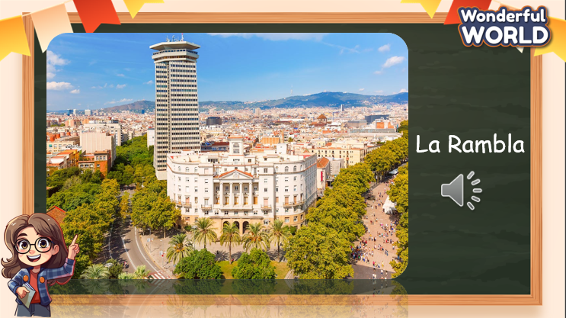 |  | - Look at the screen, listen, and repeat.  - Look at the picture, and describe what they can see.  - Learn about Barcelona and famous places in Barcelona.
Activity 3: Practice – Controlled practice (8 minutes)
Aims:
- Listen to an audio about Barcelona, Practice listening skills
- Get familiar with the True/False tasks
Teacher’s Activities |  | Students’ Activities
Task 4: Listen to a talk about Barcelona. Tick T for True  or F for False.  - Tell the students that they are going to listen to a text about  Barcelona and these three places, and while listening, they  should tick the correct answers T (True) or F (False).  - Ask students to read through the sentences 1–6.  - Play the recording and tell students to listen and tick the correct  answers. Play the recording more than once if students cannot grasp the answers.  - Invite some Ss to correct the false sentences.  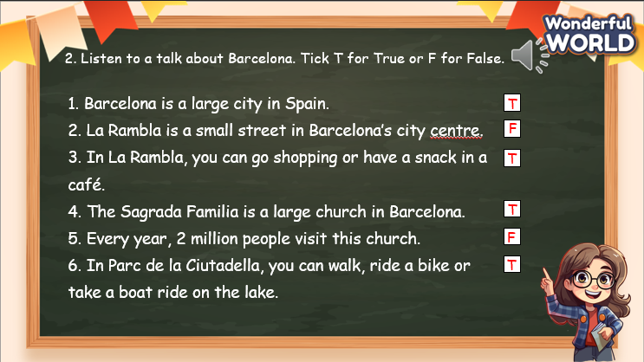  Cute Monkey game  - T divides the class into 2 groups. Each group will choose a name and play rock, scissors, and paper to decide which group goes first.  - The two groups will take turns to choose a number and answer the corresponding questions.  - T checks the answer. If it is correct, give them 5 points and play on the home screen to back to the choosing number screen.  - If the answer is incorrect, T asks the next team to choose the number.  - When all the questions are answered, the team with the higher score will win the game.  - When the game is finished, click on the STOP button on the right bottom edge to move to the next slide.  - The team with a lower score must do an exercise (hop, dance, sing, etc.).   |  | - Look at the text and identify the information they are going to listen to.  - Listen to the audio and fill in T / F.  - Listen again and check the answer.  - Correct the False sentences.  - Listen to the rules of the game.  - Appoint a representative to do rock, scissors, and paper to decide who goes first.  - Choose the number pay attention to the questions, and then answer.  - If the answer is correct, get the points.  - If not, the next team will choose another number to continue the game.  - Check the results.  - Do the exercise (for the team with a lower score).
Activity 4: Production –Speaking (6 minutes)
Aims:
- Apply the structures used in the paragraph to take note of their favourite places in their town or city.
- Talk about their favourite places in front of the class. Discuss why they like those places.
- Encourage Ss to answer the extra questions to support their ideas.
Teacher’s Activities |  | Students’ Activities
Task 3: Let’s talk.  - Tell students to look at the dialogue.  - Read out the dialogue. Read it again, pause after each sentence, and ask students to repeat.  - Ask one or two students to read out the dialogue again.  - Explain to students that they are going to talk about their favourite places in their town or city. Ask them to choose a place and prepare information on it.  - Ask students to work in pairs to take turns to ask and answer about their favourite place as demonstrated in the example  - Circulate the class, providing support and guidance as needed.  - Observe the conversations to ensure students are using the questions appropriately and responding effectively.  - Ask some volunteers to speak in front of the class. 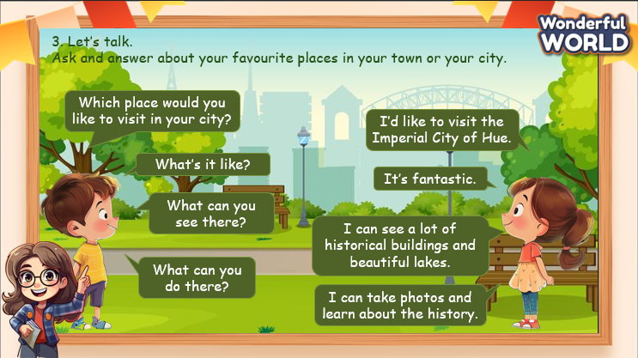 |  | - Think of the questions they can use to ask about someone’s favourite places.  - Work in pairs, ask and answer about their teammate’s favourite places.  - Practice speaking.  - Speak in front of the class. Try to explain why they like those places.  - Answer further questions.
Activity 5: Wrap up & Assessment (4 minutes)
Teacher’s Activities |  | Students’ Activities
Aims:
- Check Ss’s understanding of what they have learnt.
- Students rehearse what they have learned in the lesson.
- Ask Ss to do the assessment.  - Give the assessment to the class and some Ss.  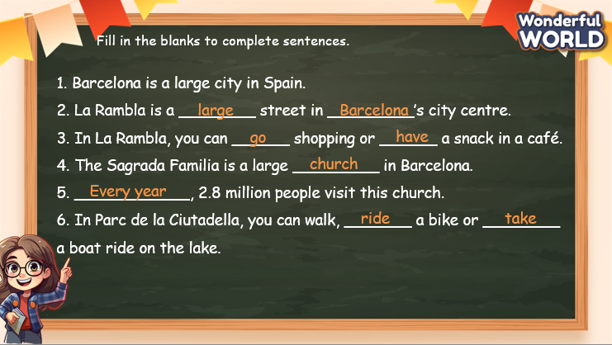  - Check with the class.  - T asks Ss about what they have learnt in today’s lesson.  - T shows the wrap-up slide and concludes the lesson.  * Remember  VOCABULARY  Barcelona, La Rambla, the Sagrada Familia, Parc de la Ciutadella  SPEAKING  Ask about someone’s favourite places:  - Which place would you like to visit?  - What’s it like?  - What can you see there?  - What can you do there? |  | - Do the assessment.  - Check with the teacher.  - Answer T’s question of what they have learnt in today’s lesson.  - Ss read the wrap-up.  - Stand up and say goodbye to the teacher.

