WEEK 21
UNIT 8. TECHNOLOGY
Lesson 1. Task 4, 5, 6
Period 81
I. OBJECTIVES:
1. Knowledge:
- Students will review words and phrases related to the topic Technology: smartphone, make videos, make phone calls, learn English, play video games, write emails.
- Students will learn about frequency adverbs: sometimes, always.
- Students will learn about new structure:
I always learn English on my computer.
He sometimes makes phone calls.
2. Competences:
- English competences: Students will be able to talk about what they can do on smartphone and computer, as well as how often they use them.
- Common competences: Students will have the opportunity to develop the creativeness by participating in games and developing communication among friends.
3. Qualities:
- Students develop topic related to technology skills.
II. EQUIPMENT AND MATERIALS:
- For Teacher: PP, flashcards, handout, track 8.3.
- For students: pens, books, crayons, paper.
III. LESSON PROCEDURE:
Activity 1: Warm up (5 minutes)
Teacher’s Activities | Students’ Activities
a, Aims: Review the words of Technology and previous structure which they have learned before.
b, Procedure  - Greet students and divide class into 4 teams.  Warm up: Crossword.  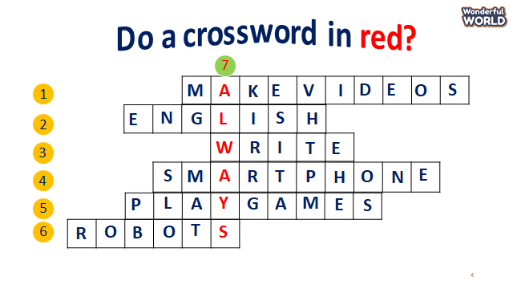  - The T shows the crosswords and asks sts to choose the numbers, then guess the answers.    - Sts can find out all words to get stars. If they find out the crossword in red, they can get double points for their team. | - Great teacher and choose the team name.  -Join the game.  - Choose the numbers and find out the words.  - Get double stars if sts figure out the key.
Activity 2: Presentation (8 minutes)
Teacher’s Activities | Students’ Activities
a, Aims: Present new grammar: Frequency adverbs.
b, Procedure  Task 4. Listen and repeat.  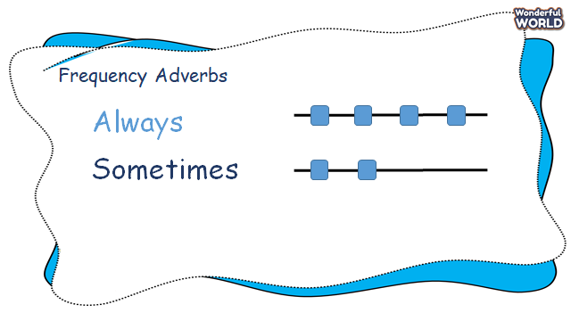  - T introduces frequency adverbs and how to use them.  - Say the words/sentences for students to repeat in the chorus.  - T explains the meaning of adverbs.  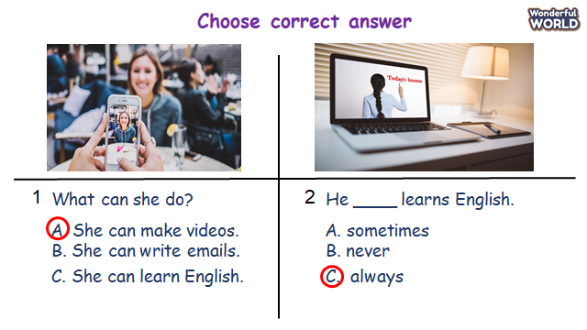  - Let sts answer the questions before listening to the task. 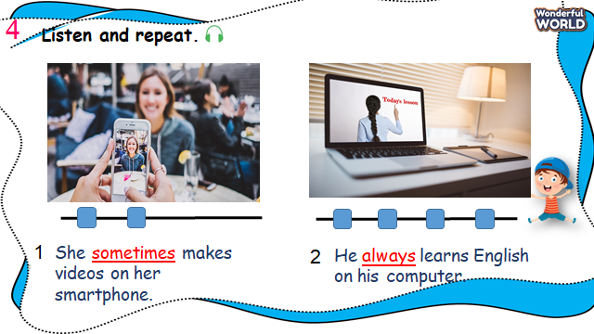  - Ask Sts to look at pictures and answer the questions.  - Say a word/sentence for students to repeat then point.  - Play track 8.3 for the students to listen to and repeat in chorus, and groups.  - Ask sts to notice the frequency adverbs in each sentence. | -Repeat after the teacher.  - Say the adverbs loudly.  -Sts listen and practice the words.  -Sts join the game and get stars.  -Sts look and answer about the pictures  -Repeat the sentences individually and in groups.
Activity 3: Practice (14 minutes)
Teacher’s Activities | Students’ Activities
Aims: Make sentences based on the structure they have learned using frequency adverbs.
Encourage sts to talk about what can they do when using technology.
Task 5: Look and say.  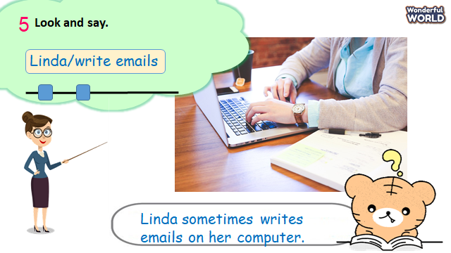  - Look at the picture and ask sts to read out the prompts.  - Tell sts the example and ask them to repeat.  - Explain the rest of the task.  - Let Sts make some sentences through some pictures and practice them in pairs.  - Require some pairs present in front of the class. | -Read out prompts.  -Read some sentences.  -Make and practice some sentences in pairs and present them to the class.
Activity 4: Production (9 minutes)
Teacher’s Activities | Students’ Activities
a, Aims: Apply words and grammar to make correct answers using frequency adverbs.
Encourage sts to read out what they can do on the phone.
b, Procedure  Task 6: Let’s talk  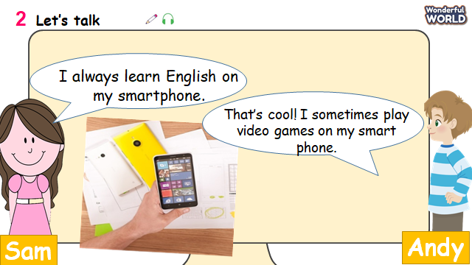  -T shows the picture of the phone and the examples.  -Read out some sentences and ask sts to repeat.  -Then let sts practice sentences through the game:  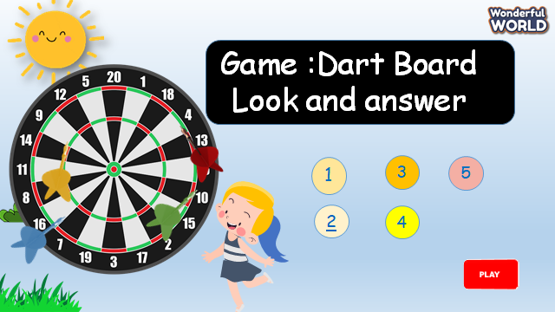  -T shows the game and asks to choose the numbers  - Answer some questions and get stars for their teams.  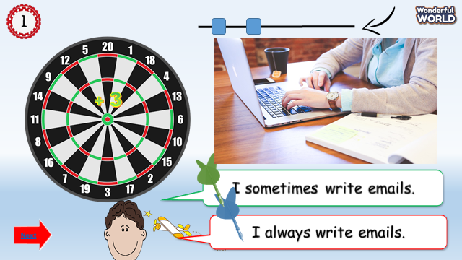  - Ask sts to make their own sentences through a game using activities and frequency adverbs.  - Allow sts some minutes and ask some volunteers read out their sentences.  - Check their answers. | -Sts read out sentences.  - Join the game to get stars.  - Make their own sentences.  - Some sts read loudly.
Activity 5: Assessment (3 minutes)
Teacher’s Activities | Students’ Activities
a, Aims: Consolidate the content of the lesson.
-Ask sts to do the assessment.  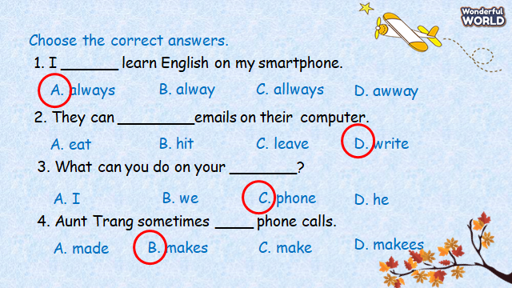  - Check with the class.  - Wrap up the vocabulary and structure  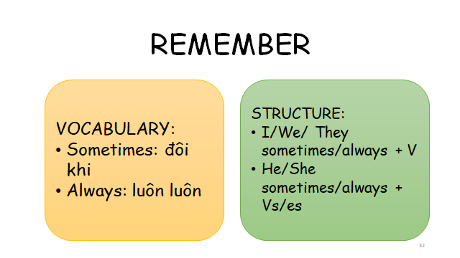 | -Do the assessment.  -Check with the teacher  - Read the wrap-up.  - Stand up and say goodbye to the teacher.
____________________________________
UNIT 8. TECHNOLOGY
Lesson 2. Task 1, 2, 3
Period 82
I. OBJECTIVES:
1. Knowledge:
- Students will learn words and phrases related to the topic Technology: use the tablet, surf the Internet, work in pairs, and work in groups.
- Students will learn about the new structure:
I/we/they sometimes/ always use the tablet.
He/She sometimes/always uses the tablet.
2. Competences:
- English competences: Students will be able to talk about different activities when using technology.
- Common competences: Students will have the opportunity to develop their creativeness by participating in games and developing communication among friends.
3. Qualities:
- Students develop topic related to technology skills.
II. EQUIPMENT AND MATERIALS:
- For Teacher: PP, flashcards, handout, track 8.4,8.5.
- For students: pens, books, crayons, paper.
III. LESSON PROCEDURE:
Activity 1: Warm up (5 minutes)
Teacher’s Activities | Students’ Activities
a, Aims: Warm-up activity to revise the words of previous lesson.
b, Procedure  - Greet students and divide class into 4 teams.  - Warm up: Matching game.  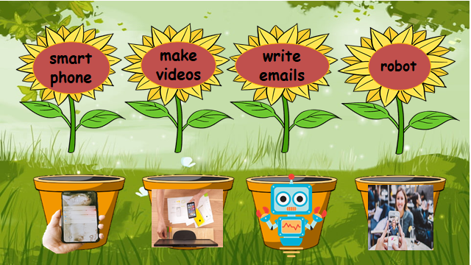  - The T shows the words and pictures.  - Ask sts to match the words to the correct pictures. Then roll the dice to get the stars.  - Check sts answers and give them stars. | - Sts greet the teacher and choose their team names.  -Join the game.  - Match pictures to the correct words.  - Answer the questions.
Activity 2: Presentation (8 minutes)
Teacher’s Activities | Students’ Activities
a, Aims: -Present some new words of Technology: use the tablet, surf the Internet, work in pairs, and work in groups.
- Encourage sts with the topic and vocab of related topic.
b, Procedure  Task 1. Listen and point. Repeat.  - Use flashcards to introduce the vocabulary and structure of the lesson.  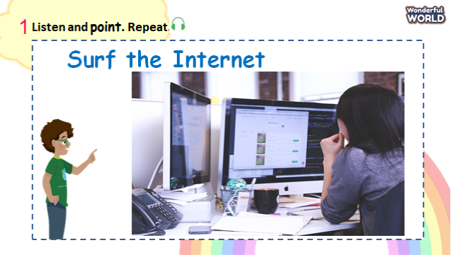  - Say the words/sentences for students to repeat in the chorus.  - Say a word/sentence for students to repeat then point.  - Play track 8.4 for the students to listen to and repeat in chorus, and group.  - Show pictures in random order and ask students to read out the dialogues.  VOCABULARY CHECKING  - Let Sts play the “Slap the board”.  - Ask some Sts to come to the board and the others read out the words.  - Then Sts slap the board, the first one can get stars.  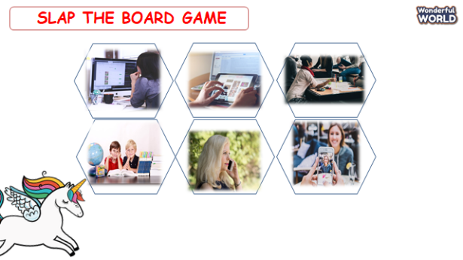 | -Look at the pictures.  -Repeat after the teacher.  -Sts listen and practice the words.  -Sts join the game and get stars.  -Sts come to the board and slap the correct ones.
Activity 3: Practice (14 minutes)
Teacher’s Activities | Students’ Activities
a, Aims: - Controlled-practice: Listen and tick a conversation using the vocab of task 1.
- Encourage sts to act out the dialogue in pairs in front of the class.
b, Procedure  Task 2: Listen and tick.  -Let Sts listen and read the dialogue by role play “Teacher” and “Robert” to practice the words and sentences.  -Pause the audio after each sentence and read out loud for sts.  - Ask sts to repeat sentences.  - Ask them to practice the dialogue in pairs.  - Then let some volunteers read out loud in front of the class.  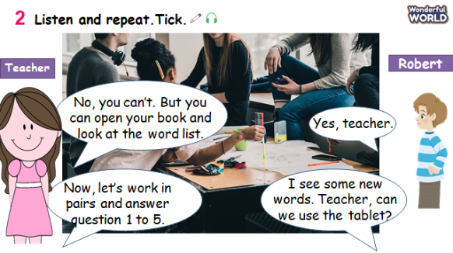  -Then play track 8.5 again and ask Sts to tick the answers.  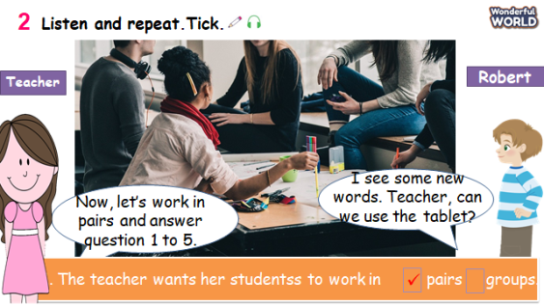  Task 3: Look and say.  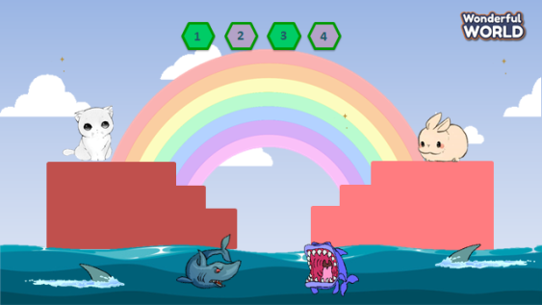  - Let Sts play the Shark Game. Sts can choose the numbers and answer the questions.  - Then ask Sts to choose the objects and read the dialogue.  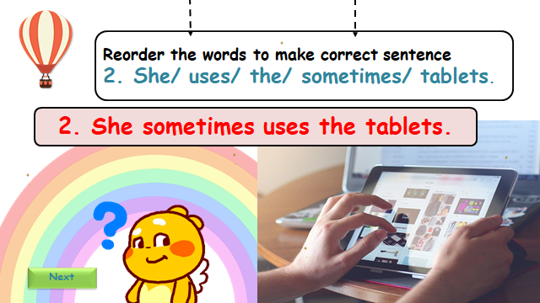  - Let Sts make sentences through the game such as reordering the words or choosing the correct answers.  - Require some pairs present in front of the class. | -Listen and read.  - Sts read aloud each sentence.  -Repeat the sentences.  -Ss play the role and work in pairs.  -Sts listen again and tick the correct answers.  -Sts play the game.  -Answer the questions.  -Make and practice some sentences in pairs and present them to the class.
Activity 4: Production (9 minutes)
Teacher’s Activities | Students’ Activities
a, Aims: Apply the new words and structures to present in front of the class about their favourite technology.
b, Procedure  Drawing your favourite technology.    -T shows the picture of some technology.  -T asks Sts to draw their favourite ones and show them to their class.  -Let Sts talk about what they can do with their technology and how often they use them. | - Sts draw the pictures.  - Sts talk about their technology.
Activity 5: Assessment (3 minutes)
Teacher’s Activities | Students’ Activities
a, Aims: Consolidate the content of the lesson.
b, Procedure  -Ask sts to do the assessment.  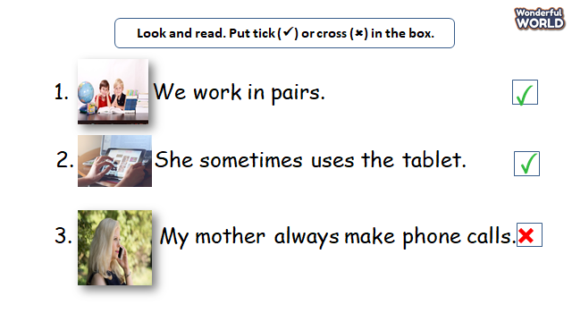  - Check with the class.  - Wrap-up  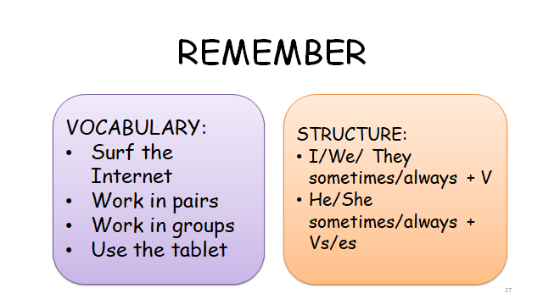 | -Do the assessment.  -Check with the teacher  - Sts read the wrap-up  - Stand up and say goodbye to the teacher.
________________________________
UNIT 8. TECHNOLOGY
Lesson 2. Task 4, 5, 6
Period 83
I. OBJECTIVES:
1. Knowledge:
- Students will revise words and phrases related to the topic Technology: use the tablet, use the phone, surf the Internet, work in pairs, and work in groups.
- Students will learn about the new structure:
Teacher, can we use the tablet?
- Yes, you can.
- No, you can’t.
2. Competences:
- English competences: Students will be able to talk about what they can do with technology and ask for permission.
- Common competences: Students will have the opportunity to develop their creativeness by participating in games and developing communication among friends.
3. Qualities:
- Students develop their technology skills.
II. EQUIPMENT AND MATERIALS:
- For Teacher: PP, flashcards, handout, track 8.6, 8.7.
- For students: pens, books.
III. LESSON PROCEDURE:
Activity 1: Warm up (5 minutes)
Teacher’s Activities | Students’ Activities
a, Aims: Review the vocabulary which they have learned from previous lesson through a game.
b, Procedure  - Greet students and divide class into 4 teams.  Warm up: Game time!    - The T shows some numbers.  - Ss can choose the numbers and answer the questions.  - Sts having correct answers will get more stars. | - Sts greet the teacher and choose their team names.  -Join the game.  - Sts choose the stars, answer the questions.
Activity 2: Presentation (8 minutes)
Teacher’s Activities | Students’ Activities
a, Aim: Present new structure: Can we …?
Encourage sts to ask and answer about their permission.
b, Procedure  Task 4: Listen and repeat.  - Let Sts listen to the song to introduce the new structure.  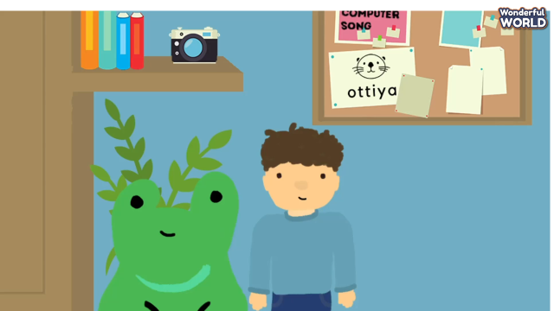  - Ask sts to underline the sentences Can we …?  - T explains the new structure that they ask for permission in English  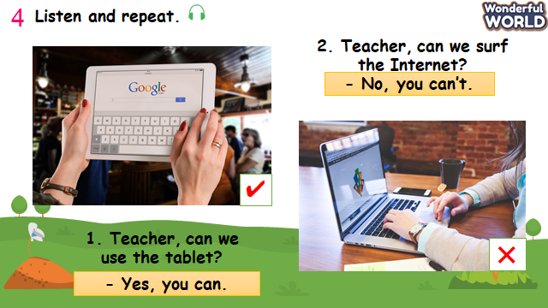  - Ask Sts to look at pictures and answer the questions.  - Say a word/sentence for students to repeat then point.  - Play track 8.6 for the students to listen to and repeat in chorus, and group.  - Ask sts to practice the sentences.  - Require some pairs to present in front of whole class. | -Listen to the song.  -Sts answer the questions.  -Sts listen and practice the dialogues.  - Take note the new structure.  - Some volunteers read the dialogue.
Activity 3: Practice (14 minutes)
Teacher’s Activities | Students’ Activities
a, Aims: Controlled-practice: to ask and answer about the permission and make sentences using Can…?
b, Procedure  Task 5: Look and say.  -Let Sts play “Yes or No” questions to review the previous lessons.  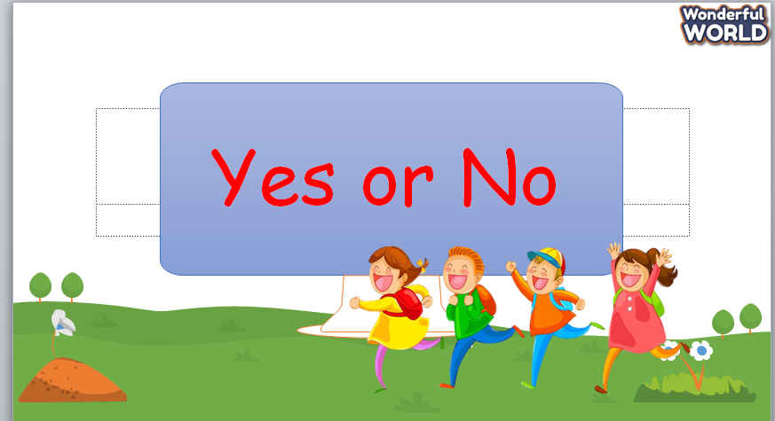  - Show some pictures and ask sts to choose.  -Then show sts the pictures and some prompts.  -Read out the prompts and make the dialogue. Then asks sts to repeat.  -Explain the rest of the task and ask sts to make and practice the dialogue in pairs through some pictures.  -Then let some pairs present in front of the class.  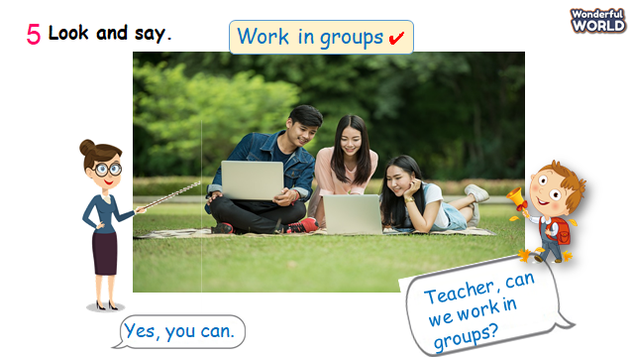 | -Take part in the games.  - Sts can look at pictures and choose Yes or No.  -Read the dialogue.  -Make and practice some dialogue in pairs and present it in the class.
Activity 4: Production (9 minutes)
Teacher’s Activities | Students’ Activities
a, Aims: Chant the song correctly according to its lyrics.
b, Procedure  Task 6: Listen and Chant.    -T shows the picture and asks sts what they can see.  -Then, T shows the song to chant.  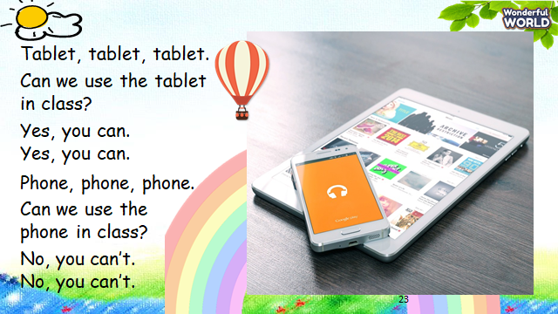  -Play the chant for students to listen and follow with their fingers.  -Read aloud each sentence, and ask sts to repeat.  -Play the chant again to sing along.  -Practice until sts are familiar with the words. | - Sts look at picture.  - Sts answer the questions.  - Listen to the chant.  - Sts repeat after a chant line.  - Sts chant the song.
Activity 5: Assessment (3 minutes)
Teacher’s Activities | Students’ Activities
Aims: Consolidate the content of the lesson.
b, Procedure  -Ask sts to do the assessment.  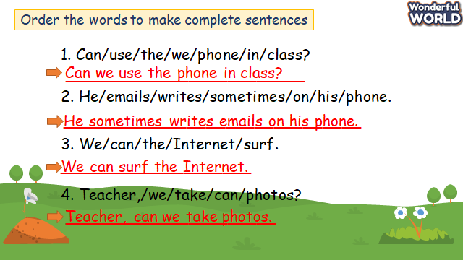  - Check with the class.  - Wrap-up  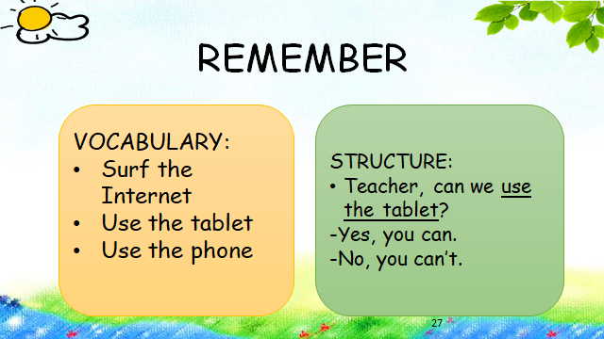 | -Do the assessment.  -Check with the teacher  - Sts read the wrap-up  - Stand up and say goodbye to the teacher.
_____________________________________
UNIT 8. TECHNOLOGY
Lesson 2. Task 7, 8, 9
Period 84
I. OBJECTIVES:
1. Knowledge:
- Students will revise words and phrases related to the topic Technology: work in group, work in pairs, play video games, use the tablet, and surf the Internet.
- Students will learn about the preposition: next to, between, in front of, behind
- Students will review about structure:
Can we use the tablet?
+Yes, you can.
+No, you can’t.
2. Competences:
- English competences: Students will be able to talk about what they can or can’t do with their technology.
- Common competences: Students will have the opportunity to develop their creativeness by participating in games and developing communication among friends.
3. Qualities:
- Students develop their soft skills.
II. EQUIPMENT AND MATERIALS:
- For Teacher: PP, flashcards, handout, track 8.8.
- For students: pens, books, crayons, paper.
III. LESSON PROCEDURE:

Activity 1: Warm up (5 minutes)
Teacher’s Activities | Students’ Activities
a, Aims: Review the words and structures which they have learned from previous lesson.
b, Procedure  - Greet students and divide class into 4 teams.  - Warm up: Game time!  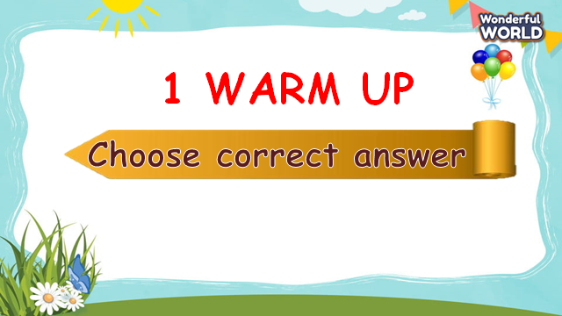  - The T shows the pictures and sentences.  - Ask Sts to choose the correct words to fill in the blanks.  - Sts can roll the dice to get stars.  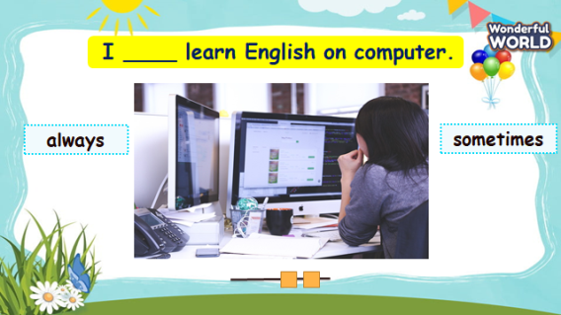 | - Sts greet the teacher and choose their team names.  - Join in the game.  - Sts choose the correct answer.
Activity 2: Presentation (8 minutes)
Teacher’s Activities | Students’ Activities
a, Aims: Practice the vocab and structures through listening skills by doing the exercise.
b, Procedure  Task 7: Listen and circle.  - After playing the game using the content of Task 7, sts will listen to a radio of Laura and circle the answers.    - Ask Sts to look at pictures and listen to the recording.  - Say a word/sentence for students to repeat then point.  - Ask sts to read through sentences 1-4 and the options.  - Play track 8.8 for the students to listen to and circle the correct answers for questions 1-4  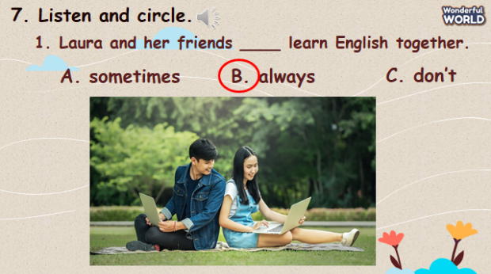.  - Play the track again and pause after each sentence to check answers. | - Sts look at pictures and listen to the recording.  -Sts repeat the sentences.  - Sts listen to the track and do the task.  - Sts check the answers.
Activity 3: Practice (14 minutes)
Teacher’s Activities | Students’ Activities
a, Aims: Controlled-practice: to discuss and make sentences using can/can’t.
Encourage sts to make full sentences using can/can’t.
b, Procedure  Task 8: Look and say.  - Let sts play the game: Help the Pooh according to the picture.  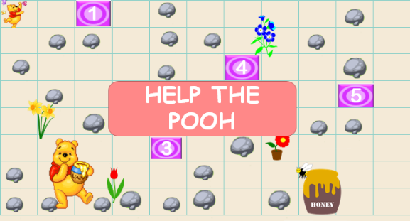  - Sts answer the questions on time to get stars and move to the next question.  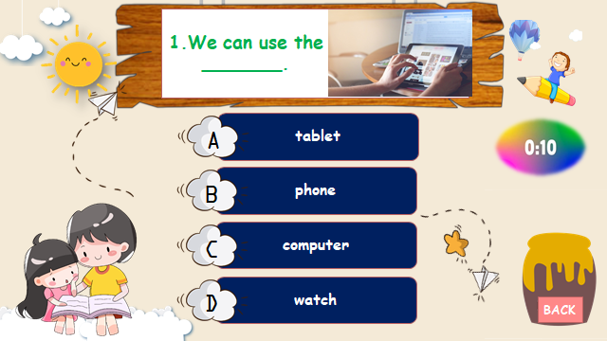  -Then tell sts that they are going to talk about classroom rules.  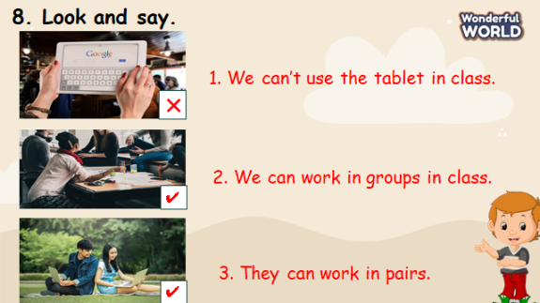  - Ask sts to look at pictures and explain the things shown in each picture.  - Tell sts to look at the picture for sentence 1 and make a sentence.  - Read out example 1 and ask sts to repeat.  - Explain the rest of the task and ask sts to make and practice the sentences individually through some pictures.  - Then let some volunteers present in front of the class. | -Sts look at the picture and answer the question.  -Take part in the games.  -Look at the pictures.  -Read the sentences.  -Make and practice some sentences individually and present them in the class.
Activity 4: Production (9 minutes)
Teacher’s Activities | Students’ Activities
a, Aims: Apply the words and structures about the permission.
Encourage sts to make class rules and present these instructions in front of the class.
b, Procedure  Task 9: Let’s play.  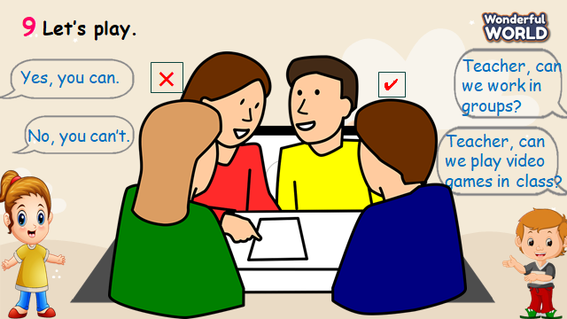  - T shows the picture and the sentences.  - Then, T shows the dialogue.  - Read out the dialogue, pause after each sentence, and ask sts to repeat.  - Ask sts to read out and practice the dialogue in pairs.  - Let sts draw what they can or can’t do in class.  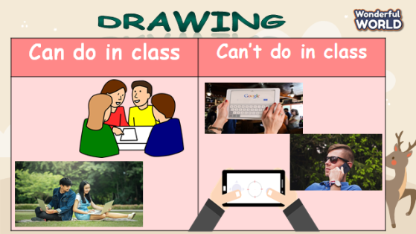  - Encourage them to use the vocabulary learnt in previous lessons.  - Ask some pairs to present in class. | - Sts look at pictures and sentences.  - Sts read aloud.  - Sts draw their own class rules activities using can or can’t.  - Some pairs present in class.
Activity 5: Assessment (3 minutes)
Teacher’s Activities | Students’ Activities
a, Aims: Consolidate the content of the lesson
-Ask sts to do the assessment.  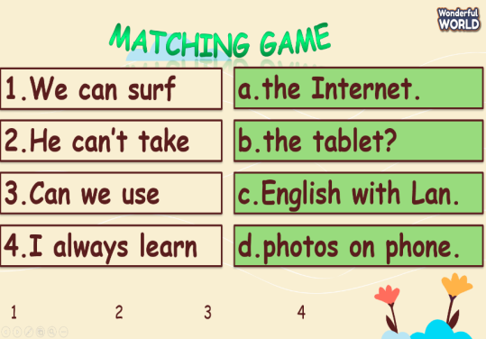  - Check with the class.  - Wrap-up  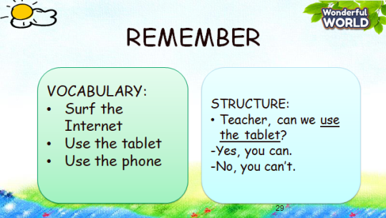 | - Do the assessment.  - Check with the teacher  - Sts read the wrap-up  - Stand up and say goodbye to the teacher.
______________________________________

