WEEK 22
UNIT 8. TECHNOLOGY
Lesson 3. Task 1, 2, 3
Period 85
I. OBJECTIVES:
1. Knowledge:
- Students will learn words and phrases related to the topic Technology: change the password, use the computer lab, use the projector, use the speaker.
- Students will learn about the new structure:
Can teachers/ students use the projector?
- Yes, they can.
-No, they can’t.
2. Competences:
- English competences: Students will be able to express possibilities with can.
- Common competences: Students will have the opportunity to develop their creativeness by participating in games and developing communication among friends.
3. Qualities:
- Students develop their information technology skills.
II. EQUIPMENT AND MATERIALS:
- For Teacher: PP, flashcards, handout, track 8.9,8.10
- For students: pens, books, paper.
III. LESSON PROCEDURE:

Activity 1: Warm up (5 minutes)
Teacher’s Activities | Students’ Activities
Aims: Warm-up activity to revise the words of previous lesson.
b, Procedure  - Greet students and divide class into 4 teams  -Warm up: Racing game.  - The T shows the race.  - Ask Sts to look at the pictures, choose the numbers and answer the questions  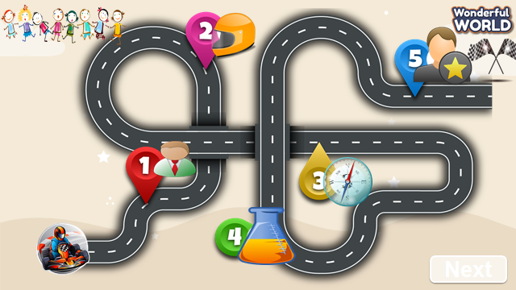  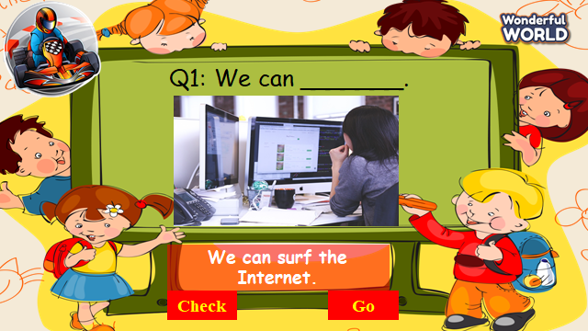  - If sts have correct answers, they can roll the dice to get stars. | - Sts greet the teacher and choose their team names.  - Join in the game.  - Look at the questions and pictures  - Sts having correct answers will have stars.
Activity 2: Presentation (8 minutes)
Teacher’s Activities | Students’ Activities
a, Aims: Present some new words of Technology: change the password, use the computer lab, use the projector, use the speaker.
Encourage sts with the topic and vocab of related topic.
b, Procedure  Task 1. Listen and point. Repeat.  - Use pictures to introduce the vocabulary and structure of the lesson.  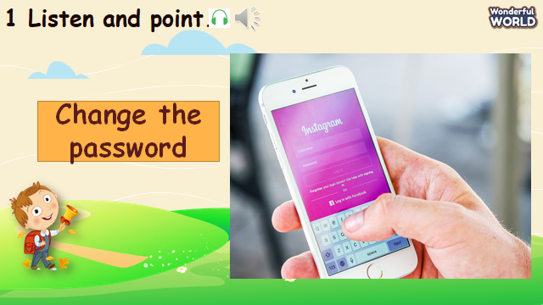  - Say the words/sentences for students to repeat in the chorus.  - Say a word/sentence for students to repeat then point.  - Play track 8.9 for the students to listen to and repeat in chorus, and group.  - Show pictures in random order and ask students to read out the words.  VOCABULARY CHECKING  - Let Sts play the “Protect the jungle”.  - Ask some Sts to choose the numbers, look at the picture and answer the questions.  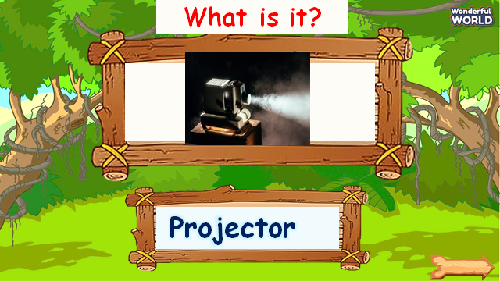  - If they have correct answers, they can hit the hunters through some monkeys and have their stars. | -Repeat after the teacher.  -Listen to the track and repeat in whole class.  -Sts practice the new words individually and in groups  -Sts join the game and get stars.
Activity 3: Practice (14 minutes)
Teacher’s Activities | Students’ Activities
a, Aims: - Controlled-practice: Listen and tick a conversation using the vocab of task 1.
- Encourage sts to act out the dialogue in pairs in front of the class.
b, Procedure  Task 2: Listen and tick.  - Ask sts to look at the picture and answer what they can see.  -Let Sts listen and read the dialogue about what they can use in the computer lab by role play “Teacher Sam” and “Andy” to practice the words and sentences.  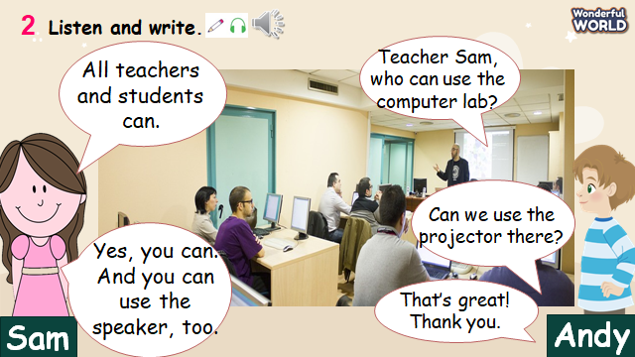  - Ask some pairs to read the dialogue.  - Then let sts read the sentences below and ask them to listen and fill in the gaps with the words from the recording.  -Then play track 8.10 again for sts to check their answers.  - Pause after each sentence to check their answers.  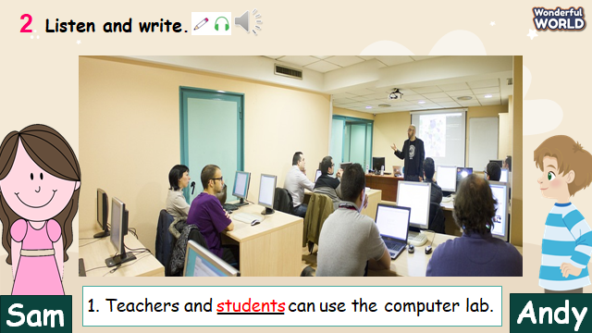  Task 3: Look and say.  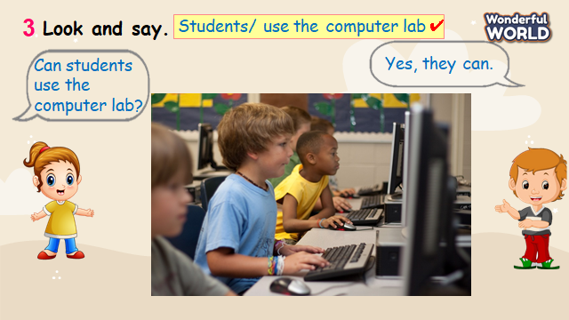  - Look at the picture and prompts. Read out prompts and ask sts to repeat.  -Read out the dialogue and let sts repeat.  -Then ask Sts to choose the objects and read the dialogue.  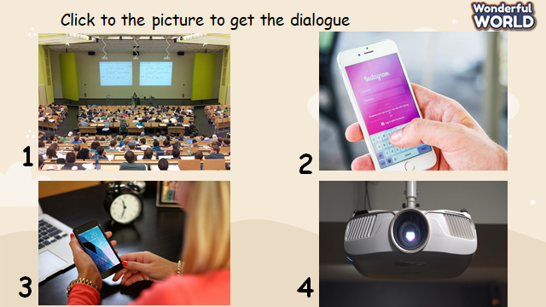  - Explain the task and allow them enough time to practice saying sentences.  - Let Sts make some dialogues through some pictures and practice them in pairs.  - Require some pairs present in front of the class. | -Listen and read.  - Sts read aloud each sentence.  - Repeat the sentences.  -Some pairs read the dialogue.  -Sts listen again and write the correct answers.  -Answer the question.  -Read some prompts and dialogue.  -Make and practice some dialogues in pairs and present it in the class.
Activity 4: Production (9 minutes)
Teacher’s Activities | Students’ Activities
a, Aims: Watch the video and write the objects that they can see.
Apply the new words and structures to present in front of the class about technology using vocabulary in task 1.
b, Procedure  Watch a video!  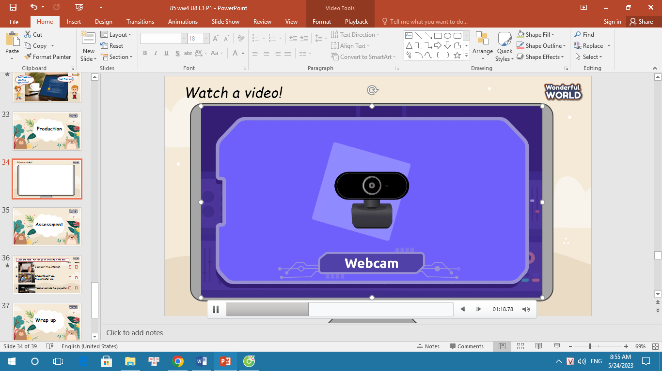  -Ask sts to count and write the name of the technology.  - Ask them to read out the objects in the video.  - Then, write some sentences about technology using the vocabulary in task 1.  - Ask some volunteers present about sentences in front of the class. | -Sts watch the video.  - Sts guess how many technologies they can see.  -Write down and answer about the objects in the video.  -Make sentences about technology  -Some sts present about it.
Activity 5: Assessment (3 minutes)
Teacher’s Activities | Students’ Activities
a, Aims: Consolidate the content of the lesson.
-Ask sts to do the assessment.  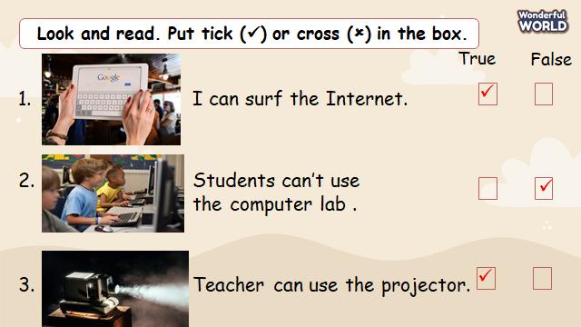  - Check with the class.  - Wrap-up  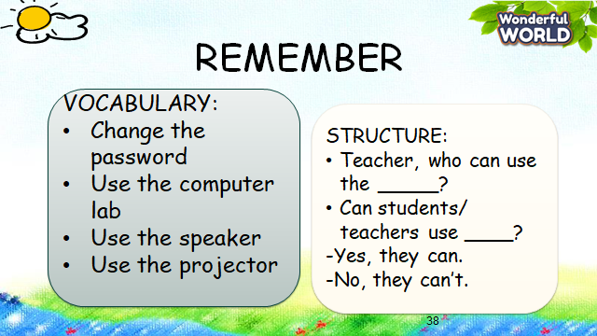 | -Do the assessment.  -Check with the teacher  - Sts read the wrap-up  - Stand up and say goodbye to the teacher.
______________________________________
UNIT 8. TECHNOLOGY
Lesson 3. Task 4, 5, 6
Period 86
I. OBJECTIVES:
1. Knowledge:
- Students will revise words and phrases related to the topic Technology: change the password, use the computer lab, use the projector, use the speaker
- Students will learn about the new structure:
We can use the speaker in class.
We can’t use smartphone in class.
2. Competences:
- English competences: Students will be able to talk about what they can or can’t do in class using technology.
- Common competences: Students will have the opportunity to develop their creativeness by participating in games and developing communication among friends.
3. Qualities:
- Students develop their technology skills.
II. EQUIPMENT AND MATERIALS:
- For Teacher: PP, flashcards, handout, track 8.11
- For students: pens, books, paper, and crayons.
III. LESSON PROCEDURE:

Activity 1: Warm up (5 minutes)
Teacher’s Activities | Students’ Activities
a, Aims: Review the vocabulary which they have learned from previous lesson.
b, Procedure  - Greet students and divide class into 4 teams  - Warm up: Unscramble Game!  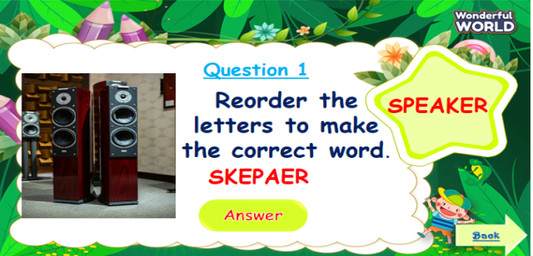  - The T shows the pictures and words.  - Ask Sts to reorder the letters to make the correct words.  - Sts answer all the questions and roll the dice to get stars. | - Sts greet the teacher and choose their team names.  - Join in the game.  - Look at the questions and pictures  - Sts having correct answers will have stars.
Activity 2: Presentation (8 minutes)
Teacher’s Activities | Students’ Activities
a, Aims: Present new structure “Who can use ….?” to express possibilities using “can”.
Encourage sts to work in pairs in front of the class using new structure.
b, Procedure  Task 4: Listen and repeat.  - Let Sts look at the word patterns and pictures.  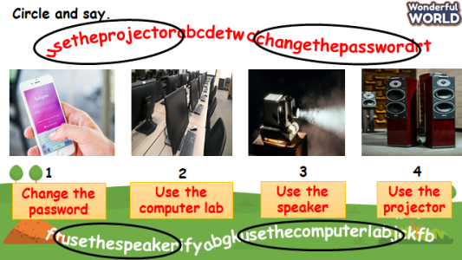  - Ask sts to figure out the words and say aloud.  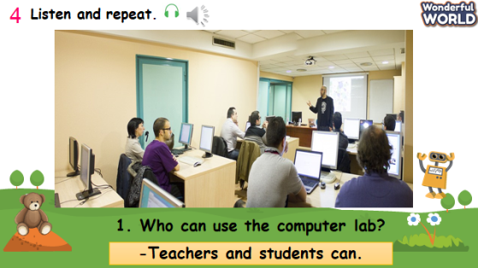  - Ask Sts to look at pictures and underline the sentence “Who can use the computer lab?”.  - Say a word/sentence for students to repeat then point  - Explain the structure “Who can use ….? to express possibilities using “can”.  - Give sts the answer of that structure by using “S+can”.  - Play track 8.11 for the students to listen to and repeat in chorus, and group.  - Ask some pairs to read the questions and answers. | -Look at some pictures and wordpatterns.  -Sts take part in the game.  -Sts repeat the answers.  -Sts underline the questions.  -Sts listen and practice the dialogues.  - Some pairs present in front of class.
Activity 3: Practice (14 minutes)
Teacher’s Activities | Students’ Activities
a, Aims: Controlled-practice: to ask and answer about permission of using technology and make sentences using can.
Task 5: Look and say.  -Let Sts play “Matching game” to review the previous lessons.  - Ask sts to play in teams.    - Let sts match the correct activities to correct people.  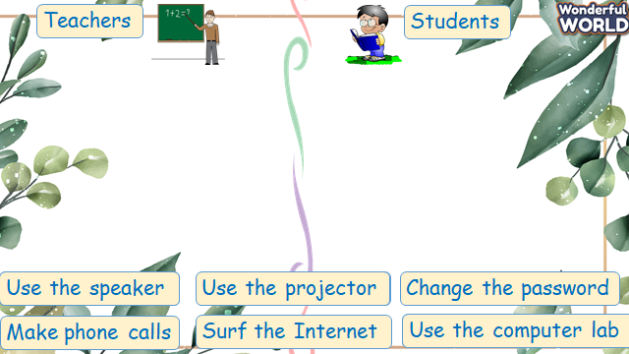  -Then show sts the pictures and some prompts.  - Read out the prompts and make the dialogue. Then ask sts to repeat.  - Explain the rest of the task and ask sts to make and practice the dialogue in pairs through some pictures.  - Then let some pairs present in front of the class.  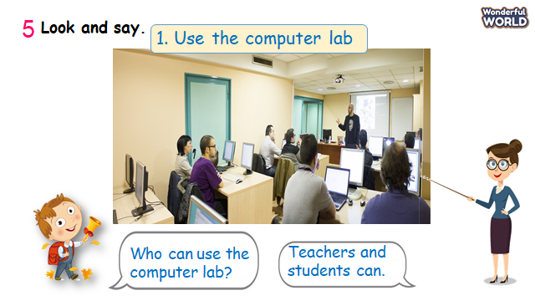 | - Look at pictures and questions.  -Take part in the games.  - Match the correct activities.  -Read the dialogue.  -Make and practice some dialogue in pairs and present it in the class.
Activity 4: Production (9 minutes)
Teacher’s Activities | Students’ Activities
a, Aims: Apply the words and structures to make sentences about technology using can or can’t.
b, Procedure  Task 6: Let’s talk  -T shows the picture and asks sts what they can or can’t do in class.  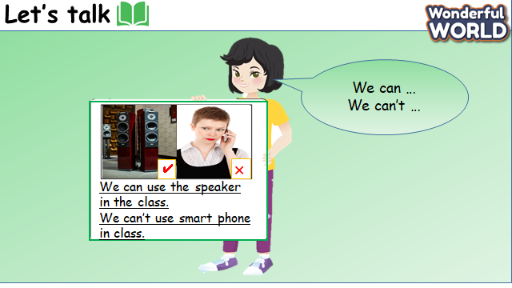  - Read out the sentences and ask them to repeat.  - Tell sts to draw a picture of what they can or can’t do.  - Ask sts to write a description using the examples.  - Ask some volunteers to show their pictures and read out their work. | - Sts repeat after T.  - Sts draw a picture.  - Sts make sentences using examples.  - Some volunteers read aloud.
Activity 5: Assessment (3 minutes)
Teacher’s Activities | Students’ Activities
Aims: Consolidate the content of the lesson through a game.
-Ask sts to do the assessment.    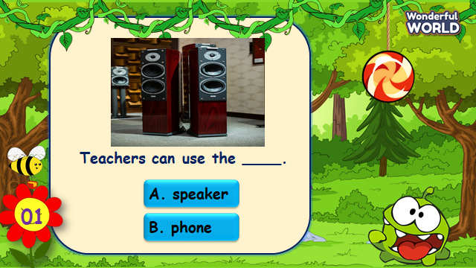  - Check with the class.  - Wrap up  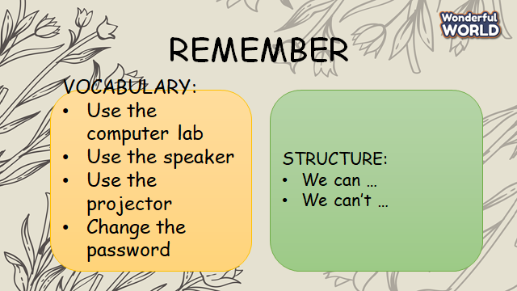 | -Do the assessment.  -Check with the teacher  - Sts read the wrap-up  - Stand up and say goodbye to the teacher.
________________________________________
UNIT 8. TECHNOLOGY
Lesson 3. Task 7, 8, 9
Period 87
I. OBJECTIVES:
1. Knowledge:
- Students will revise words and phrases related to the topic Technology: use, make
- Students will learn about how to pronounce /s/, /m/.
- Students will learn about new structure: I can use my phone. I can make videos.
2. Competences:
- English competences: Students will be able to talk about what they can use.
- Common competences: Students will have the opportunity to develop the creativeness in participating in games and develop communication among friends.
3. Qualities:
- Students develop their soft skills when using technology.
II. EQUIPMENT AND MATERIALS:
- For Teacher: PP, flashcards, handout, track 8.12,8.13.
- For students: pens, books.
III. LESSON PROCEDURE:
Activity 1: Warm-up (5 minutes)
Teacher’s Activities | Students’ Activities
a, Aims: Warm-up activity to revise the vocabulary they have learned through a song.
b, Procedure  - Greet students and divide class into 4 teams.  -Warm-up: Listen to a song: The Qwerty Song!    - The T shows the song and let sts review some words and phrase relating to Computer. | - Sts greet the teacher and choose their team names.  -Listen to the song.
Activity 2: Presentation (8 minutes)
Teacher’s Activities | Students’ Activities
a, Aims: Present new grammar: to pronounce /m/, /s/
Encourage sts to pronounce words correctly through a game.
b, Procedure  Task 4: Listen and repeat.  - Let Sts look at the pictures.  - Write //m/ on the board then write bookshelf.  - Ask sts to pronounce the word.  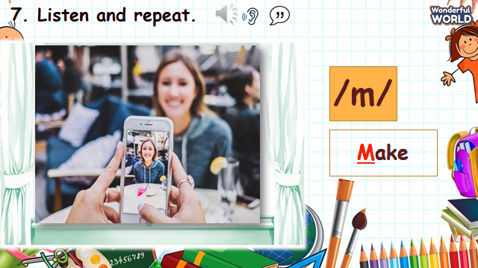  - Write //s/ on the board then write bookshelf.  - Ask sts to pronounce the word.  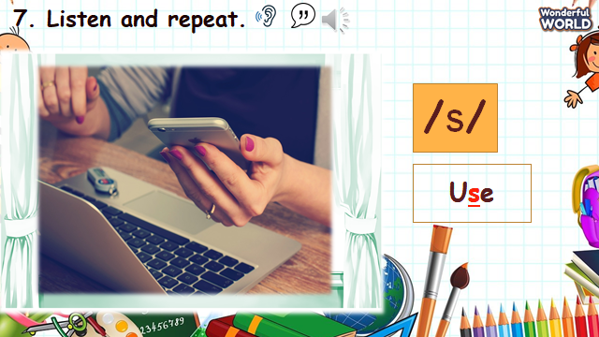  - Play the recording and tell students to point to the sounds they heard.  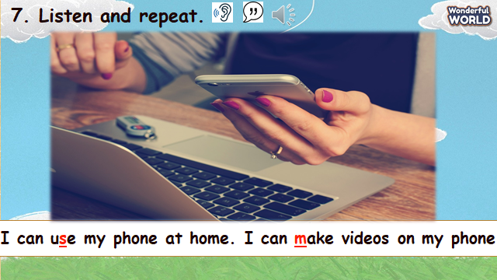  - Show sts how the sounds are different from each other.  - Ask sts to read the words.  - Play the recording again and tell sts to repeat the sentences and words, paying attention on pronounciation.  CHECKING VOCABULARY.  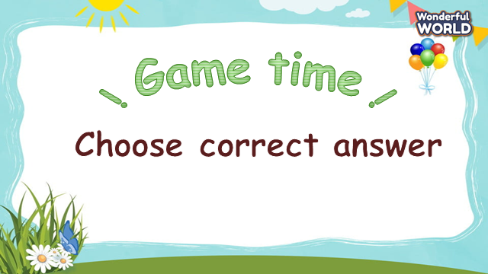  - Ask Sts to look at pictures and choose the correct answers.  - Sts having the correct answers will roll the dice to get stars. | - Look at the sounds and words.  - Sts listen to the recording and teacher.  - Repeat the words and sentences.  - Take part in the game.  - Sts look at pictures and words.  - Sts choose the correct words.
Activity 3: Practice (14 minutes)
Teacher’s Activities | Students’ Activities
a, Aims:
-Controlled-practice: help sts to practice the vocab and grammar by doing a game.
-Encourage sts to pay attention to pronunciation.
b, Procedure  Task 9: Say it!.  -Let Sts play “Wheel of fortune” questions to practice Task 9.  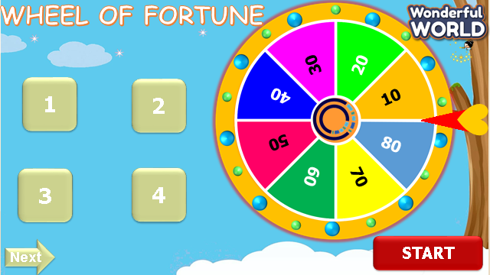  - Let sts choose the numbers and answer the questions.  - Then show sts the pictures and questions.  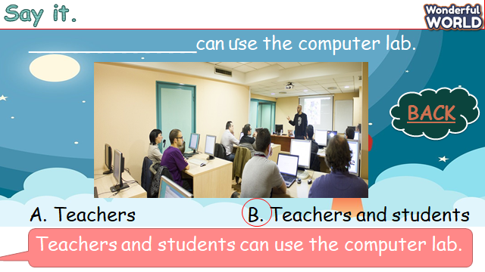  - Ask sts to choose and read out the correct answers.  - Tell sts to pay attention to the sounds that they have learnt in each word.  - Explain the rest of task and ask sts to read sentences through the game.  - Ask sts to work in pairs and say the sentences, paying attention to the correct pronounciation.  - Ask some volunteers to say in front of the class. | - Take part in the games.  - Sts choose the numbers, answer the questions and get stars through the wheel.  - Sts join the game and answer the questions.  - Sts read aloud sentences in the class.  - Sts work in pairs and say it in front of the class.
Activity 4: Production (9 minutes)
Teacher’s Activities | Students’ Activities
a, Aims: Chant the song correctly according to the lyrics.
b, Procedure  Task 8: Listen and Chant.  -T shows the picture and asks what they can see. Let sts listen to a chant.  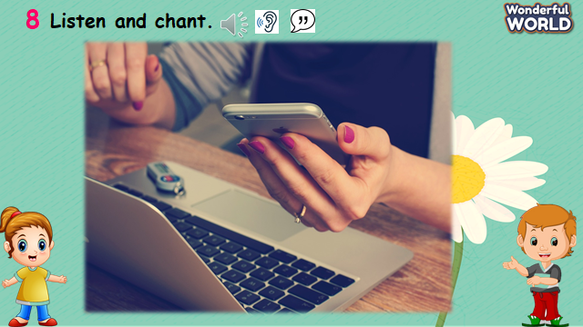  - Explain to sts that the chant uses the sounds they just have learnt.  - Play the record and ask sts to follow the chant by their fingers.  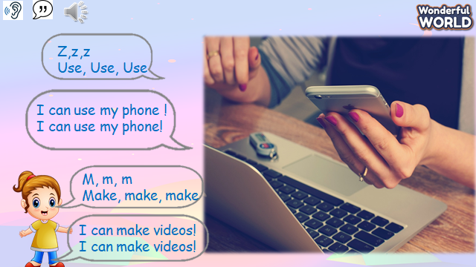  - Read out the chant one line at time and ask sts to repeat.  - Play the recording again, and ask sts to chant along.  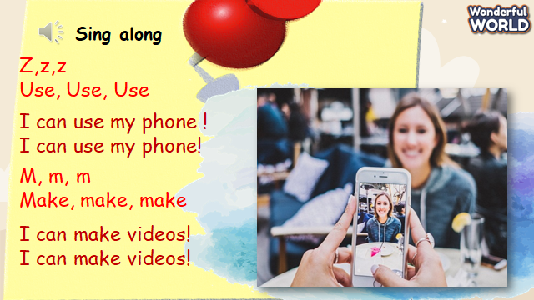 Practice several times and let them do it individually and in groups.  - Ask some volunteers to chant. | - Sts answer the questions.  - Sts listen to a chant.  - Sts repeat after teacher.  - Sts chant several times indiviadually and in groups.
Activity 5: Assessment (3 minutes)
Teacher’s Activities | Students’ Activities
Aims: Consolidate the content of the lesson.
-Ask sts to do the assessment.  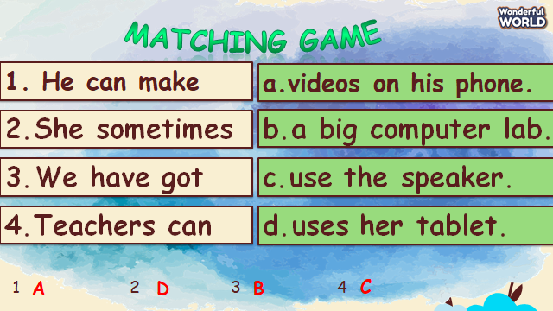  - Remember the vocabulary and structure.  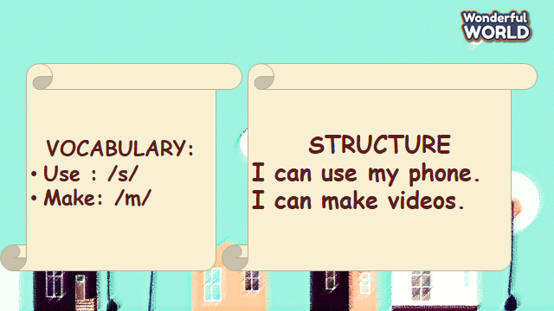  - Check with the class. | -Do the assessment.  - Check with the teacher  - Sts read the wrap-up  - Stand up and say goodbye to the teacher.
UNIT 8. TECHNOLOGY
Fun time and project. Task 1, 2
Period 88
I. OBJECTIVES:
1. Knowledge:
- Students will review clothes vocabulary and unit grammar.
2. Competences:
- English competences: Students will be able to talk about Technology.
- Common competences: Students will develop their creativity in drawing pictures.
- Know how to use structures in the presentation:
- S+ can/ can’t + V
3. Qualities:
- Students will be confident and active in communicating with friends and teacher.
II. EQUIPMENT AND MATERIALS:
- For Teacher: PP, TV, boards, markers
- For students: A4 paper, books, pens, crayons
III. LESSON PROCEDURE:

Activity 1: Fun Time (10 minutes)
Teacher’s Activities | Students’ Activities
A, Aims: Review all the words of technology.
B, Procedure:  - Greet students and divide class into 4 teams.  Warm up (3 minutes)  - Introduce the song  - Ask sts to review some vocabulary and do action  - Play the Robot dance  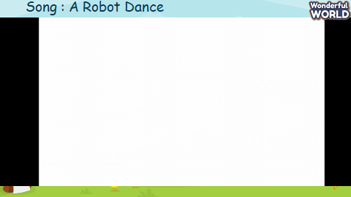  - Ask sts to sing and remember the rooms in video.  Task 1: Unscramble (7 MINUTES)  Do Task 1 through a game  Ask sts to look at the screen and choose the numbers they want. Then, answer all the questions and roll the dice to get stars.  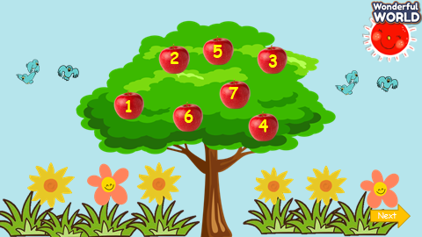  - Let sts choose the numbers.  - Sts can look at pictures and words.  - They can choose the correct words to get stars.  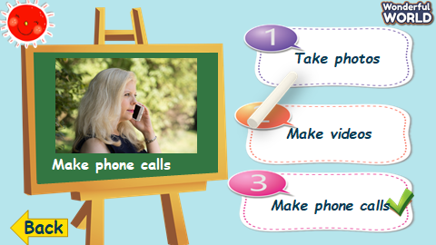  - Ask sts to work in pairs.  - Hand each pair a print of task 1.  - The sts will match the words to make correct phrases. | - Greet teacher and choose their team names.  -Listen to the teacher  - Repeat and do the action  - Sing along and repeat the song.  - Answer the question.  - Look at the pictures and words.  - Sts can choose the correct answers.  - Speak out correctly, paying attention to the pronunciation.  - Do the game and get stars.  - They can do task 1.
Activity 2: Project (20 minutes)
Teacher’s Activities | Students’ Activities
A, Aims: Review all words and structures of unit 8 through presentation.
Project: My family  B, Procedure:  Technology quiz game  - Guides sts to play with the game and tick the correct pictures with the correct words.  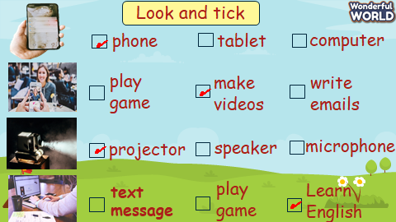  - Anyone who can answer correctly, will be given a star.  Video for the project  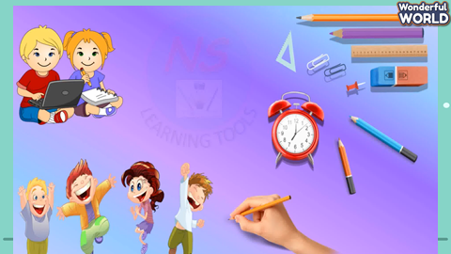  Technology  You can…  You can’t….  -T shows pictures things we can or can’t do in class.  - Writes down the structure and ask them to repeat the structure, using adjectives about objects and house.  Implementing stage  Before drawing  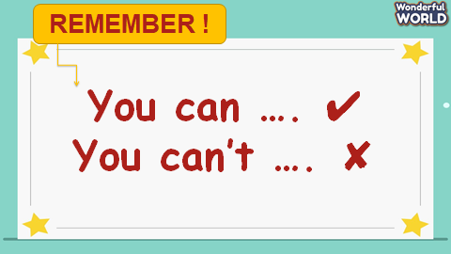  - Ask sts to work individually using the structures.  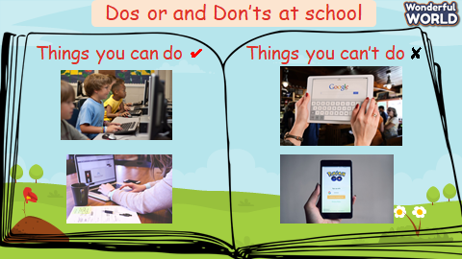  - Show the picture of things you can or can’t do in class  - Ask sts to make their own sentences according to some pictures.  - Ask sts to read aloud sentences.  - Ask sts to make sentences about their rooms. 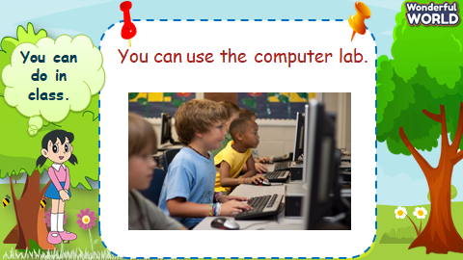  - Show the sentences one by one.  - Tell them to draw a picture of their favourite technology and write down what they can or can’t do with their technology.  - Colour the picture  - Ask sts to go to the board – group by group and present.  Displaying and Reflecting on the board  - Ask sts to come to the board and present about their pictures in class.  - Go around to offer help when necessary.  - Check the number of members they have talked to  - Award the best speaker.  Evaluation (2 MINUTES)  Go to sleep  - T shows some flashcards of technology and ask sts to guess what picture is missing.  Home work (2 MINUTES)  Myschool.com.vn | - Listen to the teacher  - Listen to the game rules  - Look at the picture  - choose the correct answer  - show the board of correct answers.  -Talk to friends about the picture.  Read aloud the answers about rooms.  Follow instructions.  - Look at the pictures and complete some words.  - Speak out the sentences.  - Draw a picture of their favourite technology.  - Present in group  - comment – cross-checking group by group.  Do the task.
______________________________________

