WEEK 23
REVIEW 4 – Part 1. Task 1,2,3
Period 89
I. OBJECTIVES:
1. Knowledge:
- Students will review the words and structures related to the topic Jobs:
+jobs: chef, doctor, farmer, photographer, vet, firefighter, feed animals, put out fires, take care of
+places of work: in a hospital, in a restaurant, in a studio, in a clinic
+ questions about someone’s job
What does he/she do? – He’s a farmer.
What does she do? – She’s a photographer.
+ questions about where someone works
Where does he work? – He works in a restaurant.
Where does she work? – She works in the field.
2. Competences:
- English competences: Students will be able to talk about their dream jobs, someone’s job and places of work.
- Common competences: Students will have the opportunity to develop communication among friends.
3. Qualities:
- Students will be responsible and well-behaved in communicating in the classroom with friends and others.

II. EQUIPMENT AND MATERIALS:
- Basic things: Student’s book, flashcards.
- Advanced things: PPT, projector/interactive whiteboard/laptop/TV.

III. LESSON PROCEDURE:
Warm up (5 minutes)
Aims: warm-up activity to introduce lesson, review the words of adjectives
Teacher’s activities | Student’s activities
- Greet students  -Ask students to sing a warm up song.  https://www.youtube.com/watch?v=2nesqKP9-5c  Game: Guessing game  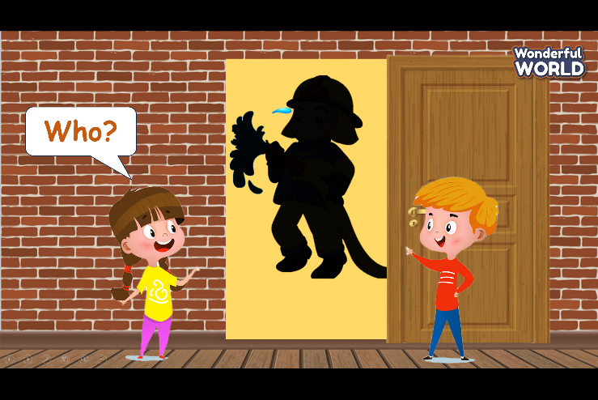  (Students look at someone’s shadow and guess what their jobs).  - Divide class into 4 groups  - Set the game rules.  - Ask students to choose 2 numbers to find the correct pairs.  - Award the best groups  Lead in: Use the pictures of game to review. | - Greet teacher  - Sit in 4 groups.  - Listen to the game rules carefully  - Play game
Review (20 minutes)
Aims: Review and practice the words and structures learnt in unit 7
Teacher’s activities | Student’s activities
Task 1: Do the crossword  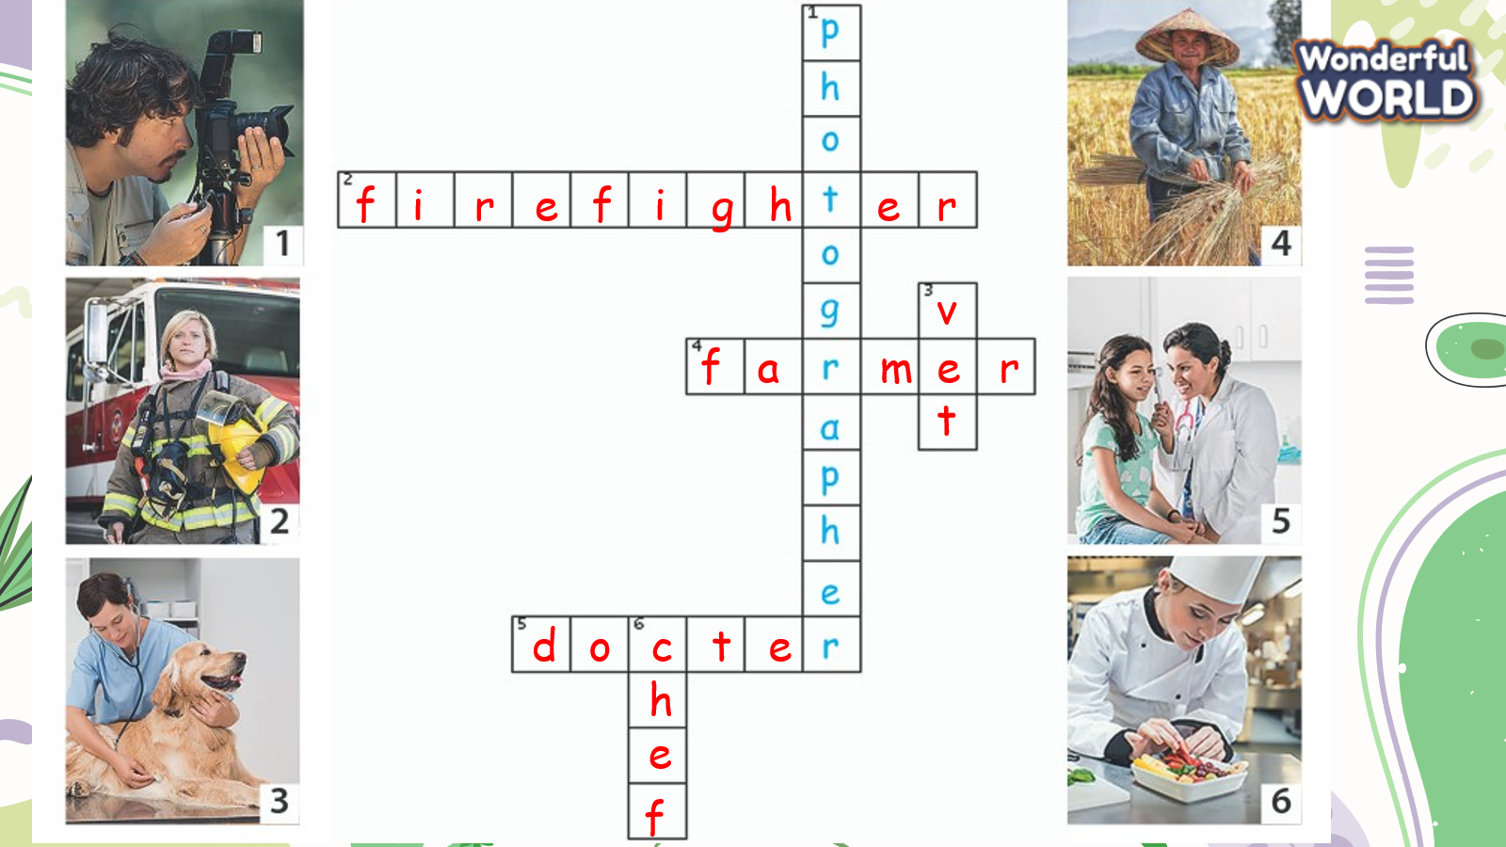  -Tell students to look at the photos 1–8.  -Ask them to tell you what they show. Elicit the words.  -Tell students that they have to complete the crosswords and they can use the photos to help them guess the words.  -Allow enough time to complete the task, alone or with a partner.  -Check answers as a class.  Task 2: Circle  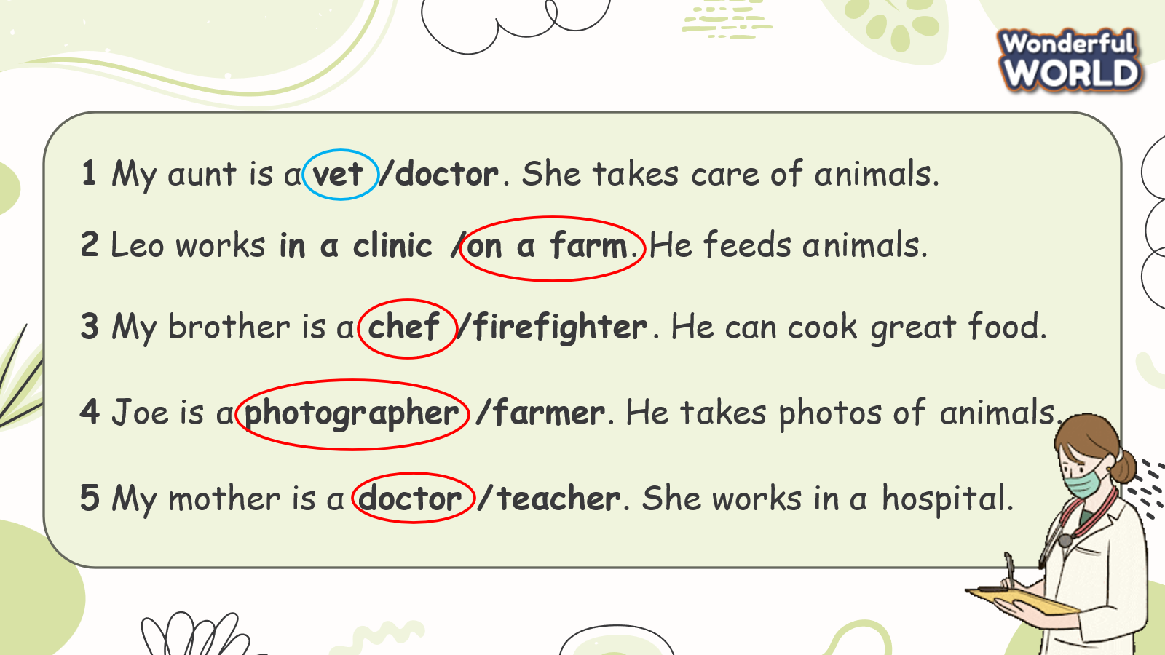  -Tell students to look at the task. Do the first one as a class and make sure students understand the task.  -Allow enough time to complete the task then check answers as a class.  Game: “Racing monster truck game”  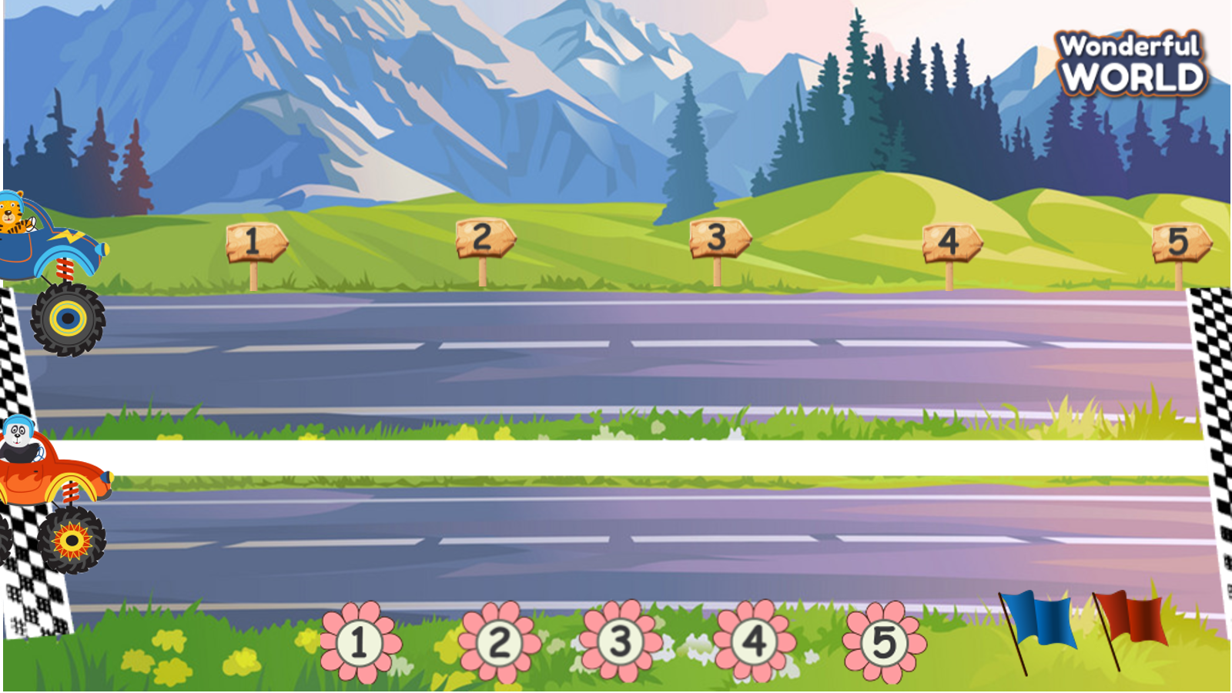  (There are 5 questions. The two teams take turns choosing a question and answer. With each correct answer the truck is moved forward 1 level. The car that gets to the finish line first will be the winner)  - Introduce and set game rules.  - Call Ss to choose a number and answer the questions.  - Check answers and give feedback.  1 Whαt does α vet do?  2 Where does doctor John work?  3 Whαt does α firefighter do?  4 Whαt does your mother do?  5 Where does your uncle work?  Task 3: Match and say  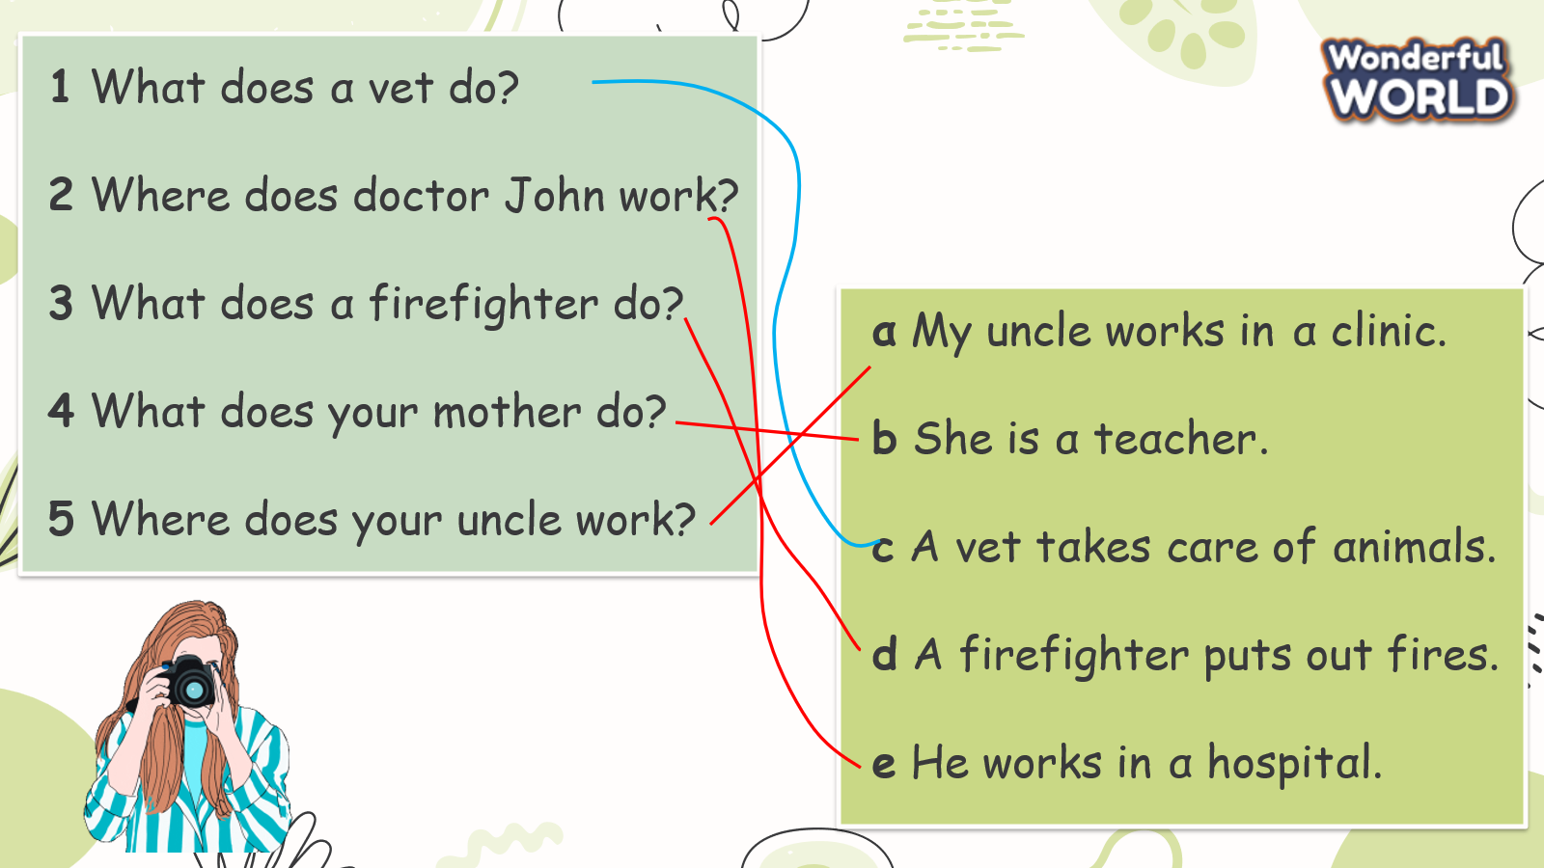  - Tell students to look at the questions 1-5 and the answers a-e and tell them they have to match the questions with the correct answers.  - Tell them to look at the first question and the example answer.  - Ask them to do the same with the other questions.  - Allow enough time for students to complete the task. Check answers as a class | -Look  -Answer  -Listen  -Do the crossword  -Check answers  -Look and listen  -Circle and check the answers.  -Join to the game  1. My uncle works in α clinic.  2. She is α teαcher.  3. Α vet tαkes cαre of αnimαls.  4. Α firefighter puts out fires.  5. He works in α hospitαl.  -Look and read the example.  -Repeat  -Match  -Check answers with friends
Extra activity (10 minutes)
Aim: apply grammar to the real world
Teacher’s activities | Student’s activities
- Talk about the job of your family members  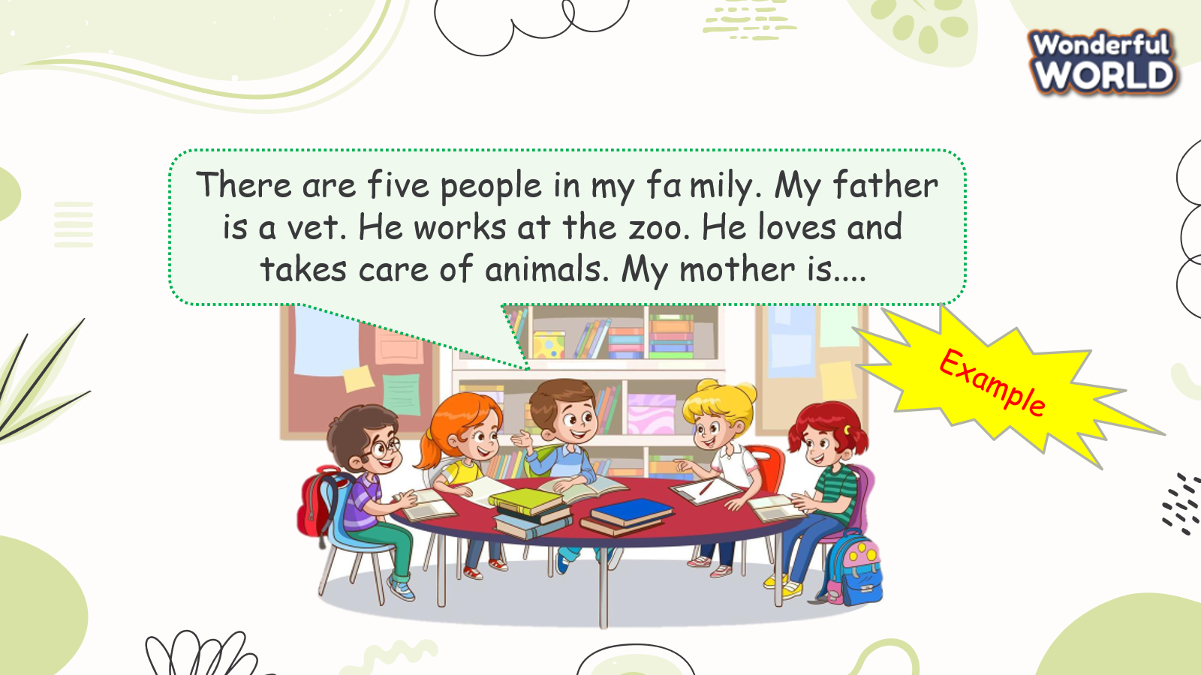  - Work in groups and talk about their family and friends  - Call some students to present in front of the class.  - Give feedback to them.  -Ask students to sing the goodbye song | - Work in groups  - Present.  - Listen to T.  -Sing

REVIEW 4 – Part 2. Task 1,2,3
Period 90
I. OBJECTIVES:
1. Knowledge:
-Students will review the words, phrases and structures related to the topic Technology:
+ smartphone, make phone calls, make videos, write emails, use the tablet, surf the internet, work in groups, work in pairs, change the password, use the computer lab, use the projector, use the speaker
+ talk about what someone does with a smartphone every day
She sometimes makes videos on her smartphone.
He always learns English on his computer.
+ ask and answer questions about who can use a certain technology device in class
Who can use the computer lab? – Teachers and students can.
Who can change the password? – Teachers can.
2. Competences:
- English competences: Students will be able to talk about some activities in class using technology
- Common competences: Students will have the opportunity to develop communication among friends.
3. Qualities:
- Students will be responsible and well-behaved in communicating in the classroom with friends and others.

II. EQUIPMENT AND MATERIALS:
- Basic things: Student’s book, flashcards.
- Advanced things: PPT, projector/interactive whiteboard/laptop/TV.

III. LESSON PROCEDURE:
Warm up (5 minutes)
Aims: Review the vocabulary and grammar of the unit 7 and 8
Teacher’s activities | Student’s activities
- Greet students  -Ask students to sing a warm up song.  https://www.youtube.com/watch?v=2nesqKP9-5c  Game: Spelling game  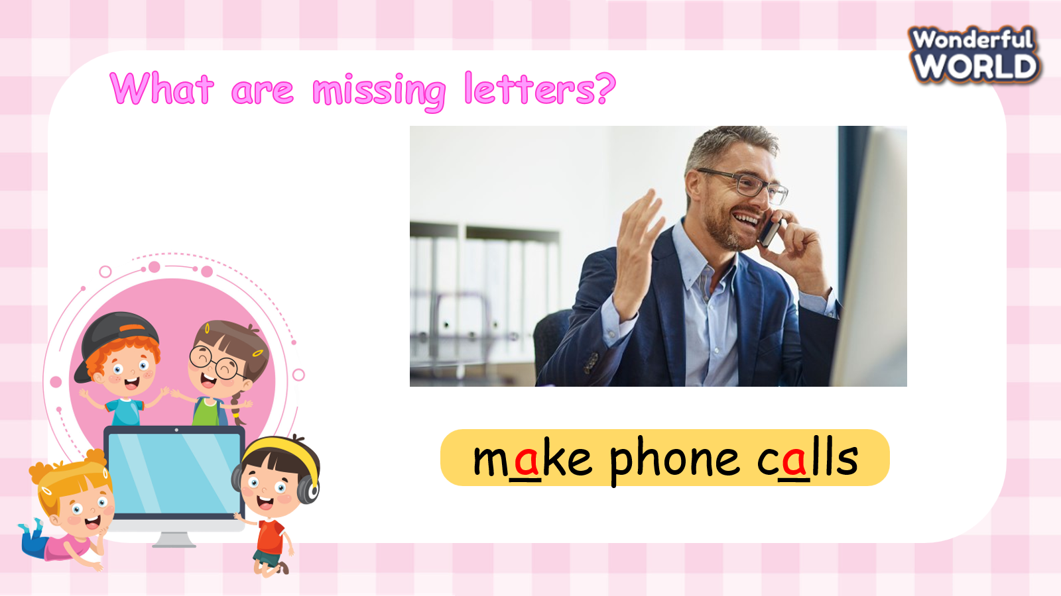  (Students find the missing letters)  - Divide the class into 4 groups  - Set the game rules.  - Ask students to fill the blanks  - Award the best groups  Lead in: Use the pictures of game to review. | - Greet teacher  - Sit in 4 groups.  - Listen to the game rules carefully  - Play game
Review (20 minutes)
Aim: Practice words and phrases that they have learnt in the unit 8 via matching and word rehearsing tasks.
Teacher’s activities | Student’s activities
Task 1: Match  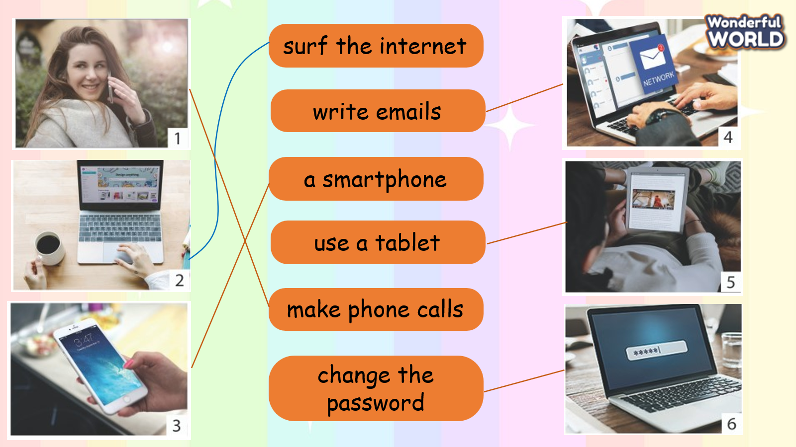  -Tell students to look at the photos 1–6.  -Ask them to tell you what they show. Elicit the words. Tell students to look at the words and match them to correct picture with a line. Do the first one as a class and make sure students understand the task.  -Allow time to complete the task, alone or with a partner.  -Check answers as a class.  Game: “Go to the Island game”  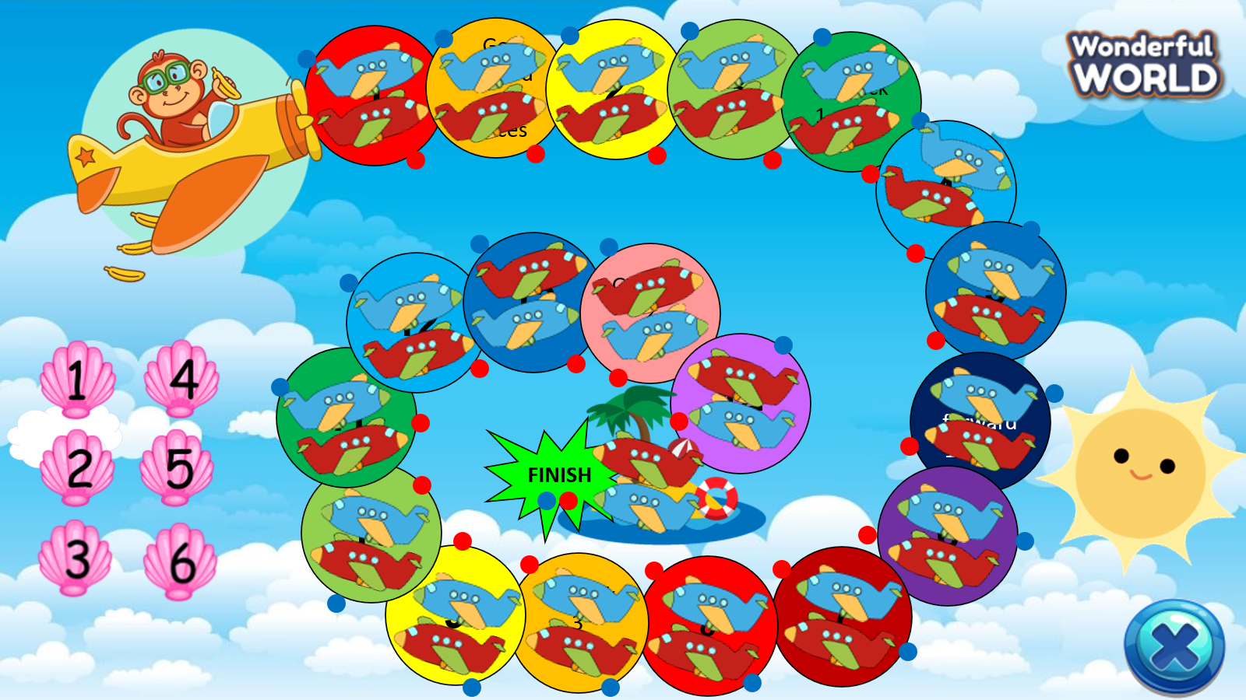  (There are 6 questions. The two teams take turns choosing a question and answer. Teacher prepares a dice. For each correct answer, students roll the dice and move their team’s plane. The team that goes to the island first is the winner)  - Introduce and set game rules.  - Call Ss to choose a number and answer the questions.  - Check answers and give feedback.  1 Cαn students use their phones in clαss?  2 Who cαn chαnge the pαss word?  3 Cαn Mr. John use the computer lαb?  4 Cαn I tαke photos in clαss?  5 Cαn Kαte mαke videos on α tαblet?  6 Cαn students surf the internet in clαss?  Task 2: Match and say  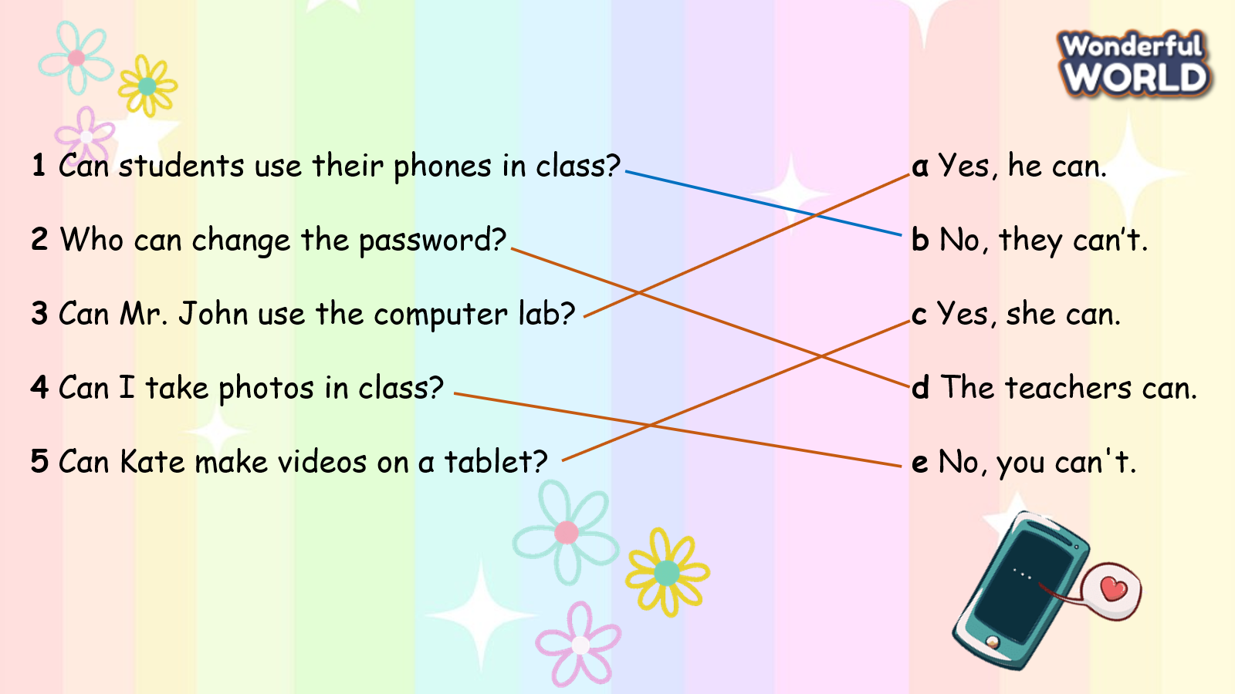  - Tell students to look at the questions 1-5 and the answers a-e and tell them they have to match the questions with the correct answers.  - Tell them to look at the first question and the example answer.  - Ask them to do the same with the other questions.  - Allow enough time for students to complete the task. Check answers in class. | -Look  -Answer  -Listen  -Do the crossword  -Check answers  -Look and listen  -Circle and check the answers.  Yes, he cαn.  No, they cαn’t.  Yes, she cαn.  The teαchers cαn.  No, you cαn’t.  No, they cαn’t.  -Look and read the example.  -Repeat  -Match  -Check answers with friends
Extra activity (10 minutes)
Aims: Consolidate the content of the lesson.
Teacher’s activities | Student’s activities
- Talk about technology in your school.  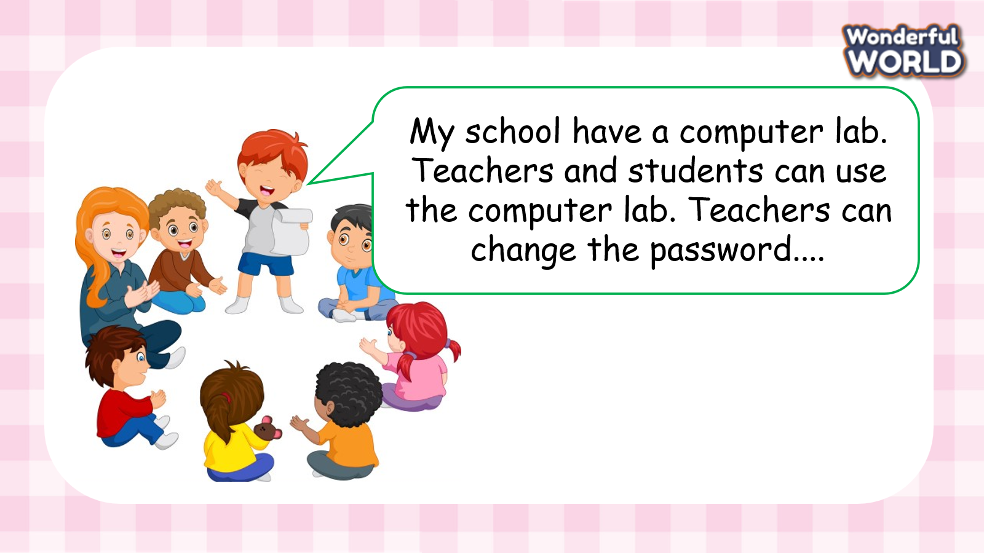  - Work in groups and talk about their family and friends  - Call some students to present in front of the class.  - Give feedback to them.  -Ask students to sing the goodbye song. | - Work in groups  - Present.  - Listen to T.  -Sing
________________________________
REVIEW 4 – Part 3 – Video. Task 1,2,3
Period 91
I. OBJECTIVES:
1. Knowledge:
- By the end of the lesson student will be able to:
+ Watch and understand a video about what photographers do.
+ Talk about what job you want to do.
2. Competences:
- English competences: Students will be able to talk about their dream jobs.
- Common competences: Students will develop their creativity in drawing pictures.
3. Qualities:
- Being respectful and showing love to their jobs.
II. EQUIPMENT AND MATERIALS:
- For Teacher: PP, TV, boards, markers
- For students: A4 paper, books, pens, crayons
III. LESSON PROCEDURE:

Activity 1: Warm-up (3 minutes)
Aims: warm-up activity to introduce lesson, review the vocabulary of topic Technology
Teacher’s Activities | Students’ Activities
- Greeting students.  - Introduce lessons.  1. Song:  https://www.youtube.com/watch?v=-FkYQlPj4mQ  Technology  - Ask students to sing the song “Technology” to start the lesson.  - Ask students to stand up, look, listen and dance with the teacher.  - Ask students to sit down after singing the song. | - Greeting Teacher.  - Listen  - Sing the song.
Activity 2: Review (20 minutes)
Aims: Review the words and structures learnt in unit 7 and 8 and watch the video
Teacher’s Activities | Students’ Activities
2.1. Vocabulary  - Tell students to look at the photo and tell you what they can see. Revise the vocabulary from Units 7.  -Hide a picture and ask the students to guess the picture is gone  Task1: What jobs would you like? Circle.  -Tell students to brainstorm different types of jobs and write them on the board.  -Tell students to open their books and read out activity 1. Complete the activity as a class.  -Look at the list on the board. Ask students if any jobs match those in the book. Circle the jobs that match.  2.2. Video :  Task 2: Which animal can you see in the video? Tick.  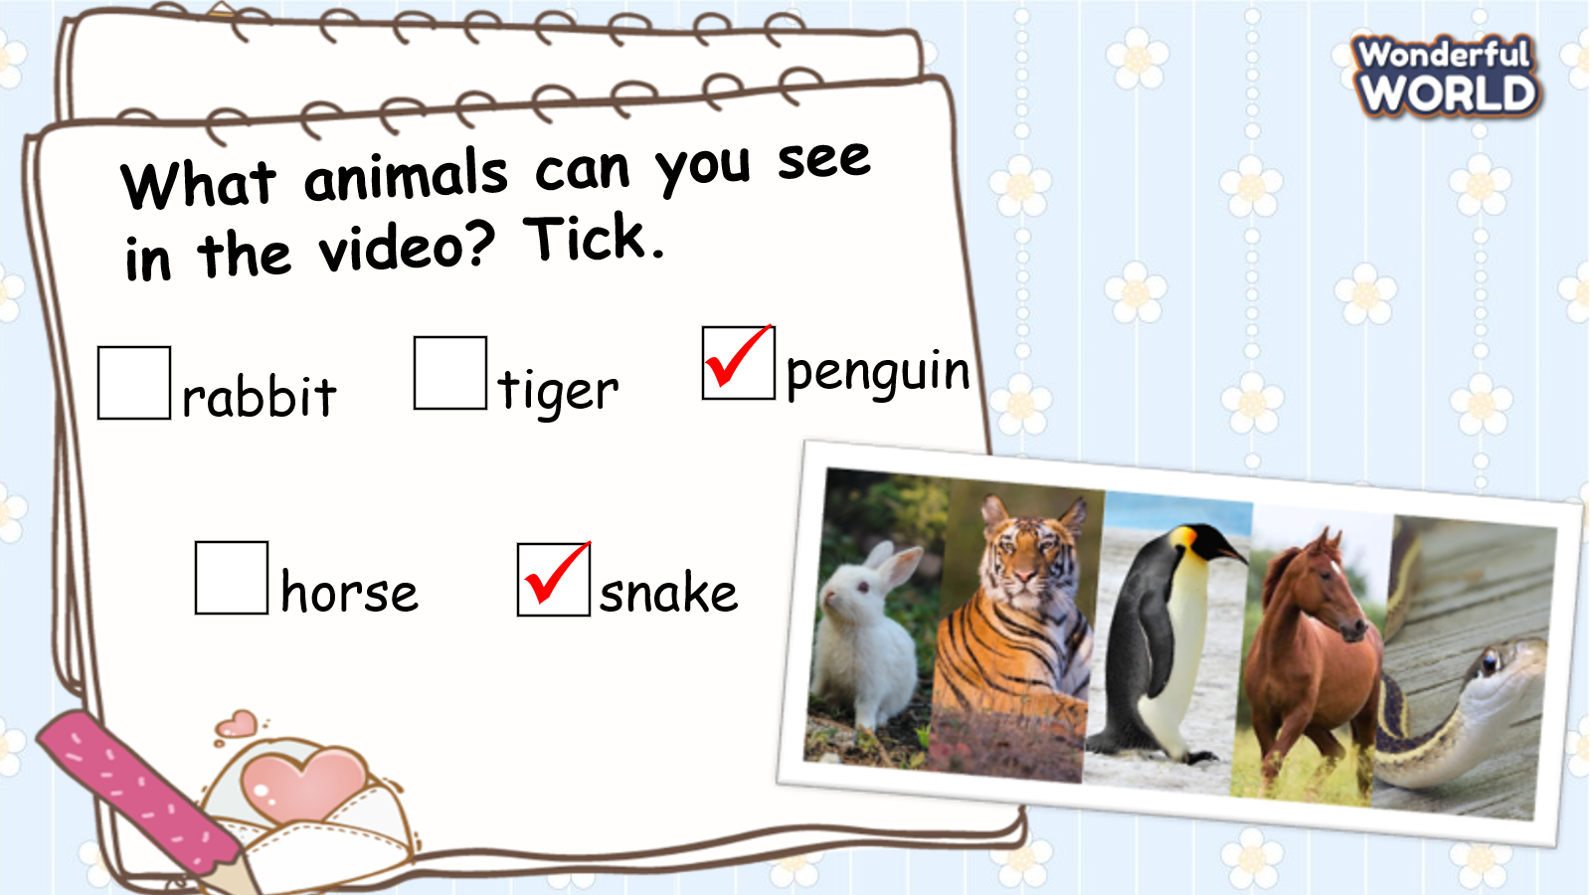  The first time :  - Ask students to watch a video with no sound about photographer takes the photo of animals then tell the teacher what animals they can see in the video.  - Praise the student who can name all the animals in the video.  The second time :  - Ask students:  + Is there any sound in this video?  - Ask students to watch the video again with sound and do exercise 2 in the student’s book – circle the correct answer they can see in the video.  - Ask students to exchange their books for pair checking.  - Ask students to raise their hands if they have all the correct answers.  Game: Doraemon magic pocket.  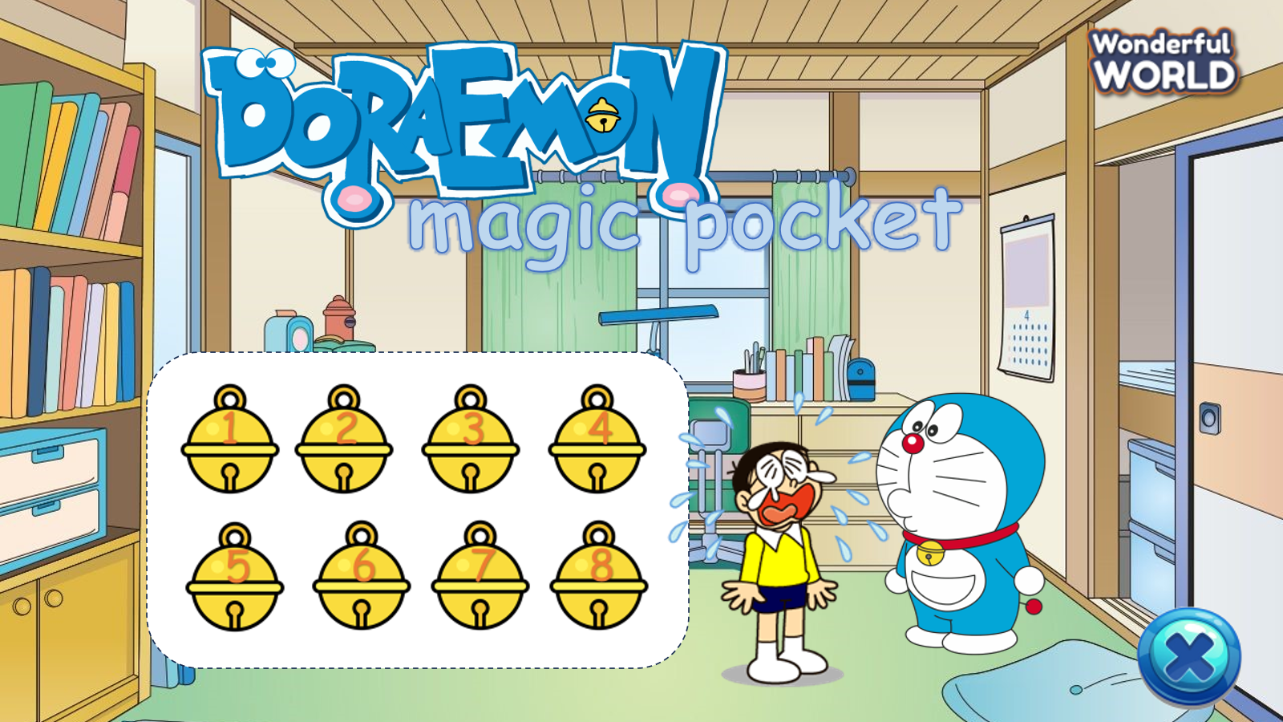  (There are 8 questions. Students choose an bell and answer the question. If students give an incorrect answer, another team can raise their hands to answer. If students get it right, they will get a Doraemon’s gadget.)  - Introduce and set game rules  - Do a demo  - Play several rounds.  Task 3: Read. Tick T for True and F for False.  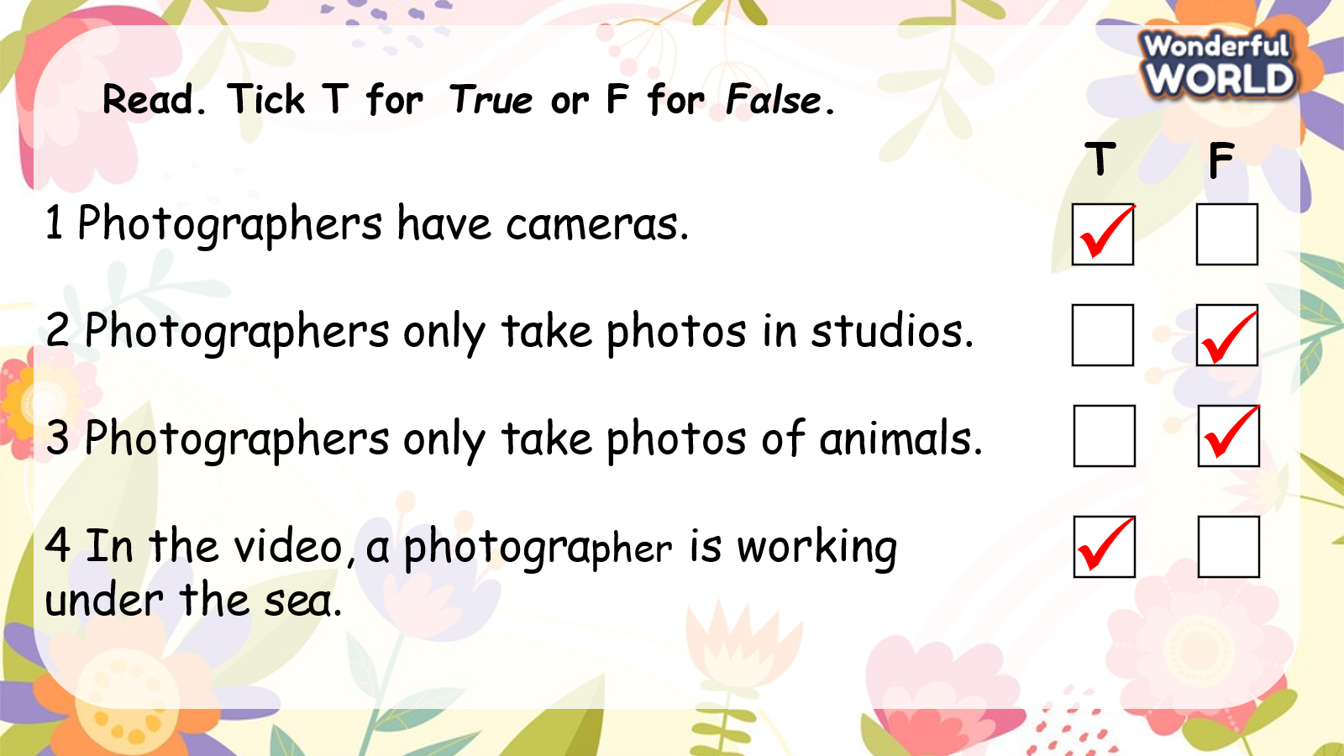  -Read out the first statement to the class. Ask students if they think that photographers need cameras. Elicit Yes. Ask students where the tick should go (T). Put a tick in the ‘T’ box.  -If necessary, play the video again and give students time to complete the activity alone.  -Check the answers with the class  Task 4 What do you want to be? Talk about what you want to do.  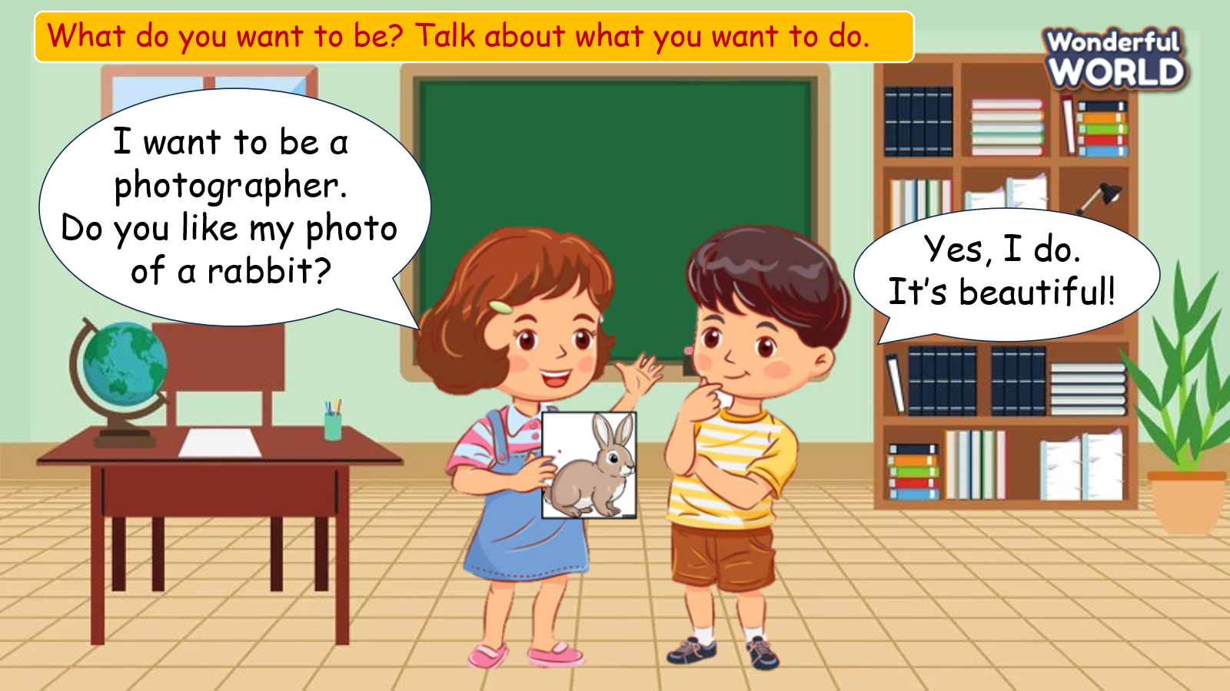  -Tell students to think of more cool jobs. Write them on the board.  -Call on a volunteer. Ask him/her what he/ she wants to be. Then tell the student to ask a classmate what he/she wants to be.  - Read the instruction to the students.  -Invite two students to read the model dialogue.  -Put students into pairs and tell them to talk with their partner about what they want to be. Remind them to use the words from activity 1 and Unit 7. | -Look and say  -Guess  -Open their book and read  -Circle  -Watch  -Join the game  -Listen and tick  -Check the answers
Activity 3: Extra activity (12 minutes)
Aims: Consolidate the content of the lesson.
Teacher’s Activities | Students’ Activities
-Tell each student to draw a picture of an animal on a blank piece of paper. On a separate piece of paper, they should write the name of the animal. Encourage students to draw different animals to their classmates.  -Collect the names of the animals and put them face down on your desk.  -Tell students to put their pictures in different places all around the room.  -Tell students they are all photographers. Invite a student to choose an animal name from the pile on your desk. They turn it over and have to find the matching picture in the classroom. When they have found it, they mime taking a photo of it, hold up the picture and say Do you like my photo of a (giraffe)?  -Take turns with each child pretending to be the photographer.  -Sing the “Goodbye” song and say goodbye  https://www.youtube.com/watch?v=2O975ewRT7Q | -Draw a picture of an animal and write the name of the animal  -Put the pictures in different places all around the room.  -Join the activity  -Sing the “Goodbye” song and say goodbye
____________________
REVIEW 4 – Part 3 – Video. Task 1,2,3
Period 91
I. OBJECTIVES:
1. Knowledge:
Students will review words and structures to ask about jobs and technology
2. Competences:
- English competences: Students will be able to ask and answer about jobs of someone.
- Common competences: Students will have the opportunity to develop the vocabulary to describe a job and the communication skills with friends.
3. Qualities:
- Students develop love of dream jobs.
II. EQUIPMENT AND MATERIALS:
- Basic things: Student’s book, flashcards.
- Advanced things: PPT, laptop, TV.
III. LESSON PROCEDURE:

Activity 1: Warm-up (5 minutes)
Aim: warm-up activity to introduce lesson from the previous lesson.
Teacher’s Activities | Students’ Activities
- Greet students.  - Play the video “When you grow up” and ask students to sing along to warm up.  https://www.youtube.com/watch?v=5rdlXji2jR0  Lead in: Ask students to list the jobs in the song.  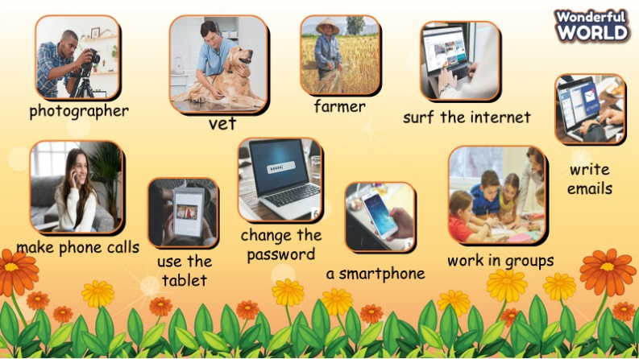  - Teacher show the photos relating to the topic Jobs and Technology.  - Teacher points to each picture and asks the whole class to repeat.  - Write on the board Review and introduce the lesson. | - Great teacher.  - Listen to the teacher and dance  - Follow the teacher
Activity 2: Review (25 minutes)
Aim: practise the words and structures learnt in unit 7 and 8
Teacher’s Activities | Students’ Activities
Task 1 Let’s play with a dice  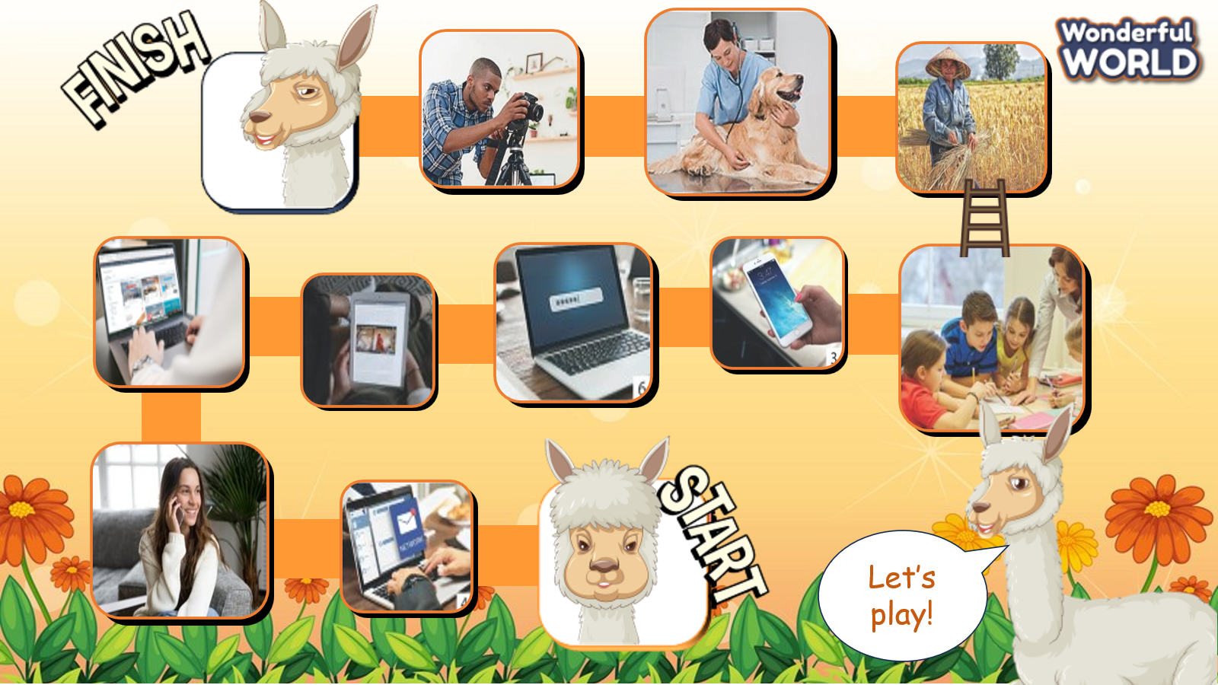  There are 10 pictures in order from START to FINISH. Teacher prepares a dice. Students roll the dice, point to the picture corresponding to the number of dots on the dice and speak.  - Set the game rules.  - Ask students to roll the dice, point and speak  - Award the best students  Play game: Find the way.  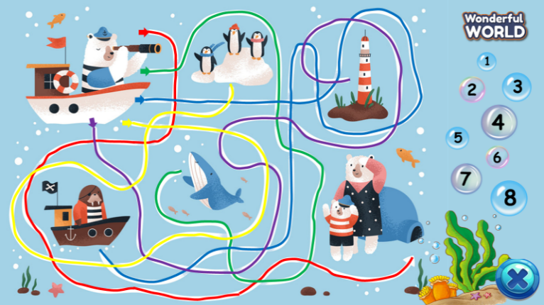  (There are 8 questions. Students choose and answer a question. For each correct answer, the student chooses the correct path to help the polar bear find its way home. )  - Set the game rules.  - Ask students to find the correct way.  - Award the best groups  Task 2 Talk about a job someone you know.  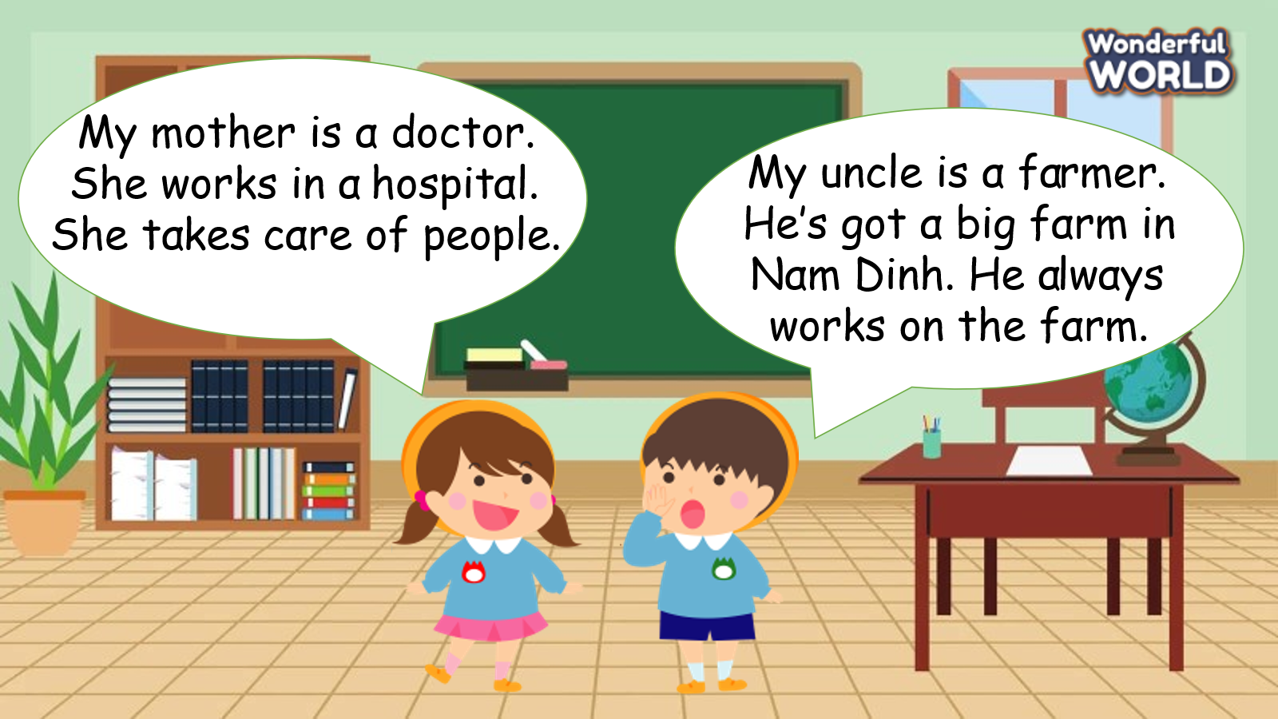  -Read the instruction to the students.  -Invite two students to read the model dialogue.  -Tell students they are going to describe a job of someone they know.  -Put students into pairs and tell them to talk about a job of someone they know with their partner. Remind them to use the words from unit 7 & 8.  -Ask some volunteers to speak in front of the whole class. T asks Ss to repeat after checking. | - Listen.  - Play the game.
Activity 3: Extra Activity (5 minutes)
Aim: Do an exercise to revive the lesson to match with the purpose of the lessons.
Teacher’s Activities | Students’ Activities
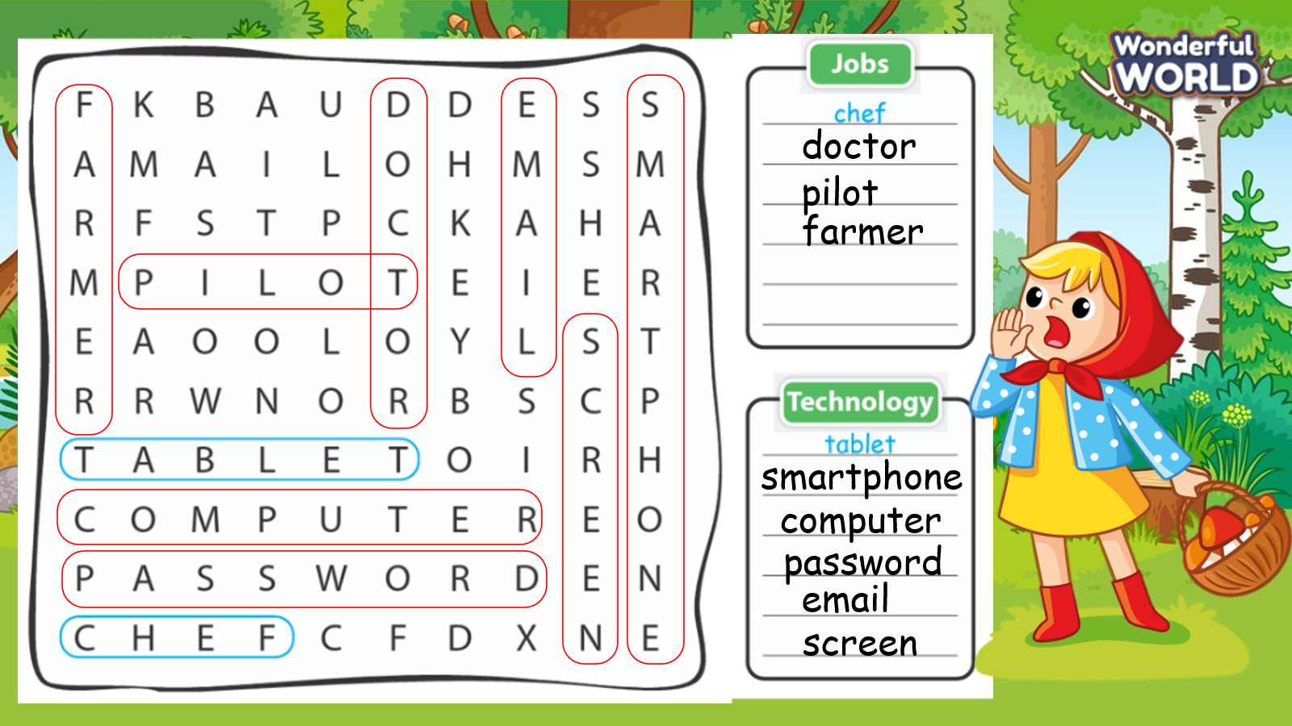  -Ask sts to do the assessment.  - Check with the class.  -Sing goodbye song. | - Do the assessment.  - Check with the teacher.  -Sing

