WEEK 24
UNIT 9. PLACES IN TOWN
Lesson 1. Task 1, 2, 3
Period 93
I. OBJECTIVES:
1. Knowledge:
Students will learn words and identify some places in town/ city: Bookshop, fountain, restaurant, street, train station. To practice listening to a conversation about places in
town.
2. Competences:
- English competences: Students will be able to introduce their town
- Common competences: Students will have the opportunity to develop creativeness in drawing and colouring the craft.
3. Qualities:
- Students develop a love for their town.
II. EQUIPMENT AND MATERIALS:
- For Teacher: PP, flashcards, handout, track 9.1, track 9.2
- For students: pens, A4 paper, crayons,
III. LESSON PROCEDURE:

Activity 1: Warm up (5 minutes)
a. Aims: Warm up the class and get the students ready for the lesson
Teacher’s Activities | Students’ Activities
b. Procedure:  -T introduces and engages students to the topic “places in town” by the song:  https://www.youtube.com/watch?v=krPMYK2aY3o  -Then, read the title of the unit together. Check students ‘s understanding what in town means.  - Ask students to work in groups of two or three and tell them to think of at least seven words that they can relate to towns. Tell them they can suggest people, places, vehicles, objects, etc and take them to the town by the GAME: “PUZZLE”.  –T takes away a box of the puzzle from the picture and let sts guess what it is.  Key of picture 1: toy shop  Key of picture 2: cinema  Key of picture 3: building; tower  From picture 3, T guides them to different famous places like CN tower in Toronto, Canada.  About the photo  - The photo shows CN Tower, an iconic tower in Toronto, Canada. The CN Tower is a concrete communications and observation tower. Its height is 553.3 metres. It was built on the former Railway Lands, so its name “CN” referred to Canadian National, the railway company that built the tower.  Toronto is a major Canadian city along Lake Ontario’s northwestern shore. It’s a dynamic metropolis with skyscrapers.  - Related vocabulary  tower, buildings, river, boats, ships, city. | - Watch the video.  - Read  - Answer  - Listen to the teacher.
Activity 2: Presentation (8 minutes)
a. Aims: Present new vocabulary of the topic places
Teacher’s Activities | Students’ Activities
b. Procedure:  Teach the new words with the flashcards.  - Vocabulary: Bookshop, fountain, restaurant, street, train station  -Using skill: Vary the volume (e.g. whisper, shout), speed, and intonation used to read words, and encourage students to copy. Younger learners will particularly enjoy using a silly voice or saying the words ‘like a robot’ or ‘like a monster’.  Listen and point. Repeat.  • Tell students to look at the vocabulary box on page 30. Find out if they know any of the words. Play the recording for students to listen and point to the correct words.  • Play the recording again, pause after each word for students to say the word. Ask if they can see any of the things from the window or from their class. | - Follow the teacher.  - Read the words.  - Look, listen and point.
Activity 3: Practice (10 minutes)
a. Aim: Controlled-practice: to listen comprehension, read and speak following a model sentence.
Teacher’s Activities | Students’ Activities
b. Procedure  2. Listen, read and tick  -Tell students to look at the photo and tell teacher what they see (boys, fountain, sun, sky, building). -Find out if students ever have fun like this. Ask what they do when it’s hot in town.  -Play the recording for students to listen and follow with their fingers. Play again, pause at the end of each sentence to check the meaning. Play again, pause for students to say as a class.  -Ask some volunteers to read the text in front of the whole class.  -Ask students to look at the sentence below the picture. Read the sentence and the options. Elicit the answers from students.  -Ask students to tick the correct answer, and check with the whole class.  3. Look and say  Game: Wheel of fortune  -Let Sts choose the number to answer the question by looking at the picture and think about how to describe them. Give students suggestions in case they have difficulties. Then, if they describe correctly, they can spin and take the stars.  • Give students time to practise other sentences in pairs.  • Ask some volunteers to read their sentences aloud in front of the whole class.  • Suggested answer:  1 The train is on Elizabeth Street.  2 The fountain is in front of the bookshop.  3 The restaurant is behind the park.  4 The bookshop is between the toyshop and the museum. | - Look and answer.  - Listen.  - Read.  - Look and read.  - Play the game by describing the pictures.
Activity 4: Production (9 minutes)
a. Aims: Apply the learned knowledge to give a presentation on the topic My town
Teacher’s Activities | Students’ Activities
b. Procedure:  -Draw: “My town”  -T tell Sts to take out the paper and draw their town and write the places of the town.  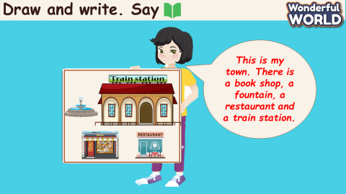 | - Draw.  - Write.
Activity 5: Assessment (3 minutes)
a. Aims: Consolidate the content of the lesson by doing some activities like filling in the missing letters so as to test their memories.
Teacher’s Activities | Students’ Activities
b. Procedure:  -Do the assessment: Fill the missing letters in the words  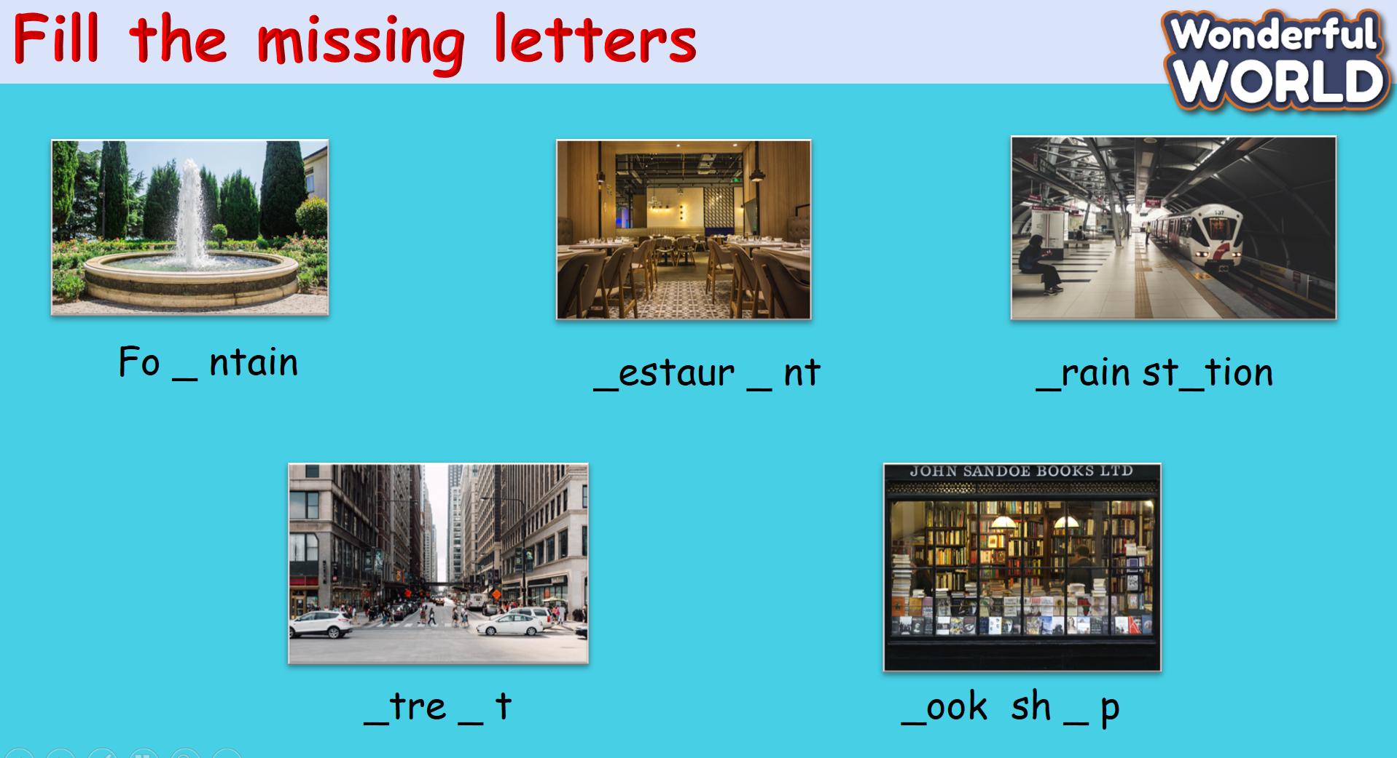 | Do the assessment.  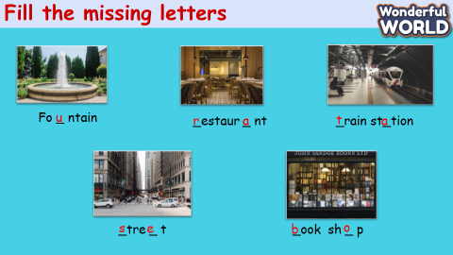
______________________
UNIT 9. PLACES IN TOWN
Lesson 1. Task 4, 5, 6
Period 94
I. OBJECTIVES:
1. Knowledge:
Students will review some places in town/city.
Students ask and answer questions about location of a certain place.
2. Competences:
- English competences: Students will be able to introduce their town.
- Common competences: Students will have opportunity to develop creativeness in drawing and colouring the craft.
3. Qualities:
- Students develop love toward their town.
II. EQUIPMENT AND MATERIALS:
- For Teacher: PP, flashcards, handout, track 9.3.
- For students: pens, A4 paper, crayons,
III. LESSON PROCEDURE:

Activity 1: Warm up (5 minutes)
a. Aims: Review the knowledge of the previous lesson by a game.
Teacher’s Activities | Students’ Activities
b. Procedure  Greet students.  WARM UP by the game: Places QUIZ:  Answer keys:  1. bookshop  2. restaurant  3. train station  4, fountain  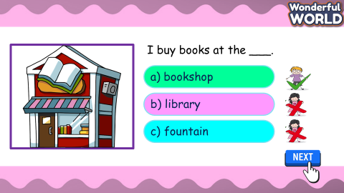 | - Answer the question
Activity 2: Presentation (8 minutes)
a. Aims: Present new the grammar point of prepositions.
Teacher’s Activities | Students’ Activities
b. Procedure  Introduce “PREPOSITIONS” by song.  Show the picture and do the action to describe the positions: In front of/ on/ behind / next to / opposite  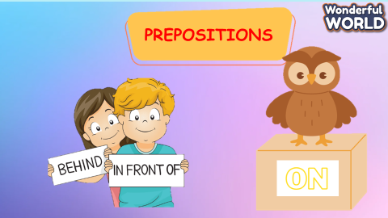  Listen and repeat. TR: 9.3  • Play the recording. Tell students to look at the sentences and follow them with their fingers.  • Play the recording again. Ask students to repeat.  • Point to the sentences. Ask students to notice the use and form of or questions and answers about locations.  • Ask students to repeat sentences and link to the next activity. | - Follow the teacher.  - Read the words  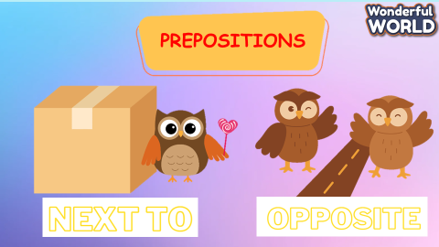  - Look, listen and point.
Activity 3: Practice (14 minutes)
a. Aim : Controlled-practice : to speak following a model sentence.
Teacher’s Activities | Students’ Activities
b. Procedure  GAME: GOLD MINER  Look and say.  • Tell students to look at the picture and suggested words for question 1. Then ask them to read out the  example sentence.  • Explain the rest of the task to students. Allow them enough time to practise saying sentences individually and in pairs. Go round the class helping students where necessary.  • Ask volunteers to read out sentences. Correct any mistakes.  • Suggested answer:  1. Is the bookshop in front of or behind the library?  - It’s behind the library.  2. Is the fountain on Park Street or on Lake Street?  - It’s on Lake Street.  3. Is the train station next to or opposite the park?  - It’s next to the park.  4. Is the fountain opposite or behind the restaurant?  - It’s behind the restaurant. | - Look and answer.  - Listen.  - Read.  - Look and read.  - Play the game by asking and answering.
Activity 4: Production (9 minutes)
a. Aims: Apply the learned knowledge to make the conversation.
Teacher’s Activities | Students’ Activities
b. Procedure  Let’s talk. Use the map in 5.  • Ask students to look at the conversation.  • Ask volunteers to read out the dialogue.  • Put students in pairs to practise asking and answering about different places on the map.  • Go round the class helping students where necessary. Ask volunteers to say their new conversation to the class | - Draw.  - Write.  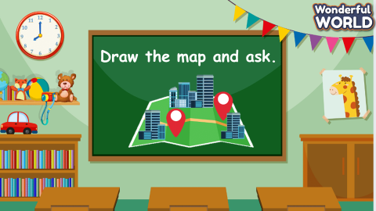
Activity 5: Assessment and Wrap Up (3 minutes)
a. Aims: Consolidate the content of the lesson
Teacher’s Activities | Students’ Activities
b. Procedure  Let Sts read and underline the correct option.  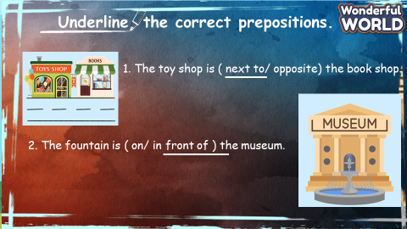 | Do the assessment.  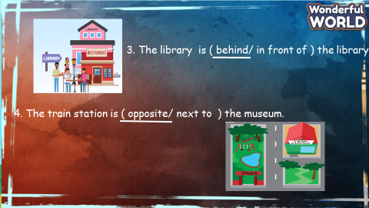
____________________________________
UNIT 9. PLACES IN TOWN
Lesson 2. Task 1, 2, 3
Period 95
I. OBJECTIVES:
1. Knowledge:
Students will learn to use some new vocabulary: bus stop, post office, shopping centre, supermarket.
And use new grammar: Where to ask and answer about places in town.
2. Competences:
- English competences: Students will be able to introduce their town
- Common competences: Students will have the opportunity to develop creativeness in drawing and coloring the craft and show their confidence in asking and answering their town.
3. Qualities:
- Students develop love toward their town.
II. EQUIPMENT AND MATERIALS:
- For Teacher: PP, flashcards, handout, track 9.4, track 9.5
- For students: pens, A4 paper, crayons,
III. LESSON PROCEDURE:
Activity 1: Warm up (5 minutes)
Aims: Review the knowledge of the previous lesson by playing a game or warm up n activity
Play a song to start the lesson
Teacher’s Activities | Students’ Activities
-Option 1: Use the flashcards to revise the words  from Lesson 1. Give volunteers a word to mime or draw on the board for classmates to guess. Repeat until all students have mimed or drawn a  word (repeat words if necessary).  -Option 2: Listen to the song.  https://www.youtube.com/watch?v=krPMYK2aY3o  and T asks sts about the places in the song. Give stars for the correct answer and give them some suggestions.  Especially, elicit the new words in the presentation part.  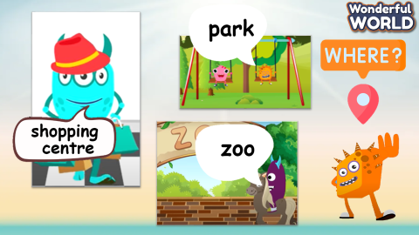 | Watch the video.  Answer the questions.
Activity 2: Presentation (8 minutes)
a. Aim: Present new vocabulary: bus stop, post office, shopping centre,
supermarket.
Teacher’s Activities | Students’ Activities
- Introduce the new words with the flashcards.  Vocabulary: bus stop, post office, shopping centre,  supermarket  -Using skills: Vary the volume (e.g. whisper, shout), speed, and intonation used to read words, and encourage students to copy. Younger learners will particularly enjoy using a silly voice or saying the words ‘like a robot’ or ‘like a monster’.  Listen and point. Repeat.  -Tell students to look at the vocabulary box on page 32. Ask if they know any of the words and what they are. Play the recording for students to listen and point to the correct pictures.  • Play the recording again, pausing after each word for students to say it. Ask volunteers to say the words in random order for their classmates to point to the correct pictures. Ask them which of the words they can match to the photo on page 32 (all of them)  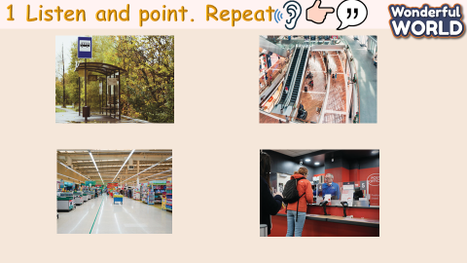 | - Follow the teacher.  - Read the words.  - Look, listen and point.
Activity 3: Practice (10 minutes)
a. Aim: Controlled-practice: to listen comprehension and read and write following a model sentence.
Teacher’s Activities | Students’ Activities
2. Listen, read. Write  -Tell students that they are going to listen to a dialogue about the places in the town and where the children go…  • Play the recording. Tell students to follow the text with their fingers. Play the recording again. Pause after each sentence and ask students to repeat.  -Ask some volunteers to act it out in front of the whole class.  -Ask students to look back at the picture and dialogue in order to complete the sentences.  • Check the answers with the whole class.  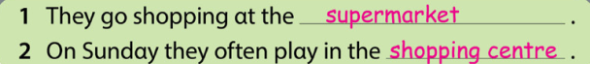  3. Look and say  Game: Who wants to be a millionaire.  T gives the Sts these questions to answer and practice to be a millionaire in the game.  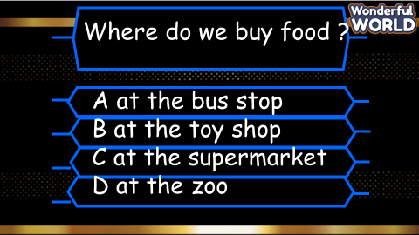  • Suggested answer:  1At the supermarket.  2. At the shopping centre  3. At the bus stop  4. At the post office  5. It’s in front of the toy shop  6. It’s next to the fountain  7. It’s behind the toy shop  8. It’s opposite the library | - Look and answer.  - Listen.  - Read.  - Look and read.  - Play the game by answering the questions.
Activity 4: Production (9 minutes)
a. Aims: Apply the learned knowledge to make their own conversation (attached with illustrated craft)
Teacher’s Activities | Students’ Activities
Draw: “My town”  T tells Sts to take out the paper and draw their town and write the places of the town.  The sts will ask and answer each other.  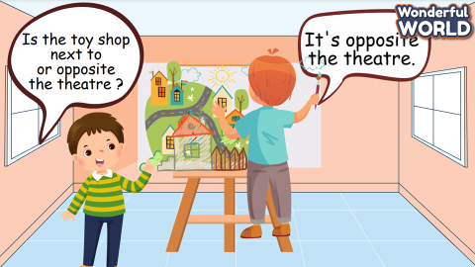 | - Draw.  - Write.  - Ask and answer.
Activity 5: Assessment and Wrap Up(3 minutes)
a. Aims: Consolidate the content of the lesson
Teacher’s Activities | Students’ Activities
b. Procedure  Let Ss do the assessment: Match  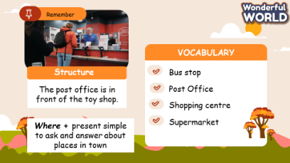 | Do the assessment.  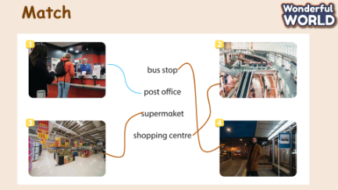
______________________________
UNIT 9. PLACES IN TOWN
Lesson 2. Task 4, 5, 6
Period 96
I. OBJECTIVES:
1. Knowledge:
Students will review some more places in town
To ask and answer questions about where someone does something
2. Competences:
- English competences: Students will be able to introduce their town where someone does something.
- Common competences: Students will have the opportunity to show their confidence in chanting.
3. Qualities:
- Students love discovering their towns.
II. EQUIPMENT AND MATERIALS:
- For Teacher: PP, flashcards, handout, track 9.6, track 9.7
- For students: pens,
III. LESSON PROCEDURE:
Activity 1: Warm up (5 minutes)
a. Aims: Review the words of the previous lesson about the places and get students ready for the lesson.
Teacher’s Activities | Students’ Activities
b. Procedure  Show the picture of the town and ask Sts to remember the places. Then hide one of them and ask them to say the name.  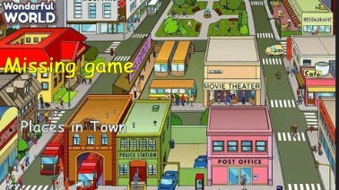  https://www.youtube.com/watch?v=kK4DOPR41Nc  Let Sts watch the video about 'places around town'. Includes places and buildings vocabulary such as: hospital, restaurant, park, airport, etc. This activity is great to introduce or review vocabulary.  To play this game, simply play the video in class and ask students to try to guess what the building or place is. Pause the video when students are ready to guess. | - Look and say.  - Watch the video and guess the place.
Activity 2: Presentation (8 minutes)
a. Aims: Present the way of using “Where” to ask and answer about places in town.

Teacher’s Activities | Students’ Activities
b. Procedure  4. Listen and repeat  Play the recording. Tell students to look at the sentences and follow them with their fingers.  • Play the recording again. Ask students to repeat.  • Point to the sentences. Ask students to notice the use and form of Where + present simple to ask and answer about places in town.  • Ask students to repeat sentences and link to the next activity. | - Follow the teacher.  - Look, listen and point
Activity 3: Practice (10 minutes)
a. Aim: Controlled- Practice to say following the model sentence with the structure
“Where do we………………?
We buy……………………….”
Teacher’s Activities | Students’ Activities
b. Procedure  5. Look and say  Tell students to look at the picture and suggested words for the question.  Then ask them to read out the example sentence.  • Explain the rest of the task to students. Allow them enough time to practise saying sentences  individually and in pairs. Go around the class helping students where necessary.  • Ask volunteers to read out sentences. Correct any mistakes.  GAME: LUCKY ANIMALS.  Let Sts choose the numbers to go to the question and choose the animals to get their stars.  1 Where do we buy apples?  -We buy apples at the supermarket.  2 Where do we buy comic books?  - (We buy comic books) at Kim Dong bookshop.  3 Where do we go shopping?  - (We go shopping) at Saigon shopping centre.  4 Where do we get Bus 22?  - (We get Bus 22) at the bus stop in front of the post office.  5. Where do we see a lot of flowers?  - We see a lot of flowers in the park.  6. Where do we watch a film?  - We watch a film in the cinema. | - Look and answer.  - Listen.  Read.  Look and read.  Play the game by answering the questions.
Activity 4: Production (9 minutes)
a. Aims: Apply the learned words and structure about the chant.
Teacher’s Activities | Students’ Activities
b. Procedure  6. Listen and chant  - Tell students they are going to learn a chant. Explain to students that the chant uses the words they have just learnt.  • Play the recording and tell students to listen and follow the words with their fingers.  • Read out the chant one line at a time and ask students to repeat after you.  • Play the recording again. Encourage students to chant along. Practise several times until students are  familiar with the words and sounds.  • Optional activity: Ask students to practise the chant individually and then in pairs or in groups. For example, one group chants the first verse, and the other group chants the second verse. Ask some volunteers to say the whole chant.  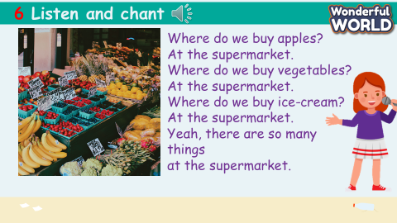 | Read the chant.
Activity 5: Assessment (3 minutes)
a. Aims: Consolidate the content of the lesson.
Teacher’s Activities | Students’ Activities
b. Procedure  Do the assessment: Circle  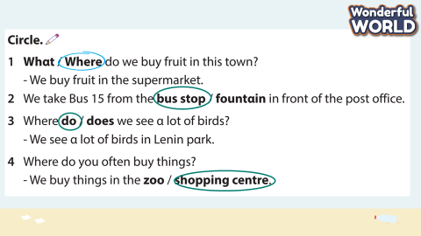 | Do the assessment.
______________________________________

