TUẦN 22 (Từ ngày 02/02/2026 đến ngày 06/02/2026)
`
THỨ | TIẾT | MÔN | TIẾT THỨ | NỘI DUNG BÀI DẠY |  | UDCNTT | ĐỒ DÙNG DẠY HỌC
Hai  02/02 | 1
Hai  02/02 | 2 | 4B | 85 | Unit 8. Technology | Lesson 3 (1, 2, 3) | Wonderfulworld | Flashcards, TV, books
Hai  02/02 | 3 | 4A | 85 | Unit 8. Technology | Lesson 3 (1, 2, 3) | Wonderfulworld | Flashcards, TV, books
Hai  02/02 | 4 | 4D | 22 | Thiết lập và duy trì quan hệ bạn bè (T2) |  | Trình chiếu hình ảnh | Máy tính, tivi
Hai  02/02 | 5 | 4A | 86 | Unit 8. Technology | Lesson 3 (4, 5, 6) | Wonderfulworld | Flashcards, TV, books
Hai  02/02 | 6 | 4C | 22 | Thiết lập và duy trì quan hệ bạn bè (T2) |  | Trình chiếu hình ảnh | Máy tính, tivi
Hai  02/02 | 7 | 4C | 85 | Unit 8. Technology | Lesson 3 (1, 2, 3) | Wonderfulworld | Flashcards, TV, books
Ba  03/02 | 1 | 5D | 22 | Bài 6: Lập kế hoạch cá nhân (T2) |  | Trình chiếu hình ảnh | Máy tính, tivi
Ba  03/02 | 2 | 4A | 22 | Thiết lập và duy trì quan hệ bạn bè (T2) |  | Trình chiếu hình ảnh | Máy tính, tivi
Ba  03/02 | 3 | 4B | 22 | Thiết lập và duy trì quan hệ bạn bè (T2) |  | Trình chiếu hình ảnh | Máy tính, tivi
Ba  03/02 | 4 | 5A | 22 | Bài 6: Lập kế hoạch cá nhân (T2) |  | Trình chiếu hình ảnh | Máy tính, tivi
Ba  03/02 | 5
Ba  03/02 | 6
Ba  03/02 | 7
Tư  04/02 | 1
Tư  04/02 | 2
Tư  04/02 | 3
Tư  04/02 | 4 | 4B | 86 | Unit 8. Technology | Lesson 3 (4, 5, 6) | Wonderfulworld | Flashcards, TV, books
Tư  04/02 | 5 | 4D | 85 | Unit 8. Technology | Lesson 3 (1, 2, 3) | Wonderfulworld | Flashcards, TV, books
Tư  04/02 | 6 | 4C | 86 | Unit 8. Technology | Lesson 3 (4, 5, 6) | Wonderfulworld | Flashcards, TV, books
Tư  04/02 | 7 | 4B | 87 | Unit 8. Technology | Lesson 3 (7, 8, 9) | Wonderfulworld | Flashcards, TV, books
Năm  05/02 | 1 | 4C | 87 | Unit 8. Technology | Lesson 3 (7, 8, 9) | Wonderfulworld | Flashcards, TV, books
Năm  05/02 | 2 | 4A | 87 | Unit 8. Technology | Lesson 3 (7, 8, 9) | Wonderfulworld | Flashcards, TV, books
Năm  05/02 | 3 | 4D | 86 | Unit 8. Technology | Lesson 3 (4, 5, 6) | Wonderfulworld | Flashcards, TV, books
Năm  05/02 | 4 | 4B | 88 | Unit 8. Technology | Fun time and project (1, 2) | Wonderfulworld | Flashcards, TV, books
Năm  05/02 | 5 | 5C | 22 | Bài 6: Lập kế hoạch cá nhân (T2) |  | Trình chiếu hình ảnh | Máy tính, tivi
Năm  05/02 | 6 | 5B | 22 | Bài 6: Lập kế hoạch cá nhân (T2) |  | Trình chiếu hình ảnh | Máy tính, tivi
Năm  05/02 | 7
Sáu  06/02 | 1 | 4A | 88 | Unit 8. Technology | Fun time and project (1, 2) | Wonderfulworld | Flashcards, TV, books
Sáu  06/02 | 2
Sáu  06/02 | 3
Sáu  06/02 | 4 | 4D | 87 | Unit 8. Technology | Lesson 3 (7, 8, 9) | Wonderfulworld | Flashcards, TV, books
Sáu  06/02 | 5
Sáu  06/02 | 6 | 4C | 88 | Unit 8. Technology | Fun time and project (1, 2) | Wonderfulworld | Flashcards, TV, books
Sáu  06/02 | 7 | 4D | 88 | Unit 8. Technology | Fun time and project (1, 2) | Wonderfulworld | Flashcards, TV, books

TIẾNG ANH KHỐI 4
WEEK 22
UNIT 8. TECHNOLOGY
Lesson 3. Task 1, 2, 3
Period 85
I. OBJECTIVES:
1. Knowledge:
- Students will learn words and phrases related to the topic Technology: change the password, use the computer lab, use the projector, use the speaker.
- Students will learn about the new structure:
Can teachers/ students use the projector?
- Yes, they can.
-No, they can’t.
2. Competences:
- English competences: Students will be able to express possibilities with can.
- Common competences: Students will have the opportunity to develop their creativeness by participating in games and developing communication among friends.
3. Qualities:
- Students develop their information technology skills.
II. EQUIPMENT AND MATERIALS:
- For Teacher: PP, flashcards, handout, track 8.9,8.10
- For students: pens, books, paper.
III. LESSON PROCEDURE:

Activity 1: Warm up (5 minutes)
Teacher’s Activities | Students’ Activities
Aims: Warm-up activity to revise the words of previous lesson.
b, Procedure  - Greet students and divide class into 4 teams  -Warm up: Racing game.  - The T shows the race.  - Ask Sts to look at the pictures, choose the numbers and answer the questions  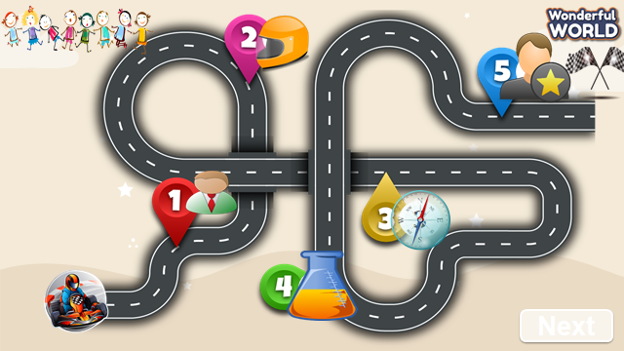  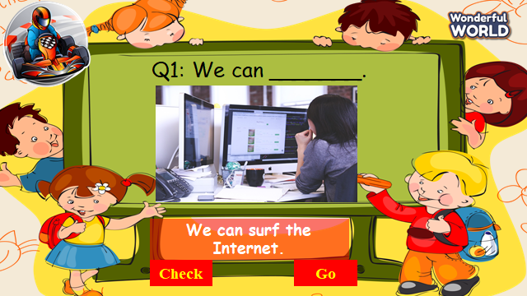  - If sts have correct answers, they can roll the dice to get stars. | - Sts greet the teacher and choose their team names.  - Join in the game.  - Look at the questions and pictures  - Sts having correct answers will have stars.
Activity 2: Presentation (8 minutes)
Teacher’s Activities | Students’ Activities
a, Aims: Present some new words of Technology: change the password, use the computer lab, use the projector, use the speaker.
Encourage sts with the topic and vocab of related topic.
b, Procedure  Task 1. Listen and point. Repeat.  - Use pictures to introduce the vocabulary and structure of the lesson.  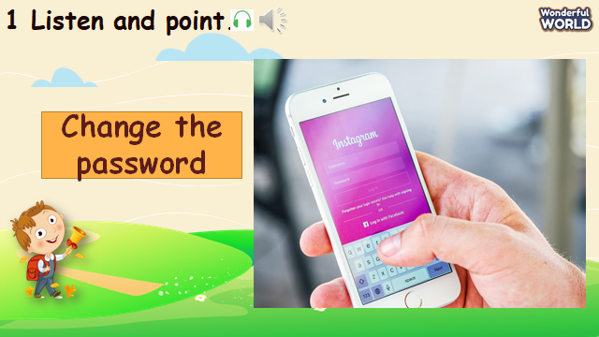  - Say the words/sentences for students to repeat in the chorus.  - Say a word/sentence for students to repeat then point.  - Play track 8.9 for the students to listen to and repeat in chorus, and group.  - Show pictures in random order and ask students to read out the words.  VOCABULARY CHECKING  - Let Sts play the “Protect the jungle”.  - Ask some Sts to choose the numbers, look at the picture and answer the questions.  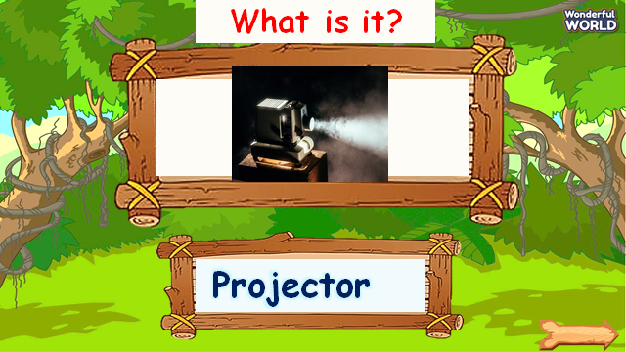  - If they have correct answers, they can hit the hunters through some monkeys and have their stars. | -Repeat after the teacher.  -Listen to the track and repeat in whole class.  -Sts practice the new words individually and in groups  -Sts join the game and get stars.
Activity 3: Practice (14 minutes)
Teacher’s Activities | Students’ Activities
a, Aims: - Controlled-practice: Listen and tick a conversation using the vocab of task 1.
- Encourage sts to act out the dialogue in pairs in front of the class.
b, Procedure  Task 2: Listen and tick.  - Ask sts to look at the picture and answer what they can see.  -Let Sts listen and read the dialogue about what they can use in the computer lab by role play “Teacher Sam” and “Andy” to practice the words and sentences.  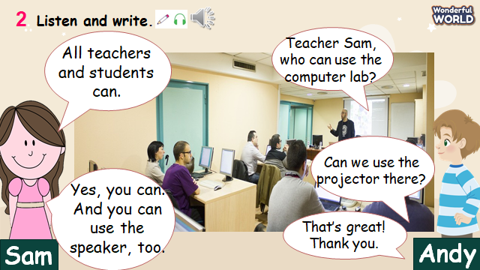  - Ask some pairs to read the dialogue.  - Then let sts read the sentences below and ask them to listen and fill in the gaps with the words from the recording.  -Then play track 8.10 again for sts to check their answers.  - Pause after each sentence to check their answers.  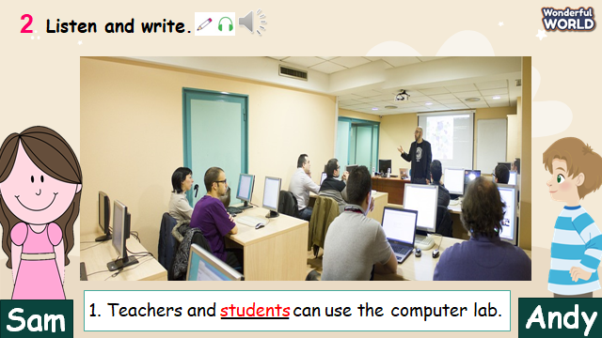  Task 3: Look and say.  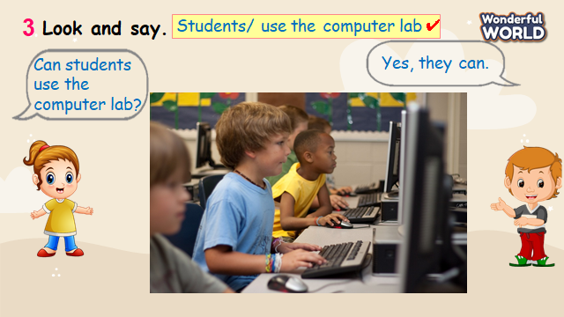  - Look at the picture and prompts. Read out prompts and ask sts to repeat.  -Read out the dialogue and let sts repeat.  -Then ask Sts to choose the objects and read the dialogue.  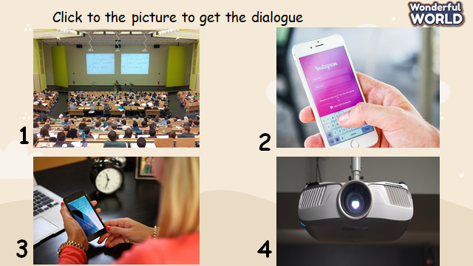  - Explain the task and allow them enough time to practice saying sentences.  - Let Sts make some dialogues through some pictures and practice them in pairs.  - Require some pairs present in front of the class. | -Listen and read.  - Sts read aloud each sentence.  - Repeat the sentences.  -Some pairs read the dialogue.  -Sts listen again and write the correct answers.  -Answer the question.  -Read some prompts and dialogue.  -Make and practice some dialogues in pairs and present it in the class.
Activity 4: Production (9 minutes)
Teacher’s Activities | Students’ Activities
a, Aims: Watch the video and write the objects that they can see.
Apply the new words and structures to present in front of the class about technology using vocabulary in task 1.
b, Procedure  Watch a video!  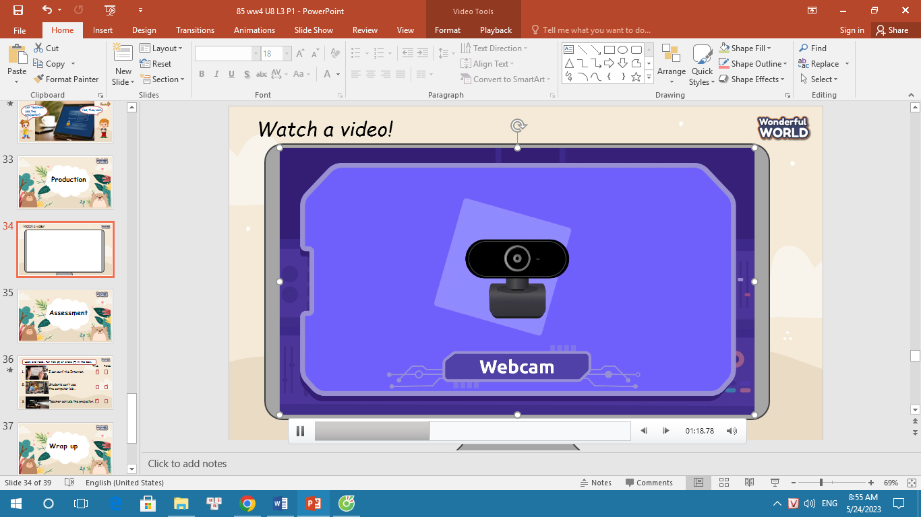  -Ask sts to count and write the name of the technology.  - Ask them to read out the objects in the video.  - Then, write some sentences about technology using the vocabulary in task 1.  - Ask some volunteers present about sentences in front of the class. | -Sts watch the video.  - Sts guess how many technologies they can see.  -Write down and answer about the objects in the video.  -Make sentences about technology  -Some sts present about it.
Activity 5: Assessment (3 minutes)
Teacher’s Activities | Students’ Activities
a, Aims: Consolidate the content of the lesson.
-Ask sts to do the assessment.  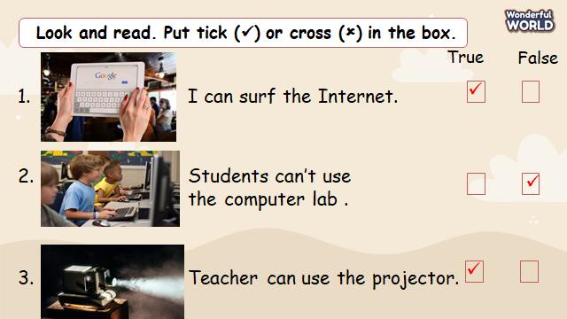  - Check with the class.  - Wrap-up  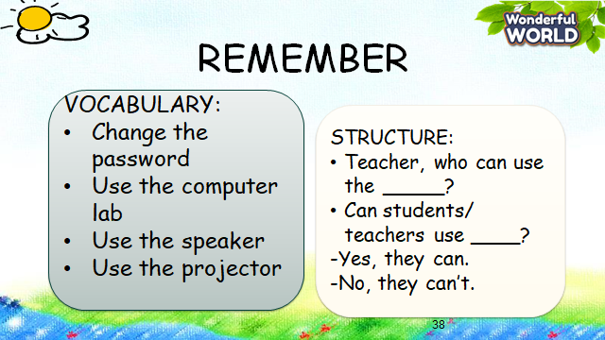 | -Do the assessment.  -Check with the teacher  - Sts read the wrap-up  - Stand up and say goodbye to the teacher.
______________________________________
UNIT 8. TECHNOLOGY
Lesson 3. Task 4, 5, 6
Period 86
I. OBJECTIVES:
1. Knowledge:
- Students will revise words and phrases related to the topic Technology: change the password, use the computer lab, use the projector, use the speaker
- Students will learn about the new structure:
We can use the speaker in class.
We can’t use smartphone in class.
2. Competences:
- English competences: Students will be able to talk about what they can or can’t do in class using technology.
- Common competences: Students will have the opportunity to develop their creativeness by participating in games and developing communication among friends.
3. Qualities:
- Students develop their technology skills.
II. EQUIPMENT AND MATERIALS:
- For Teacher: PP, flashcards, handout, track 8.11
- For students: pens, books, paper, and crayons.
III. LESSON PROCEDURE:

Activity 1: Warm up (5 minutes)
Teacher’s Activities | Students’ Activities
a, Aims: Review the vocabulary which they have learned from previous lesson.
b, Procedure  - Greet students and divide class into 4 teams  - Warm up: Unscramble Game!  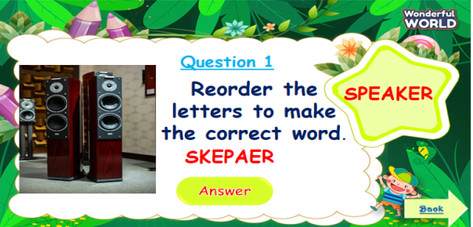  - The T shows the pictures and words.  - Ask Sts to reorder the letters to make the correct words.  - Sts answer all the questions and roll the dice to get stars. | - Sts greet the teacher and choose their team names.  - Join in the game.  - Look at the questions and pictures  - Sts having correct answers will have stars.
Activity 2: Presentation (8 minutes)
Teacher’s Activities | Students’ Activities
a, Aims: Present new structure “Who can use ….?” to express possibilities using “can”.
Encourage sts to work in pairs in front of the class using new structure.
b, Procedure  Task 4: Listen and repeat.  - Let Sts look at the word patterns and pictures.  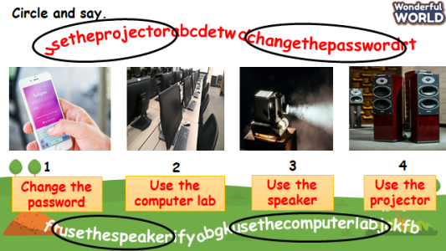  - Ask sts to figure out the words and say aloud.  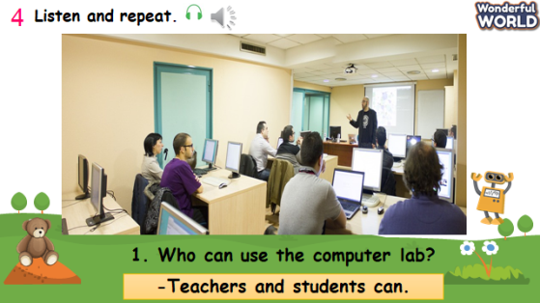  - Ask Sts to look at pictures and underline the sentence “Who can use the computer lab?”.  - Say a word/sentence for students to repeat then point  - Explain the structure “Who can use ….? to express possibilities using “can”.  - Give sts the answer of that structure by using “S+can”.  - Play track 8.11 for the students to listen to and repeat in chorus, and group.  - Ask some pairs to read the questions and answers. | -Look at some pictures and wordpatterns.  -Sts take part in the game.  -Sts repeat the answers.  -Sts underline the questions.  -Sts listen and practice the dialogues.  - Some pairs present in front of class.
Activity 3: Practice (14 minutes)
Teacher’s Activities | Students’ Activities
a, Aims: Controlled-practice: to ask and answer about permission of using technology and make sentences using can.
Task 5: Look and say.  -Let Sts play “Matching game” to review the previous lessons.  - Ask sts to play in teams.    - Let sts match the correct activities to correct people.  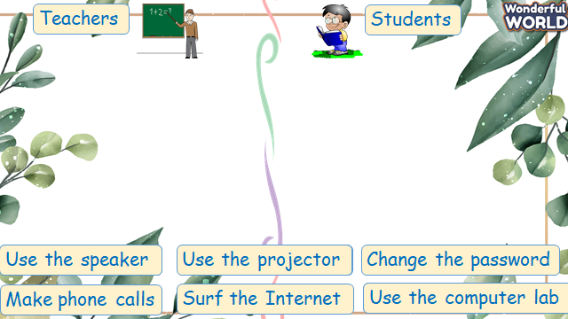  -Then show sts the pictures and some prompts.  - Read out the prompts and make the dialogue. Then ask sts to repeat.  - Explain the rest of the task and ask sts to make and practice the dialogue in pairs through some pictures.  - Then let some pairs present in front of the class.  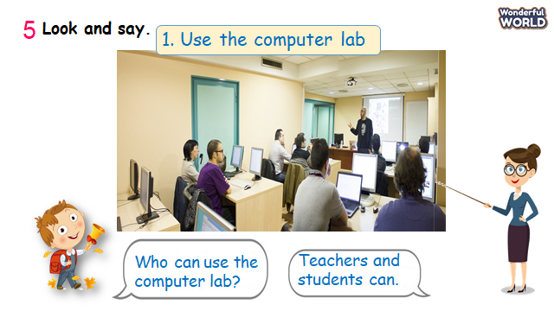 | - Look at pictures and questions.  -Take part in the games.  - Match the correct activities.  -Read the dialogue.  -Make and practice some dialogue in pairs and present it in the class.
Activity 4: Production (9 minutes)
Teacher’s Activities | Students’ Activities
a, Aims: Apply the words and structures to make sentences about technology using can or can’t.
b, Procedure  Task 6: Let’s talk  -T shows the picture and asks sts what they can or can’t do in class.  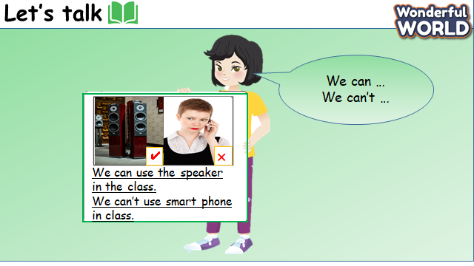  - Read out the sentences and ask them to repeat.  - Tell sts to draw a picture of what they can or can’t do.  - Ask sts to write a description using the examples.  - Ask some volunteers to show their pictures and read out their work. | - Sts repeat after T.  - Sts draw a picture.  - Sts make sentences using examples.  - Some volunteers read aloud.
Activity 5: Assessment (3 minutes)
Teacher’s Activities | Students’ Activities
Aims: Consolidate the content of the lesson through a game.
-Ask sts to do the assessment.  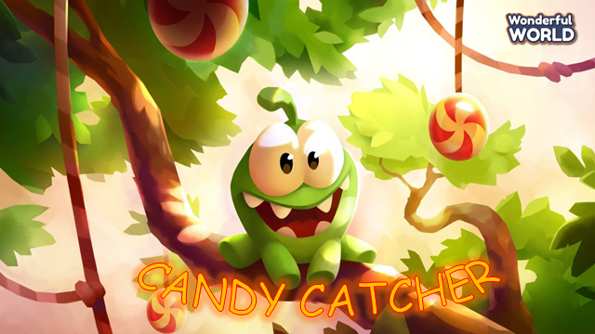  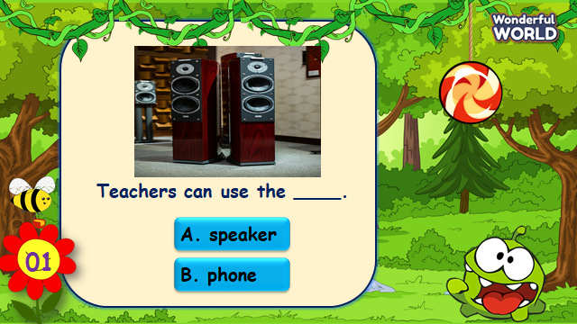  - Check with the class.  - Wrap up  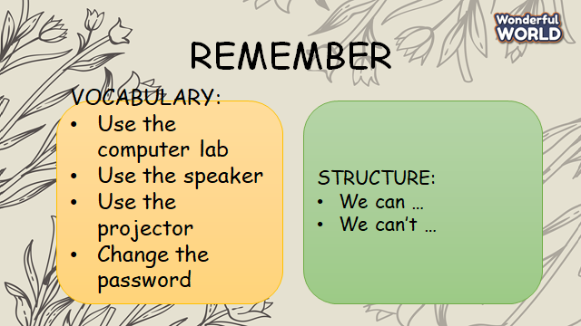 | -Do the assessment.  -Check with the teacher  - Sts read the wrap-up  - Stand up and say goodbye to the teacher.
________________________________________
UNIT 8. TECHNOLOGY
Lesson 3. Task 7, 8, 9
Period 87
I. OBJECTIVES:
1. Knowledge:
- Students will revise words and phrases related to the topic Technology: use, make
- Students will learn about how to pronounce /s/, /m/.
- Students will learn about new structure: I can use my phone. I can make videos.
2. Competences:
- English competences: Students will be able to talk about what they can use.
- Common competences: Students will have the opportunity to develop the creativeness in participating in games and develop communication among friends.
3. Qualities:
- Students develop their soft skills when using technology.
II. EQUIPMENT AND MATERIALS:
- For Teacher: PP, flashcards, handout, track 8.12,8.13.
- For students: pens, books.
III. LESSON PROCEDURE:
Activity 1: Warm-up (5 minutes)
Teacher’s Activities | Students’ Activities
a, Aims: Warm-up activity to revise the vocabulary they have learned through a song.
b, Procedure  - Greet students and divide class into 4 teams.  -Warm-up: Listen to a song: The Qwerty Song!    - The T shows the song and let sts review some words and phrase relating to Computer. | - Sts greet the teacher and choose their team names.  -Listen to the song.
Activity 2: Presentation (8 minutes)
Teacher’s Activities | Students’ Activities
a, Aims: Present new grammar: to pronounce /m/, /s/
Encourage sts to pronounce words correctly through a game.
b, Procedure  Task 4: Listen and repeat.  - Let Sts look at the pictures.  - Write //m/ on the board then write bookshelf.  - Ask sts to pronounce the word.  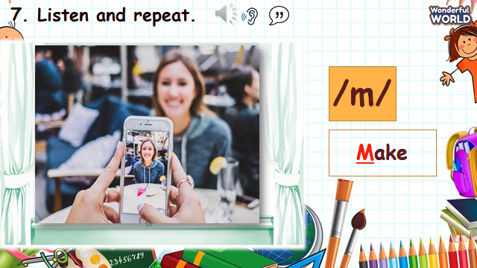  - Write //s/ on the board then write bookshelf.  - Ask sts to pronounce the word.  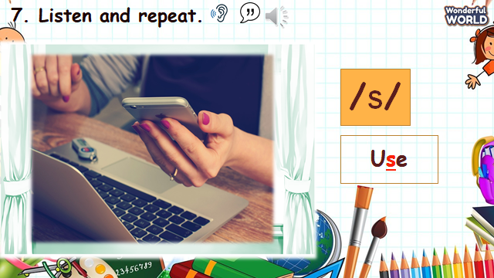  - Play the recording and tell students to point to the sounds they heard.  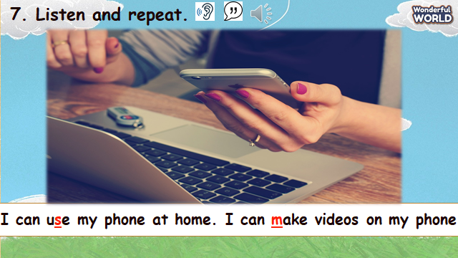  - Show sts how the sounds are different from each other.  - Ask sts to read the words.  - Play the recording again and tell sts to repeat the sentences and words, paying attention on pronounciation.  CHECKING VOCABULARY.  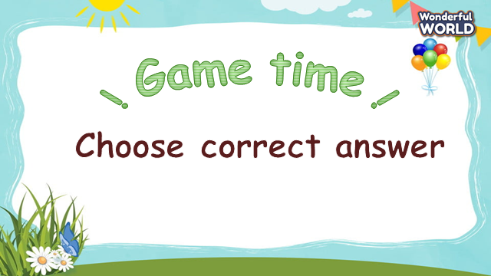  - Ask Sts to look at pictures and choose the correct answers.  - Sts having the correct answers will roll the dice to get stars. | - Look at the sounds and words.  - Sts listen to the recording and teacher.  - Repeat the words and sentences.  - Take part in the game.  - Sts look at pictures and words.  - Sts choose the correct words.
Activity 3: Practice (14 minutes)
Teacher’s Activities | Students’ Activities
a, Aims:
-Controlled-practice: help sts to practice the vocab and grammar by doing a game.
-Encourage sts to pay attention to pronunciation.
b, Procedure  Task 9: Say it!.  -Let Sts play “Wheel of fortune” questions to practice Task 9.  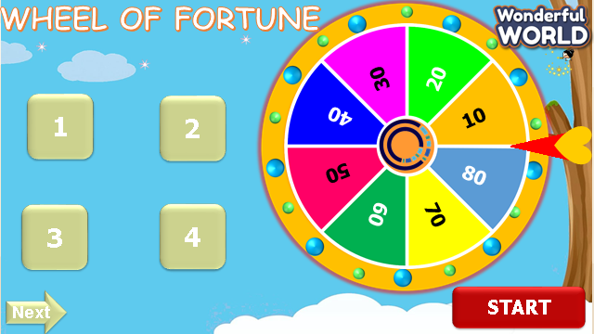  - Let sts choose the numbers and answer the questions.  - Then show sts the pictures and questions.  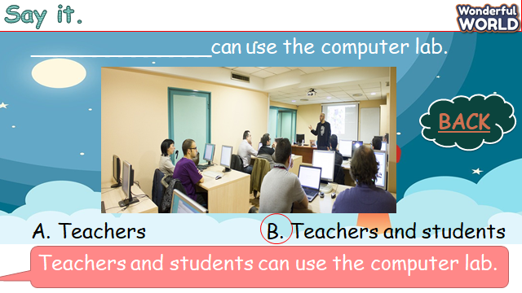  - Ask sts to choose and read out the correct answers.  - Tell sts to pay attention to the sounds that they have learnt in each word.  - Explain the rest of task and ask sts to read sentences through the game.  - Ask sts to work in pairs and say the sentences, paying attention to the correct pronounciation.  - Ask some volunteers to say in front of the class. | - Take part in the games.  - Sts choose the numbers, answer the questions and get stars through the wheel.  - Sts join the game and answer the questions.  - Sts read aloud sentences in the class.  - Sts work in pairs and say it in front of the class.
Activity 4: Production (9 minutes)
Teacher’s Activities | Students’ Activities
a, Aims: Chant the song correctly according to the lyrics.
b, Procedure  Task 8: Listen and Chant.  -T shows the picture and asks what they can see. Let sts listen to a chant.  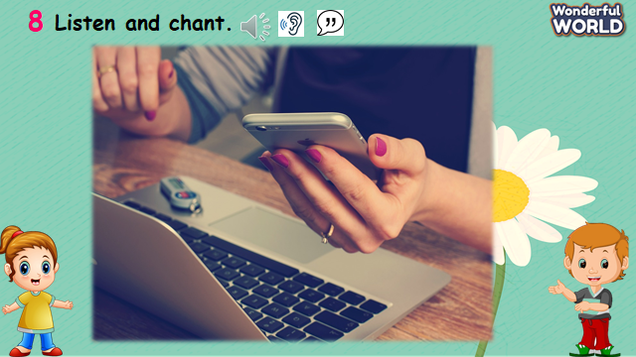  - Explain to sts that the chant uses the sounds they just have learnt.  - Play the record and ask sts to follow the chant by their fingers.  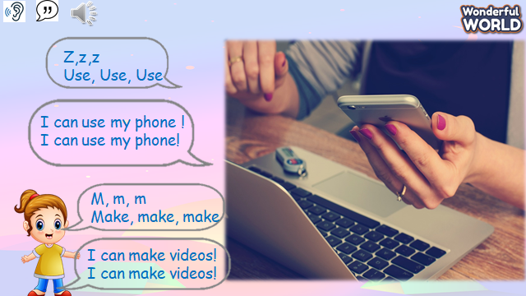  - Read out the chant one line at time and ask sts to repeat.  - Play the recording again, and ask sts to chant along.  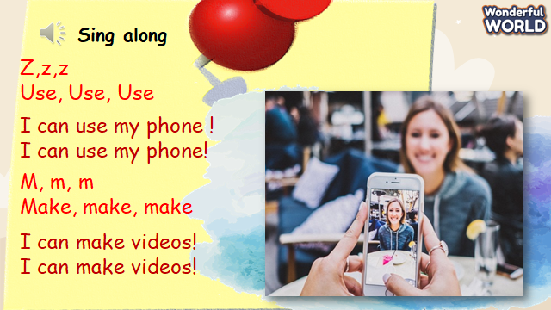 Practice several times and let them do it individually and in groups.  - Ask some volunteers to chant. | - Sts answer the questions.  - Sts listen to a chant.  - Sts repeat after teacher.  - Sts chant several times indiviadually and in groups.
Activity 5: Assessment (3 minutes)
Teacher’s Activities | Students’ Activities
Aims: Consolidate the content of the lesson.
-Ask sts to do the assessment.  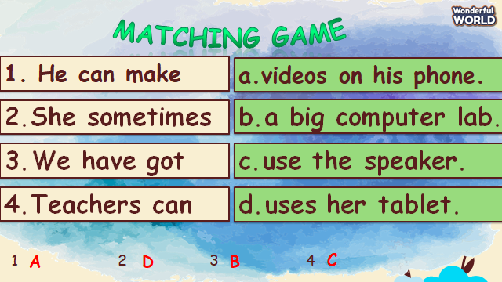  - Remember the vocabulary and structure.  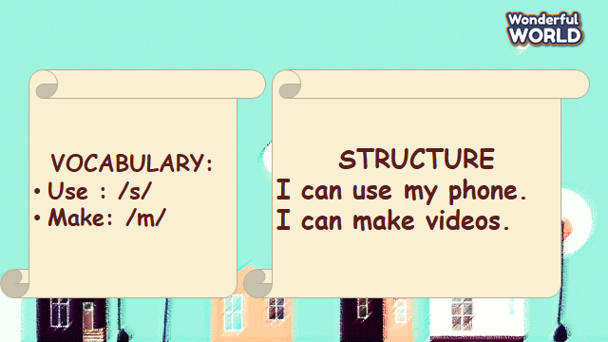  - Check with the class. | -Do the assessment.  - Check with the teacher  - Sts read the wrap-up  - Stand up and say goodbye to the teacher.
UNIT 8. TECHNOLOGY
Fun time and project. Task 1, 2
Period 88
I. OBJECTIVES:
1. Knowledge:
- Students will review clothes vocabulary and unit grammar.
2. Competences:
- English competences: Students will be able to talk about Technology.
- Common competences: Students will develop their creativity in drawing pictures.
- Know how to use structures in the presentation:
- S+ can/ can’t + V
3. Qualities:
- Students will be confident and active in communicating with friends and teacher.
II. EQUIPMENT AND MATERIALS:
- For Teacher: PP, TV, boards, markers
- For students: A4 paper, books, pens, crayons
III. LESSON PROCEDURE:

Activity 1: Fun Time (10 minutes)
Teacher’s Activities | Students’ Activities
A, Aims: Review all the words of technology.
B, Procedure:  - Greet students and divide class into 4 teams.  Warm up (3 minutes)  - Introduce the song  - Ask sts to review some vocabulary and do action  - Play the Robot dance  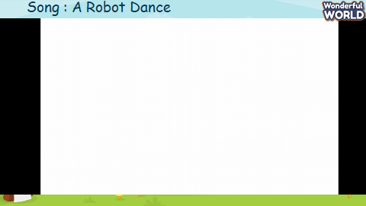  - Ask sts to sing and remember the rooms in video.  Task 1: Unscramble (7 MINUTES)  Do Task 1 through a game  Ask sts to look at the screen and choose the numbers they want. Then, answer all the questions and roll the dice to get stars.  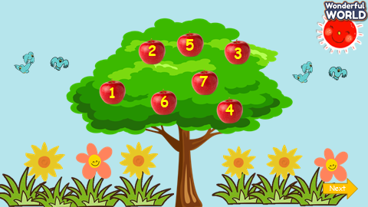  - Let sts choose the numbers.  - Sts can look at pictures and words.  - They can choose the correct words to get stars.  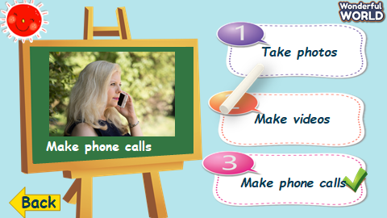  - Ask sts to work in pairs.  - Hand each pair a print of task 1.  - The sts will match the words to make correct phrases. | - Greet teacher and choose their team names.  -Listen to the teacher  - Repeat and do the action  - Sing along and repeat the song.  - Answer the question.  - Look at the pictures and words.  - Sts can choose the correct answers.  - Speak out correctly, paying attention to the pronunciation.  - Do the game and get stars.  - They can do task 1.
Activity 2: Project (20 minutes)
Teacher’s Activities | Students’ Activities
A, Aims: Review all words and structures of unit 8 through presentation.
Project: My family  B, Procedure:  Technology quiz game  - Guides sts to play with the game and tick the correct pictures with the correct words.  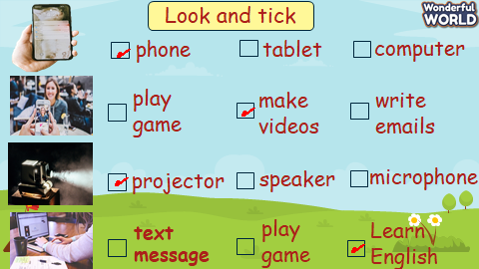  - Anyone who can answer correctly, will be given a star.  Video for the project  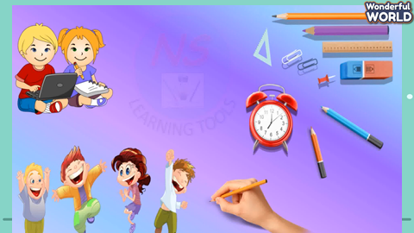  Technology  You can…  You can’t….  -T shows pictures things we can or can’t do in class.  - Writes down the structure and ask them to repeat the structure, using adjectives about objects and house.  Implementing stage  Before drawing  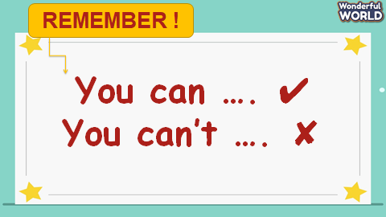  - Ask sts to work individually using the structures.  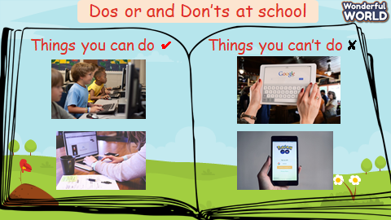  - Show the picture of things you can or can’t do in class  - Ask sts to make their own sentences according to some pictures.  - Ask sts to read aloud sentences.  - Ask sts to make sentences about their rooms. 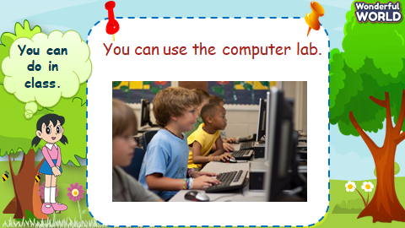  - Show the sentences one by one.  - Tell them to draw a picture of their favourite technology and write down what they can or can’t do with their technology.  - Colour the picture  - Ask sts to go to the board – group by group and present.  Displaying and Reflecting on the board  - Ask sts to come to the board and present about their pictures in class.  - Go around to offer help when necessary.  - Check the number of members they have talked to  - Award the best speaker.  Evaluation (2 MINUTES)  Go to sleep  - T shows some flashcards of technology and ask sts to guess what picture is missing.  Home work (2 MINUTES)  Myschool.com.vn | - Listen to the teacher  - Listen to the game rules  - Look at the picture  - choose the correct answer  - show the board of correct answers.  -Talk to friends about the picture.  Read aloud the answers about rooms.  Follow instructions.  - Look at the pictures and complete some words.  - Speak out the sentences.  - Draw a picture of their favourite technology.  - Present in group  - comment – cross-checking group by group.  Do the task.
______________________________________
ĐẠO ĐỨC KHỐI 4
THIẾT LẬPVÀ DUY TRÌ MỐI QUAN HỆ BẠN BÈ (T2)
I. YÊU CẦU CẦN ĐẠT:
1. Yêu cầu cần đạt về kiến thức, kĩ năng
- Biết vì sao cần thiết lập quan hệ bạn bè.
- Nhận biết được cách đơn giản để thiết lập quan hệ bạn bè
- Thiết lập được mối quan hệ bạn bè ở trường học và làng xóm, khối phố.
2. Yêu cầu cần đạt về năng lực , phẩm chất:
- Năng lực tự chủ, tự học: Biết tự chủ tự học, tự điều chỉnh hành vi, thái độ lời nói và việc làm để thiết lập quan hệ bạn bè.
- Năng lực giải quyết vấn đề và sáng tạo: Biết tìm hiểu và tham gia những hoạt động để thiết lập quan hệ bạn bè.
- Năng lực giao tiếp và hợp tác: Biết trao đổi, góp ý cùng bạn trong hoạt động nhóm.
- Phẩm chất nhân ái: Yêu mến, quý trọng bạn bè.
- Phẩm chất chăm chỉ: Có tinh thần chăm chỉ rèn luyện để nắm vững nội dung yêu cầu cần đạt của bài học.
- Phẩm chất trách nhiệm: Có ý thức trách nhiệm với lớp, tôn trọng tập thể.
II. ĐỒ DÙNG DẠY HỌC
- Kế hoạch bài dạy, bài giảng Power point.
- SGK và các thiết bị, học liệu phục vụ cho tiết dạy.
III. HOẠT ĐỘNG DẠY HỌC
Hoạt động của giáo viên | Hoạt động của học sinh
1. Khởi động:
- Mục tiêu:
+ Tạo không khí vui vẻ, phấn khởi trước giờ học.
+ Thông qua khởi động, giáo viên dẫn dắt bài mới hấp dẫn để thu hút học sinh tập trung.
- Cách tiến hành:
- GV tổ chức múa hát bài “Người bạn thân” – Nhạc và lời Đào Ngọc Dung để khởi động bài học.  + GV Cùng trao đổi với HS về nội dung bài hát: Bài hát nói về điều gì?  + GV hỏi thêm: Vì sao chúng ta nên thiết lập quan hệ bạn bè?  Em có thể thiết lập quan hệ bạn bè bằng cách nào?  - GV nhận xét, tuyên dương và dẫn dắt vào bài mới. |  | - Một số HS lên trước lớp thực hiện. Cả lớp cùng múa hát theo nhịp điều bài hát.  + HS nêu nội dung nghe thấy trong bài hát.  + Thiết lập quan hệ bạn bè giúp chúng ta có những người bạn để chia sẻ buồn, vui, cũng nhau học tập, vui chơi, trải nghiệm.  Để thiết lập quan hệ bạn bè, chúng ta cần giới thiệu bản thân; chủ động thể hiện mong muốn làm quen và chơi cùng bạn; thể hiện sự quan tâm tới bạn; luôn thể hiện thái độ thân thiện , cởi mở…  - HS lắng nghe.
2. Luyện tập:
- Mục tiêu:
+ HS nêu được cách để thiết lập quan hệ bạn bè.
+ HS biết bày tỏ thái độ, nhận xét hành vi, xử lí tình huống liên quan đến việc thiết lập quan hệ bạn bè.
- Cách tiến hành:
Hoạt động 1: Lựa chọn cách phù hợp để thiết lập quan hệ bạn bè (Làm việc nhóm 6)  - GV mời 1 HS đọc yêu cầu bài  - GV YC HS thảo luận nhóm 6 thực hiện YC, khoanh tròn chữ cái trước cách lựa chọn và giải thích vì sao lựa chọn.  -GV cho HS chơi trò chơi “Bạn chọn cách nào?”: 2 đội chơi, mỗi đội 6 người, từng thành viên lần lượt gắn thẻ mặt cười/mặt mếu vào trước các phương án trên bảng phụ. Đội xong trước, đúng là thắng  -GV cho địa diện nhóm giải thích lựa chọn của mình  - GV mời cả lớp nhận xét, bổ sung.  - GV nhận xét, tuyên dương đội thắng. Kết luận: Để thiết lập quan hệ bạn bè chúng ta nên: Tự tin giới thiệu bản thân và hỏi tên bạn, luôn thể hiện thái độ vui vẻ cởi mở, giao tiếp bằng mắt và mỉm cười khi trò chuyện, thể hiện sự quan tâm và chia sẻ sở thích của mình với bạn. Không nên: chỉ trò chuyện với người quen khi đến môi trường mới, liên tục kể với bạn về mình, luôn tỏ ra là người thông minh, tài giỏi. |  | - 1 HS đọc yêu cầu bài.  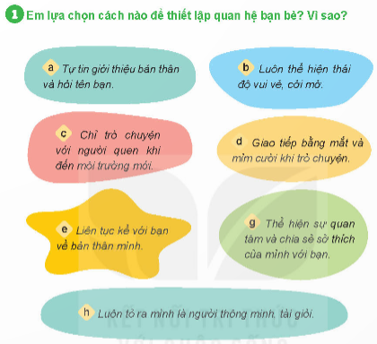  -HS TL nhóm 6  -2 độ chơi, lớp cổ vũ  -HS trả lời trước lớp:  +a. Tự tin giới thiệu bản thân và hỏi tên bạn: Thể hiện mong muốn được biết và làm quen với bạn  +b. Luôn thể hiện thái độ vui vẻ cởi mở. Thái độ vui vẻ cởi mở sẽ tạo cho bạn cảm giác vui vẻ, dễ gần  + d. Giao tiếp bằng mắt và mỉm cười khi trò chuyện. Điều này thể hiện sự lịch sự và cho thấy sự tập trung, thích thú với câu chuyện  +g. Thể hiện sự quan tâm và chia sẻ sở thích của mình với bạn. Điều này khiến bạn hiểu hơn về mình và có thể tìm ra điểm chung với mình  - Cả lớp nhận xét, bổ sung.  - HS lắng nghe.
Hoạt động 2: Nhận xét thái độ, hành vi (Làm việc nhóm 4)  - GV cho HS đọc bài tập 2:  -GV hướng dẫn HS làm nhóm 4, nhận xét về thái độ, hành vi của các bạn trong các tình huống  -GV quan sát, giúp đỡ.  - GV mời đại diện nhóm nêu nhận xét từng tình huống.  -GV hỏi khai thác thêm:  +Con sẽ làm giống bạn nào? vì sao?  +Bạn Linh và Tâm nên làm gì?  - GV nhận xét, tuyên dương, chốt: Khi đến môi trường mới, chúng ta nên chủ động làm quen, tự tin giới thiệu bản thân, và trò chuyện cởi mở cùng các bạn như Tuấn và Thanh; không nên thiếu hòa đồng hoặc tỏ ra quá nhút nhát, dè dặt sẽ khó thiết lập quan hệ bạn bè. |  | - 1HS đọc, lớp đọc thầm  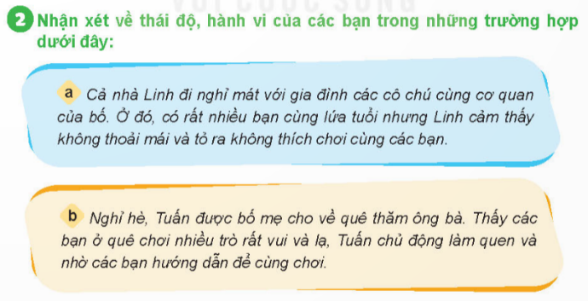  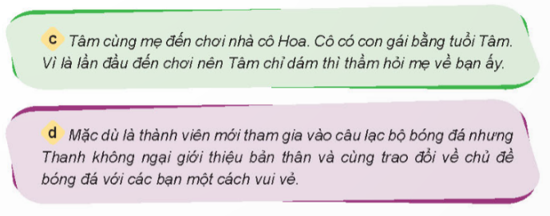  - HS lắng nghe.  -HS thảo luận nhóm 4  - Đại diện các nhóm nêu nhận xét:  +a: Bạn Linh khó thiết lập quan hệ bạn bè do chưa thân thiện, hòa đồng với các bạn cùng chuyến đi.  +b: Bạn Tuấn đã biết cách thiết lập quan hệ bạn bè khi đến môi trường mới bằng cách chủ động làm quen bắt chuyện.  +c: Bạn Tâm khó thiết lập quan hệ bạn bè vì dè dặt, chưa chủ động trong việc làm quen, kết bạn với con gái cô Hoa.  +d: Mặc dù là thành viên mới nhưng Thanh đã biết thiết lập qua nhệ bạn bè với các thành viên trong đội bóng đá bằng cách tự tin giới thiệu bản thân và trò về chủ đề yêu thích cùng các bạn  -HS khác nhận xét, bổ sung.  -HS TL:  +Tuấn và Thanh  +Nên mạnh dạn, tự tin hơn, chủ động làm quen với bạn khi đến những nơi mới  - HS lắng nghe rút kinh nghiệm
Hoạt động 3: Em đồng tình hoặc không đồng tình với ý kiến nào? Vì sao? (Làm việc chung cả lớp)  - GV cho HS đọc bài tập 3:  -GV hướng dẫn cách hoạt động cả lớp: giơ thẻ bày tỏ thái độ đồng tình/không đồng tình  - GV đưa từng ý kiến,  -GV cho HS nêu lí do đồng tình/ không đồng tình  - GV mời đại diện nhóm nêu nhận xét từng tình huống.  - GV nhận xét, tuyên dương, chốt: Khi muốn thiết lập quan hệ bạn bè với mọi người, chúng ta cần bày tỏ sự thân thiện, cởi mở, quan tâm và sẵn sàng giúp đỡ chia sẻ với họ. |  | - 1HS đọc, lớp đọc thầm  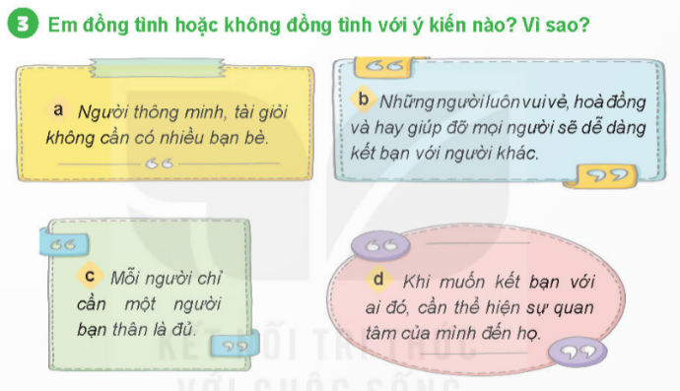  - HS lắng nghe.  - HS giơ thẻ mặt cười/mặt mếu thể thể hiện thái độ đồng tình/không đồng tình với ý kiến đó  - HS nêu: mặt cười: b,d; mặt mếu: a,c  +b,d: Khi mình cởi mở thân thiện với mọi người và sẵn sàng giúp đỡ thì mọi người cũng sẽ cở mở thận thiện và yêu quý mình nên dễ thiết lập quan hệ bạn bè  +a,c: chỉ một người bạn hay ít bạn thì khi người bạn đó phải chuyển đi hay khi vắng người bạn đó sẽ không còn ai chia sẻ, cô đơn.  -HS khác nhận xét, bổ sung.  - HS lắng nghe rút kinh nghiệm
Hoạt động 4: Đưa ra lời khyên cho bạn (Làm việc nhóm 2)  - GV cho HS đọc bài tập 4:  -GV YC HS thảo luận nhóm bàn, đóng vai đưa ra lời khuyên cho bạn. Tổ 1,2 thình huống a, tổ 3,4 tình huống b  - GV quan sát giúp đỡ  - GV cho nhóm lên thể hiện từng tình huống  - GV nhận xét, tuyên dương, chốt: Với mỗi tình huống cần đưa ra những lời khuyên phù hợp để giúp bạn dễ dàng thiết lập mối quan hệ với những người bạn mới |  | - 1HS đọc, lớp đọc thầm  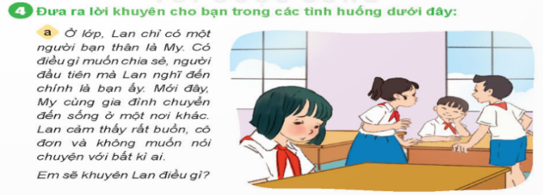  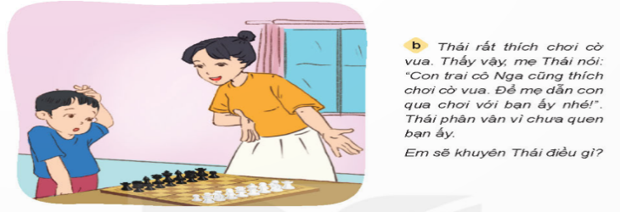  - HS lắng nghe.  - HS thảo luận đóng bai nhóm bàn theo phân công  - Mỗi tìn huống 2-3 nhoó lên thể hiện  +THa: Khuyên Lan đừng buồn vì bạn vẫn có thể liên lạc chia sẻ mọi buồn vui với My bằng nhiều cách khác nhau như viết thư hay điện thoại. Ngoài ra Lan nên vui vẻ, lạc quan và chủ động trò chuyện, vui chơi với các bạn trong lớp để có thêm những người bạn mới.  +THb: Thái nên đồng ý với đề nghị của mẹ để có thêm những người bạn mới cùng sở thích, vừa được thường xuyên chơi cờ vua cùng bạn.  -HS khác nhận xét, bổ sung.  - HS lắng nghe rút kinh nghiệm
3. Vận dụng trải nghiệm.
- Mục tiêu:
+ Củng cố những kiến thức đã học trong tiết học để học sinh khắc sâu nội dung.
+ Vận dụng kiến thức đã học vào thực tiễn.
+ Tạo không khí vui vẻ, hào hứng, lưu luyến sau khi học sinh bài học.
- Cách tiến hành:
- GV cho HS đọc ghi nhớ  - GV viết hoặc vẽ về bản thân để giới thiệu mình với người bạn mới lúc làm quen.  - GV cho HS xung phong lên giới thiệu bản thân  - GV nhận xét tiết học, tuyên dương HS học tích cực.  - GV nhận xét tiết học.  - Dặn dò về nhà. | - 3-4 HS đọc  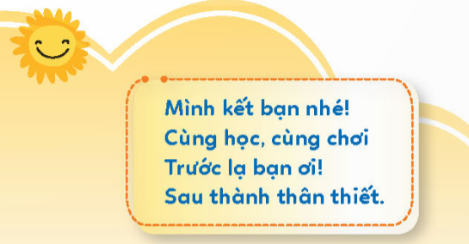  -HS thực hiện.  - 3-5 HS giới thiệu bản thân  - HS lắng nghe rút kinh nghiệm
IV. ĐIỀU CHỈNH SAU BÀI DẠY:
..............................................................................................................................
------------------------------------------------
ĐẠO ĐỨC KHỐI 5
TUẦN 22: CHỦ ĐỀ: LẬP KẾ HOẠCH CÁ NHÂN
Bài 6: LẬP KẾ HOẠCH CÁ NHÂN (Tiết 2)

I. YÊU CẦU CẦN ĐẠT:
1. Năng lực đặc thù:
- Nắm được cách lập kế hoạch cá nhân và lập được kế hoạch cá nhân để thực hiện các công việc của bản thân trong học tập và cuộc sống.
2. Năng lực chung.
- Năng lực tự chủ, tự học: Chủ động tích cực tìm hiểu cách lập kế hoạch cá nhân để thực hiện các công việc của bản thân trong học tập và cuộc sống.
- Năng lực giải quyết vấn đề và sáng tạo: Nắm được cách lập kế hoạch cá nhân và lập được kế hoạch cá nhân cho bản thân.
- Năng lực giao tiếp và hợp tác: Có thói quen trao đổi, thảo luận cùng nhau hoàn thành nhiệm vụ dưới sự hướng dẫn của giáo viên.

3. Phẩm chất.
- Phẩm chất chăm chỉ: Ham học hỏi, tự giác lập và kiên trì thực hiện các kế hoạch đã đề ra để nâng cao chất lượng, hiệu quả công việc trong học tập và cuộc sống.
- Phẩm chất trách nhiệm: Có ý thức trách nhiệm với lớp, tôn trọng tập thể.
II. ĐỒ DÙNG DẠY HỌC
- SGK và các thiết bị, học liệu và đồ dùng phục vụ cho tiết dạy.

III. HOẠT ĐỘNG DẠY HỌC
Hoạt động của giáo viên | Hoạt động của học sinh
1. Khởi động:
- Mục tiêu:
+ Tạo không khí vui vẻ, phấn khởi trước giờ học.
+ Thông qua khởi động, giáo viên dẫn dắt bài mới hấp dẫn để thu hút học sinh tập trung.

- Cách tiến hành:
- GV cho HS xem video “ Nguyễn Ngọc Ký - tấm gương vượt qua nghịch cảnh”  - GV đặt câu hỏi khai thác nội dung video.  - GV dẫn dắt vào bài. | - Cả lớp xem video.  - HS trả lời câu hỏi của GV.  - HS lắng nghe.
2. Hoạt động khám phá:
- Mục tiêu:
+ Học sinh nêu và nắm được cách lập kế hoạch cá nhân.
- Cách tiến hành:

Hoạt động 1: Tìm hiểu cách lập kế hoạch cá nhân.  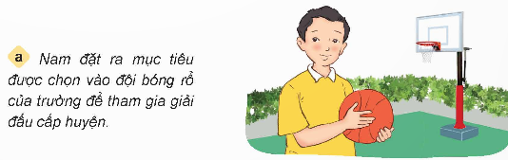  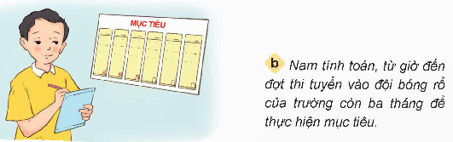  - GV gọi HS đọc tình huống trong sách.  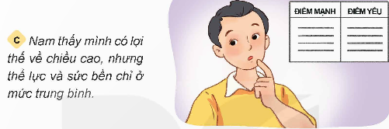  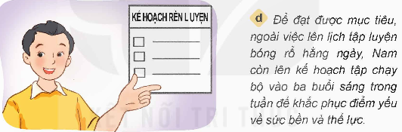  GV cho HS thảo luận nhóm 4.  - Đọc nội dung của mỗi bức tranh và trả lời các câu hỏi.  - GV mời đại diện các nhóm báo cáo kết quả thảo luận.  + Bạn Nam đã đặt ra mục tiêu gì và lên kế hoạch như thế nào để đạt được mục tiêu đó?  + Để lập kế hoạch cá nhân, cần thực hiện theo những bước nào?  - GV nhận xét, tuyên dương, chốt nội dung.  - Gọi HS đọc lại các bước thực hiện kế hoạch.  - GV giới thiệu thêm cho HS một số câu chuyện liên quan đến việc lập kế hoạch cá nhân để mở rộng cho HS. | - Gọi HS đọc to trước lớp, các HS còn lại theo dõi trong sách.  - HS thảo luận nhóm 4 và thực hiện yêu cầu của GV.  - Đại diện các nhóm trả lời.  + Mục tiêu: được chọn vào đội bóng rổ của trường để tham gia giải đấu cấp huyện.  + Lên kế hoạch thực hiện trong 3 tháng, tìm điểm yếu của bản thân và tập luyện để tăng thể lực.  + Thực hiện theo các bước sau:  1. Xác định mục tiêu.  2. Xác định thời gian tiến hành.  3. Tìm ưu điểm, nhược điểm của bản thân.  4. Xác định các công việc cụ thể để thực hiện kế hoạch  - HS lắng nghe.  - Nhiều HS đọc.  - HS lắng nghe và quan sát.
3. Hoạt động luyện tập.
- Mục tiêu:
+ Củng cố những kiến thức về lập kế hoạch cá nhân.
- Cách tiến hành:
GV tổ chức cho HS thảo luận nhóm 2, sau đó giơ thẻ từ cá nhân.  - GV chuẩn bị một số thẻ từ có hình mặt cười, mặt mếu.  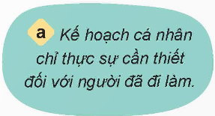  - GV gọi HS đọc các ý kiến trong sách.  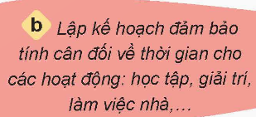  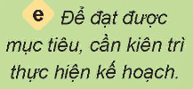    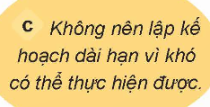  - GV cho HS thảo luận nhóm đôi chọn tán thành hay không tán thành với ý kiến nào và giải thích tại sao?  - Sau khi thảo luận nhóm đôi, GV cho HS thực hành cá nhân bằng cách giơ thẻ từ. GV chiếu từng ý kiến, HS giơ thẻ từ, tán thành thì giơ thẻ mặt cười, không tán thành thì đưa thẻ mặt mếu. Gọi một vài HS giải thích lí do vì sao chọn.  - GV nhận xét, chốt nội dung và tuyên dương. | - HS đọc.  - HS thảo luận nhóm đôi.  - HS thực hiện theo yêu cầu của GV.  - HS lắng nghe.
4. Vận dụng trải nghiệm.
- Mục tiêu:
+ Củng cố những kiến thức đã học trong tiết học để học sinh khắc sâu nội dung.
+ Vận dụng kiến thức đã học vào thực tiễn.
+ Tạo không khí vui vẻ, hào hứng, lưu luyến sau khi học sinh bài học.
- Cách tiến hành:
- GV gọi HS nhắc lại các bước để lập kế hoạch cá nhân.  - GV nhận xét tuyên dương.  - Nhận xét sau tiết dạy.  - Dặn dò về nhà. | - HS thực hiện theo yêu cầu của GV.  - HS lắng nghe, rút kinh nghiệm.

IV. ĐIỀU CHỈNH SAU BÀI DẠY:

Vĩnh Thuận, ngày 29 tháng 01 năm 2026
Kí duyệt của Khối trưởng  Lương Thị Xuyến | Người thực hiện    Nguyễn Thị Kim Chi

