TUẦN 22 Khối 3, 5 (Từ ngày 17/02/2025 đến ngày 21/02/2025)
THỨ | TIẾT | MÔN | TIẾT THỨ | NỘI DUNG BÀI DẠY |  | UDCNTT | ĐỒ DÙNG DẠY HỌC
Hai  17/02 | 1 | 5A | 85 | Unit 8. People and places | Lesson 3 (4, 5, 6) | Wonderfulworld | Flashcards, TV, books
Hai  17/02 | 2
Hai  17/02 | 3 | 3A | 85 | Unit 7. My favourite sport | Lesson 3 (1, 2, 3) | Wonderfulworld | Flashcards, TV, books
Hai  17/02 | 4 | 3A | 86 | Unit 7. My favourite sport | Lesson 3 (4, 5, 6) | Wonderfulworld | Flashcards, TV, books
Hai  17/02 | 5 | 5D | 85 | Unit 8. People and places | Lesson 3 (4, 5, 6) | Wonderfulworld | Flashcards, TV, books
Hai  17/02 | 6 | 3B | 85 | Unit 7. My favourite sport | Lesson 3 (1, 2, 3) | Wonderfulworld | Flashcards, TV, books
Hai  17/02 | 7
Ba  18/02 | 1 | 5C | 85 | Unit 8. People and places | Lesson 3 (4, 5, 6) | Wonderfulworld | Flashcards, TV, books
Ba  18/02 | 2 | 5B | 85 | Unit 8. People and places | Lesson 3 (4, 5, 6) | Wonderfulworld | Flashcards, TV, books
Ba  18/02 | 3 | 5A | 86 | Unit 8. People and places | Lesson 3 (7, 8, 9) | Wonderfulworld | Flashcards, TV, books
Ba  18/02 | 4
Ba  18/02 | 5 | 3A | 87 | Unit 7. My favourite sport | Lesson 3 (7, 8, 9) | Wonderfulworld | Flashcards, TV, books
Ba  18/02 | 6 | 5D | 86 | Unit 8. People and places | Lesson 3 (7, 8, 9) | Wonderfulworld | Flashcards, TV, books
Ba  18/02 | 7 | 3B | 86 | Unit 7. My favourite sport | Lesson 3 (4, 5, 6) | Wonderfulworld | Flashcards, TV, books
Tư  19/02 | 1 | 5A | 87 | Unit 8. People and places | Fun time and project (1, 2, 3) | Wonderfulworld | Flashcards, TV, books
Tư  19/02 | 2
Tư  19/02 | 3
Tư  19/02 | 4
Tư  19/02 | 5 | 5B | 86 | Unit 8. People and places | Lesson 3 (7, 8, 9) | Wonderfulworld | Flashcards, TV, books
Tư  19/02 | 6 | 5C | 86 | Unit 8. People and places | Lesson 3 (7, 8, 9) | Wonderfulworld | Flashcards, TV, books
Tư  19/02 | 7
Năm  20/02 | 1 | 5C | 87 | Unit 8. People and places | Fun time and project (1, 2, 3) | Wonderfulworld | Flashcards, TV, books
Năm  20/02 | 2 | 5B | 87 | Unit 8. People and places | Fun time and project (1, 2, 3) | Wonderfulworld | Flashcards, TV, books
Năm  20/02 | 3 | 5A | 88 | Unit 8. People and places | Fun time and project  (4, 5, 6, 7, 8) | Wonderfulworld | Flashcards, TV, books
Năm  20/02 | 4
Năm  20/02 | 5 | 5D | 87 | Unit 8. People and places | Fun time and project (1, 2, 3) | Wonderfulworld | Flashcards, TV, books
Năm  20/02 | 6 | 5C | 88 | Unit 8. People and places | Fun time and project  (4, 5, 6, 7, 8) | Wonderfulworld | Flashcards, TV, books
Năm  20/02 | 7
Sáu  21/02 | 1 | 3B | 87 | Unit 7. My favourite sport | Lesson 3 (7, 8, 9) | Wonderfulworld | Flashcards, TV, books
Sáu  21/02 | 2 | 5D | 88 | Unit 8. People and places | Fun time and project  (4, 5, 6, 7, 8) | Wonderfulworld | Flashcards, TV, books
Sáu  21/02 | 3 | 5B | 88 | Unit 8. People and places | Fun time and project  (4, 5, 6, 7, 8) | Wonderfulworld | Flashcards, TV, books
Sáu  21/02 | 4
Sáu  21/02 | 5
Sáu  21/02 | 6 | 3B | 88 | Unit 7. My favourite sport | Fun time and project (1, 2) | Wonderfulworld | Flashcards, TV, books
Sáu  21/02 | 7 | 3A | 88 | Unit 7. My favourite sport | Fun time and project (1, 2) | Wonderfulworld | Flashcards, TV, books

GRADE 3
Week 22 (To 17/2 to 21/2)
Unit 7: My favourite sport
Lesson 3 – Task 1,2,3
Period 85
I. OBJECTIVES:
1. Knowledge:
Students will learn and use new vocabulary: flying a kite, riding a bike, watching a match, team
- Review present continuous.
2. Competences:
- English competences: Students will be able to talk about the hobbies and things that are happening or not happening now (daily activities or sports).
- Common competences: Students will have an opportunity to develop autonomy in doing tasks, communicating among friends.
3. Qualities:
- Students will have an opportunity to talk about their hobbies, what is happening or
not happening.
II. EQUIPMENT AND MATERIALS:
- For Teacher: PP, TV, flashcards, music, audio track
- For students: pictures, handouts.
III. LESSON PROCEDURE:
Activity 1: Warm-up (5 minutes)
Teacher’s activities | Student’s activities
Greet students.  Warm up and review:  Movement Game: “Silent ball”  While the music plays, students pass the ball around the class. When the music stops, the student with the ball has to choose a pair of cards to play a matching game (review action words).  -Let the sts take a turn choosing the numbers to find the 2 matched pictures and words.  Lead in:  - Ask a student to come to the board. The teacher stands next to that student. Use TPR to show: flying a kite; riding a bike …  - Introduce the lesson. | - Greet teacher.  - Enjoy the game.  - Individual work  - Follow the teacher
Activity 2: Presentation (8 minutes)
Teacher’s activities | Student’s activities
Task 1: Listen and point.  -Tell students to open their books to page and to look at the vocabulary box. Point to the first two picture words.  -Say the words and use your arms to demonstrate flying a kite; riding a bike and ask students to repeat. Do the same with all the other words.  - - Read out the word match . Explain the meaning. Show students pictures and ask if they are funny. Tell them to answer Yes! or No! For example, Do you like watching a match? At the end of the task praise students by saying Great!  - - Read out the word team, ask them their team’s name.  - - Play the recording for the students to listen and point, then repeat the words. Then read out the words in random order and ask students to point to the correct pictures.  - -Read out all the words again one by one and ask students to repeat after you.  Game: Mime  The teacher says the words and sts act  Use slides of PowerPoint or flashcards to say the words and ask students to repeat them.  Do the same with all the words. Play the recording for the students to listen to, point to,  and repeat the words.  - Read out the new picture words in the  vocabulary box in random order and  ask students to point to the correct  pictures.  - Read out all the words again one by  one and ask students to repeat after  you.  VOCABULARY CHECKING  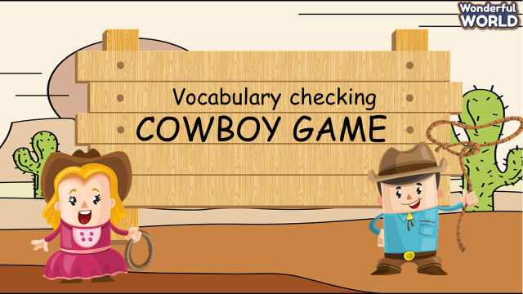  Invite two Sts to go to the board and stand back to back.  Each of the two Sts will choose one picture (keep secret).  T counts one, two three, they will turn round and read the opponent’s other’s picture.  Who is faster will be the winner.  Continue with other pairs. | - Follow the teacher  - Sts act  - Join the game.
Activity 3: Practice (12 minutes)
Teacher’s activities | Student’s activities
Task 2. Listen and match:  - Ask students to look at the photo and tell them that the boy’s name is Alex and the other’s name is Sam. They are friends.  - Ask the sts some questions about the picture:  - Who are they?  - Where are they?  - What are they doing?  - Let the sts listen for the first time  - Point to the new words in the text. Read them out and ask students to repeat them.  - - Play the recording again. Tell students to look at the picture and follow the dialogue with their fingers. And then match : 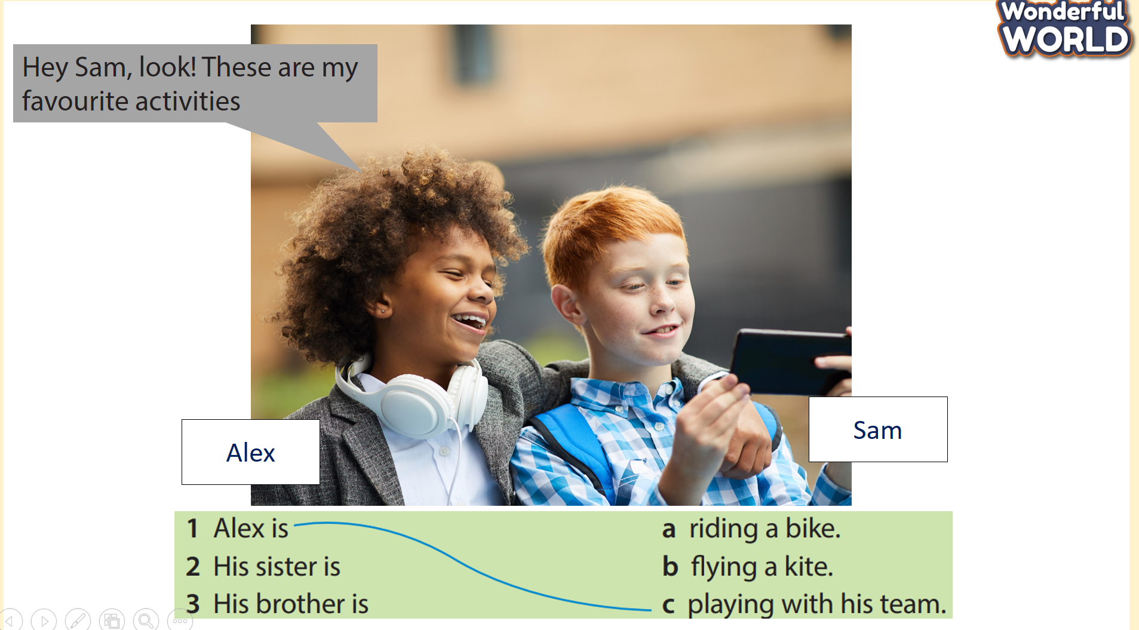  - Extension:  Game: Listen and tick  Divide the class into groups of 4 (each group has 4 sts).  Give cards with the letter A, B, C for the groups.  Sts listen and choose the correct answer (A,B,C). Who can make it will get points  Task 3. Look and say:  - Stick pictures and prompts on the board.  - The teacher calls a pair of students to come  - They have to write the correct sentence.  - Who can make it faster they will get points.  - While they’re writing, the teacher goes around the class helping students where necessary.  - Ask volunteers to check their answers. Correct any mistakes. | - Look  - Answer the questions :
Activity 4: Production (7 minutes)
Teacher’s activities | Student’s activities
- Let Sts play the game “Happy Bee”, Sts ask and answer the questions related to the grammar: present continuous (questions) to help the bear find the honey.
- There are five questions. T clicks on them, one by one from START, 1,2,3, to FINISH for volunteer Sts to answer and go to the next question.
Answer Keys :
1. What is she doing now? She is riding a bike.
2. What is he doing? He’s flying a kite.
3. Is he cooking?
No, he isn’t.
He isn’t cooking.
He is playing football.
4. What are they doing?
They are watching a football match.
5. What are you doing now?
I’m playing the piano.
Activity 5: Assessment (3 minutes)
Teacher’s activities | Student’s activities
- Ask students to do the assessment.  - Draw lines and complete the sentences.  - Check in pairs then the whole class.  - Call Sts to answer the questions, If they’re correct, Sts can row the dice to get stars.  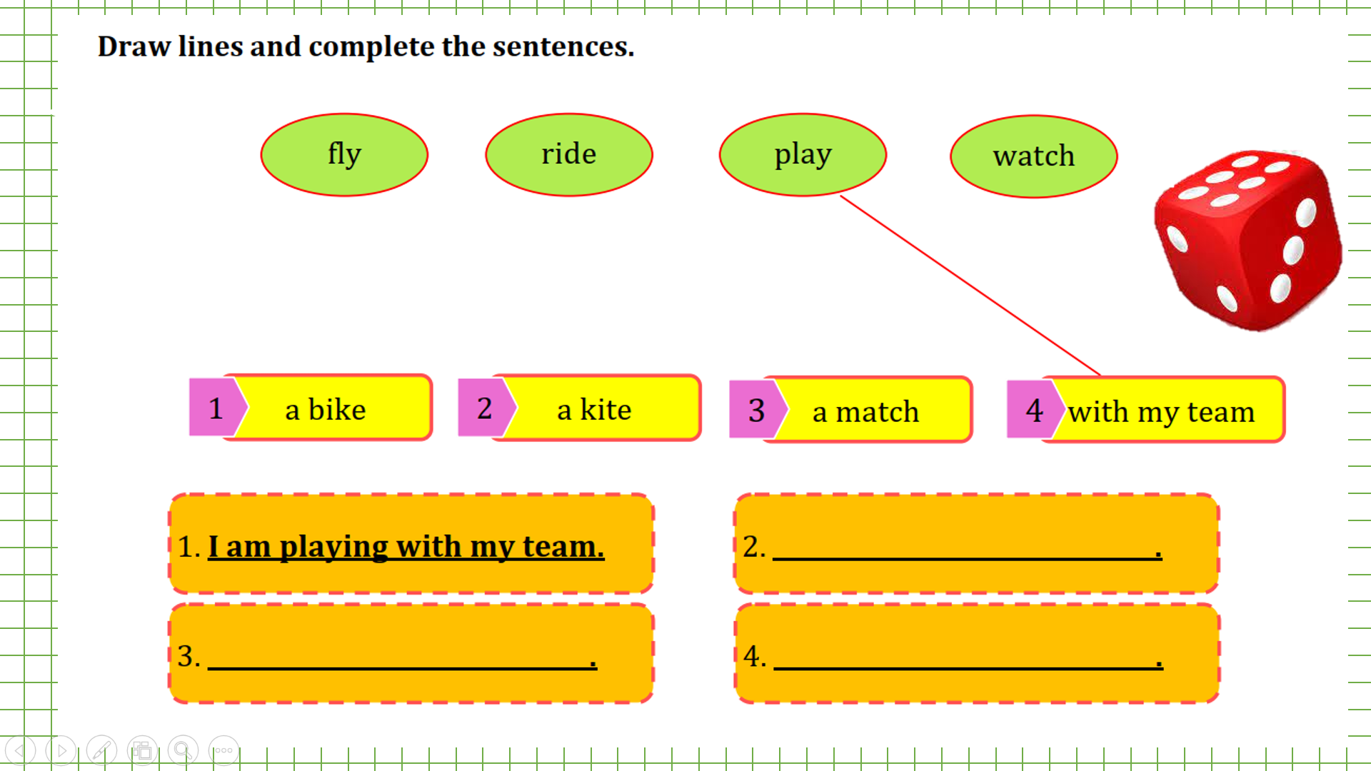  - Say goodbye | - Do the assessment.  - Check with friends and then with the teacher and the whole class.  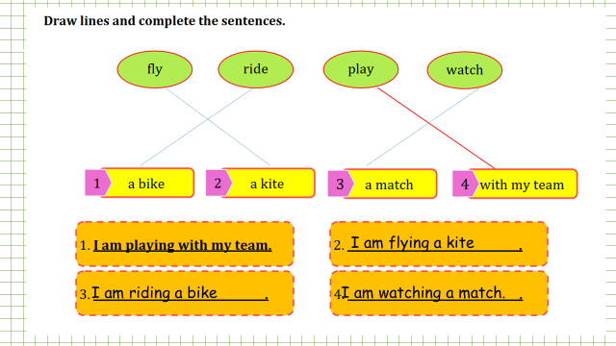  - Say goodbye

Unit 7: My favourite sport
Lesson 3 – Task 4,5,6
Period 86
I. OBJECTIVES:
1. Knowledge:
Students will review the vocabulary related to the topic of sports and activities.
- Learn new grammar: present continuous (interrogative form)
2. Competences:
- English competences: Students will be able to make question and answerabou what is happening now .
- Common competences: Students will have an opportunity to develop autonomy in doing tasks, communicate among friends, ability to sing and dance.
3. Qualities:
Students will increase their awareness of being active
II. EQUIPMENT AND MATERIALS:
- For Teacher: PP, TV, flashcards, music, audio track
- For students: pictures, handouts.
III. LESSON PROCEDURE:
Activity 1: Warm-up (5 minutes)
Teacher’s activities | Student’s activities
- Let students warm up with the song:  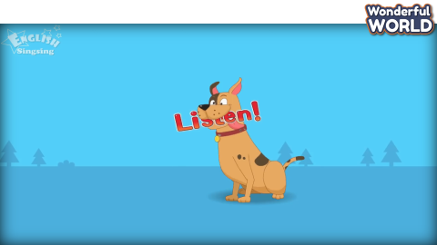  Lyrics: “ What are you doing? – I’m washing. Washing.  What are you doing? – I’m eating, eating.  What are you doing? – I’m dancing, dancing.  I’m dancing. I’m dancing now. …” | - Students listen to the song.
Activity 2: Presentation (8 minutes)
Teacher’s activities | Student’s activities
Lead in: Use the game and the picture to lead in the new lesson  - Write on the board The date and introduce the lesson.  Task 4: Listen and repeat (Track 5.11)  - Show a picture/slide of the task  - Ask sts to talk about the picture  - Collect the suitable answer on the board  - Use flashcards to introduce  - Say the words/sentences for sts to repeat in chorus.  - Play the audio  - Ask sts to listen and repeat sentence by sentence  Checking game: TPR GAME  One student is doing the action that he likes. And the student is standing in front of him so that he can’t see what other S is doing and then, guess and say the action. :  Is he …..? All the class has to answer yes/ no  And Sts can guess three times to find the correct action and get stars. | - Copy down  - Look and answer:  - Listen and repeat  - Listen and repeat  - Join the game.
Activity 3: Practice (12 minutes)
Teacher’s activities | Student’s activities
Game: Broken Sentence  - Make an enlarged copy of the worksheet and cut out the card, select the appropriate number of cards, ensuring that they make up complete sentences  - Explain that the activity involves forming sentences, and each sentence consists the cards and a picture. They should use punctuation to help them (full stop and capital letters)  - Elicit the model sentence :  Is she riding a bike? – Yes, she is.  Task 5. Look and say:  Give the sts the worksheet. Sts must look at the pictures and put the words into the correct order, and answer correctly. They can do this by:  + cutting out  + stick on the group boards  - Correct collectively on the board  * Ask sts to look at the picture of this activity then ask sts to describe the content of the picture  Revise the words of the lesson  * Circulate to monitor but try to encourage sts autonomy to write the correct words in the blank  - Sts correct their works in pairs first. Then correct it collectively  - Correct the activity collectively. Sts swap worksheets and dictate the answers  - Have sts present their works | - Repeat.  - Repeat.  - Look and describe.  - Write
Activity 4: Production (7 minutes )
Teacher’s activities | Student’s activities
Task 6: Listen and sing  Set context by the given picture of the hockey match.  - Let sts guess the song melody that they’re going to sing  - Play the track 5.11 once for sts to check the melody  - Show the lyrics one by one  - Ask sts to read the lyrics fluently  - Ask sts listen and sing along  - Play the audio again for sts to sing along  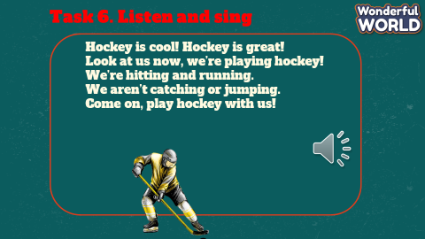 | - Answer the questions.  - Repeat.  -Sing and mime the action.
Activity 5: Assessment (3 minutes)
Teacher’s activities | Student’s activities
- Ask students to do the assessment.  - Look and circle  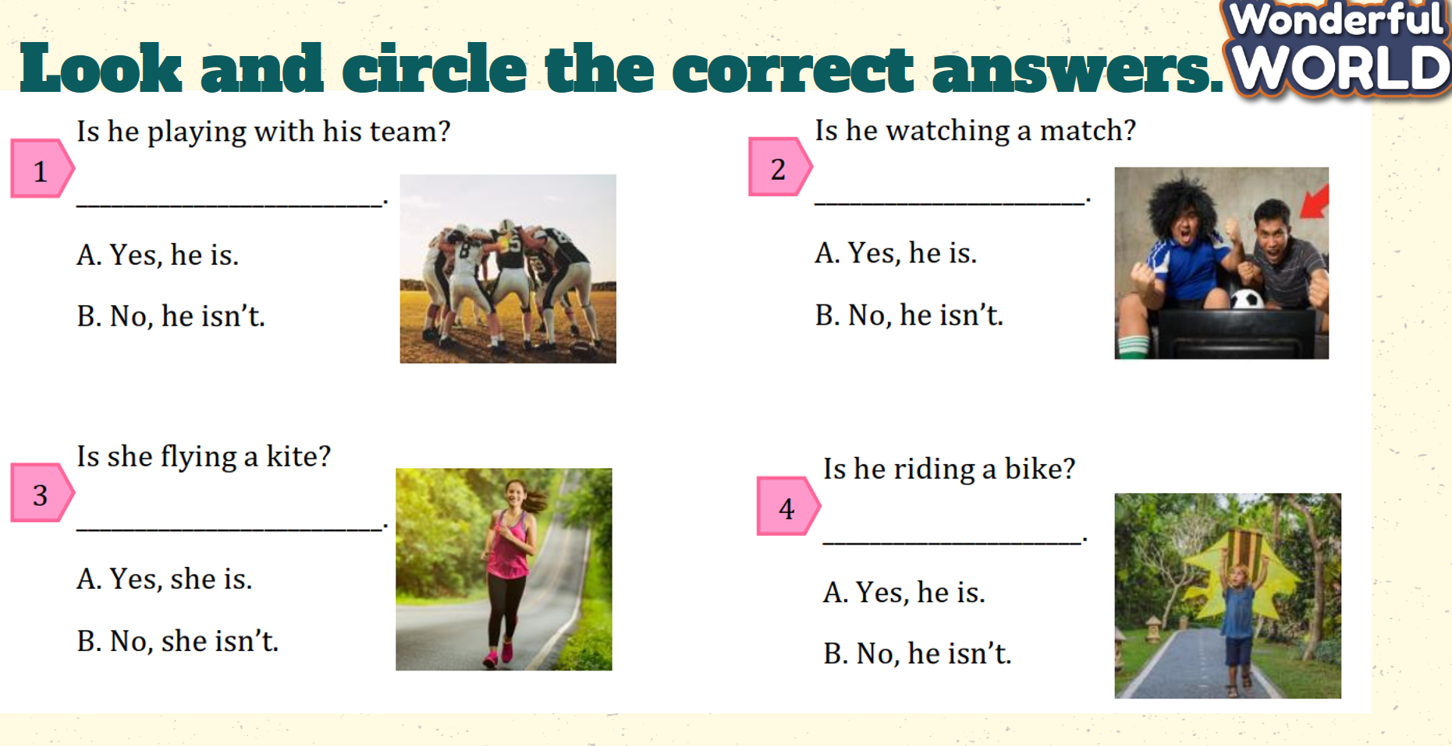  - Check the correct answers.  - Check in pairs then the whole class.  - Say goodbye | - Do the assessment.  - Check with friends and then with the teacher and the whole class.  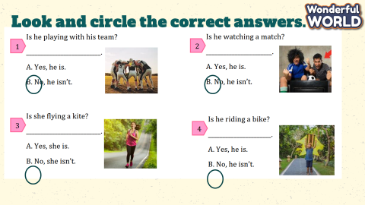  - Say goodbye

Unit 7: My favourite sport
Lesson 3 – Task 7,8,9
Period 87
I. OBJECTIVES:
1. Knowledge:
Students will learn - the sounds /i:/ and /i/ seperately in words team, hockey.
2. Competences:
- English competences: Students will be able to recognize and pronounce /i:/ and /i/ sounds correctly in words, chant and daily talking
- Common competences:
+ Students will have an opportunity to develop communication among friends and creativity in composing the chant.
3. Qualities:
- Students will be aware of working/playing in the team and its meaning.
II. EQUIPMENT AND MATERIALS:
- For Teacher: PP, TV, flashcards, music, audio track
- For students: pictures, handouts.
III. LESSON PROCEDURE:
Activity 1: Warm-up (5 minutes)
Teacher’s activities | Student’s activities
- Play the game “ magic wheel”  Choose the questions to answer, then spin the wheel to get the stars.  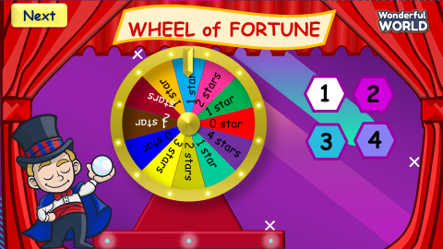  Questions and answer keys:  Question 1: E  Question 2: A  Question 3: B  Question 4: B | - Answer the questions:  - Spin the wheel to get stars.
Activity 2: Presentation (8 minutes)
Teacher’s activities | Student’s activities
Task 7. Listen and repeat. TR 7.12  - Write /i:/ on the board. Pronounce the sound. Then write team on the board. Ask students to pronounce the word.  - Write /i/ on the board. Pronounce the sound. Then write hockey on the board. Ask students to pronounce the word.  - Pronounce both sounds again and show students how they are different from each other. Point to each word on the board and ask  students to practice the sounds with you.  - Play the recording and tell students to repeat the words and the the sentence, paying attention to the correct pronunciation of /i:/ and /i/.  CHECKING UNDERSTANDING :  Game: Listen and choose!  Divide the class into 2 teams. Each student from each team comes to the board and chooses the correct answer.  Play the recording and let the sts tick on the correct one.  This can be played as “slap the board game”: The teacher says a word/sound for sts to slap to the correct one. | Follow the teacher’s instructions.  -Say the letters.  - Practice saying the letters and words.  Play game: group work.
Activity 3: Practice (12 minutes)
Teacher’s activities | Student’s activities
Task 8. Listen and chant.  - Underline the words with the sounds they have just learned.  - Play the recording and tell students to listen and follow the words with their fingers.  - Read out the chant one line at a time and ask students to repeat after you. Play the recording again. Practise several times until students are familiar with the words and sounds.  - Ask students to practice the chant individually, and then in pairs or in groups. For example, one group chants the first verse, and the other group chants the second verse.  - Optional activity:  - Ask some volunteers to say the whole chant | - Listen  - Repeat  - Practise
Task 9. Say it  - Ask students to look at the sentences. Tell them to pay attention to the sounds /i:/ and /i/ in each word.  - Read out the words with /i/ and /i:/ and ask students to repeat them. Ask students to work in pairs and say the sentences, paying attention to the correct pronunciation of /i/ and /i:/.  - Ask volunteers to say the sentences in front of the class. T can ask a pair of Sts in each team to read the sentences to avoid boringness.  - Game: Look and guess. Then say!  - Divide the class into four teams. A student from each team comes to the front and plays the game.  - The teacher shows a hidden picture. Sts look and guess what it is. Then say the sentence.  - Who can make it will get points for the team | - Underline the sounds of words.  - Repeat.  - Say
Activity 4: Production (7 minutes)
Teacher’s activities | Student’s activities
- Divide the class into 4 groups.  -T turns on the music while the sts move around.  -Sts move around the class and ask their friends to write more given words of “i” and ”i:” and write in the worksheet.  -Sts have to freeze when the music stops and continue when the music is on.  - Count the words and let the sts read their own word.  - Correct pronunciation if any.  SUGGESTED: pig, fish, sit, milk, pig…… | - Enjoy the game and practice writing words.  - Count and say the words.
Activity 5: Assessment (3 minutes)
Teacher’s activities | Student’s activities
Ask students to do the assessment.  - Listen and number from 1-5.  - Check in pairs then the whole class.  - Ask sts to say them out loud. (individual, group, whole class work)  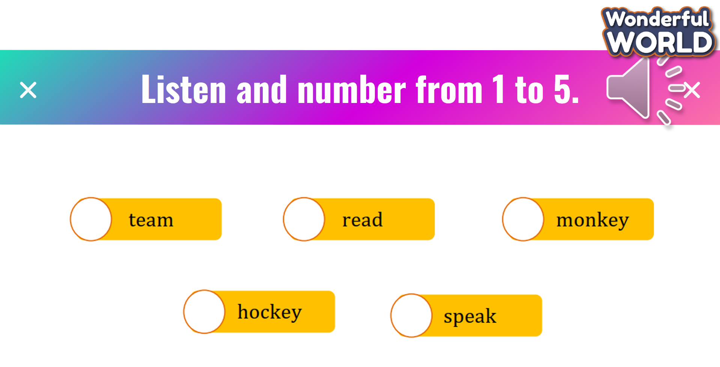  - Say goodbye | - Do the assessment.  - Check with friends and then with the teacher and the whole class.  Say the words out loud.  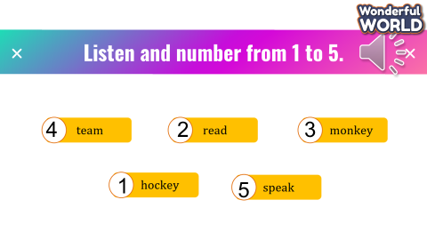  - Say goodbye

Unit 7: My favourite sport
Lesson 3 – Fun time and project
Period 88
I. OBJECTIVES:
1. Knowledge:
Students will review the learned vocabulary about sports/activities and present continuous.
2. Competences:
- English competences: Sts will be able to read and write describing on going action and do a project telling about their favourite sport.
-Common competences:
+Students will have the opportunity to develop communication among friends and creativeness in drawing and presenting.
3. Qualities:
- Raise students’ awareness about sport..
II. EQUIPMENT AND MATERIALS:
- For Teacher: PP, TV, flashcards, music, audio track
- For students: pictures, handout
III. LESSON PROCEDURE:
Activity 1: Warm-up (5 minutes)
Teacher’s activities | Student’s activities
- Play the game “ swimming race”  - Divide the class into 2 teams, the team which swims to “ FINISH” will win.  - Press “ Lifebuoy” to the question and answer. If sts answer correctly, press the boy to swim forward.  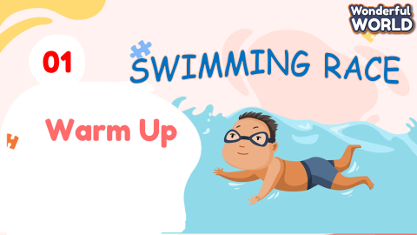  Answer keys:  Question 1: Nine  Question 2: He is eating an ice cream.  Question 3: A. No, she isn’t.  Question 4: No, she isn’t.  Question 5: She isn’t playing basketball. | - Answer the questions
Activity 2: Practice (15 minutes)
Teacher’s activities | Student’s activities
- Tell the students that they are going to look at the picture and describe the picture.  - Especially, what each person is doing.  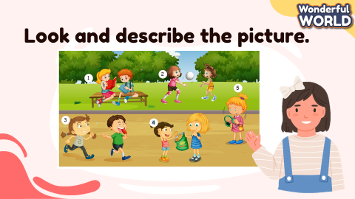  Task 1. Look and write  - 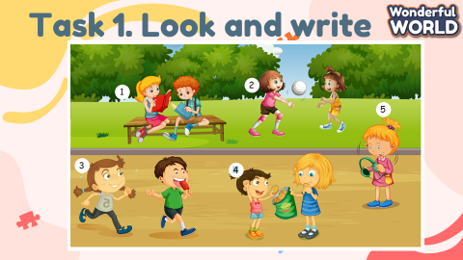  - Ask students to look at the girl with number 1 and elicit what she is doing.  - Ask students to look at the example. Then revise the present continuous with I, He, He if necessary.  - Explain the rest of the task to students. Allow them enough time to complete the task alone. Go round the class helping students where necessary. Check the answers with the class.  - Ask some volunteers to come to the board and write their answers. / Show each question.  Answer keys:  1. She’s reading.  2. She isn’t kicking the ball.  3. She is running.  4. She isn’t singing.  5. She isn’t dancing. | - Look and describe.  - Do the task and follow the picture.  - Volunteers say.
Activity 3: Project (7 minutes )
Teacher’s activities | Student’s activities
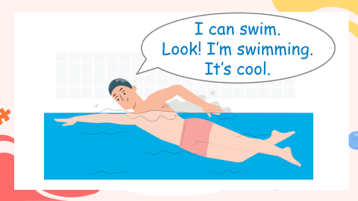  - Show the picture of the example. Let Sts read and then ask them to think of the sports they like. Then ask students to draw a picture of they are playing these sports. Tell students that they can draw their favorite sport.  - When students finish drawing, ask students to look at the sample sentences. Read out the sentences and ask students to repeat.  - Ask students to share their picture with their friends. Then ask students to say what they are and are not doing in each sport.  - Allow them enough time to practice saying in pairs. Go round the class helping students where necessary.  - Ask volunteers to tell the class about their favourite sports. Correct any mistakes.   | Draw  - Share their picture with their friends.
Activity 5: Assessment (3 minutes )
Teacher’s activities | Student’s activities
- Ask students to do the assessment.  - Look and write.  - Ask sts to say them out loud. (individual, group, whole class work)  - Check in pair then whole class.  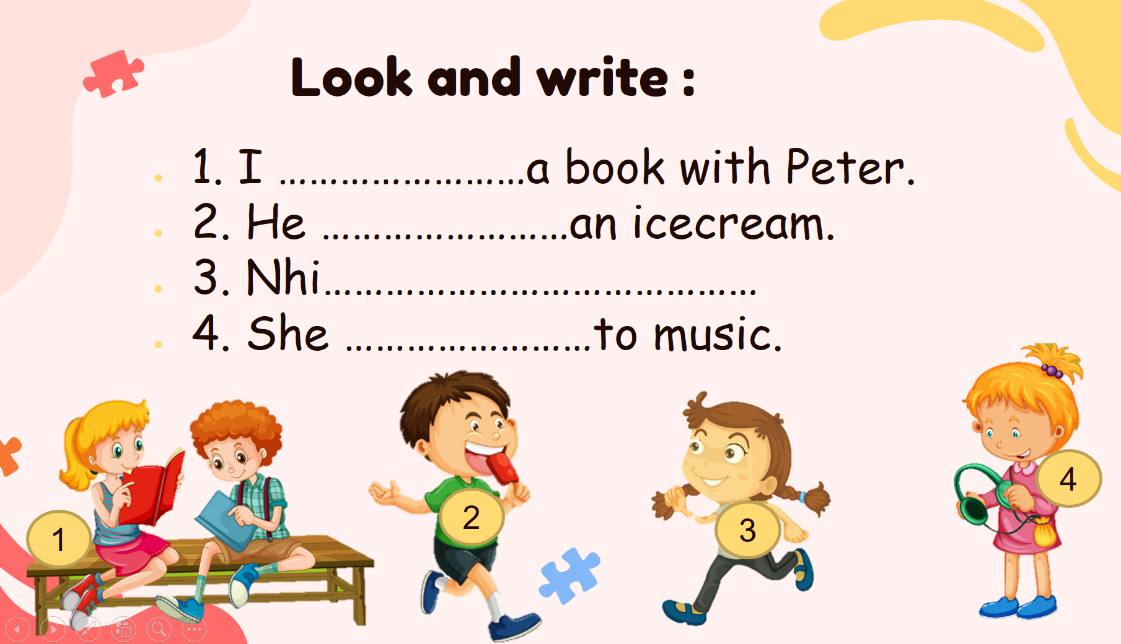  - Say goodbye | - Do the assessment.  - Say them out loud. (individual, group, whole class work)  - Check with friends and then with the teacher and the whole class.  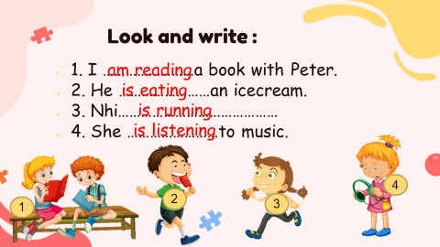  - Say goodbye
___________________________________________________

GRADE 5
Week 22 (From 17/2 to 21/2)
UNIT 8: PEOPLE AND PLACES
Lesson 3 - Part 4,5,6
Period 85
I. OBJECTIVES:
1. Knowledge:
- Students learn about conjunctions “so” and “because”.
- Students are able to explicit the usage of “so” and “because” in sentences and use them in conversations naturally.
2. Competences:
- English competences: Students are able to present results and reasons, using “so” and “because”.
- Common competences: Ss are able to communicate naturally, using “so” and “because” to add information.
3. Qualities:
- Students will
+ have strong confidence while speaking and knowledge about the usage of “so” and “because” in communication.
II. EQUIPMENT AND MATERIALS:
- Basic things: Student’s book, flashcards, photos, papers.
- Advanced things: PPT, laptop, TV.
III. LESSON PROCEDURE:
Activity 1: Warm-up (5 minutes)
A guessing game “Can you guess?”
Aims: Welcome students. Engage the class (or warm the class up) with a guessing word game to revive the vocabulary (write the words here….) and lead in the new lesson.
Teacher’s Activities | Students’ Activities
Procedure
1. Greet students. Chatting…Do you like listening to music…  2. Introduce the game: Memory game  - Ask Ss to think of the countries they know with their interesting places and national flags.  - Put students in two groups and each group will take turns choosing a number.  - Each turn, a group will open two numbers. If the place and the national flag match, click on the national flag to clear the pictures and that team will get a point.  - If not, click on the red circle button to hide the picture and move to the next turn.  - When all pictures are clear, the team with higher scores will win the game.  - T can open the slide again and show all pictures and words to review.  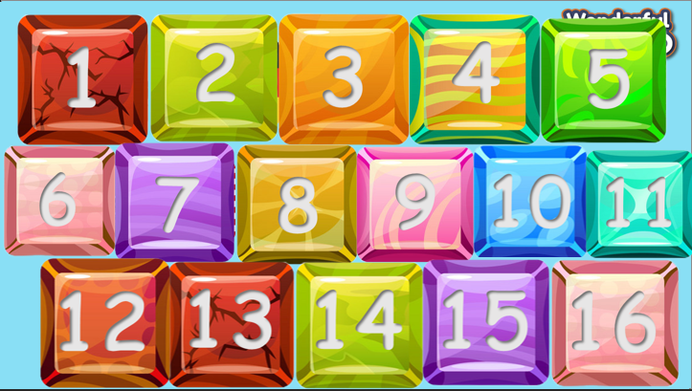  Lead in:  - T raises some pictures and asks Ss to guess the topic of the lesson.  - T writes the topic “Conjunction”. | - Greet the T.  - Listen to the rules of the game.  - Listen and play a game.  - Sit in groups and take turns to open the pictures.  - Check the result.  - Repeat after T.  - Look at the pictures and guess the topic.
Activity 2: Presentation (12 minutes)
Aims:
- Learn about coordinating conjunction “so” and subordinating conjunction “because”.
- Apply conjunctions in conversation to add information
- Finish task 4
Teacher’s Activities |  | Students’ Activities
PRESENTATION  - Show the conjunction “so” and “because” on the screen and explain the type, meaning, and how to use them in conversation.  - Read the two examples aloud then tell students to repeat. Explain that so and because are connectors because they join two clauses together. Emphasize that we use because to explain the reason for something and we use so to explain the result of something.  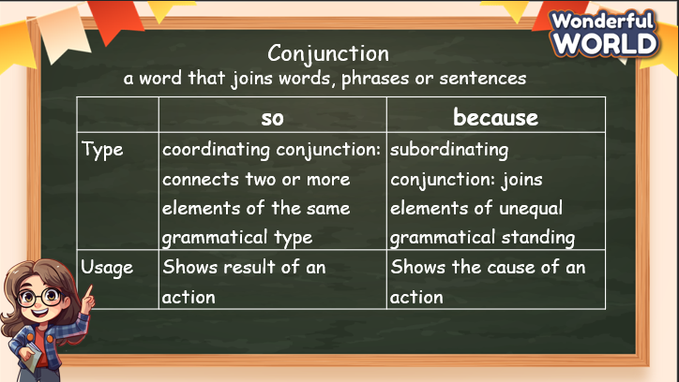  Task 4: Complete the sentences with because or so.  Then listen and check.  - Demonstrate the difference between reason and result. On the board write It’s Sunday and We can play all day. Ask students to finish the sentences using so or because.  For example: It’s Sunday, so I’m happy. We can play all day because it’s the weekend.  - Tell students to complete the remaining sentences with because or so.  - After individual work, students can compare their answers with a partner or in small groups.  - Check the answers as a class.  - Ask Ss to change the connectors and rewrite sentences.  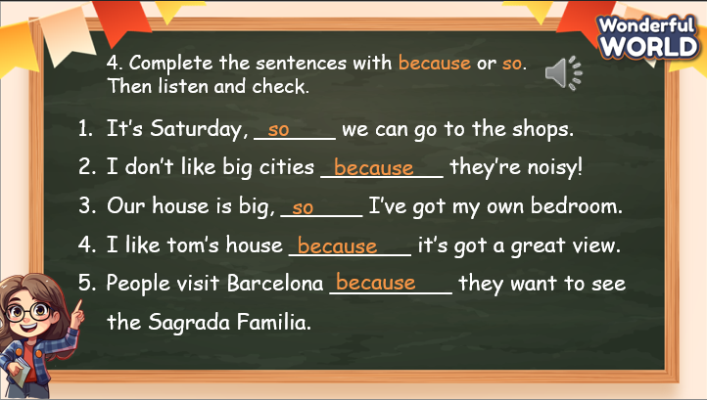 |  | - Look at the screen, and listen to the explanation.  - Understand the meaning and differences between “so” and “because”.  - Read the example and point out the differences in using “so” and “because”.  - Look at the sample sentence and do the tasks individually.  - Listen to the audio and check the answer.  - Listen and repeat after the audio.  - Re-write the sentences, using different connectors.
Activity 3: Practice – Controlled practice (8 minutes)
Aims:
- Complete task 5 to revise the usage of “so” and “because”
- Join the game “Let’s go shopping” to practice giving reason and result, using “so” and “because”
Teacher’s Activities |  | Students’ Activities
Task 5: Read and complete the gaps with because or so.  - Ask students to quickly read the paragraph to find out what the  writer doesn’t do at the beach (swim in the sea) and why (the sea is very cold).  - Tell students to read the paragraph and complete the gaps with because or so.  - Check the answers as a class  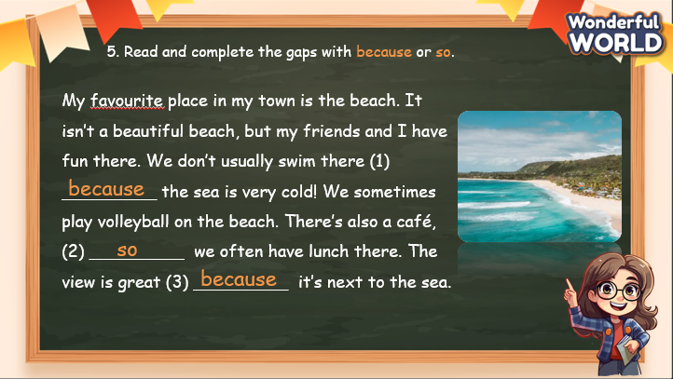  Let’s go shopping! game  - T divides the class into 2 groups. Each group will choose a name and play rock, scissors, and paper to decide which group goes first.  - The two groups will take turns to answer the corresponding questions.  - T checks the answer. If it is correct, give them 5 points and move to the next question.  - If not, move to the next question.  - When all the questions are answered, the team with a higher score will win the game.  - The team with a lower score must do an exercise (hop, dance, sing, etc.).   |  | - Look at the text and fill in “because” or “so”  - Check the answer  - Listen to the rules of the game.  - Appoint a representative to do rock, scissors, and paper to decide who goes first.  - Take turns to answer the questions.  - If the answer is correct, get the points.  - If not, move to the next questions.  - Check the results.  - Do the exercise (for the team with a lower score).
Activity 4: Production –Speaking (6 minutes)
Aims:
- Apply the structures in the paragraph to take note of their favourite places in their town or city.
- Talk about their favourite places in front of the class. Discuss why they like those places, using “so” and “because”
- Encourage Ss to answer the extra questions to support their ideas.
Teacher’s Activities |  | Students’ Activities
Task 6: Write.  - Tell students to look at the picture and the example. Read the example out loud and ask students to repeat.  - Suggest them to answer the questions before combining them into a paragraph.  - Tell students to write a paragraph about their favourite place, similar to the one in Activity 5 or in the example. Ask them to use the plan and answer the questions.  - Check whether students understand the task. Allow students enough time to complete the task.  - Check answers. Write any mistakes on the board and ask students to correct them.  - Tell students to re-read their paragraph and make sure they have  used because and so properly.  - Ask volunteers to read out their paragraph.  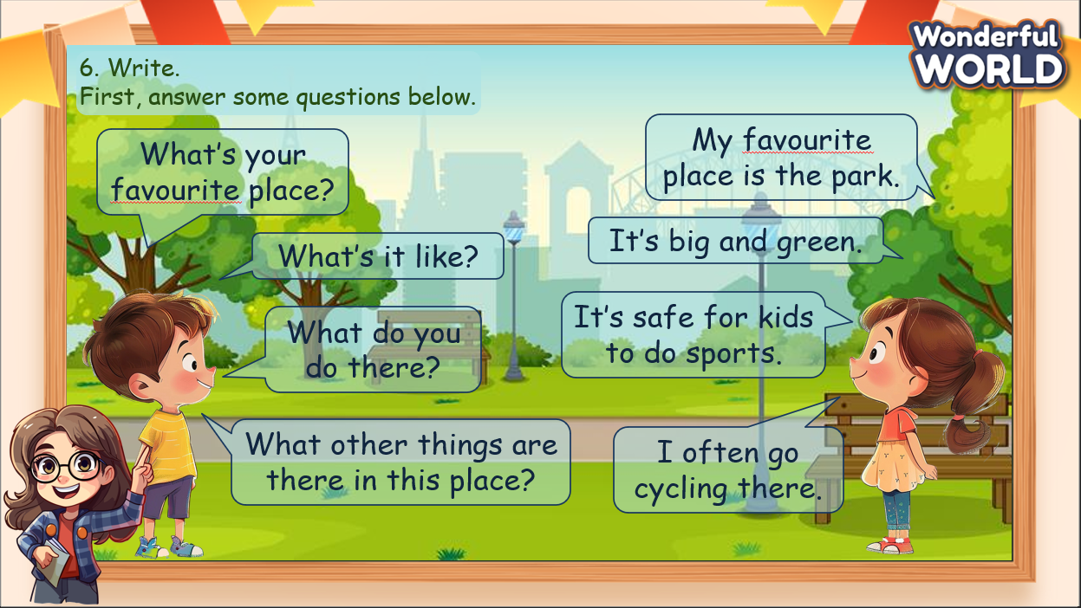 |  | - Think of the questions they can use to ask about someone’s favourite places.  - Work in pair, ask and answer about their teammate’s favourite places.  - Combine the sentences to create a paragraph.  - Show their paragraph and discuss with the class.
Activity 5: Wrap up & Assessment (4 minutes)
Teacher’s Activities |  | Students’ Activities
Aims:
- Check Ss’s understanding of what they have learned.
- Students rehearse what they have learned in the lesson.
- Ask Ss to do the assessment.  - Give the assessment to the class and some Ss.  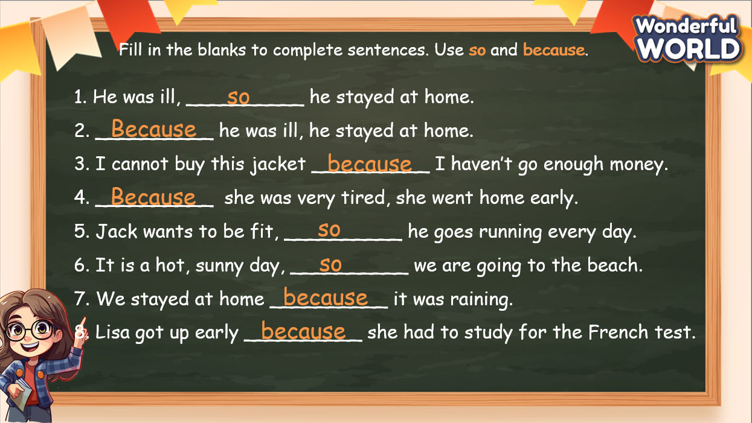  - Check with the class.  - T asks Ss about what they have learnt in today’s lesson.  - T shows the wrap-up slide and concludes the lesson.  * Remember  GRAMMAR  1. So: shows the result of an action  Example: I wanted something to eat, so I looked in the fridge.  2. Because: shows the cause of an action  Example:  - Because I wanted something to eat, I looked in the fridge.  - I looked in the fridge because I wanted something to eat. |  | - Do the assessment.  - Check with the teacher.  - Answer T’s question of what they have learnt in today’s lesson.  - Ss read the wrap-up.  - Stand up and say goodbye to the teacher.

UNIT 8: PEOPLE AND PLACES
Lesson 3 - Parts 7,8,9
Period 86
I. OBJECTIVES:
1. Knowledge:
- Students learn about sentence stress and how to indicate the word or words that are important, or the word that he/she wants the listener to pay attention to.
- Students are able to speak with natural intonation.
2. Competences:
- English competences: Students are able to speak with intonation to make conversation/speech natural and draw listeners’ attention to important information.
- Common competences: Ss are able to communicate naturally.
3. Qualities:
- Students will
+ have a strong confidence while speaking.
+ Be able to draw listeners’ attention and correct information by using intonation.
II. EQUIPMENT AND MATERIALS:
- Basic things: Student’s book, flashcards, photos, papers.
- Advanced things: PPT, laptop, TV.
III. LESSON PROCEDURE:
Activity 1: Warm-up (5 minutes)
A guessing game “Clap the rhythm!”
Aims: Welcome students. Engage the class (or warm the class up) with an activity to make a relaxing environment and lead in to the new lesson.
Teacher’s Activities |  | Students’ Activities
Procedure
1. Greet students. Chatting…Do you like listening to music? Do you often listen to instrumental music or the song with lyrics? Etc.  2. Introduce the activity: Clap the rhythm!  - Ask Ss about the beat of a song. Show them an example.  - Explain the rules of the activity: T plays the video, when it comes to the orange button, Ss will tap their fingers on the table gently without making noise. And when it comes to the blue button, Ss will clap their hands along the beat.  - Play a part of the video to show them an example.  - Play the video and ask Ss to follow.    Lead in:  - Ask Ss if they find the beat of the song similar to the rhythm of words when we say a sentence (in the song, some beats are emphasized (clap), and there are ones that are not (touch the table without making noise)).  - Lead in the sentences we speak also have beats, which is called sentence stress. It makes the sentences specific, and the conversation in general, sound natural.  - T writes the topic “Sentence stress”. |  | - Greet the T.  - Listen to the rules of the activity.  - Listen to the video and try a short verse.  - Listen and clap the rhythm.  - Think of the similarity between the beat of a song and the rhythm when we speak.
Activity 2: Presentation (12 minutes)
Aims:
- Learn about sentence stress and how to stress in a sentence.
- Analyze the examples of stresses in sentences.
- Finish task 7
Teacher’s Activities | Students’ Activities
PRESENTATION  - Show the questions about stresses in sentences and invite some Ss to answer.  - Show the definition of sentence stress and explain why we need to stress in a sentence.  - Show the examples, and ask Ss to guess the words that can be stressed.  - Play the audio and check.  - Play again and ask Ss to repeat.  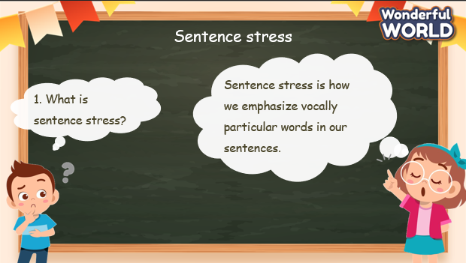  Task 7: Listen and repeat.  - Tell students to look at sentences on the screen.  - Ask Ss to point out which words should be stressed.  - Show the stressed words on the screen.  - Play the audio recording.  - Instruct students to listen carefully and pay attention to the words in bold in each sentence as they hear them.  - After playing the recording once, play it again and ask students to repeat each sentence after the audio.  - Guide identifying stressed words, such as  emphasizing the natural rhythm of spoken English and the emphasis on certain syllables. 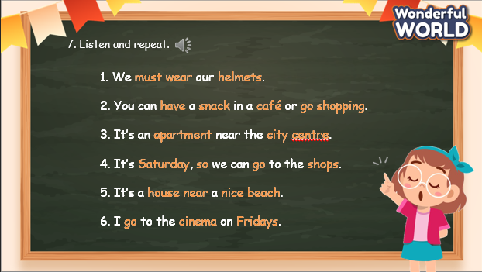 | - Look at the questions and answer.  - Look at the example and guess the words that are stressed.  - Listen to the audio and check.  - Listen to the audio and repeat.  - Look at the screen and identify which words should be stressed.  - Listen to the audio and pay attention to the bold words.  - Listen again and repeat. Try to make the bold words louder, higher, and longer.
Activity 3: Practice – Controlled practice (8 minutes)
Aims:
- Complete task 8 to practice sentence stress.
- Join the game “Correct me” to make it fun and practice sentence stress.
Teacher’s Activities | Students’ Activities
Task 8: Read and underline the stressed words in the sentences. Then listen and repeat.  - Instruct students to read each sentence silently and underline the  stressed words they identify.  - Play the audio recording for Track 8.10.  - While listening, students should pay attention to the stressed words in each sentence.  - After playing the recording, ask students to repeat each sentence  after the audio, focusing on pronouncing the stressed words  with emphasis.  - Tell students that when stressing confirmative in English, such  as emphasizing agreement or confirmation, the stress is placed  on the main content words in the sentence, particularly on verbs and important nouns.  - Encourage students to practice stress and intonation in their spoken English during conversations and activities.  - Provide positive feedback and corrections as necessary  to help students improve their pronunciation and stress  patterns.  e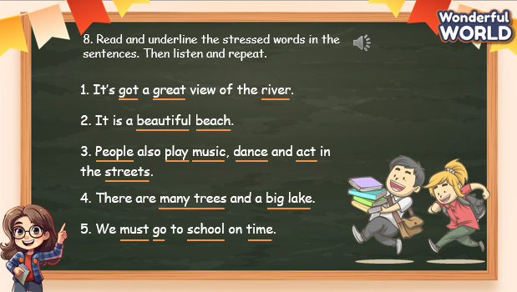  Correct me! game  - Divide the class into groups of 2.  - Invite groups randomly to practice conversations. Remind Ss to pay attention to the bold words. Make the word louder, higher, and longer.  - After each group’s practicing, ask for comments from other groups. If they find that the conversation is not stressed correctly, ask them to correct it.  - The pairs that do not make the correct stresses will do an exercise (jumping, dancing, singing, etc.)  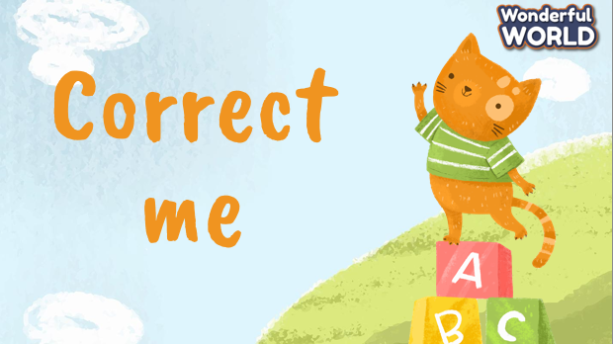 | - Read the sentence individually and underline the stressed words.  - Listen to the audio and check.  - Listen again and repeat after the audio. Try to make the stressed words louder, higher, and longer.  - Listen to the rules of the game.  - Sit in pairs and read the conversation. Remember to say the bold words louder, higher, and longer.  - Other groups: listen and make comments.  - The pairs who do not make it right will do an exercise.
Activity 4: Production – Speaking (6 minutes)
Aims:
- Practice stress with a chant
- Build the confidence to perform a chant in front of the class
Teacher’s Activities | Students’ Activities
Task 9: Listen and chant.  - Ask Ss to look at the chant and identify the stressed words.  - Tell students they are going to learn a chant. Explain to students that the chant uses the sounds they have just learnt.  - Play the recording and tell students to listen and follow the words with their fingers.  - Read out the chant one line at a time and ask students to repeat after you.  - Play the recording again. Encourage students to chant along. Practice several times until students are familiar with the words and sounds.  - Ask students to practice the chant individually, and then in pairs or groups. For example, one group chants the first verse, and the other group chants the second verse.  Optional activity:  - Ask some volunteers to say the whole chant  . 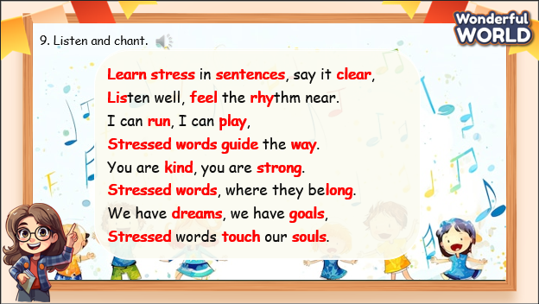 | - Look at the chant and identify the stressed word.  - Listen to the chant the first time and pay attention to the bold words.  - Listen again and chant along.  - Practice chanting sentence by sentence.  - Practice individually, then in pairs or groups.  - Perform in front of the class.
Activity 5: Wrap up & Assessment (4 minutes)
Teacher’s Activities | Students’ Activities
Aims:
- Check Ss’s understanding of what they have learned.
- Students rehearse what they have learned in the lesson.
- Ask Ss to do the assessment.  - Give the assessment to the class and some Ss.  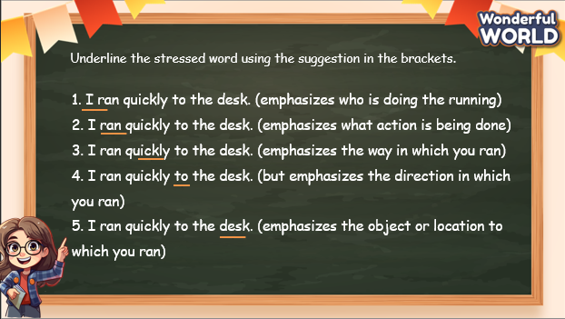  - Check with the class.  - T asks Ss about what they have learnt in today’s lesson.  - T shows the wrap-up slide and concludes the lesson.  * Remember  GRAMMAR  1. Sentence stress  We use it to indicate which word or words are the most important, and which word we want the listener to pay attention to.  Eg: He bought a red car for his daughter. (emphasis on who bought a red car) | - Do the assessment.  - Check with the teacher.  - Answer T’s question of what they have learnt in today’s lesson.  - Ss read the wrap-up.  - Stand up and say goodbye to the teacher.

UNIT 8: Fun Time & Project
Part 1 – Part 1,2,3
Period 87
I. OBJECTIVES:
1. Knowledge:
- Students review the places around the world
2. Competences:
- English competences: Students can identify the cities in the world and the interesting facts of each city.
- Common competences: Students can identify the national flags of countries around the world.
3. Qualities:
- Students will
+ have a wide knowledge of cities and interesting facts about places around the world.
+ enthusiasm for sharing their memories with their friends.
II. EQUIPMENT AND MATERIALS:
- Basic things: Student’s book, flashcards, photos, papers
- Advanced things: PPT, laptop, TV.
III. LESSON PROCEDURE
Activity 1: Warm-up (5 minutes)
“What do you hear?” game
Aims: Welcome students. Engage the class (or warm the class up) with a game to help Ss relax warm up the lesson and lead in the new one.
Teacher’s Activities | Students’ Activities
Procedure
1. Greet students. Chatting…What sounds can you hear in your life? What do they sound like?  2. Introduce the game: “What do you hear?”  - Explain the rules: after showing the video, Ss will raise their hands up to get the chance to answer the questions. They can answer continuously until the video ends. If the answer is correct, they will get a gift.  - When the video stops, click on the Check button to check the answer.  - Click on the Next button to move to the next one.  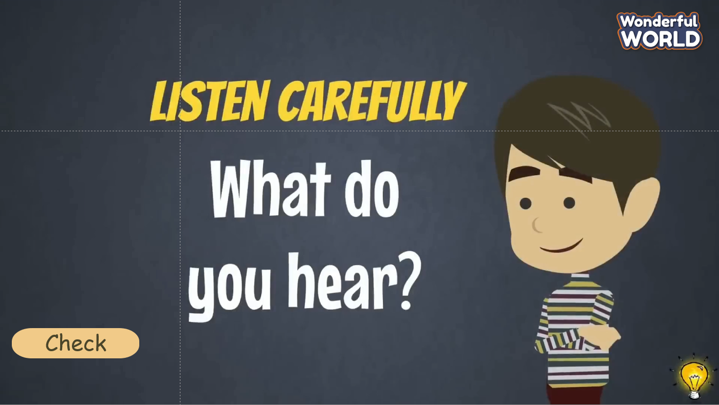  Lead in:  - T raises some pictures and asks Ss to guess the topic of the lesson  - T reviews the topic “People and places”  - Write on the board “Fun time and Project” and review the words and structures of the learned lesson | - Greet Teacher  - Warm up gently under T’s instruction in 30 seconds  - Listen to the rules.  - Watch the video and raise your hands to answer the questions.  - If the answer is correct, get a gift.  - Keep answering until all the questions are done.  - Look at the pictures and guess the topic.  - Review the words in previous lessons.
Activity 2: Review & Practice (12 minutes)
Aims:
- Review the cities and countries around the world by national flags and the facts about those places.
+ Finish Task 1, 2
Teacher’s Activities | Students’ Activities
REVIEW  Task 1: Fun quiz! Answer the questions, then listen to check your answers.  - Show the quiz on the screen and invite some Ss to read the questions aloud.  - Give the time to finish the task individually.  - Invite some Ss to share their answer.  - Click on the screen to check the answer.  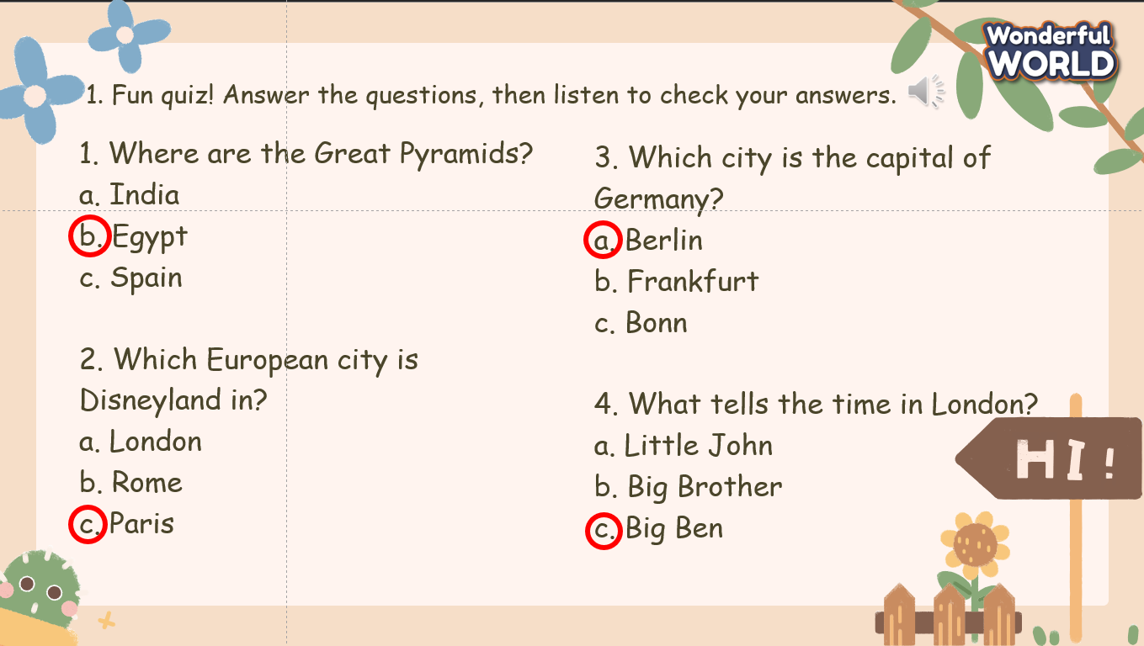  Task 2. Complete the song with the words below. Then listen and check.  - Go through the words in the box with the class.  - Read out the first sentence and ask students why ocean is the correct answer.  - Read out the given parts of the remaining questions and make sure that students understand all words.  - Explain the rest of the task to students. Tell them to cross out a word in the box when they have used it. Go round the class helping students where necessary.  - Play the recording. Ask students to check their answers. Then, call on students to read the song lyrics aloud.  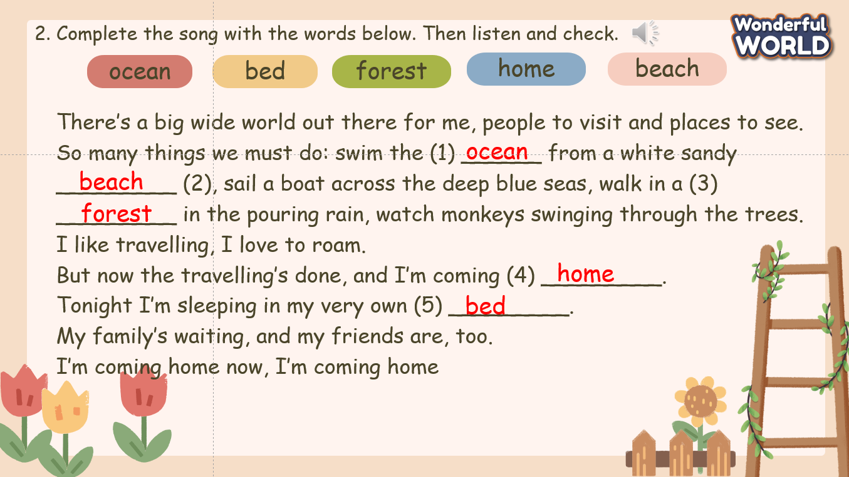  Game: “Quick quizzes”  - Divide the class into 2 groups. Each group will choose a character (boy or girl) and play rock, scissors, and paper to decide which group goes first.  - The two groups will take turns to answer the corresponding questions.  - Check the answer. If it is correct, the team gets a point.  If not, move to the next one.  - When all the questions are answered, the team with a higher score will win the game.  - The team with lower scores will do an exercise (dance, sing, jump, etc.) | - Look at the screen and read the questions aloud.  - Do the task individually.  - Share the answers with the class.  - Check the answer.  - Listen to the explanation  - Read the text aloud.  - Do the task individually.  - Share the answer with the class.  - Check the answer.  - Listen to the rules of the game  - Appoint a representative to do rock, scissors, and paper to decide who goes first  - Choose the number pay attention to the questions, and then answer  - Check the results  - Do the exercise.
Activity 3: Production (8 minutes)
Aims:
- Ss join and practice singing a song and make it fun.
- Encourage Ss to be confident in front of a crowd.
Teacher’s Activities | Students’ Activities
Task 9: Listen and chant.  - Ask Ss to look at the song and read it again.  - Tell students they are going to learn a song.  - Play the recording and tell students to listen and follow the words with their fingers.  - Read out the song one line at a time and ask students to repeat after you.  - Play the recording again. Encourage students to sing along. Practice several times until students are familiar with the words and sounds.  - Ask students to practice the song individually, and then in pairs or groups.  - Invite some groups to perform in front of the class.  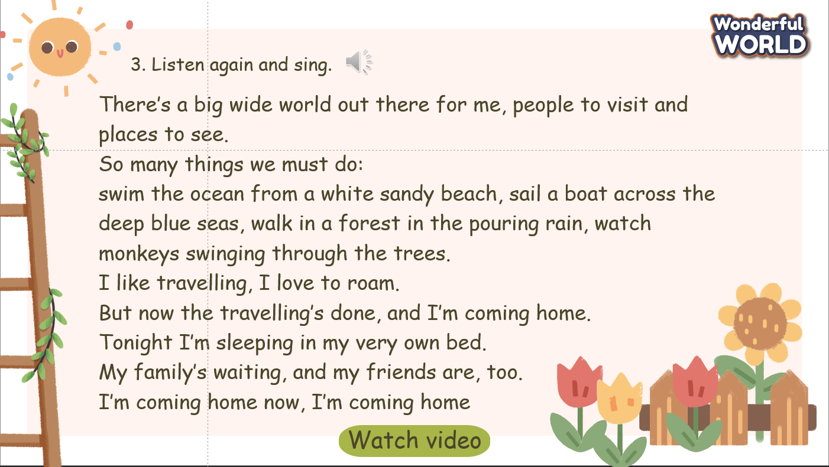 | - Look at the song and read it again.  - Listen to the song the first time and pay attention to the sounds.  - Listen again and sing along.  - Practice singing sentence by verse.  - Practice individually, then in pairs or groups.  - Perform in front of the class.
Activity 4: Wrap-up & Assessment (4 minutes)
Teacher’s Activities | Students’ Activities
Aims:
- Check Ss’s understanding of what they have learned.
- Students rehearse what they have learned in the lesson.
- Ask Ss to do the assessment.  - Give the assessment to the class and some Ss  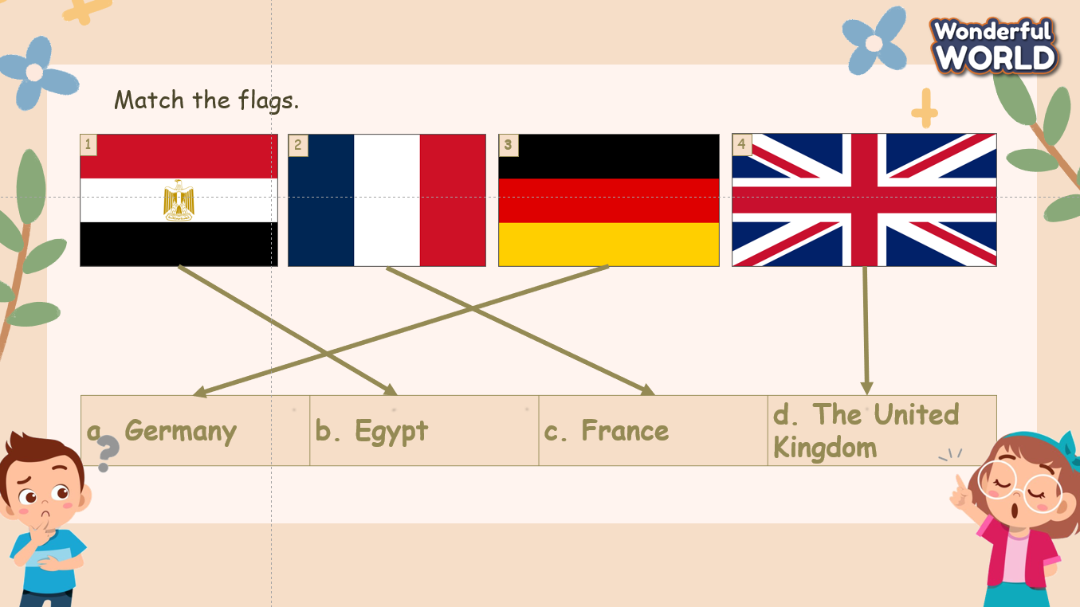  - Check with the class.  - Wrap-up  * Remember  VOCABULARY  Countries around the world: Egypt, France, Germany, The United Kingdom, etc. | - Do the assessment.  - Check with the teacher  - Ss read the wrap-up  - Stand up and say goodbye to the teacher.

UNIT 8: Fun time & Project
Part 2 – Part 4,5,6,7,8
Period 88
I. OBJECTIVES:
1. Knowledge:
- Students review the places around the world and in Vietnam
2. Competences:
- English competences: Students the facts about places around the world and in Vietnam.
- Common competences: Students can identify the places around the world with their interesting information.
3. Qualities:
- Students will
+ have a wide knowledge of cities and interesting facts about places around the world.
+ enthusiasm for sharing their memories with their friends.
II. EQUIPMENT AND MATERIALS:
- Basic things: Student’s book, flashcards, photos, papers
- Advanced things: PPT, laptop, TV.
III. LESSON PROCEDURE:
Activity 1: Warm-up (5 minutes)
Watch video activity
Aims: Welcome students. Engage the class (or warm the class up) with a video to help Ss relax warm up the lesson and lead in the new one.
Teacher’s Activities | Students’ Activities
Procedure
1. Greet students. Chatting…What sounds can you hear in your life? What do they sound like?  2. Introduce the video “Travel the World Song”  - Show the question on the screen and remind Ss to pay attention and take notes if needed while watching the video.  - Play the video.  - Ask Ss about the topic of the video.  - Ask Ss about the question, and invite some Ss to show their answer.  - Check the answer and ask Ss to repeat.    Lead in:  - T raises some pictures and asks Ss to guess the topic of the lesson  - T reviews the topic “People and places”  - Write on the board “Fun time and Project” and review the words and structures of the learned lesson | - Greet the T.  - Listen to T’s instructions about the warm-up activity.  - Watch the video and take note of what they have seen.  - Answer the questions.  - Check the results.  - Repeat after T.  - Look at the pictures and guess the topic.  - Review the words in previous lessons.
Activity 2: Review & Practice (12 minutes)
Aims:
- Review the cities in Vietnam and countries around the world by national flags and the facts about those places.
+ Finish Task 1, 2
Teacher’s Activities | Students’ Activities
REVIEW  Task 4: Write the names of some famous places in your country.  - In their notebooks, ask students to write down the names of some famous places in their country.  - Encourage them to think about well-known landmarks, natural  wonders, historical sites, or cultural attractions that they have seen in the video.  - Give them a few minutes to write down their chosen places.  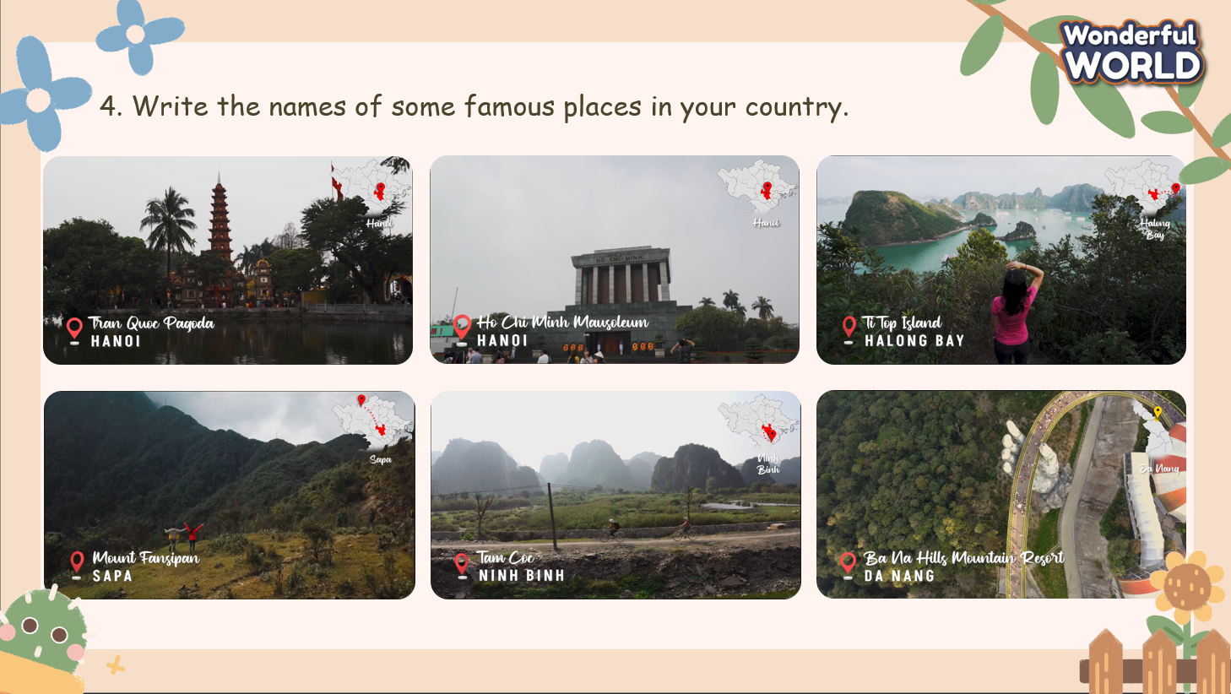  Task 5. Choose one place from Activity 4. Answer the questions.  - Explain the task to students: they will choose one place from their list and answer a set of questions about it.  - Ask them to pay attention to the questions in Activity 5: Where is it? What is it like? How old is it? What can you see there? What can you do there?  - Allow students to select their chosen place and begin answering  the questions.  - Circulate the classroom to provide assistance and answer any  questions students may have.  - Invite some Ss to share their answers.  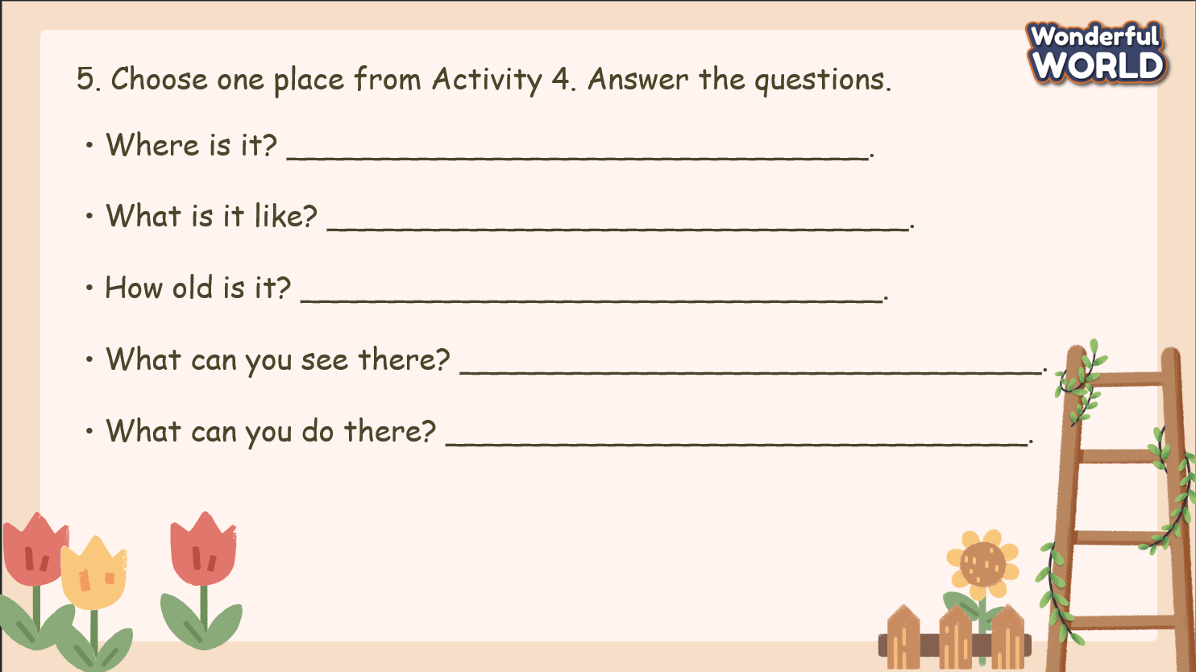  Task 6. Find out two more facts about your place.  - Inform students that they will research two more interesting facts about their chosen place.  - Tell students that they can find the information at home.  - Encourage them to use books or the internet to find reliable  information.  - Show the sample questions.  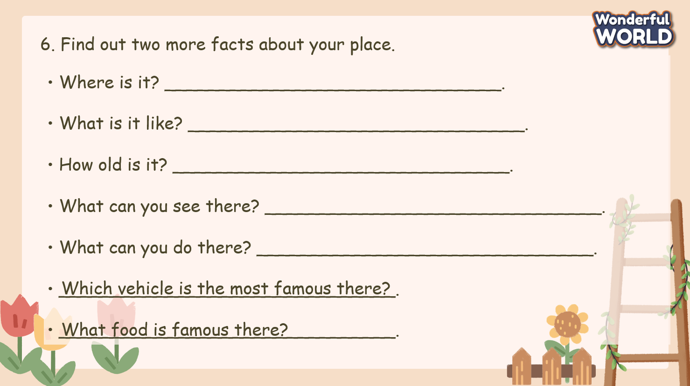 | - Look at the screen and read the questions aloud.  - List the places that they know or have visited in their country.  - Share their answer with the class.  - Listen to the explanation  - Choose a place from a list and answer the question about that one.  - Share their answers with the class.  - Try to find out two more questions about a place.  - Can do it at home.  - Check the sample questions.
Activity 3: Production (8 minutes)
Aims:
- Ss join and practice singing a song and make it fun.
- Encourage Ss to be confident in front of a crowd.
Teacher’s Activities | Students’ Activities
Game: “Guess the places”  - Divide the class into 2 groups. Each group will choose a character (boy or girl) and play rock, scissors, and paper to decide which group goes first.  - The two groups will take turns to answer the corresponding questions.  - In five seconds, the team must give out the final answer.  - When the alarm rings, click on the Check button to check the answer.  - If it is correct, that team will get a point. If not, move to the next one by clicking on the Next button.  - When all the questions are answered, the team with a higher score will win the game.  - The team with lower scores will do an exercise (dance, sing, jump, etc.).  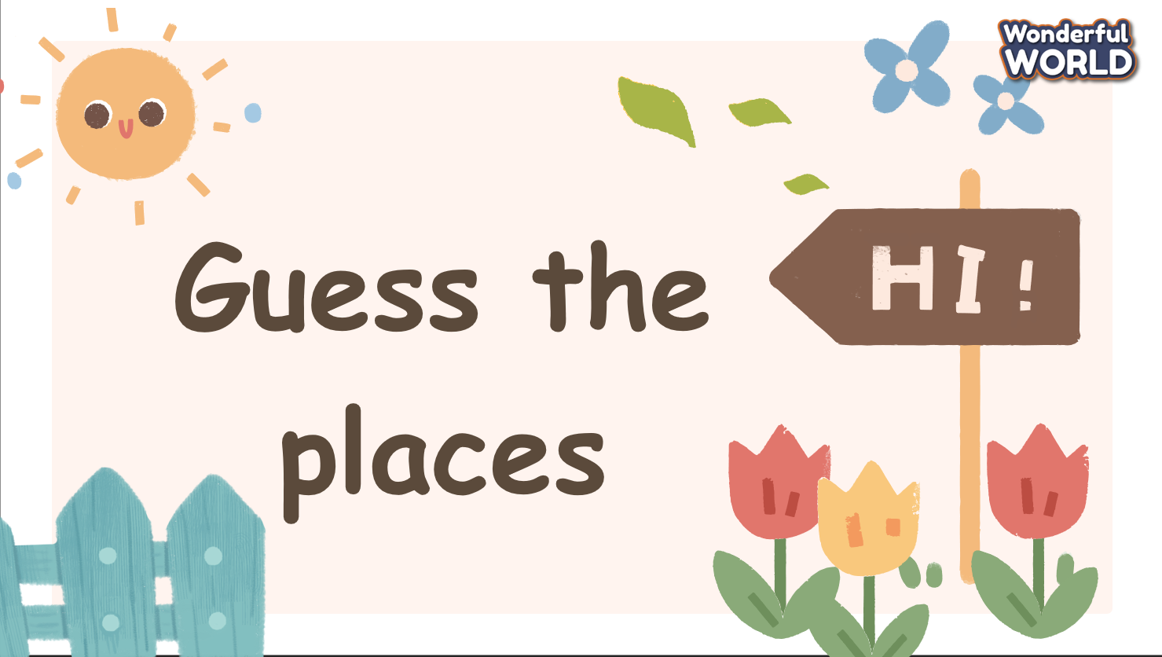  Task 7. Make a poster. Add the information from Activity 5 and Activity 6 to the poster.  - Explain that after finishing with data collection, at home  they will create a poster showcasing their chosen place and  the information they gathered.  - Encourage creativity in designing the posters, including  colorful illustrations, photographs, and interesting fonts.  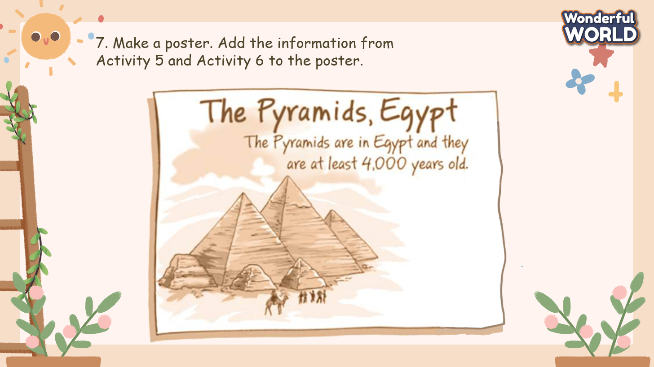  Task 8. Bring your poster to school. Share with your friends.  - Once students have completed their posters, ask them to bring them to school on a designated day.  - Arrange a time for students to share their posters with the class.  - Each student can briefly present their chosen place, discussing the information on their poster and sharing the additional facts they found.  - Encourage classmates to ask questions and show interest in each other’s presentations.  - Congratulate students on their hard work and creativity in completing the project.  - Emphasise the importance of learning about different places and cultures.  - Encourage students to continue exploring the world around them and learning about new places. | - Listen to the rules of the game.  - Sit in groups and pay attention to the pictures on the screen.  - Present the answer in five seconds.  - Check the answer.  - Do the exercise.  - Collect information from tasks 5 and 6 to draw a poster of the chosen place.  - Add information on the poster.  - Make a short presentation about the poster and share it with the class.  - Complete the poster at home.  - Bring their poster to school and share it with the class in the next lesson.
Activity 4: Wrap-up & Assessment (4 minutes)
Teacher’s Activities | Students’ Activities
Aims:
- Check Ss ’s understanding of what they have learned.
- Students rehearse what they have learned in the lesson.
- Ask Ss to do the assessment.  - Give the assessment to the class and some Ss  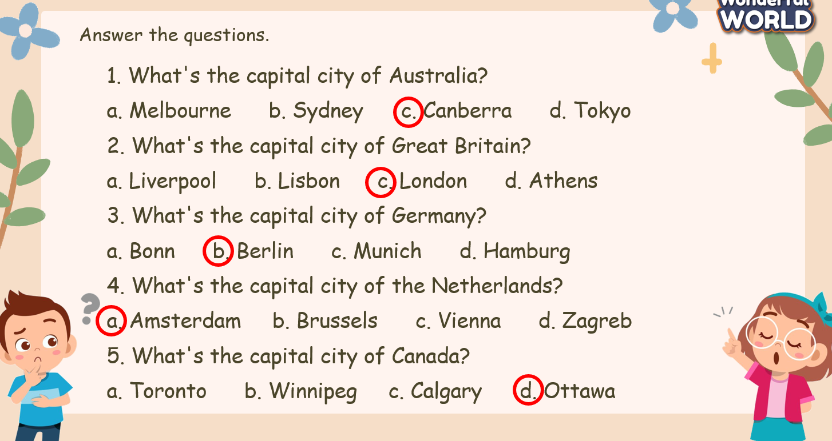  - Check with the class.  - Wrap-up  * Remember  Wring & Speaking skill  Write & talk about a famous place by answering the questions:  • Where is it?  • What is it like?  • How old is it?  • What can you see there?  • What can you do there?  Complete the poster at home. | - Do the assessment.  - Check with the teacher  - Ss read the wrap-up  - Stand up and say goodbye to the teacher.

