TUẦN 23 Khối 3, 5 (Từ ngày 24/02/2025 đến ngày 28/02/2025)
THỨ | TIẾT | MÔN | TIẾT THỨ | NỘI DUNG BÀI DẠY |  | UDCNTT | ĐỒ DÙNG DẠY HỌC
Hai  24/02 | 1 | 5A | 89 | Review 4 | Part 2. Task 1, 2, 3 | Wonderfulworld | Flashcards, TV, books
Hai  24/02 | 2
Hai  24/02 | 3 | 3A | 89 | Review 4 | Part 1. Task 1, 2, 3 | Wonderfulworld | Flashcards, TV, books
Hai  24/02 | 4 | 3A | 90 | Review 4 | Part 2. Task 1, 2, 3 | Wonderfulworld | Flashcards, TV, books
Hai  24/02 | 5 | 5D | 89 | Review 4 | Part 2. Task 1, 2, 3 | Wonderfulworld | Flashcards, TV, books
Hai  24/02 | 6 | 3B | 89 | Review 4 | Part 1. Task 1, 2, 3 | Wonderfulworld | Flashcards, TV, books
Hai  24/02 | 7
Ba  25/02 | 1 | 5C | 89 | Review 4 | Part 2. Task 1, 2, 3 | Wonderfulworld | Flashcards, TV, books
Ba  25/02 | 2 | 5B | 89 | Review 4 | Part 2. Task 1, 2, 3 | Wonderfulworld | Flashcards, TV, books
Ba  25/02 | 3 | 5A | 90 | Review 4 | Part 2. Task 1, 2, 3 | Wonderfulworld | Flashcards, TV, books
Ba  25/02 | 4
Ba  25/02 | 5 | 3A | 91 | Review 4 | Part 3 - video. Task 1, 2, 3 | Wonderfulworld | Flashcards, TV, books
Ba  25/02 | 6 | 5D | 90 | Review 4 | Part 2. Task 1, 2, 3 | Wonderfulworld | Flashcards, TV, books
Ba  25/02 | 7 | 3B | 90 | Review 4 | Part 2. Task 1, 2, 3 | Wonderfulworld | Flashcards, TV, books
Tư  26/02 | 1 | 5A | 91 | Review 4 | Part 3 - video. Task 1, 2, 3 | Wonderfulworld | Flashcards, TV, books
Tư  26/02 | 2
Tư  26/02 | 3
Tư  26/02 | 4
Tư  26/02 | 5 | 5B | 90 | Review 4 | Part 2. Task 1, 2, 3 | Wonderfulworld | Flashcards, TV, books
Tư  26/02 | 6 | 5C | 90 | Review 4 | Part 2. Task 1, 2, 3 | Wonderfulworld | Flashcards, TV, books
Tư  26/02 | 7
Năm  27/02 | 1 | 5C | 91 | Review 4 | Part 3 - video. Task 1, 2, 3 | Wonderfulworld | Flashcards, TV, books
Năm  27/02 | 2 | 5B | 91 | Review 4 | Part 3 - video. Task 1, 2, 3 | Wonderfulworld | Flashcards, TV, books
Năm  27/02 | 3 | 5A | 92 | Review 4 | Part 4. Task 1, 2, 3 | Wonderfulworld | Flashcards, TV, books
Năm  27/02 | 4
Năm  27/02 | 5 | 5D | 91 | Review 4 | Part 3 - video. Task 1, 2, 3 | Wonderfulworld | Flashcards, TV, books
Năm  27/02 | 6 | 5C | 92 | Review 4 | Part 4. Task 1, 2, 3 | Wonderfulworld | Flashcards, TV, books
Năm  27/02 | 7
Sáu  28/02 | 1 | 3B | 91 | Review 4 | Part 3 - video. Task 1, 2, 3 | Wonderfulworld | Flashcards, TV, books
Sáu  28/02 | 2 | 5D | 92 | Review 4 | Part 4. Task 1, 2, 3 | Wonderfulworld | Flashcards, TV, books
Sáu  28/02 | 3 | 5B | 92 | Review 4 | Part 4. Task 1, 2, 3 | Wonderfulworld | Flashcards, TV, books
Sáu  28/02 | 4
Sáu  28/02 | 5
Sáu  28/02 | 6 | 3B | 92 | Review 4 | Part 4. Task 1, 2, 3 | Wonderfulworld | Flashcards, TV, books
Sáu  28/02 | 7 | 3A | 92 | Review 4 | Part 4. Task 1, 2, 3 | Wonderfulworld | Flashcards, TV, books

GRADE 3
Week 23 ( From 24/2 to 28/2)
Review 4 – Part 1: 1,2,3
Period 89

I. OBJECTIVES:
1. Knowledge:
By the end of the lesson, students will review the words related to the topic ability: read a book, watch TV, fly a kite, ride a bike, play the guitar, run, buy, colour, dance, draw, paint, sing. and some structures:
- I/he/she/it/we/they/you can or can’t …
- Can I/he/she/it/we/they/you …?
+ Yes, I/he/she/it/we/they/you can.
+ No, I/he/she/it/we/they/you can’t.
- The Present Continuous tense : I/he/she/it/we/they/you + is/ are+ V-ing.
2. Competences:
- English competences: Students will able to talk and answer about people/animal’s ability.
- Common competences: Students will have opportunities to develop communication through presenting in front of the class.
3. Qualities:
+ Students are given chances to think about one’s ability.
II. EQUIPMENT AND MATERIALS:
- For teacher:
+ Basic things: Student’s book, teacher’s book, flashcards.
+ Advanced things: PPT, projector/interactive whiteboard/laptop/TV
- For students: student’s book, work book.
III. LESSON PROCEDURE:
Activity 1: Warm up (10 minutes)
Teacher’s activities | Student’s activities
- Greeting  - “Pass the ball ” Game:  + While the music is playing Ss will pass the ball around the class. When the music stops, the student with the ball must answer the question from the teacher about hobby. | - Pass the ball and answer questions
Activity 2: Review (20 minutes)
Teacher’s activities | Student’s activities
Task1: Look and say  -Show pictures about activities.  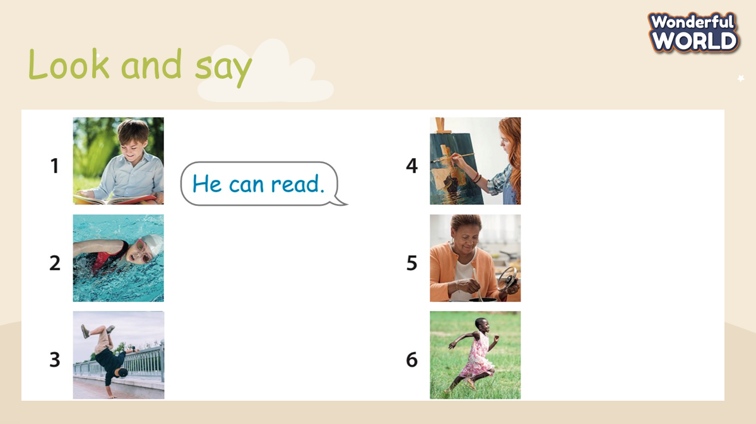  - Read the instruction to the class.  - Ask Ss to look at pictures and answers about what people can do.  - Ask Ss to read loudly individually, in team and whole class. | - Do the task and receive stars.  - Ss read loudly.
Activity 3: Review
Teacher’s activities | Student’s activities
- Play game: “ Big Wheel”  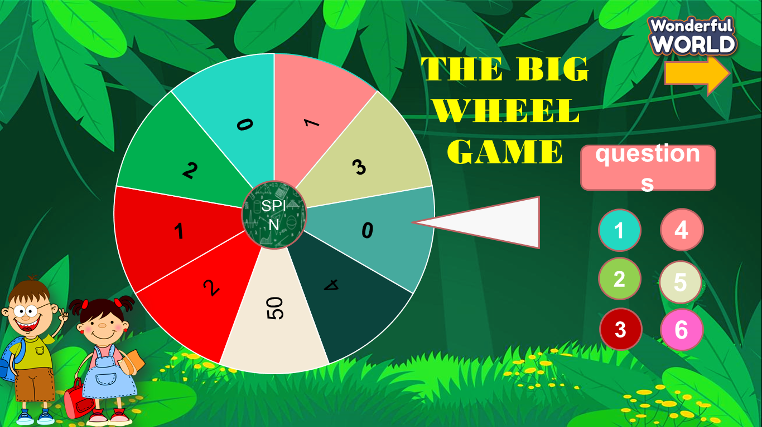  - T prepares 6 slides relating to the knowledge at previous lessons and asks students to choose the numbers and answer all questions.  - Check children’s understanding. (If children can’t understand well, T can explain the rule in Vietnamese).  - If Ss answer correctly, they will spin the wheel to get stars.  Task 2: Complete the sentences  - Ask Ss to open the book and do their task.  - Check children’s understanding. (If children can’t understand well, T can explain the rule in Vietnamese).Then, Ss will write the answer in the book.  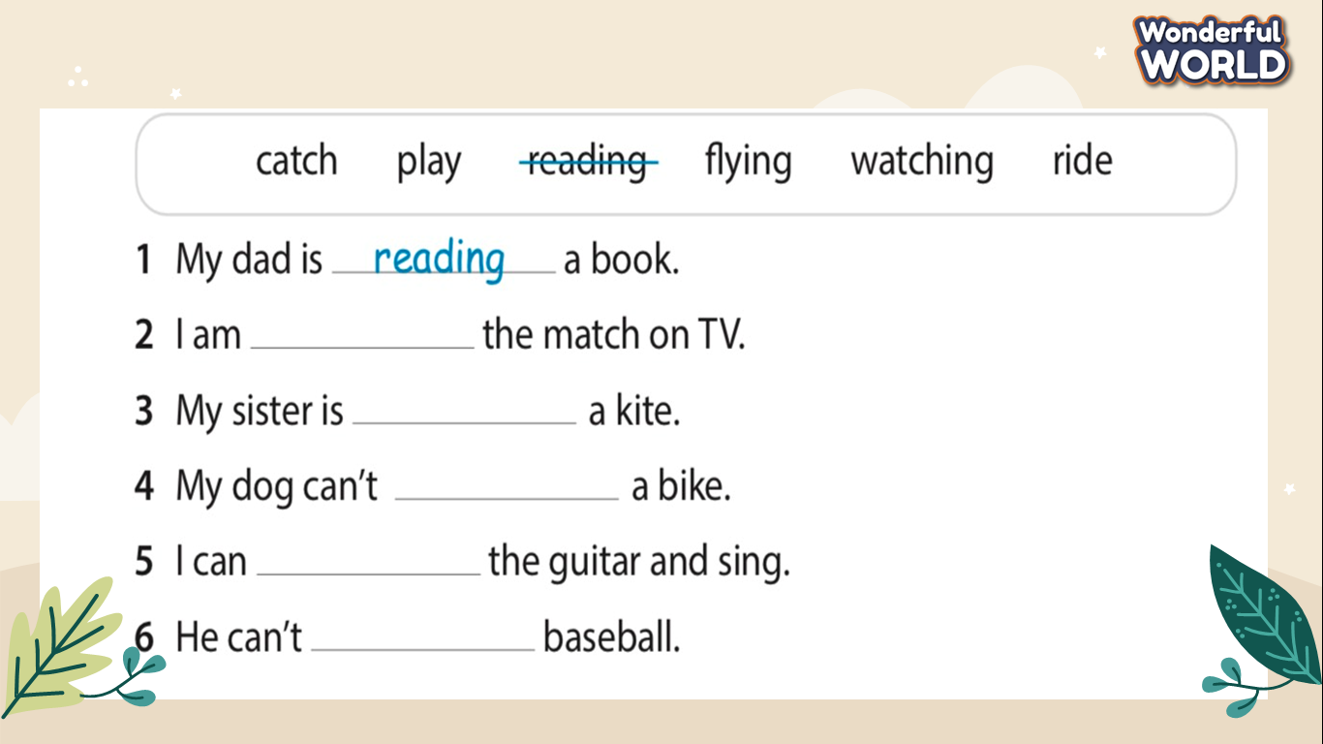  - Ask Ss to answer questions individually to get stars  - T goes around class and checks their answers | - Join the game and get stars for the team.  - Ss do the task in their books.  - Ss answer all questions.  - Ss check their results.
Activity 4: Extra Activity (10 minutes )
Teacher’s activities | Student’s activities
- Task 3: Look and say  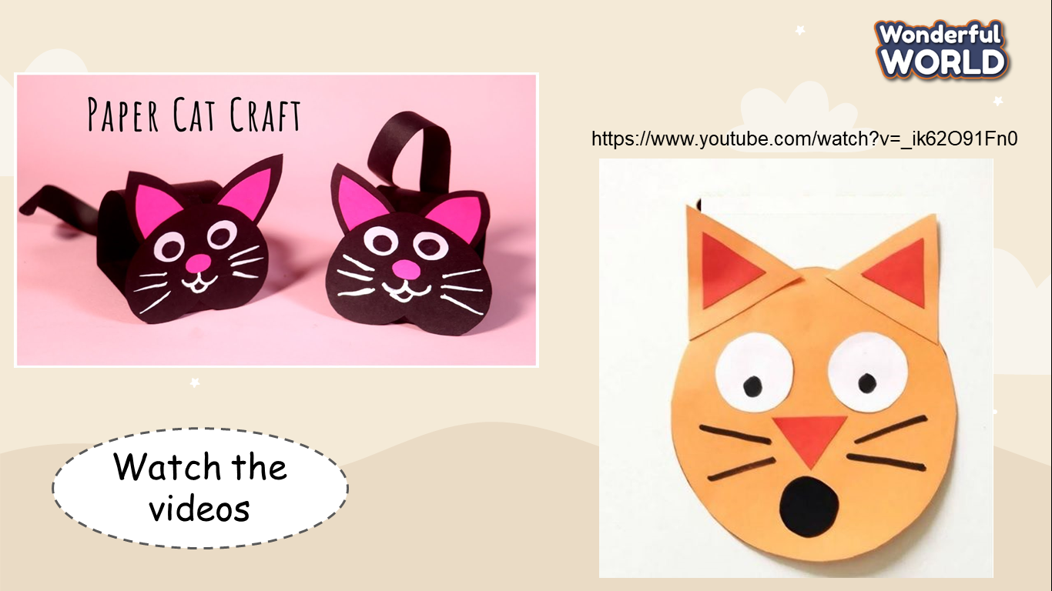  + Ask Ss to look at picture on screen and watch the video.  + Let Ss make their own cats and talk about the cats.  + Invite some SS go to the board to present.  - Assess each presentation of Ss and give them stars. | - Ss watch the video.  - Be confident and present smoothly.
Activity 5 : Wrap up (5 minutes )
Teacher’s activities | Student’s activities
- Require SS to do homework  - Say goodbye | - Say goodbye.

Review 4 – Part 2: 1,2,3
Period 90

I. OBJECTIVES:
1. Knowledge:
Students will be review vocabulary about sports: baseball, basketball, football, hockey, tennis; activities: kick, hit, catch, jump, run, dance, play, watch, fly a kite, ride a bike and Present continuous tense:
- I/he/she/it/we/they/you+ am/is/are + V-ing
- I/he/she/it/we/they/you + am not/is not/are not + V-ing.
- Interrogative with pronouns I/ He/ She:
+ Are you V-ing? Yes, I am/ No, I’m not.
+ Is he/she V-ing? Yes, he/she is./ No, he/she isn’t.
2. Competences:
- English competences: Students will able to talk and answer about sports, activities.
- Common competences: Students will have opportunities to develop communication through presenting in front of the class and build up self- learning.
3. Qualities:
+ Students are given chances to think about one’s favourite activity or sport.
II. EQUIPMENT AND MATERIALS:
- For teacher:
+ Basic things: Student’s book, teacher’s book, flashcards.
+ Advanced things: PPT, projector/interactive whiteboard/laptop/TV
- For students: student’s book, work book.
III. LESSON PROCEDURE:
Activity 1: Warm up (10 minutes)
Teacher’s activities | Student’s activities
- Greeting  - “Pass the ball ” Game:  + While the music is playing Ss will pass the ball around the class. When the music stops, the student with the ball must answer the question from the teacher about sports. | - Pass the ball and answer questions  - Get stars.
Activity 2: Review (15 minutes)
Teacher’s activities | Student’s activities
Task1: Look and write.  - T prepares 5 slides relating to the choosing.  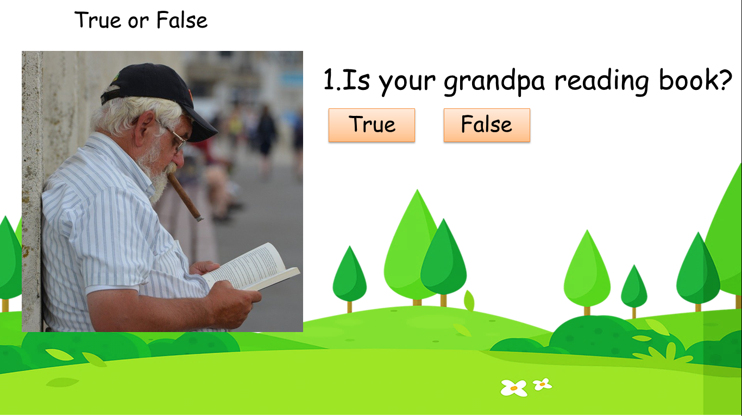  - Show the questions and pictures. Read the instruction to the class.  - Ask Ss to look at pictures and choose the answers.  - Then, Let Ss to fill in the blank.  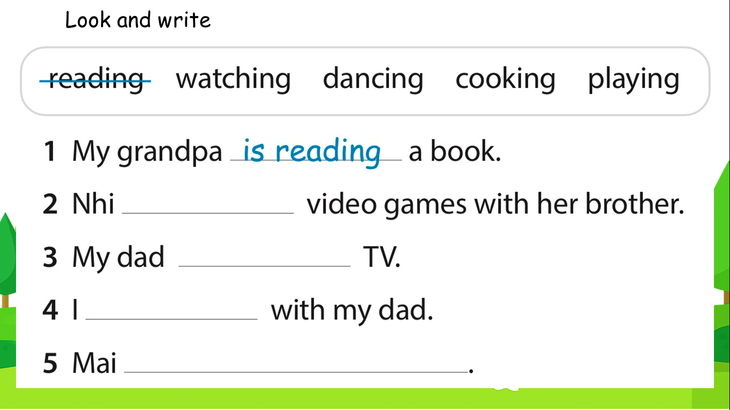  - Ask Ss to read the answers loudly individually, in team and whole class. | - Ss choose T or F and receive stars.  - Ss do the task.  - Read loudly.
Activity 3: Review
Teacher’s activities | Student’s activities
- Play game: “ Rescue the animals”  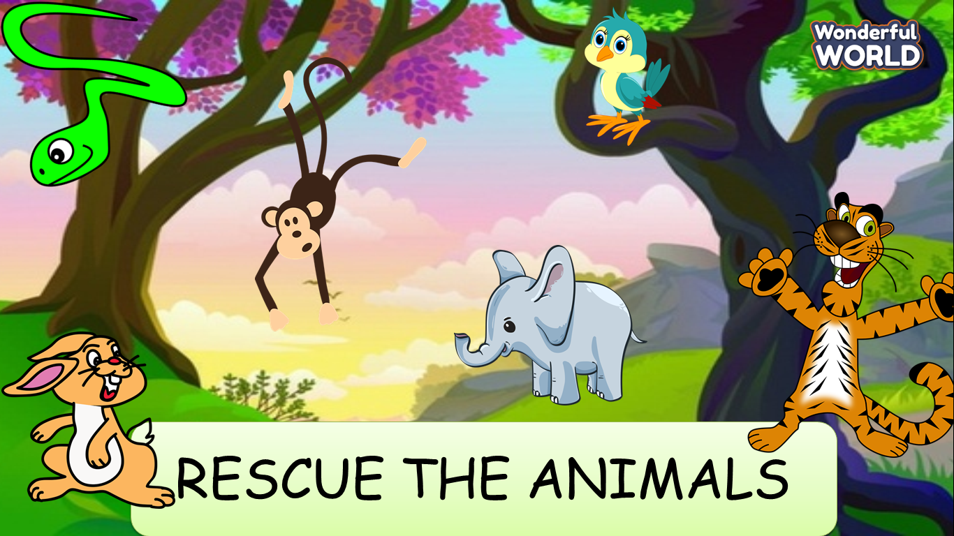  - T prepares 6 slides relating to the knowledge at previous lessons and asks Ss to choose the animals.  - Check children’s understanding. (If children can’t understand well, T can explain the rule in Vietnamese).  - If Ss answer correctly, they will rescue the animals and get stars.  Task 2: Read and write  - Ask Ss to open the book and do their task.  - Check children’s understanding. (If children can’t understand well, T can explain the rule in Vietnamese).Then, Ss will write the answer in the book.  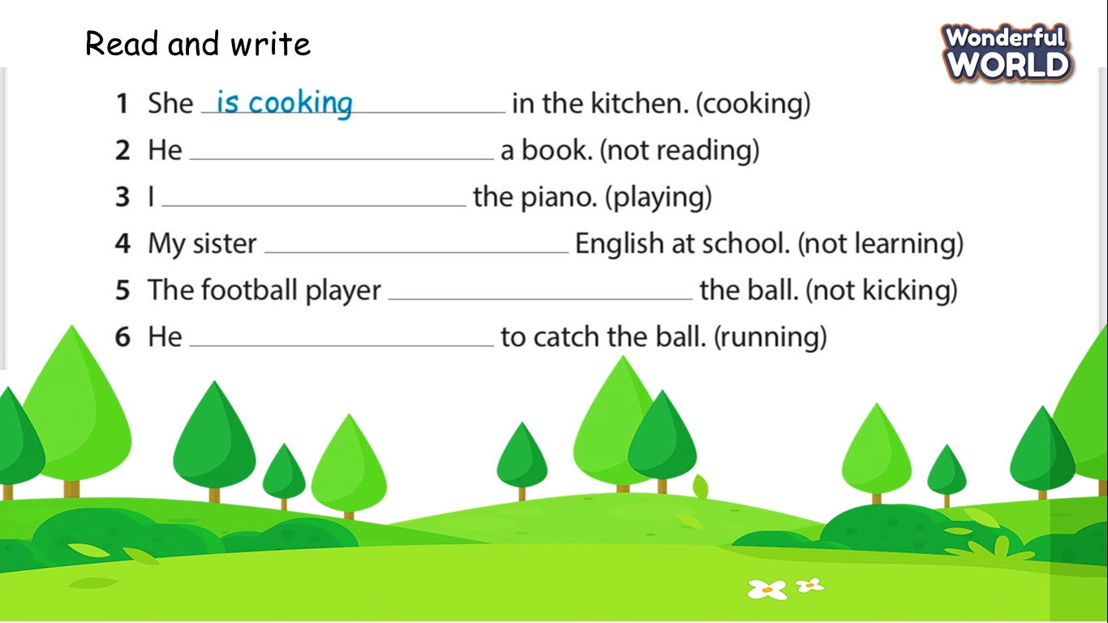  - Ask Ss to answer questions individually to get stars  - T goes around class and checks their answers | - Join the game and get stars for the team.  - Ss do the task in their books.  - Ss answer all questions.  - Ss check their results.
Activity 4: Extra review (10 minutes )
Teacher’s activities | Student’s activities
- Task 3: Ask and answer the question  + T asks Ss to look at screen.  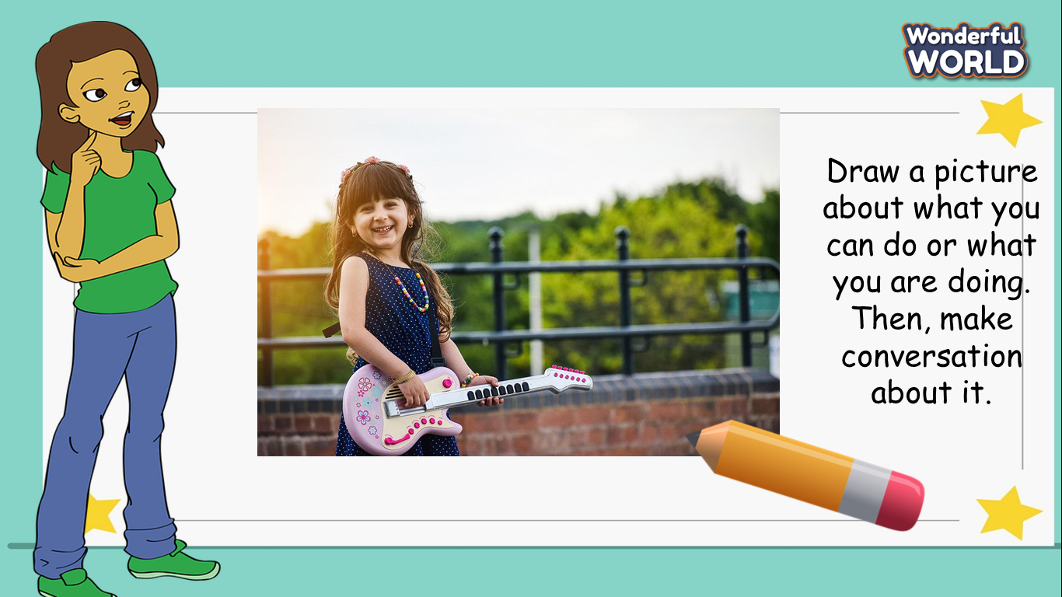  + Ask Ss to draw a picture about what they can do/ what they are doing.  + Let Ss draw their own picture and talk about them.  + Invite some SS go to the board to present.  - Assess each presentation of Ss and give them stars. | - Ss look at the picture and conversation about it.  - Be confident and present smoothly.
Activity 5 : Wrap up (5 minutes )
Teacher’s activities | Student’s activities
-Ask Ss to do homework  - Say goodbye | - Say goodbye.

Review 4 – Part 3: Video
Task 1,2,3,4,5
Period 91

I. OBJECTIVES:
1. Knowledge:
- Watch a video about people talking about their favourite activity .
-Students will review the words related to the topic sport and hobby: cook, read, speak English, swim, baseball, basketball, football,hockey, tennis, catch, hit, kick, jump, run fly a kite, ride a bike, watch a match, write buy, colour, dance, paint, sing ,play the drums / guitar / piano.
+ Review grammar:
I can read.
They can’t swim.
Can he dance? Yes, he can./No, he can’t.
2. Competences:
- Raise motivation and interests in learning English through doing some activities
- Build up self-learning skill through learning activities.
- Develop communication and collaboration skills through learning activities.
- Understand the importance of doing exercise in developing body.
3. Qualities:
- Be responsile for staying healthy .
II. EQUIPMENT AND MATERIALS:
- For teacher:
+ Basic things: Student’s book , teacher’s book , flashcards.
+ Advanced things: PPT, projector/interactive whiteboard/laptop/TV.
- For students: student’s book, work book, paper.
III. LESSON PROCEDURE:
Warm up (10 minutes)
Teacher’s activities | Student’s activities
- Greeting  - for basic facilities in class  Game “ Hang man”  +T will present with a number of blank spaces representing the missing letters that students need to find.  + After T has revealed several letters, Ss may be able to guess what the answer is and fill in the remaining letters. T will give students many stars.  + Be warned, every time students guess a letter wrong, teacher will loose a life and the hangman begins to disappear, piece by piece. | - Use the keyboard to guess a letter.
Review( 15 minutes)
Teacher’s activities | Student’s activities
Before watching:  Task 1: Circle your hobby.  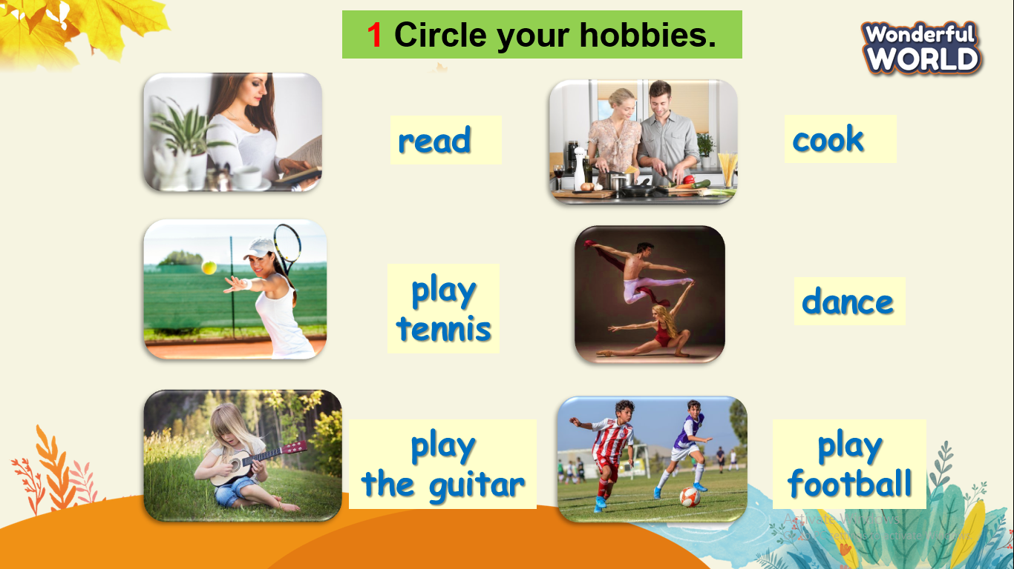  - T reads the instruction to the class.  - Point to the first item, read. Ask a student Do you like reading? If the student answers Yes, show them how to circle the item. If the student answers No, tell them not to circle the item.  - Repeat with the remaining items. Tell students to circle the activities they like, and not to circle the activities they don’t like.  While watching:  Task 2: Circle what you can see in the video.  -T asks students to look at the picture and asks a few question before watching video:  + What sports do you like best?  + How often do you ....?  + What time do you....?  + How do you feel after ( dacing,watching....)?  - T asks Ss to watch the video and circle the activity in the video.  Task 3 :Tick T for True or F for False.  -T asks Ss to watch the video again and tick T or F.  -Check answers.  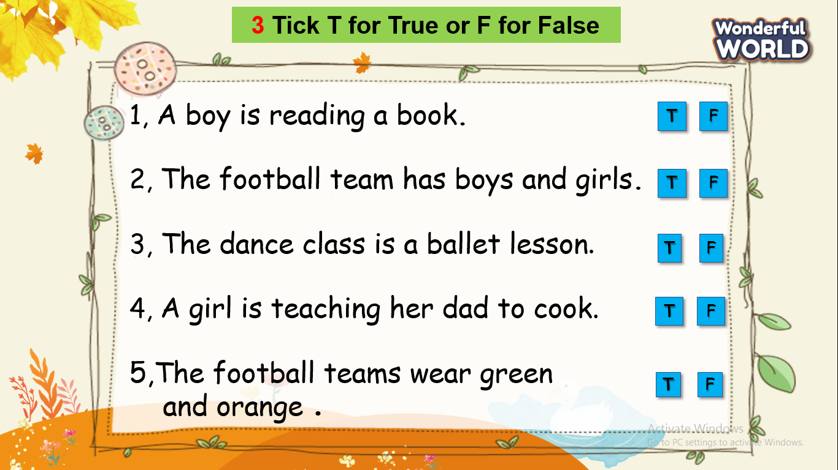  - Play game " go fishing game"  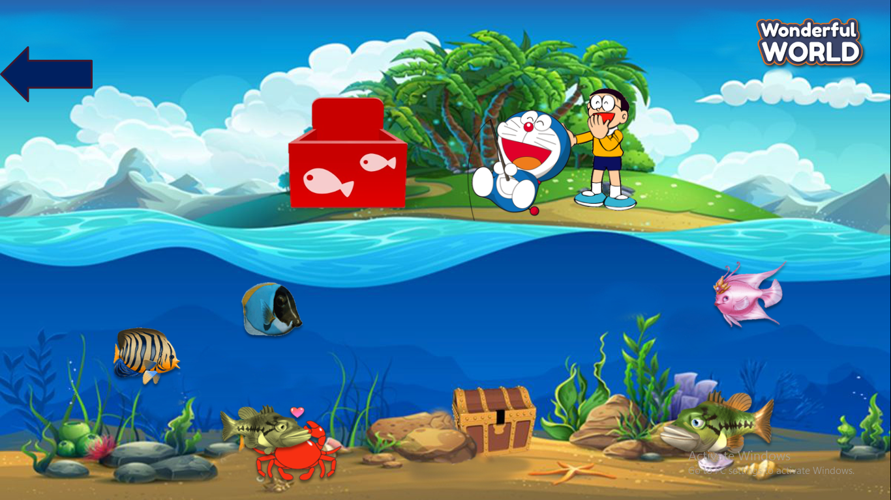  + T prepares 10 question slides related to the knowledge they have learnt at the previous lessons. If they answer correctly , they will bring fish( contain stars) for their team. | - Circle and tell the lists with the class.  -Answer question's teacher.  - Circle activities after watching the video.  -Tell the lists with the class.  - Tick T or F.  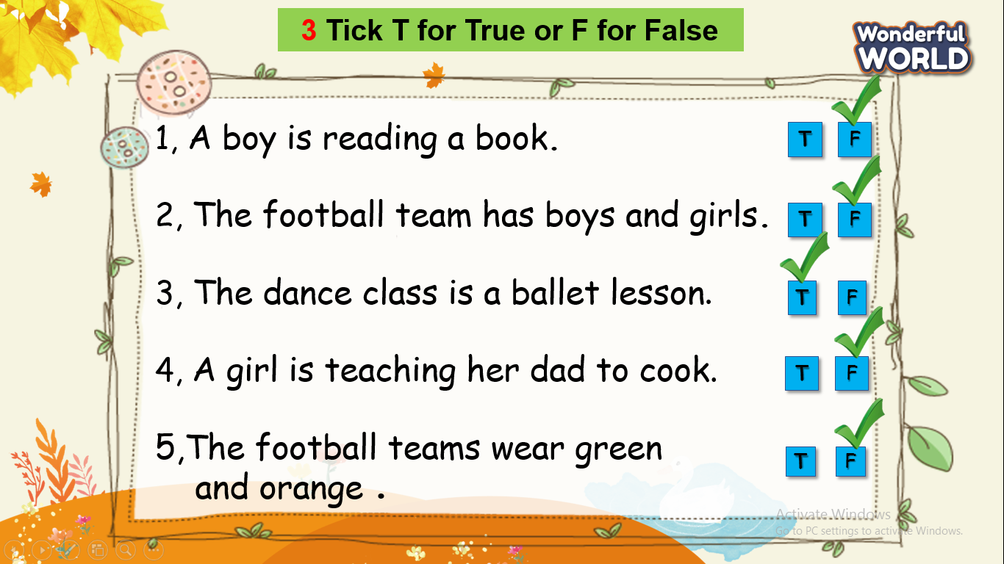  -Play game.
Extra activity (10 minutes )
Teacher’s activities | Student’s activities
Task 1: Draw picture.  - Ss will draw a picture about Their hobbies or activities  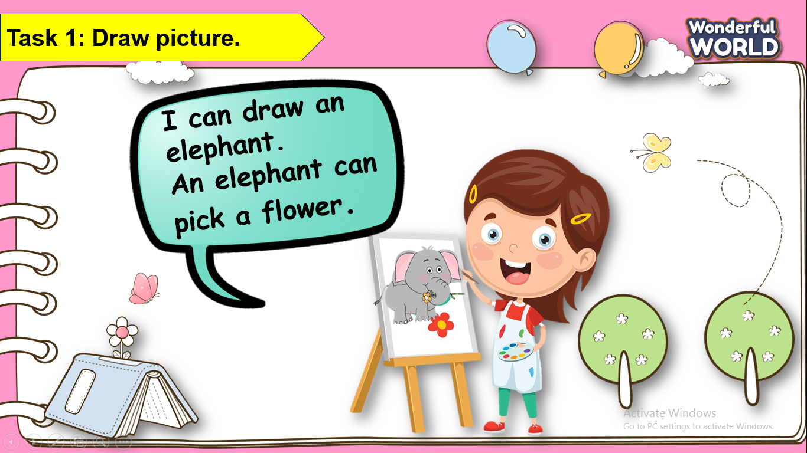  - Ask Ss to present his/her picture with the class by using structures they have learned at unit 6+7  (if it’s enough time,teacher will choose the best one to give candies. | - Draw the picture.  - Be confident to speak in front of the class.
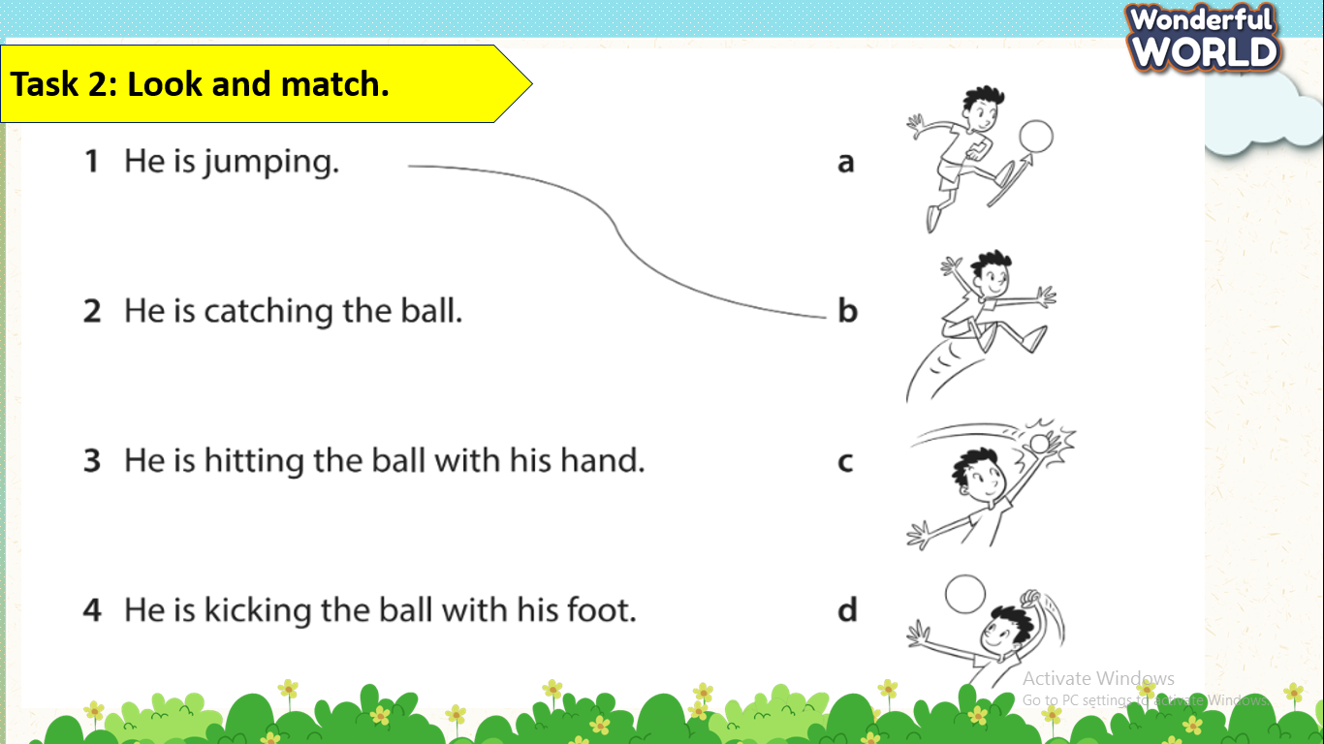  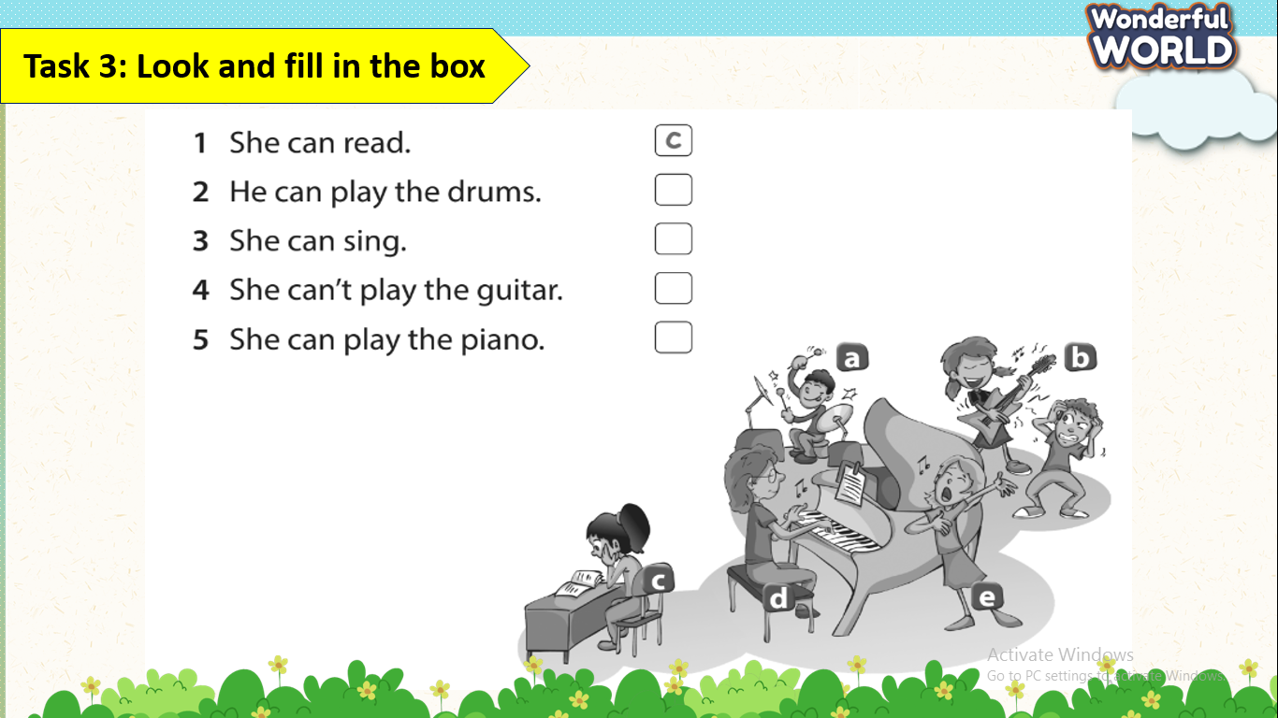  - Check answers.  - Say goodbye . | Key answer:  2-c  3-d  4-a  -Read aloud after finishing.  Key answer:  2-a  3-e  4-b  5-d  - Check with friends and then with teacher and whole class.  - Look and read aloud.  - Say goodbye.
___________________________

Review 4 – Part 3: Video
Task 1,2,3,4,5
Period 92
I. OBJECTIVES:
1. Knowledge:
- Watch a video about people talking about their favourite activity .
-Students will review the words related to the topic sport and hobby: cook, read, speak English, swim, baseball, basketball, football,hockey, tennis, catch, hit, kick, jump, run fly a kite, ride a bike, watch a match, write buy, colour, dance, paint, sing ,play the drums / guitar / piano.
+ Review grammar:
I can read.
They can’t swim.
Can he dance? Yes, he can./No, he can’t.
2. Competences:
- Raise motivation and interests in learning English through doing some activities
- Build up self-learning skill through learning activities.
- Develop communication and collaboration skills through learning activities.
- Understand the importance of doing exercise in developing body.
3. Qualities:
- Be responsile for staying healthy .
II. EQUIPMENT AND MATERIALS:
- For teacher:
+ Basic things: Student’s book , teacher’s book and flashcards,
+ Advanced things: PPT, projector/interactive whiteboard/laptop/TV.
- For students: student’s book, work book.
III. LESSON PROCEDURE:
Warm up (10 minutes)
Teacher’s activities | Student’s activities
- Greeting  - for basic facilities in class:  "missing picture" game  + T shows many flashcards on the board and asks Ss remember them in 5 seconds.  + T conceals one of these pictures and what's the missing picture.  + Give stars for Ss who have correct answer. | - After watching video,Ss have to list all of activities that are appeard in video.  - Receive stars for the correct answer..
Review ( 15 minutes)
Teacher’s activities | Student’s activities
- Task1 :Game: Do a crossword.  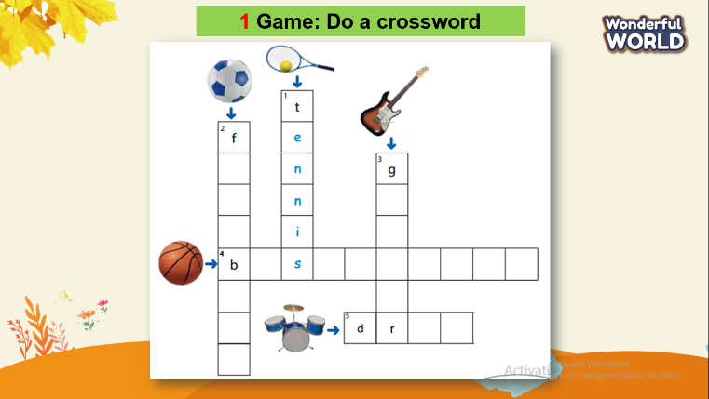  - Ask students to look at the crossword. Explain the task.  - Tell them they need to look at the picture prompt in order to find the word.  - Do the crossword with the whole class.  - Have students do the crossword individually in 5 – 10 minutes.  - Check answers. Ask volunteers to read out their answes.  - Play game:" Cross the river"  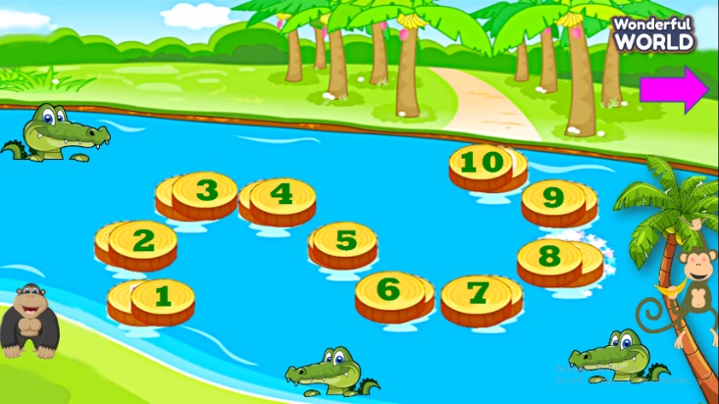  + T prepares 10 question slides related to the knowledge they have learnt at the previous lessons. If they answer correctly , they will help the monkey cross the river. | - Ss will fill in the blanks with letters .  - Receive stars for each right answer.  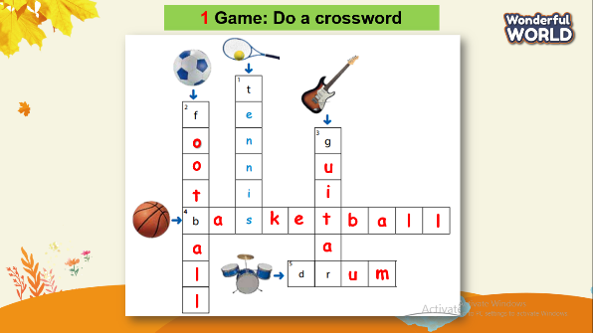  - Play game.
Extra activity (10 minutes )
Teacher’s activities | Student’s activities
Task1: Interview  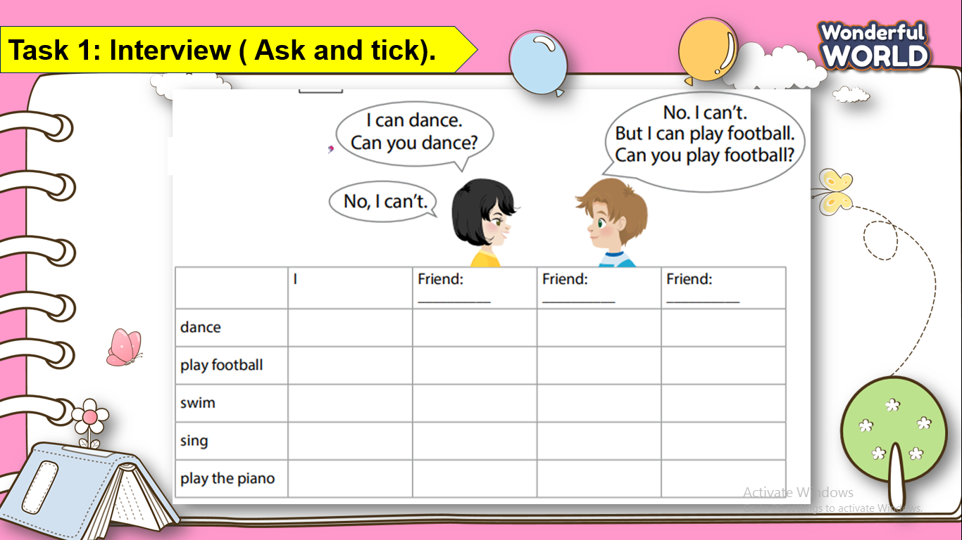  + T asks Ss to interview their friends about activities and use structure" What can you do " and tick their friend can do. If any students finish all information in interview paper will become winner and receive stars or candies from teacher.  - Go around the class to interview classmate.  - Speak the hobby of each friend in interview paper . | - Go around the class and interview.  - Be confident to speak in front of the class.
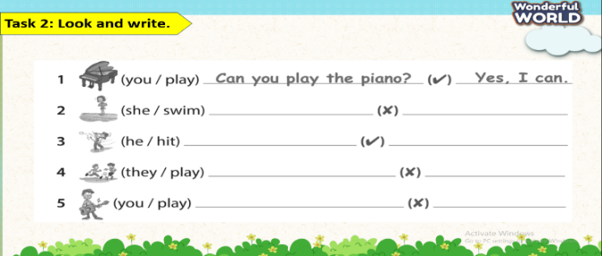  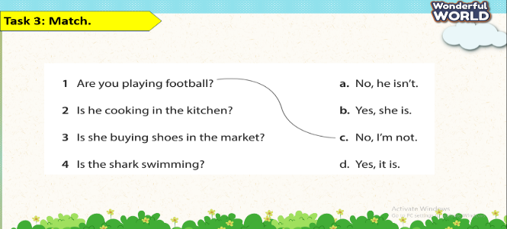  - Check answers.  - Say goodbye | 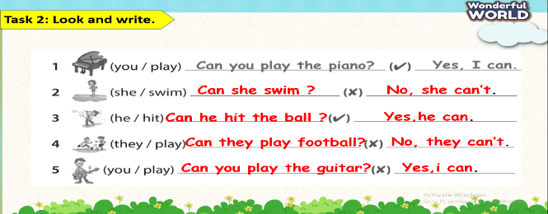  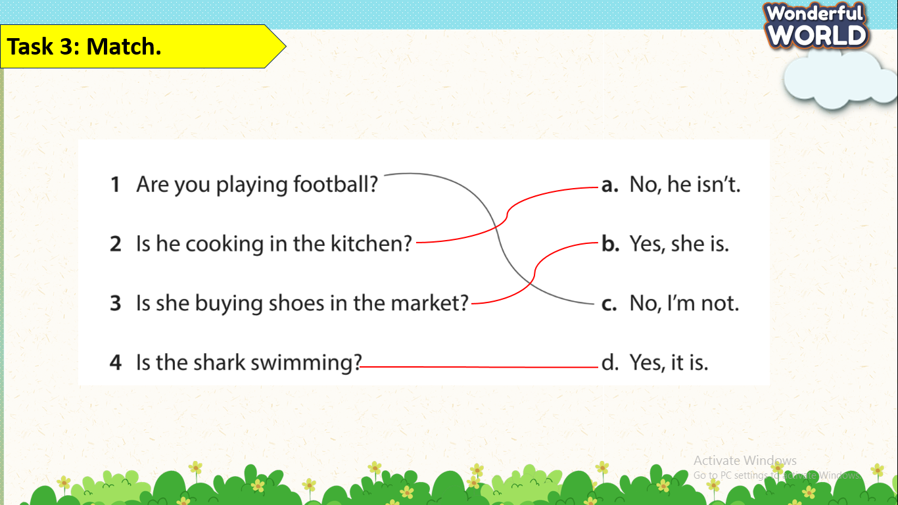  - Check with friends and then with teacher and whole class.  - Look and read aloud.  - Say goodbye.

GRADE 5
Week 23 (From 24/2 to 28/2)
REVIEW 4
Part 1 – Task 1,2,3
Period 89
I. OBJECTIVES:
1. Knowledge:
- Students review words of sports: Helmet, win, brain, kick, fast, race
- Students review grammar about:
+ Present continuous
+ Should/ shouldn’t
+ Adverbs of frequency
+ Must / mustn’t
2. Competences:
- English competences: Students can use English to introduce about sports
- Common competences: Students can communicate with each other, using adverbs of frequency.
3. Qualities:
- Students will
+ have a strong curiosity in exploring different types of sports.
+ recall and reflect on personal experiences with the Ss’s favorite sport and make them more meaningful and memorable.
II. EQUIPMENT AND MATERIALS:
- Basic things: Student’s book, flashcards, photos, papers
- Advanced things: PPT, laptop, TV.
III. LESSON PROCEDURE:
Activity 1: Warm-up (5 minutes)
A guessing game
Aims: Welcome students. Engage the class (or warm the class up) with a guessing word game to revive the vocabulary (write the words here….) and lead in the new lesson.
Teacher’s Activities | Students’ Activities
Procedure
1. Greet students. Chatting…Do you like playing games…  2. Introducing the game: Show the question, each riddle has 2 or 3 suggestions so that S can guess and engage the game by answering the questions.  Answer keys :  1. mind  2. soap  3. competition  4. towel  5. helmet  6. garden  Lead in:  - T raises some pictures and asks Ss to guess the lesson's topic.  - T reviews the topic “Sports”  - Write “Review 4” on the board and review the words and structures of the learned lesson. | - Greet Teacher.  - Listen to the clues.  - Look at the pictures and guess the topic.
Activity 2: Review (12 minutes)
Aims:
- Review the words: Helmet, win, brain, kick, fast, race
- Review Grammar:
- Present continuous
- Should/ shouldn’t
- Adverbs of frequency
- Must / mustn’t
Teacher’s Activities | Students’ Activities
REVIEW  - Show the words on the screen.  - Ask students to look at the screen and say the word.  - Show the text and audio.  - Ask Ss to listen again and repeat after the audio.  - Can play twice or three times so that Ss can practice the words.  - Ask some students to read the words or phrases individually.  REVIEW GRAMMAR:  T shows the tables of the grammar content. Explain and give them some examples:  - Present continuous  - Should/ shouldn’t  - Adverbs of frequency  - Must / mustn’t | - Look at the screen and say the words.  - Check the words and listen to the audio.  - Listen and repeat.  - Listen to the explanation.  - Create the sentences and speak in front of the class.
Activity 3: Practice – Controlled practice (8 minutes)
Aims:
- Ss join the game to review grammar about must/ mustn’t / should…
- Finish task 2
Teacher’s Activities | Students’ Activities
2 Look and read. Write Yes or No.  Explain to the students that they will be looking at different signs or notices and deciding whether the actions mentioned are allowed or not allowed.  Explain that students need to decide if the action mentioned is allowed or not allowed and write “yes” or “no” accordingly. Elicit the first one as an example.  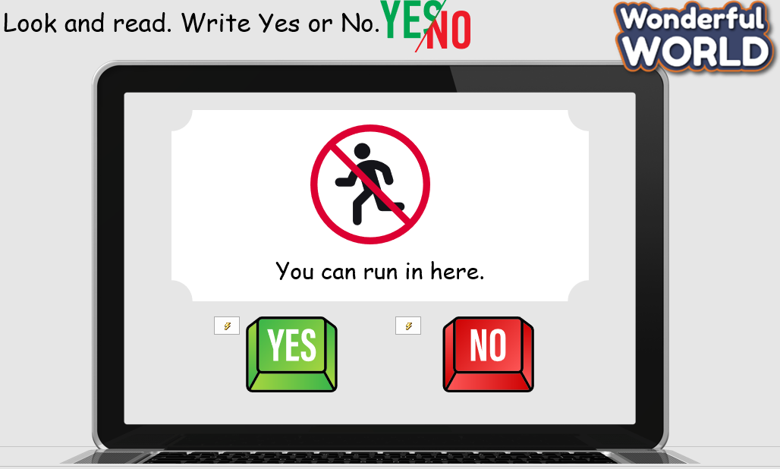  Allow students time to read each notice and decide if the action is allowed or not allowed.  - After the students have completed the activity, go over each notice one by one.  - Ask individual students to share their answers and reasoning.  - Discuss any differences in interpretation and clarify any misunderstandings.  - Summarise the activity by emphasizing the importance of following rules and respecting signs or notices in public places. | - Listen to the teacher.  - Answer the questions.
Activity 4: Production – Free practice (6 minutes)
Aims:
- Apply the words to communicate in front of the class.
- Encourage Ss to make conversation and speak freely in front of the crowd.
Teacher’s Activities |  | Students’ Activities
3 Write and say.  - Tell students they are going to read and answer questions about their habits.  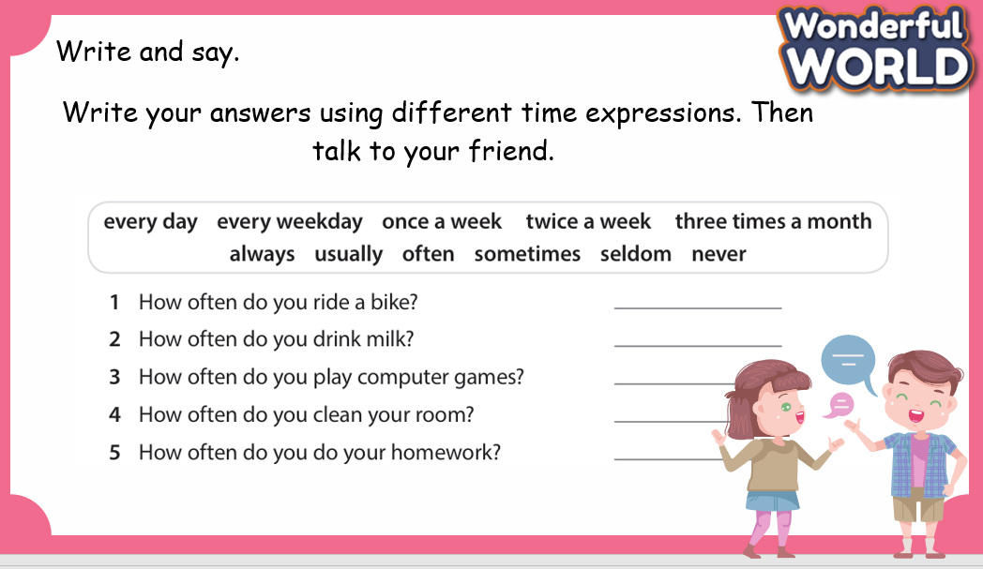  - Ask them to read the questions and then write their answers.  - Read out the questions and make sure that students understand the meanings of the questions.  - Allow students enough time to complete the task alone. Go round the class helping students where necessary.  - Give students some time to practise asking and answering in pairs.  - Ask some volunteers to read out their notes. Correct any mistakes. |  | - Present in front of the class.  - Try to answer the question.
Activity 5: Wrap-up & Assessment (4 minutes)
Teacher’s Activities |  | Students’ Activities
Aims:
- Check Ss’s understanding of what they have learnt.
- Students rehearse what they have learnt in the lesson.
- Ask Ss to do the assessment.  - Give the assessment to the class and some Ss  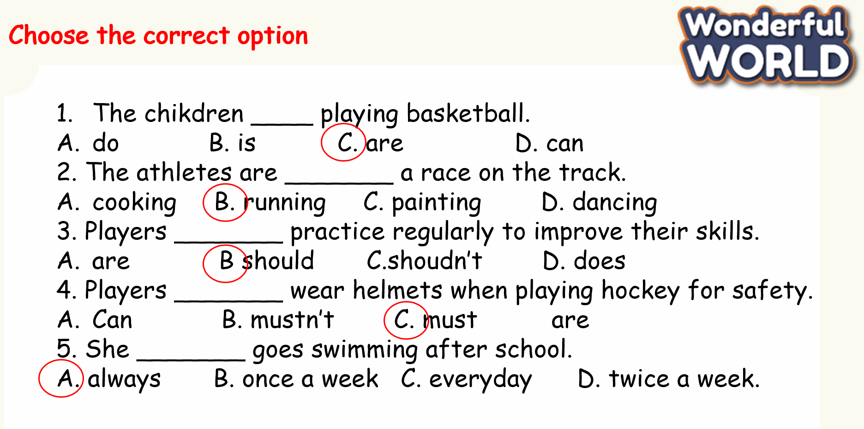  - Check with the class.  - T asks Ss about what they have learnt in today’s lesson.  - T shows the wrap-up slide and concludes the lesson.  * Remember  Vocabulary  Helmet, win, brain, kick, fast, race  Grammar  - Present continuous  - Should/ shouldn’t  - Adverbs of frequency  - Must / mustn’t |  | - Do the assessment.  - Check with the teacher.  - Answer T’s question of what they have learnt in today’s lesson.  - Ss read the wrap-up.  - Stand up and say goodbye to the teacher.

REVIEW 4
Part 2 – Task 4.5.6
Period 90
I. OBJECTIVES:
1. Knowledge:
- Students review words of activities: climbing, cycling, running, riding, sailing
- Students review the connectors: and, so, but, because
2. Competences:
- English competences: Students can use English to talk about their activities.
- Common competences: Students can use some connectors such as and, so, but, because
- Students will
+ have a strong curiosity in exploring different types of activities and sports.
+ recall and reflect on personal experiences about types of activities and make them more meaningful and memorable.
II. EQUIPMENT AND MATERIALS:
- Basic things: Student’s book, flashcards, photos, papers.
- Advanced things: PPT, laptop, TV.
III. LESSON PROCEDURE:
Activity 1: Warm-up (5 minutes)
Let’s sing a song!
Aims: Welcome students. Engage the class (or warm the class up) with a song lead in the new lesson.
Teacher’s Activities | Students’ Activities
Procedure
1. Greet students. Chatting…Do you like listening to and singing a “What do you like to do?” song?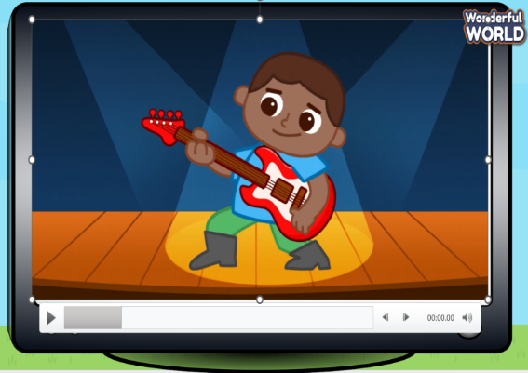  Lead in:  - T raises some pictures and asks Ss to guess the topic of the lesson.  - T reviews the topic “Sports”.  - Write “Review 4” on the board and review the words and structures of the learned lesson. | - Greet the T.  - Listen to the video  - Sing along together  - Look at the pictures and guess the topic.
Activity 2: Review (12 minutes)
Aims:
- Review the words: climbing, cycling, riding, running, sailing
+ Ss know how to practice correctly some vocabulary.
+ Finish Task 1- Write correct numbers next to the pictures
Teacher’s Activities | Students’ Activities
REVIEW  - Show the words on the screen.  - Ask students to look at the screen and say the word.  - Show the text and audio for each word.  - Ask Ss to listen again and repeat after the audio.  - Can play twice or three times so that Ss can practice the words.  - Ask some students to read the words or phrases individually.  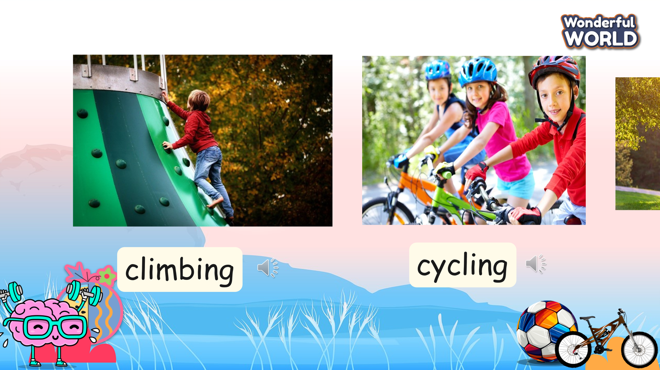  Part 1: Listen and write the numbers next to the sports.  - Show the pictures and answer which sports they are.  - Tell Ss that they are going to listen to five short talks carefully and find out what they are talking about.  - Ask Ss to write the correct numbers in the correct boxes.  - Play the recording, pause at the first talk, and check with the class why riding is numbered 1.  - Let them finish the task individually.  - Check correct answers with the whole class.  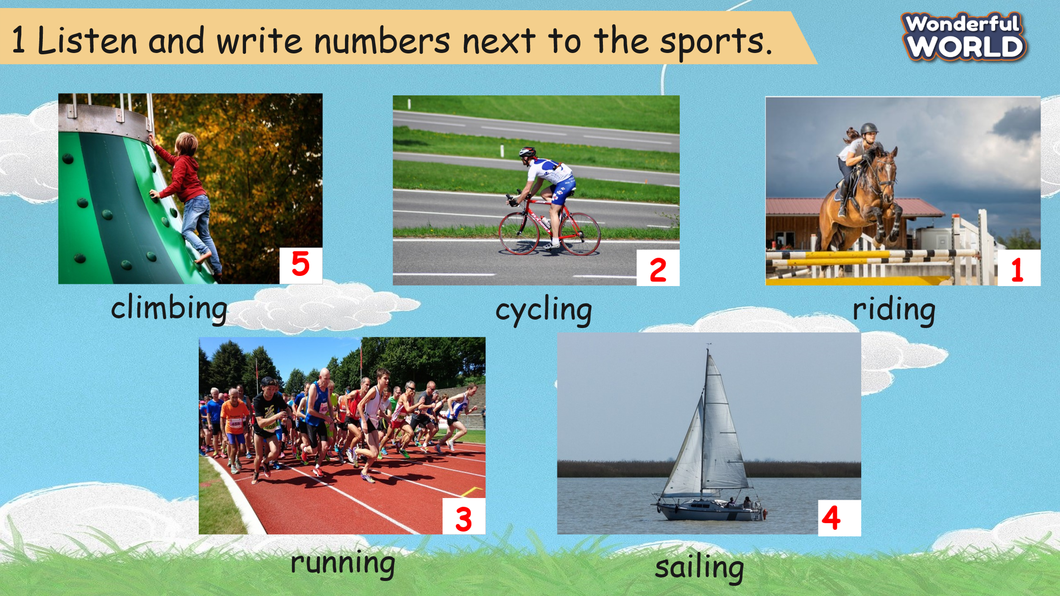 | - Look at the screen and say the words.  - Check the words and listen to the audio.  - Listen and repeat.  -Answer what sports they can see: I can see climbing, cycling, riding …  - Listen to the example carefully and write number 1 in the box of riding.  - Listen to the recording to finish task 1.  -Check the answers.
Activity 3: Practice – Controlled practice (8 minutes)
Aims:
- Ss join the “Goalkeeper” game to review some connectors such as: and, so, but, because
- Finish task 2: Complete the sentences with and, so, but, because
Teacher’s Activities | Students’ Activities
Game: “Goalkeeper”  -Let Ss take part in the game to choose the correct answers.  - T shows Ss some questions and answers.  - Ask them to choose the missing words. If they have correct answers, they can roll the dice to get stars for their teams.  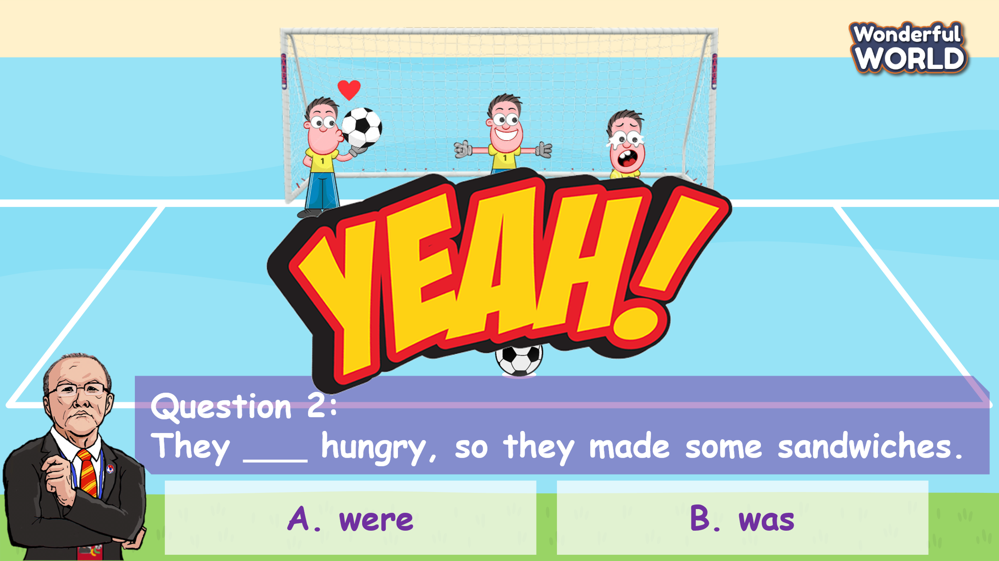  “Look at the pictures and fill in the missing blank with correct answers.”  “If you have correct answers, you can roll the dice to get stars.” Part 2: Complete the sentences with and, so, but, because  -T shows Ss 5 sentences with the gaps, then asks Ss to read some connectors that they can see.  - Read out the first sentence and ask Ss about the answer to fill in the blank and why an is the correct answer.  - Make sure that Ss can understand all four connectors meaning.  - Explain the rest of the task and let them fill in the blanks. Go round the class helping Ss.  - Check the answers as a class. | Ss participate in the game.  - Look and choose correct answers.  -If they have correct answers, Ss can roll the dice to get stars.  Answer: 1. B and  2. A were  3. B but  4. A Nam walked slowly because he was tired.  5. A didn’t  -Ss look at the sentences and the gap.  - Read out the first sentence and choose the correct connectors.  - Answer the meaning of connectors.  - Finish part 2 individually.  -Check the answers as a class.
Activity 4: Production – Writing (6 minutes)
Aims:
- Apply the words to complete the text and encourage Ss to read out the text.
- Finish task 3: Read the text. Choose and write the correct word next to numbers 1-7.
Teacher’s Activities | Students’ Activities
Matching game:  - T shows Ss some pictures and words.  - Then ask them to match pictures with the correct words.  - If they have correct answers, they can throw the ball to get stars.  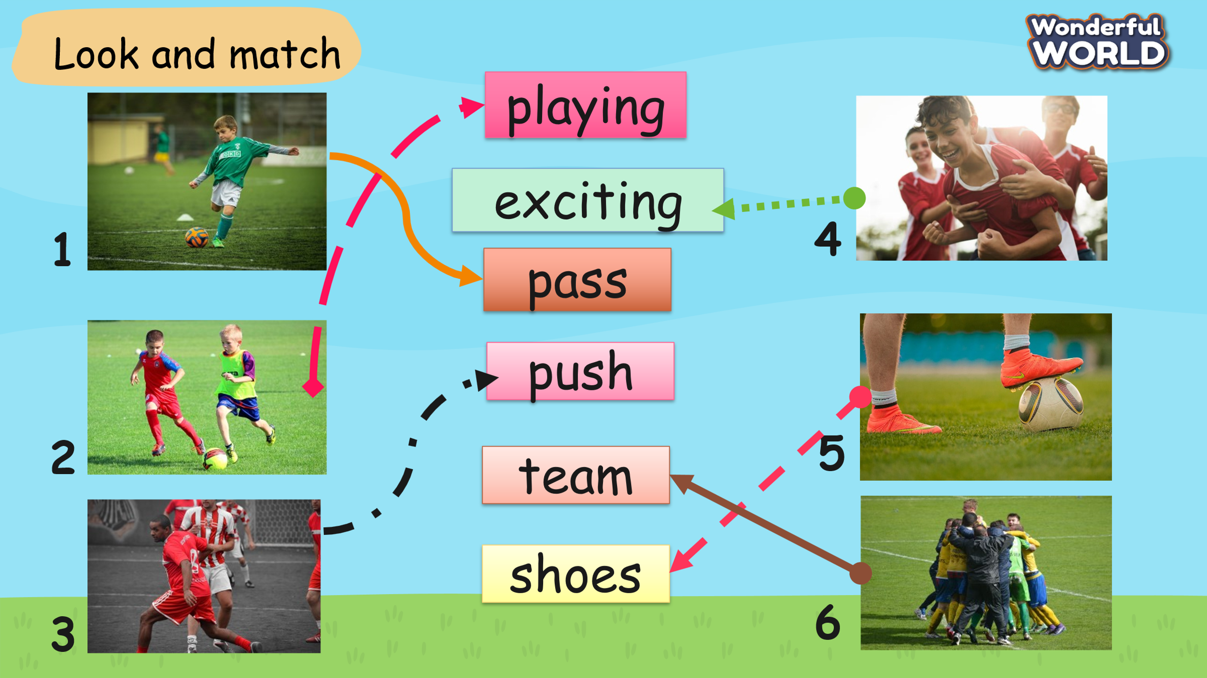  - Give them feedback and make sure that Ss can understand the meaning of those words.  Part 3: Read the text. Choose and write the correct word next to numbers 1-7  -Tell Ss to look at the text and go through all the given words.  - Ask Ss to complete the text with the words in the box.  - Read out the first sentence and ask Ss why playing is the correct answer.  - Ask Ss to do the task individually.  - Call some Ss to come to the board and write their answers.  - Check answers with the class. | -Ss take part in the game by matching the correct words to correct answers.  - They can throw the ball if they have correct answers.  -Look at the text and read all the given words.  -Complete the text with those words.  -Read out the first sentence and answer why they choose playing.  - Do the task individually.  - Some Ss write the answers on the board.  - Check their answers.
Activity 5: Wrap up & Assessment (4 minutes)
Teacher’s Activities |  | Students’ Activities
Aims:
- Check Ss’s understanding of what they have learned.
- Students rehearse what they have learned in the lesson.
- Ask Ss to do the assessment.  - Give the assessment to the class and some Ss.  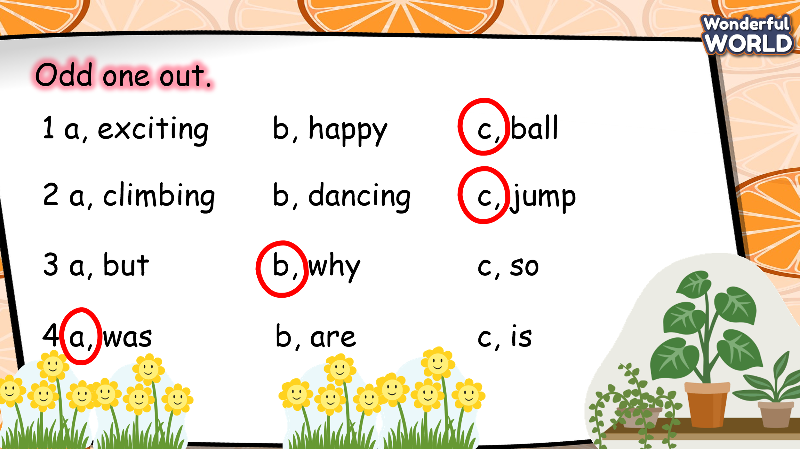  - Check with the class.  - T asks Ss about what they have learnt in today’s lesson.  - T shows the wrap-up slide and concludes the lesson.  * Remember  VOCABULARY  Climbing, cycling, riding, running, sailing  STRUCTURE  -Connectors: and, so, but, because  - Review all sentence patterns in Unit 8. | - Do the assessment.  - Check with the teacher.  - Answer T’s question of what they have learnt in today’s lesson.  - Ss read the wrap-up.  - Stand up and say goodbye to the teacher.

REVIEW 4
Part 3 – Video
Period 91
1. Knowledge:
- Students learn about water sports in general, and kayak in specific.
- Students know how to keep them safe when playing on the beach.
2. Competences:
- English competences: Students will be able to talk about kayak and answer the questions after watching a video.
- Common competences: Students will be able to keep themselves safe when playing near/on the beach.
3. Qualities:
- Students will
+ have a strong curiosity in exploring a new water sport.
II. EQUIPMENT AND MATERIALS:
- Basic things: Student’s book, flashcards, photos, papers.
- Advanced things: PPT, laptop, TV.
III. LESSON PROCEDURE:
Activity 1: Warm-up (5 minutes)
Watch a warm-up video
Aims: Welcome students. Engage the class (or warm the class up) with a video about doing exercises to encourage SS before leading in the new lesson.
Teacher’s Activities | Students’ Activities
Procedure
1. Greet students. Chatting…Do you like playing games…  2. Introduce the video: warm-up song  - Ask all of the Ss to stand up and do some warm-up first.  - Tell them that they will watch a video and do some exercises. Pay attention to the characters in the video and follow them.  - Play the video and start doing exercise.  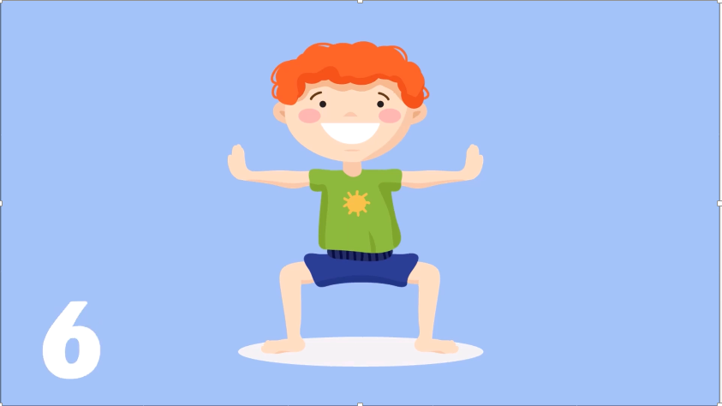  Lead in:  - T raises some pictures and asks Ss to guess the topic of the lesson.  - T introduces the topic “kayak”.  - T writes on the board “Review 4” and leads in the lesson. | - Greet the T.  - Listen to the introduction.  - Watch the video and do the exercises.  - Look at the pictures and guess the topic.
Activity 2: Presentation (20 minutes)
Aims:
- Introduce the vocabulary about kayak: wave, whirlpool, kayak, seabed
+ Ss know how to describe a festival
+ Finish Task 1, 2, 3, 4
Teacher’s Activities | Students’ Activities
- Show the words on the screen.  - Ask students to look at the screen and guess the word.  - Show the text and audio for each word.  - Ask Ss to listen and repeat after the audio.  - Play twice or three times so that Ss can practice the words.  - Ask some students to read the words or phrases individually.  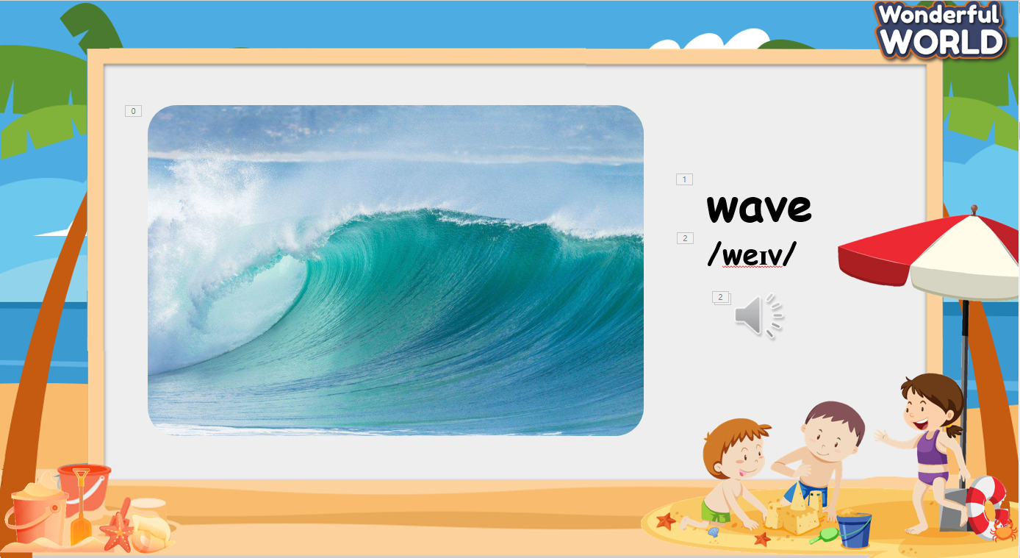  Task 1: Before you watch.  - Read the instructions to the class. Invite students to read the  list of words.  - Point to the first word, swimming. Ask a student, “Do you like swimming?” Elicit either “Yes, I do” or “No, I don’t” and tell  students to circle the word if the answer is Yes, but to leave  it blank if the answer is No.  - Repeat with the remaining word. Tell students to circle the  words if they like doing those sports.  - Go around the class asking students questions, e.g., “Do you like climbing? Where do you go climbing?”  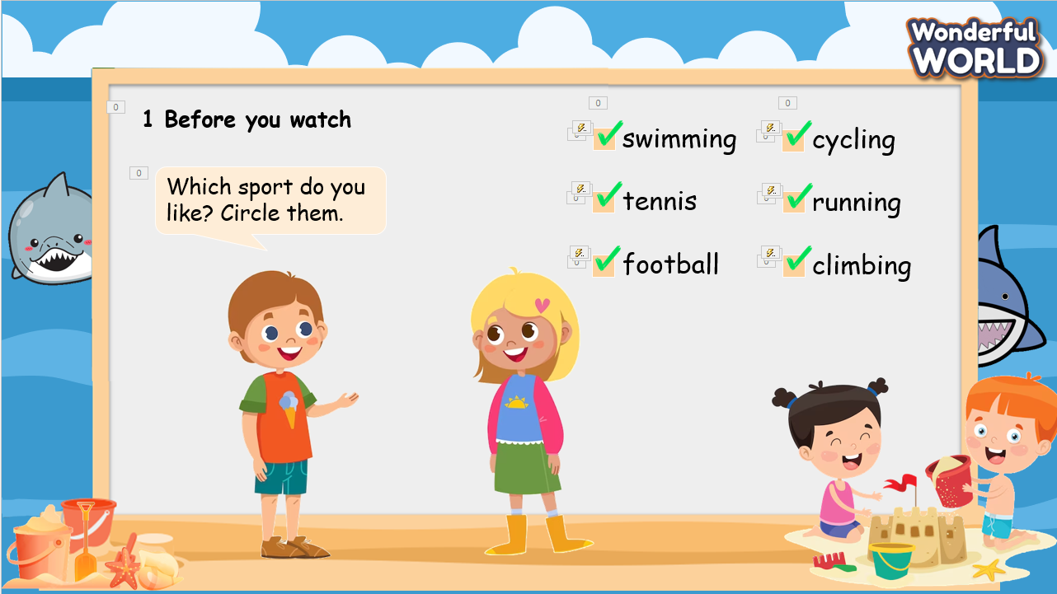  While you watch  Remind Ss of the questions they need to answer:  1. Are there kayaks in the video?  - _________.  2. Do the kayakers move quickly or slowly?  - _________.  3. Are there lots of waves?  - _________.  After watching  - Invite some Ss to answer the three questions above and check the answer.  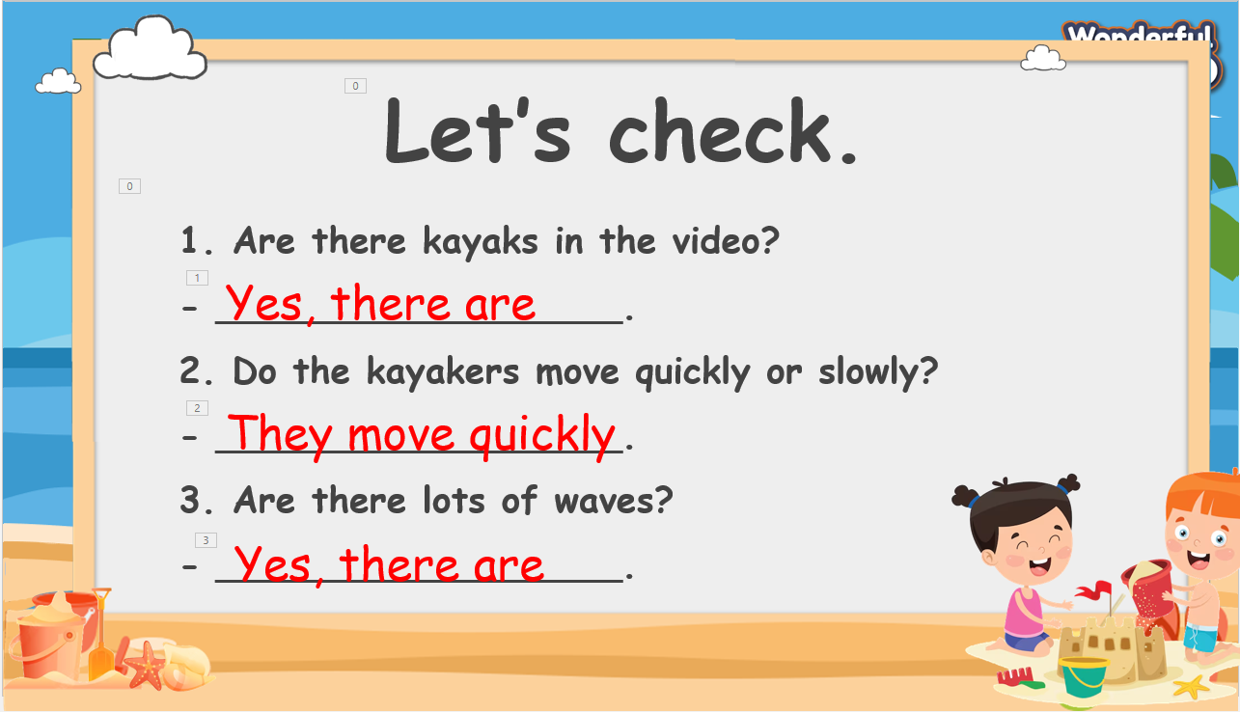  Task 4. After watching the video.  - Show the statements on the screen. Ask if Ss remember the content of the video.  - Ask Ss if it is necessary to play the video again.  - If yes, play the video and give Ss some minutes to finish the task.  - Invite some Ss to write their answers on the board.  - Play the video and check each Ss.  - Show the answers on the screen and check.  Treasure hunt Game.  T divides the class into 2 groups. Each group will choose a name and play rock, scissors, and paper to decide which group goes first.  Two groups will take turns to answer the corresponding questions to review what they have seen in the video.  T click on the answer to check. If it is correct, click on the chest to open it and show the points.  If the answer is incorrect, move to the next question.  When all the questions are answered, the team with the higher score will win the game.  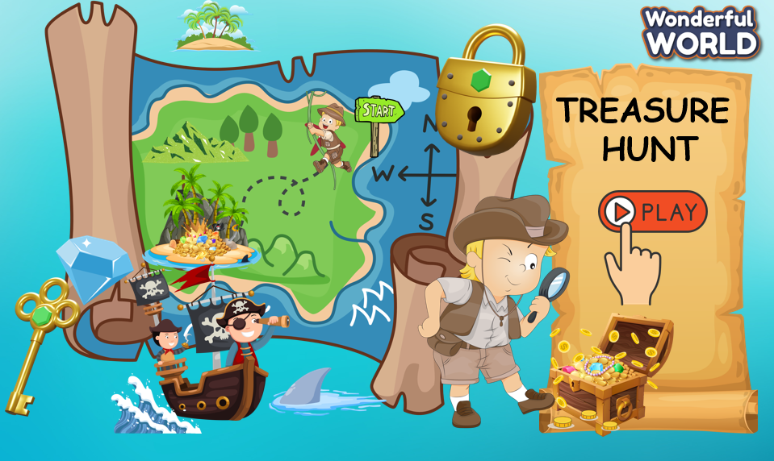 | - Look at the screen and say the words.  - Check the words and listen to the audio.  - Listen and repeat.  - Look at the screen and listen to the explanation.  - Look at the task on the screen and discuss it with T  - Discuss with the class, and explain why we should take the items  - Check the answer.  - Remember/take a note of the question  - Watch the video  - Answer the question  - Watch the video again and check the answer  - Check the statements on the screen.  - Ask T to play the video again before starting task 4.  - Fill T / F in the box.  - Write the answer on the board.  - Watch the video again and check the answers.  - Listen to the rules of the game.  - Appoint a representative to do rock, scissors, and paper to decide who goes first.  - Choose the number pay attention to the questions, and then answer.  - If the answer is correct, spin the wheel to get the points.  - If not, the next team will choose another number to continue the game.  - Check the results.
Activity 3: Production – Crafting (6 minutes)
Aims:
- Guide Ss on how to be safe when playing on a beach
- Encourage Ss’ creativity and develop teamwork skills
Teacher’s Activities |  | Students’ Activities
- Show the question on the screen.  - Ask Ss to think of the video and the game and review how to be safe when playing on a beach.  - Suggest some equipment that keeps us safe.  - Put Ss into pairs and ask them to make sentences about those equipments. Encourage them to make it like a presentation (illustration and the presentation).  - Give them some time to finish their ideas.  - Invite some pairs to talk about the measures to be safe at a beach.  - Encourage other Ss to give out questions.  - Give them feedback.  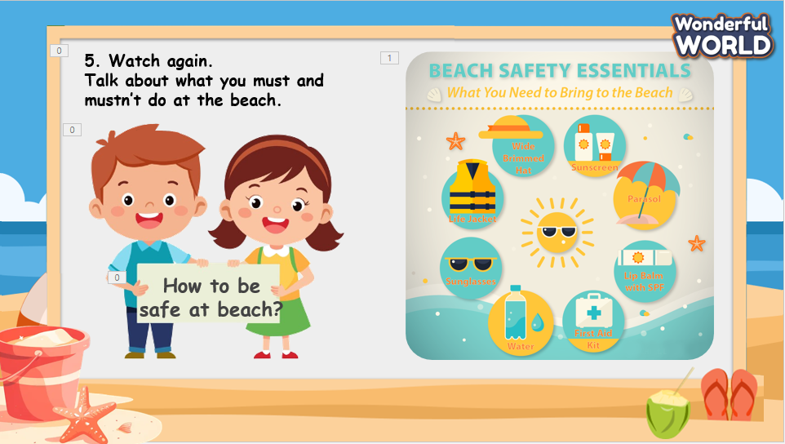 |  | - Look at the screen and identify the items needed.  - Sit in groups and listen to the instructions.  - Create their products.  - Make a short introduction about their product.  - Receive feedback.
Activity 4: Wrap up & Assessment (4 minutes)
Teacher’s Activities |  | Students’ Activities
Aims:
- Check Ss’s understanding of what they have learned.
- Students rehearse what they have learned in the lesson.
* Remember  VOCABULARY  Wave, whirlpool, kayak, seabed |  | - Ss read the wrap-up.  - Stand up and say goodbye to the teacher.

REVIEW 4
Part 4 – Task 1,2,3
Period 92
1. Knowledge:
- Students learn about different types of homes.
- Students are confident in talking about their favourite homes.
2. Competences:
- English competences: Students can talk about their home and answer the related questions (Where it is? How is it? Does it have a good view? Etc.)
- Common competences: Students can make a conversation about their homes.
3. Qualities:
- Students will
+ have strong confidence while talking about their favourite home in English.
II. EQUIPMENT AND MATERIALS:
- Basic things: Student’s book, flashcards, photos, papers.
- Advanced things: PPT, laptop, TV.
III. LESSON PROCEDURE:

Activity 1: Warm-up (5 minutes)
Watch video
Aims: Welcome students. Engage the class (or warm the class up) with a video about places in an Amusement park to encourage SS before leading in the new lesson.
Teacher’s Activities | Students’ Activities
Procedure
1. Greet students. Chatting…Do you like listening to music…  2. Introduce the video “Amusement Park”  - Show the question on the screen and remind Ss to pay attention and take notes if needed while watching the video.  - Play the video.  - Ask Ss about the topic of the video.  - Ask Ss about the question, and invite some Ss to show their answer.  - Check the answer and ask Ss to repeat.  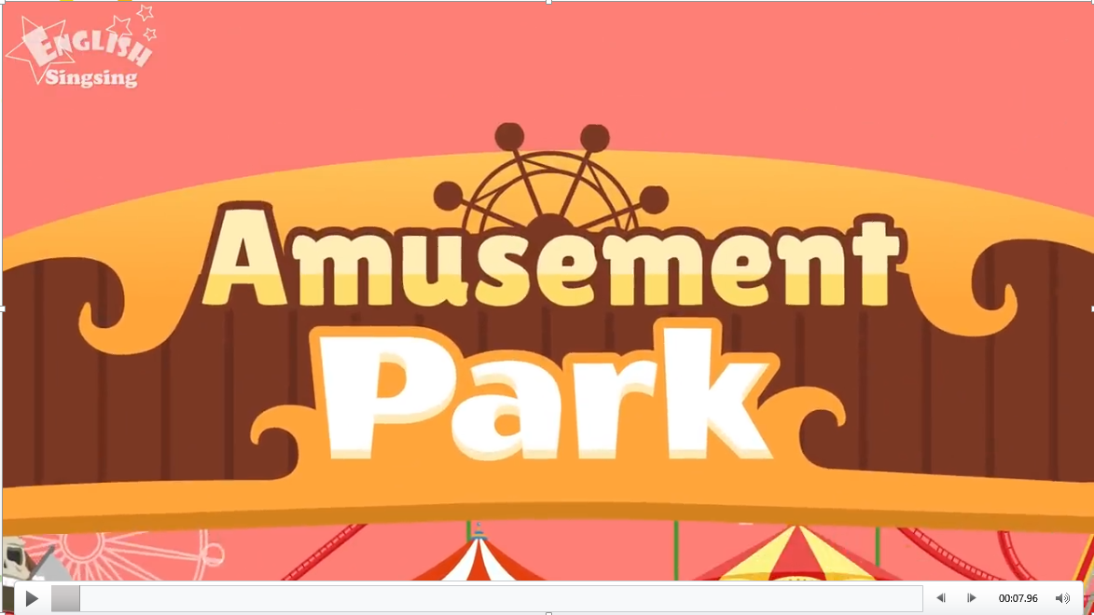  Lead in:  - T raises some pictures and asks Ss to guess the lesson's topic.  - T reviews the topic.  - Write “Review 4” on the board and review the words and structures of the learned lesson. | - Greet the T.  - Listen to T’s instructions about the warm-up activity.  - Watch the video and take note of what they have seen.  - Answer the questions.  - Check the results.  - Repeat after T.  - Look at the pictures and guess the topic.
Activity 2: Presentation (12 minutes)
Aims:
- Ss can read, understand, and answer the questions based on given information.
- Ss talk about their favourite home.
+ Finish Task 1
Teacher’s Activities | Students’ Activities
PRESENTATION  - Show the words on the screen.  - Ask students to look at the screen and guess the word.  - Show the text and audio for each word.  - Ask Ss to listen and repeat after the audio.  - Play twice or three times so that Ss can practice the words.  - Ask some students to read the words or phrases individually.  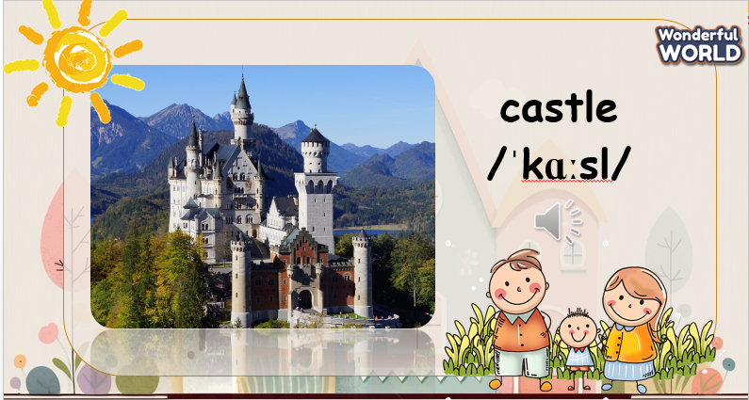  Task 1. Look and match. Which one is your favourite? Why?  - Tell the students that they are going to match words and pictures.  - Divide students into pairs or groups to do the matching task.  - Show students how to do the task if necessary by matching the first word with the correct picture. Praise or award a prize to the quickest pair or group with all correct answers.  - Ask students where they can find each of these places (castle: in the countryside/city; cottage: in a village/town/countryside; flat: in a town or city; houseboat: on a river; motorhome: in a town, city or countryside; tower: in the  countryside/city).  - Draw their attention to the questions. Let them think and  share their answers with their partners.  - Ask some volunteers to share their answers.  - Give feedback.  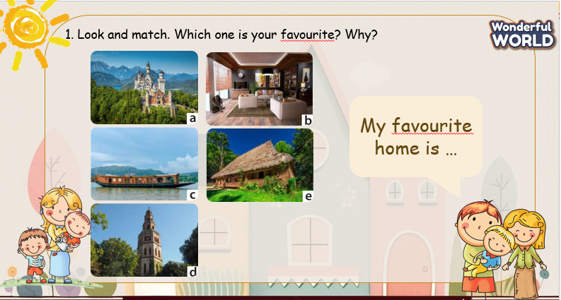 | - Look at the screen.  - Read through all three paragraphs.  - Read the text aloud.  - Look at task 2 and do the task.  - Write their answer on the board.  - Figure out the information in the paragraph and check the answer.  - Pay attention to the screen and review how the writer describes their favourite food.  - Make sentences and say them aloud.
Activity 3: Practice – Controlled practice (8 minutes)
Aims:
- Help Ss to remember the words they have learnt.
- Practice listening and answer the questions about each character’s home.
- Join a small game to review the text.
Teacher’s Activities |  | Students’ Activities
Task 2. Three people are talking about their homes. Listen  and complete the table.  - Tell students to look at the table to see what information to listen out for and complete with one-word answers. Play the recording.  - Play the recording again. Ask students to check and discuss any  different answers with a partner.  - Check answers as a class. 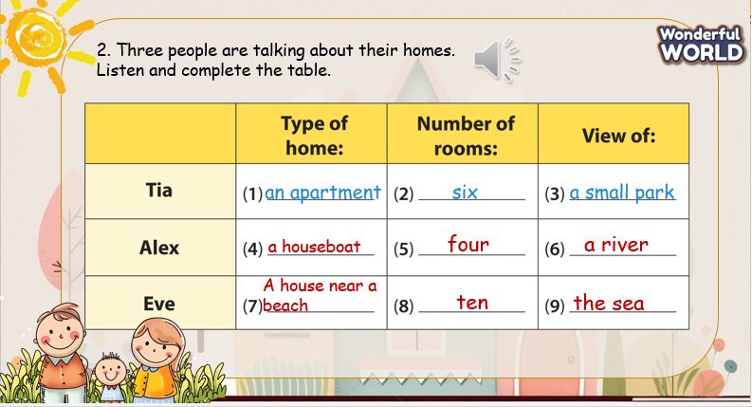  Plant vs Zombie  - Divide the class into 2 groups. Each group will choose a name and play rock, scissors, and paper to decide which group goes first.  - Two groups will take turns to choose a number and answer the corresponding questions to review what they have listened to in the video.  - Clicks on the check button to show the answer. If it is correct, click on the back button, then click on the plant to destroy the zombie and reveal the points.  - If the answer is incorrect, move to the next question.  - When all the questions are answered, the team with the higher score will win the game.  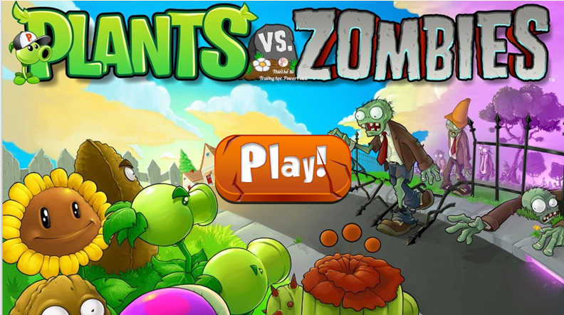 |  | - Read the text again.  - Create questions based on each paragraph.  - Work in pairs, and create a full conversation, using the given text.  - Receive feedback, and answer further questions.  - Listen to the rules of the game.  - Appoint a representative to do rock, scissors, and paper to decide who goes first.  - Read the clue.  - If Ss can answer, ring the bell and say the answer.  - If not, ask T to open the next clue.  - If all three clues are opened and Ss cannot answer, move to the next team.  - Check the results.
Activity 4: Production – Writing & Speaking (6 minutes)
Aims:
- Apply the structures used in the paragraph to write a note about Ss’ favourite home.
- Encourage Ss to introduce their favourite home to the class.
- Encourage Ss to be willing to answer the extra questions.
Teacher’s Activities |  | Students’ Activities
Task 3. Write  - Tell students to look at the sample. Read the example out  loud and ask students to repeat.  - Tell students to write a paragraph about their home, similar  to the example. Ask them to use the plan and answer the questions.  - Check students understand the task. Allow students enough time to complete the task.  - Check answers. Write any mistakes on the board and ask  students to correct them.  - Ask volunteers to read out their paragraphs.  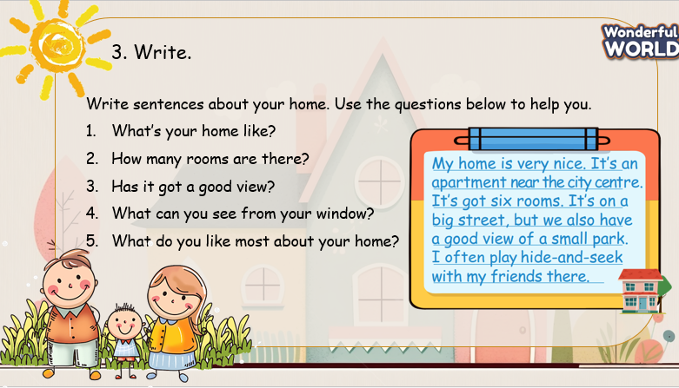 |  | - Look at the screen and work in pairs to make an introduction about their favourite home.  - Complete the introduction, using the suggestion on the screen.  - Speak in front of the class.  - Make comments for the speaker.  - Speaker: answer the extra questions.  - Receive feedback.
Activity 5: Wrap up & Assessment (4 minutes)
Teacher’s Activities |  | Students’ Activities
a, Aims:
- Check Ss’s understanding of what they have learned.
- Students rehearse what they have learned in the lesson.
* Remember  STRUCTURE  - My favourite food is ___.  - It’s delicious! / It’s great!  - I often eat it with ___.  - I often eat it in ___.  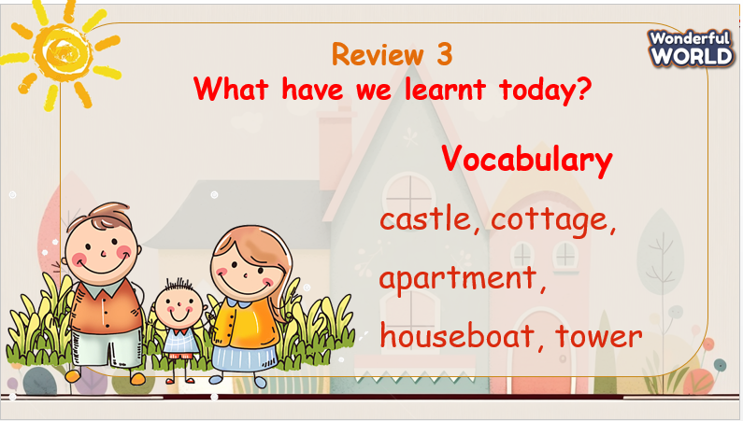 |  | - Ss read the wrap-up.  - Stand up and say goodbye to the teacher.

