TUẦN 24 Khối 3, 5 (Từ ngày 03/03/2025 đến ngày 07/03/2025)
THỨ | TIẾT | MÔN | TIẾT THỨ | NỘI DUNG BÀI DẠY |  | UDCNTT | ĐỒ DÙNG DẠY HỌC
Hai  03/03 | 1 | 5A | 93 | Unit 9. Holiday and travel | Lesson 1 (1, 2, 3) | Wonderfulworld | Flashcards, TV, books
Hai  03/03 | 2
Hai  03/03 | 3 | 3A | 93 | Unit 8. My town | Lesson 1 (1, 2, 3) | Wonderfulworld | Flashcards, TV, books
Hai  03/03 | 4 | 3A | 94 | Unit 8. My town | Lesson 1 (4, 5, 6) | Wonderfulworld | Flashcards, TV, books
Hai  03/03 | 5 | 5D | 93 | Unit 9. Holiday and travel | Lesson 1 (1, 2, 3) | Wonderfulworld | Flashcards, TV, books
Hai  03/03 | 6 | 3B | 93 | Unit 8. My town | Lesson 1 (1, 2, 3) | Wonderfulworld | Flashcards, TV, books
Hai  03/03 | 7
Ba  04/03 | 1 | 5C | 93 | Unit 9. Holiday and travel | Lesson 1 (1, 2, 3) | Wonderfulworld | Flashcards, TV, books
Ba  04/03 | 2 | 5B | 93 | Unit 9. Holiday and travel | Lesson 1 (1, 2, 3) | Wonderfulworld | Flashcards, TV, books
Ba  04/03 | 3 | 5A | 94 | Unit 9. Holiday and travel | Lesson 1 (4, 5, 6) | Wonderfulworld | Flashcards, TV, books
Ba  04/03 | 4
Ba  04/03 | 5 | 3A | 95 | Unit 8. My town | Lesson 2 (1, 2, 3) | Wonderfulworld | Flashcards, TV, books
Ba  04/03 | 6 | 5D | 94 | Unit 9. Holiday and travel | Lesson 1 (4, 5, 6) | Wonderfulworld | Flashcards, TV, books
Ba  04/03 | 7 | 3B | 94 | Unit 8. My town | Lesson 1 (4, 5, 6) | Wonderfulworld | Flashcards, TV, books
Tư  05/03 | 1 | 5A | 95 | Unit 9. Holiday and travel | Lesson 2 (1, 2, 3) | Wonderfulworld | Flashcards, TV, books
Tư  05/03 | 2
Tư  05/03 | 3
Tư  05/03 | 4
Tư  05/03 | 5 | 5B | 94 | Unit 9. Holiday and travel | Lesson 1 (4, 5, 6) | Wonderfulworld | Flashcards, TV, books
Tư  05/03 | 6 | 5C | 94 | Unit 9. Holiday and travel | Lesson 1 (4, 5, 6) | Wonderfulworld | Flashcards, TV, books
Tư  05/03 | 7
Năm  06/03 | 1 | 5C | 95 | Unit 9. Holiday and travel | Lesson 2 (1, 2, 3) | Wonderfulworld | Flashcards, TV, books
Năm  06/03 | 2 | 5B | 95 | Unit 9. Holiday and travel | Lesson 2 (1, 2, 3) | Wonderfulworld | Flashcards, TV, books
Năm  06/03 | 3 | 5A | 96 | Unit 9. Holiday and travel | Lesson 2 (4, 5, 6) | Wonderfulworld | Flashcards, TV, books
Năm  06/03 | 4
Năm  06/03 | 5 | 5D | 95 | Unit 9. Holiday and travel | Lesson 2 (1, 2, 3) | Wonderfulworld | Flashcards, TV, books
Năm  06/03 | 6 | 5C | 96 | Unit 9. Holiday and travel | Lesson 2 (4, 5, 6) | Wonderfulworld | Flashcards, TV, books
Năm  06/03 | 7
Sáu  07/03 | 1 | 3B | 95 | Unit 8. My town | Lesson 2 (1, 2, 3) | Wonderfulworld | Flashcards, TV, books
Sáu  07/03 | 2 | 5D | 96 | Unit 9. Holiday and travel | Lesson 2 (4, 5, 6) | Wonderfulworld | Flashcards, TV, books
Sáu  07/03 | 3 | 5B | 96 | Unit 9. Holiday and travel | Lesson 2 (4, 5, 6) | Wonderfulworld | Flashcards, TV, books
Sáu  07/03 | 4
Sáu  07/03 | 5
Sáu  07/03 | 6 | 3B | 96 | Unit 8. My town | Lesson 2 (4, 5, 6) | Wonderfulworld | Flashcards, TV, books
Sáu  07/03 | 7 | 3A | 96 | Unit 8. My town | Lesson 2 (4, 5, 6) | Wonderfulworld | Flashcards, TV, books

GRADE 3
WEEK 24 (From 03/3 to 07/3)
UNIT 8. MY TOWN
Lesson 1 - Task 1,2,3
Period 93
I. OBJECTIVES:
1. Knowledge:
Students will learn new vocabulary about places in the town: in the library, in the museum, at the theater, at the zoo.
2. Competences:
- English competences: Students will be able to speak his/ her own location by using the structure: I’m +place. ( Ex: I’m in the museum).
- Common competences: Students will have the opportunity to develop creativeness in drawing projects and communication among friends.
3. Qualities:
- Students will be friendly and confident in communicating with friends.
II. EQUIPMENT AND MATERIALS:
- Basic things: Student’s book, flashcards, A4 paper.
- Advanced things: PPT, projector/interactive whiteboard/laptop/TV.
III. LESSON PROCEDURE:
Activity 1: Warm-up (5 minutes)
Teacher’s activities | Student’s activities
-Greet students  - “Racing car” Game :  + Divide the class into 4 teams and each team will choose a random letter for the team.  +Ss in each team write the word beginning with the letter of the team.  For example Team letter “B”: bee, brother, boy…  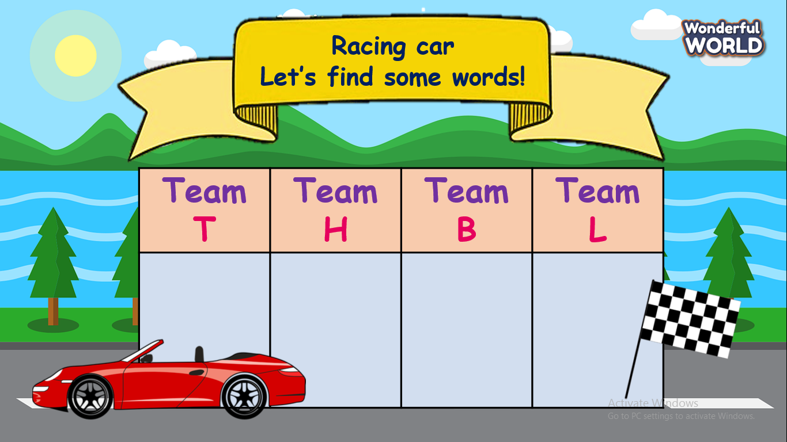  + T will record time. (about 3 minutes).  + T checks the writing of each word carefully.  + The team with the maximum number of words will be the winner.  *Unit opener  - Ask Ss to look at the picture and give them a few questions:  - What can you see in the picture?  - How many colors are there?  - Ask Ss to tick the right answers  - Check answers.  - Ask Ss to repeat the words in the task  (whole class, team and individual).  - Say random color and Ss will point and say the things that he owns that color.  - Introduce the picture’s context: colourful sky made by many umbrellas in Quebec, Canada. | -Greet teacher.  -Each student has to think one more word in his/her mind.  - Ss arrange in four lines and listen carefully teacher’s command to start the competition.  - Look and answer the questions:  - umbrellas, houses, trees, coffee shops…  - Yellow, blue, green, black, white, pink, red, orange.  -Receive stars from the teacher.  -Point and show the things that have the same color as T in the classroom.
Activity 2: Presentation (8 minutes)
Teacher’s activities | Student’s activities
Task 1. Listen, point and repeat. ( P.103)  -Use PowerPoint/ flash cash to teach vocabulary.  In the library, in the museum, at the theater, at the zoo.  - Play the recording. Tell students to  look at the pictures and follow the pictures with their fingers.  -Play the recording again. Ask  students to repeat.  CHECKING GAME : (Look and choose )  -Show a picture and two options about vocabulary. Have Ss look and choose.  1.  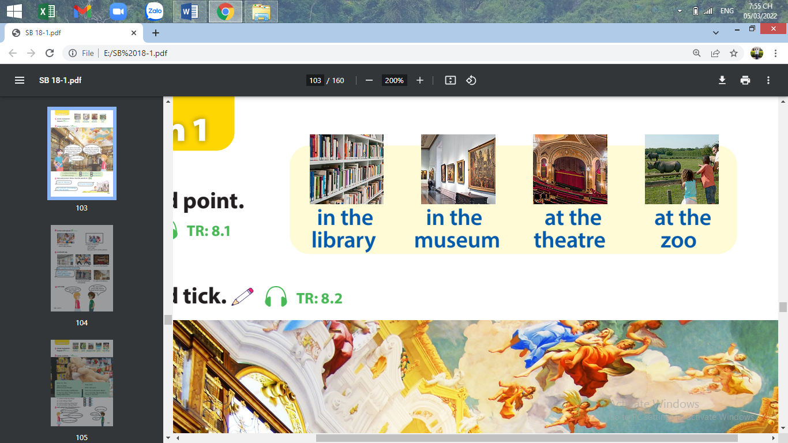  in the library/ at the theater  2.  at the zoo/ in the museum  3.  at the theater/ in the library  4.  in the museum/ at the zoo  - Check answer | -Ss listen and repeat.  - Ss listen point and repeat.  -Ss listen and choose  -Receive stars from T.  -Answer key:  - In the library  - In the museum  - At theater  - At the zoo
Activity 3: Practice (12 minutes)
Teacher’s activities | Student’s activities
-Lead-in task 2: Introduce the listening  -Show the picture in task 2.  - Ask Ss to look at the picture and answer:  + Where is she in the picture?  + What can you see?  - Play the recording. Tell the Ss to look at the picture and follow the text with their fingers  -Check answers.  1. Yes, he is  2.No.she isn’t  - Play the audio again and ask Ss to repeat  - Help Ss remember the content in the listening task.  - Play role  +Have Ss practice in pairs.  + Invite a few pairs to perform in front of the class. | - Answer the teacher’s questions  -Listen and follow the dialogue to tick the correct answer.  -Read aloud.  -Work in pairs and practice the dialogue.
Activity 4: Production (7 minutes )
Teacher’s activities | Student’s activities
* Let’s talk.  - Tell students to look at the sample sentences.  - Ask two students to read out the sample sentences again.  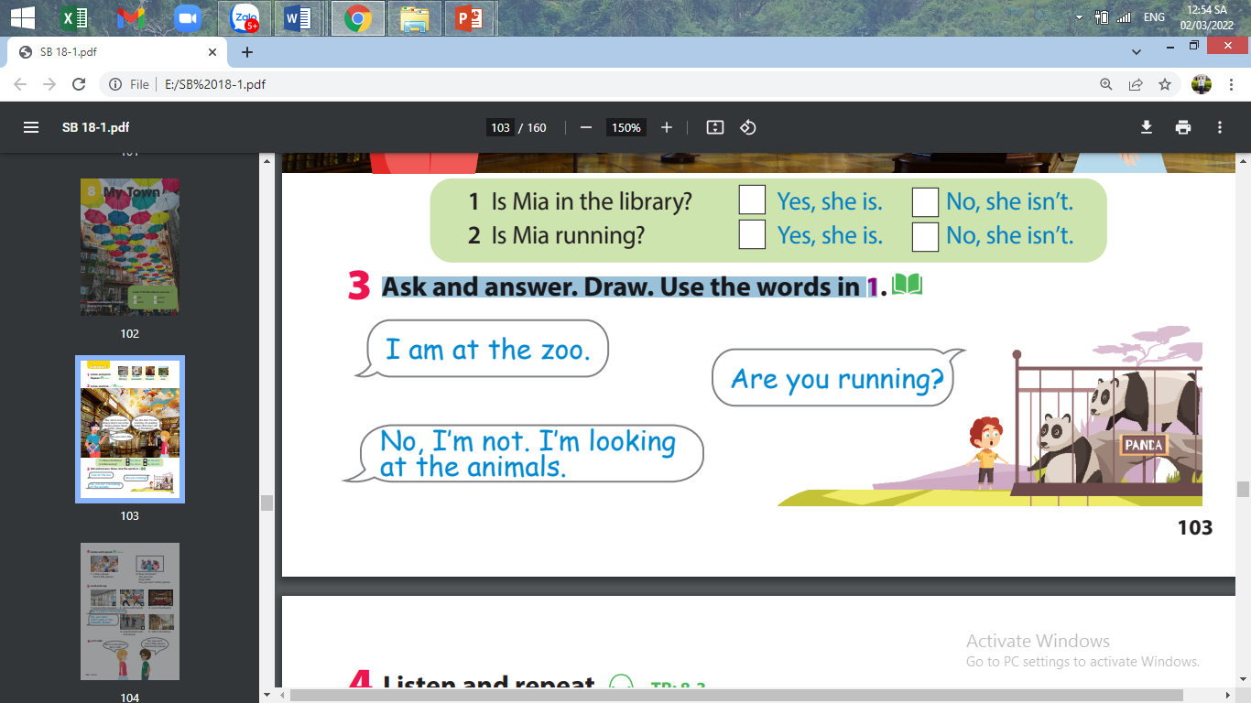  - Ask students to work in pairs. One student draws a picture, the other creates the conversation replacing with other new words  - Have Ss practice the conversation in pairs.  - Ask some volunteers to speak in front of the class. | -Look at the picture and read  -Work in pairs and do a project.
Activity 5: Assessment (3 minutes )
Teacher’s activities | Student’s activities
-Ask students to do an assessment.  Look and match  - Check in pair then the whole class.  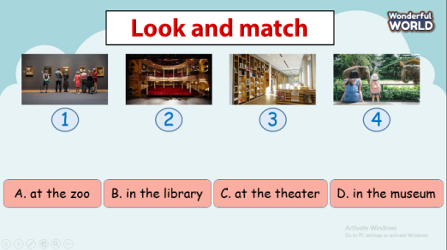  - Say goodbye | - Do the assessment.  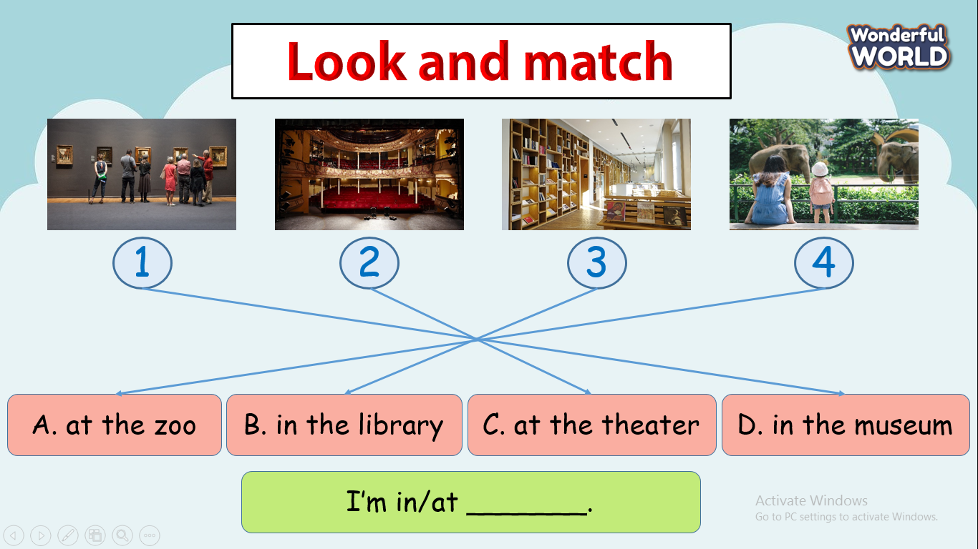  - Check with friends and then with the teacher and the whole class.  - Say goodbye by saying: I’m_(place)__
____________________________________

UNIT 8. MY TOWN
Lesson 1 - Task 4,5,6
Period 94
I. OBJECTIVES:
1. Knowledge:
- Students will learn the comparative Listen, please; Don’t talk, please… and asking for permission May I…. Yes, you can./No, you can’t.
2. Competences:
- English competences: Students will be able to follow or make comparisons and ask for permission in English.
- Common competences:
+ Students will have the opportunity to develop creativeness in making the project (rules in public places) and communication among friends.
3. Qualities:
- Students will be aware of the importance of the rules in class and public
II. EQUIPMENT AND MATERIALS:
- Basic things: Student’s book, flashcards, A4 paper.
- Advanced things: PPT, projector/interactive whiteboard/laptop/TV.
III. LESSON PROCEDURE:
Activity 1: Warm-up (5 minutes)
Teacher’s activities | Student’s activities
- Greet students  - “Simon says.” Game:  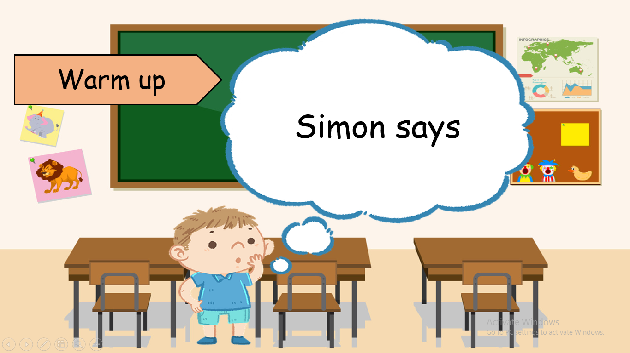  + Ss will not comply with the request if the command does not begin with the word “Simon says…”  + Dance, play football, talk, jump, run…  On the contrary, if the command sentence begins with “Simon says” but Ss do not follow the request, they will not receive stars for their team. | - Greet teacher  - Be quiet and listen carefully.  - Sit nicely if those Ss are the loser.
Activity 2: Presentation (7 minutes)
Teacher’s activities | Student’s activities
Task 4. Listen and repeat. ( P.103)  - Let Ss look at two pictures and ask Ss  + Where are they?  + How many people are there?  + What are they doing?  - Point to the pictures and teach command: Listen, please/ don’t talk, please and asking permission May I…. Yes, you can./No, you can’t.  - Play the recording. Tell Ss to  look at the pictures and follow the pictures with their fingers.  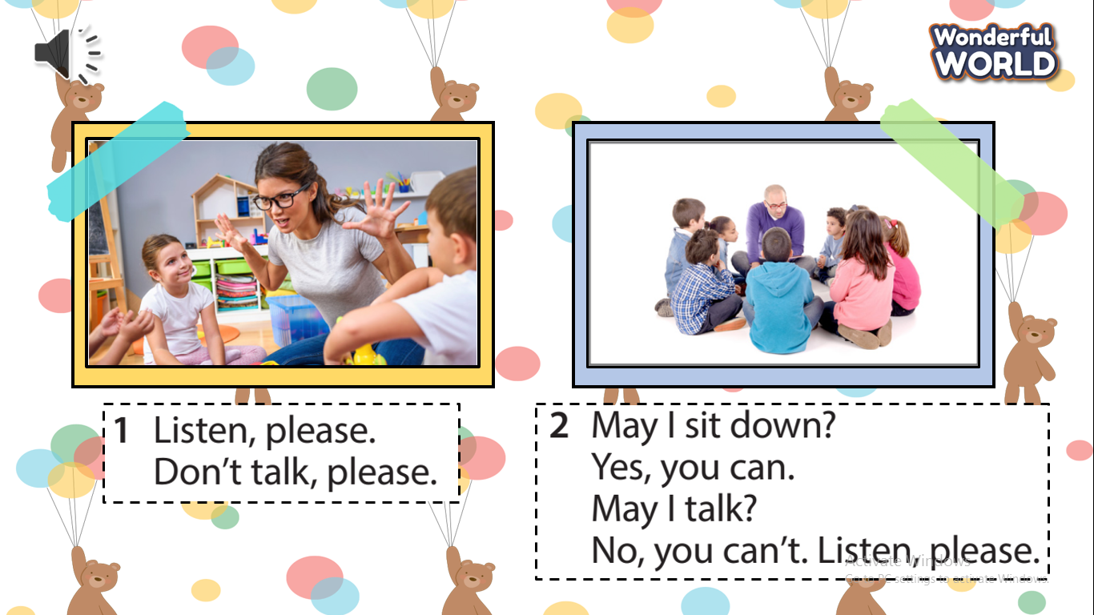  - Play the recording again. Ask Ss to repeat.  - Structure checking: “ whisper game”  + Prepare 4 sets of command cards and stick them on the board.  Listen, please  Don’t talk, please  May I talk?  May I sit down?  + T invites 4 players (The first person on each team) to go to the board and T whispers a message. Then each player whispers the message to the next player in his/her group until the last player gets the message then goes to the board and slaps the right command.  - The fastest team will be the winner. | - Answer T’s questions.  - Listen to understand the sentences.  - Listen to the T’s guide.  - Join the game.  - Listen carefully.  - Get stars from T.
Activity 3: Practice (10 minutes)
Teacher’s activities | Student’s activities
- Task 5: Look and say  - Tell Ss to look at the pictures and the prompts. Read out the prompts and ask students to repeat them.  - Tell Ss to look at the example.  Read out the example and ask  Ss to repeat.  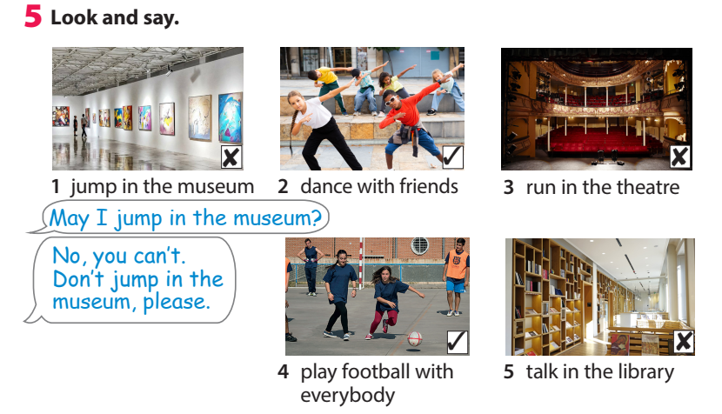  - Have Ss practice in pairs. Go  round the class helping students  where necessary.  - Ask Ss to work in pairs to say where they are and what they want their friends to do or not to do.  - Have some pairs present the conversation. | - Look and read aloud.  - Work in pairs and practice the dialogue.  - Read out the example
Activity 4: Production (10 minutes )
Teacher’s activities | Student’s activities
- Ask Ss to work in pairs to draw a table  ( place/do/don’t)  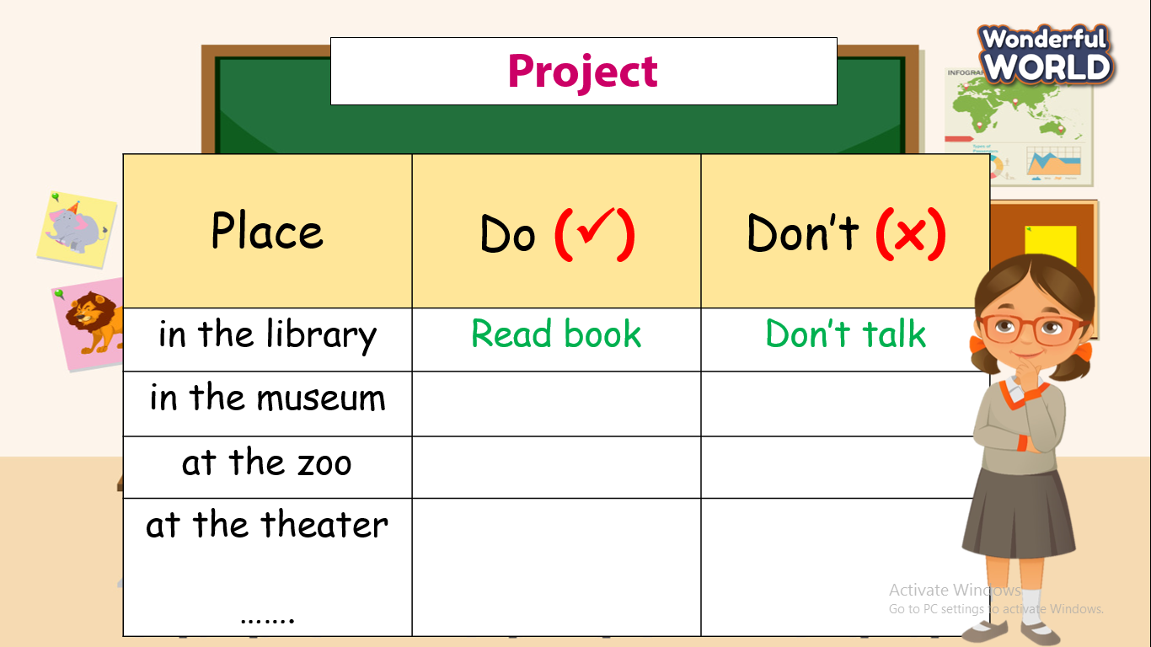  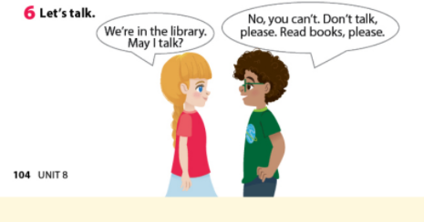  Ask Ss to work in pairs to say where they are and what they want their friends to do or not to do.  - Have some pairs present the conversation.  - fill in the blank. | -Work in pairs and do the project.
Activity 5 : Assessement (3 minutes )
Teacher’s activities | Student’s activities
-Ask Ss to do an assessment.  Look and choose  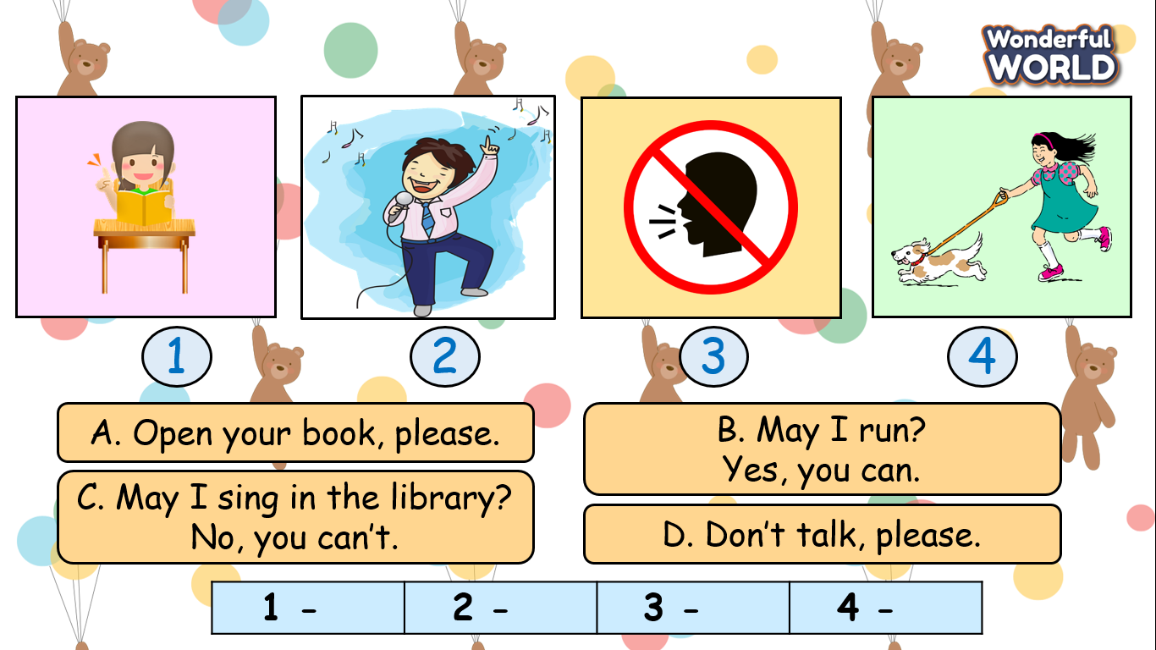  - Check in pair then the whole class.  - Say goodbye | -Do the assessment.  1-A  2-C  3-D  4-B  - Check with friends and then with the teacher and the whole class.  - Say goodbye by practising command:  Don’t___please!  ________Please!  May I_____ -Yes, you can/ No you can’t.
____________________________________

UNIT 8. MY TOWN
Lesson 2 -Task 1,2,3
Period 95
I. OBJECTIVES:
1. Knowledge:
Students will learn new vocabulary about places in the town: at the market, at the playground, at the toy shop, in the pool, in the park.
2. Competences:
- English competences: Students will be able to speak their location by using the structure: I’m +place.( Ex: I’m in the museum).
- Common competences: Students will have the opportunity to develop creativeness in drawing/doing the action in the project and communication among friends.
3. Qualities:
- Students will be friendly and confident in communicating with friends.
II. EQUIPMENT AND MATERIALS:
- Basic things: Student’s book, flashcards, A4 paper.
- Advanced things: PPT, projector/interactive whiteboard/laptop/TV.
III. LESSON PROCEDURE:
Activity 1: Warm-up (5 minutes)
Teacher’s activities | Student’s activities
- Greet students.  Game: “The secret picture”  + Set the rules: The teacher divides the class into four teams; Each secret picture is accompanied by some suggestions. The groups will discuss and give the correct answer to the name of the place.    1.  - 7 letters  - Start from letter “L”  - Books.  2.  - 6 letters  - Start from letter “M”  - Visit to learn the history  3.  - 7 letters  - Start from letter “T”  - Music, play, movie  4.  - 3 letters  - Start from letter “Z”  - Elephant, lion, monkey… | - Greet teacher.  Answer key:  - Library  - Museum  - Theatre  - Zoo
Activity 2: Presentation (8 minutes)
Teacher’s activities | Student’s activities
Task 1. Listen, point and repeat. ( P.115)  - Use PowerPoint/Flashcard to teach vocabulary.  at the market, at the playground, at the toy shop, in the pool, in the park.  - Play the recording. Tell Ss to  look at the pictures and follow the pictures with their fingers.  - Play the recording again. Ask  students to repeat.  CHECKING GAME : (Quick look)  - Show a picture at a fast speed  - Ss quick look and guess where it is.  - Give stars for the correct answer.  Answer key:  1. in the pool, 2. at the market, 3. at the playground, 4. in the park, 5. at the toy shop | - Ss listen and repeat.  - Ss listen point and repeat  - Focus on looking and guessing.  - Receive stars from T.
Activity 3: Practice (9 minutes)
Teacher’s activities | Student’s activities
Task 2: Listen and tick.  - Show the picture in task 2.  - Ask Ss to look at the picture and answer:  + Where is she in the picture?  + What can you see?  - Ask Ss to guess the answer before listening.  - Play the recording. Tell the Ss to look at the picture and follow the text with their fingers  - Check answers.  1. Yes  2. No  3. No  4. Yes  - Play the audio again and ask Ss to repeat  - Play role:  + Have Ss practice in pairs.  + Invite a few pairs to perform in front of the class.  + Give comments after each performance. | - Answer the teacher’s questions.  - Listen and follow the dialogue to tick the correct answer.  - Read aloud.  - Work in pairs and practice the dialogue.
Activity 4: Production (10 minutes )
Teacher’s activities | Student’s activities
- Task 3: Let’s play! use the phrases in 1.  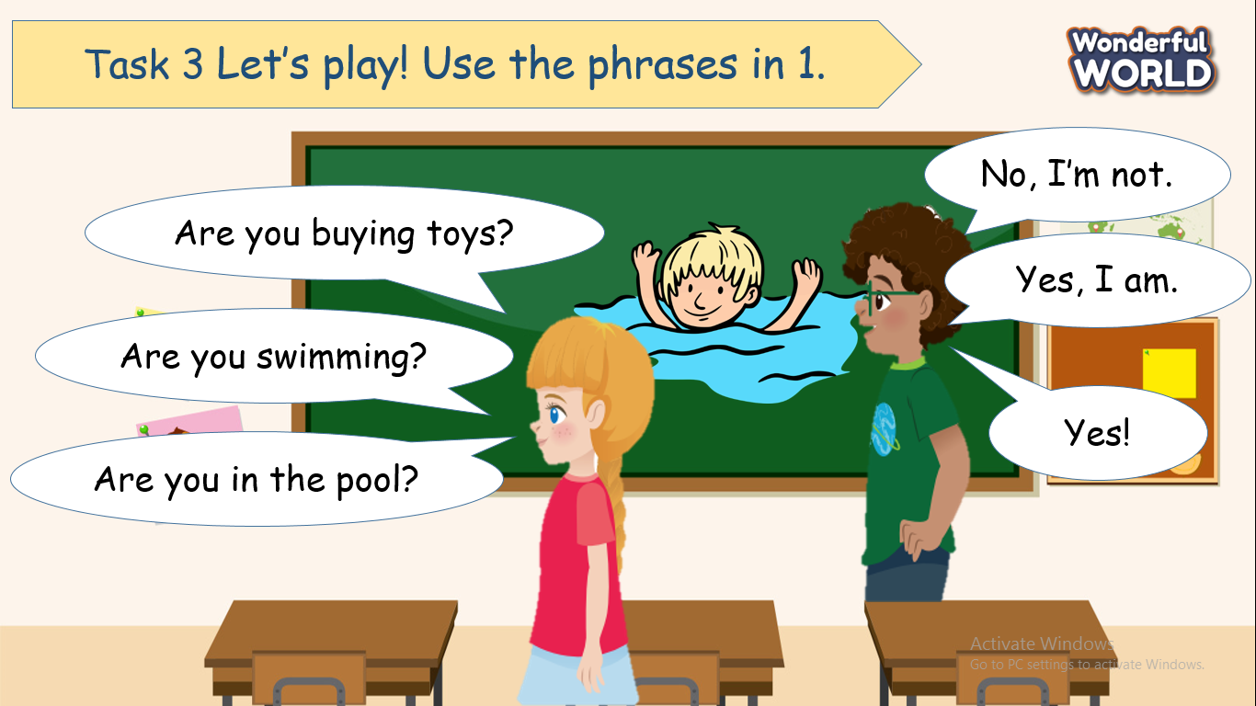  - Ask Ss to ask by replacing them with other words:  Are you __(place)______? Yes/no  - Ask two students to go to the board( one draws/does the action, one guesses) and the question that has the same picture on the board will receive 5 stars.  - Ask some volunteers to play with the project in front of the class. | - Look at the picture and read  - Make many questions and answers on their own.  - Try to get stars from a volunteer.
Activity 5 : Assessement (3 minutes )
Teacher’s activities | Student’s activities
-Ask students to do an assessment.  Look and fill in the blank.  - Check in pair then the whole class  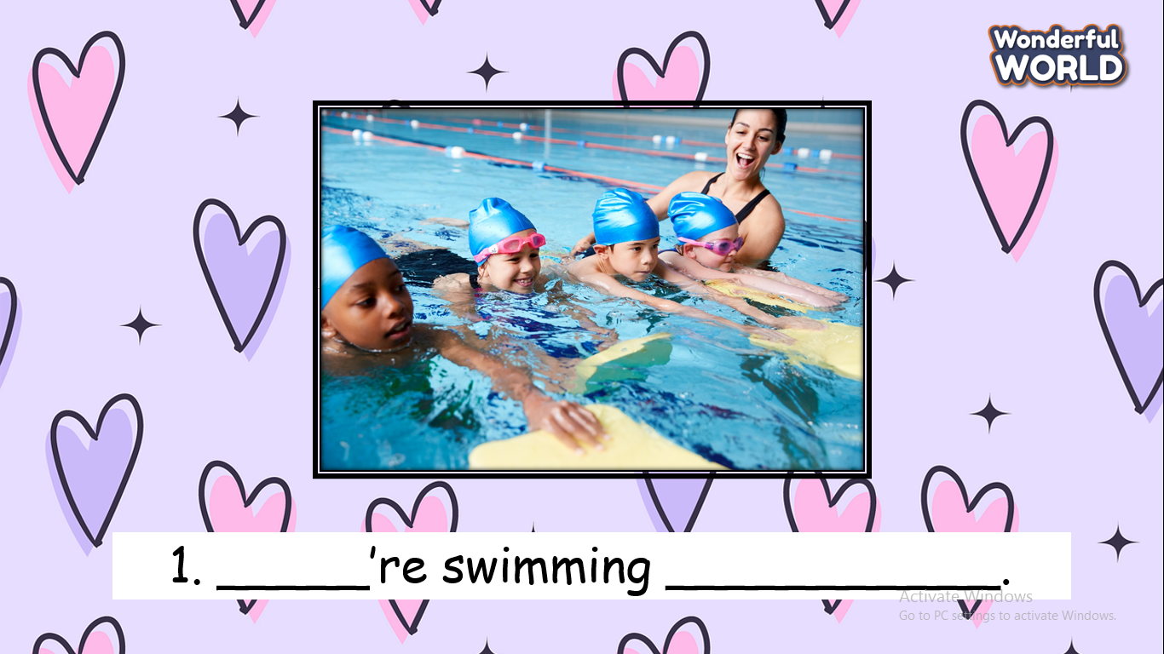  - Say goodbye | -Do the assessment.  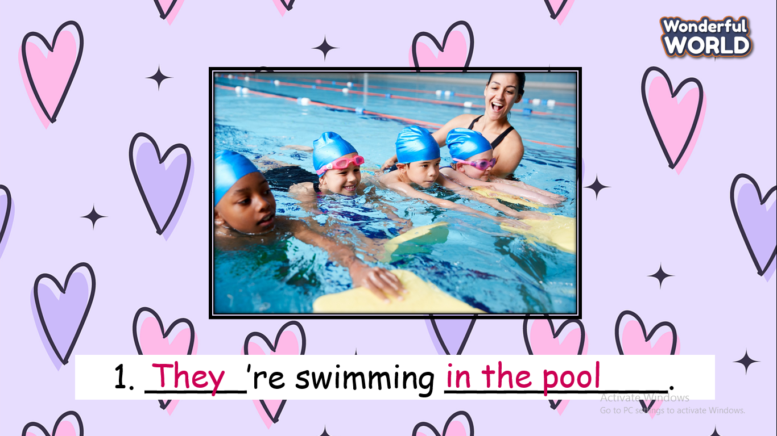  - Check with friends and then with the teacher and the whole class.  - Say goodbye by saying: I’m_(place)__
____________________________________

UNIT 8. MY TOWN
Lesson 2 - Task 4,5,6
Period 96
I. OBJECTIVES:
1. Knowledge:
- Students will learn Present continuous (question form).
2. Competences:
- English competences: Students will be able to practice asking and answering the questions about what a person is doing.
- Common competences: Students will have the opportunity to develop the solving problem in doing tasks and cooperation among teammates.
3. Qualities:
- Students will be friendly and confident in communicating with their friends.
II. EQUIPMENT AND MATERIALS:
- Basic things: Student’s book, flashcards; audio track
- Advanced things: PPT, projector/interactive whiteboard/laptop/TV.
III. LESSON PROCEDURE
Activity 1: Warm-up (5 minutes)
Teacher’s activities | Student’s activities
- Greet students.  Game: Puzzle word  - Introduce the game.  -Have Ss check and read out the words :  write, jump, swim, dance, run, read  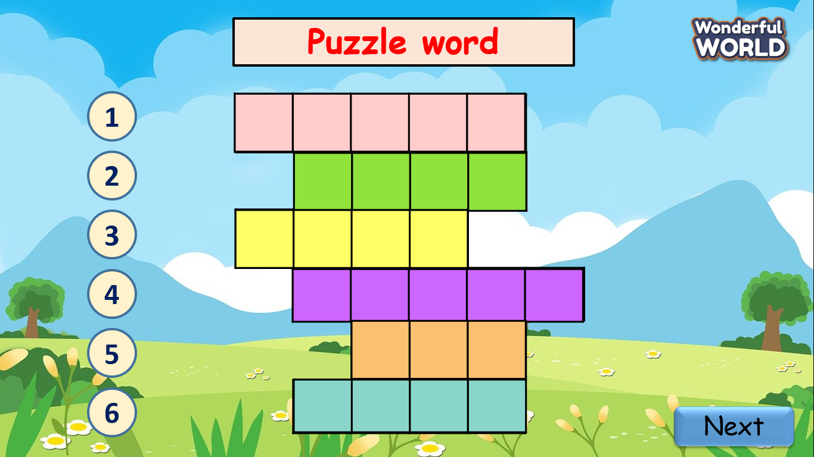 | - Greet teacher.  - Read follow the teacher  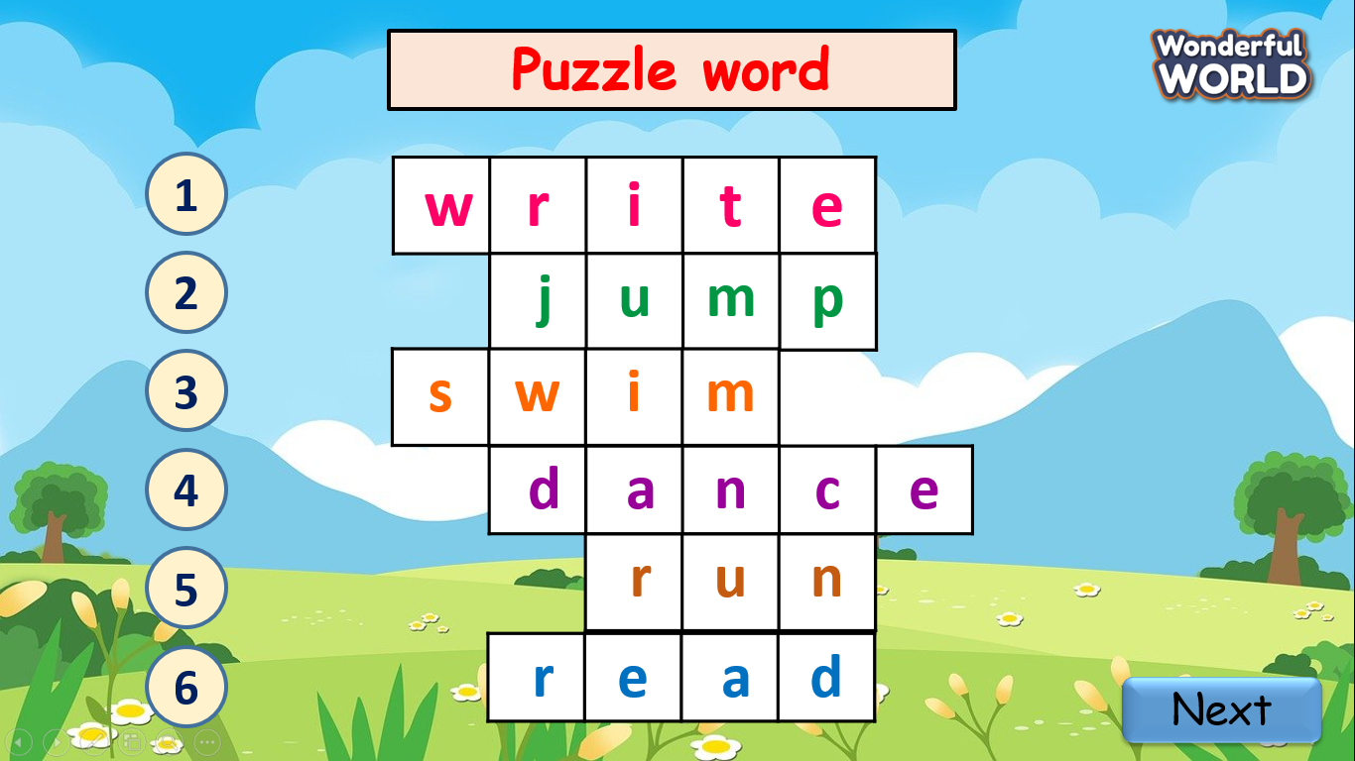
Activity 2: Presentation (8 minutes)
Teacher’s activities | Student’s activities
Task 1: Listen and repeat (P.116)  - Have Ss look at three pictures and answer the questions?  + Where are they?  + What can you see in the pictures?  + Explain the meaning of the question What are you doing? And its answer.  - Play the recording. Tell Ss to  look at the pictures and follow the pictures with their fingers.  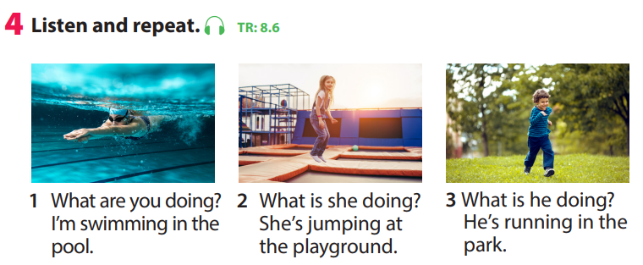  - Play the recording again. Ask Ss to repeat  * “Quick hands, quick eyes”  - Prepare 4 baskets with many small flash cash (the teacher has to cut a sentence into many small pieces).  What/ are/you/doing?  What /is/he/doing?  She’s/running/at/the/playground.  He’s/running/in/the/park.  - Invite 4 Ss to go to the board. When T turns on the audio, Ss listen carefully and choose words from his/her own basket to stick on the board.  - The fastest will be the winner. | - Repeat the words/sentences  - Repeat then point.  - Listen to the T’s guide.  - Join the game.  - Listen carefully.  - Get stars from T.
Activity 3: Practice (7 minutes)
Teacher’s activities | Student’s activities
Task 5: Look and read. Circle and say (P.116)  -Tell Ss to look at the picture then read 2 questions and the answers.  -Ask students to choose the correct answer. 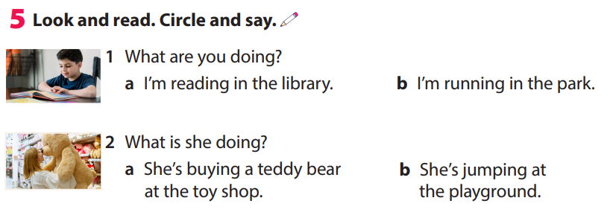  - Check the answer.  - Have Ss practice the questions and answers in pairs. Go round the class helping students where necessary. | -Look and read  -Circle and say  -Answer key:  A( I’m reading in the library.)  B( She’s buying a teddy bear at the toyshop.)
Activity 4: Production (12 minutes)
Teacher’s activities | Student’s activities
Task 6: Let’s talk  - Tell Ss to look at the picture and the dialogue and have them role-play the dialogue twice.  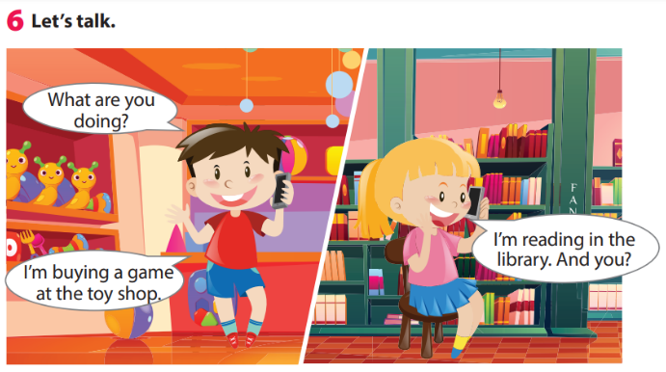  - Ask Ss to work in pairs to make the samedialogue.  - Ask some volunteers to go to the board to make a phone call (one is in the class, one is out of the class.) | -Read out the example.  -Work in pairs and do the task.
Activity 5: Assessment (3 minutes)
Teacher’s activities | Student’s activities
- Ask sts to do the assessment  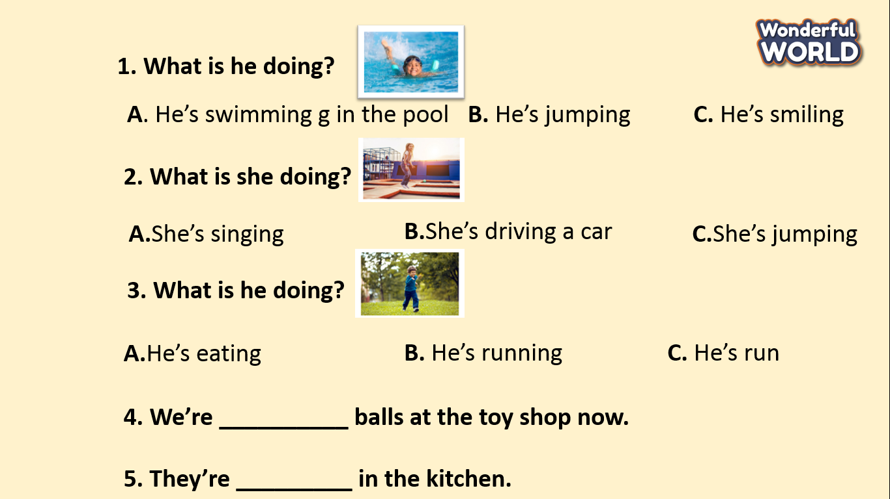  - Check in pair then whole class.  - Say goodbye | - Do the assessment.  - Check with friends and then with the teacher and the whole class.  1. A  2. C  3. B  4. buying  5. cooking  - Say goodbye.

GRADE 5
Week 24 (From 03/3 to 07/3)
UNIT 9: HOLIDAYS & TRAVEL
Lesson 1- Part 1,2,3
Period 93

I. OBJECTIVES:
1. Knowledge:
- Students will be able to:
+ List words about holidays and travel that they have learnt.
+ Remember the pronunciation and meaning of new words through reading the text.
2. Competences:
- English competences: Students can use English to describe a place of interest.
- Common competences: Students can work as a group to create some written texts.
3. Qualities:
- Students will
+ Have a strong sense of respect in pair work & group work.
+ Show their interest in traveling.
II. EQUIPMENT AND MATERIALS:
- Basic things: Student’s book, flashcards, photos.
- Advanced things: PPT, laptop, TV.
III. LESSON PROCEDURE:
Activity 1: Warm-up (5 minutes)
A guessing game “Guess places”
Teacher’s Activities | Students’ Activities
Aims: Welcome students. Engage the class with a guessing game to lead in the new lesson.
1. Greet students. Chatting….. Do you like playing games?  2. Introducing the game.  - Show some pictures of places and ask Ss where those places are and which country those places are in.  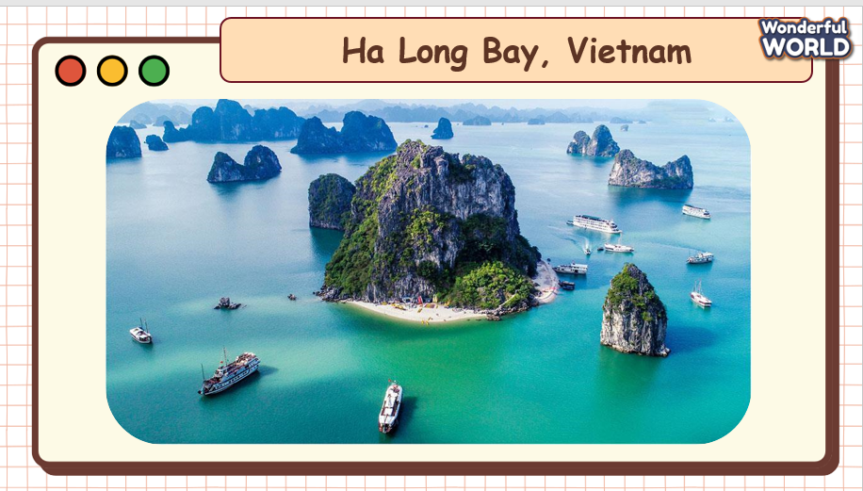  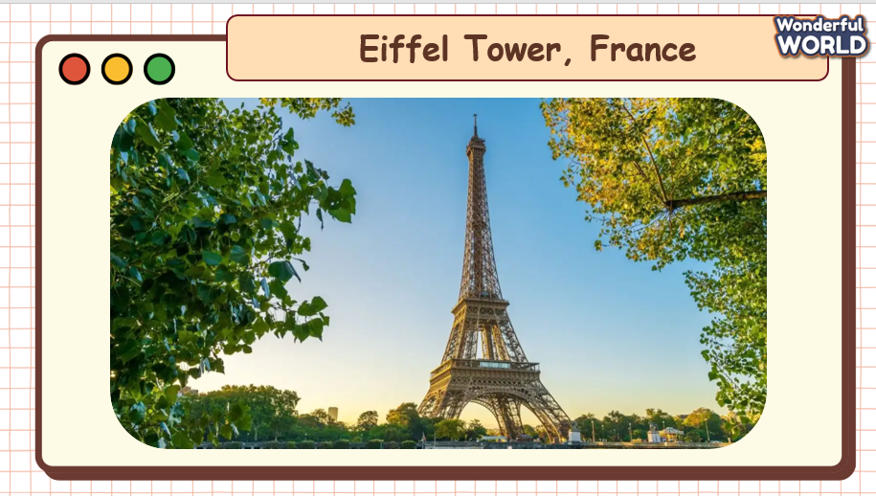  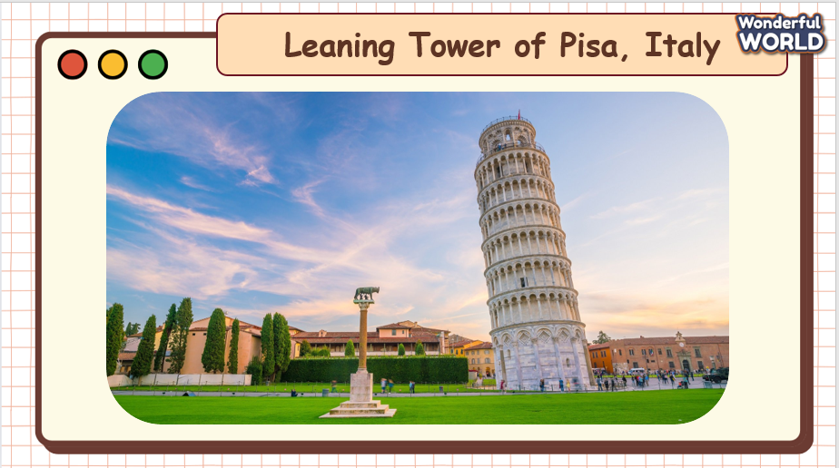      - Lead in the topic and write it down on the board.  + Today, we will learn about holidays & travel. Now, turn to page ....  3. T writes it on the board and asks them to say it aloud.  Leading in the new lesson: Unit 9 – Lesson 1 task 1, 2, 3  Lead in: Photo time!    - Show the picture of the student book on the screen and ask Ss some following questions.  + What is there in this place?  + Who can you see?  + How is this place?  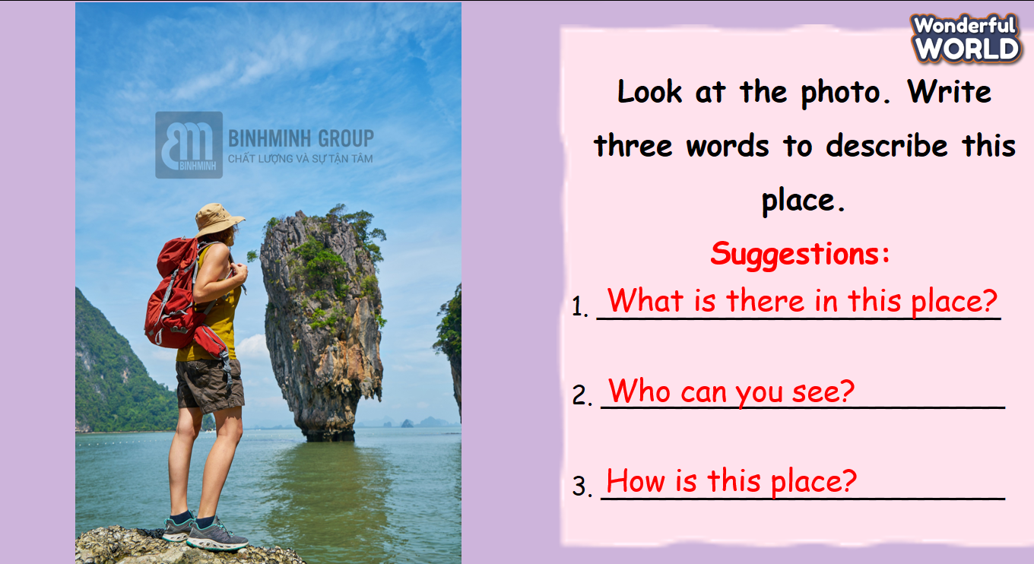  *Note: these questions are used to suggest the answer for the exercise in the student book.  - Let Ss raise their hands to share the answers to each question and then ask them to write down on their books if the words are correct. | - Greet Teacher  - Listen to the rules of the game.  - Join the activity.  - Look at the picture and say.  - Write three words
Activity 2: Presentation (10 minutes)
Teacher’s Activities | Students’ Activities
Aims:
- Present some new words: bridge, canal, crime, lock, villager.
- Encourage sts with the topic and vocabulary related to the topic.
- Instruct Ss to finish task 2.
Task 1. Listen and read.  - Show the reading text on the screen.  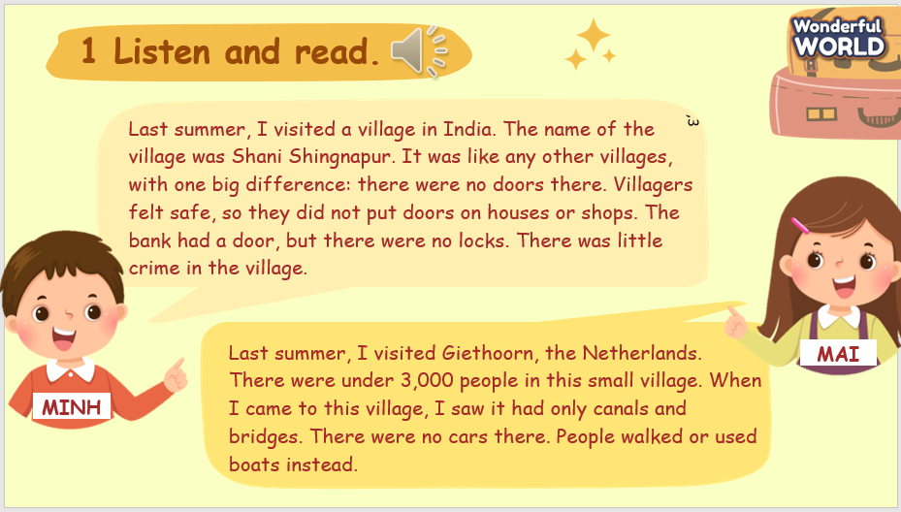  - Play track 9.1 for students to listen to.  - After the first time of listening, ask Ss which text describes the place in the picture of the Student book.  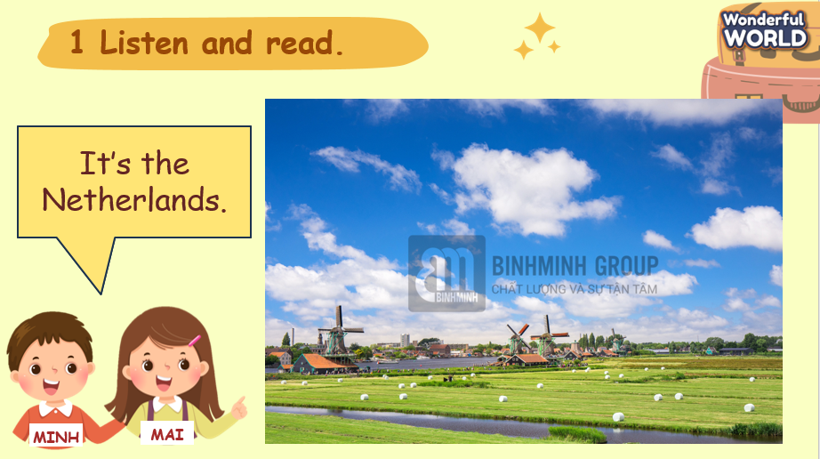  - Show the text, play the audio again, and ask students to listen and read along.  - Ask students to answer the question. Elicit the answers from students and check with the whole class.  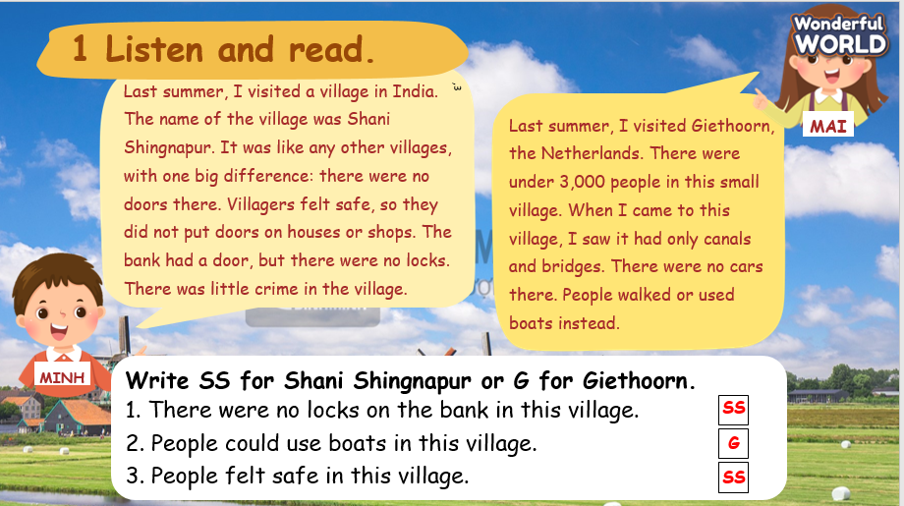  NEW VOCABULARY  - Use flashcards and PowerPoint to introduce the lesson's vocabulary (bridge, canal, crime, lock, villager).  + Show pictures  + Listen  + Repeat three times  - Correct student’s pronunciation if necessary.  Task 2: Listen and point. Repeat. (Track 9.2).  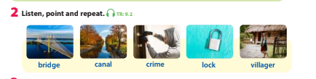  - Show all the pictures of task 2 on the screen or use the flashcards and show them on the board.  - Play track 9.2 for the students to listen to all the words again.  - Ask them to work in pairs to practice reading out the words.  - Check Ss’ understanding of each word by asking the Vietnamese meanings.  - Show pictures in random order and ask students to read out the correct words. | - Listen and answer.  - Listen and read.  - Answer questions.  - Read in front of the class.  - Learn the vocabulary.  - Say the Vietnamese meanings.  - Look and read out the correct words.  - Read the words aloud.
Activity 3: Practice – Controlled practice (10 minutes)
Teacher’s Activities |  | Students’ Activities
a. Aims:
+ Students can practice writing the words in task 2.
+ Students can finish task 3.
b, Procedure  Task 3: Unscramble. Then match.  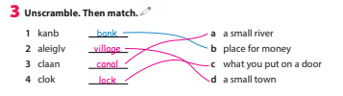  - Tell students that they are going to unscramble the words  and match each word with its relevant meaning.  + Model with number 1.  - Have students work in pairs and check answers with their  partners.  - Check answers as a class.  Games “Whispering”  - Divide the class into four teams. T whispers one word for one student sitting in the first row of each team.  - Ss are required to take turns to whisper the word to another student vertically. Then, the last student will come to the board and write down the word.  - Which team writes the fastest will get points.  + Model with one team. | - Join the activity.
Activity 4: Production (6 minutes)
Teacher’s Activities |  | Students’ Activities
Aim:
- Apply the new words to write sentences with the structures “There is/ there are”.
Activity “Continue the sentence”  - Work in groups of three or four and write sentences with the new words and the structures “There is/there are”.  - Ss share sentences in front of the class.  Rules:  + Each student in the group is asked to write one part of the sentence in a notebook/on a paper.  + After this student finishes, he/she passes it to another one so that the next one can keep writing the next part of the student.  + Each turn just lasts for 30 seconds.  + They need to apply the new words and expand the sentences with the structures “There is / there are”.  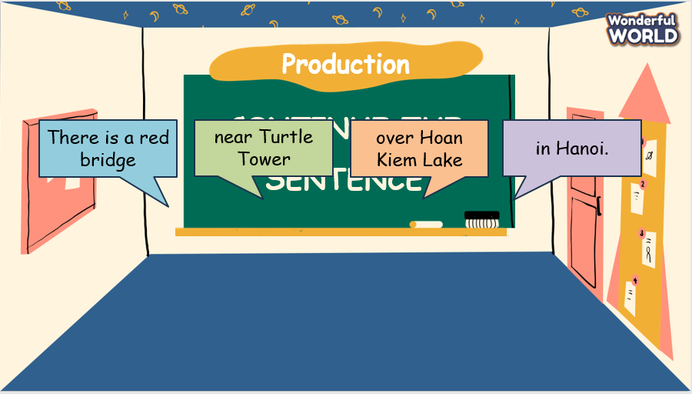 | - Work in groups.  - Write sentences.
Activity 5: Wrap up & Assessment (5 minutes)
Teacher’s Activities |  | Students’ Activities
Aims:
- Check student's understanding of what they have learned.
- Students rehearse what they have learned in the lesson.
- Check with the class.  - Activity “True or False”:  + Hold up the flashcard to Ss and either say the word for the flashcard or say an incorrect word. Ss have to guess if it’s the correct word and shout out “True” if they think it’s correct or “False” if it’s incorrect.  - Assessment: Give compliments to the group/ team that has completed the activities the best and encourage the other groups/teams to keep doing them during the next lessons.  - Wrap-up.  * Remember  VOCABULARY  bridge, canal, crime, lock, villager | - Do the assessment.  - Check with the teacher.  - Sts read the wrap-up.  - Stand up and say goodbye to the teacher.

UNIT 9: HOLIDAYS & TRAVEL
Lesson 1- Part 4,5,6
I. OBJECTIVES:
1. Knowledge:
- Students will be able to:
+ Recall words that they have learnt in the previous lesson: bridge, canal, crime, lock, villager.
+ Get to know and use the new grammar about past simple (regular verbs + time
expressions).
2. Competences:
- English competences: Students will be able to use English to talk about their last summer holidays.
- Common competences: Students will be able to develop collaborative skills through teamwork.
3. Qualities:
- Students will
+ Have a strong sense of respect for teamwork.
+ Raise their confidence by presenting in front of the class.
II. EQUIPMENT AND MATERIALS:
- Basic things: Student’s Book, Class Audio, IWB.
- Advanced things: PPT, laptop, TV.
III. LESSON PROCEDURE:
Activity 1: Warm-up (5 minutes)
A card game “Slap the board”
Teacher’s Activities | Students’ Activities
Aims: Welcome students. Engage the class with a game to review words that Ss have learnt: bridge, canal, crime, lock, villager.
1. Greeting Ss and chatting: Before starting the new lesson, do you want to play a game?  2. Introducing and playing the game:  - Put the flashcards on the board in any order.  - Form groups to give points.  - Call one student from each group to the board.  - Give a mother tongue translation for one of the words on the board. The students have got to recognise the word which translates to that word. They then run to the board and slap the correct word. The first person in each group to slap the right word gets a point.  - Alternatively, the teacher doesn't have to call out the English word, you can get other kids to call out so they're getting practice speaking too. | - Greet Teacher.  - Join the activity.
Activity 2: Presentation (10 minutes)
Teacher’s Activities | Students’ Activities
Aims:
- Present the new grammar: past simple with the form of regular verbs and time expressions.
- Instruct Ss to finish task 4.
Task 4: Listen and match (Track 9.3)  - Show the pictures of Task 4 to ask Ss what activities they are.  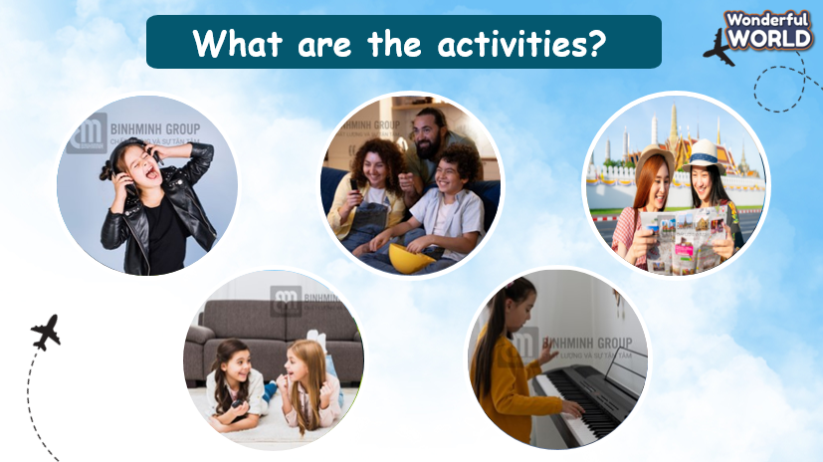  - Play the recording.  - Have students listen and match each sentence with the  correct picture.  - Ask some students to share their answers.  - Give comments and feedback.  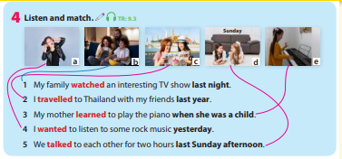  Elicit new grammar: Past simple  - Ask Ss when Past simple tense is used.  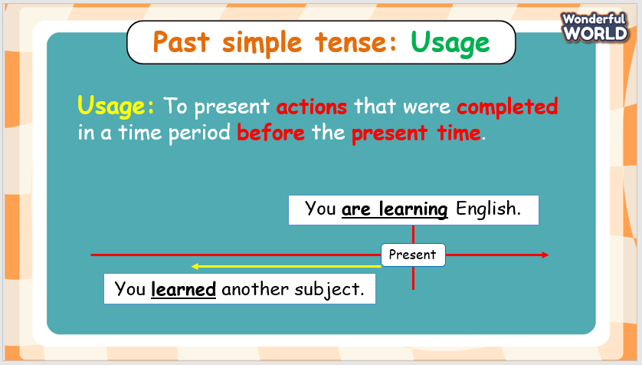  - Elicit the structure of Past simple tense and time expressions (Ss can guess from Task 4).  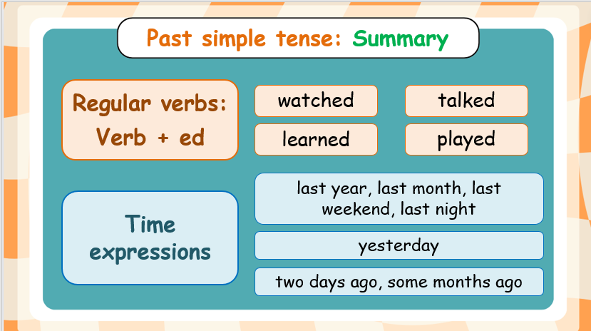 | - Look and answer.  - Listen and answer.
Activity 3: Practice – Controlled practice (10 minutes)
Teacher’s Activities | Students’ Activities
a. Aims:
- Practice giving the correct form of regular verbs in Past simple.
- Practice using Past simple in sentences through exercise 5.
b. Procedure:  “Odd one out” activity  - Choose one word that is in different forms from others.  - There are 8 questions.  - Example:  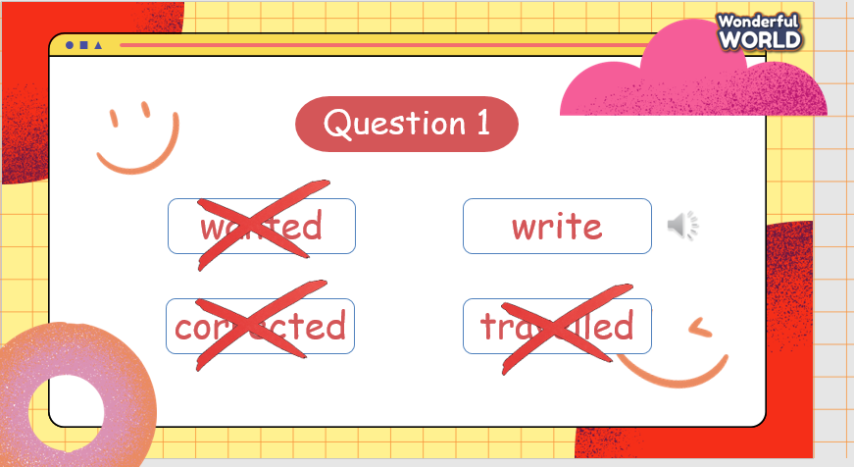  Task 5: Look and write  - Ask students to look at the five sentences and they are going to  complete each sentence by using simple past tense.  - Model sentence 1 as an example.  - Have students do the task individually.  - Have students exchange their coursebooks and give feedback to  each other.  - Give feedback as a class discussion.  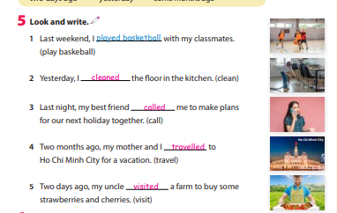 | - Join the activity.
Activity 4: Production (5 minutes)
Teacher’s Activities | Students’ Activities
a. Aims:
- Ss apply the grammar to share about their last summer holidays in Task 6.
b. Procedure:  Task 6: Talk about your activities last summer holiday.  - Tell students that they are going to talk about their last summer  holiday.  - Have students read the example.  - Encourage students to name the activities they did last summer  holiday.  - Ask students to work in groups of three or four and exchange their ideas  with their friends.  - Call one student to voluntarily share in front of the class.  - Give feedback if necessary  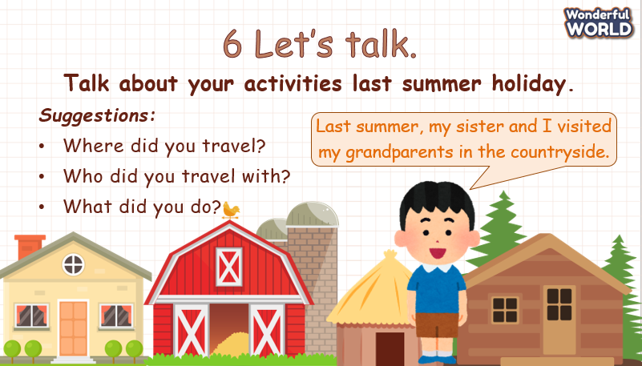 | - Work in groups.
Activity 5: Wrap up & Assessment (5 minutes)
Teacher’s Activities | Students’ Activities
Aims:
- Check students’ understanding of what they have learned.
- Students rehearse what they have learned in the lesson.
- Assessment: Give compliments to the group/ team that has completed the activities the best and encourage the other groups/teams to keep doing them during the next lessons.  - Wrap-up: Do the activity “Complete sentences with the given words”.  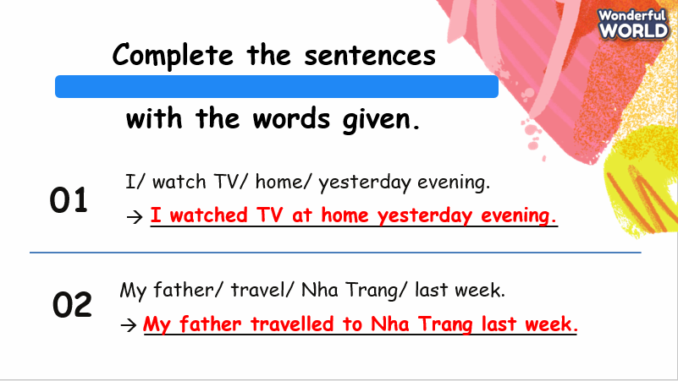  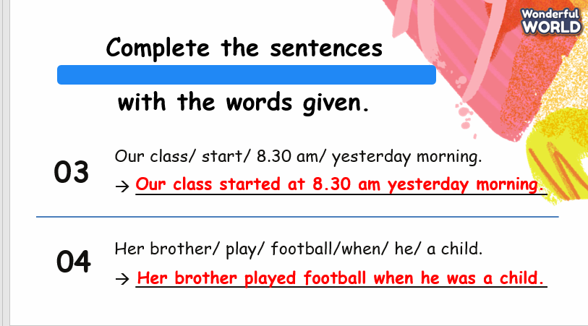  * Remember  - Review vocabulary: bridge, canal, crime, lock, villager.  - Grammar: Past simple with regular verbs and time expressions.  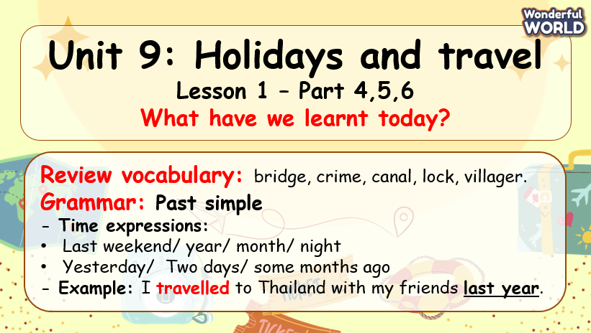 | - Check with the teacher.  - Do the activity.  - Stand up and say goodbye to the teacher.

UNIT 9: HOLIDAYS AND TRAVEL
Lesson 2 - Part 1,2,3
Period 95

I. OBJECTIVES:
1. Knowledge:
- Students get to know:
+ some words: flight, hot-air balloon, inventor, silk, smoke.
+ students can draw out new words through listening and reading the text.
2. Competences:
- English competences: Students can use English to describe an invention.
- Common competences: Students can write and talk about an invention.
3. Qualities:
- Students will
+ have a strong sense of respect for teamwork.
+ Raise their confidence by presenting in front of the class.
II. EQUIPMENT AND MATERIALS:
- Basic things: Student’s Book, Class Audio, IWB.
- Advanced things: PPT, laptop, TV.
III. LESSON PROCEDURE:
Activity 1: Warm-up (5 minutes)
Watch a video
Teacher’s Activities | Students’ Activities
Aims: Welcome students. Warm the class up with a video to lead in the new lesson.
1. Greeting Ss and chatting:  Let's start our new lesson with a video. Please pay attention and then I’ll ask you some related questions!  2. Watch a video:  - Play the video and ask students to pay attention.  https://youtu.be/QGAMTlI6XxY  - Ask Ss to answer the following questions:  1. What can you see? (ANSWER: HOT-AIR BALLOONS)  2. Where do you usually see these? (SUGGESTED ANSWERS: FAIR, EXHIBITION, ETC.)  3. Do you know who invented hot-air balloons? (SUGGESTED QUESTIONS: THE Montgolfier brothers)  3. Leading in the lesson:  Unit 9 – Lesson 2 task 1, 2, 3  - Lead in Today, we are going to read about hot-air balloons and learn some new words! | - Greet Teacher.  - Watch and answer.
Activity 2: Presentation (12 minutes)
Teacher’s Activities | Students’ Activities
Aims:
- Present some new words: flight, hot-air balloon, inventor, silk, smoke.
- Encourage Ss with the topic and vocabulary related to the topic.
- Develop Ss’ reading abilities
New words  - Use flashcards and PowerPoint to introduce the lesson's vocabulary (flight, hot-air balloon, inventor, silk, smoke).  + Show the pictures-> show the words -> play audio twice for Ss to listen then ask them to repeat in chorus, groups, and individually.  - Correct student’s pronunciation if necessary.  Task 2: Listen, point, and repeat (Track 9.5)  - Check their understanding if necessary.  - Ask students to listen, point, and repeat after the speaker.  - Call some students to read it out aloud and correct spelling  if necessary.  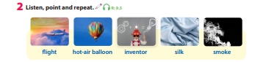  Task 1: Listen and read. Tick T for True or F for False. (Track 9.4)  - Ask students to watch the video on the screen and then listen again.  - Have students listen and read it individually.  - Call one student to read it out aloud and check pronunciation if  necessary.  - Then, ask students to read the text again and tick True or False.  - Model Sentence 1 as an example.  - Give students three to five minutes to do the task independently.  - Go around the classroom and offer help if necessary.  - Invite some students to write the answers on the board and the  whole class checks.  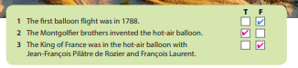 | - Look and answer.  - Listen, point, and repeat.  - Listen and read.  - Tick True or False.
Activity 3: Practice – Controlled practice (8 minutes)
Teacher’s Activities | Students’ Activities
Aims:
- Practice new words through exercise 3.
Task 3: Circle the correct words.  - Ask students to look at Activity 3. Show them Sentence 1 as an example.  - Tell students that they will read and circle the correct word in each sentence.  - Give students five minutes to complete the task by themselves.  - Call some students to share their answers with the class.  - Give feedback and comments.  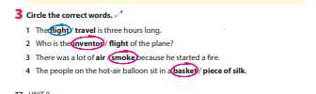  Activity “The Hot Seat”  - First, split your class into different teams (two is best, but if you have a large class, any number could be used).  - Sit the students facing the board.  - Then take an empty chair - one for each team - and put it at the front of the class, facing the team members. These chairs are the 'hot seats'.  - Then get one member from each team to come up and sit in that chair, so they are facing their team-mates and have their back to the board.  - Show the first word on the screen.  - The aim of the game is for the students in the teams to describe that word, using synonyms, antonyms, definitions, etc. to their teammate who is in the hot seat - that person can't see the word!  - The student in the hot seat listens to their teammates and tries to guess the word.  - The first hot-seat student to say the word wins a point for their team. Then change the students over, with a new member of each team taking their place in their team's hot seat. Then show the next word… | - Complete the task.  - Join the activity.
Activity 4: Production (5 minutes)
Teacher’s Activities | Students’ Activities
Aims:
- Ss apply the new words to talk about an invention – a light bulb.
- Divide the class into different groups of three to four students.  - Work in a group to talk about an invention – a light bulb.  - Call some students to share in front of the class.  - Suggested questions:  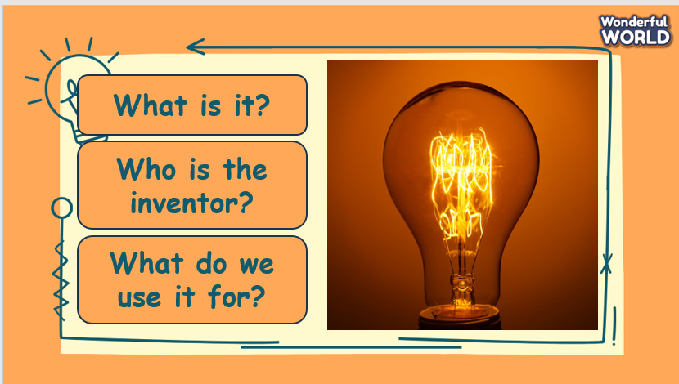 | - Work in groups.
Activity 5: Wrap up & Assessment (5 minutes)
Teacher’s Activities | Students’ Activities
Aims:
- Check students’ understanding of what they have learned.
- Students rehearse what they have learned in the lesson.
- Assessment: Give compliments to the group/ team that has completed the activities the best and encourage the other groups/teams to keep doing them during the next lessons.  - Wrap-up: Do the activity “Unscramble the words.”.  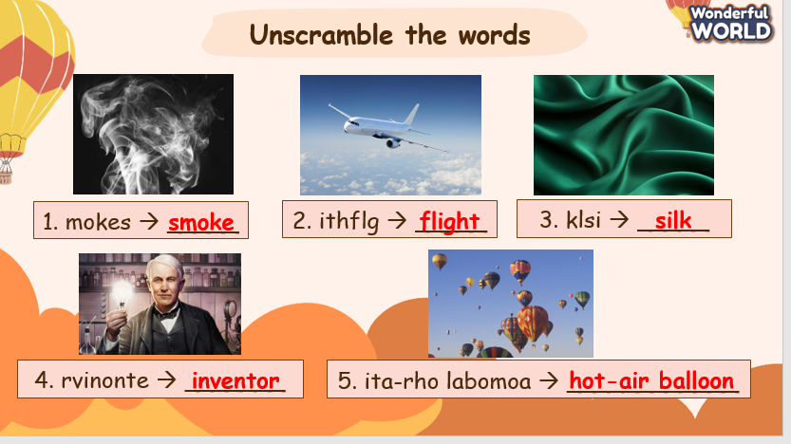  * Remember  - Vocabulary: flight, hot-air balloon, inventor, silk, smoke. | - Check with the teacher.  - Do the activity.  - Stand up and say goodbye to the teacher.

UNIT 9: HOLIDAYS AND TRAVEL
Lesson 2 - Part 4,5,6
Period 96
I. OBJECTIVES:
1. Knowledge:
- Students will be able to:
+ Recall some words that they have learned in the previous lesson.
+ Review the new grammar about Past simple with regular verbs.
2. Competences:
- English competences: Students can use English to describe activities that they did.
- Common competences: Students can write and talk about activities that they did.
3. Qualities:
- Students will
+ have a strong sense of respect in pairwork or teamwork.
+ raise their confidence by presenting in front of the class.
II. EQUIPMENT AND MATERIALS:
- Basic things: Student’s Book, Class Audio, IWB.
- Advanced things: PPT, laptop, TV.
III. LESSON PROCEDURE:
Activity 1: Warm-up (5 minutes)
“Multiple choice”
Teacher’s Activities | Students’ Activities
Aims: Welcome students. Warm the class up with a “multiple choice” activity to review the words that they have learned in the previous lesson “flight, hot-air balloon, inventor, silk, smoke”.
1. Greeting Ss and chatting:  Let's start our new lesson with an activity. Raise your hands to answer the questions shown on the screen!  2. “Multiple choice” activity:  - Divide the class into different teams. Which team has the first person to raise his/her hand can answer the question?  - Ask Ss to say the correct answers again as practice.  3. Leading in the lesson:  Unit 9 – Lesson 2 task 4, 5, 6  - Lead in Today, we are going to keep learning about the Past simple! | - Greet Teacher.  - Join the activity.
Activity 2: Presentation (8 minutes)
Teacher’s Activities | Students’ Activities
a. Aims:
- Review Past simple through recalling Ss’ previous knowledge.
Grammar: Past simple with regular verbs  - Ask Ss some questions related to Past simple to check their understanding.  - Correct Ss’ knowledge if necessary.  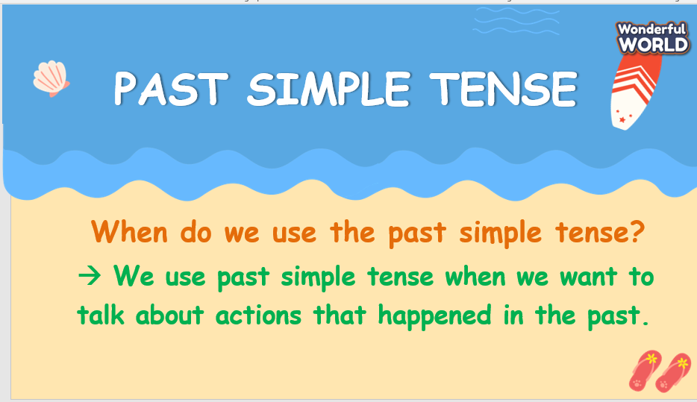  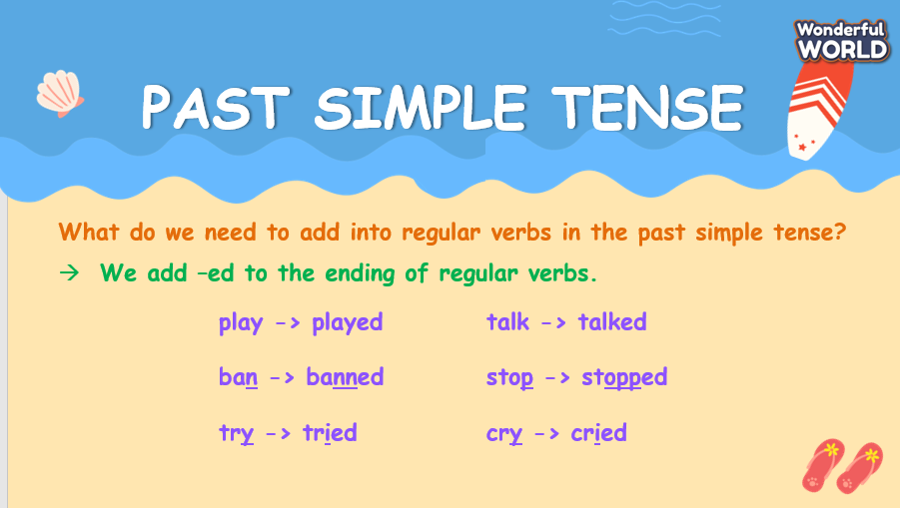  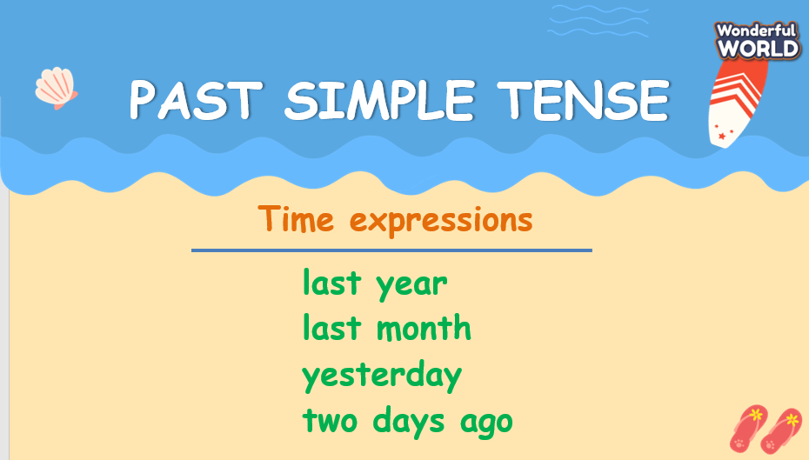 | - Listen and answer.
Activity 3: Practice – Controlled practice (10 minutes)
Teacher’s Activities | Students’ Activities
Aims:
- Practice Past simple through exercises 4 and 5.
Task 4: Listen and write (Track 9.6).  - Tell students that they are going to listen to a short passage.  - Ask students to read each gapped sentence and guess the answers.  - Play the recording for students to listen and complete the gaps.  - Show each sentence and play the recording again for the class to check answers. Call Ss to stand up and choose the correct answer.  Example:  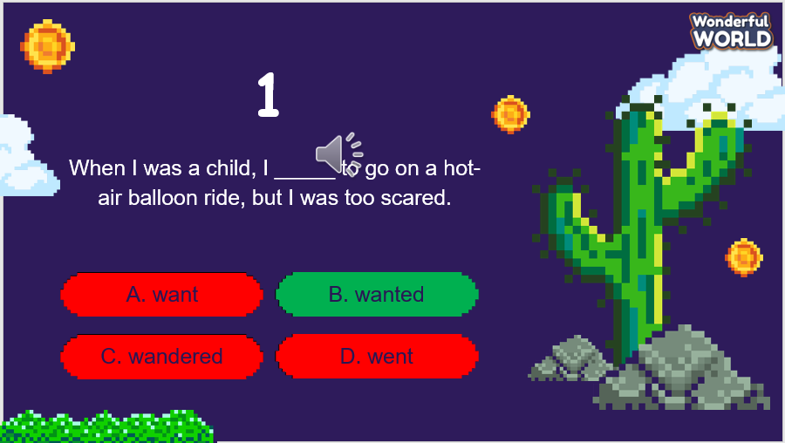  Answer:  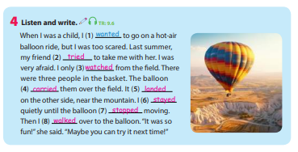  Task 5: Ask and answer  - Point to the question and answer in the bubbles. Read out the  sentences and ask students to repeat them.  - Tell students that they are going to look at the pictures then ask  and answer about activities done yesterday.  - Ask students to take turns by swapping roles.  - Go around the class helping where necessary. Encourage students to  Add more words from Activity 4 if possible.  - Ask some volunteers to act out their dialogue in front of the class. | - Complete the task.  - Join the activity.  - Listen and repeat.  - Work in pairs.
Activity 4: Production (7 minutes)
Teacher’s Activities | Students’ Activities
Aim:
- Ss apply Past simple to write sentences and share about the activities that they did last weekend.
Task 6: Write.  - Tell students that they are going to write sentences about the  activities they did last weekend.  - Show the first sentence as an example.  - Divide the class into different groups of three to four.  - Give students 5 minutes to write their sentences in the notebook.  - Challenge them by setting a five-minute timer and asking them to work in groups and write as many sentences as possible (apart from three sentences as required).  - Go around to check each group.  - Let Ss from a few groups voluntarily share in front of the class.  - Give feedback as a whole class. | - Work in a group.
Activity 5: Wrap up & Assessment (5 minutes)
Teacher’s Activities | Students’ Activities
a, Aims:
- Check students’ understanding of what they have learned.
- Students rehearse what they have learned in the lesson.
- Assessment: Give compliments to the group/ team that has completed the activities the best and encourage the other groups/teams to keep doing them during the next lessons.  - Wrap-up: Do the activity “Give the correct form of verbs.”.  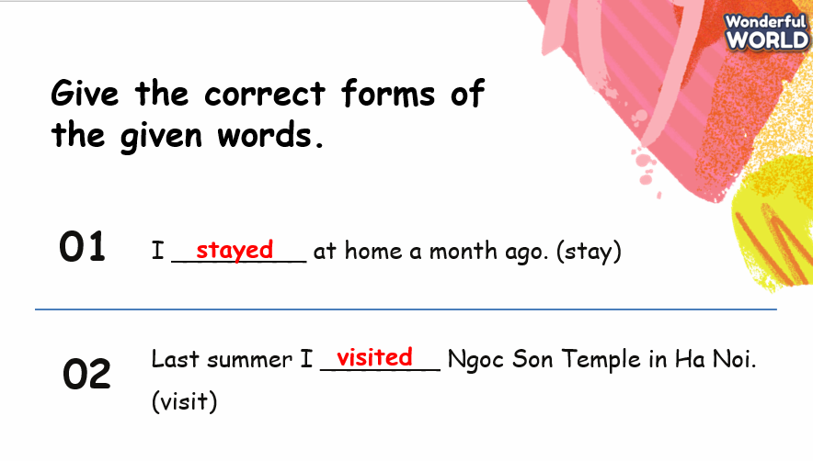  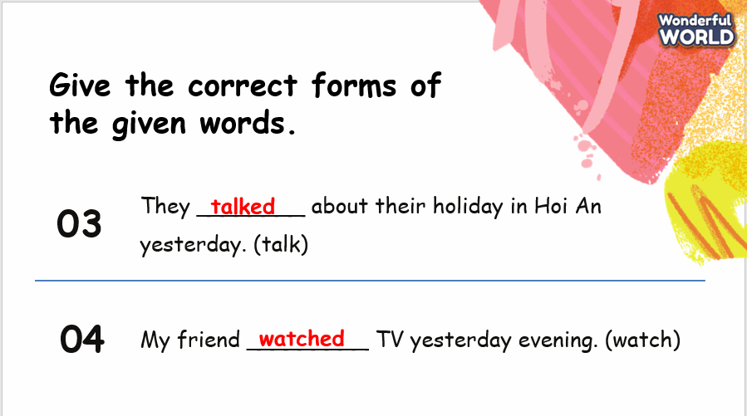  * Remember  - Review vocabulary: flight, hot-air balloon, inventor, silk, smoke.  - Grammar: Past simple with regular verbs.  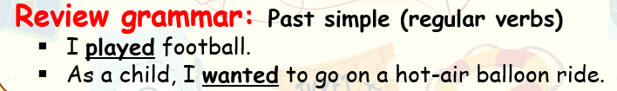 | - Check with the teacher.  - Do the activity.  - Stand up and say goodbye to the teacher.

