WEEK 25
UNIT 9. PLACES IN TOWN
Lesson 2. Task 7, 8, 9
Period 97
I. OBJECTIVES:
1. Knowledge:
Students will review some more places in town
To review asking and answering questions about where someone does something
2. Competences:
- English competences: Students will be able to talk about their town where someone does something
- Common competences: Students will have the opportunity to ask and answer where they go.
3. Qualities:
- Students love their towns.
II. EQUIPMENT AND MATERIALS:
- For Teacher: PP, flashcards, handout, track 9.8.
- For students: pens, pencils
III. LESSON PROCEDURE:
Activity 1: Warm up (5 minutes)
a. Aim: Review the knowledge of the previous lesson by playing a game or checking the learned words.

Teacher’s Activities | Students’ Activities
b. Procedure  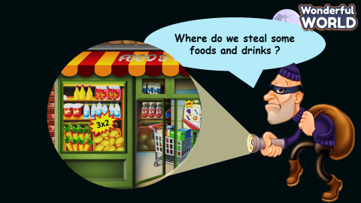  This is a guessing game on places around town. The students have to guess where the thief is by looking at the picture and reading the clue. |   - Guess the place.
Activity 3: Practice (8 minutes)
a. Aim: Controlled- Practice to say the sentences following the model sentence:
“Where do we…………………?
- ……………………………

Teacher’s Activities | Students’ Activities
b. Procedure  GAME: HELP THE MONKEY and get the stars.  Divide the questions into 2 parts:  Part 1: Listen and circle  LEAD IN:  • Stick some of the pictures on board and asks them to speak out places they can see.  • Read aloud the pictures and asks sts to identify the right one on the board  • Tell the students that they are going to listen to some sentences and circle the correct answers a or b  • Check the answer and explain when in need.  Part 2: Match and say.  • Write down the questions on te board:  Where do you buy food and drinks? At the supermarket.  • Ask sts to practice this phrase basing on the picture cards from task 7.  • Tell the students to look at the two columns and the example sentences. Read out the example.  • Explain the rest of the task to the students. Allow them enough time to match and practise saying the  sentences individually and in pairs.  • Go around the class helping students where necessary.  • Ask some volunteers to act out the dialogues. Correct mistakes if necessary.  • Suggested answer:  1.b  2.a  3.b  4.a  5. Where do we buy foods and drinks? - At the Supermarket.  6 Where do we see many plants and flowers?  - In the park.  7 Where do we play football? - In the playground.  8 Where do we surf the internet at school?  - In the computer lab. | - Follow the teacher.  - Listen and tick.  - Match and say  - Do the action as following,  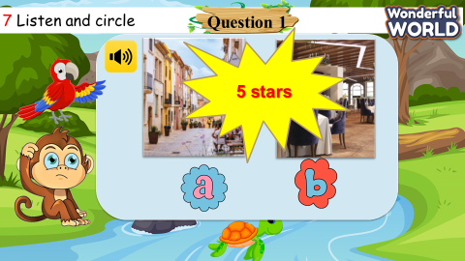
Activity 4: Production (9 minutes)
a. Aim: Apply the learned knowledge about the places, the structures to communicate with each other.

Teacher’s Activities | Students’ Activities
b. Procedure  Tell students to look at the picture and the example dialogue. Read out the example.  • Tell students to work in pairs to ask and answer questions about where they can do different things in their hometown.  • Go around the class to help students where necessary.  • Ask some volunteers to act out the dialogues. Correct mistakes if necessary.  • Give feedback on some common strengths and  weaknesses of the dialogues made by students. | Ask and answer.  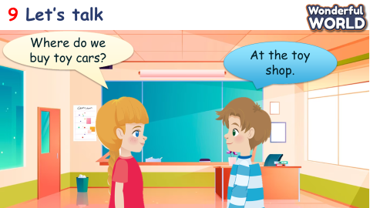
Activity 5: Assessment (3 minutes)
a. Aims: Consolidate the content of the lesson.

Teacher’s Activities | Students’ Activities
b. Procedure  Do the assessment: Circle.  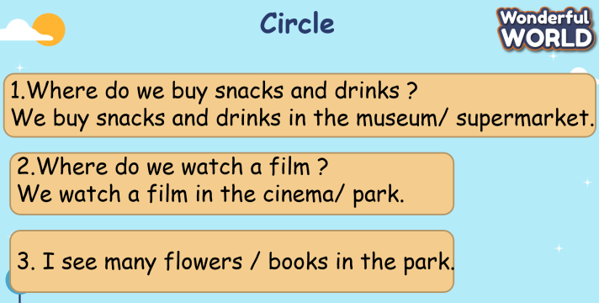 | Do the assessment.  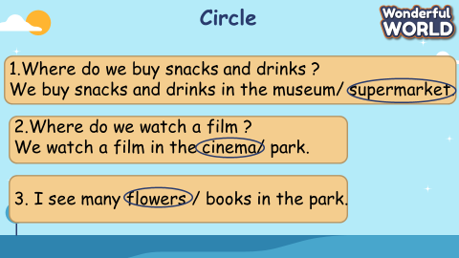
_________________________________
UNIT 9. PLACES IN TOWN
Lesson 3. Task 1, 2, 3
Period 98
I. OBJECTIVES:
1. Knowledge:
- Students will learn words and phrases related to the topic Directions: cross the road, go straight, turn left, turn right.
- Sts will practice with sentences: The cinema is ……opposite ………….. the school.
- Sts keep practicing “where” question: Like Where’s the restaurant?
-Students will learn to use word stress in two syllable nouns.
2. Competences:
- English competences: Students will ask and answer about directions.
- Common competences: Students will have the opportunity to develop their creativeness by participating in games and developing communication among friends.
3. Qualities:
- Students develop their direction skills.
roundabout, stop, traffic light, turn left, turn right, between, opposite, cross the road, go straight.
II. EQUIPMENT AND MATERIALS:
- For Teacher: PP, flashcards, handout, track 9,10
- For students: pens, books, paper.
III. LESSON PROCEDURE:

Activity 1: Warm up (5 minutes)
Teacher’s Activities | Students’ Activities
Aims: Warm-up activity to revise the words from the previous lesson.
b, Procedure  - Says hello to the whole of class,  - Asks sts to name some places they learnt  - T introduces the ongoing topic and write down on the board  Unit 9 – lesson 3 task 123.  - Now, to start the lesson today, I would like you to listen to a song and remember words of places; you can read It aloud after listening. Let’s start.  - Listen and sing a song. The wheels on the bus  - Review the words about places. | - in class  - Answer T’s question
Activity 2: Presentation (8 minutes)
Teacher’s Activities | Students’ Activities
a, Aims: Present some new words Directions: cross the road, go straight, turn left, turn right.
Encourage sts with the topic and vocabulary of related topic, paying attention to the directions.
b, Procedure  Task 1. Listen and point. Repeat.  - Shows pictures, asking sts to speak out what signals they can see, may be the Vietnamese first if they have never learnt before.  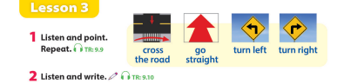  - Explains pictures of direction and guide them where they can see these directions: on the street. That’s correct.  - At the same time; teacher can turn down the other side of picture cards and ask them to read it aloud. Do this activity twice.  - Now we start with a matching exercise; pls go to the board and do the matching for me.  - Introduces the 4 new words and asks them to repeat the preposition of the lesson: cross the road, go straight, turn left and turn right.  - Write down the directions on the boards.  - Ask them to look at the PP and give their point of view about the correct preposition.  - Asks them to read these signals aloud, paying attention to their pronunciation.  - Use the body language and ask them to guess, call one or two sts to go to the stage and mime the action.  - Plays track 9.9 for the students to listen to and repeat in chorus, and group.  - Shows pictures in random order and ask students to read out the words.  - Tell sts to look at the words and phrases in the vocab box on page 35, Check they understand them and ask if they know any of the words.  - Play the recording for sts to listen and point to the correct words.  VOCABULARY CHECKING  - Let Sts play  - Explains the rules and can use the music – PASS the ball. Whenever the music stops. St has to stand up and speak loudly a sentence using words and directions.  - Gives the stars or mark when they make a correct sentence | - Read aloud words of direction, paying attention to the meaning both in Vietnamese and in English.  - Raise the hands and go to the board.  Repeat after the teacher.  - Guess the right places based on the suggested pictures  - Exchange the words with partners.  - Finding the correct places; adding preposition if they know.  -Listen to the track and repeat in whole class.  -Sts practice the new words individually and in groups  -Sts join the game and get stars.  - Play with the game; getting involved in these lovely activities.
Activity 3: Practice (14 minutes)
Teacher’s Activities | Students’ Activities
a, Aims: - Controlled-practice: Listen and tick a conversation using the vocab of task 1.
- Encourage sts to act out the dialogue in pairs in front of the class.
b, Procedure  Task 2: Listen and tick.  Asks sts to look at the picture and answer what they can see.  -Let Sts listen and read the words and phrases  - Plays the PP slide with 8 pictures, asking them to fill in the right places that they can see.  - Goes around and checks their understanding; encouraging them to speak out the word correctly.  - Corrects their pronunciation and play a game of words puzzles with the purpose to use the words of places and directions correctly. If they do not understand, teacher can make an example and they can observe.  - Sticks on the board or play the PP slides preposition and explain them carefully their meaning and usage.  - Relating the 4 prepositions they learnt from task 1.  - Asks them to work in pair and raise the hands to talk about places and word of direction  Key structure:  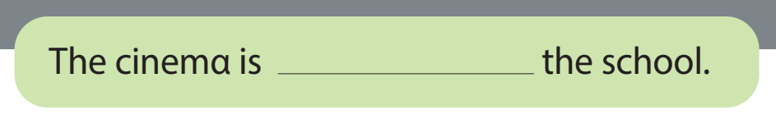  - Asks some pairs to read  - Then let sts read the sentences below and ask them to listen and fill in the gaps with the words from the recording.  -Then play track 9.10 again to check their answers.  - Pause after each sentence to check their answers.  Task 3: Look and say. Use the map in2.  - Look at the picture and example dialogue. Ask them to Read out prompts and ask them to read out the dialogue again.  -Asks Sts to look at the other words and think about how to form a dialogue. Give them the suggestions in case they have difficulties.  - Explain the task and allow them time to practice saying sentences.  - Ask some volunteer to read their dialogue aloud in front of the whole class.  - Require some pairs present in front of the class.  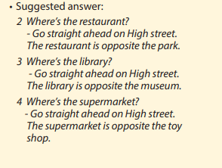 | -Listen and read.the words and phrases  - Sts read aloud each .  - Repeat the sentences.  -Some pairs read the dialogue.  -Sts listen again and write the correct answers  -Answer the question.  -Read some prompts and dialogue.  -Make and practice some dialogues in pairs and present it in the class.
Activity 4: Production (9 minutes)
Teacher’s Activities | Students’ Activities
a, Aims: Watch the video and write down places that they can see.
Apply the new words and structures to present in front of the class about directions using vocabulary in task 1.
b, Procedure  Watch a video!  -Asks sts to count and write vocabulary  - Asks them to read out the objects/ things in the video.  - Then, write some sentences about directions using the vocabulary in task 1.  - Ask some volunteers to present about sentences in front of the class.  *Game.  - ask ans answer about directions in group | -Sts watch the video.  -Write down and answer about the objects in the video.  -Make sentences about directions.  -Some sts present about it.
Activity 5: Assessment (3 minutes)
Teacher’s Activities | Students’ Activities
a, Aims: Consolidate the content of the lesson.
-Asks sts to do the assessment.  - Check with the class.  - Wrap-up  * Remember  VOCABULARY  cross the road,go straight,turn left,turn right. | -Do the assessment.  -Check with the teacher  - Sts read the wrap-up  - Stand up and say goodbye to the teacher.
________________________________
UNIT 9. PLACES IN TOWN
Lesson 3. Task 4, 5, 6
Period 99
I. OBJECTIVES:
1. Knowledge:
Students will review some directions, ask and answer questions about directions
, practice giving directions
2. Competences:
- English competences: Students will be able to review some directions.
- Common competences: Students will have the opportunity to practice giving directions.
3. Qualities:
- Students love their towns.
II. EQUIPMENT AND MATERIALS:
- For Teacher: PP, flashcards, handout, track 9.11.
- For students: pens, papers.
III. LESSON PROCEDURE:
Activity 1: Warm up (5 minutes)
a. Aim: Warm up the class and review the previous lesson with the song.

Teacher’s Activities | Students’ Activities
b. Procedure:  WARM UP:  https://www.youtube.com/watch?v=2XkyTYotNs0  Learning directions for kids! Join JJ and friends as they learn their left and right! Sing along to this educational kid’s song.  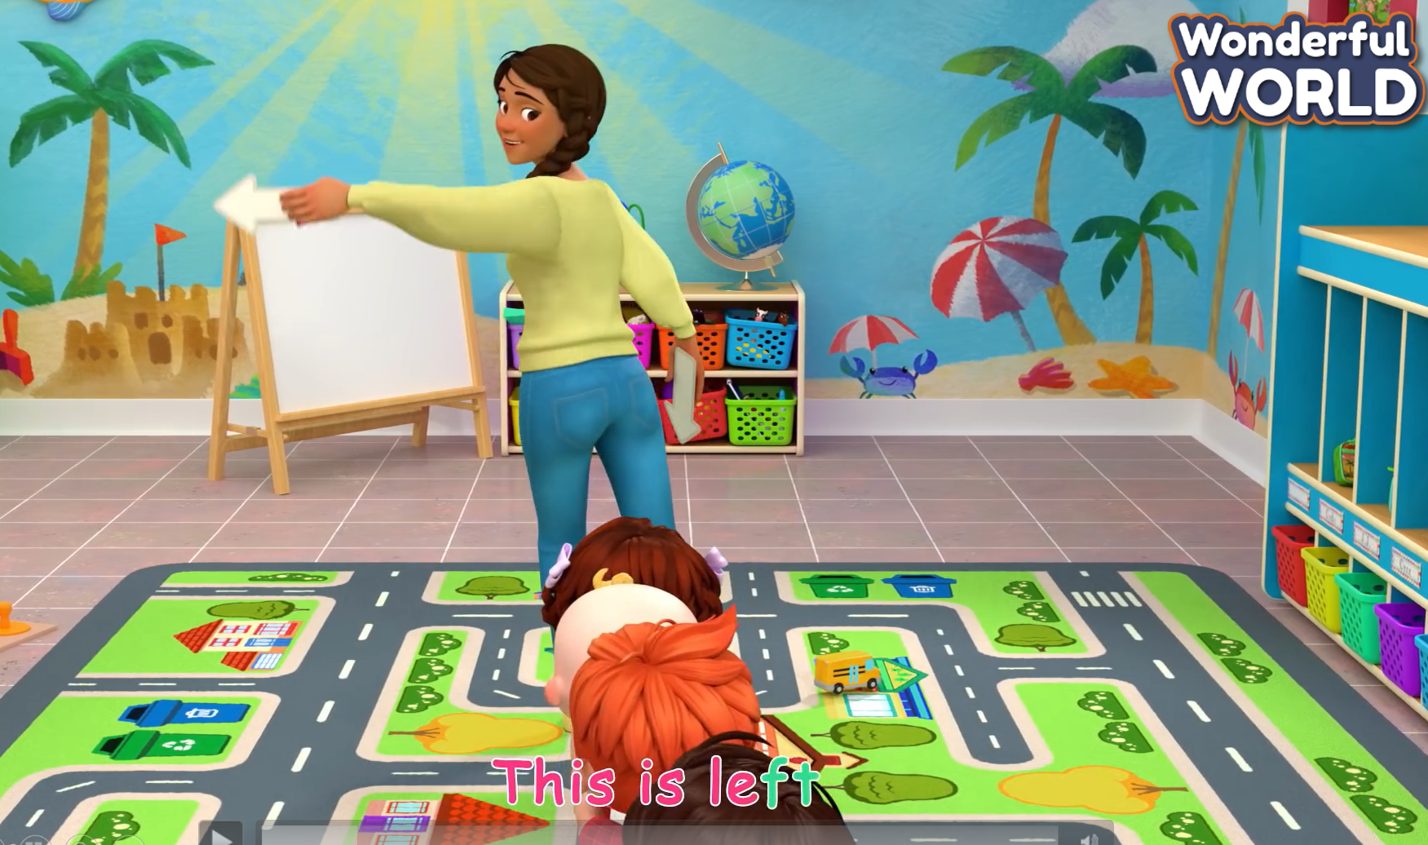 | - Listen and do the actions.
Activity 3: Practice (8 minutes)
A. Aim: Present sentences to notice the use of How + present simple to ask and answer about directions.
Teacher’s Activities | Students’ Activities
b. Procedure :  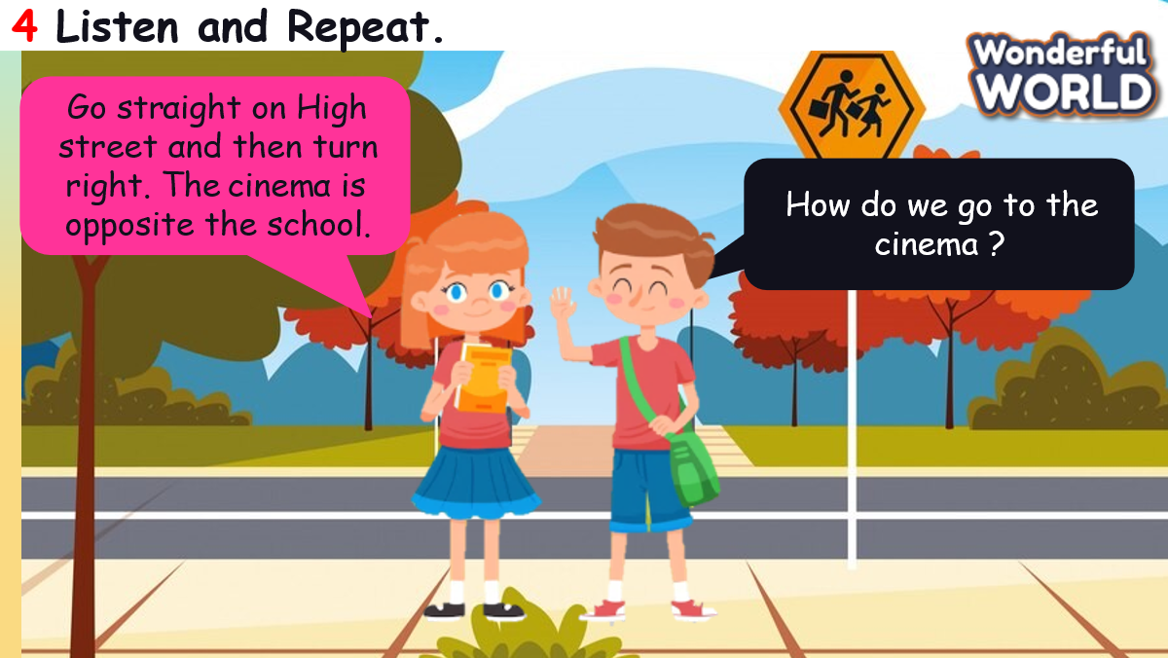  -Play the recording. Tell students to look at the sentences and follow them with their fingers.  • Play the recording again. Ask students to repeat.  • Point to the sentences. Ask students to notice the use of How + present simple to ask and answer about directions.  • Ask students to repeat sentences and link to the next activity.  Look and say.  • Tell students to look at the picture and example dialogue. Then ask them to read out the example.  • Explain the rest of the task to students. Allow them enough time to practise making dialogues  about other places on the map individually and in pairs. Go around the class helping students where  necessary.  • Ask volunteers to read out sentences. Correct any mistakes.  GAME: TELL US WHERE  Part 1 : Multiple choice  Part 2 : True or False  Part 3 : Asking and giving the directions  T can give them the dice to get stars if they answer correctly. | - Follow the teacher.  - Listen and repeat.  - Look.  - Listen  - Answer the questions.  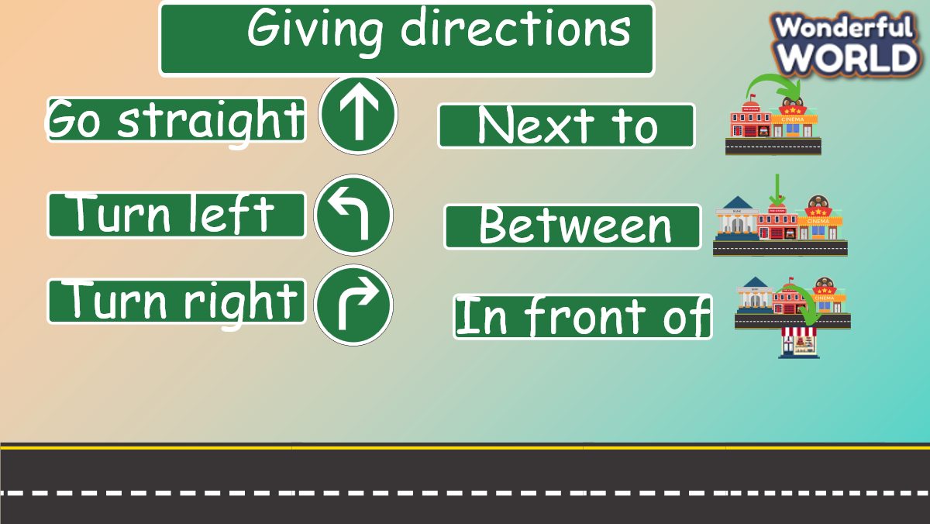
Activity 4: Production (9 minutes)
a. Aims: Apply the learned knowledge to draw a map and present ways to different places.
Teacher’s Activities | Students’ Activities
b. Procedure:  Draw and write. Say.  -Tell students that they are going to draw a map showing where they live and then write about it.  • Explain to students that they should write three sentences that answer these questions: Where is your house? How do you go to school from your house? What are you going to do today? Read the model text together to help.  • If necessary, write the following sentences on the board:  This is my house. It’s on… I … to go to school. Today, I’m going to…  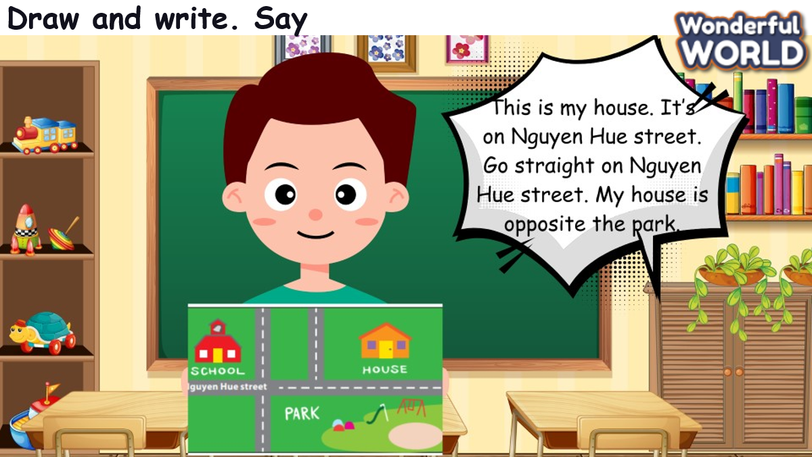  • Give students a few minutes to plan what to draw and write, then tell them to use the box or give them paper.  • Tell students to complete the task. Monitor and help students as necessary.  • Ask students to hold up their books or maps, show each other their drawings and read out their work. | - Draw and say
Activity 5: Assessment (3 minutes)
a. Aims: Consolidate the content of the lesson by doing some activities relating to places and preposition.

Teacher’s Activities | Students’ Activities
Do the assessment: Fill in the words.  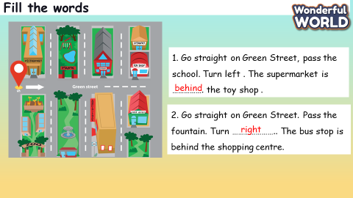 | - Do the assessment.
____________________________________
UNIT 9. PLACES IN TOWN
Lesson 3. Task 7, 8, 9
Period 100
I. OBJECTIVES:
1. Knowledge:
Students will review words and phrases related to the Places in Town Topic:
- identify and write c, f
- identify and pronounce words with initial sounds /s/, /f/.
2. Competences:
- English competences: Students will be able to talk about locations in town.
- Common competences: Students will have the opportunity to develop the creativeness in speaking new phonics and develop communication among friends.
3. Qualities:
- Students get used to new phonics.
II. EQUIPMENT AND MATERIALS:
- For Teacher: PP, TV, music, relating audio track.
- For students: Books, papers and pencils.
III. LESSON PROCEDURE:

Activity 1: Warm-up (5 minutes)
Aim: Review the words, welcome the students.
Teacher’s Activities | Students’ Activities
Dance and sing: London Bridge is falling down.  - Ask students to watch the video  - Sing along to the song. | - Listen to the instruction carefully and watch the video.  - Watch the video again and sing along to the song.
Activity 2: Presentation (8 minutes)
Aims: Learn new phonics: /s/ and /f/
Teacher’s Activities | Students’ Activities
Vocabulary:  Task A: Listen and repeat. (track 9.12)  -Write “c” on the board. Ask students to say the  word. Then write “centre” on the board.  Ask students to pronounce the sound for “s “in the  word.  -Write f on the board. Ask students to say  the word. Then write” fountain” on the board.  Ask students to pronounce the sound for “f” in  the word.  - Pronounce both sound again and show  students how they are different from each other.  - Point to each word on the board and ask students to  practise the sounds with you.  - Play the recordings and tell students to repeat  the words and the sentences. | - Join the game.  -Look and read.  -Read  -Identify and read.
Activity 3: Practice (14 minutes)
Aims: Review words and phrases of related topic, paying attention to the pronunciation.
Teacher’s Activities | Students’ Activities
1. Listen and repeat. (Track 9.12)  - Play TR: 9.12, pointing to each photo as students hear  the corresponding word.  - Have students repeat each word.  8. Listen and chant. (9.13)  - Point to the chant and say Listen. Play TR9.13 and have  students just listen and read silently.  - Say Listen and chant. Play TR: 9.13 and have students say  the chant as they read.  9. Say it  - Look at the pictures. Say the whole sentences. | - Learn the words through pictures.  - Listen then circle.  - Repeat the words.  - Repeat then point.  - Say aloud the sentences  - Listen carefully  - Check with friends and then with teacher and whole class
Activity 4: Production (9 minutes)
Aims: Review phonics: /h/ and /æ/ with an interesting activity: Slap the Board.
Teacher’s Activities | Students’ Activities
- Let’s play game.  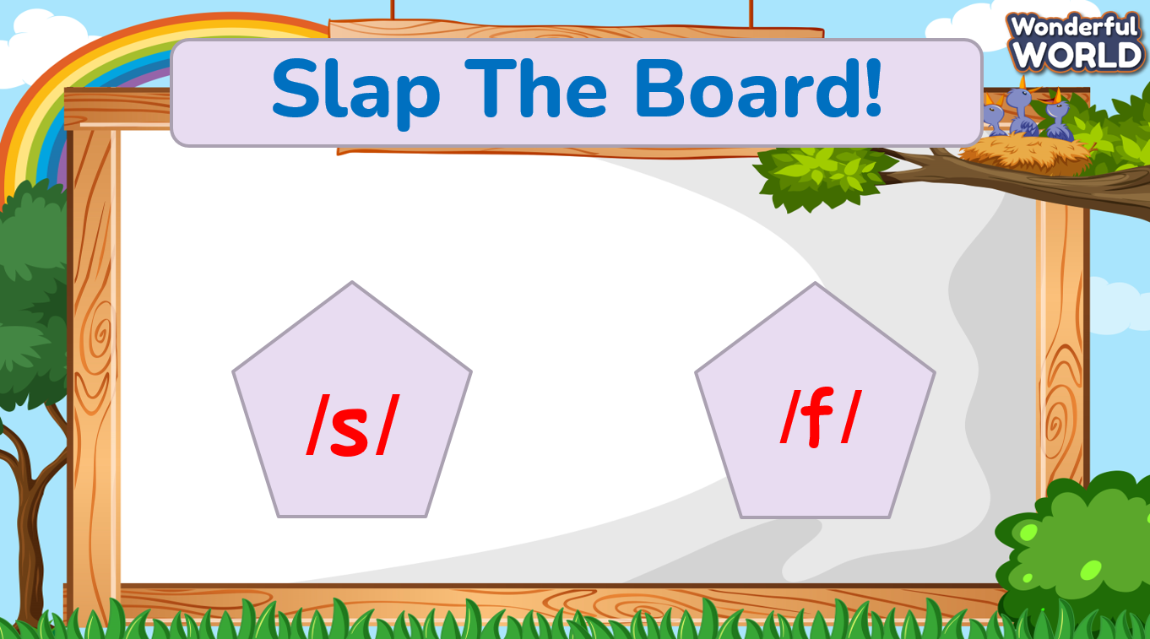  - Game: Slap the board.  - Teacher write two phonics /s/ and /f/ on the board.  - Pick 2 students from the class. Have them place against the class. The teacher reads out loud one of the words that contain the phonic, and the students must jump back and slap their hands on the correct phonic. The faster student is the winner.  - Then say the words and sounds. | - Listen the rule carefully.  -Look and read.  -Read  -Identify and read.  - Check with friends and then with teacher and whole class.
Activity 5: Assessment (3 minutes)
Aims: Review words and phrases used in the unit. Consolidate the content of the lesson.
Teacher’s Activities | Students’ Activities
-Ask sts to do the assessment  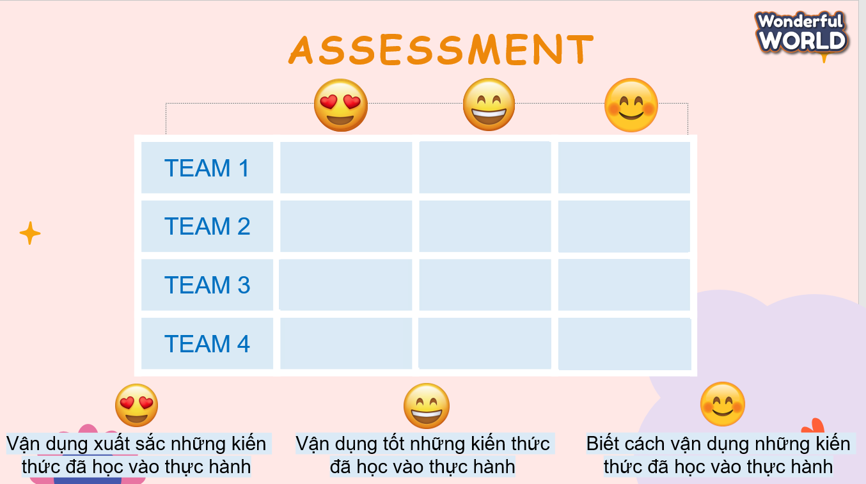  - Check with the class | - Do the assessment  - Work in pairs.
______________________________________

