NAME OF SCHOOL:
……………………. Primary School
LESSON PLAN
UNIT 10: PERFORMING ARTS
Lesson 2: Part 4-5-6

Full name of Teacher: ........................................................
Unit 10: PERFORMING ARTS
Lesson 2: Part 4-5-6
Duration (period): 35 minutes
I. OBJECTIVES:
1. Knowledge:
- Students get to know:
+ Review words: action, animated, award, cartoon, character, company.
+ Ss can use (Wh-questions +answers + time expressions).
2. Competences:
- English competencies: Ss can practice listening and reading skills through the text.
- Common competencies:
+ Understand how to use Wh-questions.
+ Work in pairs or groups to talk about Walt Disney.
3. Qualities:
- Students will have a sense of love towards Performing arts.
II. EQUIPMENT AND MATERIALS:
- Basic things: Student’s book, flashcards, photos.
- Advanced things: PPT, laptop, TV.
III. LESSON PROCEDURE:
Activity 1: Warm-up
Activity 2: Presentation
Activity 3: Practice
Activity 4: Production
Activity 5: Wrap-up & Assessment
Activity 1: Warm-up (5 minutes)
Let’s play a game: “Spin the wheel”
 | Teacher’s Activities | Students’ Activities
 | a Aim: Welcome Ss. Warm the class up with a "spin the wheel" game using words: action, animated, award, cartoon, character, and company.
 | b, Procedure  1. Greet Ss. Chatting ... Do you like playing a game?  2. Introduce the game:  - Ask Ss to play the "Spin the Wheel" game to revise the vocabulary.  - "Spin a wheel" to obtain random star numbers when Ss ask to stop it.  - Ask Ss to look at the picture and answer what it is. | - Greet T.  - Answer: "Yes"  - Join an activity.
Activity 2: Presentation (14 minutes)
Teacher’s Activities |  | Students’ Activities
- Aims: Practice reading and listening to the text.
b, Procedure  Task 4: Read and complete the text about Charlie Chaplin with the given words. Then listen and check.  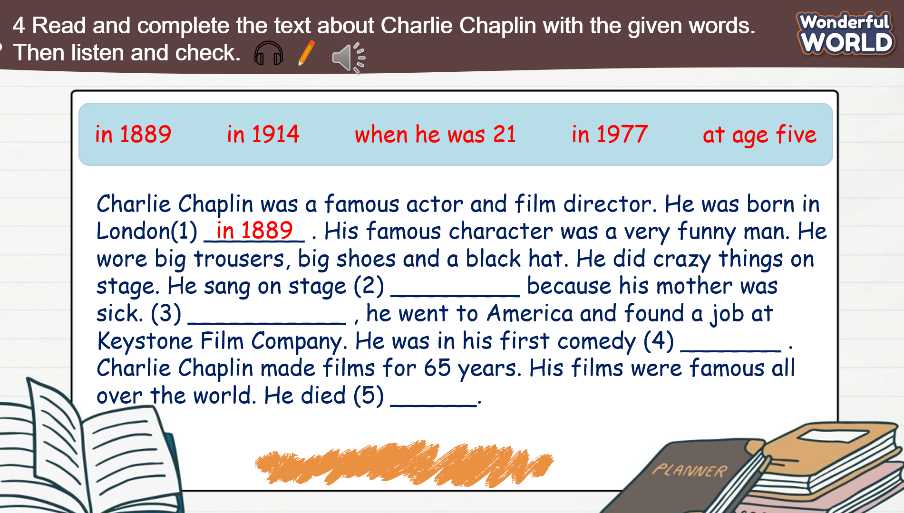  - Ask Ss to look at the text and tell Ss that they are going to fill in the blanks with the given words to complete each sentence.  - Explain the meanings of these phrases if Ss do not know.  - Ask Ss to do the task in pairs.  - Ask Ss to exchange their textbooks and give feedback to each other.  - Play track 10.6 for Ss to listen to.  - Show the text, and play the audio again.  - Ask Ss to check the answers.  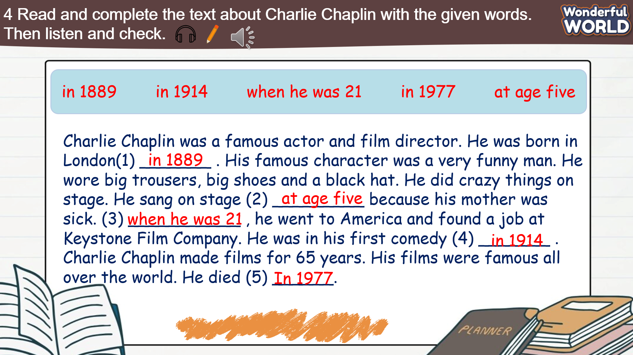  - Ask Ss to listen and read the text individually and as a group.  - Ask some volunteers to read it out in front of the whole class.  Grammar: Wh- questions: what/ who/ where/ why  - Ask Ss to remind them what, who and why are question words.  + What asks about things  + Who asks about a person  + Where asks about the places  + Why asks about the reason 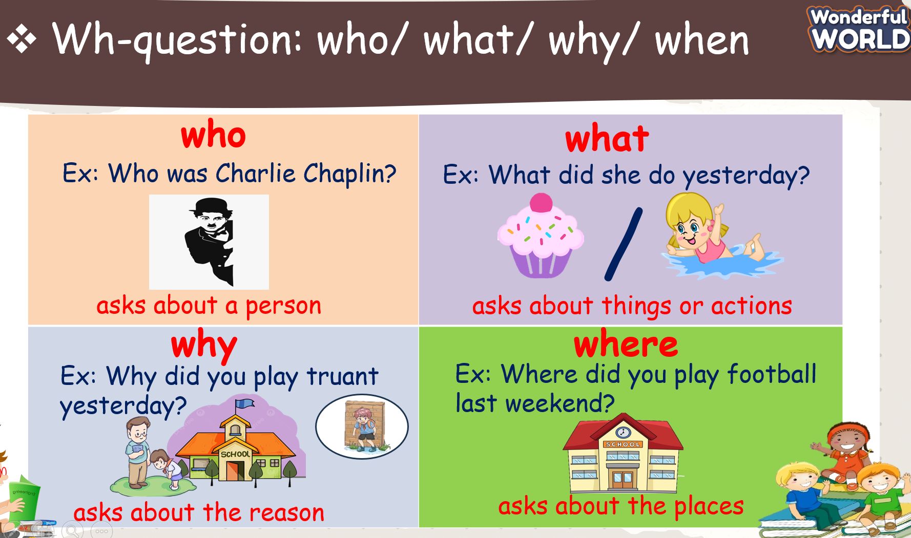  Mini-game: "Lucky Star"  - Explain the rules of the game.  - Ask Ss to choose a star, then fill in the blank.  - Check answers as a class and open the gift box to get stars for their team. |  | - Look at the text 4 and complete each sentence.  - Listen to the T explain the meanings of these phrases.  - Exchange textbooks with the partner.  - Listen to track 10.6 twice.  - Listen and check answers again.  - Read in front of the class  - Listen to the T.  - Join an activity.
Activity 3: Practice (5 minutes)
Teacher’s Activities |  | Students’ Activities
a. Aims: - Controlled practice:
+ Develop answer the questions skills, and observation skills.
+ Get familiar with Wh-questions.
b, Procedure  Task 5: Read the text in Activity 4 again. Answer the questions below.  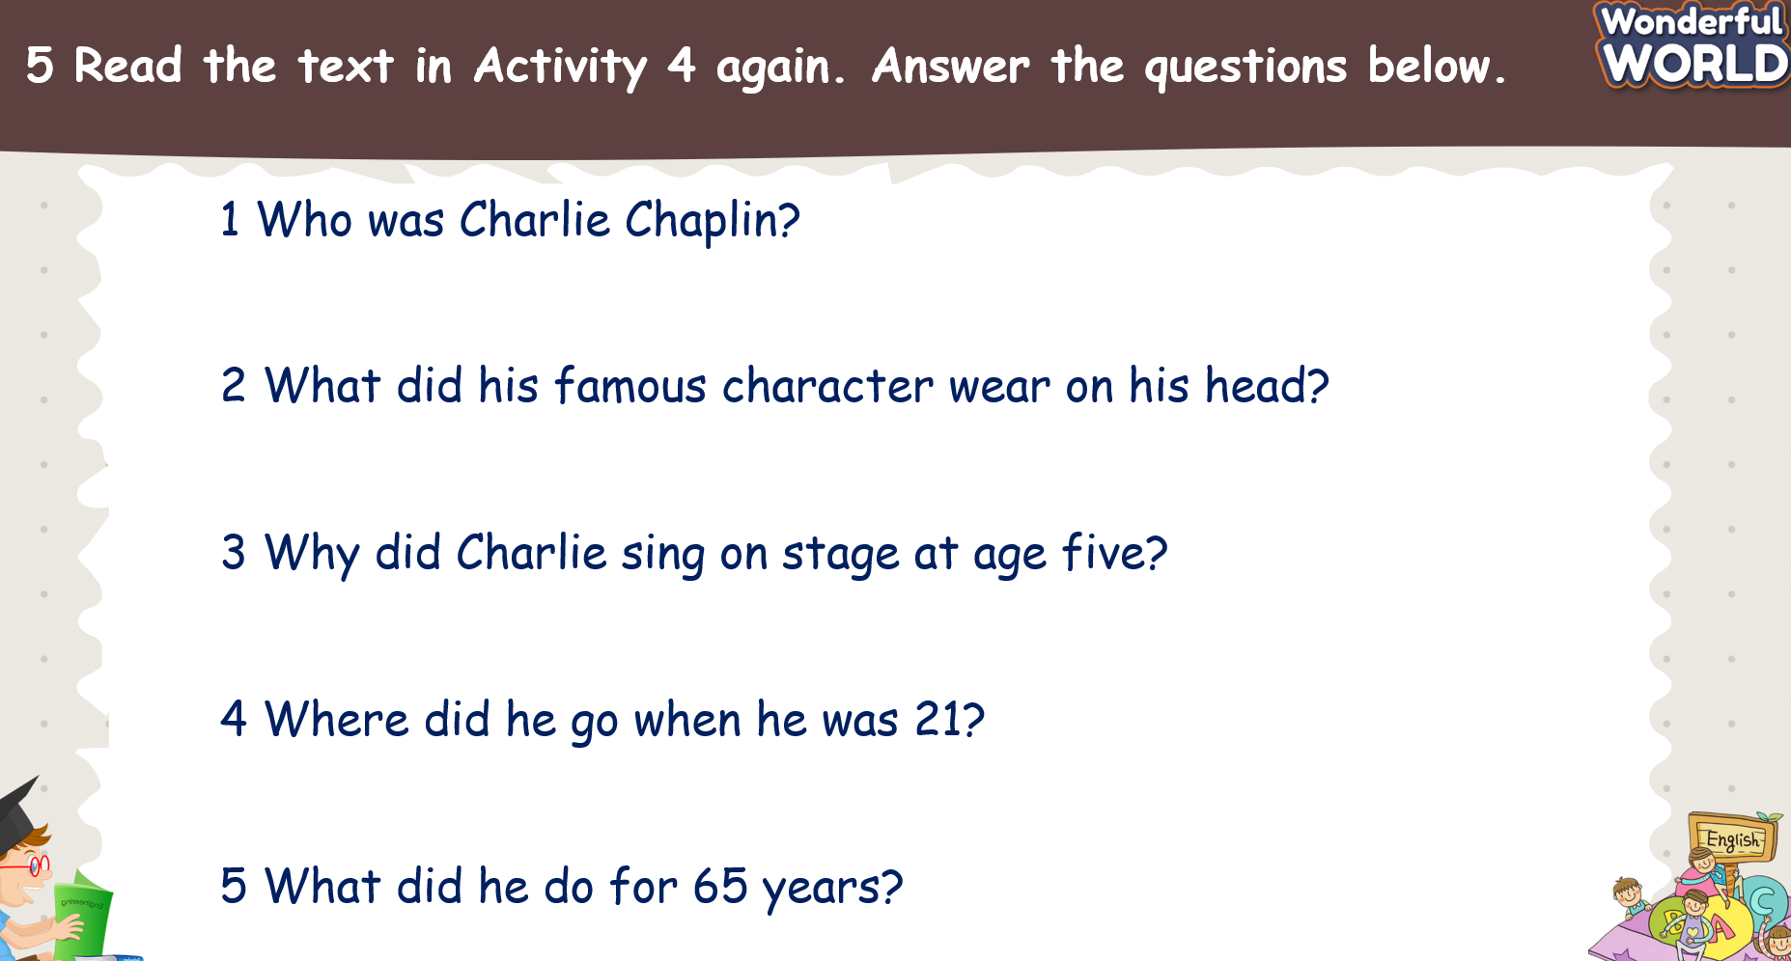  - Ask Ss to read the text in Activity 4 again and answer the questions.  - Read the questions to the class. Ss’ attention to the question form and the use of did as an auxiliary verb in past simple  questions.  - Give Ss five minutes to work in pairs.  - Call on some Ss to go to the board and write the answers.  - Check answers as a whole class.  - Keys:  1 He was a famous actor and film director.  2 He wore a black hat.  3 Because his mother was sick.  4 He went to America.  5 He made films for 65 years. |  | - Read the passage again and answer the questions.  - Work in pairs to share the answers.  - Write the answers on the board.  -Listen to the T and check them.
Activity 4: Production (6 minutes)
Teacher’s Activities |  | Students’ Activities
- Aims:
+ Complete task 6.
+ Work in pairs and talk about Walt Disney
b. Procedure  Task 6: Let’s talk about Walt Disney. Use the prompts and your ideas.  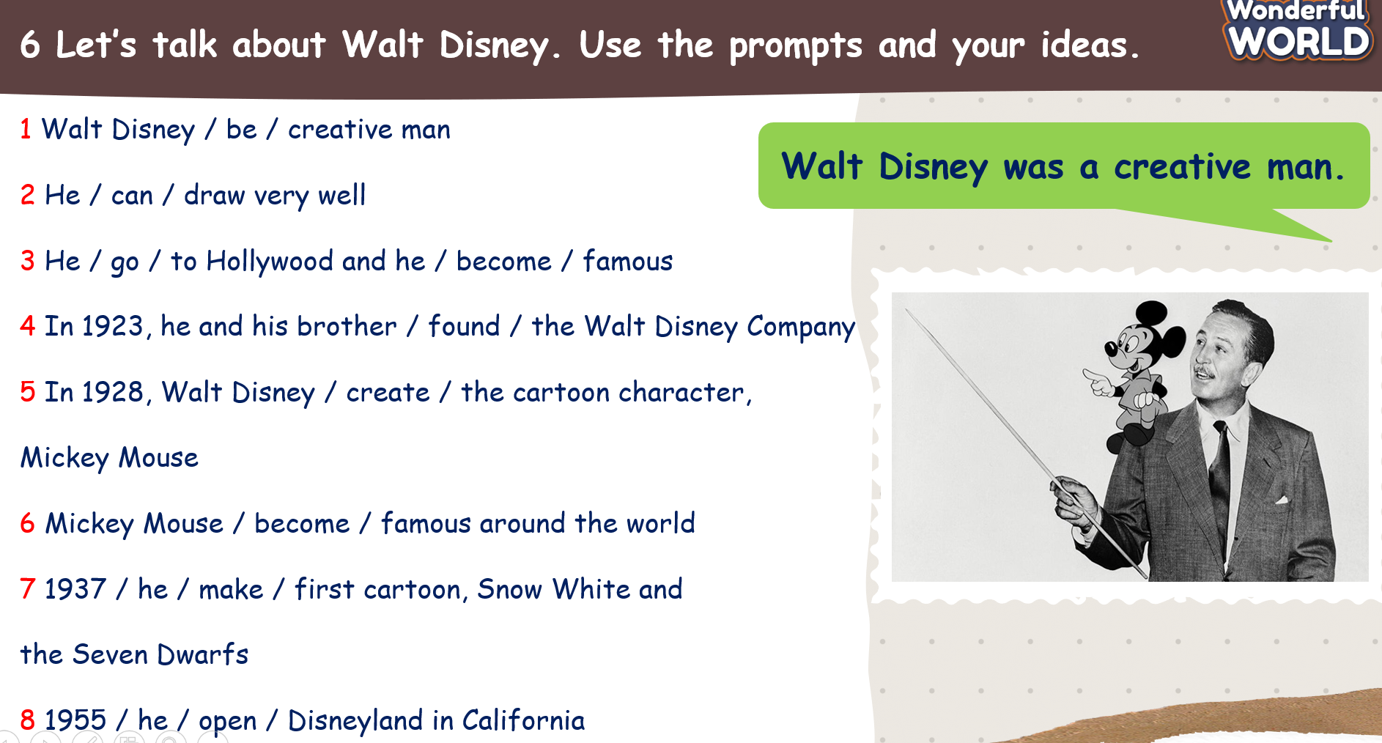  - Tell Ss they are going to talk about Walt Disney.  - Ask Ss if they know anything about him. Elicit the answers.  - Ask Ss to read the prompts.  - Ask Ss to read out the example. Read it out again and ask Ss to repeat.  - Ask Ss to work in pairs. Take turns to talk about him.  - Ask some volunteers to speak in front of the class.  - Check the answers as a whole class.  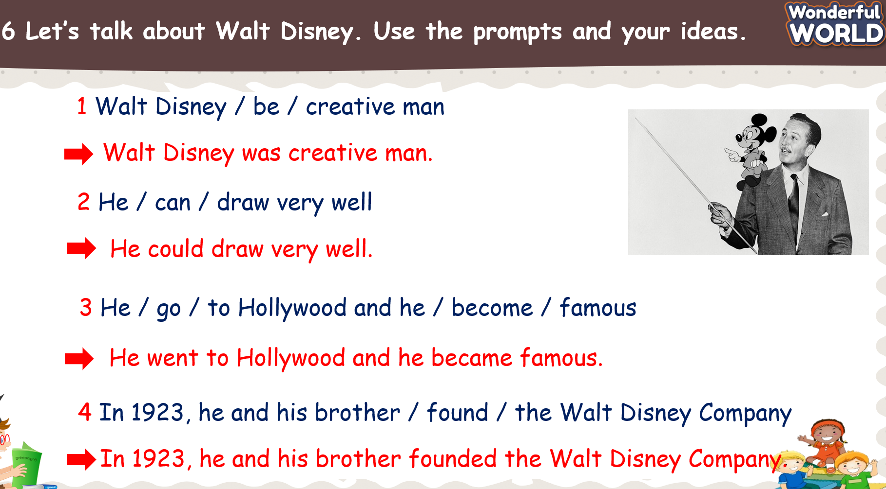  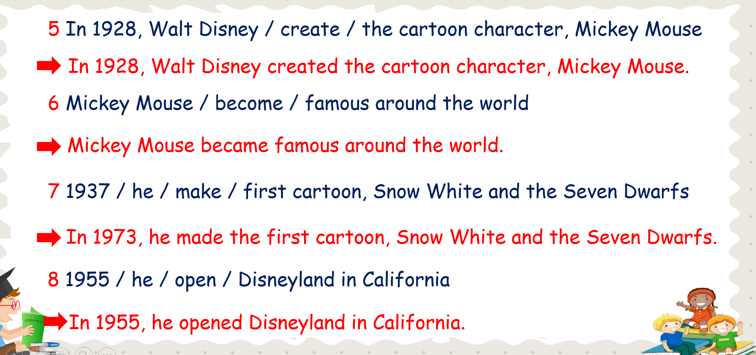 |  | - Read the prompts and read out the example.  - Work in pairs to complete task 6.  - Some Ss to speak in front of the class.  - Listen to the T and check the answers.
Activity 5: Wrap up & Assessment (5 minutes)
Teacher’s Activities |  | Students’ Activities
a, Aims:
- Check Ss’ understanding of what they have learned.
- Ss rehearse what they have learned in the lesson.
- Assessment: Look and complete.  - Ask Ss to look at the screen and fill in the blank using Wh- questions.  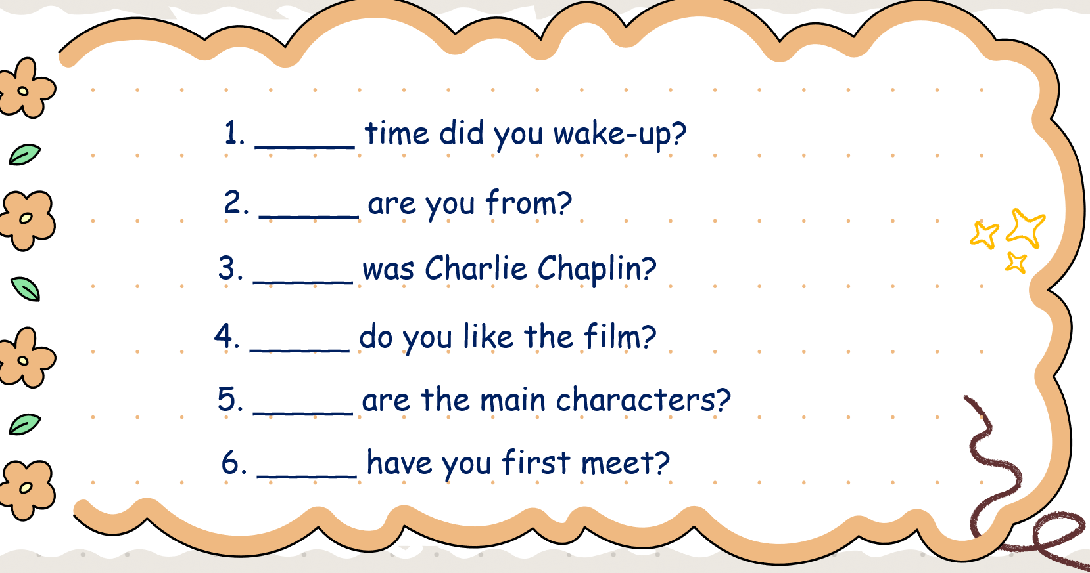  - Check with the class.  - Wrap-up  * Remember  Wh-question:  what/ who/ why/ where  - What asks about things  - Who asks about a person  - Why asks about the reason  - Where asks about the places |  | - Look at the screen carefully.  - Fill in the blank.  - Check with the teacher.  - Ss read the wrap-up.  - Stand up and say goodbye to the teacher.

