NAME OF SCHOOL:
…………………….Primary School
LESSON PLAN
Unit 10: Performing Arts
Lesson 3: Period 3: Part 7,8,9
Full name of Teacher:
Unit 10: Performing Arts
Lesson 3: Part 7,8,9
Duration (period): 35 minutes
I. OBJECTIVES:
1. Knowledge:
- Pronunciation: sentence stress
- English competencies: -To recognize the stressed words in the sentences.

2. Competences:
- To practice pronouncing stressed words
- Common competencies: Students can develop logical thinking and communication among friends.
3. Qualities:
- Students will feel confident in their pronunciation when they speak in the crowd.

II. EQUIPMENT AND MATERIALS:
- For Teacher: PPT, flashcards, printed papers, crayons.
- For students: textbook
III. LESSON PROCEDURE:
Activity 1: Warm-up
Activity 2: Presentation
Activity 3: Practice
Activity 4: Production
Activity 5: Wrap-up & Assessment

Activity 1: Warm-up (5 minutes)
Aims: warm-up activity to greed the class, create an exciting environment, and introduce the new lesson
Teacher’s Activities | Students’ Activities
Greet the Ss  Ask the Ss to read the question aloud:  + How are you?  + What’s the weather like today?  Ask them to watch the video and dance along.  Listen to the song " Ready Set Dance 1"   | - Greet the T  - Answer the questions aloud  - Watch the video and dance along  - Students can warm up and move their bodies to start the lesson.
Activity 2: Presentation (7 minutes)
Aim: Introduce the concept of sentence stress, explaining that it involves emphasizing certain words in sentences for clearer pronunciation
Teacher’s Activities | Students’ Activities
• Give examples for students to understand.  • Explain that usually, content words  such as main verbs, nouns, adjectives, adverbs,  and negative auxiliaries (don't, isn't..) are usually stressed.  • Structure words (i.e. words for correct grammar) such as pronouns, prepositions, articles (a, an, the) conjunctions  (and, but, because) or auxiliary verbs (do, have..) usually aren’t stressed.  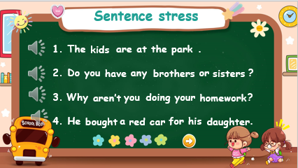 | Listen and complete the examples.  Pay attention to the teacher
Activity 3: Practice – Controlled practice (10 minutes)
Teacher’s Activities | Students’ Activities
a. Aims:
Complete task 7 and task 8
Practice listening and reading stressed sentences.
Teacher’s Activities | Students’ Activities
7 Listen and underline the stressed word. Then repeat.  TR: 10.8  • Play the recording twice.  • Have students do this task in pairs.  • Call on some students to share their answers and check.  • Have students read each sentence chorally and individually.  • Check pronunciation  8 Reorder the words to make a full sentence. Then read it  aloud.  • Tell students that they are going to put the words in the correct order.  • Give students five minutes to do the task individually.  • Call on three students to go to the board and write the answers.  • Check answers as a whole class | - Students do this task in pairs  - Listen and repeat each sentence after listening, -- Paying attention to the stressed words
Activity 4: Production (8 minutes)
Teacher’s Activities | Students’ Activities
a. Aims:
- Practice stress in sentences
- Complete task 9
9 Listen and chant. TR: 10.9  - Tell students they are going to learn a chant. Explain to students that the chant is about sentence stress.  - T plays the recording and tells students to listen and follow.  - T reads out the chant one line at a time and asks students to repeat after you.  - T plays the recording again. Encourage students to chant along.  - T asks students to practice the chant individually, and then in pairs or groups. For example, one group chants the first verse, and the other group chants the second verse. Ask some volunteers to chant (optional). | - Underline the stressed words in each sentence  - Practise the chant individually, and then in pairs or in groups
Activity 5: Wrap up & Assessment (5 minutes)
Teacher’s Activities | Students’ Activities
Aims:
- Check students’ understanding of what they have learned.
- Students rehearse what they have learned in the lesson.
T asks sts to assess the mini-game  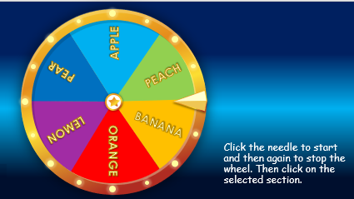  Click the needle to start and then again to stop the wheel. Then click on the selected section. | - Do the assessment.  - Check with the teacher  - Sts read the wrap-up  - Stand up and say goodbye to the teacher.

