NAME OF SCHOOL:
…………………….Primary School
LESSON PLAN
UNIT 10: Performing Arts
Fun time and Project: Period 1
Full name of Teacher: ........................................................
Unit 10. Performing Arts
Period 1: Fun time and project
Duration (period): 35 minutes
I. OBJECTIVES:
1. Knowledge:
Students will review and practice all get vocabulary and structures of Unit 10 via some fun activities with words and structures related to the topic of Performing Arts.
2. Competences:
- English competencies: Students will be able to think and talk about topics.
- Common competencies: Students will have the opportunity to develop logical thinking and develop communication among friends.
3. Qualities:
- Students develop imagination and show their favourite things.
- Be confident and active in communicating with friends and teachers.
II. EQUIPMENT AND MATERIALS:
- For Teacher: PPT, flashcards, printed papers, dice.
- For students: textbook
III. LESSON PROCEDURE:
Activity 1: Warm-up
Activity 2: Review & Practice
Activity 3: Production
Activity 4: Wrap-up & Assessment
 | Activity 1: Warm-up (5 minutes)
 | Teacher’s Activities | Students’ Activities
 | Aims: Welcome students. Engage the class with a game and review the vocabulary of Unit 2.
 | Greet the Ss  Ask the Ss to read the question aloud:  + How are you?  + What’s the weather like today?  Ask them to watch the video and dance along.  Listen to the song “ Chicken Dance”  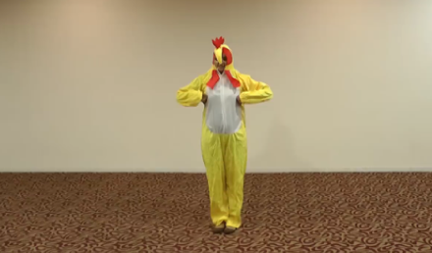  After warming up, let students play a mini-game to review vocabulary:  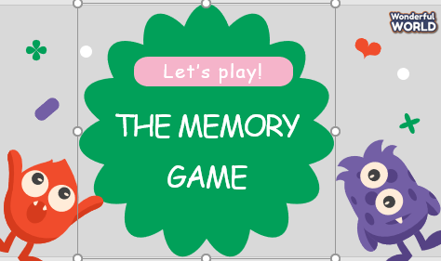  - Show the game on the side, and give instructions on how to play the game.  - Ask Ss to look at the cards carefully and remember as fast as they can. Ss will choose two cards that have the corresponding picture. Each team will only answer once each turn. | - Greet Teacher  - Watch the video and dance along  - Students can warm up and move their bodies to start the lesson.  - Listen to the rules of the game.  - Join the activity.
Activity 2: Review & Practice (17 minutes)
Teacher’s Activities |  | Students’ Activities
Aims:
- Review the words about entertainment and types of films.
- Complete the task 1
1 Unscramble the words.  • Tell students that they are going to look at the picture and  unscramble the words.  • Demonstrate number 1 as an example.  • Have students work in pairs and check answers with their  partners.  • Call on one student to write answers on the board and  check answers as a whole class. |  | - Do the task 1
Activity 3: Production (8 minutes)
Teacher’s Activities |  | Students’ Activities
Aims: - Controlled practice: develop Speaking skills.
2 Board game  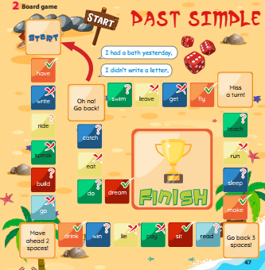  • Tell students to look at this activity and work in pairs.  • Explain the rules of the game.  • Go around the classroom and offer help if necessary.  Rule of the game:  - Play this game in pairs.  - Put the marker on Start.  - Take turns to throw the dice.  - Count the dots.  - Move the maker and make the sentence with the verb.  - The student who reaches the Finish first is the winner |  | - Listen to the rules of the game.  - Join the activity.
Activity 4: Wrap up & Assessment (5 minutes)
Teacher’s Activities |  | Students’ Activities
a, Aims:
- Do a quick exercise via a mini-game to review the words and grammar used in Unit 10
Play the game "Secret Gift Box Game”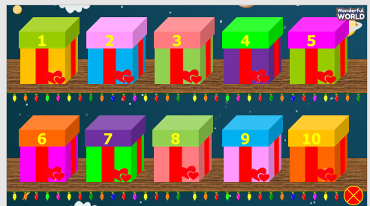  - Ask Ss to take turns choosing a box and choosing a correct answer. After choosing a correct answer, Ss open the secret box. Inside the box can be good points. |  | - Join in the activity.  - Check with the teacher.

