NAME OF SCHOOL:
…………………….Primary School
LESSON PLAN
UNIT 10: Performing Arts
Fun time and Project: Period 2
Full name of Teacher: ........................................................
Unit 10. Performing Arts
Period 2: Fun time and project
Duration (period): 35 minutes
I. OBJECTIVES:
1. Knowledge:
Students will review and practice all get vocabulary and structures of Unit 10 via some fun activities with words and structures related to the topic of Performing Arts.
2. Competences:
- English competencies: Students will be able to think and talk about topics.
- Common competencies: Students will have the opportunity to develop logical thinking and develop communication among friends.
3. Qualities:
- Students develop imagination and show their favourite things.
- Be confident and active in communicating with friends and teachers.
II. EQUIPMENT AND MATERIALS:
- For Teacher: PPT, flashcards, printed papers, dice.
- For students: textbook
III. LESSON PROCEDURE:
Activity 1: Warm-up
Activity 2: Review & Practice
Activity 3: Production
Activity 4: Wrap-up & Assessment
 | Activity 1: Warm-up (5 minutes)
 | Teacher’s Activities | Students’ Activities
 | Aims: Welcome students. Engage the class with a game and review the vocabulary of Unit 2.
 | Greet the Ss  Ask the Ss to read the question aloud:  + How are you?  + What’s the weather like today?  Ask them to watch the video and dance along.  Listen to the song “ Ready Set Dance 1”    After warming up, let students review vocabulary:   | - Greet Teacher  - Watch the video and dance along  - Students can warm up and move their bodies to start the lesson.  - Join the activity.
Activity 2: Review & Practice (17 minutes)
Teacher’s Activities |  | Students’ Activities
Aims:
- Review the words about entertainment and types of films.
- Complete the task 3
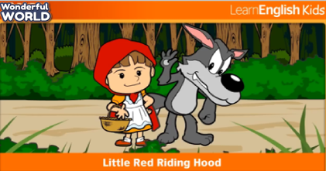  Watch the video:  - Let students watch the story " Little Red Riding Hood "  - Let them discuss, and ask and answer questions about the video.  Role play:  - The teacher divides the class into groups of 5 members.  - The members of the group take turns playing the roles of "the wolf", "little red riding hood", "the hunter" and "the grandmother", the narrator.  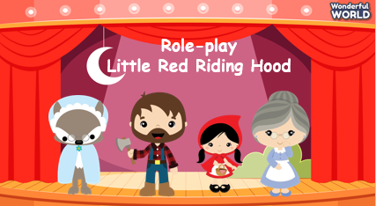  - Let the students read and memorize the character lines.  - Call the groups to act out and retell the story "Little Red Riding Hood"  - The group that performs well will win.  Similarly, the students will do task 3: Project: You are going to perform in English. Follow these steps.  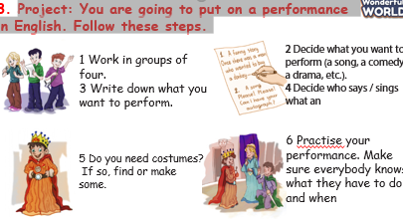  4. Do your performance for the rest of the class and watch the other groups. Which group do you think was best and why?  • Have each group do their performance in front of the class.  • Give students five minutes to observe and choose one they like  best then explain the reason.  • The most voted group will receive a gift. |  | - Students watch the story " Little Red Riding Hood "  - Discuss ask and answer questions about the video.  - Follow the teacher's instructions
Activity 3: Production (8 minutes)
Teacher’s Activities |  | Students’ Activities
Aims: - Controlled practice: develop Speaking skills.
5. Be a director. Tell each group one thing they did so well  and one thing they could do better.  • Have each group discuss and give comments on the performance of other groups.  • Have students tell one thing they did so well and one thing they  could do better.  • Listen and give feedback. |  | - Discuss and give comments on the performance of other groups.
Activity 4: Wrap up & Assessment (5 minutes)
Teacher’s Activities |  | Students’ Activities
a, Aims:
- Do a quick exercise via a mini-game to review the words and grammar used in Unit 10
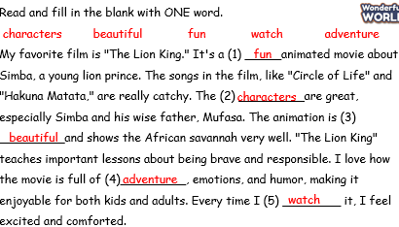  - Asks Ss about the words they have learned in the lesson without looking at the book.  - Asks sts to do the quick assessment.  - Checks with the class. |  | - Ss answer.  - Stand up and say goodbye to the teacher.

