TUẦN 29 Khối 3, 5 (Từ ngày 07/04/2025 đến ngày 11/04/2025)
 | TIẾT | MÔN | TIẾT THỨ | NỘI DUNG BÀI DẠY |  | UDCNTT |  | ĐỒ DÙNG DẠY HỌC
Hai  07/04 | 1 | 5A | 113 | Review 5 | Part 3 - Video: Task 1, 2, 3, 4 |  | Wonderfulworld |  | Flashcards, TV, books
Hai  07/04 | 2
Hai  07/04 | 3 | 3A | 113 | Review 5 | Part 3 - Video: Task 1, 2, 3, 4 |  | Wonderfulworld |  | Flashcards, TV, books
Hai  07/04 | 4 | 3A | 114 | Review 5 | Part 4 - Task 1, 2, 3 |  | Wonderfulworld |  | Flashcards, TV, books
Hai  07/04 | 5 | 5D | 113 | Review 5 | Part 3 - Video: Task 1, 2, 3, 4 |  | Wonderfulworld |  | Flashcards, TV, books
Hai  07/04 | 6 | 3B | 113 | Review 5 | Part 3 - Video: Task 1, 2, 3, 4 |  | Wonderfulworld |  | Flashcards, TV, books
Hai  07/04 | 7
Ba  08/04 | 1 | 5C | 113 | Review 5 | Part 3 - Video: Task 1, 2, 3, 4 |  | Wonderfulworld |  | Flashcards, TV, books
Ba  08/04 | 2 | 5B | 113 | Review 5 | Part 3 - Video: Task 1, 2, 3, 4 |  | Wonderfulworld |  | Flashcards, TV, books
Ba  08/04 | 3 | 5A | 114 | Review 5 | Part 4 - Task 1, 2, 3 |  | Wonderfulworld |  | Flashcards, TV, books
Ba  08/04 | 4
Ba  08/04 | 5 | 3A | 115 | Unit 10. Our world | Lesson 1 (1, 2, 3) |  | Wonderfulworld |  | Flashcards, TV, books
Ba  08/04 | 6 | 5D | 114 | Review 5 | Part 4 - Task 1, 2, 3 |  | Wonderfulworld |  | Flashcards, TV, books
Ba  08/04 | 7 | 3B | 114 | Review 5 | Part 4 - Task 1, 2, 3 |  | Wonderfulworld |  | Flashcards, TV, books
Tư  09/04 | 1 | 5A | 115 | Unit 11. Animals | Lesson 1 (1, 2, 3) |  | Wonderfulworld |  | Flashcards, TV, books
Tư  09/04 | 2
Tư  09/04 | 3
Tư  09/04 | 4
Tư  09/04 | 5 | 5B | 114 | Review 5 | Part 4 - Task 1, 2, 3 |  | Wonderfulworld |  | Flashcards, TV, books
Tư  09/04 | 6 | 5C | 114 | Review 5 | Part 4 - Task 1, 2, 3 |  | Wonderfulworld |  | Flashcards, TV, books
Tư  09/04 | 7
Năm  10/04 | 1 | 5C | 115 | Unit 11. Animals | Lesson 1 (1, 2, 3) |  | Wonderfulworld |  | Flashcards, TV, books
Năm  10/04 | 2 | 5B | 115 | Unit 11. Animals | Lesson 1 (1, 2, 3) |  | Wonderfulworld |  | Flashcards, TV, books
Năm  10/04 | 3 | 5A | 116 | Unit 11. Animals | Lesson 1 (4, 5, 6) |  | Wonderfulworld |  | Flashcards, TV, books
Năm  10/04 | 4
Năm  10/04 | 5 | 5D | 115 | Unit 11. Animals | Lesson 1 (1, 2, 3) |  | Wonderfulworld |  | Flashcards, TV, books
Năm  10/04 | 6 | 5C | 116 | Unit 11. Animals | Lesson 1 (4, 5, 6) |  | Wonderfulworld |  | Flashcards, TV, books
Năm  10/04 | 7
Sáu  11/04 | 1 | 3B | 115 | Unit 10. Our world | Lesson 1 (1, 2, 3) |  | Wonderfulworld |  | Flashcards, TV, books
Sáu  11/04 | 2 | 5D | 116 | Unit 11. Animals | Lesson 1 (4, 5, 6) |  | Wonderfulworld |  | Flashcards, TV, books
Sáu  11/04 | 3 | 5B | 116 | Unit 11. Animals | Lesson 1 (4, 5, 6) |  | Wonderfulworld |  | Flashcards, TV, books
Sáu  11/04 | 4
Sáu  11/04 | 5
Sáu  11/04 | 6 | 3B | 116 | Unit 10. Our world | Lesson 1 (4, 5, 6) |  | Wonderfulworld |  | Flashcards, TV, books
Sáu  11/04 | 7 | 3A | 116 | Unit 10. Our world | Lesson 1 (4, 5, 6) |  | Wonderfulworld |  | Flashcards, TV, books

GRADE 3
WEEK 29 (From 7/4 to 11/4)
REVIEW 5
Part 3 – VIDEO: Task 1, 2, 3
Period 113
I. OBJECTIVES:
1. Knowledge:
By the end of the lesson, students will be able to:
- Review vocabulary about foods: apple, banana, pear, tomato, bread, cheese,
chicken, juice, milk, rice, biscuit, chocolate, ice cream, sweets
- Review vocabulary about activities people do when visiting a town/city: drink, eat, have fun, look at, see, take photos
- Review grammar: There are some/a lot of/many…
- Review grammar: Present continuous (question)
+ What am I doing?
+ What’s he/she doing?
- Review grammar:
How many apples are there?
There are sixteen apples.
- Watch a video about people talking about food in a market.
- Do some exercises while and after watching the video.
2. Competences:
English competence
-Watch and understand a video about different food and drinks in a market.
General competence
- Raise motivation and interests in learning English.
- Develop communication and collaboration skills through learning activities.
- Build up self-learning skill through learning activities.
- Know how to choose healthy food in meals.
3. Qualities:
- Don't waste foods
- Support foods and vegetables for the poor or homeless people.
- Take care yourself by choosing safe and hygienic foods.
II. EQUIPMENT AND MATERIALS:
- For teacher:
+ Basic things: Student’s book ,teacher’s book and food flashcards.
+ Advanced things: PPT, projector/interactive whiteboard/laptop/TV.
- For students: student’s book, work book.
III. LESSON PROCEDURE:
Warm up (10 minutes)
Teacher’s activities | Student’s activities
- Greeting  "Draw and guess" game  - Invite one student go to the board and T shows the name of a ramdom picture for his/her to draw it  - Asks the others to guess the name of the picture that is drew on the board.  - Give stars for who has a correct answer.  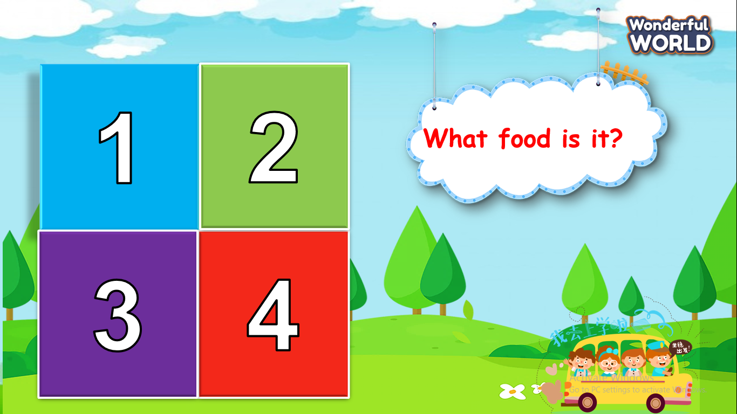 | - Play game  - Try to give the fastest answer.  - Get stars for the team.
Review ( 15 minutes)
Teacher’s activities | Student’s activities
Before watching:  Task 1: Circle your favourite food. Say.  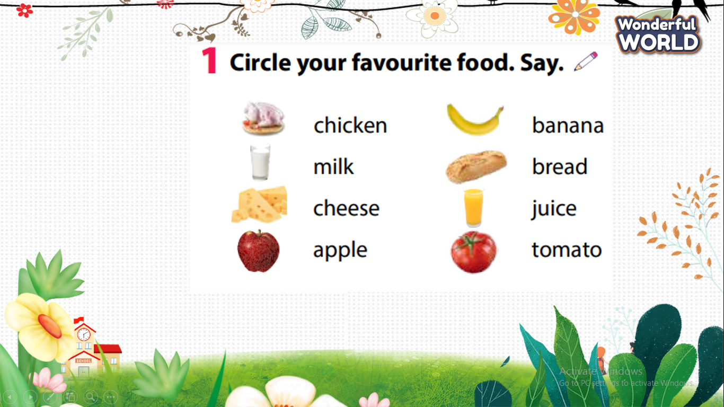  - Read the instruction to the class. Invite a student to read the list of foods and drinks.  - Point to the first item, chicken. Ask a student Do you like chicken? If the student answers Yes, ask them to circle the item. If the student answers No, tell them not to circle the item.  - Repeat with the remaining items. Tell students to circle the items they like and drink, and not to circle the items they don’t.  - Go round the class asking students to say one thing they eat or drink.  While watching:  Task 2:Tick. What food can you see in the video?  -Remind students that they are going to watch a video about different food and drinks in a market in Barcelona.  - Read the question to the students. Read through the list of words and make sure students understand the task.  - Tell students to get ready to tick the words as they watch the video.  - Play the video all the way through.  - Go through the answers as a class, playing the video again if you need to.  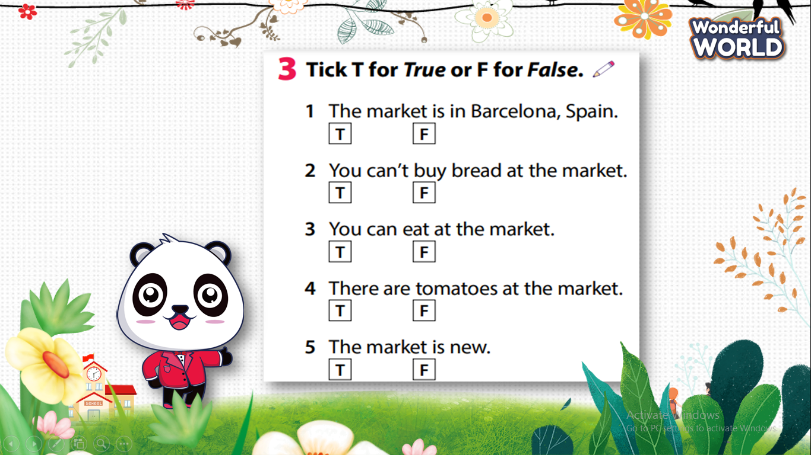  - Turn on the video and ask students to tick T or F at task 3.  - Choose the best answer and receive stars.  - Play game: Hide and seek"  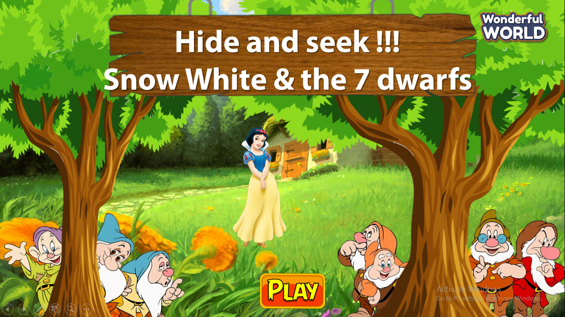  - Show many questions and ask Ss to answer.  - Give stars for the best student. | - Think about the favourite food and circle at task 1  - Volunteer to answer question.  - Watch video clearly and tick all the things as you can see as fast as possible.  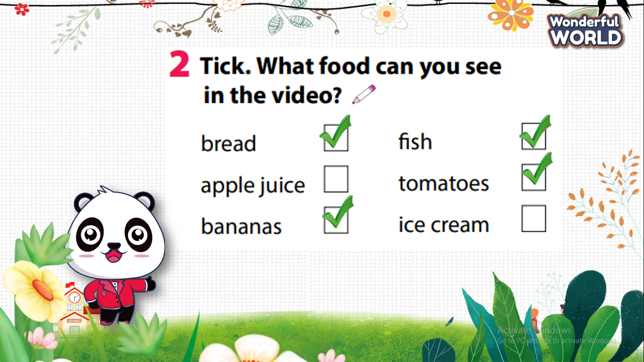  Analyse and guess T or F in each question. If it is the wrong question Ss have to show where the wrong point is?  - Give stars for the best Ss.  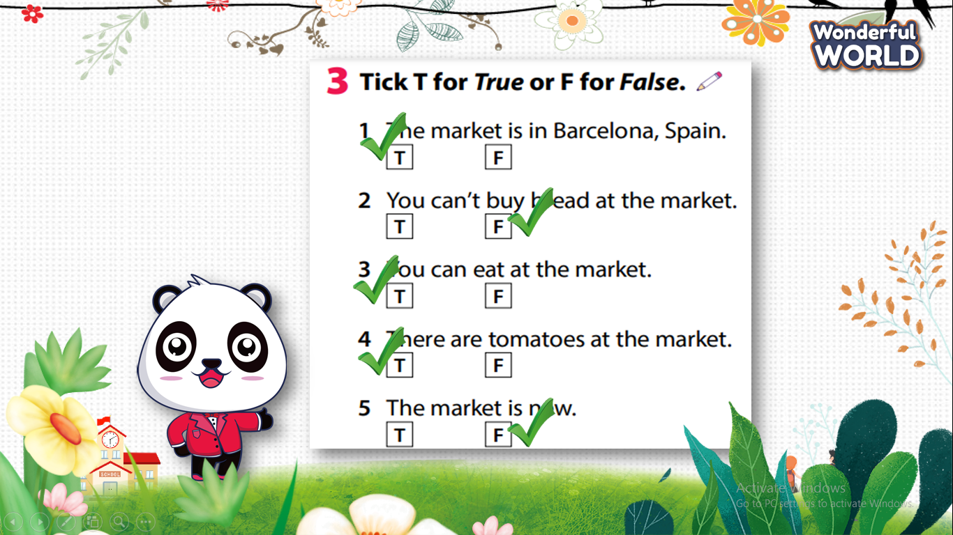  - Join the game and receive stars.
Extra activity (10 minutes )
Teacher’s activities | Student’s activities
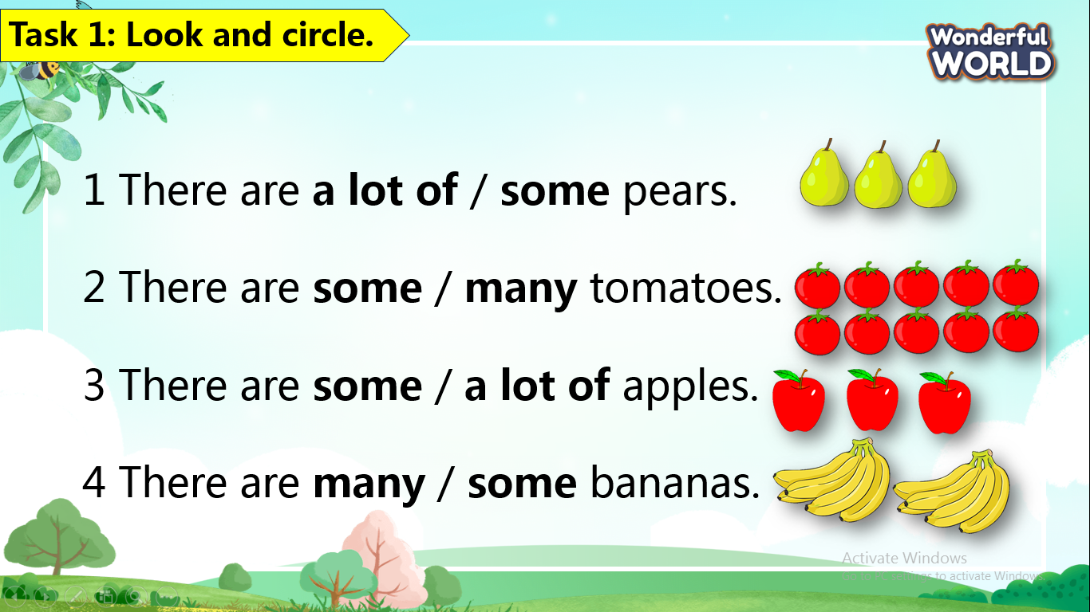  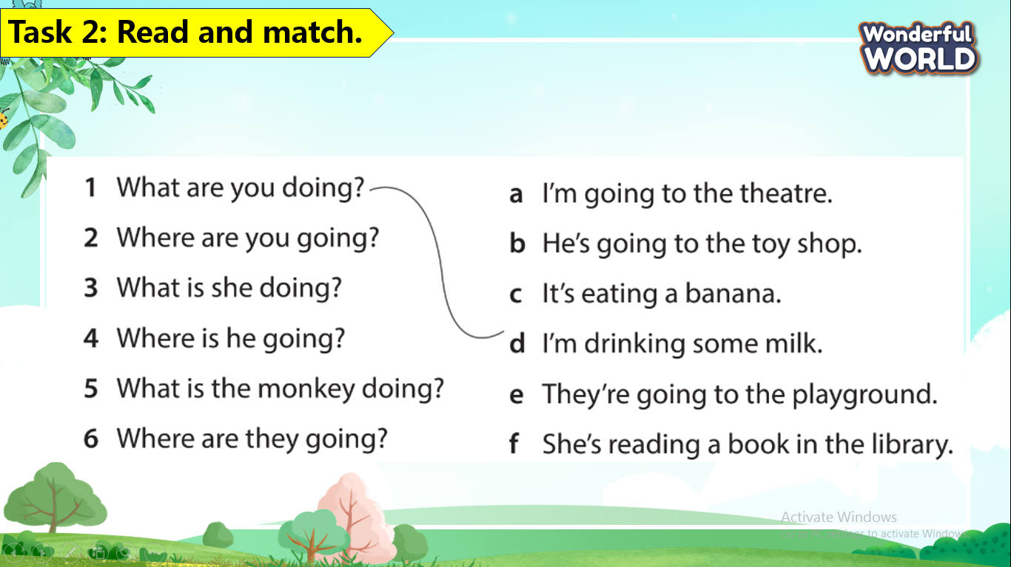  - Check answers.  - Say goodbye . | Key answer:  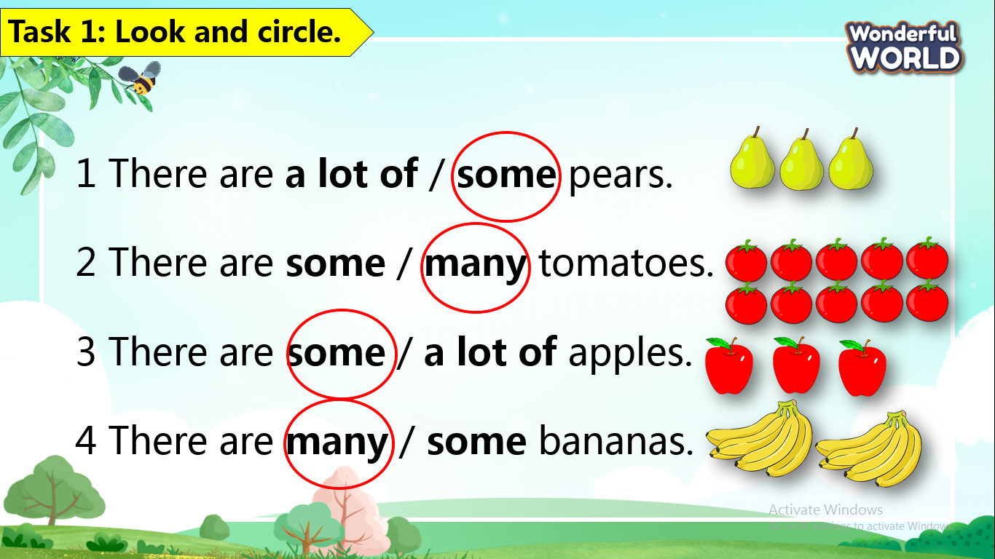  Key answer:  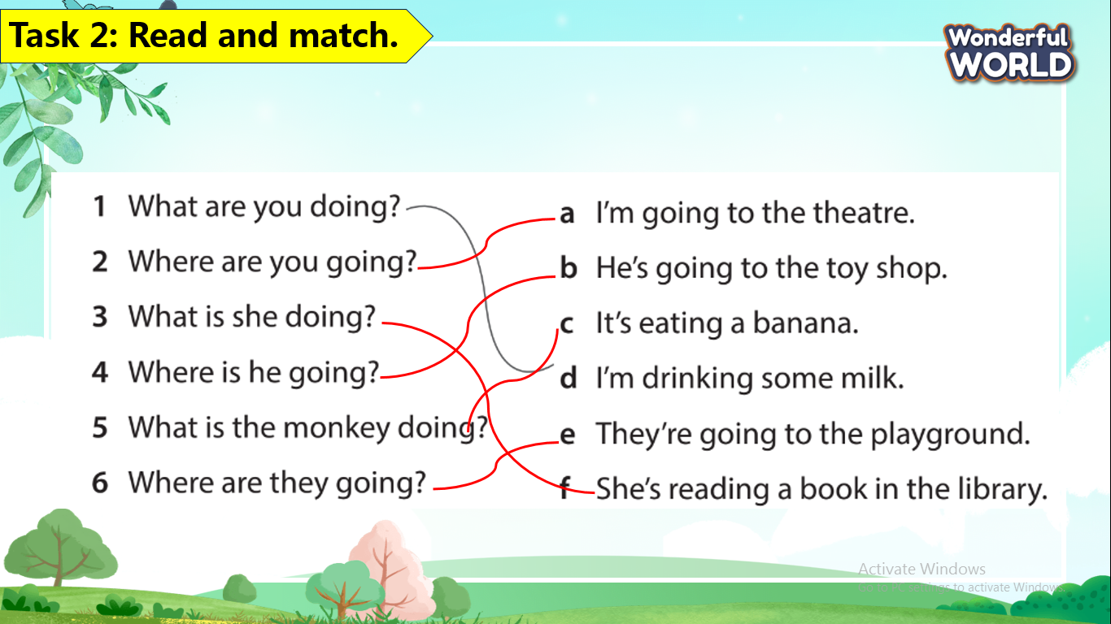  -Check with friends and then with teacher and whole class.  - Look and read aloud.  - Say goodbye.

REVIEW 5
Part 4 -Task 1,2,3
Period 114
I. OBJECTIVES:
1. Knowledge:
By the end of the lesson, students will be able to:
- Review vocabulary about places in town: in the library, in the museum, at the theatre, at the zoo, at the market, in the park, at the playground, in the pool, at the toy shop
- Review vocabulary about activities people do when visiting a town/city: drink, eat, have fun, look at, see, take photos
- Review vocabulary about foods: apple, banana, pear, tomato, bread, cheese,
chicken, juice, milk, rice, biscuit, chocolate, ice cream, sweets
- Review grammar: Present continuous (question)
+ What am I doing?
+ What’s he/she doing?
- Review grammar: There are some/a lot of/many…
- Practice asking and answering about one’s favourite foods and places.
2. Competences:
English competence
-Students know how to use vocabularies and structures of unit when they want to talk about topic:food, drinks and place .
General competence
- Raise motivation and interests in learning English.
- Develop communication and collaboration skills through learning activities.
- Build up self-learning skill through learning activities.n
- Know how to choose healthy food in meals.
3. Qualities:
- Don't waste foods
- Support foods and vegetables for the poor or homeless people.
- Take care yourself by choosing safe and hygienic foods.
II. EQUIPMENT AND MATERIALS:
- For teacher:
+ Basic things: Student’s book ,teacher’s book.
+ Advanced things: PPT, projector/interactive whiteboard/laptop/TV
-For students: student’s book, work book.
III. LESSON PROCEDURE:
Warm up (10 minutes)
Teacher’s activities | Student’s activities
+ Listen the song and sing with the video.  https://www.youtube.com/watch?v=rGyMk4yvyC0 | -sing the song.
Review ( 15 minutes)
Teacher’s activities | Student’s activities
Task1: circle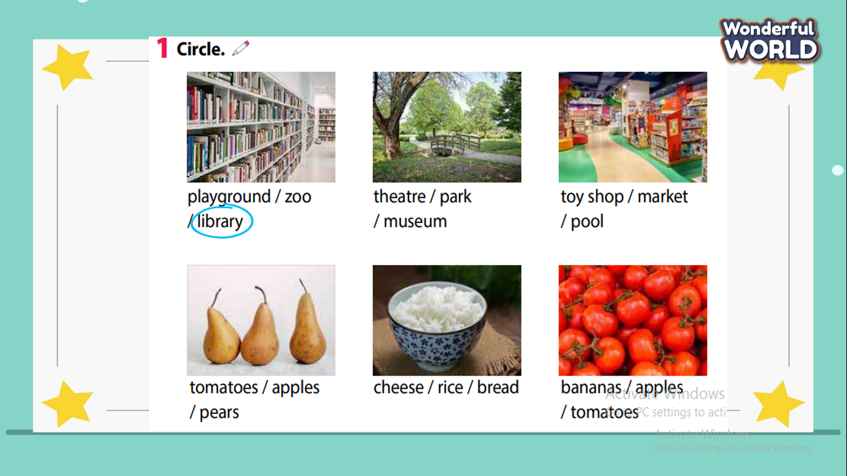  - Read the instruction to the class.  - T asks students to circle the word with the right picture.  - Tasks students to read all the words after circling.  - Read the list of words in task1.  - Receive stars for the best students who have a good pronunciation.  - Play the magic wheel game .  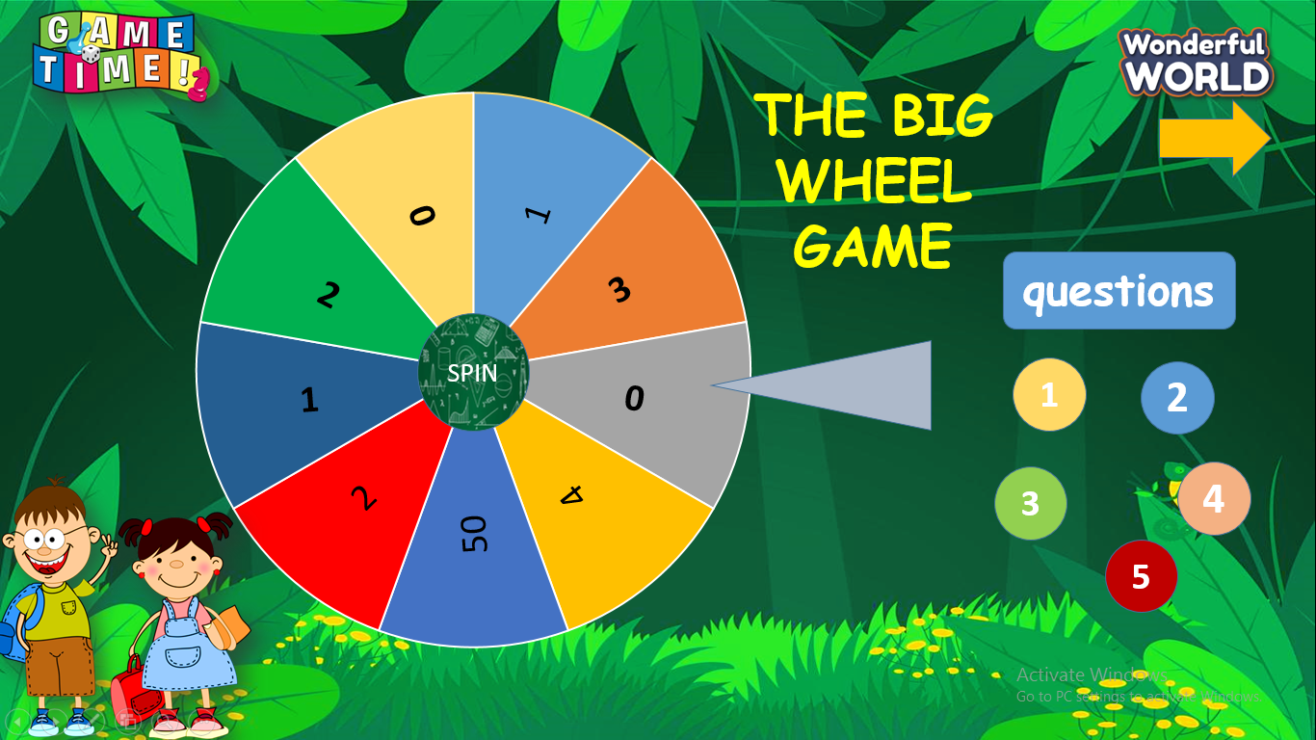  + T prepares 5 question slides about the knowledge that students have learnt at the previous lessons.  + T will call the fastest students who has the right answer to give stars. | - Key answer:  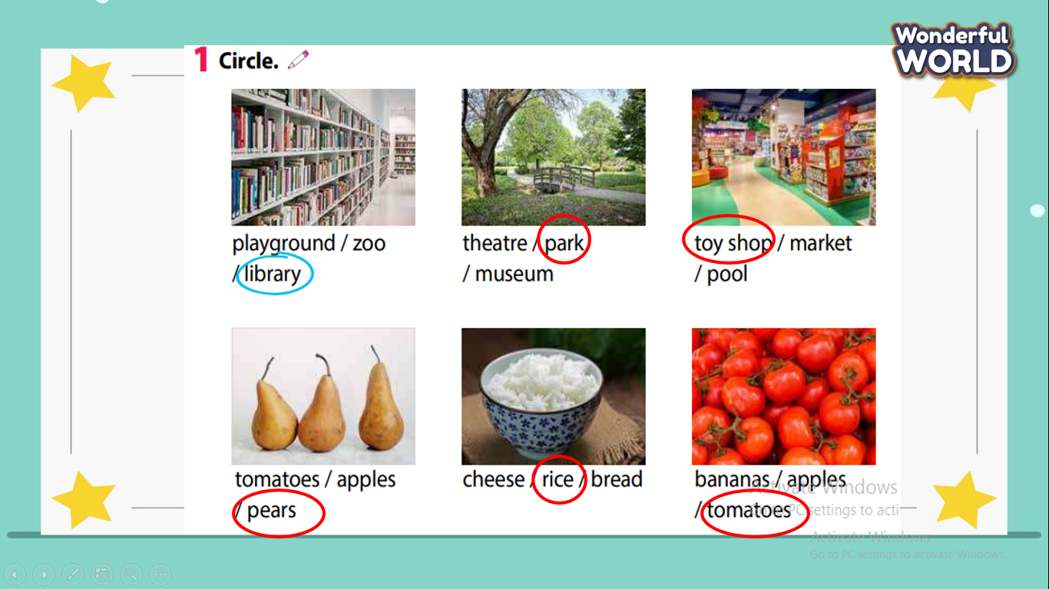  - Enjoy the game .  - Have a quick discussion in the team if they meet a few difficult questions.  - Receive stars for the team.
Task 2: Look and write. Say  + There are many foods and drinks in the task and there are 2 columns( one is the name of food ,the other is the location of it in the picture.  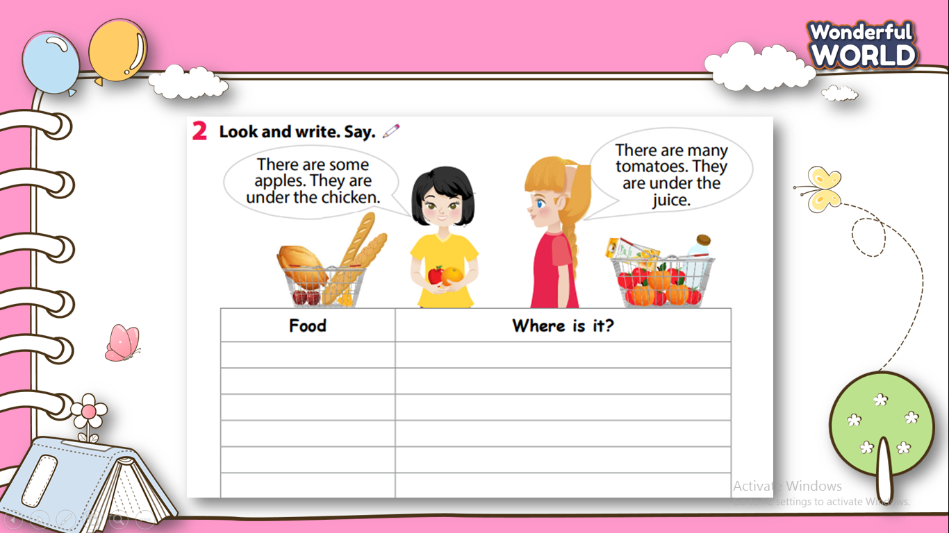  + T askes students to do this task as fast as possible ( Teacher goes around the class to help students ).'  + T invites a few students go to the board to present the result.( Teacher can choose the best presentation and give candies. | - Look the picture and describe the position of each item on the trolley.  - Students work in pairs.
Extra activity (10 minutes )
Teacher’s activities | Student’s activities
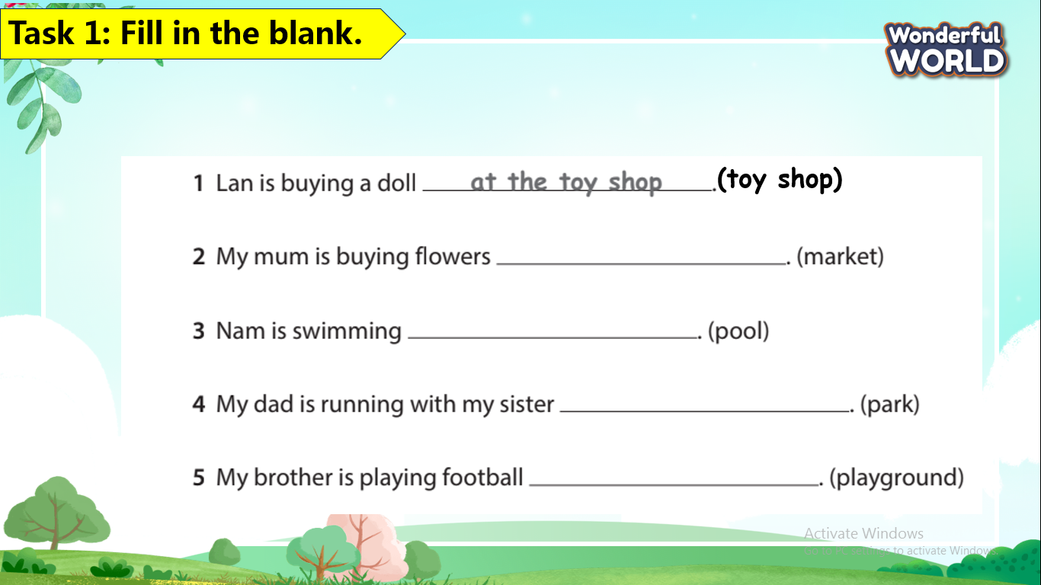  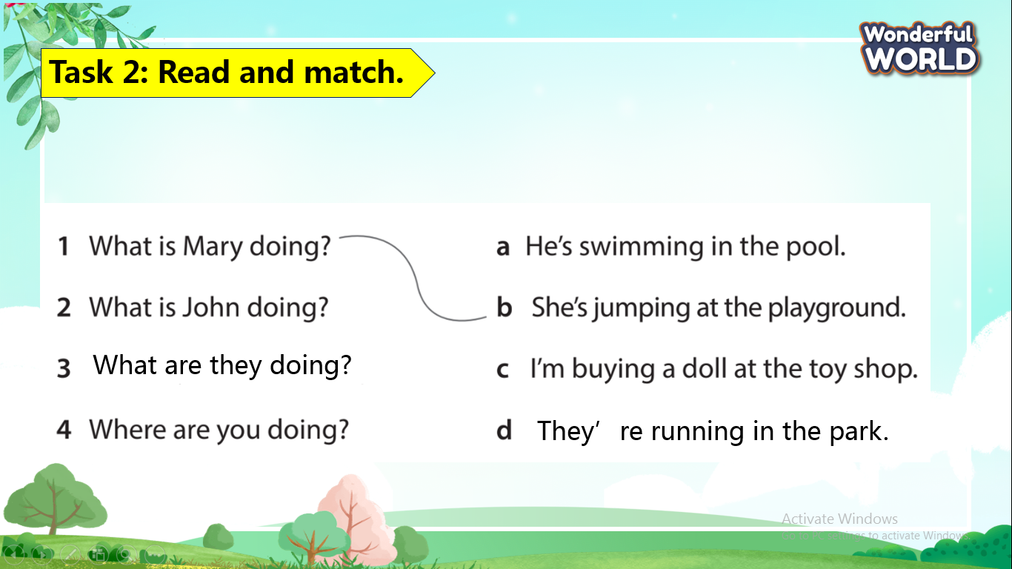  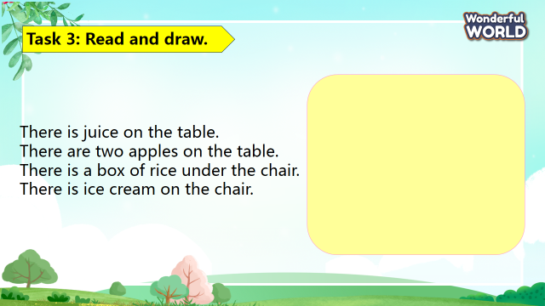  - Check answers.  - Say goodbye . | -Key answer:  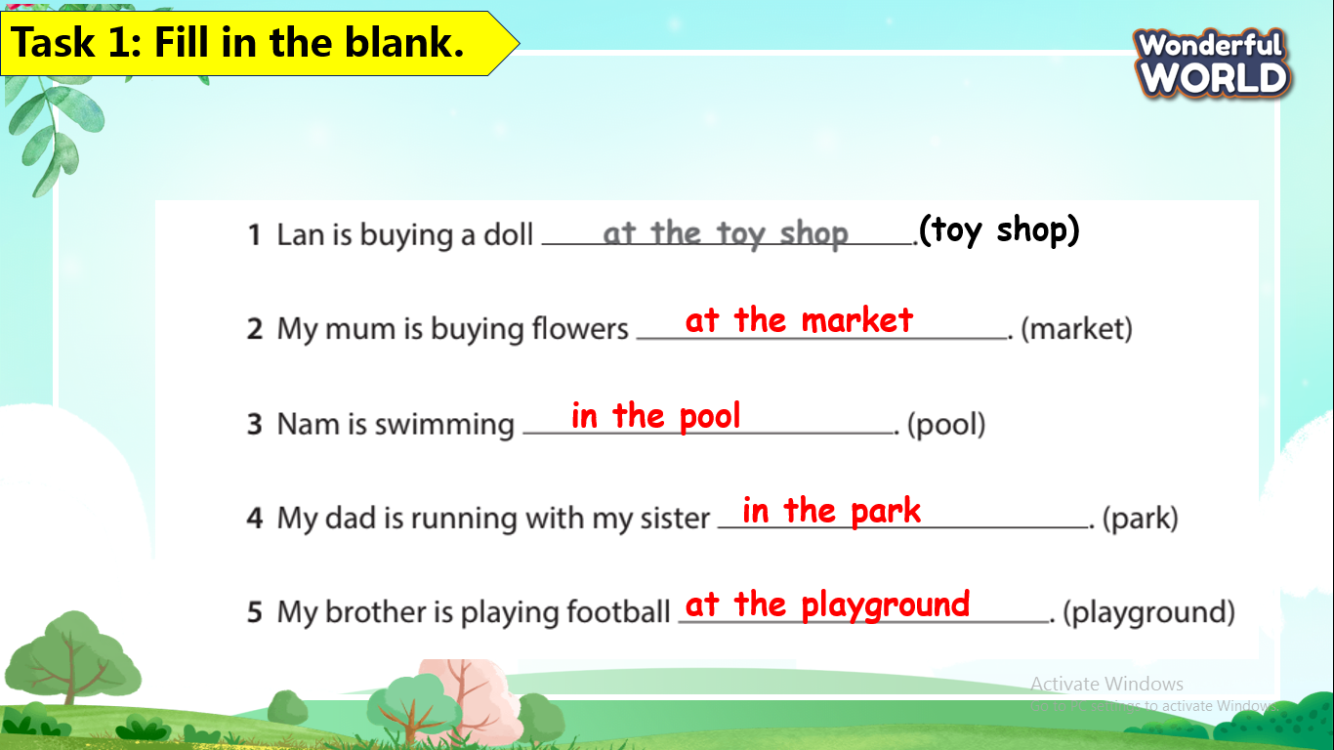  Key answer:  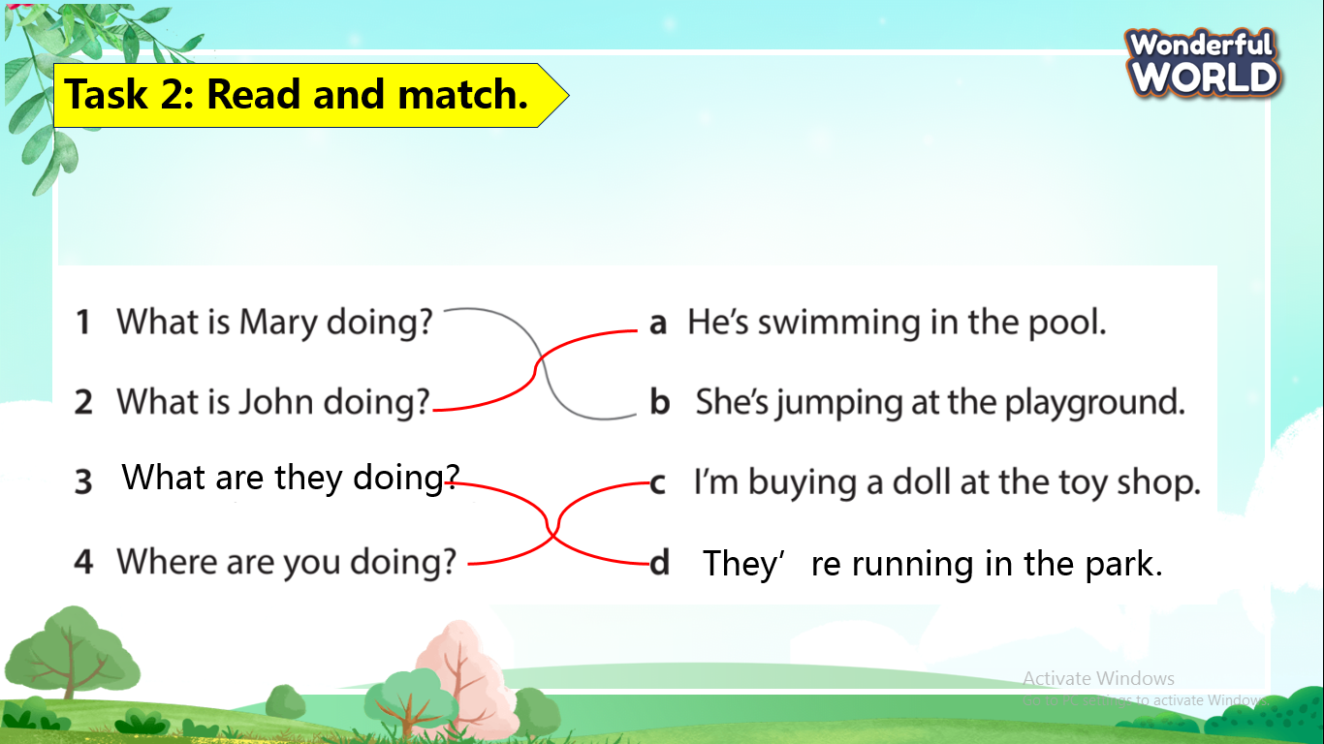  - Check with friends and then with teacher and whole class.  -Draw the picture.  - Say goodbye.
____________________________________

UNIT 10: OUR WORLD
Lesson 1 -Task 1,2,3
Period 115
I. OBJECTIVES:
1. Knowledge:
Students will be able to :
+ To learn some vocabulary about nature and nature activities.
+ To practice listening to and reading simple sentences about nature and nature activities
2. Competences:
- English competences: To talk about the nature, by using words
+ Students will have the opportunity to develop the communication among friends
3. Qualities:
- Students will be friendly and confident in communicating with friends about the knowledge of nature.
II. EQUIPMENT AND MATERIALS:
- For Teacher: PP, TV, flashcards, music, audio track
- For students: pictures, handout
III. LESSON PROCEDURE:
Activity 1: Warm-up (5 minutes)
Teacher’s activities | Student’s activities
SONG: “What do you see?”  - Devide the class in to two big teams.  - Introduce the song  - Play the song twice for sts to listen to and sing along.  - Ask sts :“What do you do see?” to elicit the name of the topic: NATURE and lead in the new lesson  https://www.youtube.com/watch?v=2CQ_K9W6vEQ  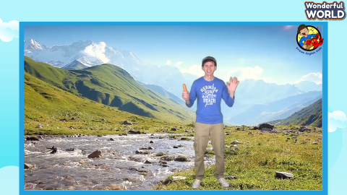 | - Ss listen and sing happily.  - Ss answer the question and name some of the things appearing in the song
Activity 2: Presentation (8 minutes)
Teacher’s activities | Student’s activities
Lead-in: Use the game and the Opener picture to lead in the topic: Our world  Answer: nice, great  Exploit the picture and ask sts to do the task in UO.  Task 1: Listen and point. Repeat. (Track 2.1)  - Create a story to introduce vocabulary. (The school is holding an expedition for sts to exploit the world. Guide sts what they are going to learn about nature to prepare for the expedition)  - Show the picture one by one  - Play the words one by one  - Play track 10.1, and ask students to listen and repeat in chorus, or groups.  - Put the 5 flashcards in 5 different corners around the room.  - Say a word/sentence for sts to repeat then point  - Vocabulary checking:  - Minigame: PASS THE BALL   - Sts play in a group. The teacher plays the music, sts pass the ball. When the music stops, sts who is holding the ball picks up a picture and says a word aloud. | - Answer the questions.  - Listen to the word and repeat  - Read and answer.  - Tick  - Repeat  - Listen to, point to, repeat.  - Join the game
Activity 3: Practice (12 minutes)
Teacher’s activities | Student’s activities
Task 2: Listen and tick (5 minutes)  - Lead-in: Introduce the listening task  - Show the picture in task 2  - Ask sts to look at the picture and answer:  + Where are the people in the picture?  + How many people are there?  + What do you know about the place in the picture?  - Ask sts to read and guess the answer before listening:  + Can uncle John climb the rock?  - Play track 10.2 twice for sts to give the answer  - Play the audio again and ask sts to do cross-check  - Show the bubble  - Help sts remember the content in the listening task  - Show the content one by one and ask sts to repeat  - Play role  - Three pairs perform in front of the class  Give comments after each performance  Listen and match. Then say (7 minutes)  Matching game  (Teacher makes a Powerpoint slide including 4 pictures: swim in the river, climb the rock, climb trees, drink cold water. Let sts listen to the audio and match the number with the correct picture. 5 stars for the correct pairs)  - Introduce and set game rules  - Have sts play in pairs  - Do a demo  - Give sts time to play (match the pictures)  :  - Can you drink cold water? – No, I can’t.  - Can you swim in the river? – Yes, I can.  - Can you climb the rock? – Yes, I can.  - Can you climb trees? No, I can’t.  Answer: 1. D, 2. B, 3. A, 4.C  Point and say  - Elicit the listening audio to withdraw the question and the answer.  - Show and the words randomly in front of the pictures.  - Divide the class into 6 groups  - Ask each group to look at the word and match with the pictures.  - Ask a group members to ask and answer as in the audio  Can you …?  + Yes, I can.  + No,I can’t. | - Listen to the listening instruction carefully  - Look at the picture  - Read and give answers  - Listen to the audio and tick the answer  - Do cross-check  - Read aloud the sentences  - Listen and repeat  - Play role  - Perform the dialogue with a peer  - Listen carefully  - Look at the demo carefully  - Perform in front of the class
Activity 4: Production (7 minutes )
Teacher’s activities | Student’s activities
Task 3:Ask and answer. Tick  Make a Survey  - Point to the question and answer in the box. Read out the sentences and ask students to repeat them after.  - Explain that students have to tick the activity they can do in the table.  - Ask students to work in pairs. One of them is going to ask “ Can you …” Then put a tick on the table if the  answer is Yes.  - Ask students to swap roles and take turns.  - Ask some volunteers to act out the dialogue in front of the class.  - Alternative: Ask a student to show their table and report their friend’s answers in front of the class. (e.g. My friend is Nam. He can swim in the river and drink cold water. He can’t climb the rock).  - Have Ss work in pairs or groups to ask and answer the structures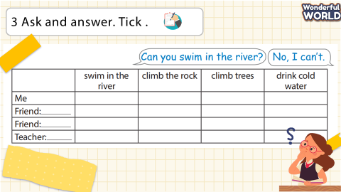 | - Answer and repeat.  - Tick.  - Work in pairs.  - Take turns.  - Act out.
Activity 5: Assessment (3 minutes )
Teacher’s activities | Student’s activities
- Ask students to do the assessment.  - Match  - Check in pair then whole class.  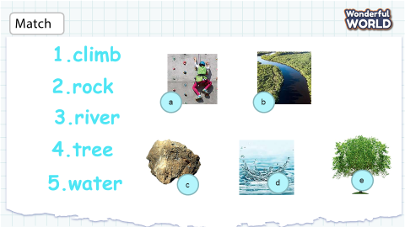  - Say goodbye | Do the assessment.  - Check with friends and then with the teacher and the whole class.  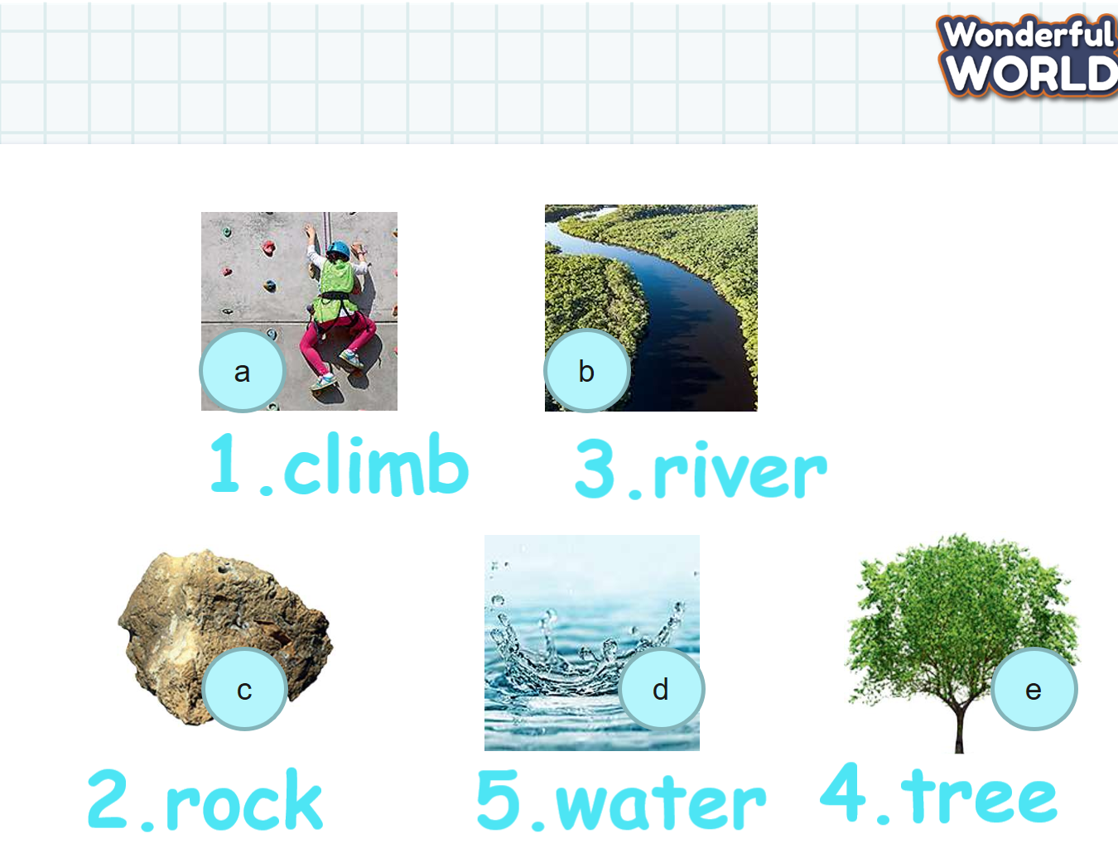  - Say goodbye
____________________________________

UNIT 10. OUR WORLD
Lesson 1 -Task 4,5,6
Period 116
I. OBJECTIVES:
1. Knowledge:
- By the end of the lesson, students will be able to:
+ To understand affirmative sentence structures of present simple
+ To practice using these sentence structures to write and talk about activities
2. Competences:
- English competences: Students will be able to introduce nature and the activities.- Common competences: Students will have the opportunity to develop creativeness in drawing and communication among friends.
3. Qualities:
- Students will be proud of nature and love to discover nature with friends.
II. EQUIPMENT AND MATERIALS:
- For Teacher: PP, TV, flashcards, music, audio track, vocabulary box, pictures, 5 sentences
- For students: Pen, pencils, crayons, A4 paper
III. LESSON PROCEDURE:
Activity 1: Warm-up (5 minutes)
Teacher’s Activities | Students’ Activities
Matching Game  - Review vocabulary: river, climb, rock, tree, water by reading the word and match the picture.  A. picture river  B. picture rock  C. picture climb  D. picture water  E. picture tree  1. climb  2. rock  3. river  4. tree  5. water  Answer keys :  - C, 2. B, 3. A, 4. E, 5. D | - Read and match the word and the correct picture
Activity 2: Presentation (10 minutes)
Teacher’s Activities | Students’ Activities
Listen and tick  Context: Tomas and some of his friends are going to the mountains together. Listen and find out what his friends do in the mountains.  Lead-in: Let Sts listen and tick the correct pictures.  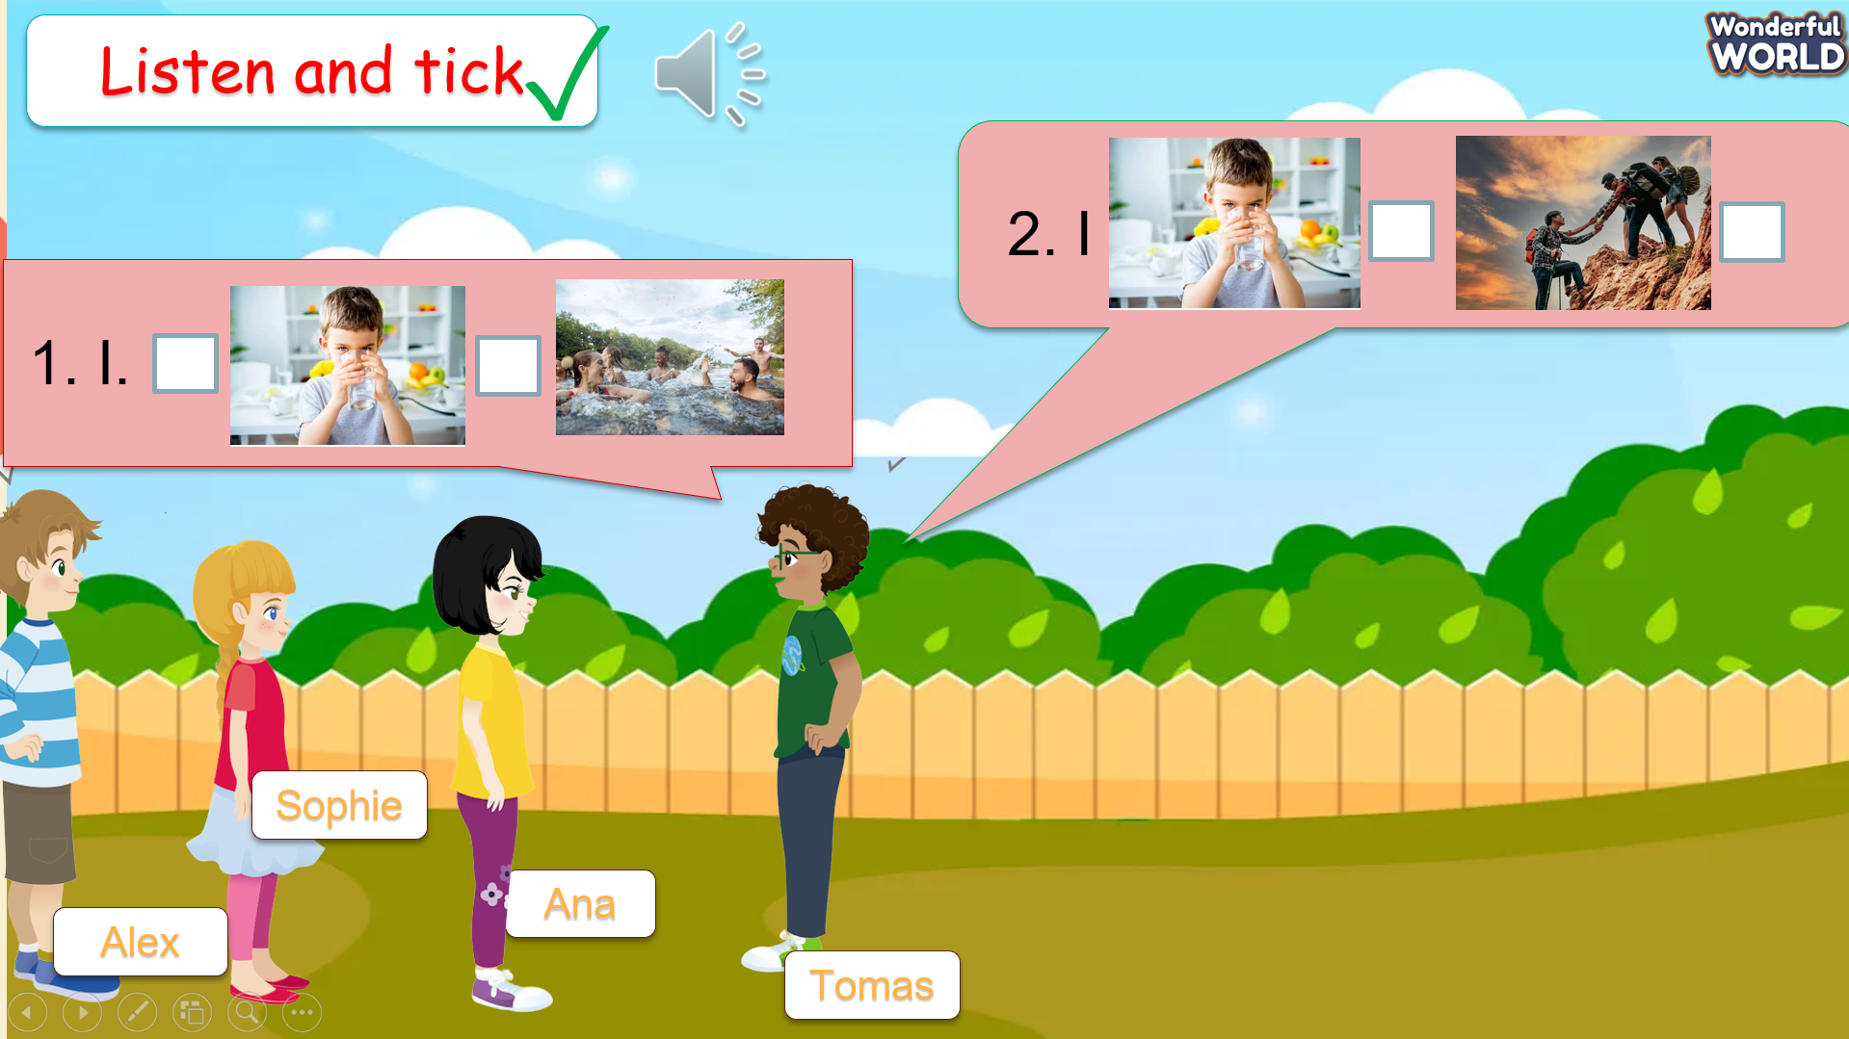  Audio:  1. I drink water.  2. They climb the rock.  3. We swim in the river.  Task 4: Listen and repeat  - Show the three pictures one by one  - Ask sts to listen and repeat  - Ask sts to take turns to practise as a character  - Perform in front of the class  Note: Guide sts how to use activities with I, they, and we | 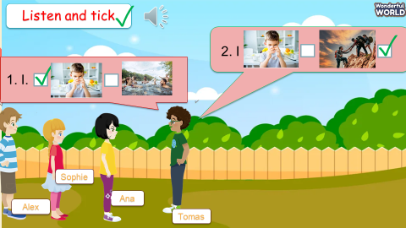  Listen and tick the correct picture  - Listen to teacher  - Look, listen and repeat  - Practise saying the sentences  - Perform with friends  - Listen to the teacher nad note
Activity 3: Practice (10 minutes)
Teacher’s Activities | Students’ Activities
Task 5: Look and say  Super-Hero Team  (Set context: Yesterday, some thieves entered our school. you’re a special member of Super-Hero Team, Please help the police to catch the thieves.  1. They swim in the river.  2. I climb the rock.  3. They climb the trees.  4. We drink water.  - Set context  - Give game instruction  - Ask sts to form 4 team  - Ask sts to choose the team’s leader  - Let time for sts play the game: click on a number, Look at the picture and form the sentence from the given words. Then say aloud.  - Award the winner  Write and say:  - Give groups a set of the 4 pictures  - Ask the group to write the sentences  - Group work under the leader’s control.  - Group members pick up the picture and say the sentence.  - Group that finished the game first get 4 stars and the others get 3,2,1 stars. | - Listen carefully to the game instruction  - Form the group  - Choose your team’s leader  - Play game/ Look and say
Activity 4: Production (9 minutes)
Teacher’s Activities | Students’ Activities
Draw and say  Context: Sts are going to have a picnic out in nature. Ask sts to draw what they do at the picnic.  - Ask sts to draw their favourite activities in nature.  - Let sts time to draw and colour  - Ask them to talk about the pictures in front of the class  - Give comments when needed  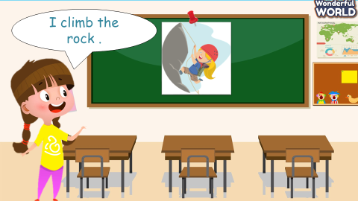 | - Listen to teacher  - Draw and colour the picture  - Talk about the picture  - Listen to friends  - Give comment
Activity 5: Assessment (3 minutes)
Teacher’s Activities | Students’ Activities
-Ask sts to do the assessment  Look, read and circle the correct answer  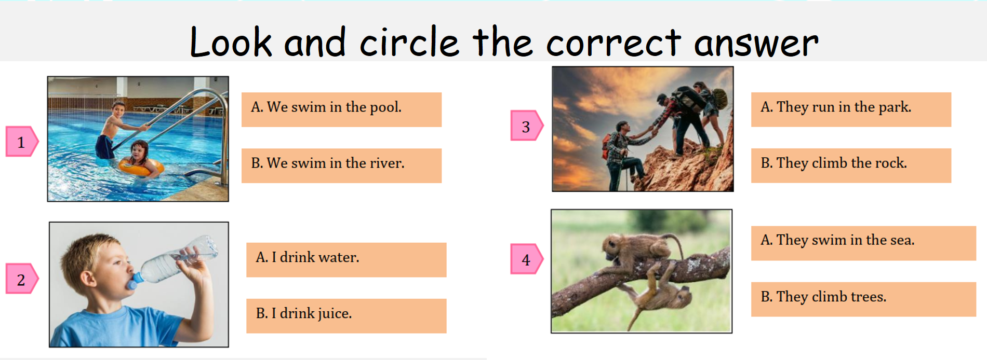  - Ask sts to check in pairs then the whole class  - Goodbye | - Do the assessment  - Check in pairs then check with the teacher  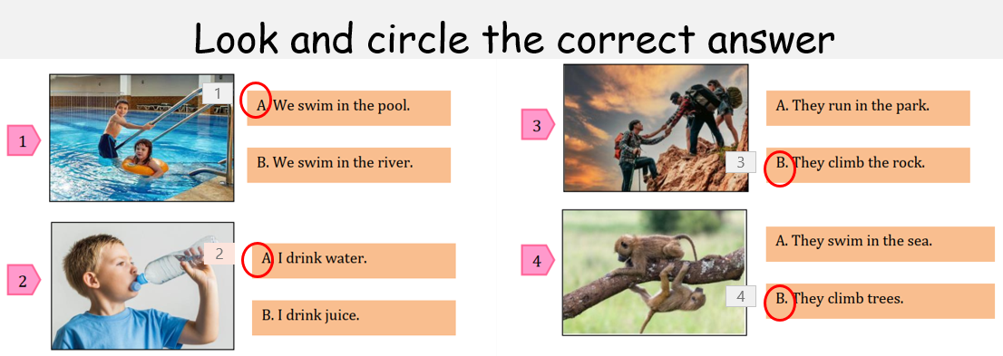  - Say “Goodbye.”

GRADE 5
Week 29
REVIEW 5
Part 3 – Period 113
I. OBJECTIVES:
1. Knowledge:
- Students will review vocabulary related to “holiday and travel” topics and simple past which have been taught before.
- Students will watch and understand a video about Mexico.
- Students will talk about sightseeing.
2. Competences:
- English competences: Students can use English to write the places where they went on holiday.
- Common competences: Students can talk about the places where they went on holiday.
3. Qualities:
- Students will
+ have a strong sense of respect in pair work and teamwork.
+ raise their confidence by presenting in front of the class.
II. EQUIPMENT AND MATERIALS:
- Basic things: Student’s book, flashcards, photos, papers
- Advanced things: PPT, laptop, TV.
III. LESSON PROCEDURE:
Activity 1: Warm-up (5 minutes)
A game “Guess the Word”
Aims: Welcome students. Engage the class (or warm the class up) with a “Guess the word” game.
Teacher’s Activities | Students’ Activities
Procedure
1. Greet students. Chatting…Do you like playing games…  2. Introducing the game:  - Divide the class into different teams.  - Ask Ss to look at the sentences, say the whole sentences aloud, and guess what the words of those sentences are.  Example: | - Greet Teacher.  - Join the activity.
Activity 2: Practice (17 minutes)
Aims:
- Watch and understand a video about Mexico.
Teacher’s Activities |  | Students’ Activities
BEFORE YOU WATCH  What do you take on holiday? Tick.  - Read the instructions to the class. Invite students to read the list of words.  - Point to the first item, suitcase. Ask a student, “Do you take a suitcase on holiday?” Elicit either “Yes, I do,” or “No, I don’t,”  and tell students to tick the box if the answer is Yes, but to leave it blank if the answer is No.  - Repeat with the remaining items. Tell students to tick the box if they take those items on holiday.  - Go around the class asking students questions, e.g., “Do you take a uniform on holiday?”  WORDS TO KNOW  Match the words to the pictures.  - Ask students to look at the pictures and match them with the words in the box.  - Give them time to write the answers.  - Check the answers with the class.  WHILE YOU WATCH  There are many ancient ruins in Mexico. How many can you  see in the video?  - Remind students that they are going to watch a video about a sightseeing trip on holiday.  - Remind them of their suggestions of where the trip is, and tell them to see if anyone was correct with their guess.  - Read the instructions to the students and tell them to get ready to count the number of ruins they see in the video.  - Play the video all the way through.  - Ask students to answer the question (two).  - Ask students if they want to go on a sightseeing trip to Mexico. Why / Why not?  AFTER YOU WATCH  Tick T for True or F for False.  - Read out the first statement to the class. Ask students if they remember seeing any form of transport in the video. Ask them what it was (airplane) and what the narrator said (one of the quickest ways to travel is by airplane). Ask them which box  they should tick (F).  - Give students time to complete the activity alone.  - Check the answers with the class.  - Ask students which of the places they saw in the video they would most like to go to and why. |  | - Complete the tasks.  - Watch and follow T’s guides.
Activity 3: Production – Free practice (8 minutes)
Aims:
- Apply simple past to talk about the places where they went on holiday.
Teacher’s Activities |  | Students’ Activities
Procedure:
- Ask Ss to write down the places where they went on holiday, based on suggested questions and simple past use.  - Divide the class into different groups of three to four.  - Work in a group.  - Ask Ss to discuss and share about the places where they went on holiday.  - Go around and give some comments or feedback if needed.  - Call some groups to share in front of the class.  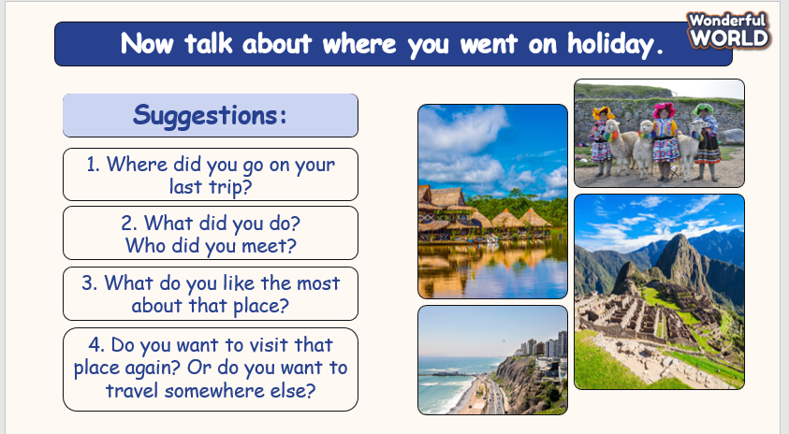 |  | - Discuss, write, and share.
Activity 4: Wrap-up & Assessment (5 minutes)
Teacher’s Activities |  | Students’ Activities
Aims:
- Check Ss’ understanding of what they have learnt.
- Students rehearse what they have learnt in the lesson.
- Ask Ss to do the assessment.  - Give the assessment to the class and some Ss.  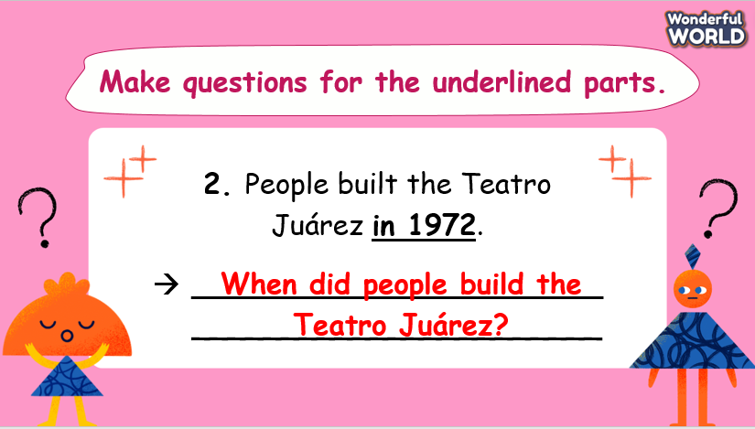  - Check with the class.  - T asks Ss about what they have learnt in today’s lesson.  - T shows the wrap-up slide and concludes the lesson.  * Remember  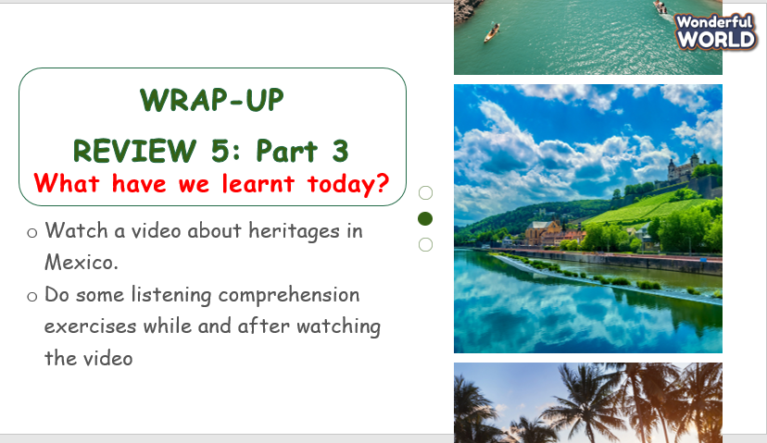 |  | - Do the assessment.  - Check with the teacher.  - Answer T’s question of what they have learnt in today’s lesson.  - Ss read the wrap-up.  - Stand up and say goodbye to the teacher.

REVIEW 5
Part 4 – Period 114

I. OBJECTIVES:
1. Knowledge:
- Students will review vocabulary related to “Holidays and travel; Performing Arts” topics that have been taught before.
- Students will review simple past with regular and irregular verbs.
2. Competences:
- English competences: Students will be able to use English to make a plan for next summer holiday.
- Common competences: Students will be able to talk about planning for next summer holiday.
3. Qualities:
- Students will
+ Have a strong sense of respect in pair work and teamwork.
+ Raise their confidence by presenting in front of the class.
II. EQUIPMENT AND MATERIALS:
- Basic things: Student’s book, flashcards, photos, papers
- Advanced things: PPT, laptop, TV.
III. LESSON PROCEDURE:
Activity 1: Warm-up (7 minutes)
A game “Guess what this is”
Aims: Welcome students. Engage the class (or warm the class up) with a “Guess what this is” game.
Teacher’s Activities | Students’ Activities
Procedure
1. Greet students. Chatting…Do you like playing games…  2. Introducing the game:  - Divide the class into different teams.  - Ask Ss to look at the pictures and then they have 10s to come up with the answers.  - 7 words:  + canal + character  + award + villager  + advert + inventor  + director  Example:  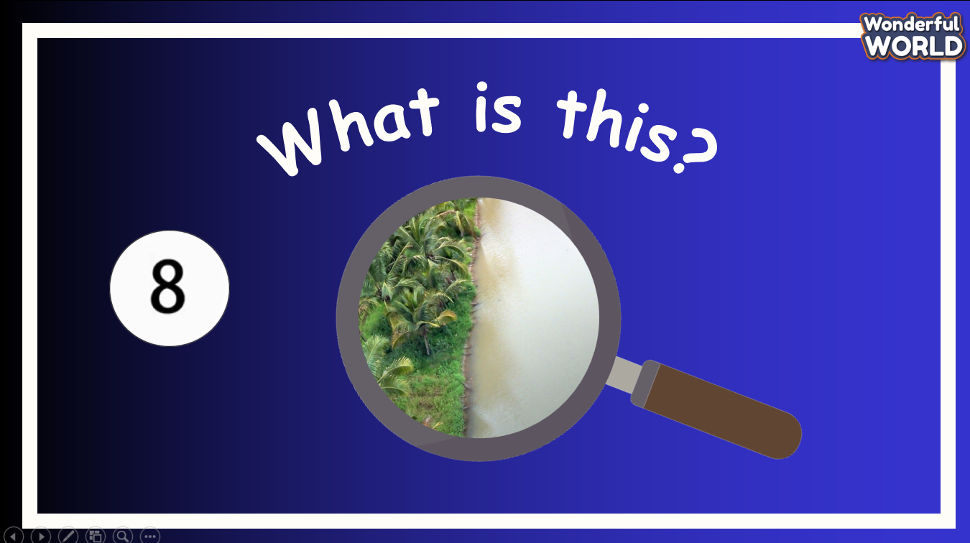 | - Greet Teacher.  - Join the activity.
Activity 2: Practice (15 minutes)
Aims:
- Review targeted words which have been taught in Units 9 and 10.
- Review simple past with regular and irregular verbs.
- Finish tasks 1 and 2.
Teacher’s Activities | Students’ Activities
Procedure
Task 1: Listen and number the correct pictures. (Track: 5.2).  - Tell students that they are going to listen and number the pictures.  - Ask students to look at the pictures and elicit what each picture shows.  - Play the recording for students to listen and number.  - Play the recording again. Ask students to discuss their answers  in pairs and justify any different answers.  - Check answers as a whole class.  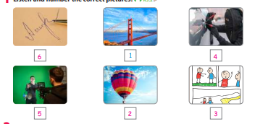  Task 2: Put the sentences of the conversation in the correct order. The conversation begins with (1).  - Tell students that they are going to rearrange the sentences into the correct conversation.  - Model sentence 1 as an example.  - Tell students to read each sentence and explain the meaning of the words if needed.  - Give students five to seven minutes to do this task in pairs.  - Call some students to share the answers.  - Check answers as a whole class.  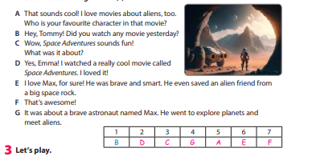 | - Listen and number.  - Put the sentences in the correct order.
Activity 3: Production – Free practice (8 minutes)
Aims:
- Apply present simple simple past to carry out the game “Guess the Star”.
Teacher’s Activities | Students’ Activities
Procedure:
- Tell students to look at this activity and work in pairs.  - Explain the rules of the game.  + Take turns to ask the questions to guess which star the other thinks about.  - Model and check students’ understanding of the  instruction.  - Go around the classroom and offer help if necessary.  - Suggested questions:  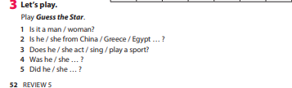  - Take Taylor Swift as an example.   | - Work in pairs.  - Join the activity.
Activity 4: Wrap-up & Assessment (5 minutes)
Teacher’s Activities | Students’ Activities
Aims:
- Check Ss’ understanding of what they have learnt.
- Students rehearse what they have learnt in the lesson.
- Ask Ss to do the assessment.  - Give the assessment to the class and some Ss.  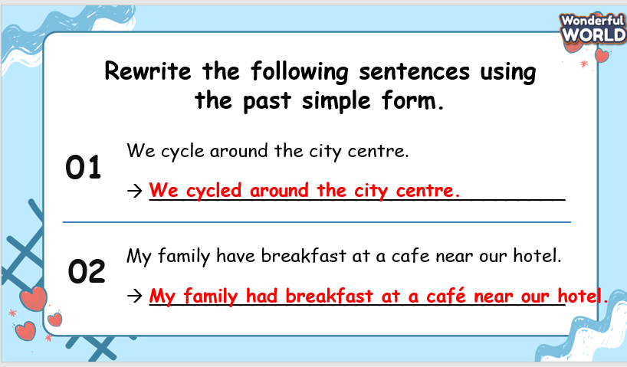  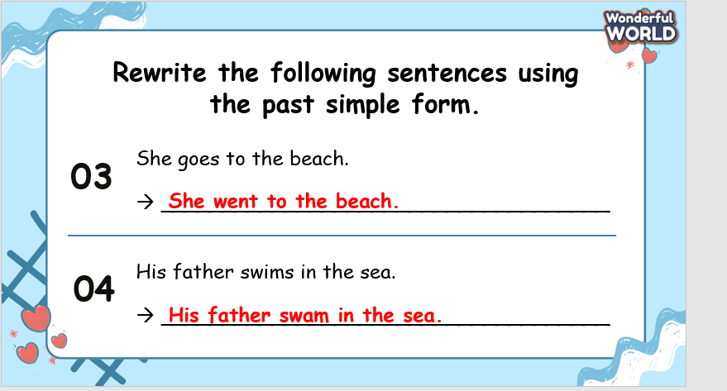  - Check with the class.  - T asks Ss about what they have learnt in today’s lesson.  - T shows the wrap-up slide and concludes the lesson.  * Remember  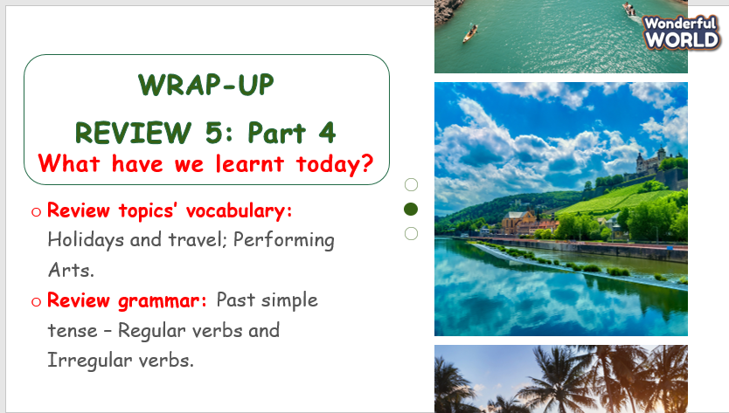 | - Do the assessment.  - Check with the teacher.  - Answer T’s question of what they have learnt in today’s lesson.  - Ss read the wrap-up.  - Stand up and say goodbye to the teacher.

Unit 11. Animals
Lesson 1 - Task 1,2,3
Period 115
I. OBJECTIVES:
1. Knowledge:
To introduce and engage students to the topic of the unit
To identify words relating to animals
Vocabulary: binoculars, butterfly, cave, insect, lizard, torch
To listen to and read a passage about animals in Costa Rica.
2. Competences:
- English competences: Students are able to use English to effectively use new vocabulary and structures to describe and discuss various types of animals.
- Common competences: Students can draw their trip and introduce them to their friends.
3. Qualities:
- Students will
+ foster a curious mindset by encouraging questions and discussions about animals.
+ broaden kids’ understanding and appreciation of global biodiversity.
II. EQUIPMENT AND MATERIALS:
- Basic things: Student’s book, flashcards, photos, papers
- Advanced things: PPT, laptop, TV.
III. LESSON PROCEDURE:
Activity 1: Warm-up (5 minutes)
GUESS Game: ANIMALS
Quiz game about animals
Aims: Welcome students. Warm the class up with a game to introduce students to the topic of the unit (animals) and engage students with the topic and activate knowledge and vocabulary.
Teacher’s Activities | Students’ Activities
Procedure
Do you want to explore the animals with me? I will take you to discover them.  Let’s guess the correct name of the animal behind the rock. Remember to look at it carefully.  Quiz Instruction :  - You get one point for each right answer.  Question 1 . Monkey  Question 2: Giraffe  Question 3. Insect  Question 4. Chameleon  Lead in the picture of a chameleon, ask Ss some questions: Have you seen it in real life?  Explain the photo :  Tell students to look at the photo and say what they can see. Elicit ideas (tree, green, spots, chameleon, tail, eye) and write them on the board  Ask students to read the questions and write their answers.  Check answers as a class.  Possible answers:  1 The chameleon is big. It is green with many spots on the skin. It has a long tail and big eyes.  2 It is moving slowly.  3 It is trying to catch some insects.  “In the picture, there’s a green chameleon sitting on a tree branch. It looks like part of the tree because it’s the same color as the leaves. The chameleon’s skin has cool patterns, and its eyes help it see well. It can hide easily among the leaves because it looks just like them. This shows how amazing nature is at fitting in and doing well in its home”.  There are some related vocabulary :  green, chameleon, branch, plant. | - Greet teacher  - Join the activity.  - Answer the questions
Activity 2: Presentation – Controlled practice (8 minutes)
a. Aims: Ss can practise listening and writing skills about the topic: the animals in Costa Rica.
b. Procedure
Teacher’s Activities | Students’ Activities
-Split the class into two teams and tell students they will play animal charades. Decide which team will go first and who will act out the first animal. Whisper or write down the name of an animal to the player of the first team.  -The player should try to pretend to be the animal so that team members can guess the correct animal. If their team members guess correctly, they get two points. If incorrect, offer it to the other team for one point. Then play another round with the other team. Play until all students who want to act out an animal get a chance to do so.  - The team with the most points at the end is the winner.  1 Listen and read. What animals did Juliana see in Costa Rica? Tick.  - Tell students that they are going to read about a park in Costa Rica. Ask them to read quickly and find out which animal lives in caves (a bat).  - Play the recording twice.  - Students listen and read the text individually and chorally.  - Call on two students to read two paragraphs out aloud and check pronunciation if necessary.  - Ask students to read the texts again and tick.  - Model an example.  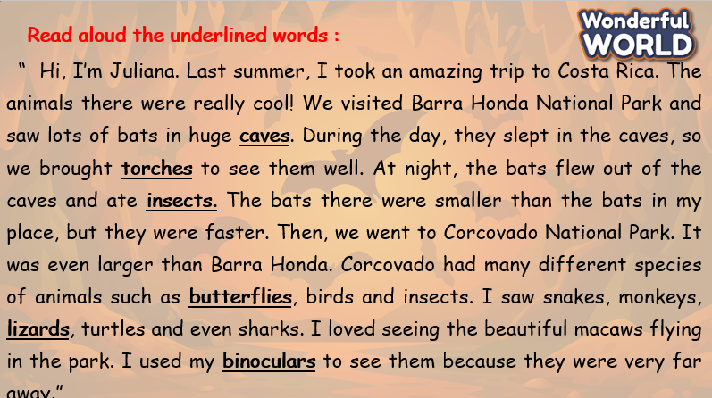  Elicit the new words :  -Listen, point and repeat.  -Ask students to look at six pictures, explain what they see, and guess the meaning of each word.  -Check their understanding if necessary.  -Play the recording.  -Have students listen and point to each picture in the textbook along with the recording.  -Play the recording again and ask students to listen, point to each picture, and repeat.  -Call on some students to read each word out loud. | - Join the game  - Read the passage.  -Listen, point, and repeat.
Activity 3: Practice – Controlled practice (8 minutes)
Aims: Ss can play the Animals Quiz related to the passage and new words.
Teacher’s Activities | Students’ Activities
Instruction :  There is a question.  Choose the correct answer. Which team answers the most correctly will win!  Question 1: _________usually live in caves and fly out at night.  a. bats  Question 2: It’s dark outside. We need________  - a torch  Question 3: Bats eat thousands of __________in a night.  - insects  Question 4 : Use ___________to see the birds well. They’re up high.  - binoculars  Which team got the most correct answers? | Answer questions :
Activity 4: Production – Free practice (6 minutes)
Aims:
Apply their understanding in drawing the picture and write about the trip.
Teacher’s Activities | Students’ Activities
1. Preparation  Gather Materials: Supplies (paper, pencils, crayons, markers) and writing materials (paper, pencils, or pens).  2. Introduce the Activity  Tell the kids that they will draw a picture related to their trip and write a description about it.  A. Brainstorm and Plan  Brainstorm: Ask kids to think about what they want to draw from the trip. This could be a specific animal, a memorable scene, or a favorite part.  Sketch Ideas: Encourage them to sketch a few rough ideas before settling on one. Discuss elements such as animals, people, or landmarks that they might include.  B. Create the Drawing  Outline: Show them how to lightly sketch the main elements of their drawing. This might include the main object or scene and its details.  Add Details: Guide them in adding details to their drawing. Encourage them to include textures, patterns, and features that make the picture more interesting.  Color: Allow them to use colors to bring their drawing to life. Discuss color choices and how they can represent different parts of the scene.  4. Writing About the Trip  Discuss Content: Talk about what they might write, such as the setting, what they did, and their feelings about the experience.  Organize Ideas: Help them outline their writing. This could include:  Introduction: What was the trip? Where did it take place?  Body: Key events or highlights of the trip. Describe what is shown in the drawing.  Conclusion: Personal reflections or what they enjoyed the most.  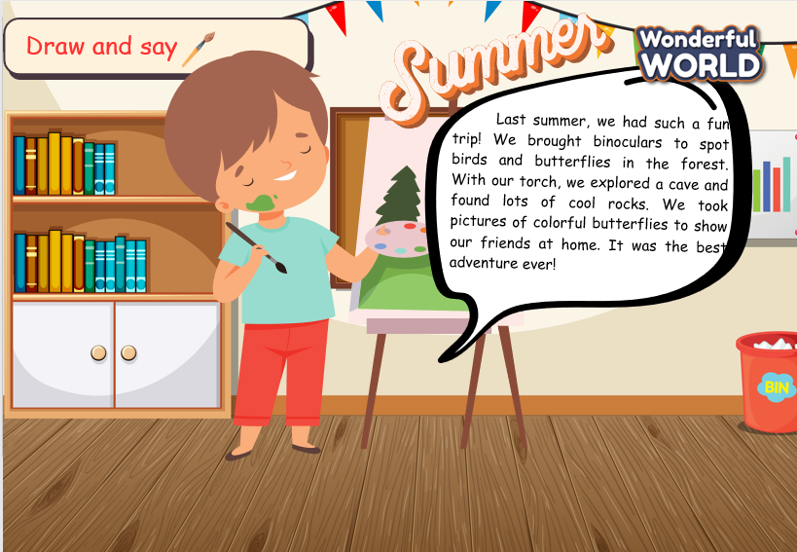 | - Draw and say in front of the class.
Activity 5: Wrap up & Assessment (4 minutes)
Teacher’s Activities | Students’ Activities
Aims:
- Check students’s understanding of what they have learned and new words.
Asks sts to do the assessment.  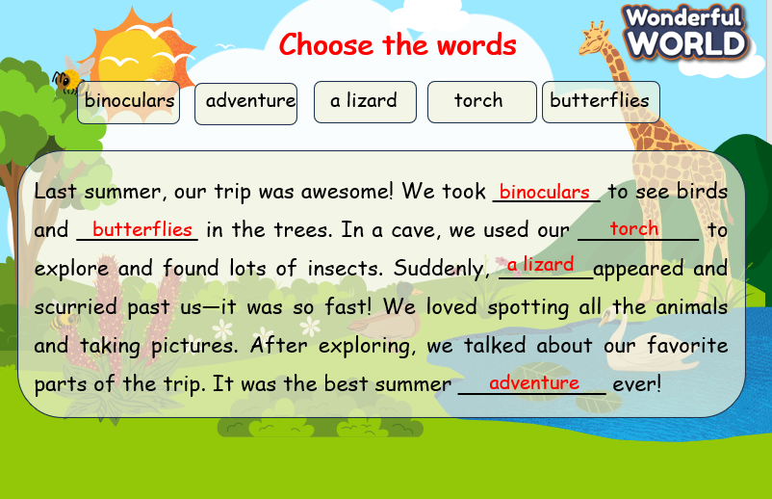  T gives the assessment to the class and some Ss.  - Check with the class.  - Wrap-up  * Remember  Vocabulary:  binoculars, butterfly, cave, insect, lizard, torch | - Do the assessment.  - Check with the teacher  - Sts read the wrap-up  - Stand up and say goodbye to the teacher.

UNIT 11 Animals
Lesson 1 - Task 4,5,6
Period 116

I. OBJECTIVES:
1. Knowledge:
- Students review words relating to animals
- Students can learn the structures of comparative of short, regular adjectives
2. Competences:
- English competences: Students can build a strong foundation of words related to animals.
- Common competences: Students can introduce them to their friends.
3. Qualities:
- Students will
+ be able to describe animals using relevant adjectives.
+ be able to to construct sentences that compare different animals using comparatives.
II. EQUIPMENT AND MATERIALS:
- Basic things: Student’s book, flashcards, photos, papers
- Advanced things: PPT, laptop, TV.
III. LESSON PROCEDURE:
Activity 1: Warm-up (5 minutes)
BINOCULAR GAME
Aims: Welcome students. Engage the class (or warm the class up) with Binocular Game and lead in the new lesson.
Procedure
 | Teacher’s Activities | Students’ Activities
 | Greet students. Chatting…Do you like playing games…  Introduce the game:  To lead in the lesson, let Ss join the game with the animals  Instruction :  Call 2 students compete to identify animals faster through binoculars.  Who says an animal's name quicker will get a point.  Picture 1: butterfly  Picture 2: chameleon  Picture 3: elephant  Picture 4: worm  T says: Let’s compare these animals to lead in the grammar: COMPARATIVES | - Greet teacher  - Join the game
Activity 2: Presentation – Controlled practice (8 minutes)
a. Aims:
Ss can learn the structures of comparative of short, regular adjectives
b. Procedure
Teacher’s Activities |  | Students’ Activities
 | Show the picture of the animals to explain the grammar: comparative.  Explain how to use it.  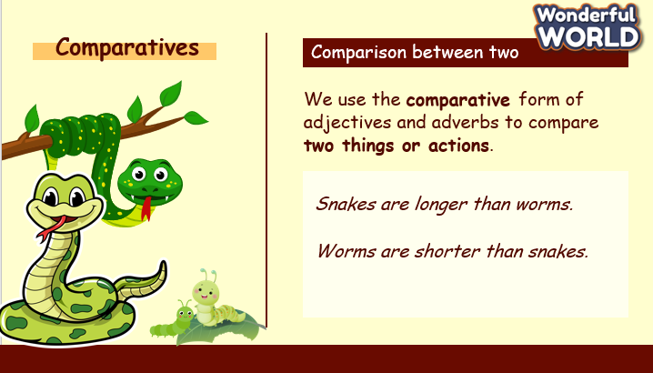  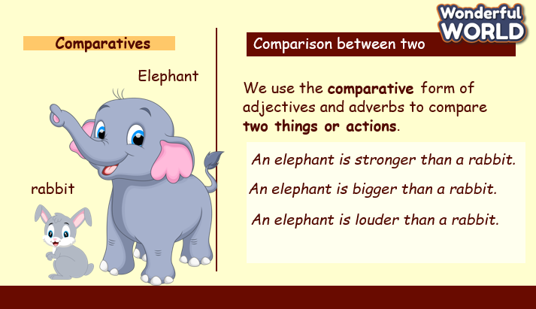  4 Listen and read. Ask students to look at sentences and play the recording twice.  Have students listen and read it chorally.  Have students work in pairs to practise the next four sentences.  Call on some students to read each sentence out aloud and check pronunciation if necessary. | - Greet Teacher  - Listen to the teacher
Activity 3: Practice – Controlled practice (8 minutes)
a. Aims:
Ss can read the questions and choose the short answers.
Teacher’s Activities |  | Students’ Activities
GAME : RACE GAME : The turtle and the hare  - Are horses faster than turtles?  - Yes, they are.  - Are parrots slower than planes?  - Yes, they are.  - Are snails stronger than lions?  - No, they aren’t.  - Are bats louder than butterflies?  - Yes, they are.  - Lucky Box  - Are worms longer than snakes?  - No, they aren’t.  - Lions are _______than giraffes.  Shorter  - Lucky box |  | - Join the game.
Activity 4: Production – Free practice (6 minutes)
Aims:
Apply the structures to use the language, make it more meaningful and memorable in using grammar in the lesson.
Teacher’s Activities |  | Students’ Activities
-Tell students to say the words in the box. Then point to each photo and elicit the animal. Correct pronunciation if necessary.  -Tell students to work in pairs to describe and compare the animals using the words in the box.  -Tell students to look at the first two pictures and the prompt for words in the box. Read out the example and ask students to repeat it.  -Explain the rest of the task to students. Allow them enough time to practise saying the sentences individually and then in pairs. Go round the class helping students where necessary. Ask volunteers to read out their answers. Correct any mistakes.  Suggested answers:  1 Which animal is faster, a leopard or a crocodile? - A leopard is faster than a crocodile.  2 Which animal is louder, a bear or a lion? - A lion is louder than a bear.  3 Which animal can fly higher, a butterfly or an eagle? - An eagle can fly higher than a butterfly.  4 Which animal is smaller, a worm or a lizard? - A worm is smaller than a lizard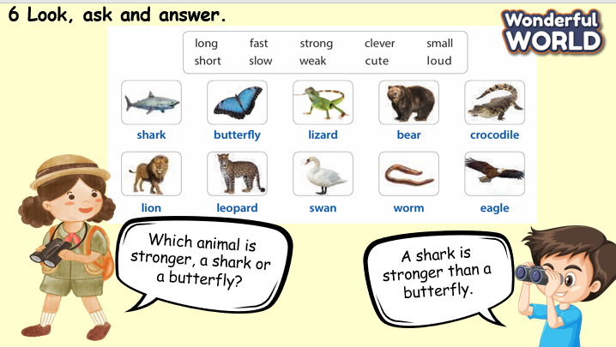 |  | - Ask and answer.
Activity 5: Wrap up & Assessment (4 minutes)
Teacher’s Activities |  | Students’ Activities
Aims:
- Check students’s understanding of what they have learned.
- Students rehearse what they have learned in the lesson.
-Ask sts to do the assessment.  -T gives the assessment to the class and some Ss  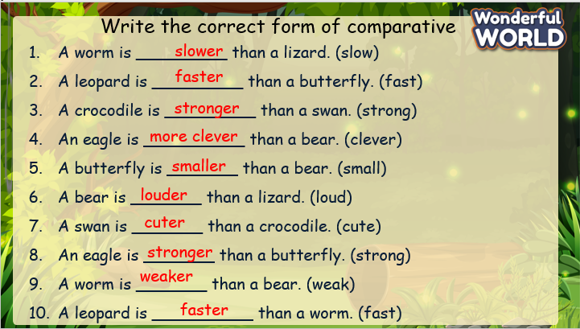  - Check with the class.  - Wrap-up  * Remember  Review Vocabulary:  binoculars, butterfly, cave, insect, lizard, torch  Grammar: Comparative with short, regular adjectives.  An elephant is bigger than a rabbit.  Snakes are longer than worms. |  | - Do the assessment.  - Check with the teacher  - Sts read the wrap-up  - Stand up and say goodbye to the teacher.

