WEEK 28
UNIT 10. OUR HOLIDAY
Lesson 3. Task 7, 8, 9
Period 109
I. OBJECTIVES:
1. Knowledge:
Students will review words and phrases related to the On holiday Topic:
- Identify phonics / o/
- Identify and pronounce words with initial sounds /o/
2. Competences:
- English competences: Students will be able to talk about some outdoor activities.
- Common competences: Students will have the opportunity to develop the creativeness in speaking new phonics and develop communication among friends.
3. Qualities:
- Students get used to new phonics.
II. EQUIPMENT AND MATERIALS:
- For Teacher: PP, TV, music, relating audio track.
- For students: Books, papers and pencils.
III. LESSON PROCEDURE:

Activity 1: Warm-up (5 minutes)
Aim: warm-up activity to introduce the topic, leading “o” sound
Teacher’s Activities | Students’ Activities
Dance and sing: If You’re Happy.  - Ask students to watch the video  - Sing along to the song. | - Listen to the instruction carefully and watch the video.  - Watch the video again and sing along to the song.
Activity 2: Presentation (8 minutes)
Aim: Present the new words and practise the “o” sound, using the correct places and Ving
Teacher’s Activities | Students’ Activities
Vocabulary:  Task A: Listen and repeat. (track 10.12)  -Write “o” on the board. Ask students to say the  word. Then write “o” on the board.  -Write f on the board. Ask students to say  the word.  - Pronounce both sound again and show  students how they are different from each other.  Point to each word on the board and ask students to  practise the sounds with you.  - Play the recordings and tell students to repeat  the words and the sentences. | - Join the game.  -Look and read.  -Read  -Identify and read.
Activity 3: Practice (14 minutes)
Aim: Practise new words, ask and answer using structure I like or I can go…..
Get used to practising the song chant.
Teacher’s Activities | Students’ Activities
1. Listen and repeat. (Track 10.12)  - Play TR: 10.12, pointing to each photo as students hear  the corresponding word.  - Have students repeat each word.  8. Listen and chant. (10.13)  - Point to the chant and say Listen. Play TR10.13 and have  students just listen and read silently.  - Say Listen and chant. Play TR: 10.13 and have students say  the chant as they read.  9. Say it  - Look at the pictures. Say the whole sentences. | - Learn the words through pictures.  - Listen then circle.  - Repeat the words.  - Repeat then point.  - Say aloud the sentences  - Listen carefully  - Check with friends and then with teacher and whole class
Activity 4: Production (9 minutes)
Aim: Join the game to review the words and structure
Teacher’s Activities | Students’ Activities
- Let’s play game.  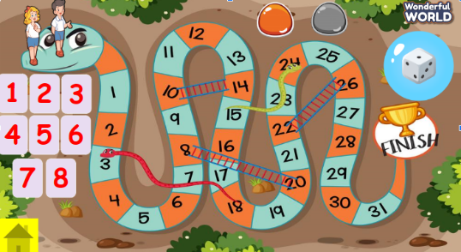  T divides the class into 2 teams. Each team will choose a figure (girl or boy).  Each team chooses a number from 1 to 8 and answer the question. If the answer is correct, the team will get the chance to roll the dice. If not, the chance is given to the other team.  Click on the dice icon to roll. The steps each team can move are corresponding to the number on the dice. If they move to the head of snake or one side of the ladder, they can move to the tail of snake or the other side of the ladder.  The first team coming to finish will win the game. | - Listen the rule carefully.  -Look and read.  -Read  -Identify and read.  - Check with friends and then with teacher and whole class.
Activity 5: Assessment (3 minutes)
Aim: Do the exercise to review and remember the words
Teacher’s Activities | Students’ Activities
-Ask sts to do the assessment  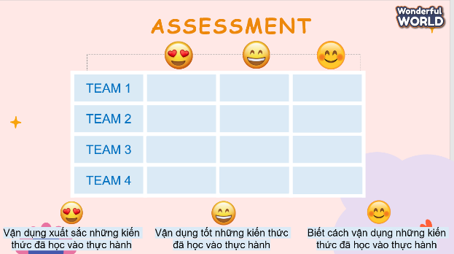  - Check with the class | - Do the assessment  - Work in pairs.
______________________________
UNIT 10. OUR HOLIDAY
Fun time and project. Task 1, 2
Period 110
I. OBJECTIVES:
1. Knowledge:
- Students will review on holiday vocabulary and unit grammar.
2. Competences:
- English competences: Students will be able to remember the words and structures they have learnt.
- Common competences: Students will have the opportunity to develop logical thinking and develop communication among friends.
3. Qualities:
- Students develop love for different leisure activities and be friendly to their friends in the class.
II. EQUIPMENT AND MATERIALS:
- For Teacher: PP, TV, boards, markers, sweets.
- For students: A4 paper, books, pens, notebook/paper.
III. LESSON PROCEDURE:

Activity 1: Fun Time (10 minutes)
Aim: warm-up activity to introduce the topic of traveling to different places
Teacher’s Activities | Students’ Activities
WARM-UP : (4 MINUTES)  - Ask sts to review some vocabulary and do action  - Play the song: Ten Little Indians  Task 1: Unscramble (7 MINUTES)  Before unscrambling through a game  Ask sts to look at the screen and choose the characters they want. Then, answer all the questions and get stars  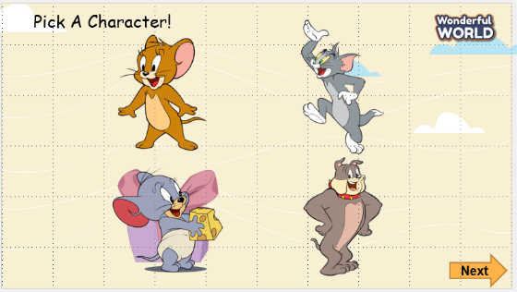  While gaming  - Ask sts to work in groups  - Hand each group a print of task 1  - The sts will unscramble the words and get stars.  - The team, who gets the highest scores, will be the winner. | - Listen to the teacher  - Repeat and do the action  - Sing along and repeat the song.  Speak out correctly, paying attention to the pronunciation.  Do the game and get stars
Activity 2: Project (20 minutes)
Aim: Review the words and practise verbs and phrases
Teacher’s Activities | Students’ Activities
Project: Hobbies  Outdoor activities quiz  - Guides sts to play with the game and match the correct pictures with the correct words  - Anyone who can answer correctly, will be given a star.  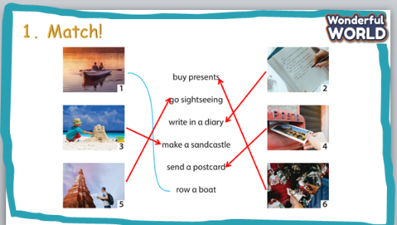  Project: Your travel plan  - Tell them to draw a picture of a camp  - Colour the picture  - Ask sts to go to the board – group by group and present.  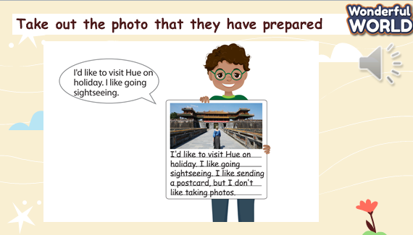  Evaluation (2 MINUTES)  Answer the multiple choice and show answers  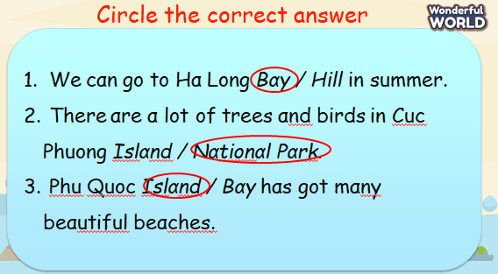  Home work (2 MINUTES) | - Listen to the teacher  - Listen to the game rules  - Look at the picture  - Choose the correct answer  - Show the board of correct answers.  -Talk to friends about the picture  - Read aloud the answers about objects.  - Students to think about their plan for an ideal trip.  - Students they are going to talk about their travel plan.  - Studnets look at the picture and the example sentences.  - Students to repeat after teacher.  - Students take out the photo that they have prepared  and think of some similar sentences to describe their plan.  - Work in pairs or groups.  - Write down the answer on their own board/book.  - Work in pairs or groups.
________________________________
REVIEW 5
Part 1. Task 1, 2, 3, 4
Period 111
I. OBJECTIVES:
1. Knowledge:
- Students will review the words and structures related to the topic On holiday:
2. Competences:
- English competences: Students will be able to talk about “On holiday”.
- Common competences: Students will have the opportunity to develop communication among friends.
3. Qualities:
- Students will be responsible and well-behaved in communicating in the classroom with friends and others.
II. EQUIPMENT AND MATERIALS:
- Basic things: Student’s book, flashcards.
- Advanced things: PPT, projector/interactive whiteboard/laptop/TV.
III. LESSON PROCEDURE:
Warm up (5 minutes)
Aim: warm-up activity to ongoing review topics of the lesson.
Teacher’s activities | Student’s activities
- Greet students  To start:  - Revise the words from flashcards (Units 9 and 10).  - Stick the flashcards on the board. Ask a volunteer to point to a flashcard on the board and to say what it is.  - Ask a volunteer to say three words quickly one after the other for a classmate to put the correct three flashcards in order on the board. Repeat  with different volunteers  Look and say. Use the picture to answer.  • Suggested answer:  1 How do we get to the park?  – We go strαight on King street, αnd  then turn right. The park is between the restaurant and the toy shop.  2 How do we get to school?  - We go strαight on King street, αnd  then turn right. The school is opposite the market  3 How do we get to the restaurant?  We go strαight on King street, and  then turn left. The restaurant is opposite the zoo. | - Greet teacher  - Look the flashcards on the board  - Say three words quickly  • Suggested answer:  1 How do we get to the park?  – We go strαight on King street, αnd  then turn right. The park is between the restaurant and the toy shop.  2 How do we get to school?  - We go strαight on King street, αnd  then turn right. The school is opposite the market.  3 How do we get to the restaurant?  We go strαight on King street, and  then turn left. The restaurant is opposite the zoo.
Practice (20 minutes)
Aim: Practise saying words on holiday, focussing on verbs and nouns and places of holiday.
Teacher’s activities | Student’s activities
Task 1: Circle  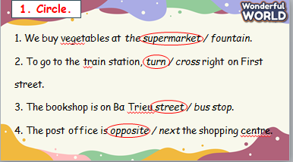  • Tell students to look at the pictures  and write the words.  • Allow enough time to complete  the task. Check answers as a class.  Ask students to spell the words.  Task 2: Point and say  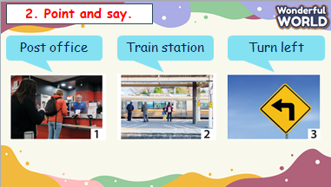  • Tell students to play a quick game individually or in pairs. Students take turns to point to a random picture and say the word.  • Play the game with the whole class by pointing to a word and asking a student to say the word  immediately  3. Let’s play :  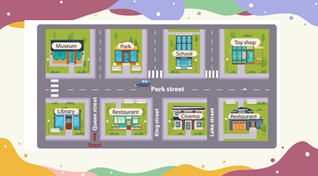  • Read the instruction to the student.  • Invite two students to read the model dialogue.  • Put students into pairs and tell them to play the game.  • Ask some volunteers to play the game in front of the class. | - Look at the pictures.  - Write the words.  -Check answers  - Look and read the example.  - Look and read.  - Join the game by looking and saying.  -Check answers with friends  -Listen  -Ask and answer the questions in pairs  -Check and practice in front of class
Extra activity (10 minutes)
Aim: Do the exercise to review and practice the preposition of places.
Teacher’s activities | Student’s activities
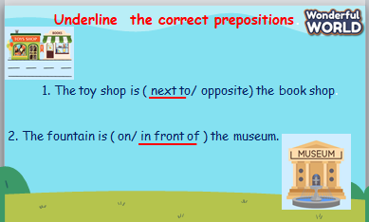  -Check answers. Ask volunteers to read out their answers.  - Give feedback to them.  -Ask students to sing the goodbye song. | - Work in groups  - Present.  - Listen.
_____________________________
REVIEW 5
Part 2. Task 1, 2, 3
Period 112
I. OBJECTIVES:
1. Knowledge:
- Students will review the words and structures related to the topic On holiday:
2. Competences:
- English competences: Students will be able to talk about “On holiday”.
- Common competences: Students will have the opportunity to develop communication among friends.
3. Qualities:
- Students will be responsible and well-behaved in communicating in the classroom with friends and others.
II. EQUIPMENT AND MATERIALS:
- Basic things: Student’s book, flashcards.
- Advanced things: PPT, projector/interactive whiteboard/laptop/TV.
III. LESSON PROCEDURE:
Warm up (5 minutes)
Aim: warm-up activity to introduce the topic of the lesson, guiding direction to the right place
Teacher’s activities | Student’s activities
- Greet students  To start:  In this fun song we learn about left, right, forward, and back! Dance and sing along!  Lead in the topic: DIRECTION  . | - Greet teacher  - Listen to the instruction carefully and watch the video.  - Watch the video again and sing along to the song.  Listen and answer the questions.
Practice (20 minutes)
Aim: Practise words, ask and answer using key structures by doing different activities.

Teacher’s activities | Student’s activities
Task 1: Do the crossword.  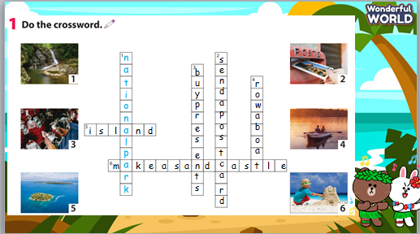  • Ask student to look at the crossword. Then ask them to look at the first picture and the example answer. Tell them to find the words to describe other pictures.  • Check students understand the task. Allow students time to complete it.  • Check answers in class.  Task 2: Circle  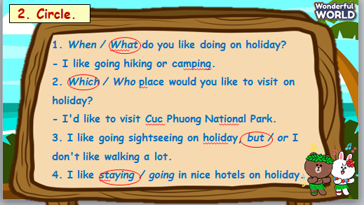  - Tell students to read the sentences and circle the correct answer options. Ask them to look at the  example.  - Allow time to complete the task then check answers in class  Task 3. Activity: Talk about activities  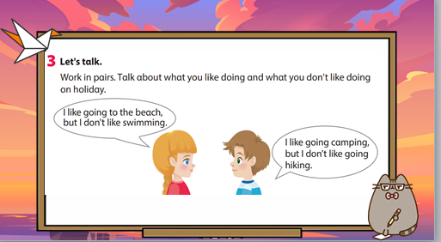  • Ask students to look at the example sentences. Read out the example.  • Read the instruction to students.  • Tell students to work in pairs and make their own dialogue.  • Go round the class helping students where necessary.  • Ask volunteers to act out their new dialogue to the class  3.Production  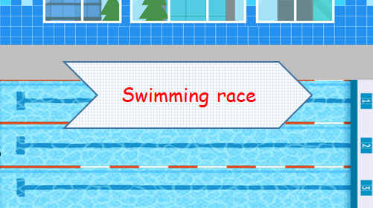  - Divide class into 2 teams.  - Explain game’s rules:  + Each team chooses a number to answer a question.  + If Ss have the right answer, the swimmer of their team will swim forward one step.  + The team finishes the race sooner will be the winner.  Teacher needs to click the swimmers to make them swim forward. | - Look at the crossword and look at the first picture and the example answer.  - Find the words to describe other pictures.  • Do the crossword  • Check answers as a class.  -Look and read the example.  - Circle the correct answer options  -Check answers with friends  -Listen  -Ask and answer the questions in pairs  Practice in class and cross checking if possible,  - Listen to the rule carefully.  - Join the game.  -Look and read.  - Join the game by looking and saying.
Extra activity (10 minutes)
Aim: Do the exercise to review and remember the words, practicing rearranging sentences
Teacher’s activities | Student’s activities
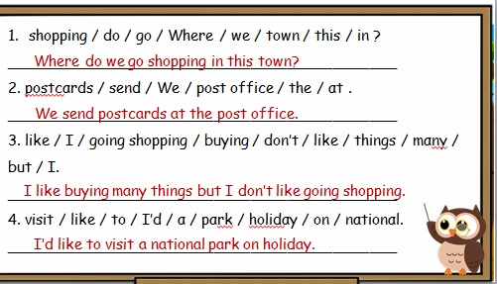  -Check answers. Ask volunteers to read out their answers.  - Give feedback to them.  -Ask students to sing a goodbye song | - Work in groups  - Present.  - Listen.

